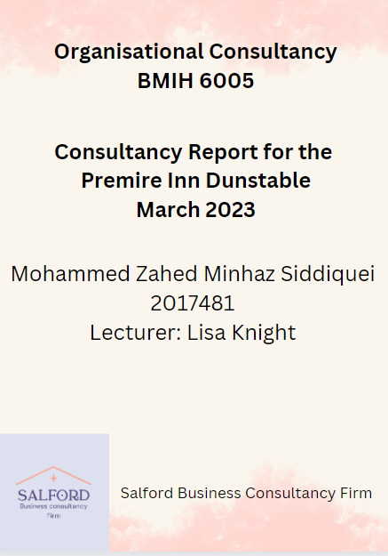
Table of Contents
Executive summary 3
Introduction 7
Scope & analysis 9
Overview of the hotel Premier Inn 9
Brand reputation of the hotel Premier Inn 10
Negative publicity 11
SWOT 13
Star model (GALBRAITH) 16
Analysis of the issues in Premier Inn 18
Analysis of the health and safety depertment 18
Positive Aspects: 18
Negative Aspects: 21
Analysis of the security department 22
Positive aspects 22
Negative aspect 25
Findings & Results 27
TOWS analysis 27
Online analysis and Literature review 31
Action Plan 34
Recommendations 37
Conclusion 38
Reference 40

Executive summary
The problem or issue at stake
Consulting services can help Premier Inn, Dunstable to assess its current operations and develop strategies for improvement. They can also provide guidance on how to improve the guest experience, optimize staff performance, and identify areas of cost savings in two major aspects such as health and safety issues and security issues. The hotel Premier Inn industry has a responsibility to ensure the safety and security of guests, employees, and property. This includes ensuring that all safety protocols are in place and that all workers are trained in safety and emergency procedures. Hotels must also ensure that all areas of the hotel are maintained to a high standard and that all fire safety regulations are strictly adhered to (Silva et al. 2021). In addition to health and safety concerns, the hotel Premier Inn, Dunstable also takes measures to ensure the privacy and security of guests, employees, and property. Hotels have to maintain strict policies in place to protect the personal information of guests and employees (Chen, 2019). This includes secure storage of guest and employee data, secure access to hotel rooms, and secure disposal of customer information. The hotel industry must also take steps to protect guests from any health risks. This includes having a plan in place to respond to any health or safety issues, as well as having a procedure for reporting any health and safety concerns quickly and effectively.
Findings
Hotel Premier Inn’s health and safety and security concerns can have a significant negative impact on both guests and employees. Hotel safety and security are of utmost importance to ensure the safety of everyone on the premises. Poor health and safety and security practices of Primer Inn lead to guests feeling unsafe and uncomfortable, while employees may be put in danger (Kunageuro, 2019).
For guests, the lack of health and safety measures can lead to a wide range of issues. These include slips, trips, and falls, as well as the potential for fires, food poisoning, and other accidents (Huang et al. 2023). Poor security can also put guests at risk of theft or assault. Poor health and safety measures can also lead to discomfort in the form of inadequate temperature control, unclean rooms, and other issues. on the other hand premier Inn's share of hotel rooms in the UK hospitality market is expected to increase by 11 % in 2022. But it can not be possible due to the COVID pandemic and inadequate safety measures of this hotel (Statista Research Department, 2019).
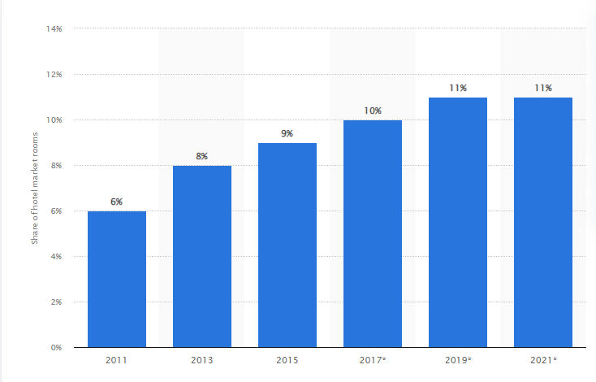
Figure: Premier Inn’s share of hotel rooms in the UK hotel industry
Source: Statista Research Department, (2019)
For employees, a lack of safety and security can be even more serious (Nwokorie and Igbojekwe, 2020). Poor health and safety measures can lead to accidents and illness, while inadequate security can leave employees in danger of theft and assault. Poor security can also lead to a lack of privacy for employees, which can lead to stress and discomfort.
Analysis of these findings
From the SWOT and star model analysis of the hotel premier inn can be concluded that though this hotel has an exceptional brand reputation 93% in the UK and among them, 37% were loyal customer base (Kunst, 2023). But the some of the customers have cleaning and hygiene issues regarding food and housekeeping service. Inadequate fire safety systems may mean that the guests are not safe in the event of a fire and may be at risk of injury or death. Additionally, a lack of security personnel may make guests feel unsafe and vulnerable or may leave them exposed to theft or other forms of crime. A lack of fire safety systems may put them at risk of injury or death if a fire were to occur, while a lack of security personnel may leave them vulnerable to theft or other crime (Steen-Hansen et al. 2021). Additionally, employees may feel unsafe and vulnerable due to the lack of security personnel, which can lead to a decrease in morale and productivity. on the other hand distribution of premier Inn hotel booking by online sites Premier inn.com increased to 88% (Statista Research Department, 2020).
Recommendations to the client
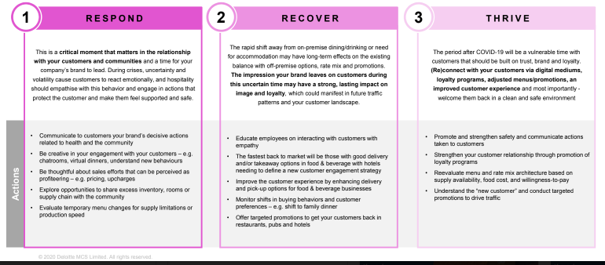
Figure: Quick action plan of the consultant
Source: (lecture notes)
During the COVID-19 pandemic business consultancy follow quick and appropriate action to help the hospitality sector analysis by responding, recovering and thriving cycle. To Improve the health and safety and security issues of the hotel Primer Inn is essential for the success of the business. Firstly, the management should ensure that all staff members are provided with appropriate health and safety training and that they abide by the safety guidelines that are in place (Muthee and Peter, 2020). It is also important to have regular safety inspections carried out to ensure that all areas of the hotel are maintained to the highest standards. To address security issues, the hotel should install more CCTV cameras in all public areas and ensure that the security staff is well-trained and vigilant (Muthee and Peter, 2020). The hotel should also strictly enforce its policies regarding guest access to areas within the hotel, and the use of access cards should be mandatory. Furthermore, the hotel should also introduce a policy that ensures all guests are verified upon check-in (Lee and Tse, 2021). Finally, the management should ensure that all safety and security equipment is regularly checked and maintained, and any necessary repairs and replacements should be carried out promptly. By implementing these measures, the hotel can ensure that all its guests have a safe and secure stay.
Conclusion
The Primer Inn, Dunstable is committed to providing a safe and secure environment for its guests. The hotel has implemented a number of safety measures to ensure the safety of its guests. All exterior doors are locked at all times and security cameras are installed throughout the hotel. The hotel also employs a 24-hour security staff to monitor the premises and respond to any security concerns. Fire alarms and smoke detectors are also installed in all areas of the hotel for added protection. The hotel also takes a proactive approach to health and safety issues. All staff are trained in basic first-aid and CPR and are ready to respond to any medical emergencies. The hotel also follows strict regulations on food safety and hygiene and conducts regular health inspections and tests. Furthermore, the hotel has taken steps to ensure a hygienic environment by providing hand sanitizer and surface cleaners in all areas of the hotel.

Introduction
Health and safety issues in the hotel industry are extremely important. Hotels must ensure that all areas of the premises are safe and secure for guests and staff. This includes ensuring that all lighting and fire safety systems are functional and up-to-date, as well as making sure that all areas are regularly inspected for any potential hazards (Nwokorie and Igbojekwe, 2020). Furthermore, hotels should be aware of any potential allergens or hazardous materials that may be present, and provide appropriate information to guests and staff. It is also important to make sure that all employees are trained in health and safety procedures, and that safety equipment is provided and maintained. Finally, hotels should ensure that all guests are aware of potential risks and provided with the necessary information to stay safe. A consultancy report is usually prepared by an expert for the client or company that wants to address a particular issue related to business and improve it in a short time. Here is the discussion made on the consultancy report of Hotel Primer Inn which has health and safety and security issues. Within a Salford business consultancy firm environment, the consultant need to consider a particular issue in the hotel industry safety and health issue is a major concern and the security of the customer is another important fact of the hotel industry. In the finding section of the consultancy, report consultants can use SWOT analysis as it can help them easily understand the company's internal environment analysis. In this report Salford business consultancy firm will notice on the health and safety and security Department of the hotel premier inn.
The Star Model is a comprehensive tool that considers the Strategy, Structure, Processes, Rewards, and People of an organization to provide an overall picture of sustainability (The star model, 2021). Therefore, it is appropriate to analyse the situation. With the help of this report, one can analyse the incubator and accelerator factors of the UK business industry specifically the hotel industry. As the hotel, Premier Inn, Dunstable is a reputed company in the UK this report focuses on the findings of the key major issues of the company and how it overcome them by applying some action plans.
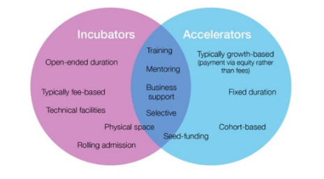
Figure: Defining characteristics of Incubators and Accelerators
(Source: lecture notes)

Scope & analysis

Overview of the hotel Premier Inn

Figure: Premier Inn hotel logo
(Source: Premier Inn Hotels: Book Direct 2023)
The Premier Inn is a UK-based chain of budget hotels with over 800 locations across the UK and Ireland. It is one of the largest and most popular hotel chains in Britain, offering comfortable yet affordable accommodations for business and leisure travelers alike. The hotel offers a wide range of amenities, including free Wi-Fi, flat-screen TVs, and modern bathrooms (Nwokorie and Igbojekwe, 2020). Guests can also enjoy a range of on-site restaurants serving traditional British meals, as well as a bar. The hotel also offers a 24-hour reception and a range of additional services, such as laundry and dry-cleaning services. Premier Inn also offers a range of special packages, including the popular 'Premier Inn Explore' which offers discounts on activities and attractions in the local area (Giousmpasoglou and Hua, 2020). With its great location, comfortable rooms, and excellent value for money, the Premier Inn is perfect for those looking for a budget-friendly stay in the UK. Hotel Premier Inn takes safety and security seriously. All visitors must present a valid ID and any security risks are reported and dealt with promptly. Cameras are located in public areas and staff is regularly trained in safety protocols. Although, there is some issue regarding the health and safety aspect of this hotel which is a major concern of customers after the COVID-19 pandemic (Bas and Sivaprasad, 2021).

Brand reputation of the hotel Premier Inn
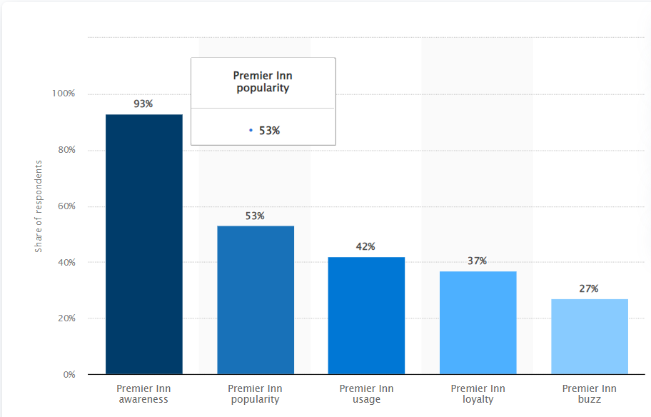
Figure: Consumer loyalty to Premier Inn
(Source: Kunst 2023)
The Hotel Premier Inn is part of the Whitbread Group, one of the UK’s largest hospitality companies, and has been operating since 1987 (Premier Inn Hotels: Book Direct, 2023). The hotel chain has become well known for offering great value for money and excellent customer service, which is demonstrated by its extensive customer satisfaction surveys. The brand reputation of this hotel is about 93% in the UK hotel industry among them 37% of customers are loyal to the hotel (Kunst, 2023). The hotel chain is also renowned for its commitment to sustainability, with all its hotels being designed to reduce energy and water consumption and waste. This commitment to sustainability has been praised by many, including the Carbon Trust, which awarded Premier Inn with its highest sustainability rating.
The hotel chain is also well known for its commitment to providing its guests with the best possible experience (Volodymyrivna and Andriyic, 2019). All of its hotels have been designed with the guest in mind and feature comfortable rooms, great amenities, and excellent customer service.
Overall, the Hotel Premier Inn has established itself as one of the leading hospitality brands in the UK and is renowned for its great value for money, excellent customer service, and commitment to sustainability. Its commitment to providing excellent customer service and comfortable rooms has ensured that the brand has a great reputation amongst its customers and the wider hospitality industry.

Negative publicity
The Premier Inn hotel chain has recently been subject to a large amount of negative publicity, both online and in the media. This has been due to a range of issues, from customer complaints to reports of bed bugs and health and safety issues. In April 2020, an investigation by the BBC revealed that Premier Inn, Dunstable had received hundreds of complaints of bed bugs in their hotels over the past 5 years (BBC News, 2019). These complaints were not always dealt with appropriately and some customers received little compensation for their experience.
In addition, the BBC also uncovered evidence of poor health and safety practices in some of the chain's hotels. This included reports of dirty sheets, broken furniture, and inadequate fire safety measures. These revelations caused a significant backlash from customers and led to a significant drop in bookings. Although this fact the occupancy rate of Premier Inn, Dunstable in the UK hotel industry was reported to be 67.3% out of 841 hotels in the UK accounting in 2021- 22 due to COVID -19 this hotel faced a decrease of 29.4% occupancy rate in 2020-21 ( Statista Research Department, 2022).
Furthermore, there have been several reports of poor customer service at Premier Inn, Dunstable hotel over the past year. Customers have reported issues such as long wait times for check-in, as well as issues with billing and refunds (Peres and Paladini, 2022). These complaints have been widely reported online, leading to a further decline in customer satisfaction. Finally, there have been reports of unfair employment practices at some of the chain’s locations. In particular, reports have emerged of staff being asked to work longer.

SWOT
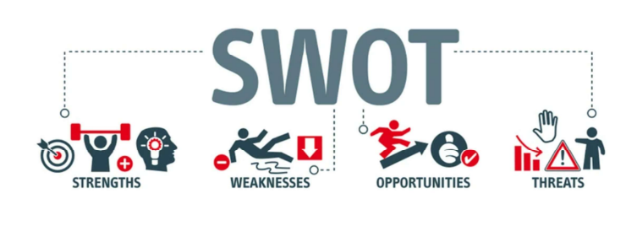
Figure: SWOT analysis
Source: (Lecture Notes)
Strength  - This hotel is located in a prime tourist spot with plenty of local attractions for guests to explore.  - Have a great loyal customer base  - 8,332 rooms with technological advancement (Berry 2022).  - This hotel has 53% brand awareness in the UK hotel industry (Alnawas and Hemsley-Brown, 2019).  - Have all premium and luxurious facilities for the guests. | Weakness  - Social media reach is limited  - Does not offer any discounts or loyalty programs to attract guests.  - Lack of hygienic Spa services, which guests looking for (Roy and Thohari, 2020)
Opportunity  - create a website and social media accounts to market itself to potential cust  - upgrade its amenities to include Wi-Fi and flat-screen TVs to attract more guests (Annual reports, 2022)  - can create a strategic partnership with other competitors like Emirates groups(Attractions & Partners, 2023) | Threats  - can offer discounts and loyalty programs to encourage repeat customers  - Surrounded by members of other competitor hotels  - High cost of rooms  - subject to changes in government regulations or policies, which could affect its operations
Figure: SWOT analysis of Primer Inn
Source: (Self-made)
Hotel Primer Inn is a well-established hotel located in a prime location in the city. Its strengths include its excellent reputation for customer satisfaction, a wide range of services and amenities, and well-trained and experienced staff. Its weaknesses include a lack of modern technology and a limited marketing budget. Its opportunities include reaching out to new customers, utilizing technology to increase efficiency, and expanding services to meet customer demands. Its threats include increased competition from other hotels and the risk of losing customers due to changes in the market. By leveraging its strengths and taking advantage of opportunities, Hotel Primer Inn can continue to provide exceptional experiences for its customers.

Star model (GALBRAITH)

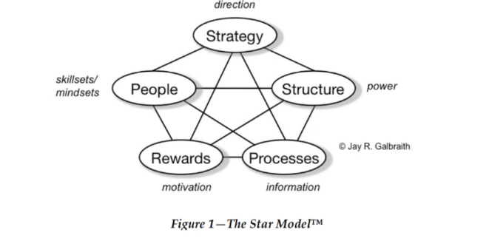
Figure: Star model
Source: (lecture notes)
Strategy | Structure | Process | People | Rewards
The company strategy should be high and luxurious and service at affordable pricing (About Us 2023). | The centralized organizational structure is used by the vertically integrated model of the business strategy including the help of the chief, executive group, chairman, finance group, HR, staff, and other non-executive directors. (Mody et al. 2020) | Promotion of diverse cultures and a good working environment | Trained with safety and hygienic practice employee out of 35000 people 77% of employees engaged with team members (Annual reports, 2022). | Rewards like salary increments of an employee with the loyalty recognition program 50% discount on food and social club for customer encouragement.
Figure: Star Model of Premier Inn, UK
(Source: Self-made)

The Galbraith Star Model is a framework for analysing the strategic position of a hotel, such as Hotel Primer Inn (Galbraith, 2021). It evaluates the hotel’s market position, product and service offerings, customer experience, operating efficiency, and financial performance. This model helps to identify strengths and weaknesses that can be used to inform strategic decision-making. The market position of Hotel Primer Inn is driven by its location, brand and reputation, size, and marketing strategy. The product and service offerings consist of the amenities provided, pricing, and accessibility. The customer experience evaluates the quality of the services provided to customers, the level of engagement and feedback, the appearance of the hotel, and overall customer satisfaction. The operating efficiency of Hotel Primer Inn is based on its operating processes, staff productivity, and cost control. Finally, the financial performance is measured through the hotel’s profitability and liquidity. By considering each of these components, a hotel can gain a better understanding of its strategic position and determine how to improve its operations and performance.

Analysis of the issues in Premier Inn

Analysis of the health and safety department

Positive Aspects:
The Premier Inn hotel chain places a great emphasis on providing a safe and healthy environment for its guests and staff. Premier Inn, Dunstable hotels adhere to strict health and safety standards, from their fire safety systems to the cleanliness of their rooms. This hotel staff ensures that their reception is managed by 24 * 7in a day service for every customer of the hotel (safety in primer Inn, 2022). Premier Inn, Dunstable has a comprehensive fire safety program in place at all of its hotels. Fire alarms are regularly tested, and emergency exits are clearly marked and easily accessible. All staff is trained in fire safety and emergency procedures, and smoke detectors are installed in all rooms.
The hotel also takes food safety seriously, ensuring that all food is handled and prepared properly and stored in a safe temperature-controlled environment. All staff are trained in food safety and hygiene and food waste are disposed of in a manner that prevents the spread of foodborne illnesses. As per Bajaj, (2021), tourists are more prone to sustainable food practicing the hotel industry and this hotel easily adopts it through trained staff.
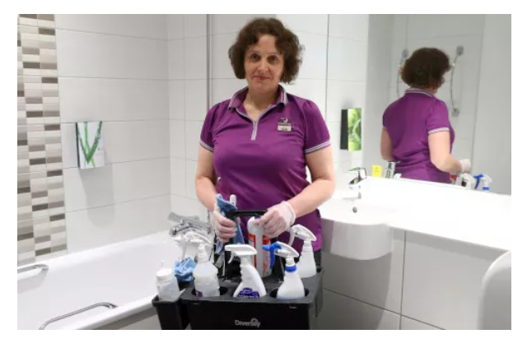
Figure: Cleaning stuff of Premier Inn
Source: (Safety in primer Inn, 2022)
Premier Inn, Dunstable also takes steps to ensure that its hotel premises are kept clean and hygienic. All hotel rooms are cleaned daily using approved cleaning products and methods and all surfaces are regularly disinfected. The hotel is also regularly inspected for signs of pests, such as bed bugs, and pest control measures are taken if needed.
After the Covid-19 pandemic, the rate of occupancy in the UK hotel industry is expected to be down from 83 and 75% to just 29 and 38 % respectively (Armstrong and Richter, 2020). As this hotel has several outlets in different regions of the UK this cannot be a major issue.
Overall, Premier Inn takes health and safety seriously and strives to provide a safe and healthy environment for its guests and staff (Dennerlein, 2020). Their comprehensive safety protocols and commitment to employee wellbeing ensure that all those staying at a Premier Inn, Dunstable hotel can do so in the knowledge that their safety and health are being taken care of. Premier Inn, Dunstable takes steps to ensure the health and well-being of its staff (Dennerlein, 2020). All staff is provided with personal protective equipment, such as gloves, masks, and eye protection, and regular health and safety training is provided (Galuh, 2019). The hotel also promotes a healthy lifestyle and offers employees a range of wellness benefits, such as discounted gym memberships and access to on-site health checks.

Negative Aspects:
For preparing a business consultancy report defining the problem is a crucial step. Evaluation of the problem in health and safety aspects in the hotel industry has gained a reputation after the Covid pandemic so this report wants of find some negative aspects in the hotel Primer Inn. The Premier Inn, Dunstable is a well-known chain of hotels across the UK and beyond. However, as with any accommodation, there are potential health and safety risks associated with staying at one of these establishments. On a hotel booking site, customers give negative reviews and said that health and safety were missing in their experience and give 1 rating on this site (Kunageuro, 2019).
One of the most common health and safety risks at a Premier Inn, Dunstable is the presence of bed bugs. Bed bugs are tiny insects that feed on human blood and can leave guests with itchy, red welts. To minimize the risk of bed bugs, guests should inspect their rooms for signs of pests before unpacking their luggage (Giousmpasoglou and Hua, 2020). If a room is found to be infested, the guest should inform staff immediately so that the issue can be addressed.
Another health and safety issue that can present itself at Premier Inn hotels is the presence of mould or mildew. According to (Smith, 2019). This is often caused by poor ventilation, or by a build-up of moisture in the room due to a lack of air circulation. The presence of mould or mildew can cause health problems, such as respiratory issues, so it is important to notify staff if this is noticed. On the other hand, a health and safety risk associated with Premier Inn hotels is the presence of dust and other allergens. Guests should be aware that carpets and other furnishings in the room may harbour dust and other allergens, which can trigger allergies or asthma (Adams et al. 2021). Guests with allergies should take extra care to ensure that their room is kept as clean and dust-free as possible. Finally, guests should be aware that the facilities at Premier Inn hotels are not always up to date. Electrical outlets, lighting fixtures, and other features may be outdated or unsafe. If these features are not up to code, guests should inform staff immediately so that any necessary repairs or replacements can be made.
In conclusion, there are potential health and safety risks associated with staying at a Premier Inn. Guests should take the necessary steps to inspect the room for signs of bed bugs, mould or mildew, dust, and outdated fixtures. By taking these precautions, guests can ensure that their stay is safe and comfortable.

Analysis of the security department

Positive aspects
The Premier Inn is one of the world’s leading hotel chains, with over 800 hotels in the UK and Ireland alone. With the ever-increasing threat of cybercrime, the Premier Inn, Dunstable has implemented a wide range of security measures to ensure the safety of both its guests and employees. Premier Inn, Dunstable also takes steps to ensure the safety of its guests. All rooms are equipped with emergency exit maps and safety cards and all staff are trained in first aid and CPR (Huang et al. 2022). The hotel also has CCTV in public areas and a 24-hour security guard. the Premier Inn, Dunstable has taken steps to improve physical security at all its properties. All hotel entrances and exits are monitored by CCTV cameras, and a team of security personnel is on duty at all times to ensure that only authorized personnel can access the premises. All guest rooms are fitted with electronic locks, and key cards are provided for easy access. In addition, the hotel has implemented several measures to prevent theft and other unauthorized activities, such as visible signage and regular patrols of the premises by security personnel.
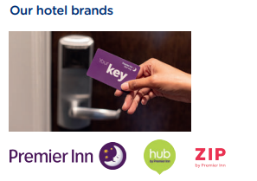
Figure: RFID-enabled card system of Premier Inn
Source: (Annual reports, 2022)
Premier Inn, Dunstable has also invested heavily in technological security measures. All room access is managed through an RFID-enabled card system, and all guest information is stored securely on a cloud-based system (Annual reports, 2022). The hotel’s Wi-Fi system is protected with the latest encryption technology, and all online payments are processed through a secure payment gateway. In addition, the hotel has implemented a number of measures to protect its guests from cybercrime, such as regular software updates, firewalls, and anti-virus software.
The Premier Inn, Dunstable has also taken steps to ensure the safety and security of its employees. All staff are required to undergo regular security training and are given access to a secure online portal for reporting any suspicious activity (Chung and Byrom, 2021). The hotel also operates a strict policy of background checks for all new employees, and all staff members are subject to regular drug tests. An average of 34 thousand employees worked at Premier Inn, in the financial year 2018 (Statista Research Department, 2020).
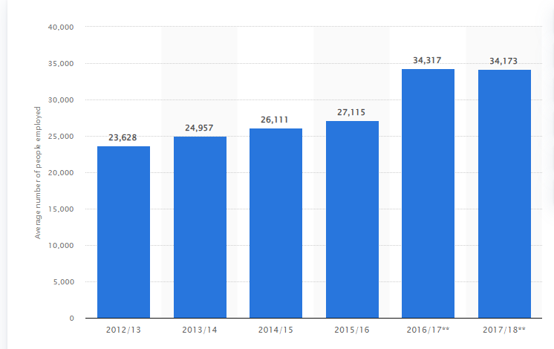
Figure: people directly employed by Premier Inn
Source: (Statista Research Department and 19, 2020)
The Premier Inn, Dunstable has implemented a number of measures to protect its guests’ personal data. All guest information is stored securely on a secure server, and all online payments are processed through a secure payment gateway (Filimonau, and Magklaropoulou, 2020). The hotel also has a strict policy of not sharing any guest information with third parties.
Overall, the Premier Inn, Dunstable has taken several steps to ensure the safety and security of both its guests and employees. Through the implementation of physical, technological, and personnel security measures, the hotel chain has ensured that its guests and staff are protected from both physical and cyber threats.

Negative aspect
The Premier Inn, Dunstable hotel chain has been popular for its convenient locations, affordability, and amenities. However, the security of the hotel can be a concern for some guests. There have been reports of thefts from hotel rooms and the hotel’s general premises, as well as reports of unwanted guests entering the hotel. Some of the Premier Inn, Dunstable hotels have limited staff presence and surveillance cameras, making it difficult to adequately monitor the security of the premises (PREMIER INN PRIVACY NOTICE, 2022). Additionally, some hotels have inadequate lighting in common areas and hallways, which can make it difficult to identify suspicious individuals. In some cases, guests have reported that the staff at the hotel did not take appropriate measures to ensure the safety of their belongings. Finally, the hotel chain has been criticized for failing to respond quickly to reports of security issues or to provide assistance in the event of an emergency (Sese et al. 2022). All in all, Premier Inn, Dunstable may offer great value for money, but the security of their premises should be taken into consideration before booking a stay.
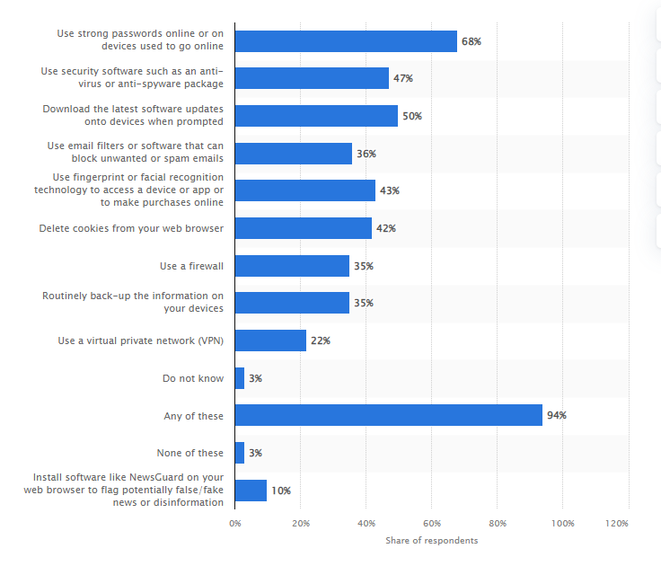
Figure: UK online security measures
source: (Ani Petrosyan, 2022)
Employee security is an important part of any business, especially within the hospitality industry. Hotel Premier Inn, Dunstable is no exception and must take measures to ensure the safety of its employees. Unfortunately, there are also some negative aspects associated with such measures. One of the main negative aspects of employee security at Hotel Premier Inn is the cost. Security measures can be expensive to implement and maintain, especially when sophisticated technology is involved (Alzyoud, 2019). Hiring additional staff to monitor security systems and respond to potential threats may also be necessary. This can quickly add up, putting a strain on the hotel’s budget. The Premier Inn, Dunstable Hotel does not have a specific budget for staff security or data security. The hotel's security policies and procedures are managed by the hotel's Security Manager, who will work with the hotel's budget to ensure that the necessary security measures are in place for staff and data.
In addition, employee security measures can make employees feel uncomfortable. Surveillance cameras and other security technologies can be intimidating and make employees feel as if they are constantly being monitored (Manokha, 2020). This can have a negative impact on employee morale and productivity.
Another potential issue is data privacy (Manns, 2020). Hotel Premier Inn may be collecting a great deal of data about its staff, including their movements, conversations, and even personal information. This data can be vulnerable to breaches or misuse. It is important for the hotel to have strict protocols in place to protect this data and ensure that it is only used for legitimate purposes. As per (Ani Petrosyan, 2022) 95% of UK people use any internet security measures majority of them about 70% use only passwords to protect their data.

Findings & Results

TOWS analysis
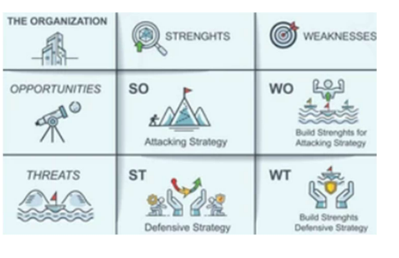
Figure: TOWS analysis
source: (Lecture Notes)
TOWS | STRENGTHS  - The brand awareness of Premier Inn is pretty high about 93% as per (Kunst 2023)  - 53% of UK consumers prefer Premier Inn.  - the hotel operates in a variety of tourist locations which is a strategy of the hotel business (Premier Inn Hotels: Book Direct 2023).  - the shorts are providing their customers with easy transportation facilities.  - highly dedicated employment of 35000 people.  - luxurious facilities give opposition to satisfy customers.  - promotion of a good working atmosphere for employees  - the technological facility provided in every room of the hotel | WEAKNESS  - low customer satisfaction form and their staff service  - limited social media reach  - hygienic practices of employees are missing  - employee and customer health and safety were neglected sometimes  - low motivation and dissatisfaction of staff are caused by low and irregular wage pay and long working hours in the hotel industry (Cabalcar, 2022)  - customer personal information data security is not appropriate  - 95% UK population think password is a security measure in an online platform
The TOWS analysis (Threats, Opportunities, Weaknesses, and Strengths) can help Premier Inn make decisions by providing an overview of the organization's external environment and the internal environment (Dandage et al. 2019). It allows the company to identify and evaluate strategic options in order to make the most effective decisions. It helps to identify the competitive advantages and disadvantages of the firm and highlights areas where it can improve and capitalize on its strengths. It can also help to identify potential threats and weaknesses so that the company can take steps to address them. In addition, it can be used to compare the firm's performance with that of competitors, so that Premier Inn can identify and capitalize on any opportunities.

Online analysis and Literature review
According to (Awan et al. 2021), The health and safety of hotel guests and employees are of paramount importance in the hospitality industry. Hotels must adhere to a variety of regulations and best practices to ensure the well-being of their guests and staff (Gallan et al. 2021). This literature review will discuss the health and safety measures that the hotel industry has implemented over the years and the impact they have had on customer satisfaction and employee morale. The most common health and safety measure implemented by hotels is the implementation of regular cleaning and sanitation protocols (Awan et al. 2021). Hotels must ensure that all areas of their establishment are cleaned and sanitized on a regular basis. This includes the guest rooms, lobbies, and common areas, as well as any public spaces such as restaurants, swimming pools, and fitness facilities. In addition, hotels must also adhere to food safety protocols to ensure that the food served to guests is safe and uncontaminated. As per Rosemberg, (2020) during Covid -19 employers in the hospitality industry are obliged to safeguard the health and safety of their workers as per the hierarchical control from the National Institute for occupational safety and health.
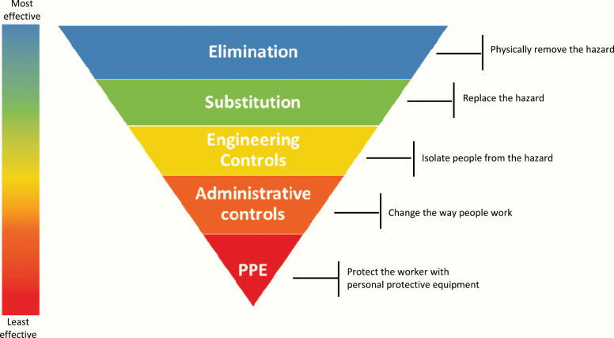Figure: Hierarchy of control of NIOSH’s
Source: (Rosemberg, 2020)
Another important health and safety measure in the hotel industry is the implementation of fire safety protocols. Hotels must adhere to strict fire safety regulations, such as the installation of fire alarms, fire extinguishers, and smoke detectors (Ivanov et al. 2022). These safety measures are essential to protect guests and employees from fire hazards. Hotels must also ensure that their buildings are maintained in a safe and secure manner. This includes the installation of security systems and the provision of adequate lighting in all areas of the hotel. Hotels must also ensure that all staff is trained on proper safety procedures and that they are aware of any potential hazards in the hotel. the market value of fire suppression equipment and the consumables market was expected to be 18.8 billion US dollars in 2019 and expected to increase to 24.8 billion U.S. dollars by 2024 (Statista Research Department, 2023). therefore, the hotel Primer Inn should allocate an extra budget for the purchase of fire-suppressed equipment.
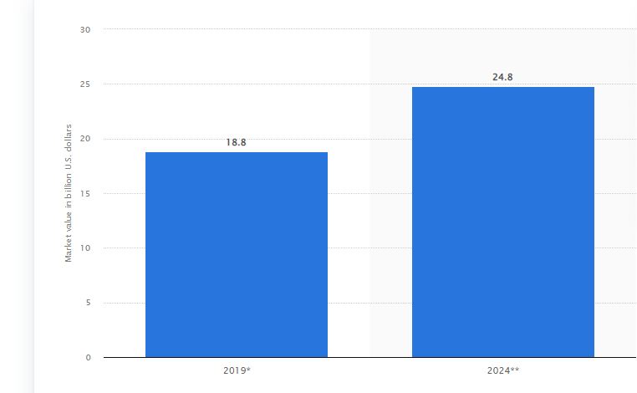
Figure: Market value of Fire suppression equipment worldwide
Source: (Statista Research Department and 9, 2023)
Finally, hotels must also provide employees with proper training and safety equipment to ensure their safety while on the job. This includes protective clothing, safety glasses, and other necessary equipment (Jiang and Wen, 2020). Hotels must also have a clear policy regarding the use of drugs and alcohol on the premises. The implementation of health and safety measures in the hotel industry has had a positive effect on customer satisfaction and employee morale. Hotels that take the necessary steps to ensure the safety of their guests and staff can expect to receive higher ratings from customers and more productive staff (Ali et al. 2020). In addition, these safety measures can also help to reduce the risk of accidents and increase the efficiency of hotel operations.

Action Plan
Number | Problem | Solution | Desired outcome | Time  scale | Completion Date | Planned  Budget
1. | Fire Safety | security alarm with industry 4.0 advanced technology and all staff is properly trained on fire safety procedures (Ivanov et al. 2022) | more protection from the fire | 3-month | 2nd week of May 2023 | £10,000
2 | Security | implement new CCTV cameras with the employment of new security guards | ensure that all guests, employees, and visitors are safe and secure within the premises | 1-month | 1st week of April | £10,000
3 | Food Hygiene | food must be stored, prepared, and served according to health and safety regulations train the staff accordingly (Safety in primer Inn, 2022) | the guests were satisfied with the quality of food and kitchen hygiene | 1- month | 1st week of April | £10,000

Recommendations
- Premier Inn, Dunstable should implement security alarm with industry 4.0 advanced technology and all staff is properly trained on fire safety procedures (Ivanov et al. 2022)
- This hotel should implement new CCTV cameras with the employment of new security guards (Ireland, 2021).
- Premier Inn, Dunstable’s food must be stored, prepared, and served according to health and safety regulations train the staff accordingly (Safety in primer Inn, 2022)
- This hotel should provide a diverse and inclusive working atmosphere, including hiring a more diverse workforce, having an inclusive recruitment strategy, and providing similar opportunities for all staff.
- Premier Inn, Dunstable should implement employee safety protocol and ensure proper pest control service every week.

Conclusion
The purpose of a consultancy report for a company is to provide an independent assessment of the company's current operations and to recommend strategies for improvement. This report focuses on a specific area of health and safety and security of the company's operations such as marketing, finance, or operations, or it may provide a comprehensive assessment of the company's overall performance. Through the review of the documents, it has been established that the Hotel Premier Inn has to be implemented a range of policies and procedures to ensure the safety and security of its staff and customers. There are some areas that could be improved, such as the security system, which is not up-to-date and could be improved. Furthermore, the staff needs to be better educated on the importance of health and safety and security protocols, as well as being aware of the potential risks that are associated with their roles. Additionally, the Hotel Premier Inn should ensure that all areas of the hotel are regularly inspected and maintained to the highest standard, to ensure the safety and security of its customers and staff. Overall, the Hotel Premier Inn is doing a good job in ensuring the safety and security of its customers and staff, but it must continue to review and update its policies and procedures to ensure the highest standards are being met.
Reference
Adams, R., Milligan, A. and Simpkins, N. (2021). Interior resistance. Journal of Interior Design, 46(1), pp.11-25.Available at:https://discovery.dundee.ac.uk/ws/files/54932550/Interior_Resistance_MILLIGAN_SIMPKINS_ADAMS_final_edits_for_publication.pdf (Accessed: February 16, 2023).
Ali, A.A.A.M., Kee, D.M.H., Singh, A., Pandey, R., Alhamlan, H., Ahmad, K.M., Quttainah, M.A., Siw, M.Y., Ong, R.S. and Narayanan, Y. (2020). Does motivation improve employees job performance? A case of absolute hotel services. International Journal of Tourism and Hospitality in Asia Pasific (IJTHAP), 3(3), pp.9-21.Available at:http://ejournal.aibpmjournals.com/index.php/IJTHAP/article/view/940 (Accessed: February 16, 2023).
Alnawas, I. and Hemsley-Brown, J. (2019). Examining the measuresensions of customer experience quality in the hotel industry. Journal of Hospitality Marketing & Management, 28(7), pp.833-861. Available at: https://www.tandfonline.com/doi/abs/10.1080/19368623.2019.1568339(Accessed: February 15, 2023).
Alzyoud, S.Y. (2019). Psychological safety and employee innovation in four-and five-star hotels in the UK (Doctoral dissertation, Manchester Metropolitan University).Available at: https://e-space.mmu.ac.uk/623723/1/Sultan%20Alzyoud%20PhD%20Thesis%202019%20Psychological%20Safety%20and%20Employee%20Innovation%20in%20Four%20and%20Five%20Star%20Hotels.%20Updated.pdf(Accessed: February 15, 2023).
Ani Petrosyan and 29, A. (2022) Use of online security and safety features 2021, Statista. Available at: https://www.statista.com/statistics/707945/use-of-selected-online-security-and-safety-features-in-the-uk/ (Accessed: February 16, 2023).
Annual reports. (2022) Www.annualreports.com, Annual reports . Available at: https://www.annualreports.com/HostedData/AnnualReports/PDF/LSE_VOD_2022.pdf (Accessed: February 15, 2023).
Armstrong, M. and Richter, F. (2020) Infographic: UK Hotels: No light at the end of the Coronavirus Tunnel, Statista Infographics. Available at: https://www.statista.com/chart/23338/uk-hotel-occupancy-forecasts/ (Accessed: February 15, 2023).
Awan, M.I., Shamim, A. and Ahn, J. (2021). Implementing ‘cleanliness is half of faith’in re-designing tourists, experiences and salvaging the hotel industry in Malaysia during COVID-19 pandemic. Journal of Islamic Marketing, 12(3), pp.543-557. Available at: https://www.emerald.com/insight/content/doi/10.1108/JIMA-08-2020-0229/full/html
Bajaj, M.P.A., (2021). Study on Food Safety Standards of a Hotel an Important Factor in Tourist Decision Making. PalArch's Journal of Archaeology of Egypt/Egyptology, 18(1), pp.4551-4558. Available at: https://archives.palarch.nl/index.php/jae/article/view/6962(Accessed: February 15, 2023).
Bas, T. and Sivaprasad, S., (2021). COVID-19 and Implications for Future Trends in the UK Travel and Tourism Sector. Available at SSRN 3623404. Available at: https://www.researchgate.net/profile/Serhat-Alpagut-2/publication/366192593_The_Relationship_Between_Inflation_Public_Revenues_and_Public_Expenditure_A_Panel_Analysis_on_European_Countries/links/639715bc11e9f00cda3dc1fd/The-Relationship-Between-Inflation-Public-Revenues-and-Public-Expenditure-A-Panel-Analysis-on-European-Countries.pdf#page=364(Accessed: February 15, 2023).
BBC News. (2019) Premier inn to hail isle of man 'tourism renaissance', BBC News. BBC. Available at: https://www.bbc.com/news/world-europe-isle-of-man-48762374 (Accessed: February 15, 2023).
Berry, C.T.P., (2022). Equity research-Whitbread PLC (Doctoral dissertation, Instituto Superior de Economia e Gestão). Available at: https://www.repository.utl.pt/bitstream/10400.5/27132/1/DM-CTPB-2022.pdf(Accessed: February 15, 2023).
Burhan Ismael, N., Jabbar Othman, B., Gardi, B., Abdalla Hamza, P., Sorguli, S., Mahmood Aziz, H., Ali Ahmed, S., Sabir, B.Y., Ali, B.J. and Anwar, G. (2021). The role of training and development on organizational effectiveness. Ismael, NB, Othman,
Gardi, B. et al. (2021). The Role of Training and Development on Organizational effectiveness. International Journal of Engineering, Business and Management, 5(3), pp.15-24. Available at: https://aipublications.com/uploads/issue_files/3IJEBM-MAY20215-TheRole.pdf(Accessed: February 16, 2023).
Cabalcar, S.M., (2022). Factors Influencing Young Employees to Leave the Hospitality Industry.Available at: https://scholarworks.calstate.edu/downloads/jh343z92g (Accessed: February 15, 2023).
Chen, H., Chau, P.Y. and Li, W., (2019). The effects of moral disengagement and organizational ethical climate on insiders’ information security policy violation behavior. Information Technology & People, 32(4), pp.973-992.Available at: https://www.researchgate.net/profile/Hao-Chen-50/publication/328616930_The_effects_of_moral_disengagement_and_organizational_ethical_climate_on_insiders'_information_security_policy_violation_behavior/links/5f636ba0a6fdcc008627523d/The-effects-of-moral-disengagement-and-organizational-ethical-climate-on-insiders-information-security-policy-violation-behavior.pdf (Accessed: February 16, 2023)
Chung, S.Y. and Byrom, J., (2021). Co-creating consistent brand identity with employees in the hotel industry. Journal of Product & Brand Management, 30(1), pp.74-89. Available at: https://livrepository.liverpool.ac.uk/3109500/1/Chung%20and%20Byrom%20-%20Co-creating%20consistent%20brand%20identity%20with%20employees%20in%20the%20hotel%20industry.pdf(Accessed: February 15, 2023).
Dennerlein, J.T. et al. (2020). An integrative total worker health framework for keeping workers safe and healthy during the COVID-19 pandemic. Human factors, 62(5), pp.689-696. Available at: https://psycnet.apa.org/doiLanding?doi=10.1037%2Fapl0000860(Accessed: February 15, 2023).
Filimonau, V. and Magklaropoulou, A., (2020). Exploring the viability of a new ‘pay-as-you-use’energy management model in budget hotels. International Journal of Hospitality Management, 89, p.102538. Available at: https://eprints.bournemouth.ac.uk/34076/3/R2%20CHANGES%20ACCEPTED.pdf(Accessed: February 15, 2023).
Galbraith, S., (2021). Master of organization design–recognizing patterns from living, breathing organizations. In The Palgrave Handbook of Organizational Change Thinkers (pp. 631-650). Cham: Springer International Publishing. Available at: https://www.proquest.com/openview/cb5f04c12b7b8fba5171fd8409e80656/1?pq-origsite=gscholar&cbl=1796422(Accessed: February 15, 2023).
Gallan, A.S. et al. (2021). Transformative hospitality services: A conceptualization and development of organizational dimensions. Journal of Business Research, 134, pp.171-183. Available at: http://scholarsindex.com/newuploads/tranformative-services.pdf(Accessed: February 16, 2023).
Galuh, D.L.C., (2019), November. Reliability Evaluation of Public Building: Case Study Atrium Premiere Hotel Yogyakarta, Indonesia. In IOP Conference Series: Earth and Environmental Science (Vol. 366, No. 1, p. 012017). IOP Publishing.Available at: https://iopscience.iop.org/article/10.1088/1755-1315/366/1/012017/pdf (Accessed: February 16, 2023).
Gardner, P., Coates, S., Stevenson, N., Barnes, Z. and Jones, F., (2020). Good practice principles for grid-scale battery storage. Everoze Partners Ltd.Available at:https://era.ed.ac.uk/bitstream/handle/1842/37299/Good%20practice%20principles%20for%20grid-scale%20battery%20storage%20October%2020.pdf?sequence=3&isAllowed=y(Accessed: February 15, 2023).
Giousmpasoglou, C. and Hua, T.T., (2020). The use of self-service technologies in budget hotels: the case of bournemouth. European Journal of Tourism, Hospitality and Recreation, 10(3), pp.251-261.Available at:https://www.journals.aserspublishing.eu/jemt/article/view/6906(Accessed: February 15, 2023).
Huang, A., Chao, Y., de la Mora Velasco, E., Bilgihan, A. and Wei, W., (2022). When artificial intelligence meets the hospitality and tourism industry: an assessment framework to inform theory and management. Journal of Hospitality and Tourism Insights, 5(5), pp.1080-1100. Available at: https://par.nsf.gov/servlets/purl/10353780(Accessed: February 15, 2023).
Huang, R., Xie, C., Lai, F., Li, X., Wu, G. and Phau, I., (2023). Analysis of the Characteristics and Causes of Night Tourism Accidents in China Based on SNA and QAP Methods. International Journal of Environmental Research and Public Health, 20(3), p.2584.Available at: https://www.mdpi.com/1660-4601/20/3/2584 (Accessed: February 16, 2023)
Ireland, T.N., (2021). Quality Assurance Guidance for Hotels. Available at: https://niopa.qub.ac.uk/bitstream/NIOPA/13785/1/quality-assurance-guidance-for-hotels-june-2021%281%29.pdf(Accessed: February 16, 2023).
Ivanov, M.L., Chow, W.K., Yue, T.K., Tsang, H.L. and Peng, W., (2022). Upgrading of fire safety requirement for tall buildings in Bulgaria and proposal of implementing fire safety management under facility management. Facilities. Available at: https://www.emerald.com/insight/content/doi/10.1108/F-10-2021-0107/full/html(Accessed: February 16, 2023).
Jiang, Y. and Wen, J., (2020). Effects of COVID-19 on hotel marketing and management: a perspective article. International journal of contemporary hospitality management, 32(8), pp.2563-2573. Available at: https://methodorecherche.com/wp-content/uploads/2022/05/Example-of-perspective-article.pdf(Accessed: February 16, 2023).
Dandage, R.V., Mantha, S.S. and Rane, S.B., (2019). Strategy development using TOWS matrix for international project risk management based on prioritization of risk categories. International Journal of Managing Projects in Business. Available at: https://www.emerald.com/insight/content/doi/10.1108/IJMPB-07-2018-0128/full/html(Accessed: February 16, 2023).
Kodur, V., Kumar, P. and Rafi, M.M., (2020). Fire hazard in buildings: review, assessment and strategies for improving fire safety. PSU research review, 4(1), pp.1-23. Available at: https://www.emerald.com/insight/content/doi/10.1108/PRR-12-2018-0033/full/html(Accessed: February 16, 2023).
Kunageuro, (2019) Review: Serious health and safety near miss, premier inn don't care. - premier Inn London Enfield Hotel, Enfield, Tripadvisor. Available at: https://www.tripadvisor.co.uk/ShowUserReviews-g580413-d570624-r657305804-Premier_Inn_London_Enfield_hotel-Enfield_Greater_London_England.html (Accessed: February 15, 2023).
Lee, C.K.H. and Tse, Y.K., (2021). Improving peer-to-peer accommodation service based on text analytics. Industrial Management & Data Systems, 121(2), pp.209-227.Available at: https://orca.cardiff.ac.uk/id/eprint/136222/6/PDF_Proof%20%281%29.pdf (Accessed: February 16, 2023)
Manns, J., (2020). Growing closer: Reflections on the future of visitor accommodation and the city. Journal of Urban Regeneration & Renewal, 13(4), pp.357-364. Available at: https://www.ingentaconnect.com/content/hsp/jurr/2020/00000013/00000004/art00003(Accessed: February 16, 2023).
Manokha, I., (2020). The implications of digital employee monitoring and people analytics for power relations in the workplace. Surveillance and Society, 18(4).Available at:https://ora.ox.ac.uk/objects/uuid:7ca936fe-8d01-4f29-a144-3c399dcad280(Accessed: February 16, 2023).
Modrusan, N., Rabuzin, K. and Mrsic, L., (2020). Improving Public Sector Efficiency using Advanced Text Mining in the Procurement Process. In DATA (pp. 200-206). Available at: https://www.scitepress.org/Papers/2020/98231/98231.pdf(Accessed: February 16, 2023).
Mody, M., Wirtz, J., Fung So, K.K., Chun, H.H. and Liu, S.Q., (2020). Two-directional convergence of platform and pipeline business models. Journal of Service Management, 31(4), pp.693-721. Available at: https://www.researchgate.net/profile/Jochen-Wirtz/publication/339927537_Two-Directional_Convergence_of_Platform_and_Pipeline_Business_Models/links/5fa0c1af458515b7cfb5b7b5/Two-Directional-Convergence-of-Platform-and-Pipeline-Business-Models.pdf(Accessed: February 15, 2023).
Muthee, M.L. and Peter, P.W., (2020). Security Preparedness and Organizational Operations in Laikipia County, Kenya. Social Sciences, 9(5), pp.195-211.Available at: https://ir-library.ku.ac.ke/bitstream/handle/123456789/22920/Security%20Preparedness%20.....pdf?sequence=1 (Accessed: February 16, 2023)
Nguyen, N.T., Yadav, M., Pande, S., Bhanot, A. and Hasan, M.F., (2022). Impact of diversity management on organizational performance in hotel organizations: a conceptual framework. International Journal of System Assurance Engineering and Management, pp.1-11. Available at: https://www.researchgate.net/profile/Sagar-Pande-2/publication/355781318_Impact_of_diversity_management_on_organizational_performance_in_hotel_organizations_a_conceptual_framework/links/6184c677a767a03c14f6d682/Impact-of-diversity-management-on-organizational-performance-in-hotel-organizations-a-conceptual-framework.pdf(Accessed: February 16, 2023).
Nwokorie, E.C. and Igbojekwe, P., (2020). Security challenges for the hotel industry: Implications for selected hotels in Owerri, Nigeria. Academica Turistica-Tourism and Innovation Journal, 12(2).Available at:https://academica.turistica.si/index.php/AT-TIJ/article/view/153 (Accessed: February 15, 2023).
Nwokorie, E.C. and Igbojekwe, P., (2020). Security challenges for the hotel industry: Implications for selected hotels in Owerri, Nigeria. Academica Turistica-Tourism and Innovation Journal, 12(2).Available at: https://academica.turistica.si/index.php/AT-TIJ/article/view/153 (Accessed: February 16, 2023)
Öztürk, H.M. and Öztürk, H.K., (2019). Maintenance and maintenance management systems in accommodation. Available at: http://acikerisim.pau.edu.tr/bitstream/handle/11499/30302/1122278.pdf?sequence=1&isAllowed=y(Accessed: February 16, 2023).
Peres, C.K. and Paladini, E.P., (2022). Quality attributes of hotel services in Brazil and the impacts of COVID-19 on users’ perception. Sustainability, 14(6), p.3454.Available at:https://www.mdpi.com/2071-1050/14/6/3454 (Accessed: February 16, 2023).
PREMIER INN PRIVACY NOTICE, (2022) Premier inn. Available at: https://www.premierinn.com/content/dam/pi/websites/desktop/why/force%20for%20good/final-esg-report-2021-2022.pdf (Accessed: February 15, 2023).
Rosemberg, M.A.S., (2020). Health and safety considerations for hotel cleaners during Covid-19. Occupational Medicine, 70(5), pp.382-383. Available at: https://www.ncbi.nlm.nih.gov/pmc/articles/PMC7197552/(Accessed: February 16, 2023).
Roy, A. and Thohari, A.H., (2020). Making a Video Profile of the Sultan Mahmud Riayat Syah Mosque. JOURNAL OF APPLIED MULTIMEDIA AND NETWORKING, 4(2), pp.66-75. Available at: https://jurnal.polibatam.ac.id/index.php/JAMN/article/view/2508(Accessed: February 15, 2023).
S Sese, J., Cabuang, R.P. and Angelica, J., (2022). Content Analysis of Online Complaints Towards Hotels in Baguio City, Philippines. European Online Journal of Natural and Social Sciences: Proceedings, 11(4 (s)), pp.pp-121. Available at: https://european-science.com/eojnss_proc/article/view/6705(Accessed: February 15, 2023).
Smith, J., (2019). Sounds Like HBO: The Politics of Mold in Treme's Opening Credits. Journal of Popular Film and Television, 47(2), pp.90-100. Available at: https://www.tandfonline.com/doi/abs/10.1080/01956051.2018.1533798?journalCode=vjpf20(Accessed: February 15, 2023).
Statista Research Department, (2019) Whitbread: Premier Inn Hotel Room Share 2011-2021 statistic, Statista. Available at: https://www.statista.com/statistics/755691/premier-inn-share-of-hotel-market-rooms-united-kingdom-uk/ (Accessed: February 16, 2023).
Statista Research Department, (2022) Premier Inn Hotel Occupancy Rates 2022, Statista. Available at: https://www.statista.com/statistics/739831/premier-inn-hotel-occupancy-rates/ (Accessed: February 15, 2023).
Statista Research Department, (2020) Whitbread: Premier inn employment 2012-2018, Statista. Available at: https://www.statista.com/statistics/740679/whitbread-premier-inn-and-restaurant-employment/ (Accessed: February 15, 2023).
Statista Research Department, (2023) Fire suppression equipment and consumables global market value 2024, Statista. Available at: https://www.statista.com/statistics/1113588/global-market-size-fire-suppression-equipment-consumables/ (Accessed: February 16, 2023).
Steen-Hansen, A., Storesund, K. and Sesseng, C., (2021). Learning from fire investigations and research–A Norwegian perspective on moving from a reactive to a proactive fire safety management. Fire Safety Journal, 120, p.103047.Available at: https://www.sciencedirect.com/science/article/pii/S0379711220301880 (Accessed: February 16, 2023)
The star model (2021) The star model jay galbraith (PDF) - cobi.cob.utsa. Available at: https://cobi.cob.utsa.edu/the-star-model-jay-galbraith/trackid=EvoRhQSgj8VM&sitesec=reviews&redir_esc=y (Accessed: February 15, 2023).
Volodymyrivna, F.S. and Andriyich, T.S., (2019). DEVELOPMENT TRENDS OF HOTEL CHAINS IN THE UKRAINE. ENTERPRISES IN THE MODERN BUSINESS ENVIRONMENT 9, p.22. Available at: https://sci.ldubgd.edu.ua/jspui/bitstream/123456789/9568/1/%D0%A1%D0%B1%D0%BE%D1%80%D0%BD%D0%B8%D0%BA%2009.03.19.pdf#page=22(Accessed: February 15, 2023).
Ypapanti, A. and Constantoglou, M., (2021). The Impact of Leadership on the Motivation of Hotel Employee During the Pandemic Era: Evidence from Greece. Available at: https://essuir.sumdu.edu.ua/bitstream-download/123456789/86077/1/Ypapanti_The_Impact_of_Leadership.pdf;jsessionid=5CFD04619FA2C7AB95EB18B9B2F673B9(Accessed: February 16, 2023)

