Module Title and Code: BMIH 5003 – Foreign Languages & Cultural Awareness
Intercultural Competence Report on Hotel Radisson in Germany and United Kingdom

Student Name: Mojnu Miah
Student ID: 2233687
Table of Contents
Executive Summary 2
Introduction 4
Main Body 5
Conclusion 8
Recommendation 9
References 10

Executive Summary
Intercultural leadership requires skillful management of communication obstacles, differences in hierarchy, conflict resolution, team unity, and prejudice reduction. Possible solutions include of cross-cultural training, open communication, inclusive settings, team-building programs, and outstanding leadership (Dogru et al, 2020). These tactics promote cultural competency, mutual understanding, and respect, leading to successful cooperation and organisational success in varied cultural settings.

Introduction
As the assistant general manager of Hotel Radisson, I was included in Radisson hotel in Germany. During my tenure in here I have seen significant changes that are currently included with the United Kingdom. The fundamental difference is mostly connected with how they deal with cultural difference along with other prospect which is essential for the smooth running of the operation (Eid and Agag, 2020). By using proper methods, I have found out what are the key differences that are available in the market. By using the proper scenario, the total analysis is given below as the personal thinking as assistant general manager.

Main Body
Differences with England and German Radisson
What guests of the Radisson Hotel in Germany and England may expect from their stay varies according to regional tastes, architectural preferences, and cultural norms. A first consideration is the influence of cultural norms on the ambiance and service of Radisson Hotels in Germany and England (Guiz et al, 2018). Because of its long and illustrious history, England may be more characterised by traditional furnishings and guarded hospitality. In contrast, the modern, energy-efficient design of Radisson Hotels in Germany may be a reflection of the nation's technical prowess. Secondly, Radisson Hotels in Germany and England could provide regional specialties.
In England, you may get both traditional British fare like fish and chips and more modern dishes like afternoon tea. German and international foods like as schnitzel, sausages, and pretzels may be available at Radisson Hotels in Germany. Radisson Hotels in Germany and England may provide varying levels of service because of cultural differences. The service in England is more formal yet friendly, with an emphasis on privacy and discretion (Hung et al, 2018). In contrast, Radisson Hotels in Germany may prioritise professionalism and efficiency without sacrificing a warm and inviting atmosphere. If Radisson Hotels in England want to preserve the area's historic charm, they may mix modern and antique styles. On the other hand, Radisson Hotels in Germany can go for a more contemporary style to reflect the country's progressive spirit. While staying at a Radisson Hotel in Germany or England will guarantee a high-quality stay, guests may experience subtle cultural differences (Koburtay, 2019).
GLOBE’s Project Culture and Leadership Study
The GLOBE Project Culture and Leadership Study has the potential to reveal leadership and organisational culture differences between the UK and German Radisson Blu Hotels. The corporate culture of the Radisson Blu Hotel may mirror Germany's inclination for collaboration (Nain, 2018). Decisions and ideas may be better handled when employees work together. Honesty and planning for the future are important to leaders who encourage participation. However, guests at the Radisson Blu Hotel in the United Kingdom may feel more encouraged to take the lead and achieve their own goals. Motivating workers to take initiative and achieve their own goals is one option (Nazarian et al, 2020). Competent team members may be given power and responsibilities by a delegative leader.
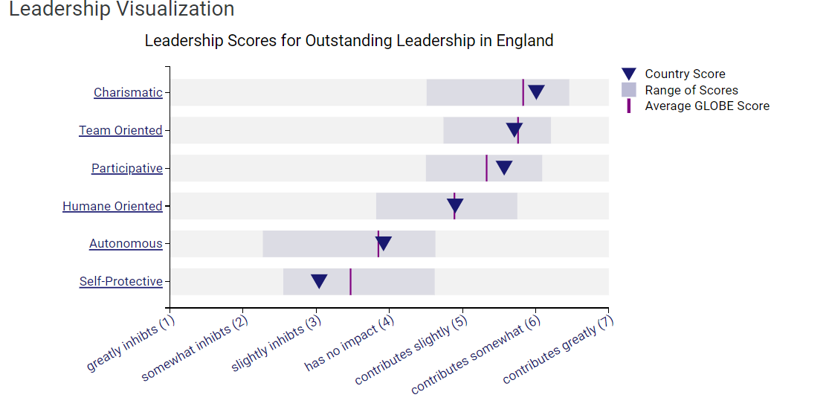
Fig 1: Leadership Visualisation of United Kingdom (Globeproject.com)
These inequalities might be explained by cultural differences, historical factors, and regional preferences. In contrast to their British counterparts, German organisations place a premium on equality and consensus-building. There may be cultural differences in leadership styles based on societal mores and expectations in the workplace.
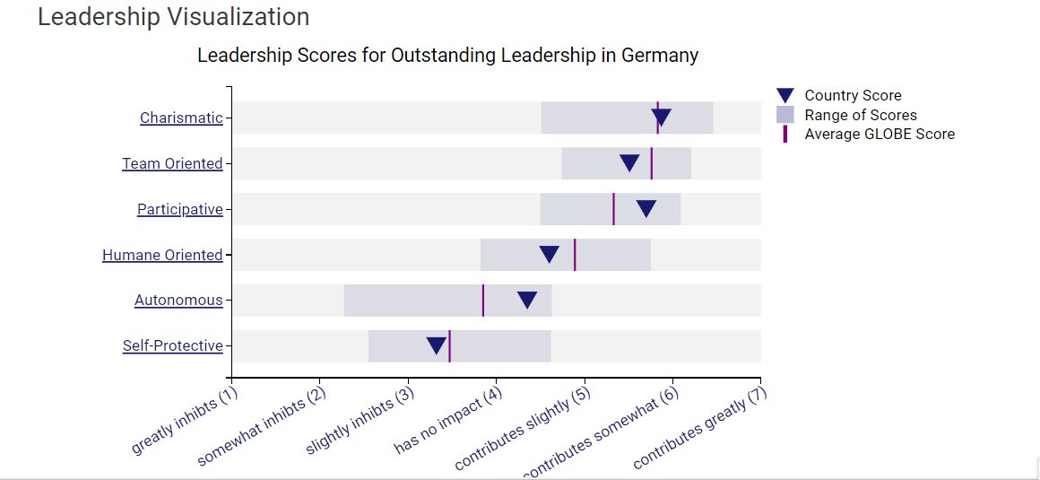
Fig 2: Leadership Visualisation of Germany (Globeproject.com)
While CEOs in the UK may encourage employees to make their own decisions, their German counterparts may advocate for a welcoming work environment where everyone's opinions are valued (Nazarian, 2024). While the two Radisson Blu Hotels couldn't be more different, they have a same goal: to make our employees happy and productive. By understanding and accommodating cultural variations, they may build on the strengths of their corporate culture and provide their diverse staff a sense of belonging.
Challenges of Intercultural Leadership
Managing employees from a variety of cultural backgrounds is a significant challenge for intercultural executives. Effective communication is a major challenge. Nonverbal cues, communication styles, and language skills may all contribute to misunderstandings. In order to build trust, communicate effectively, and work with individuals of diverse cultural backgrounds, leaders need strong cross-cultural communication abilities. At times, conflicts may arise due to culturally distinct perspectives on power dynamics and hierarchy. While some societies place a premium on top-down command and control structures, others place a premium on bottom-up approaches that encourage participation and agreement among all members of the group. To effectively and respectfully satisfy cultural expectations, intercultural leaders must adapt their leadership style (Nazarian, 2022). Conflict resolution and handling differing viewpoints are also challenging. Cultural differences in ways of thinking about problems and addressing them may lead to disagreements within a team. Intercultural leaders need strong negotiating skills to settle disagreements and reach agreements that benefit all parties involved.
Furthermore, it is challenging to build multicultural teams that are both cohesive and inclusive. Differences in social norms, work practices, and communication styles among cultures may hinder collaboration. It is the responsibility of intercultural leaders to provide an environment where team members are able to learn from and appreciate one another's diverse perspectives while also increasing their own cultural knowledge and understanding (Wang et al, 2020). Last but not least, overcoming bias and assumptions is an important part of multicultural leadership. Disruptions to dialogue, choices, and teamwork could result from cultural biases. All team members should feel welcome and valued in an inclusive and welcoming work environment, and intercultural leaders should constantly challenge their own biases. Multicultural leaders who want to make a difference must possess cultural competence, excellent communication skills, adaptability, and a strong commitment to valuing and including people of all backgrounds. In a worldwide environment, cultural diversity may help intercultural leaders overcome these challenges and increase company performance.

Conclusion
I was included in Radisson hotels in Germany as deputy general manager. I've observed major UK changes over my time here. The main distinction is how they handle cultural differences and other factors that affect operations. I discovered the market's main disparities utilising suitable procedures. The assistant general manager's personal thinking is analysed below utilizing the right situation.

Recommendations
The recommendations are given below:
- To enhance the cultural awareness of team members, cross-cultural training should be used (Dogru et al, 2020).
- In order to address misconceptions and learn about each other's cultures, it's important to encourage open communication among team members.
- One should emphasize the importance of a diverse, inclusive, and cooperative work environment (Nain, 2018).
- To promote cross-cultural understanding and friendships, team-building exercises should be held on a regular basis.
Lastly, always show people how to be culturally aware, empathetic, and respectful.

References
Dogru, T., Hanks, L., Mody, M., Suess, C., & Sirakaya-Turk, E. (2020). The effects of Airbnb on hotel performance: Evidence from cities beyond the United States. Tourism Management, 79, 104090.
Eid, R., & Agag, G. (2020). Determinants of innovative behaviour in the hotel industry: a cross-cultural study. International Journal of Hospitality Management, 91, 102642
Guix, M., Bonilla-Priego, M. J., & Font, X. (2018). The process of sustainability reporting in international hotel groups: An analysis of stakeholder inclusiveness, materiality and responsiveness. Journal of Sustainable Tourism, 26(7), 1063-1084.
Hung, K. K., Mark, C. K., Yeung, M. P., Chan, E. Y., & Graham, C. A. (2018). The role of the hotel industry in the response to emerging epidemics: a case study of SARS in 2003 and H1N1 swine flu in 2009 in Hong Kong. Globalization and health, 14, 1-7.
Koburtay, T., & Syed, J. (2019). A contextual study of female-leader role stereotypes in the hotel sector. Journal of Sustainable Tourism, 27(1), 52-73.
Nain, A. (2018). A study on major challenges faced by hotel industry globally. International Journal of Creative Research Thoughts, 6(1), 561-571.
Nazarian, A., Atkinson, P., Foroudi, P., & Edirisinghe, D. (2020). Leaders or organisations? A comparison study of factors affecting organisational citizenship behaviour in independent hotels. International Journal of Contemporary Hospitality Management, 32(6), 2055-2074
Nazarian, A., Shabankareh, M., Ranjbaran, A., Sadeghilar, N., & Atkinson, P. (2024). Determinants of intention to revisit in Hospitality Industry: A cross-cultural study based on Globe Project. Journal of International Consumer Marketing, 36(1), 62-79.
Nazarian, A., Velayati, R., Foroudi, P., Edirisinghe, D., & Atkinson, P. (2021). Organisational justice in the hotel industry: revisiting GLOBE from a national culture perspective. International Journal of Contemporary Hospitality Management, 33(12), 4418-4438.
Nazarian, A., Zaeri, E., Foroudi, P., Afrouzi, A. R., & Atkinson, P. (2022). Cultural perceptions of ethical leadership and its effect on intention to leave in the independent hotel industry. International Journal of Contemporary Hospitality Management, 34(1), 430-455.
Wahyuningsih, S. H., Sudiro, A., Troena, E. A., & Irawanto, D. (2019). Analysis of organisational culture with Denison’s model approach for international business competitiveness. Problems and perspectives in management, (17, Iss. 1), 142-151.
Wang, C., Hu, R., & Zhang, T. C. (2020). Corporate social responsibility in international hotel chains and its effects on local employees: Scale development and empirical testing in China. International Journal of Hospitality Management, 90, 102598.

