Financial Management for the Hotel Industry
BMIH5007
Student Name:Adriana Alexandra Birsan
Student ID2118849:
Course Name:Financial Management for the Hotel Industry
BMIH5007
Lecturer Name: Christopher Wilkin

Table of Contents
1. Introduction 3
2. Overview of the Organisation (Hilton Hotels and Resorts) 3
3. Discuss critically how to monitor organisational approaches 4
3.1 Comparison of Insourced Housekeeping Team Vs Outsourcing Housekeeping 4
3.2 Abilities of those employed 5
3.3 Implication of cost 5
3.4 Results 5
3.5 Sustainability 6
3.6 Consistency 6
3.7 Guest experience 6
4. Evaluate financial performance within Hotel 7
4.1 Revenue 7
4.2 Market position 8
4.3 Potential 8
4.4 Corporate social responsibility 8
5. Recommendations 9
6. Conclusion 9
References 10

Assignment title: Sustainable Business Revenue Generation Plan

1. Introduction
According to Kim et al., (2019, p.618), financial management is defined as the process of planning, organising, and controlling the financial aspects of an industry. Financial management includes the development and implementation of financial plans, policies, and procedures. For the hotel industry the financial performance can be measured through metrics including the revenue generation per year or the occupancy rate on average can be used for measuring the performance in sales. The aim of financial management in the hotel industry is to maximise the profit of the owners although the occurrence of market shrinking can be considered as an agency problem that affects the overall financial performance of an organisation.

2. Overview of the Organisation (Hilton Hotels and Resorts)
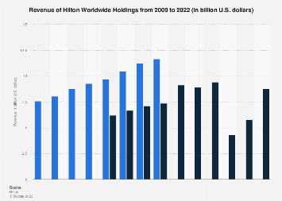
Figure 1: Revenue of Hotel Hilton and resorts
(Source: Statista. com, 2023)
Hilton Hotels and Resorts is a leading global hospitality industry comprising 19 world-class brands consisting of more than 7200 properties in nearly 122 countries worldwide (Hilton. com, 2023). The mission of this hotel is to provide the warmth of hospitality to the guests and improve their experience in the accommodation. This organisation has been founded on 31st May in 1919 in Cisco, Texas. Headquarter of this hotel is situated in Tyson, Virginia. Hilton Hotel and Resorts provides the foundation of the travel experience to be exceptional comprising more than 584 hotels across six continents. The revenue of the organisation is 8.77 billion dollars in the year 2022 (Statista. com, 2023). There was a reduction in the organisational financial performance to the global pandemic which forced several Hilton properties to shut its door.

3. Discuss critically how to monitor organisational approaches

3.1 Comparison of Insourced Housekeeping Team Vs Outsourcing Housekeeping
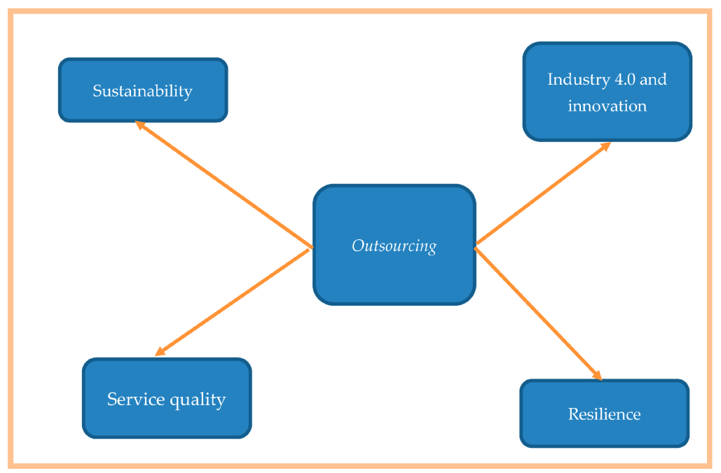
Figure 2: Outsourcing of housekeeping
(Source: mdpi.com, 2023)
The travel and tourism industry has taken a hit in the global pandemic resulting in many companies overhauling their existing procedure. The drivers to this change are to manage the cost in case the tour and travel industry is at an all-time low. In cases like this, the hospitality establishments aim to cut the labour cost which is on the higher side of the total expenses in the operation. As per Alvarez et al., (2021, p.31), in-sourced housekeeping is a term that has been used in the business industry to utilise internal sources than sources from the outside in conducting business activities such as hiring and operations. Whereas outsourcing housekeeping is the procedure of obtaining housekeeping staff from a third party rather than hiring directly within the organisation. The advantage of in-sourced housekeeping is to generate better employment opportunities for professional employees in this sector. The hired staffs are trained under the brand value which acts as a prime driver. Through conducting behaviour and training, creating genuine brand value from the professionals are the primary reasons for the organisation to focus on hiring staff from in-sources. On the other hand, as argued, the advantage of outsourcing housekeeping is to provide flexibility in scheduling the listed staff (Usmanjanovna and Obidjonovich, 2023, p. 48). For the chosen organisation, Hilton Hotel and Resorts, the hiring process should be conducted by in-sourcing the housekeeping team to create brand value among staff and conducting proper training for them to adapt the mannerisms that are required for the revenue of the organisation.

3.2 Abilities of those employed
For employment in the hotel industry, the abilities required to fit into the organisation is to have effective communication skills for providing service to the customers in addition interpersonal skills such as people skills are necessary for communicating with the guest and improving their accommodation experience by solving their queries (Mueller and Sensini, 2021,p.121). In the hotel industry, it is all about the approval, comfort, and satisfaction of the guests so paying attention to detail including presentation of the food, room preparedness, and wakeup call need to be adhered to by the employees. Great hospitality employees possess strong leadership skills and can handle projects that are a significant contribution to the overall success of the organisation (Reidhead, 2020). Employees in the hospitality industry have enthusiasm about the job and strive to do their best in performing the work. People with commitment, people skills, and attentiveness, teamwork, and leadership skills are considered highly valued employees in the hotel industry.

3.3 Implication of cost
As per Man et al., (2022, p.1247), as the hotel industry is a crucial driver for enhancing economic growth globally, the cost in the hotel industry is implied to increase the profitability of the business. For example, the cost of the dishes helps the business in identifying the profitable dishes and adjusting their price accordingly. This approach helps the business to maximise its profitability and ensures enhanced efficiency as much as possible. On the contrary, the key elements of costing are inputs in food and beverages, labour cost, and operational expenses which include operational energy, insurance, water charges, bank charges, advertising, entertainment and audit fees, and legal and professional fees (Úbeda-García et al., 2021, p.61). For the Hilton Hotel implementation of Activity-based Costing would be applicable with a cost accounting system in a detailed manner. The costing system would help the organisation to identify its costing aspects and make changes as per the costing strategy. The hotel needs to ensure that all the expenses and fixed prices are covered resulting profitability of the hotel.

3.4 Results
As opined by Botta, (2019, p.351), the major cost of hospitality facilities are classified into three categories including initial cost, renovation cost, and operation costs where the implication of the costing system is important for the renovation and operation process to be conducted successfully. On the contrary, for implementing a cost-cutting strategy in the industry the bank statement needs to be documented to identify the spending (Johnson et al., (2019, p.2). Having a good cost management system is important for the organisation o simplified the method of making estimations and allocates its budget accordingly. The result of the costing management system is to reduce the chance of exceeding the budget by forecasting impending expenditure in a higher amount. For Hilton Hotels, hotel accounting is important for making a better decision that brings good revenue to hoteliers if handled effectively and efficiently. In addition, the system comprises the process of summarising, reporting, and analysing the position of the hotel in the market on the financial aspect which helps in budgeting and cost planning for the future.

3.5 Sustainability
As evidenced by Afianti and Megasari, (2022, p.347), sustainability is important for the hotel industry to reduce energy consumption without compromising the guest experience to save the cost as well as the environment. It is important to take initiatives to reduce the environmental impact by making plans for the long term in staying eco-friendly. On the contrary, other hotels in the UK enhance their sustainability by reducing the environmental imprint and utilises biomass energy, regulators for water flow, and providing chemical-free cleaning products. The essence of eco-friendliness is important for maintaining the brand value and reputation of the organisation (Al-Wattar et al., 2019, p. 15). It has been observed that Hilton Hotel enhances its sustainability by reducing carbon emissions and water waste for the expansion of the organisation by conducting a recycling program for the hotel chains of the organisation. In addition to their initiative in using energy-efficient lighting and minimising plastic use would be associated with economic viability, protect the environment and provide social equity in the future (Alrawadieh et al., 2021, p.341).

3.6 Consistency
As opined by Pavlatos et al., (2021, p.91), for the hotel industry consistency is important as it generates ways of providing service quality to the guests, and service consistency is an exception for all customers. For maintaining consistency in their service, Hilton Hotel uses strategy in travelling to redefine the sustainability level worldwide. Implementing this strategy helps the organisation to enhance the social impact and reduce the environmental footprint significantly. As per, Santoso and Supatmi, (2021, p., 351), consistency needs to be prioritised as missing the expectation of the hoteliers would lead to problems of poor reviews that influence the reputation of the organisation.

3.7 Guest experience
According to Edrees et al., (2023, p. 75), the guest experience is associated with the overall satisfaction of the guests before and during their accommodation in the hotel. In each stage, the creation of positive emotion in certain aspects helps the customer in determining whether the experience reaches their expectation. For the Hilton Hotel, the guest experience would indicate quality service as this encourages the customers in returning to the hotel and give it a try. Bad experience of the customers depicts as an indicator for the organisation to improve based on the need of the customers.

4. Evaluate financial performance within Hotel

4.1 Revenue
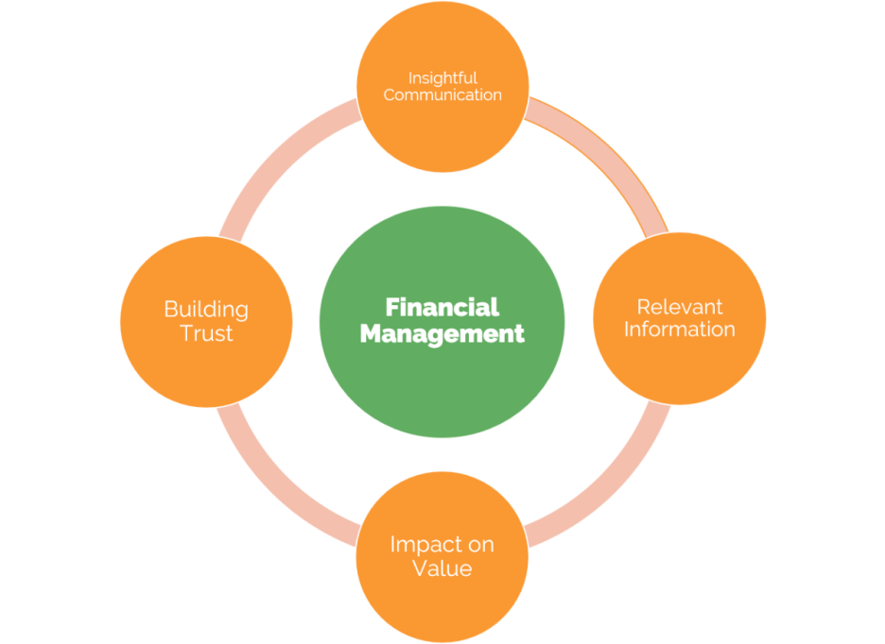
Figure 3: Financial management
(Source: Financial management, 2022)
In the aspect of financial performance, revenue management involves the use of analytics and data which helps in predicting the behaviour of the customer in the hotel industry. The calculated data is utilised in making appropriate decisions on the aspect of pricing and distribution strategies. In the hotel industry, the revenue is calculated by multiplying the average daily rate (ADR) by the rate of occupancy (Slavković et al., 2023, p.2268) This method is considered a common method on the other hand the total revenue in a specific period is divided by the number of rooms that are available in the specific period.

4.2 Market position
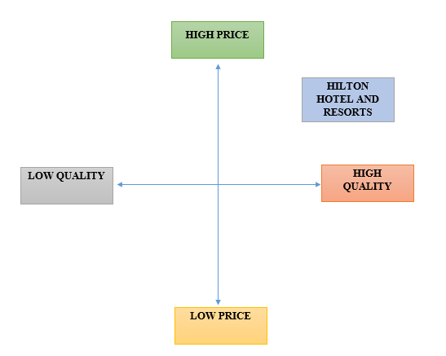
Figure 4: Positioning map of Hilton Hotel
(Source: Developed by author)
As evidenced by Mucharreira et al., (2019, p.171), the market position refers to the identification of the brand created for the consumers and ways to distinguish the brand from other competitors in providing a better experience to the guests. The market position of a hotel is important for targeting the consumers in becoming loyal and increasing the chance of repetition. The target market of Hilton Hotels comprises clients with higher income groups who value multiculturalism. The target consumers influence the service the hotel offers by catering to the different tastes and preferences of the customers.

4.3 Potential
The potential of the Hilton hotel is expected to reach up to its hotel portfolio growth levels globally. The potential of hotel is expected by a positive set of revenue in the year 2022. According to the report, the hotel has opened nearly 355 hotels achieving net unit growth comprising 4.7 percent of the hotel portfolio (Zeng, 2021, p. 25)). Efforts in the development globally have proven beneficial for Hilton Hotels to show its performance.

4.4 Corporate social responsibility
For the Hilton Hotel, the goal of corporate social responsibility is to create a positive brand value for the organisation and conduct business ethically and sustainably without compromising its quality or comfort to the guests by striving to improve the service quality for improving the experience of the guests.

5. Recommendations
R1: It is recommended that Hilton Hotel improve its service by knowing the guests by implementing personalisation. Personalising services can increase the revenue of the hotel as well as improve the experience of the customers. It is an essential step to be focused on the preferences of guests and develop their requirements by tracking their information and recorded in the operating software CRM.
R2: It is recommended that the hotel utilise the opportunity in serving the guest against hotel operations in several ways. It would result in taking a proactive stance and driving the customer experience and enhancing the overall revenue of the organisation. Communication with the customers can be improved by making the service more attentive on a higher level. This would influence the experience of the guests by providing them with inspiring plans added to the itinerary.
R3: It is recommended for the hotel implement standardisation in building a strong brand among other competitors in the market. Improving hotel operations is important as it acts a key role in ensuring the process runs smoothly and guests are provided with the best services by maintaining consistency as much as possible.

6. Conclusion
It can be concluded that the hotel industry provides good service for the clients by offering a variety of services in improving their overall experience of staying in the hotel. Management on the aspect of financially is important for any hotel industry as it helps in generating revenue and manages the assets for conducting the organisational operation successfully. Effective financial management is essential for gaining success in the hospitality industry. By planning and controlling the finances business can ensure it meets its obligation in achieving the desired goal.

References
Afianti, A.F. and Megasari, C., 2022. FINANCIAL AND COST MANAGEMENT STRATEGIES FOR HOTEL OPERATIONS WITH PUBLIC SECTOR ACCOUNTING (CASE STUDY OF EHNAII HOTEL BANDUNG). JurnalManajemenPelayanan Hotel, 6(2), pp.341-348.http://mapindo.ejurnal.info/index.php/manajemen_pelayanan_hotel/article/view/172
Alrawadieh, Z., Alrawadieh, Z. and Cetin, G., 2021. Digital transformation and revenue management: Evidence from the hotel industry. Tourism Economics, 27(2), pp.328-345.https://journals.sagepub.com/doi/pdf/10.1177/1354816620901928
Alvarez, T., Sensini, L., Bello, C. and Vazquez, M., 2021. Management accounting practices and performance of SMEs in the Hotel industry: Evidence from an emerging economy. International Journal of Business and Social Science, 12(2), pp.24-35.https://www.researchgate.net/profile/Luca-Sensini/publication/351305386_Management_Accounting_Practices_and_Performance_of_SMEs_in_the_Hotel_Industry_Evidence_from_an_emerging_economy/links/609112d092851c490fb569df/Management-Accounting-Practices-and-Performance-of-SMEs-in-the-Hotel-Industry-Evidence-from-an-emerging-economy.pdf?_sg%5B0%5D=started_experiment_milestone&origin=journalDetail
Al-Wattar, Y.M.A., Almagtome, A.H. and Al-Shafeay, K.M., 2019. The role of integrating hotel sustainability reporting practices into an Accounting Information System to enhance Hotel Financial Performance: Evidence from Iraq. African Journal of Hospitality, Tourism, and Leisure, 8(5), pp.1-16.https://www.researchgate.net/profile/Akeel-Almagtome/publication/336778683_The_role_of_integrating_hotel_sustainability_reporting_practices_into_an_Accounting_Information_System_to_enhance_Hotel_Financial_Performance_Evidence_from_Iraq/links/5db223b34585155e27f9294c/The-role-of-integrating-hotel-sustainability-reporting-practices-into-an-Accounting-Information-System-to-enhance-Hotel-Financial-Performance-Evidence-from-Iraq.pdf
Botta, M., 2019. Financing decisions and performance of Italian SMEs in the hotel industry. Cornell Hospitality Quarterly, 60(4), pp.335-354.https://journals.sagepub.com/doi/pdf/10.1177/1938965518816948
Edrees, H.N., Sobaih, A.E.E., Gharbi, H. and Abu Elnasr, A.E., 2023. The Influences of Procedural Justice on Turnover Intention and Social Loafing Behavior among Hotel Employees. Journal of Risk and Financial Management, 16(2), p.75.https://www.mdpi.com/1911-8074/16/2/75
Financial management (2022) Mission Control. Available at: https://aprika.com/glossary/financial-management (Accessed: 07 June 2023).
Hilton. com,2023.Available at :https://www.hilton.com/en/locations/united-kingdom/hilton-hotels/[acessed on June 07, 2023]
Johnson, M.F., Johnson, M.S. and Tessmer, A.C., 2019. Hotel asset and equity risk before, during, and after the global financial crisis. Journal of Hospitality Financial Management, 27(2), p.2.https://scholarworks.umass.edu/jhfm/vol27/iss2/2/
Kim, Y.H., Barber, N. and Kim, D.K., 2019. Sustainability research in the hotel industry: Past, present, and future. Journal of Hospitality Marketing & Management, 28(5), pp.576-620.https://www.tandfonline.com/doi/abs/10.1080/19368623.2019.1533907
Man, S.S., Lee, W.K.H., Wong, K.P. and Chan, A.H.S., 2022. Policy Implications for Promoting the Adoption of Cogeneration Systems in the Hotel Industry: An Extension of the Technology Acceptance Mode. Buildings, 12(8), p.1247.https://www.mdpi.com/1777354
mdpi. com,2023.Available at:https://www.mdpi.com/2673-5768/4/1/2/[acessed on June 07, 2023]
Mucharreira, P.R., Antunes, M.G., Abranja, N., Justino, M.R.T. and Quirós, J.T., 2019. The relevance of tourism in the financial sustainability of hotels. European Research on Management and Business Economics, 25(3), pp.165-174.https://www.sciencedirect.com/science/article/pii/S2444883419301019
Mueller, A. and Sensini, L., 2021. Determinants of financing decisions of SMEs: evidence from the hotel industry. International Journal of Business and Management, 16(3), pp.117-127.https://www.researchgate.net/profile/Andreas-Mueller-92/publication/349674606_Determinants_of_Financing_Decisions_of_SMEs_Evidence_from_Hotel_Industry/links/603cb46192851c4ed5a54b92/Determinants-of-Financing-Decisions-of-SMEs-Evidence-from-Hotel-Industry.pdf
Pavlatos, O., Kostakis, H. and Digkas, D., 2021. Crisis management in the Greek hotel industry in response to the COVID-19 pandemic. Anatolia, 32(1), pp.80-92.https://www.tandfonline.com/doi/abs/10.1080/13032917.2020.1850485
Reidhead, C., 2020. Impact of organizational culture on employee satisfaction: A case of Hilton hotel, United Kingdom. Journal of Economics and Business, 3(1).https://papers.ssrn.com/sol3/papers.cfm?abstract_id=3563546
Santoso, T.G. and Supatmi, S., 2021. Financial Ratio Analysis to Assess Financial Performance of the Hotel Industry. International Journal of Social Science and Business, 5(3), pp.346-353.https://ejournal.undiksha.ac.id/index.php/IJSSB/article/view/37003
Slavković, M., Ognjanović, J. and Bugarčić, M., 2023. Sustainability of Human Capital Efficiency in the Hotel Industry: Panel Data Evidence. Sustainability, 15(3), p.2268.https://www.mdpi.com/2071-1050/15/3/2268
statista. com,2023.Available at :https://www.statista.com/statistics/297760/revenue-of-hilton-worldwide-holdings-inc//[accessed on June 07, 2023]
Úbeda-García, M., Claver-Cortés, E., Marco-Lajara, B. and Zaragoza-Sáez, P., 2021. Corporate social responsibility and firm performance in the hotel industry. The mediating role of green human resource management and environmental outcomes. Journal of Business Research, 123, pp.57-69.https://www.sciencedirect.com/science/article/pii/S0148296320306251
Usmanjanovna, A.L. and Obidjonovich, A.A., 2023. EVOLUTION OF THE ACCOUNTING OF INCOME AND EXPENSES IN THE HOTEL SYSTEM. PEDAGOGS jurnali, 34(2), pp.45-49.http://www.pedagoglar.uz/index.php/ped/article/download/4651/3053
Zeng, L., 2021. Analysis of Hilton Worldwide Hotel Group’s Transnational Operation Strategy. Academic Journal of Business & Management, 3(11), pp.20-27.https://francis-press.com/uploads/papers/6WdwdrACthtaKangNJVKP6kmJOGaCSMmyeMcnTHG.pdf

