

LEVEL 7 ASSESSMENT SPECIFICATION
APPENDIX GA36d
Student name: | Bala Jaya Chandra.Pichikala | Student ID number: | 2219819
Programme: | MSc/PgDip/PgCert Cybersecurity and Digital Forensics
Module: | Digital Forensics Analysis
Module code: | ACCA7031 | Contribution to Overall Module Assessment (%): | 100%
Lecturer: | Dr. Nitheesh Kaliyamurthy | Internal Verifier: | Munyaradzi Murira
Assignment Title: | Research, Analyse and Investigate Digital Cybersecurity incidents and perform digital forensic assessment | Word count (or equivalent): | 5000
Submission deadline: | 2nd January 2024 | Return date of provisional marks & written feedback: | TBA

Digital Forensics Analysis

Table of Contents

Task 1 4
Digital Forensics 4
Current State of the Field 4
Intersection of digital forensics and cyber security 4
Emerging trends 5
Key Challenges 5
National and International Job Markets 7
Recommendations 8
Task 2 9
Current State of digital forensics tools, their features and capabilities 9
Evaluate open-source tools with commercial forensics tools 10
Recommendation: For open-source vs Commercial forensics tools 11
Task 3 12
Digital Forensics Investigation by Collecting and analysing data
Task 4 15
Mobile Forensics Investigation
Annexure 22
Reference 23

Task 1:

Digital forensics

Current state of the field

Digital forensics (DF) is a branch of forensic science that focuses on the recovery and investigation of material found on digital-related devices to cybercrime [1]. Cybercrime is at an all-time high, with the cybercrime insurance industry alone expected to grow from $8 billion in 2020 to $20 billion in 2025. [2]. The worldwide Digital Forensics field was worth USD 2453.06 million in 2022 and is expected to grow at 13.38% during the forecast period, reaching USD 5211.15 million by 2028 [3]. The activity of collecting, identifying, extracting, and analysing evidence from digital devices such as computers, laptops, hard discs, and so on is known as digital forensics or computer forensics. This forensics technique is used in both criminal and civil court cases [3]. This technology is currently widely used in the private sector for internal investigations.

Intersection of digital forensics and cybersecurity

Digital forensics is concerned with analyzing digital evidence after an attack has occurred, whereas cybersecurity is concerned with preventing attacks and securing systems. In general, cybersecurity is concerned with the protection of digital assets, whereas digital forensics is concerned with the investigation of incidents after they occur [4].

The association between digital forensics and cyber security can be viewed as mutually beneficial. Given that digital forensics is essential in the investigation of cyber security incidents, the intersection of digital forensics and cyber security is critical. Digital forensic scientists can collect and analyze digital evidence to identify the attacker in the event of a cyber-attack. It assesses the impact of damage and safeguards the organization in the event of further damage [4].

Furthermore, digital forensics may be employed to inform cybersecurity approaches. The findings gained from inquiries into digital forensics can be used to identify flaws in an organization's cybersecurity measures and to inform advancements that may avert comparable events in the future. Cybersecurity and digital forensics are two edges of the same coin. Both fields are critical in protecting modern organizations from cyber threats, and organizations looking to protect their digital assets must have a strong understanding of their intersection and importance [4].

Emerging trends

The increasing use of artificial intelligence and machine learning is one of the most significant trends in digital forensic space thus shaping the future of digital forensics. Many of the digital forensic tasks that are currently performed manually are being automated by these AI and machine learning technologies. As a result, forensic analysts are capable of devoting more time to complex cases and achieving improved outcomes in the shortest time possible [5].

Furthermore, the growing use of cloud computing presents a significant emerging trend that is seemingly impacting digital forensics. Cloud-based services have grown increasingly common and they provide several benefits to digital forensic scientists. Emerging cloud-based services, for example, Amazon Web Services (AWS) enable it to be easier for digital forensic scientists to share data and interact in circumstances [6]. In particular, AWS-Gov Cloud can be utilized to store sensitive data and is available through AWS' Partner program. AWS also collaborates with technology providers such as Cellebrite to provide seamless integration with evidence management and storage programs via Cellebrite Guardian [6].

Key Challenges
Interpretability of methods: As the complexity of these models has increased - due to the availability of data and improvements in hardware and techniques used it has also become more difficult to interpret which factors influence their decisions. This limitation in the interpretability of the models considerably reduces their application in real cases. In sensitive contexts such as legal, financial, or medical scenarios, it is essential that an algorithm's decisions are transparent and based on human-like logic. Ensuring the interpretability of complex AI models is a fundamental step for automated decisions to occur in a transparent and fair way, allowing society to take advantage of the benefits that these models can provide [7].
Bias in data and models: Complex AI models used for digital forensics are capable of learning directly from a large volume of data which characteristics are most efficient for the problem at hand. Consequently, its quality is directly linked to the quality of the available data. As the latter are a part of our society, they often end up reproducing undesirable gender, ethnic, and economic biases, among others [7]. Due to their learning capacity, models end up capturing these biases, taking them into account during their execution.
There are several examples of real systems that present biases that have the power to unfairly impact people's lives, such as denying job offers based on the candidate's sex, unfairly increasing the cost of health insurance, or even influencing judges in criminal decisions based on the defendant's ethnicity [8]. In a recent episode, it was found that software used in the American penal system to assess the risk of convicted people committing crimes again showed clear signs of bias against black people. In the work of Datta, Tschantz, and Datta (2015), the authors present a real-world example where a Google ad system suggested fewer high-paying job openings for women compared to men [9].

These biases can manifest themselves in data in different ways, such as personal attributes such as an individual's race or gender. Simply removing these attributes does not guarantee the extinction of the bias as they may be strongly correlated with other attributes. For example, in the United States and several other countries, neighborhoods have a high correlation with the ethnicity of their residents and the use of this attribute can generate models that make decisions indirectly considering a person's race [8],[9]. Another form of manifestation concerns the representation of different groups. The process of collecting and annotating data used to train AI models can generate different types of biases: selection, information, and detection biases [10]. The result may be a lack or excess of representation of certain groups of people, which coincides with historically discriminated social groups and which is reflected in the decisions of these models. The search for bias mitigation along with the development of more interpretable models, as detailed above, are current and essential challenges for the AI community and, more broadly, for society. These challenges are not completely unrelated, as interpretable models can assist in the process of searching for corrections in biased models.

National and International Job Market
The Digital Forensics job market has many opportunities, however, professionals must prepare themselves to work in the most diverse scenarios for which theoretical and practical knowledge is essential and often requires proof of this knowledge, which can be achieved through experience, academic training or certifications. The national average earnings for a digital forensic analyst is around $70,000 per year; however, senior-level roles can earn up to $170,000 per year or more. According to the report, forensic science jobs will grow by 14% through 2029, making the career more lucrative in light of rising cybersecurity incidents [11].

The digital forensics job market internationally has frightening statistics about fraud and corruption in all layers of society. A survey published by Net Group shows that 61% of entrepreneurs suffered internal fraud in their companies in 2019, and this number rose to 82% in 2019 a survey shows that almost half of the international population has already suffered card fraud. credit, according to Global Digital Fraud 2019 [12]. So, despite this scenario, few businesspeople know about the possibility of recovering damages suffered in internal fraud and cyber-attacks because there is a lack of professionals available on the market who demonstrate that they can resolve these issues.

Recommendation
Due to the volume of information that makes manual analysis impossible promptly, modern AI methods have become essential tools in the expert's arsenal. The scientific community has successfully explored machine learning, computer vision, and NLP techniques at virtually every stage of the analysis process. Due to the methods' ability to recognize and draw relationships between data, their application complements the efforts of a specialist, regardless of whether the event occurred in the physical or virtual world, or both.
Despite being valuable tools in the forensic process, the use of these techniques also brings with it challenges that need to be discussed so that their application is viable in real cases, especially in sensitive CFD contexts. Although powerful, existing complex models are still largely “black boxes” that cannot be easily explained. The interpretability and transparency regarding the decision-making flow of these models is an essential characteristic for their use in practice [13], [14]. Additionally, it is necessary to mitigate the biases that are often built into models during training so that your decisions do not reproduce them.
Along these lines, the General Data Protection Regulation (GDPR) of the European Union, gives a user the right to obtain clear information regarding the criteria and procedures used in the process decision-making process of an algorithm [15]. Therefore, for the models to be applicable in practice, it is essential that their decision flow is interpretable not only for AI experts but also for lay users.

Task 2

Current state of digital forensic tools, their features and capabilities
Digital forensic tools come in many categories, so the exact choice of tool depends on where and how one wants to use it. Regardless of these variations, it’s essential that computer forensics tools offer a large number of possibilities to obtain information during an investigation. The digital forensics landscape is dynamic with new tools and features being released regularly to keep up with constant device updates some of the tools and their capabilities are discussed below.
FTK Imager: is a data and image preview tool that allows one to browse files and folders on local hard drives, network drives, CDs/DVDs, and review the contents of forensic images or memory dumps [16]. The FTK Imager is capable of helping forensic expert features to apply hash SHA1 or MD5 files, export forensic image files and folders to disk, review and recover files that have been deleted from the Recycle Bin, and mount a forensic image to view its contents in Windows Explorer [16].
Hash calculator: HashCalc is a calculator program developed by SlavaSoft. Used to calculate HMAC, message digests, and checksums for files. It can also be used to calculate hexadecimal strings and text strings [17]. The program provides 13 of the most common checksum and hashing algorithms. The program interface has the ability to offer a standard window that provides all the options directly from the main interface. To use it, the user only has to choose the file to be calculated and the desired cryptographic hash functions.
Volatile memory analyser: For volatile memory analysis there are several tools such as; Volatility: used for incident response and malware analysis [18]. With this tool, you can extract information from running processes, network sockets, network connections, DLL files, and log hives. Moreover, it supports data extraction from Microsoft Windows failure dumps and hibernation files. This tool is available for free under the GPL license [18].
Belkasoft Live RAM capturer: is a small free forensic tool to reliably extract the entire contents of the computer's volatile memory, even if it is protected by an active anti-scraping system or antidumping. Versions 32-bit and 64-bit are offered separately to reduce the tool's size as much as possible. Crash dumps captured with Belkasoft Live RAM Capturer can be analyzed with any forensic tool [19].
Sleuthkit: It is a collection of command line tools and a C library with the capability that allows the forensic analyzer to analyze disk images and recover files from them [20]. It is used behind the scenes in Autopsy and many other commercial and open-source forensic tools. Also, it allows quick search, identification, and prioritize potential evidence, on computers and mobile devices, to determine if further investigation is warranted [20].

SIFT Workstation 3: It is a group of open-source forensic and incident response tools designed to perform detailed digital forensic examinations in a variety of environments. It can match any current incident response and forensic toolset [21]. SIFT demonstrates that advanced incident response capabilities and deep-dive digital forensics techniques for intrusions can be achieved using cutting-edge open-source tools that are freely available and frequently updated.

Evaluate Open-source tools with commercial forensic tools
Open Source forensic tools not only mean access to source code but also to free distribution since digital forensic licenses must are not restricted in any way to the sale or distribution of the program free of charge, as a component of another program or not. However, the forensic license must permit modifications and derivative works and must permit them to be distributed under the same terms as the original license. The forensic license may restrict source code from being distributed in a modified form only if the license permits the distribution of patch files with the source code for the purpose of modifying the program at the time of its release [22].
The license must explicitly allow the distribution of the forensic program built from the modified source code. However, the license can still require that derivative programs have a different name or version number than the original program. Furthermore, non-discrimination against areas of forensic activity is supported since any forensic auditor is not restricted from using the forensic program in a specific field of activity [22]. For example, it should not prohibit the program from being used in a company, or from being used for genetic research.

Conversely, commercial forensic tools, like FTK, refrain from releasing their source code. This implies that the majority of users will be subject to vendor lock-in. unless the brand goes out of company, this is not necessarily a bad thing. Open-source forensic tools, as compared with commercial tools, share their code, and users are not subject to vendor lock-in. Because commercial software fails to disclose its source code, it is impossible to know how good it truly is. Because open-source code is reviewed by everyone who uses it, it is more credible. This turns into less of an issue when addressing big brands such as FTK and Encase, which are very well-received in the marketplace compared to lesser-known companies. Training and documentation are more readily available with commercially purchased software such as FTK and Encase than with open-source software [22]. When it comes to licensing, commercial software is far more costly than open-source alternatives.

Recommendation: For Open-source vs Commercial forensic tools
Selection between open-source or commercial forensic tools depends on the type of forensic project, its funding, and its significance. It is recommended that for academic projects, users select open-source forensic tools since they are freely available and offer good community support. Though, if the forensic project is non-academic or professional in nature, it is recommended to use commercial forensic tools since they have been rigorously tested, and provide accurate details on all known error rates. This makes it suitable in most courts nowadays for commercial forensic activities to be considered more than open-source ones. Thus, it is recommended that one choose commercial forensic tools in case they forecast a legal battle. However, the selection of either is recommended given the underlying capabilities since some commercial forensic tools incorporate their open source equivalents, allowing users to benefit from the best of both environments.

Task -3
Digital Forensic Investigation by Collecting and Analysing Data
Part-1: Selecting Theme and Collecting Data
Group C - Data Collection Report
Materials:
1 hard disc for each team
Financial crime is the theme.
FTK, Steganography, Encryption, Screen capture, RDP Session, setoolkit, and Msfvenom are examples of digital forensic tools.
Analysing Data:
In this project, we addressed a financial crime scenario within a virtual environment configured in Oracle VirtualBox. The setup involved using Kali Linux as the attacker's platform and Windows 10 Home as the victim's operating system.
The team engaged in a simulation of a phishing attack, where they exploited the victim's wireless connection to dispatch an email featuring a reverse shell payload. This enabled the attacker to remotely observe and manipulate the victim's actions, including making unauthorized purchases on Amazon. To carry out this operation, tools such as Setoolkit and msfvenom were utilized for crafting malware. The team scrutinized different pieces of evidence, including phishing emails, sessions captured by the Screen Capture tool, and screenshots from Remote Desktop Protocol (RDP) sessions. Each piece of evidence was meticulously marked with specific timestamps. Additionally, techniques such as steganography and encryption were employed to hide evidence, and the hard drive was partitioned to separately host the Windows client and Kali Linux. The primary emphasis of the task was on identifying, analyzing, and presenting digital evidence within the context of a complex cybercrime scenario.
My Contribution:
I created the Amazon account and after that, I analyzed the payload along with the phishing email. I even worked with the hidden files and contributed to this steganography process. I even worked with encryption files. I was working with the payload but it was a bit complicated so I took help from my team members and worked on it.

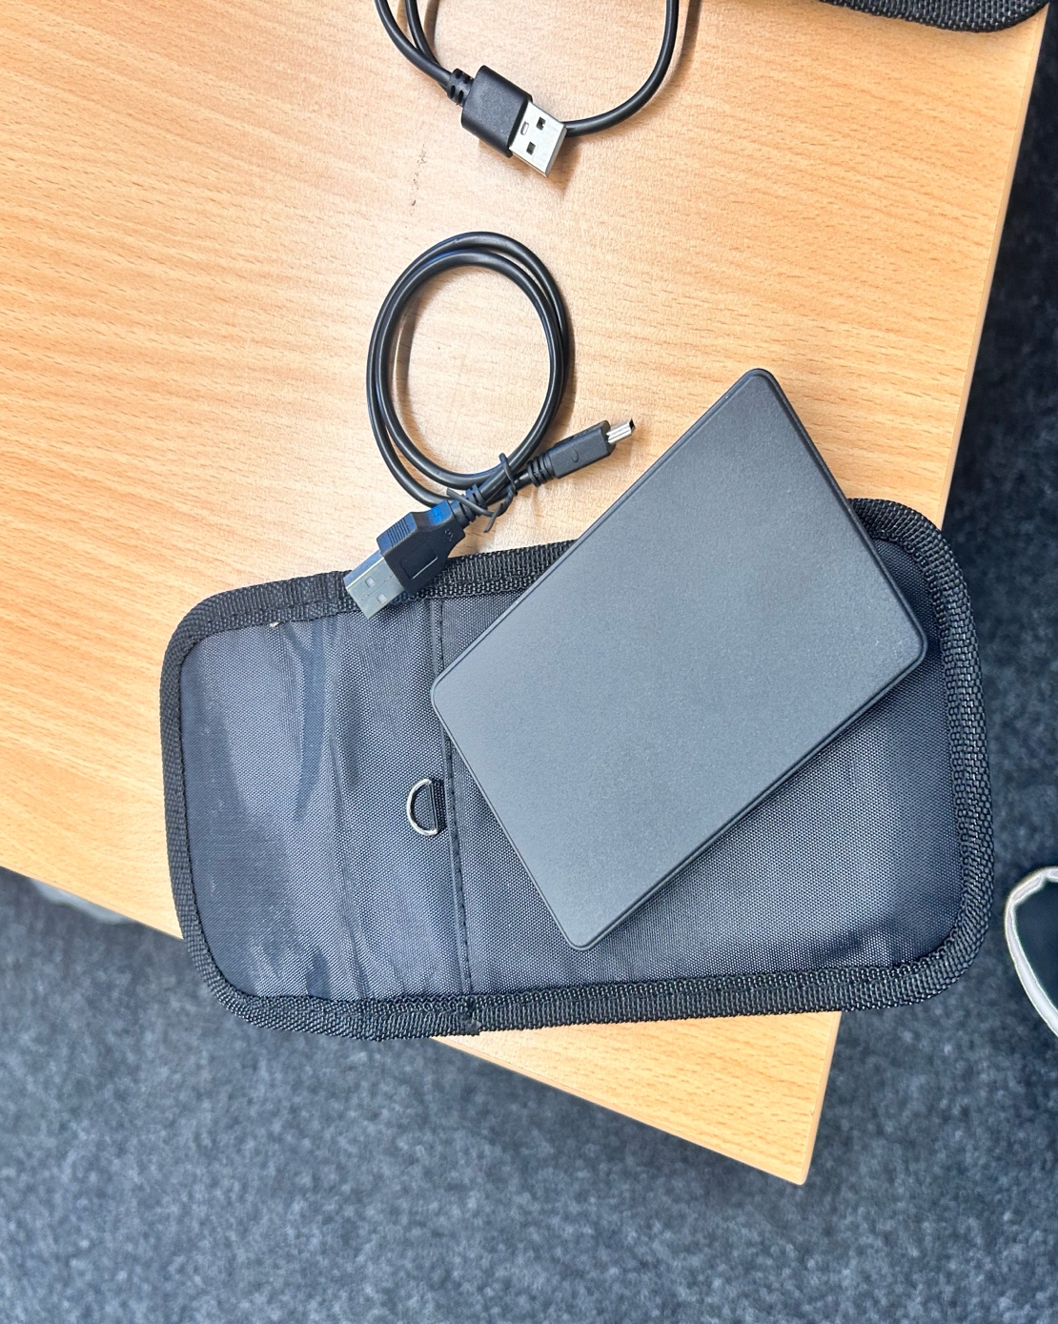

Figure1: Hard Disk(SUHSAI) .

PART - 2: Exchanging Hard Disk

Analysing data:

When 'disk part' and 'list volume' commands were used to examine a 500GB Maxone hard drive that had been formatted with the ExFAT file system and appeared empty at first, no more partitions were found. On a Windows 11 computer, however, the 'attrib -h -r -s /s /d E:.' command revealed hidden files and folders within the E:\ disc.

My contribution:
I first attempted to use FTK images to analyze the data files. certain of the files are C++ files, and encryption files which are essentially steganographic. In addition, certain chats take place amongst the other people. After analyzing all the facts about technology and criminal activity, it was determined that cyberbullying had occurred in this particular situation. I did the decryption part as well.

Conclusion:
Our team effectively managed a cyberbullying issue through a successful digital forensic investigation, using numerous technologies to locate evidence and deliver a detailed case analysis. Through our digital forensics investigation, Emily James, the victim, and Justine Elias were involved in a heartbreaking case of cyberbullying. The evidence, which included call logs, social media analysis, and a police report, showed persistent harassment. The hard drive's forensic analysis revealed cutting-edge methods like encryption and steganography. After overcoming decryption difficulties, our team was able to retrieve important data from encrypted files, confirming the legal actions that Elias was facing. A trend consistent with symptoms of cyberbullying was found in the phone logs. A systematic investigation was ensured by cooperative efforts, which were recorded in meeting minutes and chain of possession files. We demonstrated our dedication to justice and cybersecurity by using PGP encryption to secure data. The hard drive, report, and presentation are all-inclusive documentation of our team's expertise in digital forensics.
TASK - 4
Mobile Forensic Investigation

Resources:
One cell phone for each squad
Digital Forensic Tools: Cellebrite UFED, Oxygen Forensic Detective, Magnet AXIOM, and other tools covered during courses.
Phone Details:
Model: Note 14 (16G)
Brand: Ulefone
Colour: Lavender Purple
IMEI-1: 355617730545789
IMEI-2: 355617730545771
S/N:3102SH1010027469
MediaTek Helio A22
3GB RAM+16GB ROM
6.52-inch HD+ Display
8MP Main Camera
5MP Front Camera
Face Unlock
4500mAh Battery
Powered by Android™ 12
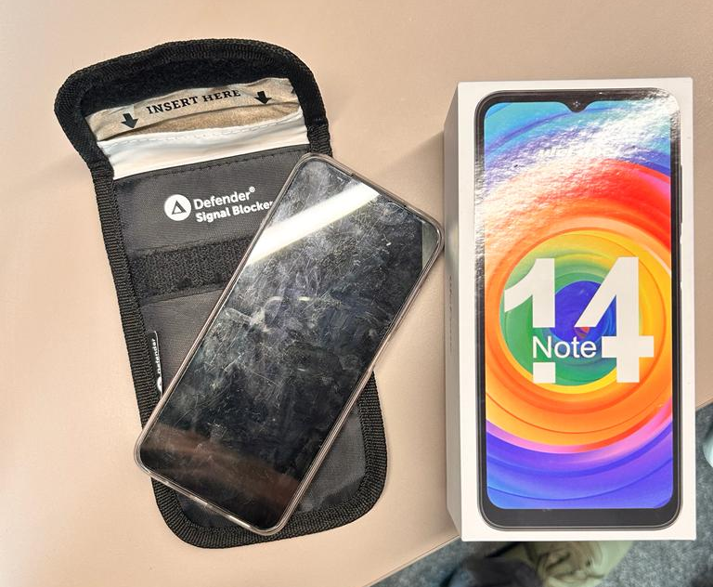
Figure2: Mobile phone (Ulefone Note 14 (16G)).

Analyse Data:
Password Cracking:
I attempted to break the phone. I tried several different techniques,
- Including rooting the phone. However, the issue arises when the phone is in the debugging options, as debugging is frequently not possible.
- As a result, this was our first attempt, which failed.
- Our second attempt involved calling customer service to attempt to obtain the password details by using the PUK Code.
- After our third attempt, we approached our lecturer and requested for a hint. He provided us with the following numbers, which we will use in our password: 0 1 2 4 5 8. I looked up several password combinations by looking at these digits, and eventually, we found one that worked. Thankfully, this allowed us to open the phone using the password, which is 1224.
The tool we employed for the Mobile analysis:
Cellebrite is a digital intelligence provider of mobile device analysis, digital forensics, and data extraction solutions. The business is well-known for its technology, which helps law enforcement, intelligence services, and other institutions gather and examine data from mobile devices for use in court cases and other legal investigations. The Universal Forensic Extraction Device is one of its well-known products (UFED). This is the tool that we use in analysing the data.
Chipset: MT6761
Client Utilization in Extraction: Yes
Advertising ID: 0a24f44d-5908-42bd-a7cb-f7e37ea3aad5
Android ID: 749c315aaaa78ca3
Detected Manufacturer: Ulefone
Detected model: Note 14
Phone date/time: 08/12/2023, 12:57:49
Phone Revision: 12 SP1A.210812.016, build number 1679135682
IMEI: 355617730545771
Model: Note 14
MSISDN: 918778244595
MSISDN Type: Standard (MSISDN)
OS: Android 12
OS_Version: 12
SecurityPatchLevel: 05/03/2023

Cellebrite data extraction process:
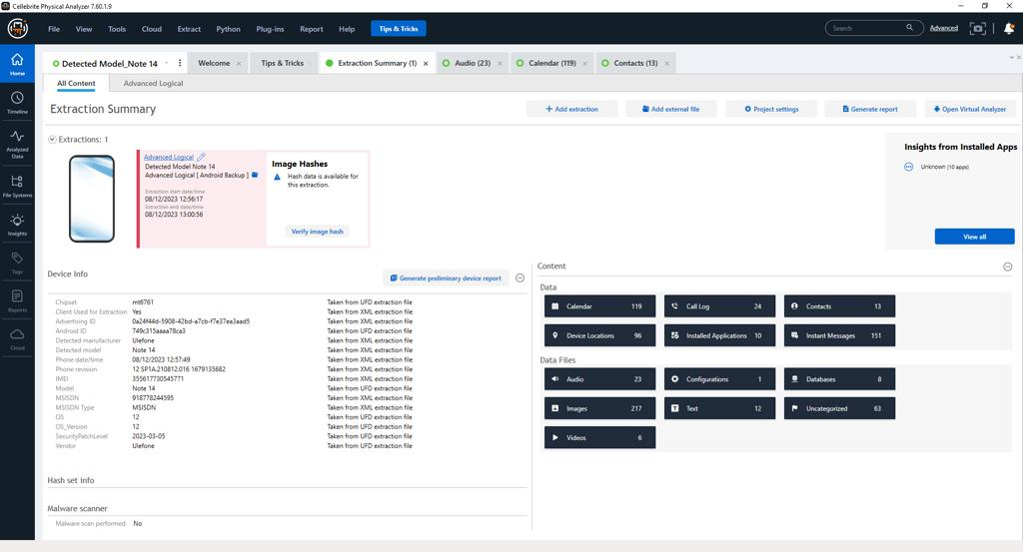
Figure 3:Extraction summary from Cellebrite.
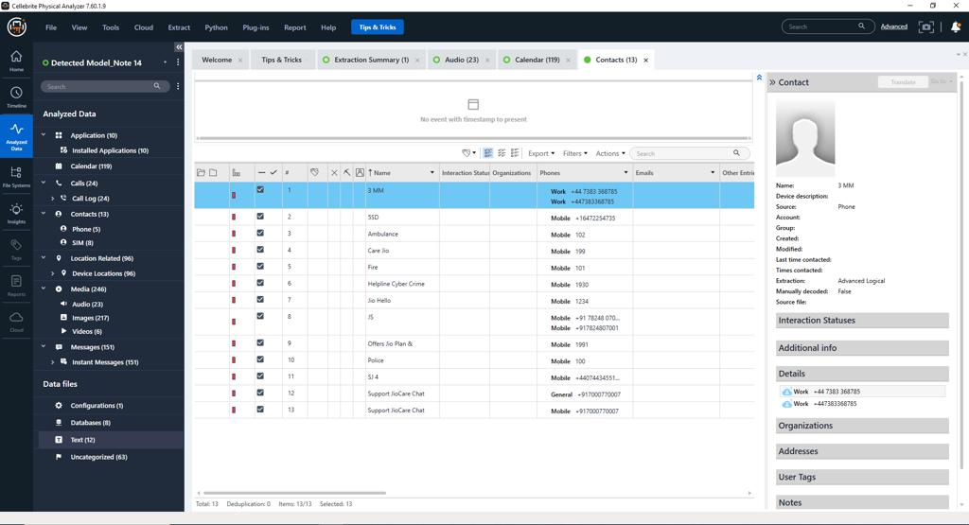
Figure 4:Analyzed Data from Cellebrite.

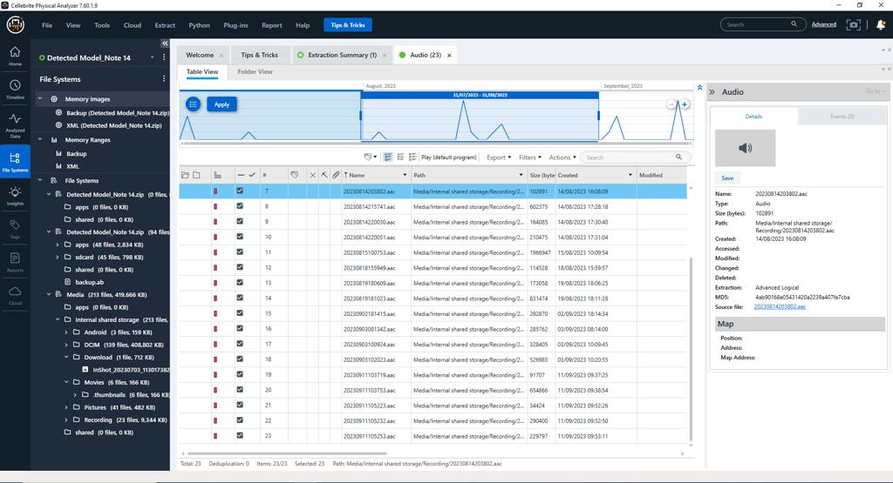
Figure 4:File system from Cellebrite.

My Contribution:
Following my acquisition of the phone, I undertook numerous procedures to examine the data. I obtained a variety of data types, including contact details, audio files, video files, and images. I thoroughly examined each type of data using Cellebrite Toolkit, and I also played a part in deciphering the password by combining numbers. I mapped out every geographic location the user visits by going over all of the data. I also looked over and verified every picture. I saw every video and compared it to the audio files. I made a note of what would occur during the journey in each video compiled the information I learned from the audio and noted it down in our team report.

Entire travel route for the suspect is travelled below:
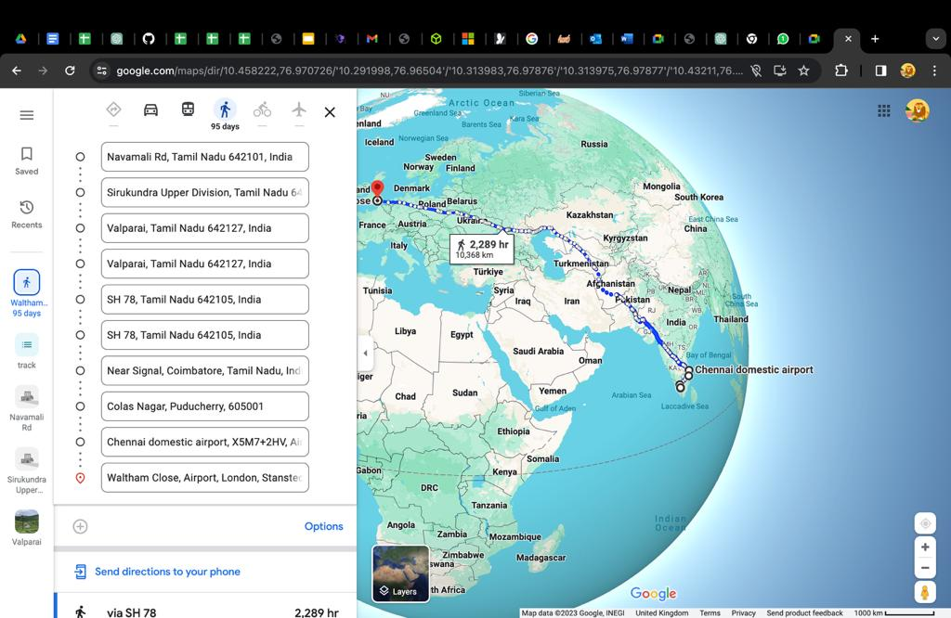
Figure 5: Route1
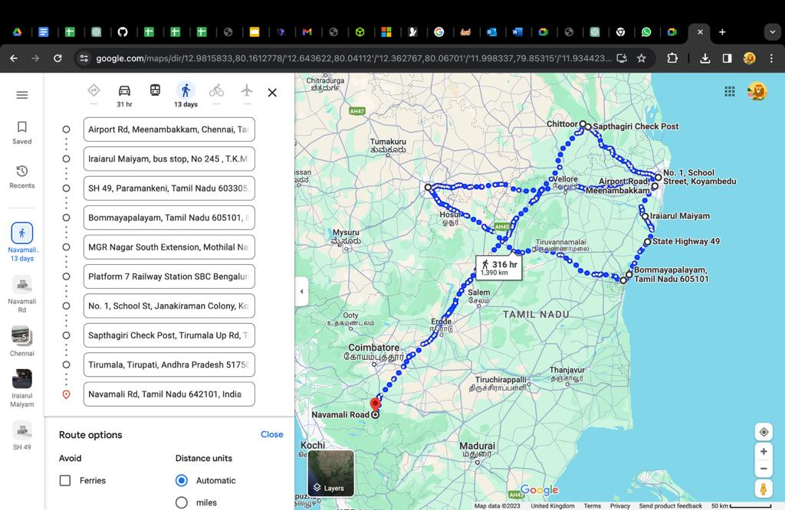
Figure 6: Route 2

Conclusion:
Investigation of the suspect's activities turned up 23 audio recordings. These recordings were made in 2023 during July and September, with a clear emphasis on specific dates in August and September that might have been significant meetings or discussions during those times. An study of call logs turned up several possibly dubious talks, with the longest one coming from an Indian number. A UK work contact number on the suspect's contact list confirms their professional ties to the UK. After 218 media files were examined, a thorough itinerary including stops in Poland, Dubai, India, and the UK was discovered. Interestingly, the suspect's stay in Dubai seems to be transitory—the fact that their trip ends in Swansea, UK, suggests that they may be residents.

Annexure
All of these files can be found in the OneDrive Folder.

Chain of Custody
  - Team C - Task 3 - Receiver.docx
  - Team C - Task 3 - Sender.docx
  - Team C - Task 4.docx

Minutes of Meeting
  - Meeting Notes - 1.docx
  - Team Discussions/Meeting Notes.docs

Video Presentation
  - Group C - Task 3 - Video Presentation.mp4

Data Collection Report.pdf

Team Reports
  - Group C - Task 3 - ACCA7031 - Digital Forensics Analysis.docx
  - Group C - Task 4 - ACCA7031 - Mobile Digital Forensics Analysis.docx

Google Sheet
  - Google Sheet - Task 3 & 4.xlsx

References
[1] Dweikat, M., Eleyan, D. and Eleyan, A., 2020. Digital Forensic Tools Used in Analyzing Cybercrime. Journal of University of Shanghai for Science and Technology, ISSN, pp.1007-6735.

[2] Singh, M. and Arora, A.P., 2017. Perspective and Growth of Cyber Insurance. World Journal of Research and Review, 4(6), pp.61-64.

[3] Market Research Guru. 2023. Digital Forensics Market: Current and Future Growth Analysis. [Online]. Available at: <https://www.linkedin.com/pulse/digital-forensics-market-current-future-growth-analysis> Accessed on 12 December 2023.

[4] Lucifer. 2023. Digital Forensics and Cybersecurity: Interrelated Different Approach. [Online]. Available at: < https://www.forensicsinsider.com/digital-forensics/digital-forensics-and-cybersecurity/> Accessed on 12 December 2023.
[5] Wilkinson-Smith, C., 2022. Does big brother need a full time guardian? the case for an inspector-general of police data management (Doctoral dissertation, Open Access Te Herenga Waka-Victoria University of Wellington).

[6] AWS. 2022. Cellebrite Launches Cloud-Based Digital Intelligence Solution, Doubles Cloud Footprint Each Year through AWS Partner Transformation Program. [Online]. Available at: <https://aws.amazon.com/partners/success/cellebrite/>. Accessed on 12 December 2023.
[7] Grubl, T. and Lallie, H.S., 2022. Applying artificial intelligence for age estimation in digital forensic investigations. arXiv preprint arXiv:2201.03045.

[8] Nelson, G S. 2019. Bias in artificial intelligence. North Carolina Medical Journal, v.80, n.4, p.220-2, 2019.

[9] Datta, A.; Tschantz, MC; Datta, A. Automated experiments on ad privacy settings. Proceedings on Privacy Enhancing Technologies, v.2015, n.1, p.92-112, 2015.
[10] Ntoutsi, E. et al. Bias in data-driven artificial intelligence systems-an introductory survey. WIREs Data Mining and Knowledge Discovery, v.10, n.3, p.e1356, 2020.
[11] SANS Institute. 2023. Digital Forensics Salary, Skills, and Career Path. [Online]. Available at: <https://www.sans.org/blog/digital-forensics-salary-skills-and-career-path/>
[12] Nets Group. 2019. European Fraud Report – Payments Industry Challenges. [Online] Available at: <https://www.nets.eu/solutions/fraud-and-dispute-services/Documents/Nets-Fraud-Report-2019.pdf>
[13] Rudin, C., 2019. Stop explaining black box machine learning models for high stakes decisions and use interpretable models instead. Nature machine intelligence, 1(5), pp.206-215.

[14] Guidotti, R., Monreale, A., Ruggieri, S., Turini, F., Giannotti, F. and Pedreschi, D., 2018. A survey of methods for explaining black box models. ACM computing surveys (CSUR), 51(5), pp.1-42.
[15] Brkan, M., 2019. Do algorithms rule the world? Algorithmic decision-making and data protection in the framework of the GDPR and beyond. International journal of law and information technology, 27(2), pp.91-121.

[16] Sangeetham, K., 2020. OR-3 FTK Vs Autopsy - Secure Enterprise Systems . [Online] Availableat: <https://sites.google.com/site/secureenterprisesystems/home/outside- readings/or-3-ftk-vs-autopsy> Accessed on 12 December 2023.

[17] Moreb, M., 2022. Impact of Device Jailbreaking or Rooting on User Data Integrity in Mobile Forensics. In Practical Forensic Analysis of Artifacts on iOS and Android Devices: Investigating Complex Mobile Devices (pp. 227-258). Berkeley, CA: Apress.

[18] Volatility foundation. Volatility 3: The volatile memory extraction framework. [Online] Available at: https://github.com/volatilityfoundation/volatility3. Accessed on 12 December 2023.
[19] Gaur, S. and Chhikara, R., 2016. Memory forensics: tools and techniques. Indian J. Sci. Technol, 9(48), pp.1-12.
[20] Leuthkit.org. Autopsy. [Online]. Available at: https://www.sleuthkit.org/autopsy . Accessed on 12 December 2023.
[21] Delija, D., Stojkovic, D., Velickovic, M. and Erlevajn, D., Comparing integrated and non-integrated digital forensics tools. dani arčibalda rajsa ““archibald reiss days, p.239.

[22] Dion, J., 2020. Evaluation Of Open Source Versus Commercial Forensic Tools: Online Courses, Training And Tutorials On Linkedin Learning. [Online]. Available at: <https://www.linkedin.com/learning/search?keywords=evaluation%20of%20open%20source %20versus%20commercial%20Forensic%20tools&u=2039756> Accessed on 12 December 2023.

