BA (Hons) Leadership and Management Skills for the Workplace

Coaching and Mentoring Skills for the Workplace
BMSW6105

Student Name: Ana Maria Stanciu -2018244
Lecturer: Nishi Ramsurrun

Appendix

Role play Feedback

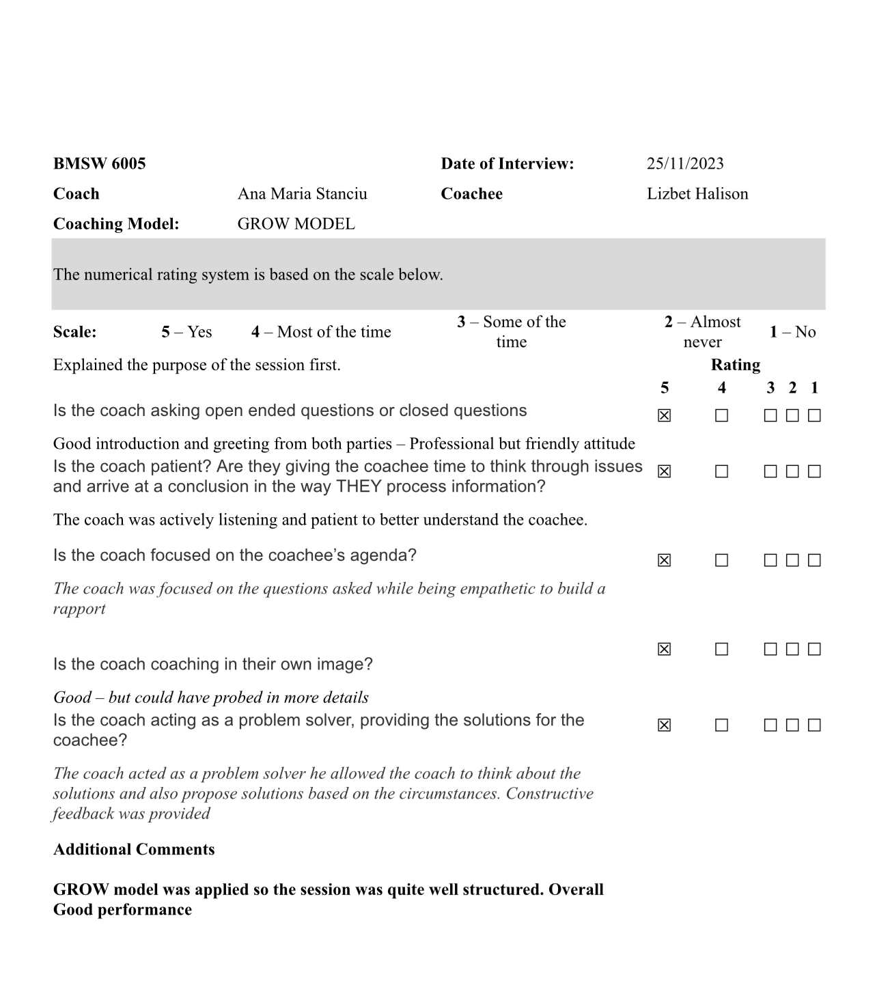
Table of Contents
1. Introduction 2
1.1 Five benefits of coaching to an individual 2
1.2 Five benefits of coaching to the employer 3
2. A reflection on the coaching and mentoring session 3
2.1 Gibbs’ Reflective Cycle 3
2.1.1 Description 4
2.1.2 Feelings 4
2.1.3 Evaluation 5
2.1.4 Analysis 5
2.1.5 Conclusion 6
2.1.6 Action Plan 6
3. Critical evaluation of the coaching and mentoring process and its impact on improving performance and/or morale 10
3.1 GROW Model of coaching and mentoring 10
3.1.1 Improving productivity 11
3.1.2 Better work environment 11
3.1.3 Enhance healthy communication between colleagues 11
3.1.4 Feel more enthusiastic about work 11
4. A brief analysis of behaviours, beliefs, attitudes, and skills of coaches in developing a positive work attitude, and empathetic, organised, and effective communication skills 12
5. Conclusion 12
6. References 13

1. Introduction
Coaching and mentoring are the two crucial aspects that help individuals develop skills, acquire knowledge, and also promote career as well as personal growth (Cipd.org, 2023). As opined by Soraia Romão et al., (2022), coaching generally provides guidance to individuals to achieve a goal. Whereas, mentoring refers to the process of sharing knowledge, experiences, and skills to develop clarity and depth on a particular topic. The basic difference between coaching and mentoring is the time needed by both processes. It has been often identified that coaching is a short-term process. On the other hand, mentoring takes a little longer period of time to develop adequate knowledge and skill sets.
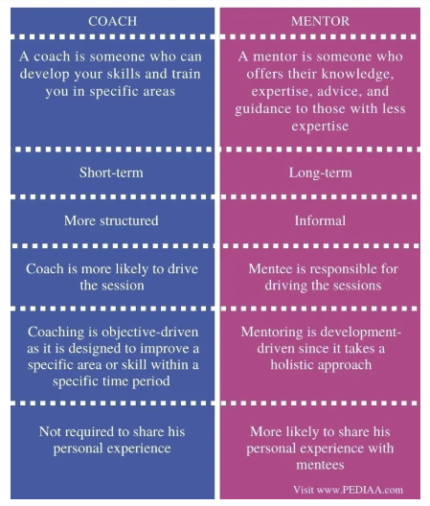
Figure 1: Difference between Coaching and Mentoring
(Source: Pediaa.com, 2020)

1.1 Five benefits of coaching to an individual
- Coaching improves the self-awareness and self-confidence of individuals in an effective way
- Coaching also helps in setting better goals to achieve by providing lower stress levels (Koopman et al., 2021).
- In organisations, proper coaching sessions help in developing critical thinking, and problem-solving and boost employee engagement.
- Betterment in communication skills and capability to interact and connect with colleagues could be easier through a coaching program (Ed.ac.uk, 2023).
- The productivity of employees could be increased and a level-up of employee motivation could also be achieved through this process.

1.2 Five benefits of coaching to the employer
- Leadership qualities could be polished by developing coaching plans by managers.
- Developing transferable skills in employers is done by a coaching session.
- Reflection on personal attitude, behaviour, and techniques to deliver skills can also be evaluated.
- Self-confidence is boosted by coaching programs (Koopman et al., 2021).
- Innovation, adaptability, transparency and other important aspects are developed.

2. A reflection on the coaching and mentoring session

2.1 Gibbs’ Reflective Cycle
Gibbs’ reflective cycle is one of the best models for reflecting on own learning experiences. It helps individuals to identify own strengths and weaknesses and provides support to create a strategic approach to meet the identified drawbacks (Ed.ac.uk, 2023). The reflection model has six distinct stages including description, feelings, evaluation, analysis, conclusion, and action plan.
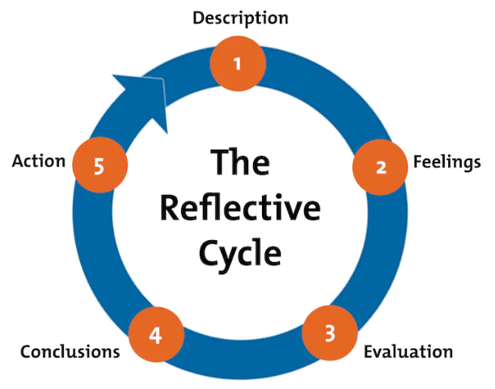
Figure 2: Stages of Gibb’s Reflective Cycle
(Source: Taken from the material)

2.1.1 Description
Description is the first stage in this reflective cycle that depicts the overall scenario and experience of a particular situation. As a four-year experienced Quality Assurance manager of the microbiology department, my overall experience has been good as the company has a record of achieving targets. The staff turnover rates have been observed low and the employee morale within the workforce has also been higher. In recent years, due to certain changes, the company has faced several difficulties in people management, employee engagement, decreased efficiency and production rates, and felt the corporate pressure of cost-cutting to reduce the departmental cost. I have identified that the main reason for these recent changes could be the decreased efficiency of employees in the entire microbiology department. My identifications revealed that there is a need to implement automation technologies to achieve cost-cutting measures.

2.1.2 Feelings
The feeling is the second stage in Gibbs’ reflective model that helps me in expensing my own views on the situation of the department. I feel that there is a need for effective coaching and mentoring sessions for employees to train with adequate microbiological techniques. I also feel that the production rate that has been increased is due to the inability of staff to produce desired products on time and lack of knowledge on the safety and contamination measures. As a result, valuable resources have been used in an improper way which causes the wastage of rare resources. This entire process gradually increases the costs of the department. I feel that if the HR department allows me to develop certain coaching and mentoring sessions to train my staff that could be helpful for the organisation to reduce costs. I feel that the proper usage of sterilisation techniques could reduce the chance of contamination which would help the department to save resources and expensive chemical and biological substances in terms of utilised rapidly. The coaching and mentoring process could help me to develop proper SOPs (Standard Operating Procedures) to minimise the chance of errors both in the formulation and desired product yield.

2.1.3 Evaluation
This is the third part in the reflective cycle that helped me in evaluating all aspects of every employee in the microbiology department in terms of their strengths and weaknesses. I have evaluated that I have a strong set of employees with strong academic backgrounds. Some of them are experienced some are gaining experience in the organisation. In the matter of Robert Lee, he has been feeling threatened by the process of automation. Robert has been working for almost fifteen years in the organisation and his main job role is to monitor employees and make staff available all the time for distributing the workload. Talking with him, I have evaluated that there has been an issue with time and people management as Robert felt difficulties in providing manpower on time. Janice Rowlands is a young, enthusiastic senior microbiologist having strengths in adaptability and flexibility in gaining new skills and is interested in expanding her experiences. John Griffiths has been evaluated to have difficulties in managing workload. Whereas, Maria Cook faced challenges in cooperating with other staff in the department. Lakshmi Darim is another potential employee who has an excellent work record of eleven years in this organisation who faced difficulties in making effective communications and felt that she has been taken for granted by her colleagues.

2.1.4 Analysis
The analysis stage helped me to understand the need for developing the correct mitigation strategies of the organisation to maintain the balance. After the evaluation of the employee set, I have analysed that different staff have different challenges and need different strategies to meet their issues. I have analysed that by implementing automation technologies, the people/staff management criteria could be fulfilled. On the other hand, availing of work-from-home facilities could also be helpful for some employees to maintain a balance in organisational behaviour and through this process, the main aim of departmental cost-cutting could be mitigated. A detailed analysis has revealed that I need to perform coaching and mentoring sessions for my employees to provide adequate support in laboratory work, promote cooperation and connections between employees to reduce unfairness and provide WFH facilities where needed to reduce costs.

2.1.5 Conclusion
In this context, it has been concluded that Gibbs’ reflective cycle is one of the best reflective models that helps individuals to reflect on their own strengths and drawbacks and also helps in developing effective strategies to achieve goals. The conclusion has also been made on the basis of employee motivation as well as demotivation rates in the organisation. It has been also concluded that there are some employees who are more comfortable doing work from home and there are some individuals who perform work from home but feel the need to go physically to the office as they believe physical appearance could avail of chances to be promoted and make good impressions in front of seniors. At last, the conclusion has been made on the need for developing strategies in meeting time and people management issues, adaptability and flexibility, cooperating with other staff, and effective communication between colleagues.

2.1.6 Action Plan
Objectives | Specific | Measurable | Attainable | Realistic | Time Bound
To promote work-from-home facilities where needed | As a Senior Quality Assurance manager of the microbiology department, I have planned to promote or provide WFH facilities to employees who could easily perform their job roles from home. I believe this strategy would help the organisation in cost-cutting as the organisation does not have to pay allowances to the employees who wish to work from home. In this way, departmental cost-cutting measures could be fulfilled to some extent (Benanav, 2020). | The work-from-home facilities are measurable for some employees who do not play the laboratory in-hand experimentations. These facilities could be availed by the persons who could perform their works from their homes (Benanav, 2020). | Promoting work-from-home facilities to employees could be done by receiving applications from employees who are interested in working from home and shortlisting them according to the requirements. | Availability of the WFH facilities to some employees is important for specific job roles as through this process the productivity levels of employees could be increased. It also helps in supporting employee morels in the organisation. | 3 Months
To implement automated technologies to reduce cost | I have also planned to introduce and implement digital technologies as well as automation technologies, especially in the people management aspects. The automated people management software tools could help Robert Lee to manage the workforce working from home and this also reduces the main aim of the organisation as cost-cutting. This process would be also helpful for the company to work efficiently even in workforce shortage situations. | As the main aim of the organisation is cost-cutting, the automation process helps in this process by managing people in an organised and effective manner. | The automated technologies could be attained by observing the organisational performances who have already adopted the technology in their operations. Learning through the existing market experience could be helpful for our organisation to understand the benefits and drawbacks of implementing automation technologies. | In recent days, automated technologies could help organisations and employees in many aspects such as reducing time taken for every process, helping in managing and tracking people in an effective way and many more. | 6 Months
To provide adequate training to employees | I have planned to develop an effective coaching and mentoring program in the organisation to provide adequate hands-on knowledge on proper microbiological techniques so that both the production and formulation errors could be minimised and the savings of important, rare, and imported chemical substances could also be saved (Brighthr.com, 2023). | Training and development are the most important factors in organisations, especially in the microbiology departments to ensure adequate performance of laboratory techniques and achieve the desired yield (Brighthr.com, 2023). | This objective could be attained by collaborating with other bio-pharmaceutical organisations to share and develop knowledge. | A proper training in the core microbiological laboratory techniques are important for every microbiology departmental employee. Several sterilisation techniques such as autoclaving, surface sterilising, and nutrient media sterilisation are important to perform an effective laboratory role that helps to achieve the desired yield from the input (Adeani et al., 2020, p. 141). | 1 Year

3. Critical evaluation of the coaching and mentoring process and its impact on improving performance and/or morale

3.1 GROW Model of coaching and mentoring
The GROW model refers to the simple framework that helps in coaching and mentoring sessions of an organisation to increase employee productivity, skills and communication skills. The GROW model stands for Goal, Current Reality, Options, and Way Forward (Scheler et al., 2019, p. 64). The model helps individuals to plan the journey to achieve certain targets in the professional world.
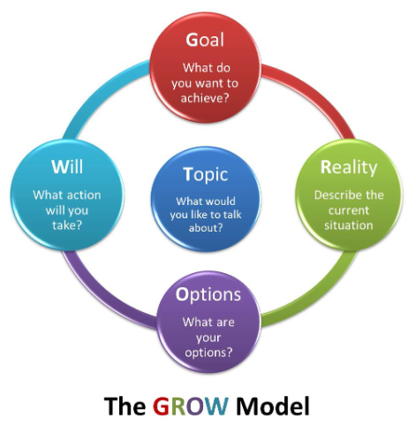
Figure 3: GROW model of Coaching and Mentoring
(Source: German W. Zeceña, 2019)

3.1.1 Improving productivity
The GROW model helps individuals to set a particular goal to achieve in the professional field. It has been identified that setting up a particular Goal helps employees to boost their productivity to achieve the goal. It has been observed that utilising the GROW model helps employers to achieve self-confidence by 80%, Better relationships by 73%, and improved interpersonal skills by 71% (Benanav, 2020). The productivity levels have also been increased by 70% by implementing the elements of the GROW model. The coaching and mentoring process needs to set a goal to boost employee enthusiasm to achieve the target (Bachkirova et al., 2020, p. 365).

3.1.2 Better work environment
Options which is the third component of the GROW model provide employees with a clear idea about the process by which employees could achieve the target that has been set for them (Membrillo-Hernández et al., 2019, p. 1111). In this process, employees need to talk and discuss important aspects that help in developing a positive attitude towards other employees. This process also helps in developing good communication, collaboration, cooperative activities, and positive interactions between employees. A positive and healthy work environment could be achieved through this process.

3.1.3 Enhance healthy communication between colleagues
As opined by Garvey et al., (2021), the GROW model also helps to enhance healthy communication between colleagues. The implementation of a perfect and well-organised coaching and mentoring process helps organisations to achieve and maintain a healthy workplace environment as the coaching and mentoring processes promote teamwork and teamwork and boost healthy communications among employees.

3.1.4 Feel more enthusiastic about work
Reality and Will are the two major components of the GROW model that help employers to understand what is happening now, and what resources do they need to promote coaching and mentoring processes in an organisation (Al Hilali et al., 2020, p. 44). The Will describes what could be committed by the employers to the employees and who would fulfil the commitment and by when the commitment has been fulfilled. Introducing the resources to the employees helps employers to increase the enthusiasm of employees about knowing the outcomes of the new changes and coaching techniques.

4. A brief analysis of behaviours, beliefs, attitudes, and skills of coaches in developing a positive work attitude, and empathetic, organised, and effective communication skills
Developing a positive work attitude, empathy, and effective as well as collaborative communication skills, the behaviour of coaches and their attitudes toward employees play a great role in organisations. As opined by Soraia Romão et al., (2022), a positive and helpful attitude of coaches to employees could reduce the chance of creating discriminatory factors, inequality, and unfairness in the organisational culture. In the case of healthcare organisations, especially in the microbiology departments the need for a motivational coach and proper mentor is important as the employees working in the department need a high level of concentration and peace of mind to do the task (Koopman et al., 2021). Proper coaching and mentoring help employees to work in an organised way and develop patience to work efficiently.

5. Conclusion
In this context, the conclusion has been made on the basis of the importance of the coaching and mentoring processes of employers and the possible outcomes of these techniques on employee productivity, motivation, and morale. The conclusion has also been made on the benefits of coaching and mentoring for both employees and the employer within an organisation. To conclude the effectiveness of personal reflection in developing coaching and mentoring processes, it is important to mention that among all other reflective frameworks, Gibbs’ Reflective Cycle is one of the best models through which a perfect personal reflection has been done. On the other hand, the importance of the SMART objectives has also been evaluated and concluded that SMART objectives help individuals to rectify and develop effective strategies to mitigate the identified issues through personal observations. The GROW model of coaching and mentoring has also been concluded and revealed that the four components of the model help employers to develop a well-organised strategy to provide coaching to employees. In this study, it has also been concluded that a good coaching and mentoring process could help organisations develop effective skills, help boost communication skills, make more engagements with work, and maintain a healthy workplace environment.

6. References
Adeani, I.S., Febriani, R.B. and Syafryadin, S., 2020. Using GIBBS’reflective cycle in making reflections of literary analysis. Indonesian EFL Journal, 6(2), pp.139-148. https://journal.uniku.ac.id/index.php/IEFLJ/article/view/3382
Al Hilali, K.S., Al Mughairi, B.M., Kian, M.W. and Karim, A.M., 2020. Coaching and mentoring. Concepts and practices in development of competencies: A theoretical perspective. International Journal of Academic Research in Accounting, Finance and Management Sciences, 10(1), pp.41-54. https://pdfs.semanticscholar.org/cbb2/b60cccfa0bcc4c3c2b3aeb3e0d6762252a3f.pdf
Bachkirova, T., Arthur, L. and Reading, E., 2020. Evaluating a coaching and mentoring program: Challenges and solutions. Coaching Researched: A Coaching Psychology Reader, pp.361-378. https://onlinelibrary.wiley.com/doi/abs/10.1002/9781119656913.ch19
Benanav, A., 2020. Automation and the Future of Work. Verso Books. https://books.google.com/books?hl=en&lr=&id=vIUBEAAAQBAJ&oi=fnd&pg=PR7&dq=automated+technology+importance&ots=0bh-DpsPFl&sig=S6vluHtm61EnnkYSPR5O03rOJFA
Brighthr.com, 2023. ‘What are the benefits of coaching and mentoring in the workplace?’ Available at: https://www.brighthr.com/articles/training/coaching-mentoring/benefits-of-coaching-and-mentoring-in-the-workplace/ (Accessed on 31st Oct 2023)
Cipd.org, 2023. ‘Coaching and mentoring’ Available at: https://www.cipd.org/en/knowledge/factsheets/coaching-mentoring-factsheet/ (Accessed on 31st Oct 2023)
Ed.ac.uk, 2023. ‘Gibbs' Reflective Cycle’ Available at: https://www.ed.ac.uk/reflection/reflectors-toolkit/reflecting-on-experience/gibbs-reflective-cycle (Accessed on 31st Oct 2023)
Garvey, B., Garvey, R. and Stokes, P., 2021. Coaching and mentoring: Theory and practice. Sage. https://books.google.com/books?hl=en&lr=&id=OsxAEAAAQBAJ&oi=fnd&pg=PP1&dq=coaching+and+mentoring+impacts+in+pharma+company&ots=CwElfaksw4&sig=yR3sy8cerPcrS34_PaJzGBwOdxc
German W. Zeceña, 2019. ‘The GROW Model of Coaching and Mentoring.’ Available at: https://www.linkedin.com/pulse/grow-model-coaching-mentoring-german-w-zece%C3%B1a/ (Accessed on 31st Oct 2023)
Koopman, R., Englis, P.D., Ehgrenhard, M.L. and Groen, A., 2021. The Chronological Development of Coaching and Mentoring: Side by Side Disciplines. International Journal of Evidence Based Coaching & Mentoring, 19(1). https://www.academia.edu/download/89685967/3586.pdf
Membrillo-Hernández, J., J Ramírez-Cadena, M., Martínez-Acosta, M., Cruz-Gómez, E., Muñoz-Díaz, E. and Elizalde, H., 2019. Challenge based learning: the importance of world-leading companies as training partners. International Journal on Interactive Design and Manufacturing (IJIDeM), 13, pp.1103-1113. https://link.springer.com/article/10.1007/s12008-019-00569-4
Pediaa.com, 2020. ‘What is the Difference Between Coach and Mentor’ Available at: https://pediaa.com/what-is-the-difference-between-coach-and-mentor/ (Accessed on 31st Oct 2023)
Scheler, O., Postek, W. and Garstecki, P., 2019. Recent developments of microfluidics as a tool for biotechnology and microbiology. Current opinion in biotechnology, 55, pp.60-67. https://www.sciencedirect.com/science/article/pii/S0958166918300399
Shafiquzzaman Siddiquee, 2017. ‘The Basic Concept of Microbiology’ Available at: https://www.ncbi.nlm.nih.gov/pmc/articles/PMC7123386/ (Accessed on 31st Oct 2023)
Soraia Romão, Neuza Ribeiro, Daniel Roque Gomes, and Sharda Singh 2022. ‘The Impact of Leaders’ Coaching Skills on Employees’ Happiness and Turnover Intention’ Available at: https://www.mdpi.com/2076-3387/12/3/84 (Accessed on 31st Oct 2023)

