

Programme | MSc Public Health and Social Care in Practice
Module | Social Epidemiology and Public Health Development
Module code | LCHS7000
Word Count | 2737
Student Name
Student code

Table of Contents
Task 1: Social Epidemiological Analysis 3
1. Introduction: 3
2. Contextual background and underlying factor: 4
2.1 Disease 1: Cardiovascular disease 4
2.2 Disease 2: Mental health illness 4
2.3 Disease 3: Reproductive health 5
2.4 Social issue 1: Gender-based violence 5
2.5 Social issue 2: Economic inequality 5
2.6 Social issue 3: Health access and gender bias 6
3. National response for reducing gender and health inequality: 6
4. Organisation supporting the group: 7
5. Conclusion: 7
Task 2: Epidemiological Analysis 8
1. Introduction: 8
2. Main body: 8
2.1 Public health response (3P’s): 8
2.2 Determinants/ risk factors: 9
2.3 Epidemiological studies to identify the most affected population: 9
2.4 Monitoring and surveillance system: 10
2.5 Public health impact: 10
2.6 Intervention design and evaluation: 11
2.7 Strengths and limitations of the epidemiological approach: 11
3. Conclusion: 12
References: 13

Task 1: Social Epidemiological Analysis
Title: Health Disparities and Gender Inequality in the UK: An Epidemiological Analysis.

1. Introduction
Gender inequality is one of the major concerns in the healthcare sector that significantly impacts the health outcome of patients. The gender inequality in health also refers to unequal distribution of power, opportunities and resources of healthcare setting between women and men (Newman et al., 2023). This inequality in the healthcare setting causes several health risks for individuals. In the UK, women are more likely face inequality in the healthcare setting due to the social and cultural factors. Evidence shows that around 53% of women in the UK don't have proper access to healthcare services, whereas only 38% of men in the UK face this issue (Health Shield, 2026). These kinds of inequalities are not due to biological factors, but are influenced by different social factors such as income, exposure to violence.
For this report, women are the target group because they face higher risks than men in the case of some specific diseases that affect their health significantly. Social epidemiology will help to understand how the different social conditions influence the health inequalities among men and women in healthcare.
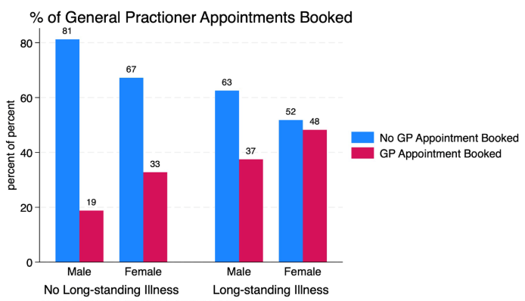
Figure 1: Male vs female appointment book in healthcare
(Source: LSE, 2026)

2. Contextual background and underlying factor

2.1 Disease 1: Cardiovascular disease
Cardiovascular disease is one of the most important causes of death among the population in the UK. Evidence shows that although men face high rates of cardiovascular disease, women still face high mortality from heart disease in the UK. Around 82,000 women die annually in the UK from cardiovascular disease, whereas for men, this number is around 79,000 (BBC, 2014). The report also shows that underdiagnosis is the main reason for the high mortality rate among women for cardiovascular disease. Also, women aged about 65 years and older face a high threat of suffering from CVD (Cleveland Clinic, 2023). This inequality exists because, compared to women, men are more likely to face heart disease. To resolve this inequality, gender sensitive medical research and improved awareness among medical professionals are required.
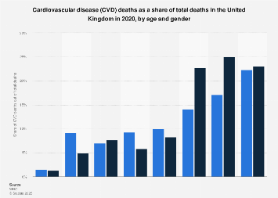
Figure 2: CVD death rate in 2020 by age and gender
(Source: Stewart, 2025)

2.2 Disease 2: Mental health illness
In the UK, women face more mental health issues like anxiety and depression than men. Evidence shows that in the UK, around 24% of women face mental health problems, whereas around 15% of men face this problem (Mental Health Foundation, 2026). This unequal rate of mental disorder between men and women indicates women receive weaker diagnoses for the betterment of mental health. Among women, hormonal changes and social violence are the major reasons for improved mental health issues (NIH, 2026). As the solution, the mental health organisations must focus on listening to the needs of different genders and should establish equal workplace policies.

2.3 Disease 3: Reproductive health
The reproductive health issue is highly faced by UK women as compared to men. Evidence shows that around 1 in 8 women face reproductive issues. On the other hand, 1 in 10 men face fertility problems (Datta et al., 2016). Among UK women, it is also found that women belonging to ethnic minority groups face high challenges in accessing fertility care due to the cultural stigma and systemic barriers (Merkison et al., 2023). As a result, it significantly impacts the physical and mental health of women. To resolve this issue, the healthcare organisations should arrange awareness campaigns and targeted interventions for high risk groups.

2.4 Social issue 1: Gender-based violence
Gender violence is one of the serious concerns in the UK, which directly or indirectly impacts the health of an individual. A report shows that a large number of women, i.e., around 1 in 4, are the victims of domestic abuse, one of the forms of gender-based violence, which causes high mental issues in women compared to men (Plan International, 2026). It indicates that women in the UK are the victims of violence by men. To resolve this issue, it is important to arrange an awareness programme and strengthen the legal structure.

2.5 Social issue 2: Economic inequality
Economic inequality is one more crucial factor that impacts women's health significantly. A report shows that in the UK, the hourly pay of women full-time employees is 6.9% lower than that of men employees (UK Parliament, 2025). Therefore, due to this income equality, independent women in the UK sometimes could not afford proper healthcare treatment which may lead to the high risks of women suffering from CVD. To resolve this, it is important to create suitable policies for reducing the gender pay gap in the organisation.
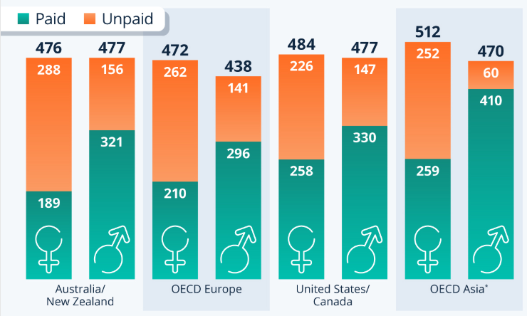
Figure 3: Gender pay gap in different countries
(Source: Buchholz, 2026)

2.6 Social issue 3: Health access and gender bias
In the UK, there is lower healthcare access for females due to gender bias. Evidence shows that around 44% of women feel neglected while availing healthcare services compared to 35% of men (Slater Gordon, 2025). The structural inequality in healthcare is the key reason for this kind of unequal treatment in the UK healthcare sector. In the case of CVD patients, the unequal treatment may lead to a high health risk. As an action, the healthcare organisations require structural changes and must provide gender-based training to healthcare professionals.

3. National response for reducing gender and health inequality:
The UK government has established several policies and frameworks for reducing the unequal treatment delivered by healthcare organisations. The Department of Health and Social Care in the UK initiated the 'Women's Health Strategy for England', which aims to reduce gender inequality in the healthcare setting by managing systematic issues (Connolly and Regan, 2022). This initiative from the UK healthcare body also enhances accessibility of care for the genders, especially for women. In addition, the UK Parliament passed an act, namely 'Domestic Abuse Act 2021', which ensures a high level of legal protection against gender-based violence (Women's Aid, 2026). It is effective for reducing physical and mental harm to women. These are the key responses of the UK national bodies for reducing health and gender inequality in the UK. Although there is a good response from national bodies to resolve gender and health inequalities, the unequal treatment-related incidents indicate a lack of implementation lacking of these responses.

4. Organisation supporting the group
Women's Aid, one of the most popular charitable organisations in the UK, organises a campaign, namely 'Deserve To Be Heard', with the goal of reducing the domestic abuse of women to ensure a better mental health for women (Women's Aid, 2021). This charitable organisation also works on providing proper counselling and safe accommodation to women for rebuilding and recovering their lives. Considering these ways, the charity is working for the mental health wellbeing of women in the UK.

5. Conclusion
The overall report concludes that gender health inequality is one of the rising concerns in the UK that is highly influenced by the structural and social factors. The UK women are facing health issues related to mental health disorders, reproductive health problems and cardiovascular disease and social problems like economic inequality, domestic violence, and bias in accessing healthcare services. Lastly, it can be said that by improving awareness, arranging campaigns and implementing policies, the healthcare bodies and the charity organisations can easily fix the healthcare inequality-related issues in the UK.

Task 2: Epidemiological Analysis
Title: Epidemiological Analysis among women in the UK: A focus on cardiovascular disease.

1. Introduction
Cardiovascular disease (CVD) is a group of health problems that directly impact the blood vessels and heart, including hypertension, stroke and heart disease. This is one of the common causes of death of humans globally and in the UK. Although men globally are highly affected by CVD, the inequality in treatment and diagnosis is the main cause of the high number of deaths of women globally from CVD. A report shows that globally, around 7 million women die every year from CVD (Siemens Healthineers, 2026). In addition, other evidence shows that around 1 in 4 women in the UK dies due to CVD (World Heart Federation, 2026). This evidence shows that CVD is a major health issue among women globally and in the UK. Apart from that, it can be said that women often are neglected in getting early and proper healthcare treatment. In support, a report shows that around 54.5% women globally feel neglected at the time of availing healthcare services (Mirzania et al., 2025). This report is going to focus on selecting the women belonging to the Borough, London as the key target population, as this population has a high range of diversity. This report is also going to explore the epidemiological processes in accessing, managing and identifying cardiovascular diseases, including the evaluation of the effectiveness of healthcare interventions.

2. Main body

2.1 Public health response (3P’s)
This section consists of a discussion about managing, treating, reducing, and controlling CVD, and it will be drawn by using 3Ps model. The three factors of this model, including prevention, protection, and promotion, will outline the way of reducing the impact of this disease.
Prevention:
The prevention of CVD focuses on reducing the risk factors that cause cardiovascular disease. First of all, women must avoid smoking and should maintain a healthy diet to prevent the chances of CVD (Tokgozoglu et al., 2020). In addition, for the prevention of CVD, the NHS Health Check, one of the free healthcare programmes that helps in assessing risks of cholesterol and blood pressure to ensure a reduction in cardiovascular disease (NHS, 2026).
Protection:
This factor includes the reduction of risk factors through implementing different regulations and policies. For example, the government of the UK passed legislation that aims to achieve a smoke-free generation for women and men. As an action, the UK government aimed to stop smoking among women born after 1 January 2009 by increasing the legal smoking age by 1 year every year (Roberts, 2026). The UK government also passed the Food Safety Act 1990 with the focus of reducing health risk for unhygienic and unhealthy food items (UK Legislation, 2026). Following these ways, the UK bodies are trying to control the number of CVD cases in the country.
Promotion:
It focuses on improving the health of people through making them aware of health by arranging awareness campaigns and providing education. For example, the British Heart Foundation (BHF) launched a campaign named 'Heart Month' which aims to enhance awareness among women about cardiovascular disease among the population (BHF, 2026). This campaign also promotes a healthier lifestyle and provides training about CPR skills to prevent risks for CVD.

2.2 Determinants/ risk factors
There are different risk factors or determinants, including social, behavioural, and biological factors, that significantly influence CVD. Considering the social factors, the income and education of an individual are the major causes of CVD. The women with lower income struggle to access healthy food and a hygienic living environment, which is the key factor for the occurrence of CVD throughout their lifespan (Chaturvedi et al., 2024). Considering behavioural factors, the unhealthy diet, smoking habit and lack of physical activity are the key reasons for suffering in CVD by women aged about 65 years and more (Jafari et al., 2023). In addition, among women, the reduced level of oestrogen hormone and genetic predisposition are the key biological factors that cause CVD.

2.3 Epidemiological studies to identify the most affected population
Epidemiological studies are essential for detecting the most affected population by the CVD and the key reasons for the disease. Epidemiological data show that around 3.6 million women in the UK suffer from CVD, and the inequalities in diagnosis raise risks for under-represented groups of women (BHF, 2024). Another epidemiological data shows that around 8.7% of women in the UK smoke cigarettes (GOV.UK, 2025). The health needs assessment is also used to recognise the specific needs of a particular group. A report shows that the women who belong to low-income and ethnic minority groups face high challenges for Cardiovascular disease (Balla et al., 2020). Also, women aged about 65 years and older face a high threat of suffering from CVD (Cleveland Clinic, 2023). Therefore, women belonging to low-income and ethical minorities are the most specifically defined audience affected by CVD.
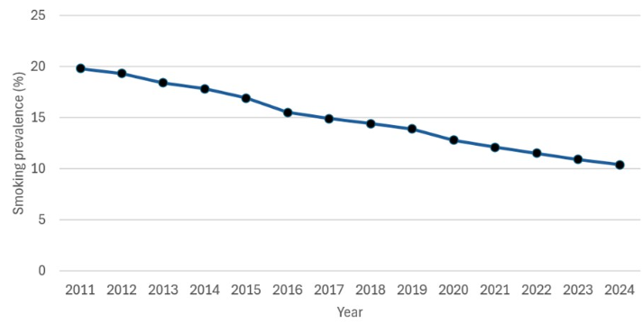
Figure 4: Smoking rate among UK women
(Source: GOV.UK, 2025)

2.4 Monitoring and surveillance system
As the monitoring and surveillance system, the different data from the National Statistics, Public Health England, and the National Institute of Health (NIH) is used for assessing the cases of CVD. These systems collect data about hospital admissions, health risk factors, and mortality rates. As an example, a report from NIH shows that women are more likely to die from a heart attack than men due to improper treatment and delayed diagnosis (Keteepe-Arachi and Sharma, 2017). At the local level, the London Borough uses a public health dashboard for tracking the health risks of populations. Using this dashboard, the London Borough also tackles the health inequality in the population (Institute for Health Equity, 2022). However, the surveillance system may have some sort of limitations. First of all, this could overlook the disaggregation of ethnicity and gender. In this context, it can be suggested that gender sensitivity and improving data quality are important for enhancing the effectiveness of monitoring and surveillance activities.

2.5 Public health impact
In the case of short-term impact, this disease can lead to serious health outcomes like strokes and heart attacks among women (Sulashvili and Nimangre, 2025). This could lead to a high threat to life, and often, individuals with these short-term impacts become hospitalised. Considering the long-term impact, CVD can cause failure health consequences that may lead to death. In addition, the CVD may also cause long-term physical disability in an individual by raising the chances of paralysis. In the long run, the CVD can also enhance the dependency on family members and healthcare professionals. In addition, the CVD enhances the economic burden on the specific population and reduces the productivity level of women significantly (Luengo-Fernandez et al., 2024). Therefore, the reduction and control of CVD is improved to reduce its short-term and long-term impact.

2.6 Intervention design and evaluation
Name of the intervention:
Early screening and awareness programme of CVD in the community.
Aim and target of the intervention:
This intervention aims to reduce the chances of CVD in the community, especially among women belonging to the ethnic minority and the economically weaker section in the London Borough.
Activities of the intervention:
This intervention consists of the mobile health clinic, with flexible appointment times for delivering the best quality caregiving services. This intervention is going to promote a healthy lifestyle to women that will help to prevent the chances of CVD (Banach, 2020). Through this intervention, the awareness will be spread among women about the key symptoms of CVD. In this programme, both qualitative and quantitative data will be used for gathering patient feedback and participation rate.
Possible impact of the intervention:
The well-designed and successful intervention will eliminate or reduce health inequality and reduce the chances of having CVD among women.

2.7 Strengths and limitations of the epidemiological approach
First of all, the data-driven insight of this approach helps to identify trends and patterns of context about the CVD cases among women. One more strength of this approach is evidence-based decision-making that improves the effectiveness of decisions (Lauterbach, 2023). In contradiction, the key limitation of this approach is the biased or incomplete data that may cause a barrier in getting the actual insight about a particular group of participants, including underrepresented women and their health impact (Weber et al., 2021). In addition, the measurable characteristic of the epidemiological approach could overlook the cultural and social influence of CVD among women. Despite having these limitations, the combination of epidemiological approach with the social influence could significantly influence the understanding of public health problems.

3. Conclusion
This report concludes that cardiovascular disease (CVD) is a rising health problem globally and in the UK, especially among women with lower incomes and ethnic minorities. Epidemiological approaches are helpful to identify, manage and address the issue properly. This approach also helped to identify that a higher number of women globally die from CVD compared to men. This disease has major health risks, including heart attack, stroke, heart failure, and paralysis. By creating a successful intervention, the health risk of women could be reduced by making them aware of health consciousness and CVD symptoms.

References
Balla, S., Gomez, S.E. and Rodriguez, F., (2020). Disparities in cardiovascular care and outcomes for women from racial/ethnic minority backgrounds. Current treatment options in cardiovascular medicine, 22(12), p.75.
Banach, M., (2020). Where are the recommendations on healthy lifestyle and cardiovascular disease prevention for pregnant women?. Journal of the American Heart Association, 9(4), p.e016052.
BBC, (2014). Why more women die from heart disease than men. Available at: https://www.bbc.com/news/health-26472725#:~:text=Heart%20disease%20is%20normally%20considered,we%20look%20after%20our%20bodies.
BHF, (2026). Heart Month 2026. Available at: https://www.bhf.org.uk/how-you-can-help/support-our-campaigns/heart-month
Buchholz, K. (2026). Women Work More Than Men. Statista. Available at: https://www.statista.com/chart/13940/women-work-more-than-men/
Chaturvedi, A., Zhu, A., Gadela, N.V., Prabhakaran, D. and Jafar, T.H., (2024). Social determinants of health and disparities in hypertension and cardiovascular diseases. Hypertension, 81(3), pp.387-399.
Cleveland Clinic, (2023). Cardiovascular Disease in Women. Available at: https://my.clevelandclinic.org/health/diseases/17645-women--cardiovascular-disease
Connolly, A. and Regan, D.L., (2022). Women’s health matters. The British Journal of General Practice, 72(725), p.556.
Datta, J., Palmer, M.J., Tanton, C., Gibson, L.J., Jones, K.G., Macdowall, W., Glasier, A., Sonnenberg, P., Field, N., Mercer, C.H. and Johnson, A.M., (2016). Prevalence of infertility and help seeking among 15 000 women and men. Human reproduction, 31(9), pp.2108-2118.
GOV.UK, (2025). Smoking profile: statistical commentary, November 2025. Available at: https://www.gov.uk/government/statistics/smoking-profile-november-2025-update/smoking-profile-statistical-commentary-november-2025
Health Shield, (2026). The Hidden Struggles of Women Accessing Healthcare in the UK. Available at: https://www.healthshield.co.uk/blog/the-hidden-struggles-of-women-accessing-healthcare-in-the-uk/
Institute of Health Equality, (2022). HEALTH INEQUALITIES IN LONDON. Available at: https://www.instituteofhealthequity.org/resources-reports/a-snapshot-of-health-inequalities-in-london/full-report.pdf
Jafari, N., Alivand, S., Molaee, H., Shahabi Rabori, V., Asadian, A., Abbasian, S. and Faramarzzadeh, R., (2023). How lifestyle factors can contribute to cardiovascular disease incidence; a review study. Journal of Preventive Epidemiology, 9(1), pp.e35232-e35232.
Keteepe-Arachi, T. and Sharma, S., (2017). Cardiovascular disease in women: understanding symptoms and risk factors. European Cardiology Review, 12(1), p.10.
Lauterbach, K.W., (2023). Evidence-based policy-making-epidemiology as a key science for quality of life in society. European Journal of Epidemiology, 38(12), pp.1205-1212.
LSE, (2026). Barriers to Women in Accessing Healthcare in the UK – A Review. Available at: https://ppr.lse.ac.uk/articles/10.31389/lseppr.122
Luengo-Fernandez, R., Little, M., Gray, A., Torbica, A., Maggioni, A.P., Huculeci, R., Timmis, A.D., Vardas, P. and Leal, J., (2024). Cardiovascular disease burden due to productivity losses in European Society of Cardiology countries. European heart journal-quality of care and clinical outcomes, 10(1), pp.36-44.
Mental Health Foundation, (2026). Men and women: statistics. Available at: https://www.mentalhealth.org.uk/explore-mental-health/statistics/men-women-statistics#:~:text=Mental%20health%20problems%20affect%20both,majority%20of%20the%20prison%20population.
Merkison, J.M., Chada, A.R., Marsidi, A.M. and Spencer, J.B., (2023). Racial and ethnic disparities in assisted reproductive technology: a systematic review. Fertility and Sterility, 119(3), pp.341-347.
Mirzania, M., Shakibazadeh, E., Maleki, A., Noorafrooz, M., Karimi, N., Mayra, K., Dashtkoohi, M. and Hantoushzadeh, S., (2025). Prevalence of mistreatment and disrespect of women during childbirth in the world: a systematic review and meta-analysis. Reproductive Health, 22(1), p.193.
Newman, C., Nayebare, A., Gacko, N.M.N.N., Okello, P., Gueye, A., Bijou, S., Ba, S., Gaye, S., Coumba, N.D., Gueye, B. and Dial, Y., (2023). Systemic structural gender discrimination and inequality in the health workforce: theoretical lenses for gender analysis, multi-country evidence and implications for implementation and HRH policy. Human Resources for Health, 21(1), p.37.
NHS, (2026). NHS Health Check. Available at: https://www.nhs.uk/tests-and-treatments/nhs-health-check/
NIH, (2026). Women and Mental Health. Available at: https://www.nimh.nih.gov/health/topics/women-and-mental-health#:~:text=Why%20is%20women's%20mental%20health,of%20hormone%20change%2C%20such%20as:
Plan International, (2026). What is gender-based violence & what are its impacts?. Available at: https://plan-uk.org/our-work/protection-from-violence/what-is-gender-based-violence#:~:text=In%20the%20UK%2C%201%20in,abuse%20in%20their%20own%20regard.&text=Sexual%20violence%20can%20be%20committed,in%20any%20setting%2C%20including%20online.
Roberts, M. (2026). Smoking ban for people born after 2008 in the UK agreed. BBC. Available at: https://www.bbc.com/news/articles/cn08jy6w0l5o
Siemens Healthineers, (2026). Women and Cardiovascular Disease. Available at: https://www.siemens-healthineers.com/en-in/clinical-specialities/womens-health-information/laboratory-diagnostics/women-and-heart-disease
Slater Gordon, (2025). What is gender bias in healthcare?. Available at: https://www.slatergordon.co.uk/newsroom/breaking-silence-on-gender-bias-health-inequalities%20/
Stewart, C. (2025). CVD deaths as a share of total deaths in the UK in 2020, by age and gender. Statista. Available at: https://www.statista.com/statistics/1421069/cvd-deaths-as-a-share-of-total-deaths-in-uk-by-age-and-gender/
Sulashvili, N. and Nimangre, R.R., (2025). Manifestation of some aspects of cardiovascular diseases, implications, pharmacotherapeutic strategies, effects, impacts and potential hazards in general. Junior Researchers, 3(1), pp.1-27.
Tokgozoglu, L., Hekimsoy, V., Costabile, G., Calabrese, I. and Riccardi, G., (2020). Diet, lifestyle, smoking. Prevention and Treatment of Atherosclerosis: Improving State-of-the-Art Management and Search for Novel Targets, pp.3-24.
UK Legislation, (2026). Food Safety Act 1990. Available at: https://www.legislation.gov.uk/ukpga/1990/16/contents
UK Parliament, (2025). The gender pay gap. Available at: https://commonslibrary.parliament.uk/research-briefings/sn07068/
Weber, A.M., Gupta, R., Abdalla, S., Cislaghi, B., Meausoone, V. and Darmstadt, G.L., (2021). Gender-related data missingness, imbalance and bias in global health surveys. BMJ global health, 6(11).
Women’s Aid, (2021). Survivors deserve to be heard: The reality of the barriers to mental health support. Available at: https://womensaid.org.uk/the-reality-of-the-barriers-to-mental-health-support/#:~:text=6th%20December%202021:%20Today%2C%20Women's,heard%20and%20responded%20to%20effectively.
Women’s Aid, (2026). Domestic Abuse Act 2021. Available at: https://womensaid.org.uk/get-involved/campaign/domestic-abuse-bill/
World Heart Federation, (2026). Women & CVD. Available at: https://world-heart-federation.org/what-we-do/women-cvd/#:~:text=Cardiovascular%20disease%20is%20responsible%20for,they%20have%20of%20beating%20it.

