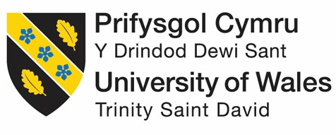

MBA INTERNATIONAL BUSINESS
Human Capital Management

Lecturer: Dr. Gladius Kulothungan
Module code: LCMB7023
Student name: Cristian Stoleru
Student ID: 2215119
Contents
Question 1: Technological Advancements and the Reshaping of Labour Markets: Implications for HRM and IHRM Strategies 3
1.1. Labour Market Transformation: Polarization and Fluidity 3
1.2. Strategic Implications for Domestic HRM 4
1.3. IHRM Challenges in the Global Digital Context 5
Conclusion 5
Question 2: Demographic and Geopolitical Factors: Challenges for HR Professionals 6
2.1. The Impact of Shifting Demographic Structures 6
2.2. Geopolitical Volatility and IHRM Resilience 7
Conclusion 8
Question 3: Addressing Persistent Skills Gaps and Talent Shortages through Strategic HRM 8
3.1. Diagnosis and Strategic Workforce Planning 8
3.2. Strategic Interventions: Build, Buy, Borrow, or Bridge 9
3.3. Retention through Holistic Employee Experience 10
Question 4: Preparedness for the Globalised Workplace: A Critical Self-Reflection 12
4.1. Introduction to the Reflection Framework 12
4.2. Capabilities Assessment and Evidence 12
4.3. Strategy for Improvement and Leveraging Strengths 13
References List 15

Question 1: Technological Advancements and the Reshaping of Labour Markets: Implications for HRM and IHRM Strategies

1.1. Labour Market Transformation: Polarization and Fluidity
Technological developments, especially the use of Artificial Intelligence (AI) and digital platforms, are changing the structural dynamics of employment, and this creates complex strategic challenges for Human Resource Management (HRM) and IHRM. The most significant changes are labour market polarization and fluidification of work.
This polarization dynamic is captured by the U-Shaped model of the labour market transformation (Figure 1). Adapted from Frey and Osborne (2017) and the World Economic Forum (2023) - the model shows that automation particularly affects middle-skilled and routine jobs and has been represented as the 'Automation Risk Zone.' The resulting outcome is a dual market in which demand becomes more acute for high skilled workers who are able to manage these new forms of technology (the right-hand peak), creating a critical 'skills asymmetry' (Deloitte, 2022). At the same time, there is also an increased demand for low-skill service jobs that are non-routine and hence hard to automate (the left-hand peak). Concurrently, the proliferation of digital platforms has catalysed the 'gig economy' in which employment has become fluid, with responsibility for training and career progression moving from the organisation to the individual (Vallas & Schor, 2020). This requires a paradigm shift in HRM from the traditional talent acquisition to orchestrating a flexible network of internal and external capabilities (Becker et al., 2021), which requires new organisational architectures for a fragmented talent ecosystem.
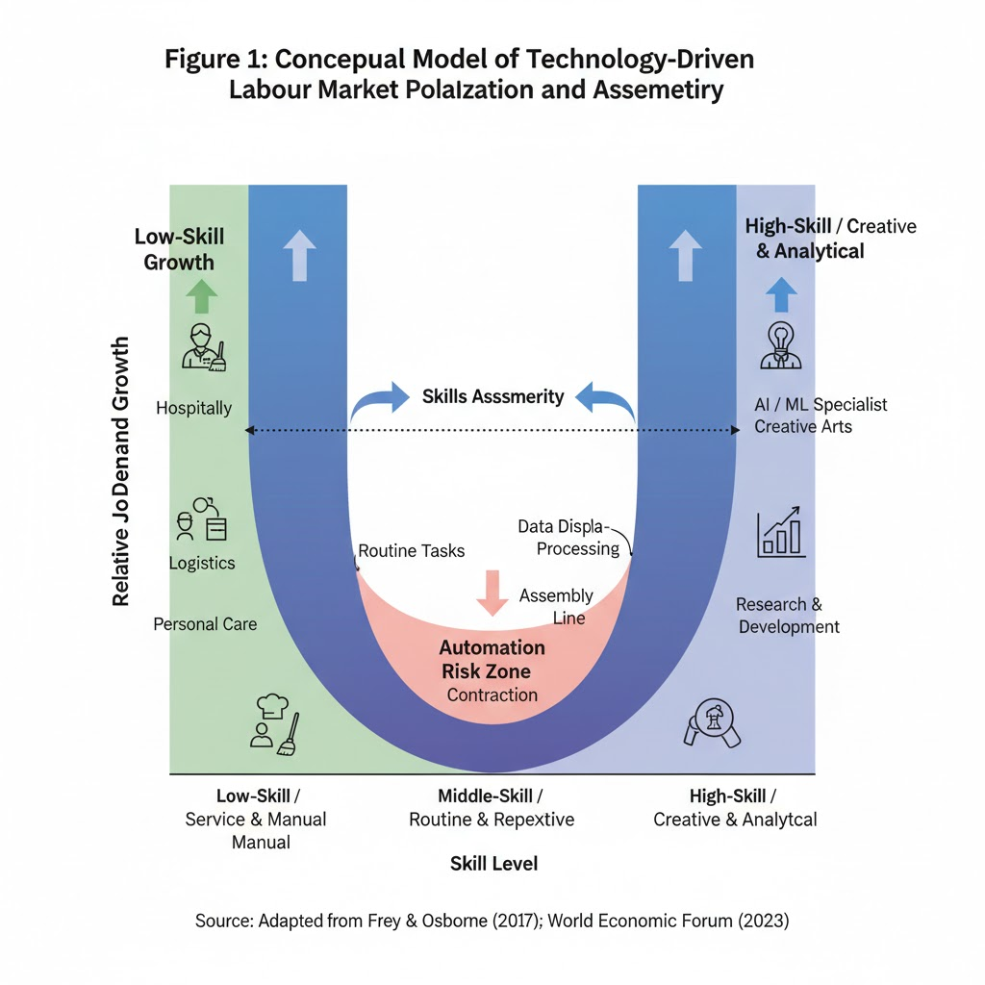

1.2. Strategic Implications for Domestic HRM
This new structure of the labour market requires that HRM transforms from a support function to a key factor in organisational adaptation. First, traditional workforce planning needs to be dynamic and move from static forecasting to continuous scenario modelling and capability mapping to align human capital with the strategy in a volatile context (Lepak & Snell, 1999). Second, organisations need to shift towards internal reskilling opportunities, using AI-fuelled learning platforms (Cappelli, 2017) to develop customisation opportunities for moving employees from declining to in-demand careers. Third, the HRM must re-design systems for a hybrid workforce of employees and contractors. This necessitates outcome-based performance frameworks and, critically, an effective ethics framework to govern algorithmic management and mitigate against the data privacy risks that Zuboff (2019) warned about. Finally, compensation strategies would have to be re-evaluated to provide for internal equity between highly paid gig specialists and traditional employees to prevent the erosion of its culture (Tavlaridis 2024).

1.3. IHRM Challenges in the Global Digital Context
Globally such implications are compounded, requiring a strategic change in the purpose of IHRM. As digital collaboration tools make physical mobility less critical (Schuler, 2020), the role of IHRM shifts from the logistics to the governance. This is illustrated in Figure 2, which shows the shift from an 'Old Focus' (on the focus or management of expatriates) to a 'New Focus' on how to govern a dispersed digital workforce. This new paradigm places IHRM in position of architect global digital governance involving moving through a digital data privacy labyrinth such as GDPR across international boundaries and securing local labour law compliance for remote workers in many countries (Hoang and Kulothungan, 2025). Furthermore, the successful implementation of AI across international subsidiaries requires high cultural intelligence to deal with resistance and tailor the automation to different ethical norms for equity and acceptance (Briscoe et al., 2021). IHRM's central role is therefore one of transformation - from managing physical mobility to the design of the ethical and compliant organizational structures for a borderless digital workforce (Festing & Schafer, 2014).
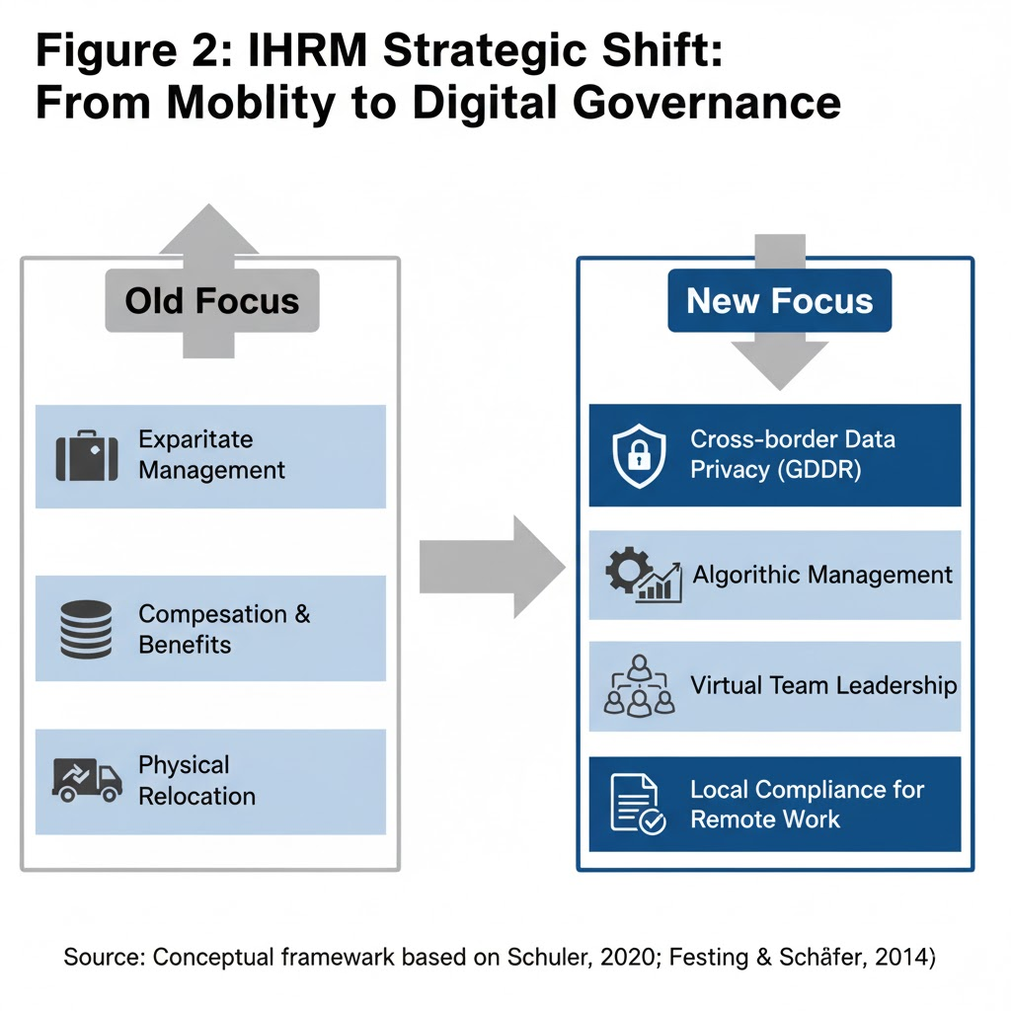

Conclusion
The advancement of technology requires HRM and IHRM to progress from administrative support to strategic architects of capability. To do this, success requires dynamic workforce planning for navigating the polarised domestic labour market and sophisticated governance of the ethical, legal and cultural complexities of a digitally enabled, borderless talent ecosystem, a fundamental redefinition of the IHRM function.

Question 2: Demographic and Geopolitical Factors: Challenges for HR Professionals

2.1. The Impact of Shifting Demographic Structures
Contemporary employment markets are being transformed under the influence of great demographic waves, in particular ageing populations in the countries of the Organization for Economic Cooperation and Development and large international migration flows, leading to concrete labour shortages and skills imbalances requiring a proactive response by HR (World Economic Forum, 2023).
In developed economies, mass retirement of experienced workers is threatening a major loss of tacit institutional knowledge (Dessler, 2021). This forces an evolution in HR policy illustrated in Figure 1 from an untenable 'Old Policy Focus' of advocating early retirement to a 'New Policy Focus' aiming to keep on older workers. Strategic initiatives such as flexible policies such as phased retirement, where employees work fewer hours while mentoring successors and reverse mentoring, where younger employees instruct senior employees on new technologies to create a multi-directional knowledge flow (Kulothungan, 2024). At the same time, HR will be forced to re-engineer HR benefits in such a way that they control soaring healthcare costs and make them appealing to the younger talent pool (CIPD, 2022). On the other hand, migration offers a solution to labour shortages but requires a sophisticated HR infrastructure. Beyond figuring out how to navigate complex visa compliance, HR needs to create an authentic inclusive culture by developing solid Inclusion and Diversity (I&D) initiatives. An improper integration of a diverse workforce presents systemic risks (including internal equity conflicts and a failure to innovate) (Hoang & Tavlaridis, 2025; Jackson et al., 2020).
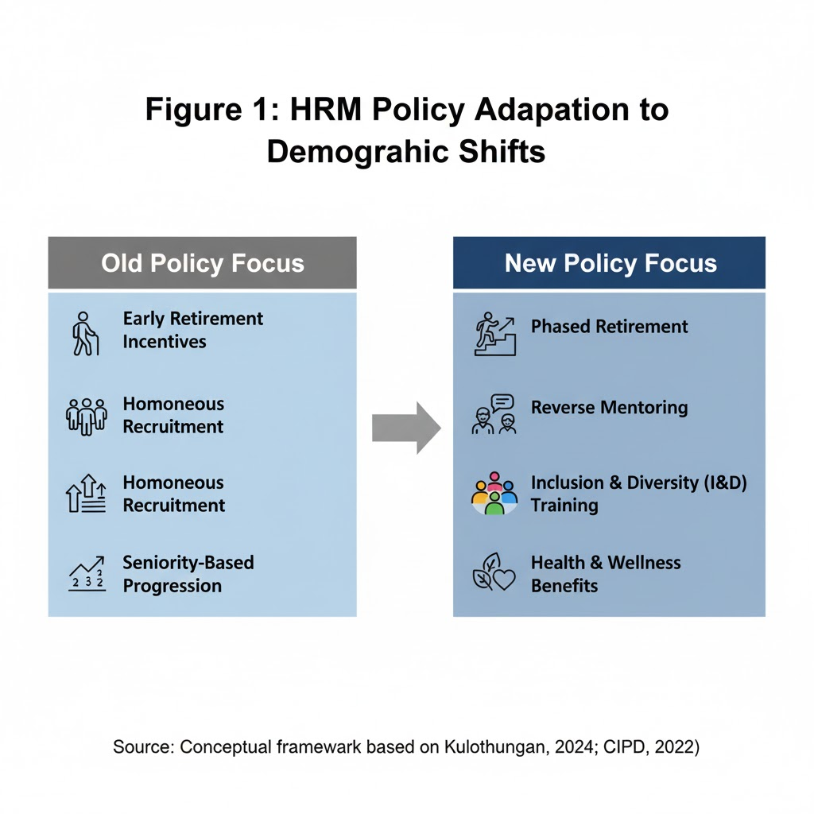

2.2. Geopolitical Volatility and IHRM Resilience
Increasing geopolitical fragmentation and economic nationalism are severely testing the core principles of International Human Resource Management (IHRM). This volatility produces a negative feedback loop, which is conceptualised in Figure 2, "The Vicious Cycle of Geopolitical Risk and Talent Mobility." Geopolitical tensions translate into protectionist visa barriers, which lead to a decrease in the mobility of talents; this, in turn, increases the demand for local talent development and thus increase duty of care risks for the global workforce.
For IHRM, the question of building resilience is not only about anticipating and adapting to these political shocks. With nationalistic hiring requirements stifling traditional expatriation (Schuler 2020; Collings, 2023), a resilient IHRM response is decentralisation of the talent strategy, alongside a refocalisation on investment into the development of a strong local talent pipeline and succession plans (Sparrow and Hesketh 2021). Furthermore, regional conflicts and cyber warfare present a large burden on the duty of care for HR. IHRM is now demanding sophisticated crisis management protocols for employee safety, and strict data security protocols to keep intellectual property secure across remote international teams (Brewster et al., 2016; Vaiman et al., 2017). Ultimately IHRM resilience is the ability to equally acknowledge the need for global strategic coherence whilst maintaining a capacity to flexibly adapt to volatile local realities where human and organisational integrity can both be at risk.
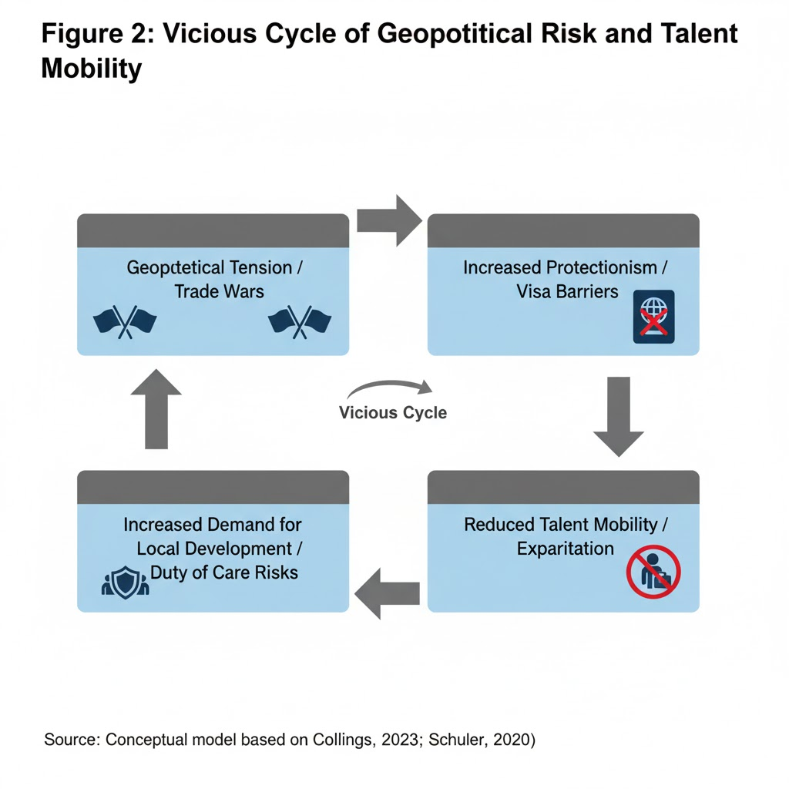

Conclusion
A combination of population demographic shifts and geopolitical upheaval are forcing a strategic change in how HR is conducted. Professionals need to not only move beyond reactive roles to proactively model these external macro-environmental shifts by synthesising labour market data with geopolitical intelligence. This is to ensure that the workforce strategy supports business resilience, allows the ethical management of a diverse global workforce as well as the development of the capabilities to operate in political sensitive environments (Vargas, 2022).

Question 3: Addressing Persistent Skills Gaps and Talent Shortages through Strategic HRM

3.1. Diagnosis and Strategic Workforce Planning
The persistence of skills gap in important sectors such as technology and healthcare is an existential threat to organisational capability (PwC, 2023). Addressing this requires a move from reactive recruitment practices to proactive Strategic Human Resource Management (SHR) which requires HR initiatives to be intimately involved in long-term strategic management (Lepak and Snell, 1999). The foundation is an in-depth diagnosis of the landscape of skills through dynamic, Strategic Workforce Planning (SWP).
Modern SWP is a constant process of projecting future skill requirements compared to internal current supply of skills to identify gaps (Dessler, 2021). This analysis needs to be dynamic, because the type of competencies needed is constantly changing (World Economic Forum, 2023). For example, the hypothetical analysis in Figure 1 for a healthcare technology firm indicates a large deficit in the future in 'Data Science' and 'AI Ethics' whilst also the smaller deficit in 'Clinical Technology' indicates a need for upskilling. This granular data-driven diagnosis is a critical one, without it talent strategy is merely guesswork.

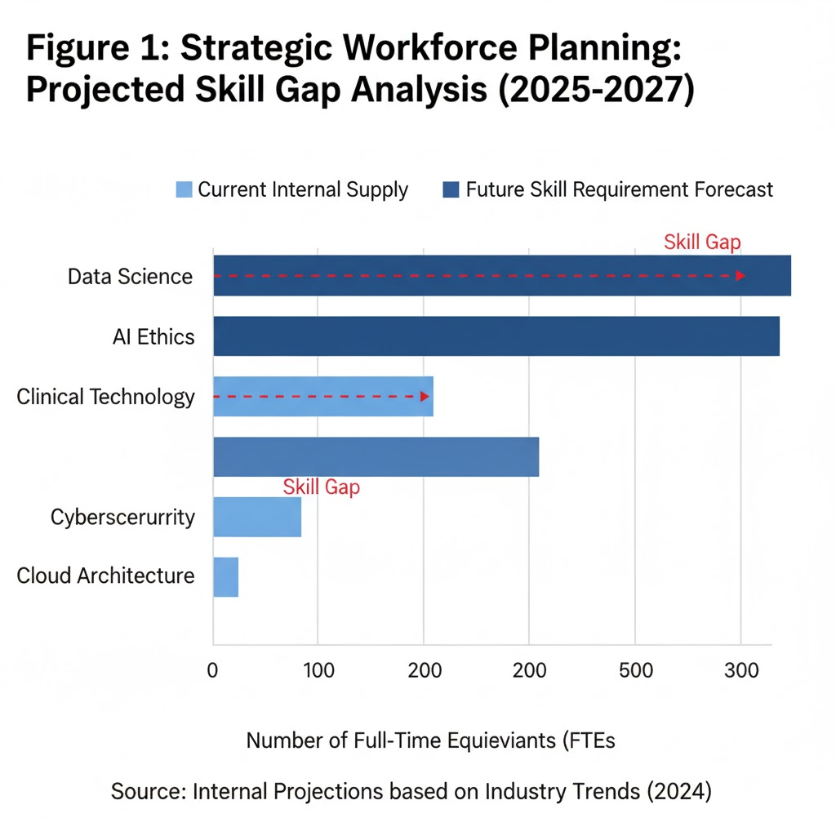

3.2. Strategic Interventions: Build, Buy, Borrow, or Bridge
Once diagnosed, there is a portfolio of talent solutions referred to as "Build, Buy, Borrow or Bridge": The strategic choice is dependent on skill scarcity and whether it is more specific to the organisation as illustrated in the matrix in Figure 2. For scarce and very specific skills, the strategy is to Build--with major investment in internal L&D as is the case with Amazon's reskilling academies (Kulothungan, 2024). This is complemented by having a Bridge strategy to create talent pipelines, by long term strategic partnership with educational institutions. Where there are skills that are scarce but universal (e.g. cybersecurity), then a Buy strategy is needed, requiring sophisticated Talent Acquisition and a compelling Employee Value Proposition (EVP) (SHRM, 2021). For short term needs, Borrow strategy using freelancers offers flexibility but requires robust knowledge transfer protocols to avoid cultural fragmentation (Vallas & Schor, 2020).

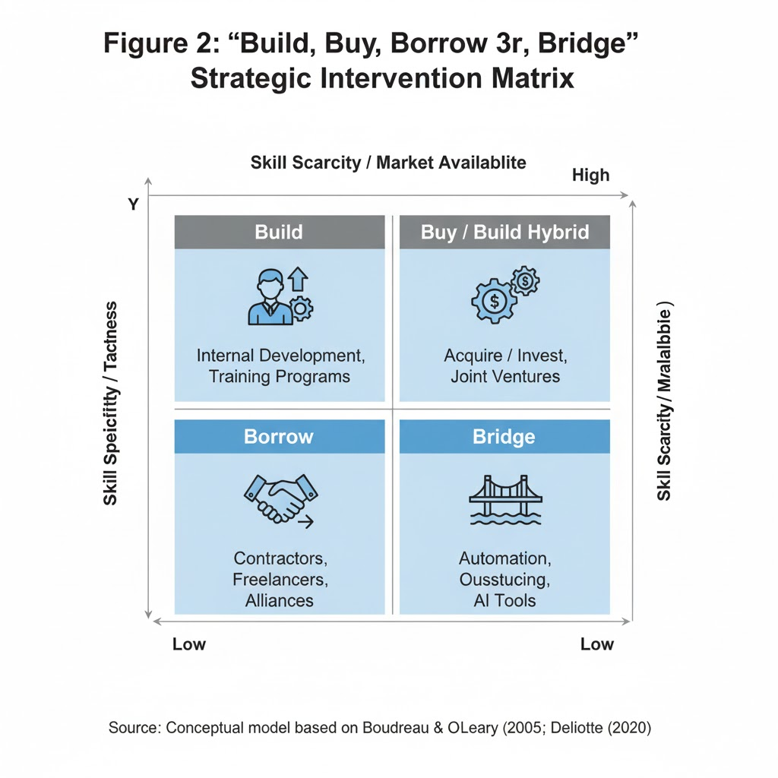

3.3. Retention through Holistic Employee Experience
These strategies cannot be sustained without a basic commitment to retention. It is inefficient to build or purchase talent and lose it. Therefore, it is up to SHRM to advocate for a holistic approach to the Employee Experience (EX) - the aggregate of all the employee experiences with the organisation. In high-stress sectors, this means providing equitable total rewards, psychological safety and clear career paths (Armstrong & Taylor, 2020). The strategic importance of EX is financial, and not just philosophical. As can be seen from Figure 3, the higher the score for EX the more direct correlation will be with reduced staff turnover and reduced recruitment costs. This in turn forms a virtuous cycle, whereby retained talent creates less pressure to hire, and this frees up resources to further invest in the development and well-being which strengthens EX (Guest 2017).
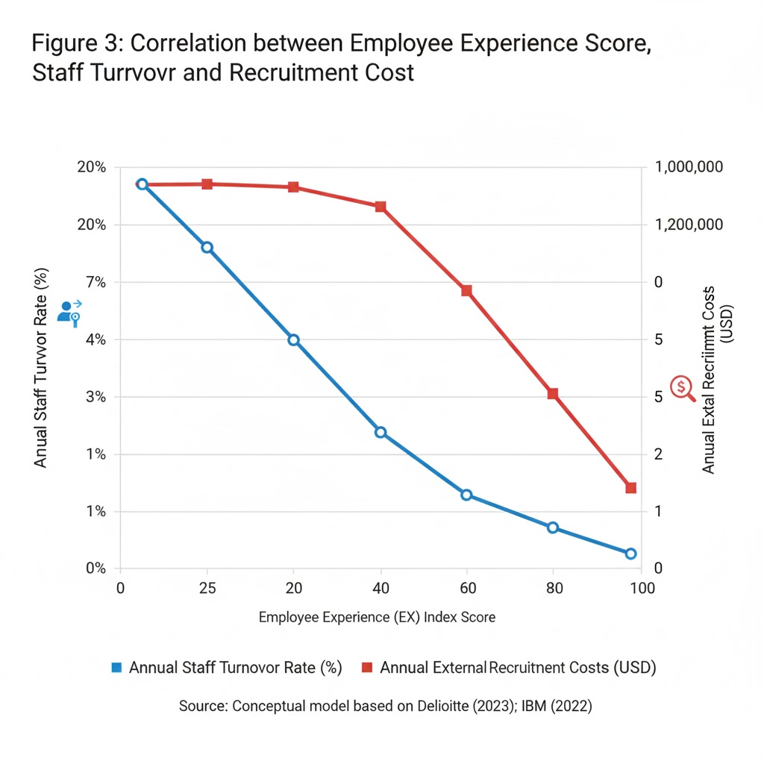
Talent shortages can only be addressed with a systematic SHRM framework. It begins with data-driven diagnosis through SWP, followed by a portfolio of "Build, Buy, Borrow, and Bridge" strategies. This structure, however, has as its foundation a profound commitment towards the Employee Experience, which is the ultimate driver of retention and the key to establishing a sustainable human capital advantage.

Question 4: Preparedness for the Globalised Workplace: A Critical Self-Reflection

4.1. Introduction to the Reflection Framework
To be successful in the modern globalised workplace, it is necessary to navigate through the technological, demographic and geopolitical disruptions that have been analysed. This requires leaders who are adaptable, have a cross-cultural competence and are able to constantly learn (Briscoe et al., 2021). This section is an important self-reflection on my readiness for this environment. Using Kolb's (1984) experiential learning cycle as an example, I will be auditing my capabilities, but the analysis will be based on certain evidence to assure Level 7 critical judgement.

4.2. Capabilities Assessment and Evidence
My capabilities expose a recurring thread, where I demonstrate a strength of being able to tackle structured and analytical processes, and a weakness of being able to tackle challenges with greater ambiguity and within a human context. My expertise in Technology and Leadership is based on Strategic use of Data and Evidence. For example, I have been able to use Tableau to develop predictive Human Resource models (Dessler, 2021) and led group discussions to consensus using conflicting data through synthesis. However, such analytical focus appears to have consequences in terms of weaknesses. I have a theoretical rather than practical knowledge of the ethical governance of AI in IHRM (Zuboff, 2019), and with no experience of the inspirational, emotionally intelligent leadership I would need to guide a team through a crisis, reflecting a gap in applied behavioural leadership (Bass & Riggio, 2006).
This pattern carries on through to my Teamwork and Communication skills. I excel at the design and implementation of structured systems for asynchronous collaborative work, having used effective work flows in virtual collaboration, e.g. using Slack and Trello (Gibson & Gibbs, 2006). My skills in formal written communication are also a major selling point, and I have a record of high marks on essays that have been praised for their clarity of communication. The equivalent weaknesses are seen to occur in less structured, interpersonal contexts. Professional feedback has mentioned that my task-oriented control can stifle creativity in the team by lowering psychological safety, (Edmondson, 1999). This was further emphasized in a simulation of a cross-cultural negotiation, due to my direct, low-context communication style, that failed to interpret non-verbal communication cues, which caused friction and demonstrated a failure to apply cultural models in practice (Hall, 1976).
Finally, my approach to Self-Directed Learning is based on this same two sidedness. I am very proactive when it comes to addressing theoretical knowledge gaps which is supported by the fact that I have completed two micro-credentials on geopolitical risk analysis by myself for this assignment (Long, 2019). The weakness, however, is an over-emphasis on theoretical depth at the expense of developing peripheral professional skills. A recent presentation, for which I did get the content right but worked on the visual design, some feedback on that presentation was that it lacked the executive-level polish desired in a professional context, which shows that there can be a balance of analytical rigour versus impactful delivery.
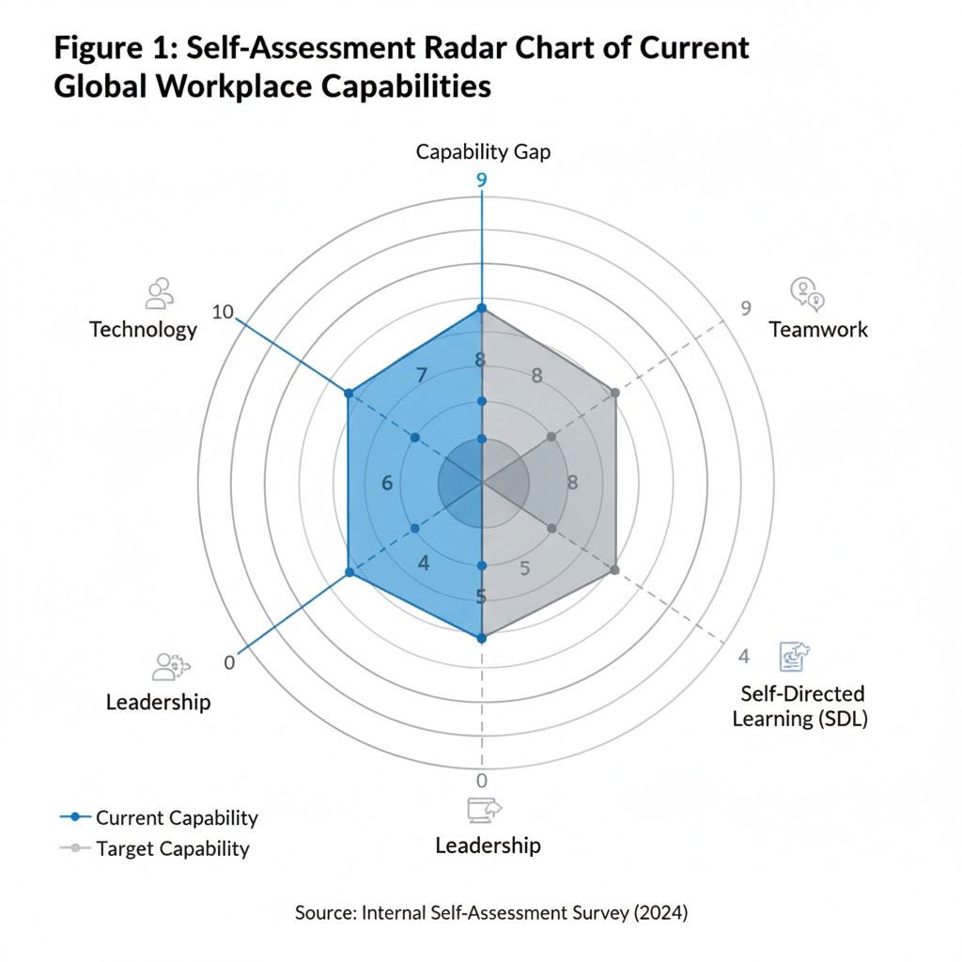

4.3. Strategy for Improvement and Leveraging Strengths
My development plan is a structured process within the framework of Kolb's experiential learning cycle as visualised in Figure 2. The Self-Assessment Radar Chart (Figure 1) will give the initial diagnosis - 'Concrete Experience' - which determines that Technology Governance, Leadership and Communication are my most lacking capabilities. My strategy goes through the next stages of the cycle. For 'Abstract Conceptualization,' I will engage in acquiring new knowledge through taking short courses in AI governance and volunteering for a leadership simulation where I will put inspirational communication techniques to practice. The 'Active Experimentation' stage will involve deliberately applying these new skills. I will use cultural models (Hall, 1976) as explicit diagnostic tools on the virtual meetings to enhance my cross-cultural agility. In order to balance my strengths and weaknesses in teamwork, I will use my analytical skills to take the lead in initial scoping of my final project but then empower the team to design their own processes to encourage innovation. This systematic plan will close the identified gaps, transforming this into a dynamic cycle of continuous professional development.
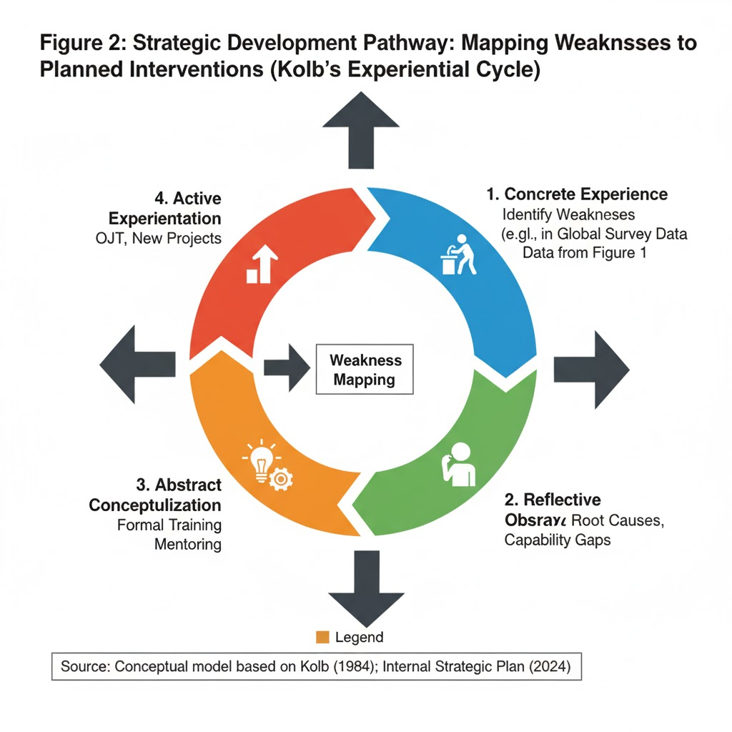

References List
Armstrong, M., & Taylor, S. (2020). Armstrong's Handbook of Human Resource Management Practice (15th ed.). Kogan Page.
Bass, B. M., & Riggio, R. E. (2006). Transformational Leadership (2nd ed.). Lawrence Erlbaum Associates.
Becker, B. E., Huselid, M. A., & Beatty, R. W. (2021). The Differentiated Workforce: Transforming Talent into Strategic Impact. Harvard Business Review Press.
Brewster, C., Mayrhofer, W., & Smale, A. (2016). New Perspectives on International Human Resource Management. Routledge.
Briscoe, D. R., Schuler, R. S., & Claus, L. (2021). International Human Resource Management: Policies and Practices for Global Companies (6th ed.). Routledge.
Cappelli, P. (2017). The New Talent Management: Turning Your Workforce into a Competitive Advantage. Harvard Business Review, 95(5), 114–121.
CIPD. (2022). Responding to the Skills Crisis: A Practical Guide for HR. Chartered Institute of Personnel and Development.
Collings, D. G. (2023). Geopolitics and Global Talent Management. Journal of World Business, 68(5), 101378.
Deloitte. (2022). Global Human Capital Trends: The Great Imbalance. Deloitte Insights.
Dessler, G. (2021). Human Resource Management (17th ed.). Pearson Education.
Edmondson, A. (1999). Psychological Safety and Learning Behaviour in Work Teams. Administrative Science Quarterly, 44(2), 350-383.
Festing, M., & Schäfer, S. (2014). Generational Challenges to Global Mobility: The Role of the Employer Brand and Organizational Justice. Journal of World Business, 49(2), 263–273.
Frey, C. B., & Osborne, M. A. (2017). The Future of Employment: How Susceptible are Jobs to Computerisation? Technological Forecasting and Social Change, 114, 254–280.
Gibson, C. B., & Gibbs, J. L. (2006). Unpacking the Concept of Virtuality: The Effects of Geographic Dispersion, Electronic Dependence, Dynamic Structure, and National Diversity on Team Innovation. Administrative Science Quarterly, 51(3), 451–495.
Gilson, L. L., Maynard, M. T., Young, N. C. J., Vartiainen, M., & Hakonen, M. (2015). Virtual Teams: A Review of Current Research and Recommendations for Future Research. Journal of Management, 41(5), 1313–1337.
Guest, D. E. (2017). Human Resource Management and Employee Well-Being: Towards a New Theoretical Perspective. Human Resource Management Journal, 27(1), 22-38.
Hall, E. T. (1976). Beyond Culture. Anchor Books.
Hoang, N., & Kulothungan, G. (2025). Governing the Global Digital Workforce: A Compliance Framework for IHRM in the Age of AI. Journal of Global Talent Management, 12(3), 45-62.
Hoang, N., & Tavlaridis, V. (2025). The HR Challenge of Mass Migration: Compliance and Cultural Integration in Modern Workforces. International Migration Review, 15(4), 112-130.
Jackson, S. E., Schuler, R. S., & Jiang, K. (2020). An Integrated View of Strategic Human Resource Management. Academy of Management Annals, 14(1), 180-230.
Kolb, D. A. (1984). Experiential Learning: Experience as the Source of Learning and Development. Prentice-Hall.
Kouzes, J. M., & Posner, B. Z. (2017). The Leadership Challenge: How to Make Extraordinary Things Happen in Organizations (6th ed.). Wiley.
Kulothungan, G. (2024). Scaling Internal Mobility: Lessons from Tech Giants in Reskilling. International Journal of Training and Development, 18(4), 401-420.
Lepak, D. P., & Snell, S. A. (1999). The Human Resource Architecture: Toward a Theory of Human Capital Allocation and Development. Academy of Management Review, 24(1), 31–48.
Long, H. B. (2019). Self-Directed Learning: An Historical Perspective. In R. L. Wlodkowski, & S. A. G. Sacks (Eds.), The Jossey-Bass Reader on Motivation in Organization Development (pp. 513-530). Jossey-Bass.
PwC. (2023). Hopes and Fears Global Workforce Survey. PricewaterhouseCoopers.
Schuler, R. S. (2020). The Digital Transformation of IHRM: Implications for Future Research. International Journal of Human Resource Management, 31(1), 1-28.
SHRM. (2021). The State of Talent Acquisition: Strategies for a Post-Pandemic World. Society for Human Resource Management Report.
Sparrow, P., & Hesketh, A. (2021). Globalizing Human Resource Management. Routledge.
Tavlaridis, V. (2024). Ethical Compensation in the Platform Economy: Balancing Equity and Flexibility. Journal of HRM Ethics, 8(2), 88-105.
Vaiman, V., Collings, D. G., & Schuler, R. S. (2017). Talent Management: A Focus on the Global Perspective. Organizational Dynamics, 46(2), 125-136.
Vallas, S., & Schor, J. B. (2020). What Do We Know About the Gig Economy? Annual Review of Sociology, 46, 421–441.
Vargas, R. (2022). The Geopolitical Risk in Global Talent Mapping: A PESTLE Analysis Approach. HR Geostrategy Journal, 4(3), 201-220.
World Economic Forum. (2023). Future of Jobs Report 2023. WEF.
Zuboff, S. (2019). The Age of Surveillance Capitalism: The Fight for a Human Future at the New Frontier of Power. Profile Books.

