Angur Ali (1805335)
1805335@student.uwtsd.ac.uk
UWTSD
Published on 5th April 2019
Report on communication within the workplace
BMSK4002 Effective Team-working and Communication

Executive Summary

This report is to explain why communication skills are required to achieve effective teamwork. This report will explain how effective and methods of communications will help the toy store to use.

The report will discuss the communication issues the Michelle Sullivan’s toy store is having and what impact its doing to the store. A number of communication models such as Shannon- Weaver, Berlo, Tuckman and Belbin theories will be used to explain the toy store communication and teamwork issues.

The report concludes that the toy store need to require to work as a team with better communication understanding among others, as a team to be successful. It also contains the recommendation for the owner of the toy store.
Table of Contents

Executive Summary 1
1.0 Introduction 3
2.0 Procedure 4
3.0 Findings 5
3.1 Effective Communication 5
3.2 Verbal and Non-Verbal 5
3.3 Importance of Two-Way Communication 5
3.3.1 Shannon – Weaver Model of Communication 5
3.3.2 Berlo’s (SMCR) Model of Communication 7
3.4 Effective Methods of Communication 9
3.5 Application of Teamwork Theories 9
3.5.1 Tuckman’s Theory of Team Work 9
3.5.2 Belbin Team Roles 10
4.0 Conclusion 12
5.0 Recommendations 13
6.0 Reference Lists 14

Introduction

Michelle Sullivan started a toy shop in Swansea about a year ago employing 5 people. Now the business has expanded due to rapid growth to a medium size toy store employing 27 people. The business has 3 managers, 14 sale assistants, 6 stockroom staffs, 2 security guards and 2 cleaners. Most working part-time basis around 8am to 10pm and some working night shifts. Due to this rapid expansion Michelle decided to make the business follow a formal processes and run smoothly by asking business consultant, to advise how to create a team structures that can facilitate and enable effective channels of communication in a workplace. Also preventing small issues becoming big problems in the workplace.

2.0 Procedure

For this report books, websites and journals has been used.

3.0 Findings

3.1 Effective Communication

Effective communication is important part of organisation that allows productivity and operate effectively. Having ineffective communications has a problem among employees and others that are part of the workplace. Probably there can been no responsibility or organisational structure in place that will affect the profits and build-up of the business. (A, Gutierez, 2014). There are three keys to effective communication in workplace active listening, preparing your message and getting it through. (D, Sebastian, 2004). Listening what someone is saying then preparing what you need to say and then delivering your point of view.

3.2 Verbal and Non-Verbal

Verbal communication is important in a workplace as this allows to communicate among each other through spoken, written and signed. With help of powerful words can get information through better that require action to be taken and needed to be done. (A, Lucas, 2018).
Non-Verbal communication is also important in workplace to allow to understand the body movements which comes long with speech and adds meaning to interaction. There are components which relates to nonverbal communication like Facial expression, eye contact, posture, orientation, proximity, fine movement, gross movement and clothing and artefacts. (N, Thompson, 2011).

3.3 Importance of Two-Way Communication

Two way communication is a way of sending and receiving of ideas among each others. (mHub, 2018). There are model of communications that can be follow below:

3.3.1 Shannon – Weaver Model of Communication

This Model was invented by Shannon, who was an American mathematician and Weaver, who was an American scientist, in 1948 called Shannon-Weaver’s model of communication. This was introduced for effective communication between sender and receiver. The communication model was first introduced to make the technical communication better, and then it was activated broadly in all area of communication.


The sender is the person who creates the message, chooses the channel and sends the message. Encoder is the sender who converts the message into signals or binary data, which then transform the message, so it could be passed through transmitted signal. Decoder is the reverse of encoder that coverts signals or binary data back into message that came through. The receiver then can receive the message that the sender sent, this is the final destination of the process. When the receiver gets the message normally they give feedback to the sender. During the process of decoding, the message could be distracted by surrounding noises which could then cause the receiver getting the wrong message and this can lead to misunderstanding the communication progress between the sender and receiver (Communication Theory, 2010).

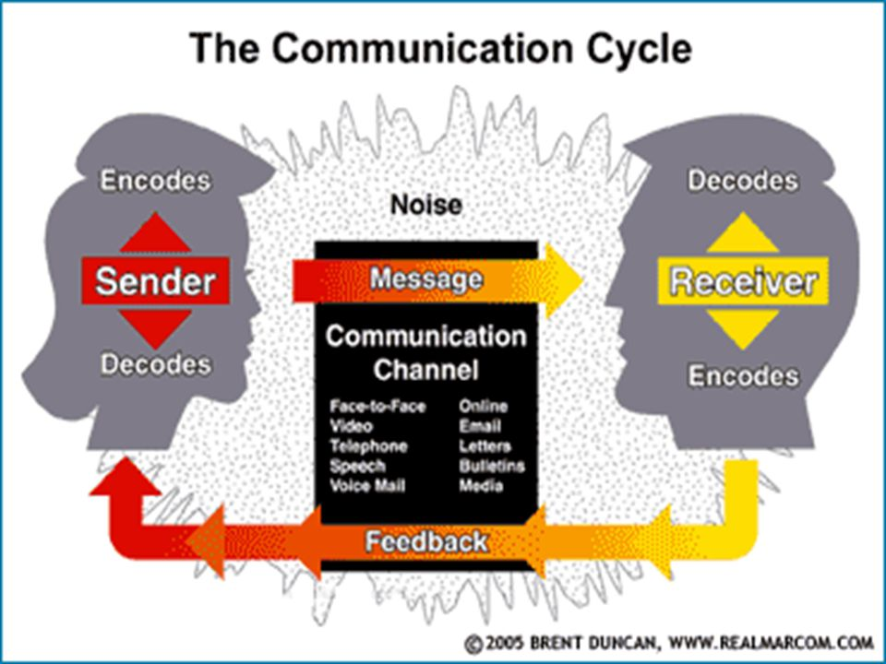
This above communication cycle is the Shannon-Weaver’s model showing the communication channels the sender could conduct messages through such as face to face, video, telephone, speech, voicemail, online, email, letters, bulletins and media. Every step in the communication cycle model is important, and it’s very difficult to miss a step. By paying attention to every component, both the sender and recipient are able to communicate effectively, understand each other better and react to each other more emphatically. (P. Mulder, 2018).

3.3.2 Berlo’s (SMCR) Model of Communication

David Berlo expanded this linear communication in 1960 after Shannon and Weaver model of communication was to improve technical communication. He created Sender-Message-Channel-Receiver (SMCR) model of communication in 1960.
This model is base around the encoding and decoding before sender send the message and before the receiver receives the message separately.

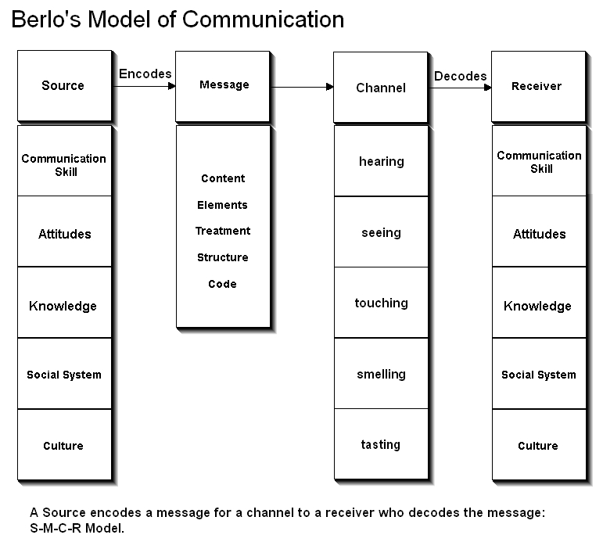
The conditions which are identifies with sender and is also the same of the receiver which are communication skills, attitude, knowledge, social systems and culture. The important conditions which will have impact on the messages are content, elements, treatment, structure and code. In normal communication, the five senses of a person are the channel. Hearing, seeing, touching, smelling and tasting. The five senses which are required for the communication to progress is it has influence of viability to the channel. The receiver is the person who receives and subsequently decodes the coded message. In a linear communication process, the receiver is always located at the end. In order to make communication as effective and smooth as possible, Berlo’s SMCR Model of Communication assumes the receiver’s thinking pattern must be in accordance with that of the sender. The same factors therefore influence this component in Berlo’s SMCR Model of Communication. (B. Janse, 2019).

3.4 Effective Methods of Communication

The communication used in this toy store is one way, which has no feedback. This is due to the owner has employed staff only communicating face to face using verbal speech telling what work needs to be done and left it as this. There is no clear understanding if staff understood the information. Now the store has expanded the system still working one way, staffs choosing their own shift with no proper communication in place. Therefore, the owner will need the staffs to understand that they got the message clear. It is required for owner to use the Shannon-Weaver’s model to receive a feedback from all staff, so that this could comprehend what the staffs have understood.
The toy store has no written communication in place that they can communicate with the members. The company should consider using the written communication such as email or write letters, this will allow to pass on important information such as work, shift and any other changes in work. Written communication is broadly utilised and admired methods for conveying from a number of years ago.

3.5 Application of Teamwork Theories

3.5.1 Tuckman’s Theory of Team Work
Bruce Tuckman who was psychologist, in 1965 he identified four stages of development – forming, storming, norming, performing and later in 1977 he added a fifth stage adjourning. (Mindtools, 2019). This model is one of the highly recognised team development theory, and it has developed many additional ideas since its origination. Tuckman’s theory targets the process how a group handles the responsibility from the basic development of the group to the end of the activity (Teambuilding, 2018). Individuals don’t need to go through the stages in the right order, if a new individual is added to the group then that individual goes back to the beginning of the stage. The image below explains the stages a group goes through. Heathfield (2018).
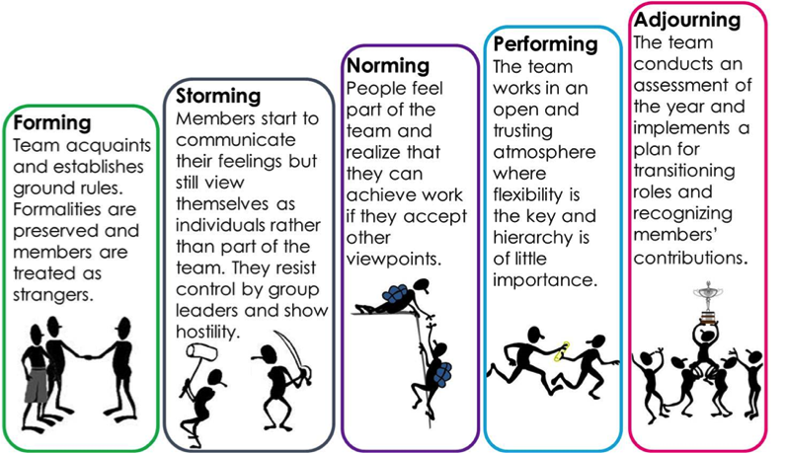

The toy store will need to delegate a person from working group, so they can represent each other, otherwise problems will be created when forming a team. Normally the one with confident knowledge will stand out from the group, this will allow to choose the leader among the team. “Building a team takes time and effort. Communication between members is very important when developing a team”. (Jamaledine, 2018). Forming stage the team leader play a dominant role at this stage to help members to establish clear goals and objective for the whole team. Storming stage, the team leader will need to step in to reduce tension and remain positive. Also ensure to support each team members and that they support each other and building trust is crucial part at this stage. Norming stage, the team leader will step back and allow their team to take responsibility towards the goal. Also providing feedback for both positive and negative of the team. Performing stage, the team leader will offer rewards to the members individually and also to the team for their striving performance. Adjourning stage the team leader can now allow for celebrations or farewell party, give recognitions and rewards to members for their contributions.

3.5.2 Belbin Team Roles
Raymond Meredith Belbin, a researcher and theorist, came up with development of Belbin team roles with nine clusters of individual behaviours participating in a team. (Belbin, 2019). Below is a brief summary of each of the nine team roles:

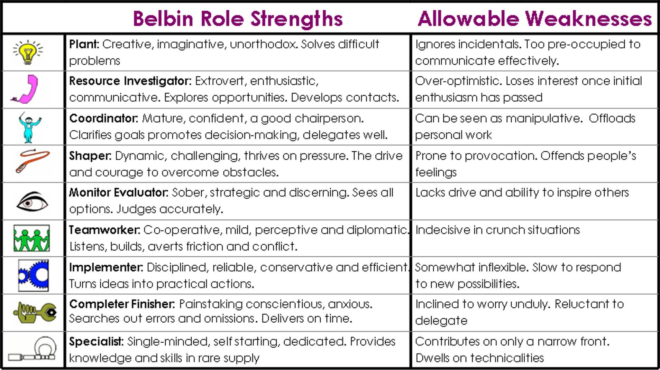

There are nine roles but in a team it doesn’t need nine people to take a role, rather in a small team can take up 1 or more roles of their comfort and change around when they need to.

4.0 Conclusion

When the toy store was a smaller shop communication was simpler with staff using face to face and verbal speech with more understanding between each other. The expansion of the toy store have cause a problems, with more staff got employed there were no formal communication in place. The toy store did not use any kind of like the Shannon-Weaver or Berlo’s models. The store also didn’t have any team created in the workplace to communicate between the workers and the managers.

5.0 Recommendations

It is recommended the toy store should use the Shannon-Weaver’s model to receive feedback from the staffs. Also, the toy store should start using the Tuckman and Belbin theories as this will help to create a team leader, which can lead to having better communication between managers and the workers. It is required to improve management communication methods by arranging regular meetings with all employees to inform the progress of the toy store and future plans. To develop the management team, it is required to employ qualified staff or train staff to the high standard, so they could work with the new employees in the team as a leader. It is required to engage employees in the company progress and they should have the right to say their concerns.

6.0 Reference Lists

Amy Lucas, 28th Nov, 2018. The Importance of Verbal & Non-Verbal Communication. [Online] available at: https://www.livestrong.com/article/156961-the-importance-of-verbal-non-verbal-communication/ (accessed on 4/4/2019).
Anthony Gutierez (2014), Effective Communication in the Workplace: Learn How to Communicate Effectively and Avoid Common Barriers to Effective Communication. Createspace Independent Publishing Platform, United States.
Belbin, (2019). The Nine Belbin Team Roles. [online] available at: https://www.belbin.com/about/belbin-team-roles/ (accessed: 4/4/2019).
Ben Janse (2019). Berlo’s SMCR Model of Communication. [Online] available at: https://www.toolshero.com/communication-skills/berlos-smcr-model-of-communication/ (accessed: 5/4/2019).
Communication Theory, (2010). Shannon and Weaver Model of Communication. [online] available at: https://www.communicationtheory.org/shannon-and-weaver-model-of-communication/ (accessed: 4/4/2019).
Don Sebastian. Effective Communication in the Workplace. Executive Housekeeping Today. Dec 2004, Vol.25, Issue 12, p16-17.
Heathfield, S. (2018). The 5 Stages of Team Development: How You Can Support Team Development. [Online] Available at: https://www.thebalance.com/what-are-the-stages-of-team-development-1919224. (Accessed: 4/4/2019).
mHub,(2018). [Online] available at: http://www.mhub.tv/importance-two-way-communication/ (Accessed on 4/4/2019).
MindTools (2019). Belbin’s Team Roles. [Online] available at: https://www.mindtools.com/pages/article/newLDR_83.htm. (Accessed on 4/4/2019).
Neil Thompson, Effective Communication, A Guide for the People Professions 2ed. Palgrave Macmillan. Hampshire. (2011).
Patty Mulder, (2018). Toolshero. Communication Cycle model by Shannon and Weaver [online] available at: https://www.toolshero.com/communication-skills/communication-cycle-shannon-weaver/ (Accessed: 4/4/2019).
Raneen Jamaledine. 2018. Teamwork – Step by Step Guide for Effective Team Building. [ONLINE] Available at: https://www.potential.com/articles/teamwork/. [Accessed: 4/4/2019].
R. Meredith Belbin, (2010). Team Roles at Work, 2 ed. Butterworth-Heinemann. UK.
Teambuilding, (2019). Tuckman; Forming - Storming - Norming - Performing. [Online] Available at: https://www.teambuilding.co.uk/theory/Forming-Storming-Norming-Performing.html (Accessed: 4/4/2019).

