University of Wales Trinity Saint David

School of Engineering

Title of Coursework

Assignment 2

Module name and code

Materials and Introduction to Manufacturing Technology

M4X01163

Hussain Khan

1701219

Date

30/04/2020

Contents
1 Figure list 1
2 Introduction 2
3 Literature Review 3
4 Methodology 4
5 Discussion 5
5.1 Manufacturing Method 1: 3D Printing 5
5.1.1 How does 3D Printing work 5
5.1.2 Science behind 3D Printing 5
5.1.3 Benefits of using a 3D printer 6
5.1.4 Problems using a 3D printer 7
5.1.5 What materials will work with 3D- Printing? 7
5.1.6 What materials will not work using a 3D printer? 9
5.2 Manufacturing Method 2: Electron Beam Machine 10
5.2.1 How does Electron Beam Machine Work 10
5.2.2 Science behind Electron Beam Machine 11
5.2.3 Benefit of using Electron Beam Machine 11
5.2.4 Problems Using an Electron Beam Machine 11
5.2.5 What materials will work with the Electron Beam Machine? 12
5.3 Self-Healing Materials 13
5.3.1 Description of Self-Healing and how Self-Healing material work 13
5.4 The Structure of Polymer 14
5.4.1 The Structure of Polymer 14
5.4.2 What is Polymer used for? 14
5.4.3 Why do Polymer’s properties make it good for the purpose of a Self-Healing Material? 14
5.4.4 Are there any difficulties associated with using Polymer? 15
5.5 3D Printing 16
6 Conclusion 17
7 References 18
7.1 Figure Reference 18
7.2 Reference 19

Figure list
Figure 1: FDM and SLS Process…………………………………………………………………………………………………………………………………Page 5
Figure 2: ABS Material Fidget Spinner …………………………………………………………………………………………………………………….Page 8
Figure 3: PLA Material .…………………………………………………………………………………………………………………………………………..Page 8
Figure 4: Electron Beam Machine Welding……………………..……………………………………………………………………………………..Page 10
Figure 5: Self-Healing Material ………………………………………………………………………………………………………………………………Page 13

Introduction

The aims of this report are to demonstrate a level of knowledge with several newer manufacturing methods and an understanding of the structure and properties of a new manufacturing material. Whilst undertaking this task, the aim will be to examine the application, advantages and limitations of the manufacturing processes and to determine the basis for the selection of an engineering material and explain the manufacturing process for which the material is employed in. An example of the typical costs of setting up 3D printing will be included at the end of this report.

Literature Review
This report has utilised several literary sources, mainly derived from academic online sources. This brief literature review will consider examples of the sources used. Ben Redwood’s (2020) online article on the Advantages of 3D Printing was informative and easily accessible as a guide to this manufacturing process. Sachin Thorat’s (2020) article on Electron Beam Machining (EBM) was useful when examining the advantages and disadvantages of this manufacturing method. The online journal article on An Investigation on Manufacturing of Self-healing Materials by Rajesh Purohit et al (2015) was highly informative as a research source.

Methodology
The two new manufacturing processes featured in this report will be 3D Printing and Electron Beam Machining (EBM), whilst the new material featured in this report will be Self-Healing Materials, with specific emphasis on the use of Polymers. With reference to academic sources and literature, each featured manufacturing process (Sections 5.1 and 5.2) will be examined in terms of how the process works, what the science is for the process, the benefits and limitations of the process and what materials are, or are not, suitable for the process. Following this section, an exploration of the new manufacturing material of Self-Healing Materials, will be undertaken (Section 5.3). This will include a description of Self-Healing Materials and how they work. An examination of a specific Self-Healing Material: Polymer, will then follow. A description of the structure of Polymer and what Polymer is used for, will be covered, followed by an exploration of why Polymer is a good Self-Healing Material. There will be a look into whether there are any problems with using Polymer as a Self-Healing Material. Finally, there an example of the typical costs of setting up 3D printing will be included at the end of this report (Section 5.5).

Discussion

Manufacturing Method 1: 3D Printing

How does 3D Printing work

3D Printing works on the principle of laying down successive layers of material, such as polymer, to form a 3D scaffold. There are many different types of 3D Printing methods which include: Fused Deposition Modelling (FDM), Inkjet Printing, Selective Laser Sintering, Colour Jet Printing and Stereo Lithography (Ramakrishna, 2019). An illustration of the process of 3D Printing using FDM and SLS can be seen below in Figure 1.
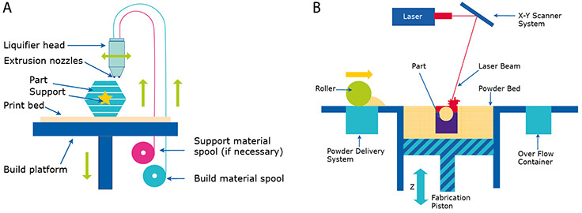
Figure 1: Figure A shows the FDM and Figure B shows SLS Process (Zhenyu and Choi, 2010).

Science behind 3D Printing
The Science behind 3D printing is that it requires the use of a computer aided design, known as CAD, or a 3D object scanner. The 3D printing manufacturing process allows for the creation of an object that produces a geometric shape which is built up, layer by layer. This manufacturing process contrasts with traditional manufacturing methods, which typically require machining or other techniques to allow for the removal of surplus material (TWI, 2020).

Benefits of using a 3D printer

The benefits of 3D printing are that this manufacturing method can produce around 30% less material waste and it requires the use of less energy and resources. 3D printing can also enable in-situ production, which can cut the transport cost of the materials (Ghaffar, 2018). The other benefits of 3D printing are that it enables increased architectural freedom and the process generates fewer CO2 emissions throughout the entire lifecycle of the product (Ghaffar, 2018).
The industrial production name given to 3D printing is additive manufacturing. To further emphasise the benefits of additive manufacturing, it is safe to say that the speed of the manufacturing process is one of the main advantages. For example, complex 3D designs from a CAD model can be uploaded to a 3D Printer which can then take only a few hours to print (Redwood, 2020).
Another advantage of using 3D printing is that the machine operation costs are low, as 3D Printers consume around the same amount of power than a laptop computer would generally require. This is in comparison with other industrial additive manufacturing technologies which typically consume a higher amount of energy to produce a single part. The 3D printing process can be used to manufacture complex geometries in a single step process, thereby increasing the efficiency and turnaround rate of certain products (Redwood, 2020).
Labour costs for 3D printing are generally very low, which can become another benefit of the manufacturing process. Most 3D Printing only requires an operator to press a button, and then the machine follows a completely automated process to produce the part (Redwood, 2020). This can be compared to a traditional manufacturing process which would typically require highly trained machinists and operators to ensure the process and machinery is functioning properly. The labour cost for using a 3D Printer is almost next to nothing (Redwood, 2020).

Problems using a 3D printer

When it comes to the manufacture of large volumes of parts using 3D Printing there can be several problems involved. These are typically the cost of the equipment, whether or not the material is available in the industry, the cost of the post-processing requirements of the material and the cost of manufacturing as the materials may be expensive to manufacture (Tractus, 2020). Other problems using a 3D Printer are the possible lack of expertise with the operators, the software development, and capabilities, as the software could be expensive to develop for the use of a 3D Printer. Additionally, another problem using a 3D Printer is the recyclability, as most of the material is not recyclable when using a 3D Printer (Tractus 3D, 2020).

What materials will work with 3D- Printing?

The materials that are excellent for 3D printing are plastics, as they are the most common material that is used in 3D printing. There are many different types of plastic that are used in 3D printing such as ABS (Acrylonitrile Butadiene Styrene) which is used for bodywork on cars, appliances, and mobile phone cases. ABS is known as a thermoplastic and it contains polybutadiene which makes it more flexible and resistant to shock (Alexandrea, 2018). ABS filament is commonly used for 3D printing whereby the filament is heated between 23⁰c and 260⁰C. It is a tough material and can withstand temperatures of -20⁰c to 80⁰c. ABS is high in strength and it is a reusable material which can be welded during a chemical process. There is a problem using ABS, as it is not biodegradable, and it can shrink when it is in contact with air. The 3D Printer must be used in a closed chamber to limit the particles of emissions when printing with ABS (Alexandrea, 2018). Figure 2 shows a Fidget spinner which is made using ABS (Alexandrea, 2018).
Fused deposition modelling (FDM) technologies incorporate another range of plastic materials used in 3D printing. They utilise a filament spool which is placed in or on a 3D Printer. These FDM technologies use a variety of plastics, dependent on the project (Alexandrea, 2018).
Another plastic material which is used in 3D Printing is PLA; this is known as Polylactic Acid. Figure 3 shows that PLA offers a wide range of colours.

Figure 2 ABS Material Fidget spinner (Alexandrea, 2018).


Figure3 PLA Material (Alexandrea, 2018).

What materials will not work using a 3D printer?

The materials that will not work using a 3D Printer are sintered technical ceramics, composites with high ceramics content, long fibre woven composites, nano- Crystalline materials and metal glasses (Fais, 2014).

Manufacturing Method 2: Electron Beam Machine

How does Electron Beam Machine Work

Electron Beam Machines incorporate laser technology which is used in industry for high efficiency welding applications including: automotive, electronics, electrical engineering, aerospace, and mechanical engineering. The process guarantees high quality welded joints with structural metals ranging in thickness between 0.025mm to 300mm (Philips, 2016). Additionally, Electron Beam machines can be used to produce films and coatings by surface modification. Figure 4 shows the process of the Electron beam machine and it starts off with a high voltage cable.

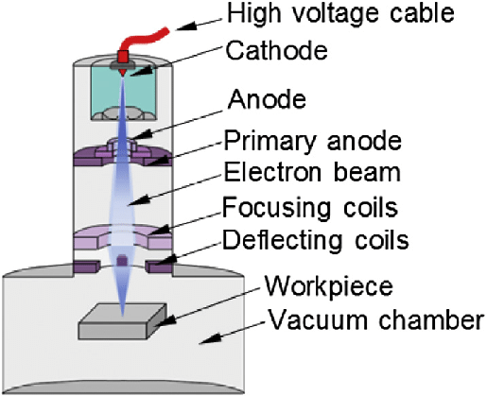
Figure 4 Electron Beam machine welding (Weglowski, 2016).

Science behind Electron Beam Machine

The science behind the Electron Beam Machining is that high velocity electrons strike the workpiece and the force creates kinetic energy within the electron which converts into heat energy (Mishra, 2017). The heat energy is used to melt and vaporize the material and the whole process takes place in a vacuum (Mishra, 2017).

Benefit of using Electron Beam Machine

The benefits of using an Electron Beam Machine are that very hard and heat resistant materials can be welded easily, and it causes no physical or metallurgical damage to the workpiece (Thorat, 2020). The other benefits of using the Electron Beam Machine is that close dimensional tolerances can be gained as there is no cutting tool wear. There is also minimal contamination in the process and holes, down to the size of 0.002mm, can be drilled (Thorat, 2020).

Problems Using an Electron Beam Machine

The problems using the Electron Beam Machine are that the machine costs are very high, and it requires a highly skilled person to carry out the operations of the Machine (Thorat, 2020). Another problem using the Electron Beam Machine is that the power consumption is very high. It is also not suitable when sinking deep holes. Special care will need to be taken when drilling a deep hole, in case the hole becomes cone shaped (Thorat, 2020). The Electron Beam Machine is only suitable when there is less material to be removed, whereby Thorat (2020) states that, `The material removal rate being of the order of a fraction of milligram per sec’. The operation of the machine can only be carried out in a vacuum (Thorat, 2020).

What materials will work with the Electron Beam Machine?

Primarily, the materials that are used with the Electron Beam Machine are those which can exist in a vacuum. This includes Metals, such as Al, Cu and Ferrite (Zone, 2019). The other materials that will work with the Electron Beam Machine are Carbon, Silicon and alloys, such as stainless steel and alloy steel. The machine can also be applied to Ceramics which include Glass, Refractories, Ruby, Sapphire and Quartz (Zone,2019). The last materials that the Electron Beam Machine will work on are Composites and these include cement, plastic and leather materials (Zone, 2019).

Self-Healing Materials

Description of Self-Healing and how Self-Healing material work

Self-healing materials work through the process of a chemical reaction which creates material repair to the damaged area of the original part (Self-Healing Materials, 2017). Self-Healing Materials have an ability to repair themselves and do not require external treatment. They have the properties of remaining undamaged (Wang, 2019). Self-Healing materials are known as smart materials. They incorporate the ability to repair structural damage, which may have occurred due to lengthy mechanical usage (Purohit, 2015). Self-Healing Materials, including polymers and ceramics, have an ability to correct damage that occurs during typical production processes and can lead to subsequent lower production costs. The materials support many different industrial processes in helping parts to last for longer periods of time and lower the costs of material failure (Purohit, 2015). Self-repairing materials have also benefited other industrial processes through the lowering of maintenance costs which in turn, lowers the cost of production and increases safety levels (Purohit, 2015). See Figure 5 below which shows the damaged material and healed material.

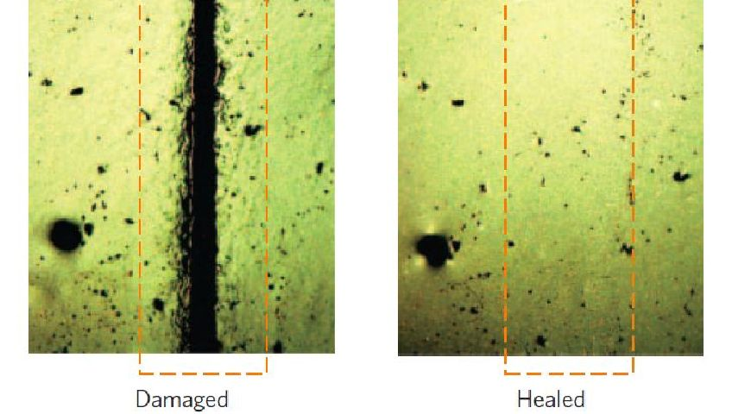
Figure 5 Self-Healing material Process (Self-Healing, 2017).

The Structure of Polymer

The Structure of Polymer

The structure of polymer consists of a very large molecule which comprises hundreds or thousands of atoms and in engineering terms it has led to a series of successes in commercial polymer synthesis (Hall, 1981, p. 1). Polymer has been established as a new sector in the chemical industry and has produced many polymeric materials such as plastic, rubbers, coatings, and adhesives
(Hall, 1981, p.1).

What is Polymer used for?

Polymers are used in everyday modern living, including for the manufacture of grocery bags, soda and water bottles, textile fibres, phones, computers, auto parts and many more. Other uses of Polymer are for the membranes of water desalination and for the carriers used in controlled drug release. The popular polymers used in manufacturing include polyethylene and polypropylene (Bradford, 2017).

Why do Polymer’s properties make it good for the purpose of a Self-Healing Material?

The reasons why the properties of Polymers make for good Self-Healing Materials is that they have the capability to repair themselves when they are damaged and without the need of detection or repair by manual intervention (Wiley, 2010). Polymers have an ability to repair cracks, in materials, when they are very small which prevents the further spreading of the cracks which in turn increases the lifetime of the material. This is then the emerging purpose of self-healing technologies, which are designed to give the polymeric materials the capability to arrest crack propagation at an early stage. This prevents catastrophic failures in materials and is why Polymers have a large scope in the application as a Self-Healing Material (Wiley, 2010).

Are there any difficulties associated with using Polymer?
There are some difficulties associated with Polymers, as they are difficult to dispose of and most polymers, that include polyethene and polypropene are not biodegradable. Microorganisms cannot break the polymers down and therefore this can cause litter problems when they are disposed of carelessly, lasting for many years in landfill sites (BBC Bitesize, 2020).

3D Printing

This section will be a brief investigation into the costs of a budget priced 3D Printing setup as an example of the typical costs of this new manufacturing method. The cost to purchase a 3D printer depends on the skill level of the user. Suppliers, Technology Outlet, quote (2019 prices) for a budget price printer, called the Flashford Adventurer 3, at £279. Consideration should be given to the possibility of running into problems, such as nozzle-jams. A Creality 3D Brass Nozzle costs around £12.95 (Gray, 2019). Depending on the usage and getting new nozzles every month, the cost per year would be £77.70 (Gray, 2019). Before buying a 3D printer certain factors should be contemplated. Filament prices are important when considering the long-term cost of 3D printing. This will depend on the type of filament the designer of the project will be using and how big the objects, which are going to be made, will be (Gray, 2019). For example, Premium PLA Filament comes with 1KG of filament. If the design of the object were to use 100 grams worth of filament, the cost would be approximately £1.94 per print. However, if the design of the project used 500 grams worth, then it would cost approximately £9.97 per print (Gray, 2019). One of the advantages of 3D Printing is the low running costs, as discussed in (5.1.3). Typically, a 3D printer can use the same amount of electricity as a fridge. The electricity costs of running a 3D printer can cost between £25-£62, depending on usage (Gray 2019).

Conclusion

The research of two new manufacturing methods and one new manufacturing material was undertaken to produce this report. The two researched methods were 3D Printing and Electron Beam Machining, whilst the material researched was Self-Healing Material. Information was discovered, which the author of this report would take into consideration when designing objects in the future. 3D Printing is beneficial when manufacturing with plastics, such as ABS and PLA plastics, which are especially suited for designs incorporating a range of colours. 3D Printing is beneficial because it typically requires less energy resources. However, if using 3D Printing, attention is required in relation to the costs of the 3D Printer, the manufacturing costs of the materials and the costs of the software. One of the key benefits of using Electron Beam Machining is that very hard and heat resistant materials can be welded easily, causing no physical or metallurgical damage to the workpiece (Thorat, 2020). However, some of the disadvantage of using Electron Beam Machining are that the machine costs are very high, and it requires a highly skilled person to carry out the operations of the Machine (Thorat, 2020). As for the research into Self-Healing Materials, the author discovered that the materials could repair themselves and do not require external treatment.

References

Figure Reference

Alexandrea, P. (2018) 3D Printer Materials Guide

[Online]

Available at: https://www.3dnatives.com/en/plastics-used-3d-printing110420174/

(Accessed: 26th April 2020)

Self- Healing materials (2017) About self- healing materials

[Online]

Available at: https://www.self-healingmaterials.com/about/

(Accessed: 19th May 2020)

Weglowski, M. (2020) Schematic of electron machine for welding and surface modification

[Online]

Available at: https://www.researchgate.net/figure/Schematic-of-electron-beam-machine-for-welding-and-surface-modification-36_fig7_301915302

(Accessed: 26th April 2020)

Zhenyu, B. and Choi, J. (2010) 3D printing process for Carbon Fibre- Reinforced Plastics.

[Online]

Available at: https://www.sigmaaldrich.com/technical-documents/articles/technology-spotlights/3d-printing-of-carbon-fiber-reinforced-composites.html

(Accessed: 26thApril 2020)

Reference

Alexandrea, p. (2018) 3D Printer Materials Guide
Available at: https://www.3dnatives.com/en/plastics-used-3d-printing110420174/
(Accessed: 26th April 2020)

Bitesize, B. (2020) Problems with Polymers
Available at: https://www.bbc.co.uk/bitesize/guides/ztr7b82/revision/3
(Accessed: 13th May 2020)

Bradford, A. (2017) What is Polymer
Available at: https://www.livescience.com/60682-polymers.html
(Accessed: 27th April 2020)

Fais, A. (2014) What Kind of Material 3D Printer Cannot Print
Available at: https://www.quora.com/What-are-the-kinds-of-materials-that-3D-printer-cannot-print
(Accessed: 10th May 2020)

Ghaffar, S. (2018) Here is the Science behind 3D printing in construction
Available at: https://www.citymetric.com/fabric/here-s-science-behind-3d-printing-construction-4029
(Accessed: 26th April 2020)

Gray, T. (2019) How much does a 3D printer cost?
Available at: https://technologyoutlet.co.uk/blogs/news/how-much-does-3d-printing-cost

(Accessed: 25th May 2020)

Hall.C (1981) Molecular Structure in Polymer Materials London: Palgrave
Available at: https://link.springer.com/chapter/10.1007/978-1-349-10187-0_1
(Accessed: 25th May 2020)

Mishra, P. (2017) How Electron Beam Machining Process works
Available at: https://www.mechanicalbooster.com/2017/04/electron-beam-machining.html
(Accessed: 26th April 2020)

Philips, A. (2016) Electron Beam Welding Techniques and Trends
Available at: https://www.sciencedirect.com/science/article/abs/pii/S0042207X16301245#
(Accessed: 26th April 2020)

Purohit, R. et al (2015) An investigation on Manufacturing Self-Healing Materials
Available at: https://www.sciencedirect.com/science/article/pii/S2214785315005568
(Accessed: 27th April 2020)

Ramakrishna, C. (2019) Three Dimensional Printing

Available at: https://www.sciencedirect.com/topics/engineering/3d-printing

(Accessed: 26th April 2020)

Redwood, B. (2020) The advantages of 3d printing
Available at: https://www.3dhubs.com/knowledge-base/advantages-3d-printing/
(Accessed: 26th April 2020)

Self- Healing materials (2017) About self- healing materials
Available at: https://www.self-healingmaterials.com/about/
(Accessed: 19th May 2020)

Thorat, S. (2020) Electron Beam Machining (EMB)
Available at: https://learnmech.com/electron-beam-machining-ebm-advantages-disadvantages/
(Accessed: 27th April 2020)

Tractus3D. (2020) 3D printing in manufacturing
Available at: https://tractus3d.com/used-by/manufacturing
(Accessed: 26th April 2020)

Weglowski, M. (2020) Schematic of electron machine for welding and surface modification
Available at: https://www.researchgate.net/figure/Schematic-of-electron-beam-machine-for-welding-and-surface-modification-36_fig7_301915302
(Accessed: 26th April 2020)

Wiley, J. (2010) Self-Healing Polymers
Available at: https://onlinelibrary.wiley.com/doi/pdf/10.1002/0471440264.pst469
(Accessed: 13th May 2020)
Zone, H. (2019) Electron Beam Machining (EMB)
Available at: https://www.researchgate.net/publication/333017361_ELECTRON_BEAM_MACHINING_EBM
(Accessed: 27th April 2020)

