
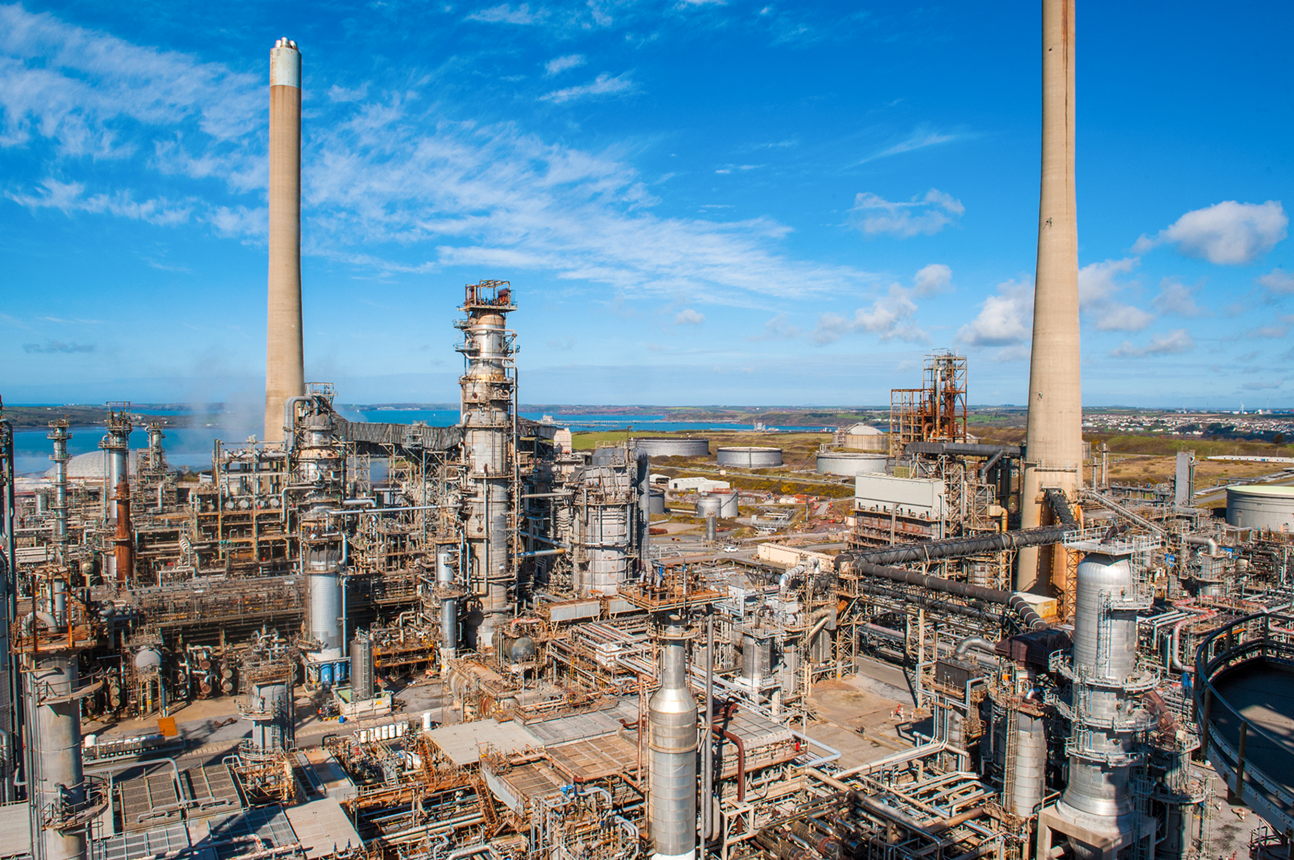

Responsibility, operational and maintenance activities



2022/2023

HNC Process Operations Engineering
Authored by: Tom Boswell



Contents

Table of Contents

- Student Feedback Form…………………………………………….3
- Task 1…………………………………………………………………4
- Task 2…………………………………………………………………9
- Bibliography/References……………………………………………17

Student FEEDBACK FORM
Generic Assessment Criteria | Marks available | Marks  awarded
1. Engagement with Literature Skills
.
 | 10
2. Knowledge and Understanding Skills

 | 40
3. Cognitive and Intellectual Skills

 | 10
4. Practical Application Skills

 | 30
5. Transferable Skills for Life and Professional Practice

 | 10
Assessment Mark (Assessment marks are subject to ratification at the Exam Board. These comments and marks are to give feedback on module work and are for guidance only until they are confirmed. ) | Late Submission Penalties (tick if appropriate) |  | %
 | Up to 1 week late (40% Max) |  | %
 | Over 1 week late (0%) |  | %
This section details the extent to which the assessment criteria are demonstrated by you, which in turn determines your mark. The marks available for each category of skill are shown. Lecturers will use the space provided to comment on the achievement of the task(s), including those areas in which you have performed well and areas that would benefit from development/improvements
Task 1 (LO1)
For task one you are required to demonstrate a knowledge and understanding of the operational and maintenance activities within a process engineering environment of your choice.
Introduction
Within the process engineering world there are many different types of units and processes which are designed to create different products either for further treatment or to be sold as a final product. For this task I will be concentrating on the Alkylation unit at Pembroke refinery as my process engineering environment of choice. I have chosen this as it is the unit that I am currently carrying out my training on and it is a good opportunity to showcase my learning and competency of the refinery and specifically in the area I am spending most of my time on.
Alkylation Unit
The purpose of the alkylation unit is to take olefins that have a low value and use them to create a high-octane product known as alkylate. This is produced by taking olefins (C3/C4) and IC4 as the two main feed products from other units and off plots storage which reacts with the hydrofluoric acid (HF) which acts as a catalyst for the reaction to take place. During this process, there is also side products that are taken out of the mix of olefins, IC4 and HF which are propane and butane, these are taken from the process when the reaction has taken place to separate them from the high octane alkylate and HF. These two side products continue through the alkylation unit and are then sent to off-plot storage tanks. As part of the make up of the alkylation unit, as is with all units, there is many different pieces of equipment that needs both operational and maintenance activities to take place to ensure that the unit is running at its highest productivity whilst remaining as safe as possible.
Types of Equipment
As mentioned before, the alkylation unit has got many different pieces of equipment that make up the entire system to ensure that they can get the maximum out of the products they are putting through the pipes. This includes equipment such as compressors, vessels, heat exchangers, turbines, instrumentation etc. The three that I will be focussing on are:
- Pumps
- Fired Heaters
- Valves and Piping
Pumps
A pump is a common piece of equipment that can be found on oil refineries all over the world, they are essentially used to move a product from one place to another by entering the pump and getting moved around quickly to go through another pipe to move on through the process. There are many different types of pumps that are on the alkylation unit. As part of an operator’s duties it is important that they carry out all of the correct activities so that the pumps are always working at the correct level and not dropping off in performance. At the start of every shift, the unit operator must take great care in carrying out all the necessary checks on each pump, this will include completing sensory checks such as touching pumps to ensure that they are not too hot or cold and aren’t overly vibrating, completing a visual inspection of the pumps and surrounding area making sure there is no obvious external damage or leaking, listening to what sound the pumps are making (operators will be aware of how each pump should sound when running smoothly) and also making sure there are no unusual smells which could indicate internal temperature rising or a product leak.
Other important operational activities on pumps could include ensuring that the Denco oil bottles are always full to make sure that the system is always oiled up as without this the pump could run dry and begin to overheat, leading to internal damage and shutting the pump down. Operator’s will also have to carry out vibration and temperature checks on the pumps using hand held equipment to ensure that all sectors in the system are running at an acceptable level. By completing all of these activities, operations are able to keep pumps healthy and safe, if they do notice impurities then it could be early signs of damage or wear and therefore the maintenance team would step in.
Maintenance are activities carried out on the pumps in the alkylation unit in a few different ways whether that be in a planned routine maintenance or as part of a reactive maintenance to fix urgently. An example of planned maintenance activities on a pump could be general checks to all of the parts, ensuring there is no internal damage and that when ran up it is acting smoothly as it should. Depending on the criticality of equipment, these planned activities could take place every 3,6,9 or 12 months to keep track of it. Reactive maintenance could happen due to a pump failing or dropping in performance. Here the maintenance technicians can inspect where the problem has occurred and rectify it by either replacing parts or repairing what is there, common issues and replacements could be seal damage or bearings that have overheated which requires a simple replacement change over.
Fired Heaters
Fired heaters are common place on oil refineries and there are two of them on the alkylation unit at Valero. These heaters are used to heat up incoming products to get them to the desired temperature required to continue the rest of the process in the unit. These each have 6 flames inside them which are produced by adding a controlled amount of fuel gas to the pilot flame. As part of the operational daily activities the operator must carry out checks on the fired heaters to ensure they are in the correct working order and conditions. Things that are being looked for include the 6 flames being on, are the flames a good height and colour, is there a negative pressure inside, are there any issues with the internal equipment such as thermocouples overheating etc. These things are checked at the start and end of shift by opening the hatches around the heater and looking inside. Operators can only look inside once they have received approval to do so by the control operator on the panel and they must ensure they have adequate PPE on such as correct standard gloves and a visor to avoid any possible injuries due to high temperature air or flames.
If a fired heater was to trip this needs to be rectified as soon as possible as it can lead to the operators to take the entire unit down for safety issues. In this instance, they would need to follow procedure and try to relight the burners within the heater by using the pilot gas and a handheld sparker which is used to ignite the gas inside and get it all back online.
Maintenance activities may need to be carried out on fired heaters if there is a more serious issue such as transmitters and instrumentation failure. Here the heater would have to be safely taken down by operations to allow the maintenance team to carry out their reactive work to fix all issues.
Valves and Piping
The most popular equipment found on all units all over the world is valves and piping. They are the fundamentals to all processes and systems and the same can be said on the alkylation unit at Valero. Valves can be used to control many different things such as the flow, pressure or volume going through it to the pipes. Operator activities on valves and pipes on the unit include carrying out general inspections ensuring that there is no visible damages or leaks to the equipment, ensure there are no unusual smells coming from the equipment just in case there are colourless gases and ensuring that there is no overheating taking place. If any of these factors are present, then it must be amended to make sure the process is running smoothly.
One of the main operational activities carried out on valves is stroking the valves, this is a technique that is used to check the integrity of the valves and how accurate they are. It involves opening and closing the valve in stages (25%, 50%, 75%, 100%) via the control panel to make sure that what they are asking for inside is represented on the valve stem outside.
Maintenance activities will be performed on valves when the operational activities are failed or found not to be working correctly. A common activity will be instrumentation maintenance coming out and amending the valves setting by using specialised technology and calibrating the valve so that it matches up with what is being asked of it on the panel. If there is more permanent damage such as snapped components, then an overhaul will be required by the mechanical maintenance staff and the bypass will be put on whilst the main valve is out of service. Any dodgy or broken pipe work will also be removed and replaced by maintenance workers either during a shutdown or in the case where a bypass can be put on to avoid process production disruption.

Task 2 LO2
In order to demonstrate your knowledge, understanding and responsibility within the process industry, you are required to provide the following evidence:
- CV, current job description and person specification.
- Your current development action plan.
- Provide evidence to prove your technical competence. Evidence could include:
- Competence framework, copies of company,
- Appraisals or any assessments,
- Key certificates and training records,
- Samples of relevant work undertaken,
- Plans and evidence of work preparation,
- Evaluation of work outcomes and personal effectiveness.
- Recognition of the results of your work and your achievements.
- Evidence of application of knowledge and skills as well as your responsibilities and autonomy when carrying out key work activities.

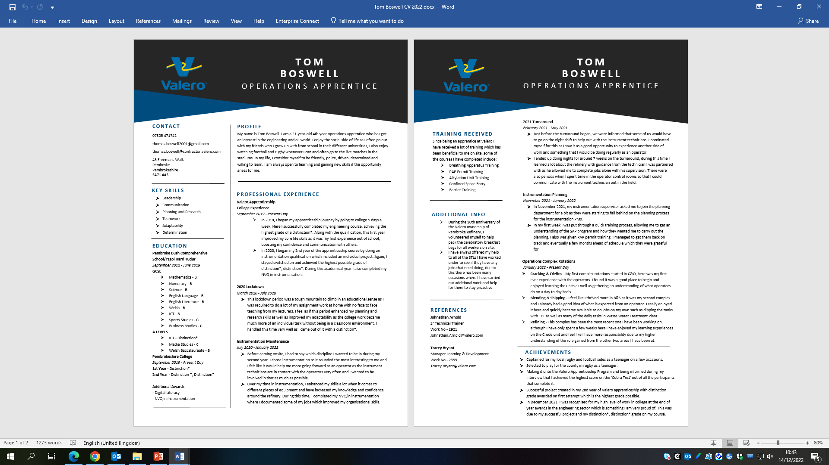
Up to Date CV
Current Development Action Plan
As of January 2023, I have just began training my first unit on site at Valero Pembroke refinery which is the one I have been referring to throughout this assignment, the alkylation unit. My current goal is to be passed out and fully trained on my unit by May 2023 so I can become an operator and begin to run the unit by myself on my shift. After I pass out, I have a probation period of 6 months before I can begin to think about my next unit to study. I would hope that within the next 12 – 18 months I am beginning to train my next unit in the olefins sector of the refinery.
In terms of where I am with college work, I am aiming to complete my process operations HNC course by the summer of 2023. Most of my units were completed in the first year of my HNC and I am now left with only two academical units left to complete. My goal is to achieve a merit or distinction grade at the end of this and graduate with my qualification complete to a high standard.

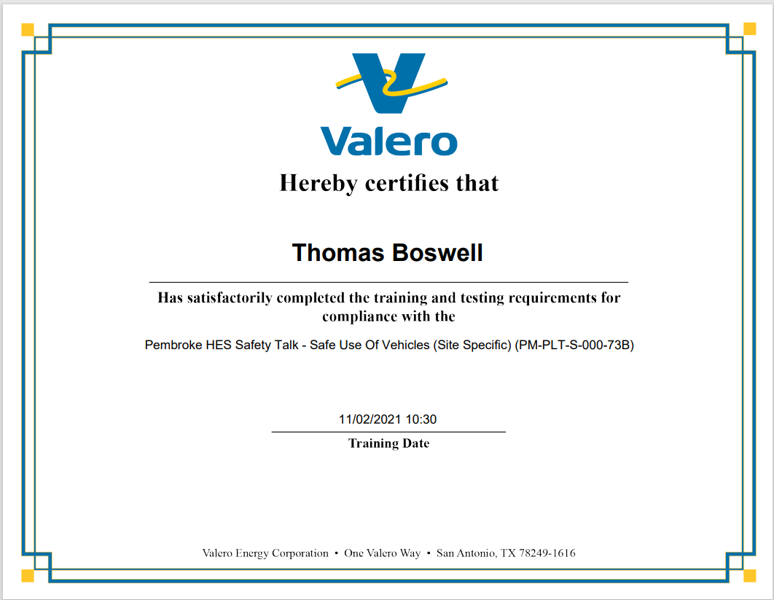
Evidence of technical performance - Certificates

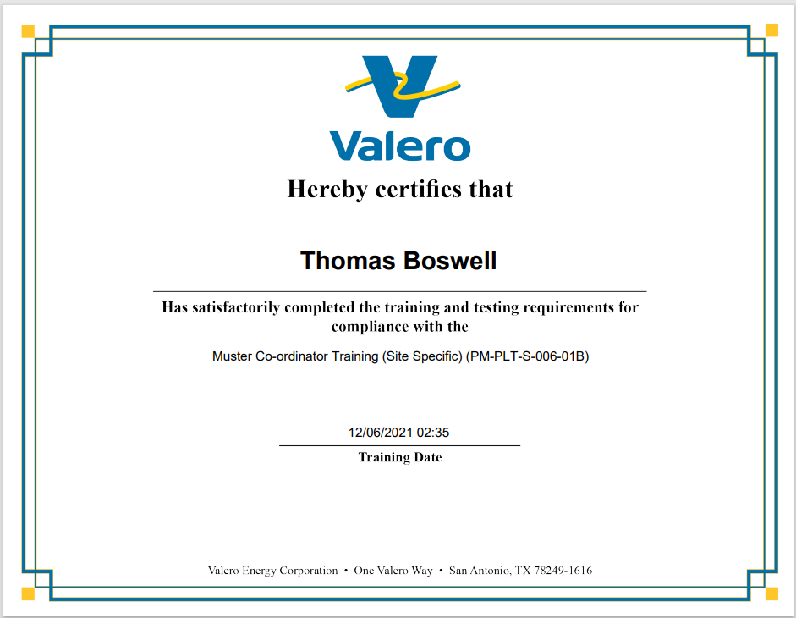

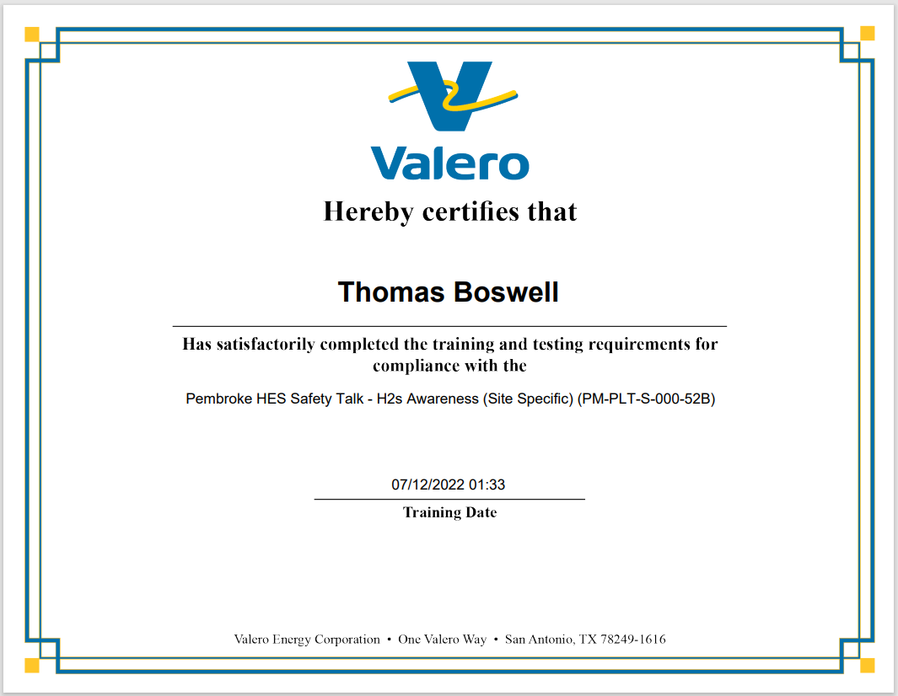

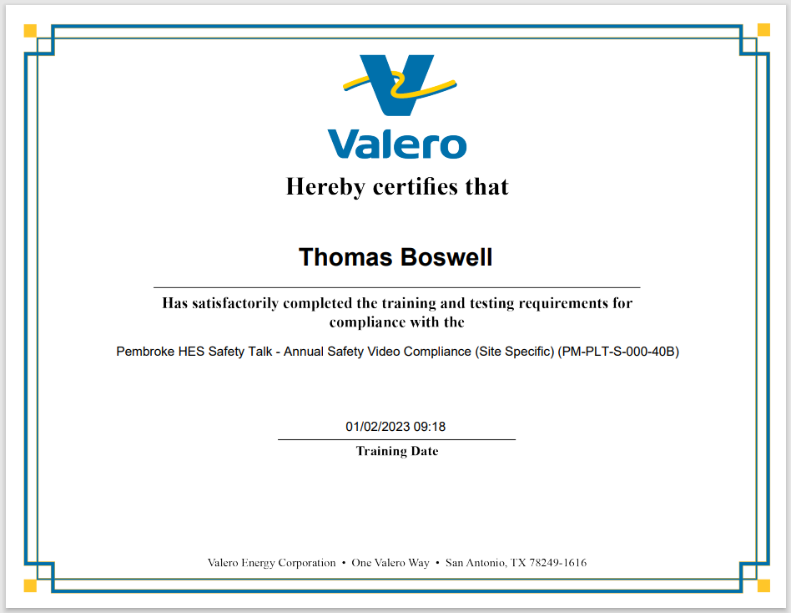

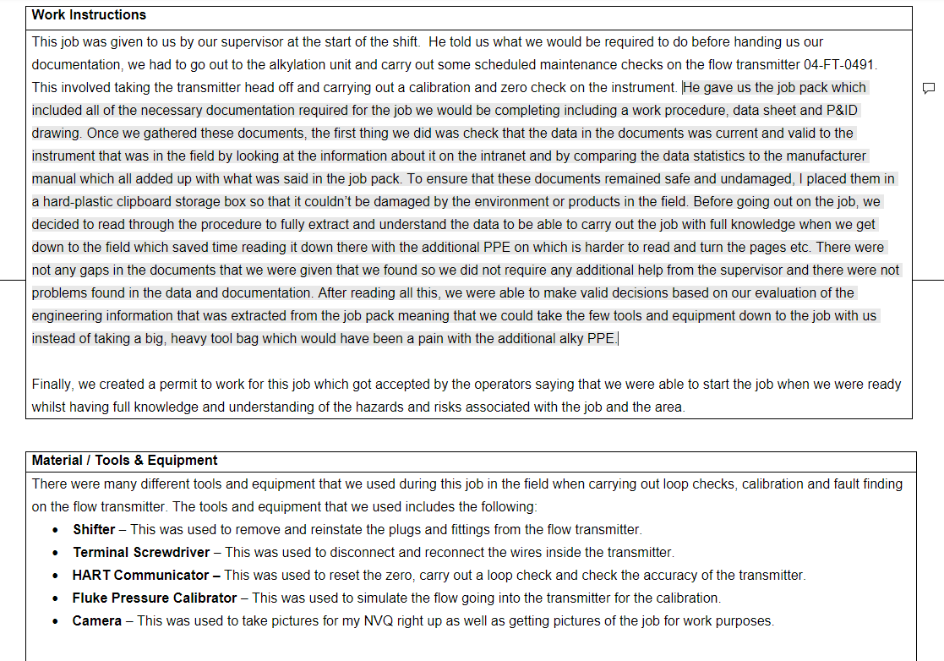

Instrumentation NVQ Job Report

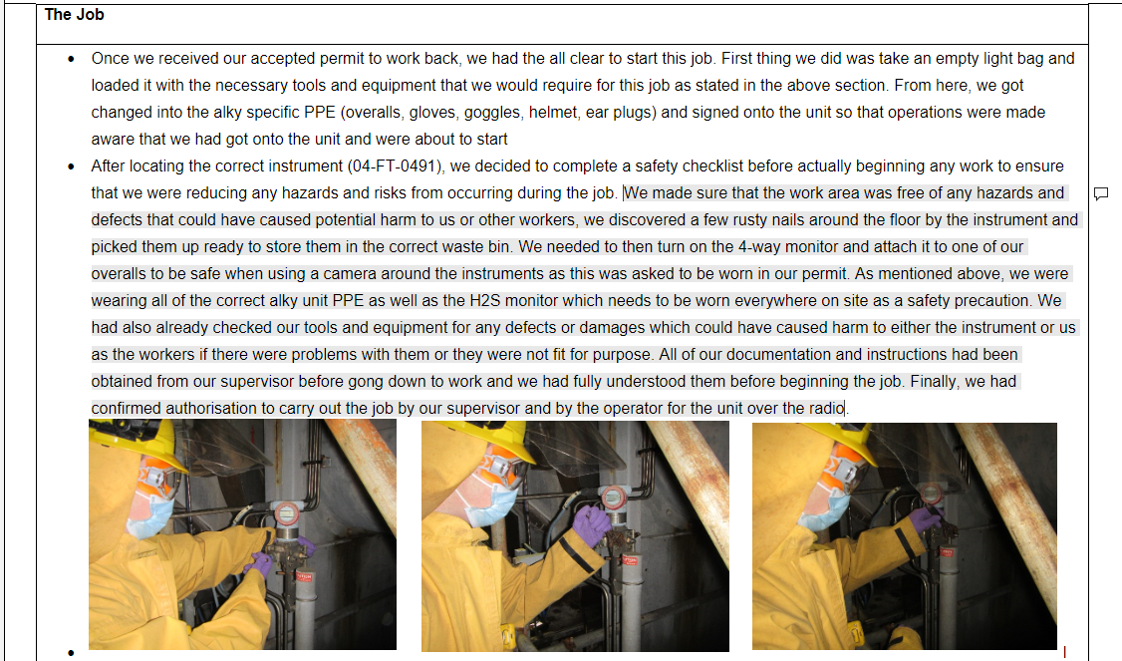

Above is some evidence of me carrying out my work on site at Valero. I have taken a few screenshots from my NVQ job reports which should show my competence on completing instrumentation jobs onsite. I completed my NVQ in 2021 and my assessor agreed that I had hit all of the points that are required to distribute the qualification which includes understanding of equipment, ability to complete jobs under supervision of technicians, ability to complete jobs independently, ability to follow procedure and understanding of safety systems and procedures at the refinery.
As part of this task, I have also included screenshots of my certificates which show me completing and passing some of my computer-based training (CBTs) which are set every month by Valero. Each of which shows a high level of competence and understanding of the task. Alongside these training tests, I have also completed many enhance training days to give me the ability to use specific PPE and enter specialised areas on site, of which I received a pass/card which may need to be shown as proof. This includes:
- Confined Space Training
- Breathing Apparatus Training
- Alkylation Unit Training
- CCNSG course

I believe that all of the above as well as my CV and development action plan is enough to show that I have been progressing well in my apprenticeship and I am of an ability which shows my competence in the industry that I am now working in. I have now reached a stage of performance and confidence where I am able to carry out jobs on my own and those around me trust me to carry this out effectively.

Bibliography/References

- S Parkes. (2021). Alkylation Unit Manual. Pembroke: Valero Energy.
- Gainesville Industrial Electric. (2023). Industrial Pump Selection Guide. [Online]. Gainesville Industrial Electric. Available at: https://www.gainesvilleindustrial.com/blog/pump-types/#:~:text=Industrial%20pumps%20are%20designed%2
- Anup Kumar Dey. (2016). Fired Heaters: Working, Components, Types, Function, Sections, Maintenance (PDF). [Online]. What Is Piping. Available at: https://whatispiping.com/fired-heaters/
- Unified Alloys. (2023). INTRODUCTION TO VALVES: WHAT ARE VALVES & HOW DO THEY WORK?. [Online]. Unified Alloys. Available at: https://www.unifiedalloys.com/blog/valves-101

