Web Services
Assignment 1

Arthur Burke
2222155
DVLA: MSc Software Engineering (Web Development)
Word count: 1228

Table of Contents
1 Design choices 2
2 Implementation 3
2.1 DTOs 3
2.1.1 Controllers, Services & Repositories 4
2.2 Security 5
2.3 OpenApi-UI / Documentation 8
2.4 Testing 11
3 Future improvements 13
4 Bibliography 14

Figure 1 Models ERD displaying entities within API design 2
Figure 2 DTO implementation 3
Figure 3 Controllers, Services and Repositories 4
Figure 4 VehicleRepo 4
Figure 5 KC healthcheck 5
Figure 6 SecurityConfig 6
Figure 7 configureRepositoryRestConfiguration()-1 7
Figure 8 configureRepositoryRestConfiguration()-2 7
Figure 9 main application.properties 8
Figure 10 SpringDocConfig 8
Figure 11 OpenAPI-UI information 9
Figure 12 annotation-ui-result 9
Figure 13 springdoc-openapi-javadoc-ui 9
Figure 14 springdoc-openapi-javadoc-code 10
Figure 15 TestContainerPostgres 11
Figure 16 testcontainers - docker-compose 12
Figure 17 putPatchDeleteEndpoints() helper method 12
Figure 18 testBlocksPUTPATCHDELETEEndpoints() method 13

Design choices
This project’s design (Figure 1) is based upon certain assumptions. The API is the backend implementation for a pre-existing frontend UI, through which users can pay their vehicle tax online without the need to login and without the need to be the registered keeper. Payments are not processed by this API; it is not concerned with banking or payment card details and does not interact with financial ledgers. Valid tax payments can only be made for vehicles that are already registered with the DVLA. Vehicle tax payments do not have to be made by the registered owner of the vehicle, and payments are made based on a pre-defined set of options presented to users in the UI.
All vehicles are registered to a driver keeper and are assigned an existing tax band when added to the database.
Admin users can produce reports showing vehicles with overdue payments, to send reminders for payment. Tax bands are based upon bands present on the DVLA website, and all tax bands are assigned tax rates, all of which can be adjusted. They are based on current DVLA values [1]. Tax bands can be adjusted and deleted if the government changes classification rules and groupings of vehicles.
All drivers have registered addresses, and they can only have one registered address, but multiple drivers can be living at the same address. Drivers have unique licence numbers that are used to identify them. In this project, the licence numbers are auto-incrementing digits since the driver records do not contain sufficient data to calculate realistic licence numbers in keeping with real licences [2].

Access authorisation is based on:
- Basic users can submit payments, view data specific to themselves, and general tax details.
- Admin users can perform the same actions as basic users, as well as viewing personal details and payment data for all users.
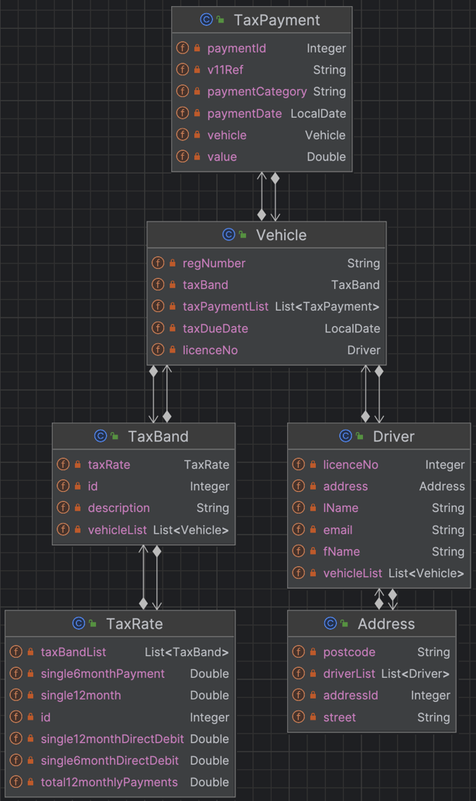
Figure 1 Models ERD displaying entities within API design

Implementation

DTOs

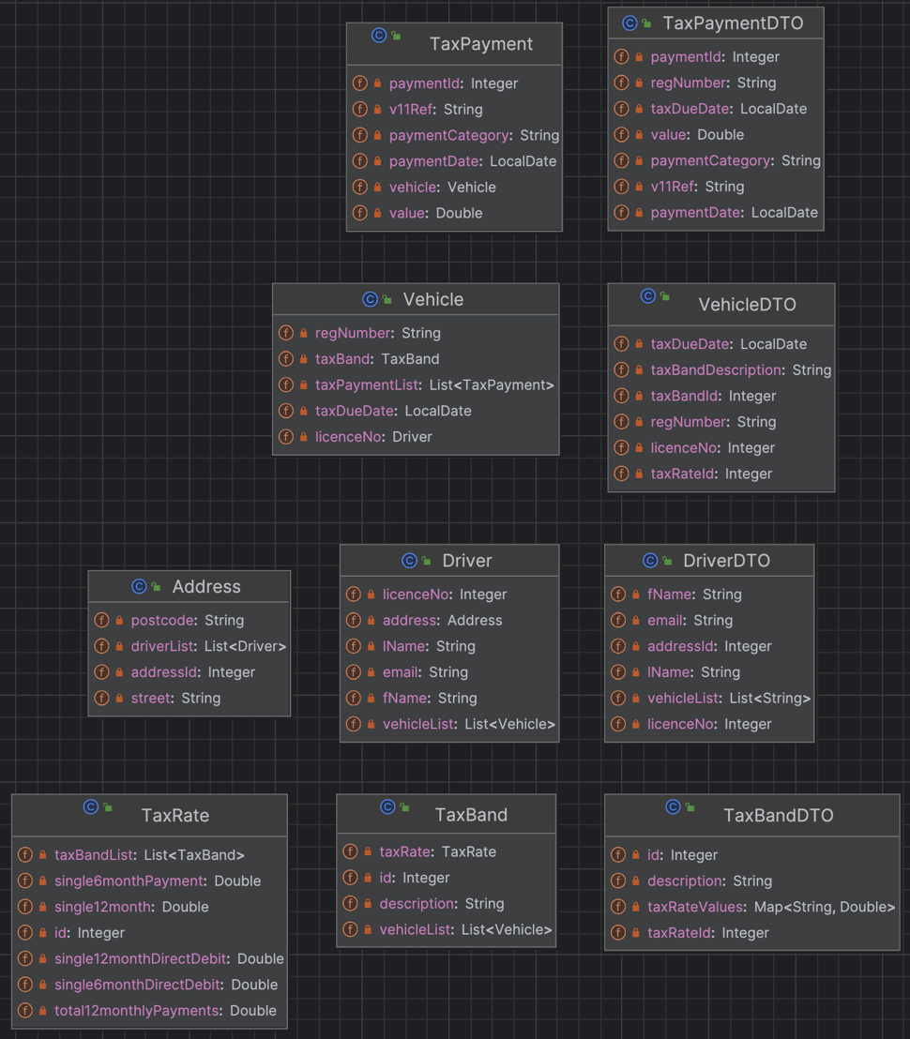
Figure 2 DTO implementation
Figure 2 displays DTOs within the application, the decision for these was based upon extracting the key data from the relative classes / nested classes to transfer the key information of use in a front-end. I focused specifically on including most of the parent class and identifiers from nested classes.

Controllers, Services & Repositories
Figure 3 displays the implementation of custom JPA queries within the repository interfaces. The classes ending in ‘Repo’ act as controllers for the API, they expose endpoints with specific paths designed to indicate authorisation levels for access.

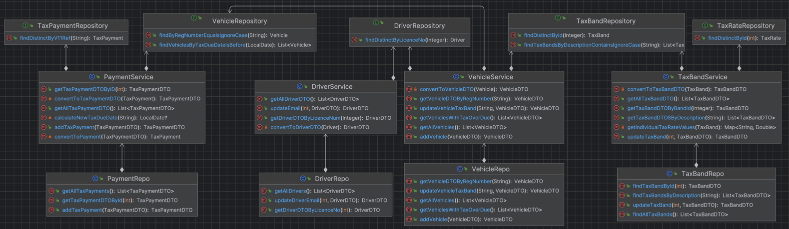
Figure 3 Controllers, Services and Repositories
An example implementation of custom endpoints is displayed in the @Mapping annotations in Figure 4. These are set using ‘admin’ and ‘user’ as keywords for the security configuration.

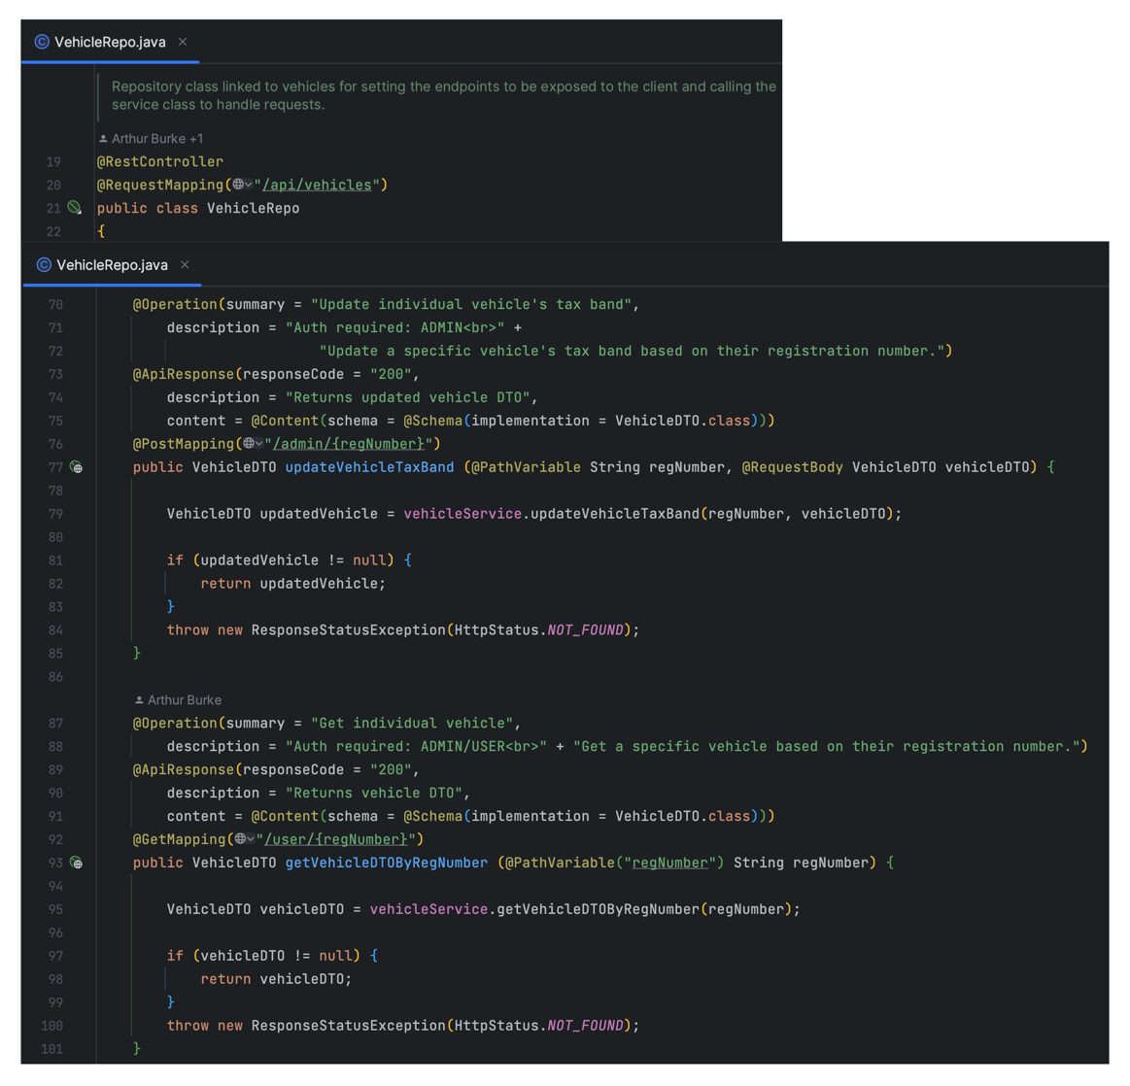
Figure 4 VehicleRepo

Security
The Keycloak server was setup with super, admin, and basic users for the Spring client to retrieve authentication and authorisation levels for. The super user is intended to represent senior staff who can change and delete tax information, the 'taxserviceadmin’ role represents DVLA staff who would be interacting with the system on a daily basis processing drivers data. Aside from the super user's access to changing tax bands and rate, the two groups share the same authorisation levels. ‘Taxserviceuser’ role represents end-users paying tax.

Postgres is used for persisting the Keycloak data, I used a separate Postgres container as I think it's probably safer to keep the authorisation and the user/transactions/vehicles data separate as then any intrusion into one should in theory not provide access to the persisted data from the other. I again used docker 15 for consistency and to reduce the overall size of the stack, not having to download multiple Postgres version images. Healthchecks were implemented Figure 5, as Keycloak containers crash if there is not a database immediately available to connect to. Production implementation of Keycloak should use a database [3], I didn't get round to building a production-ready Keycloak server, so just implemented the database.

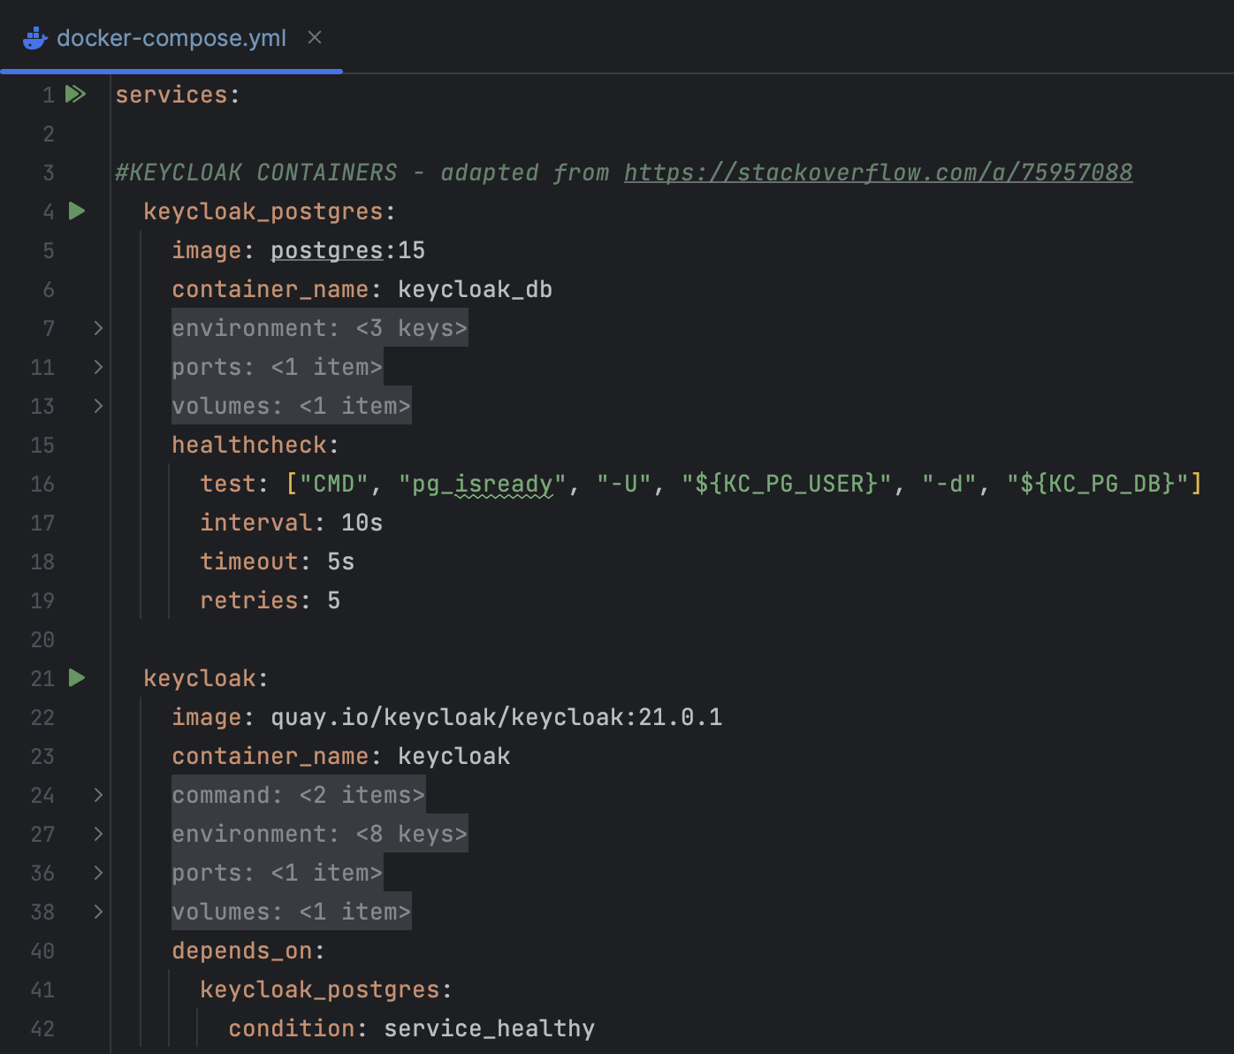
Figure 5 KC healthcheck

The combination of endpoint setting (Figure 4) and the security configuration in Figure 6 – where regex matching for paths has been used, enforces the path-based access levels. Lines 44 and 45 have been used to allow un-authenticated users access to the OpenAPI UI and JSON endpoints. Line 57 is used as a catch-all approach for any endpoints not specifically included in the preceding code, ensuring that all other endpoints are only accessible by admin users.

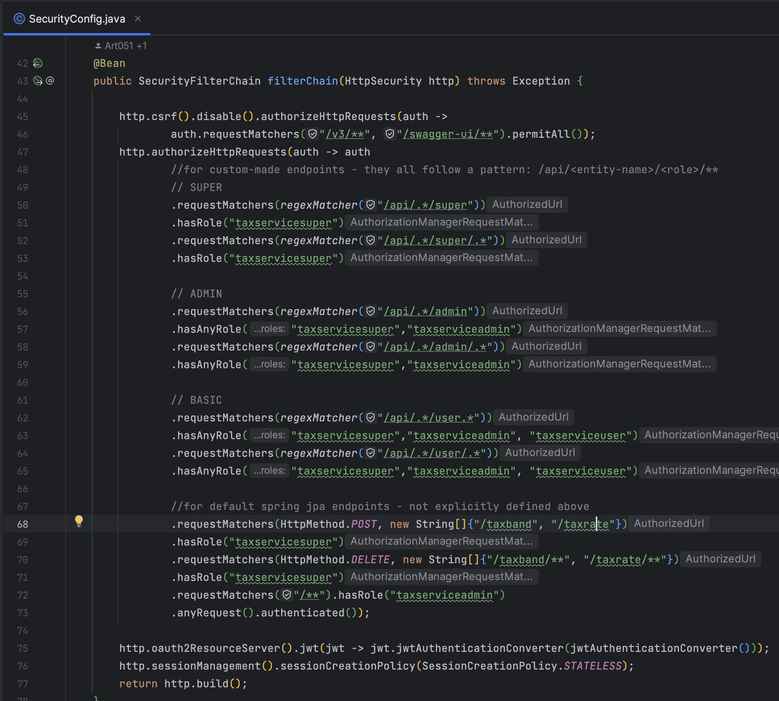
Figure 6 SecurityConfig

RestConfig. configureRepositoryRestConfiguration() (Figure 7 and Figure 8) was used to block all PUT, PATCH and DELETE requests for all entities, other than DELETE requests for TaxBand and TaxRate, which was to allow super users to delete/change them if government taxation laws change.

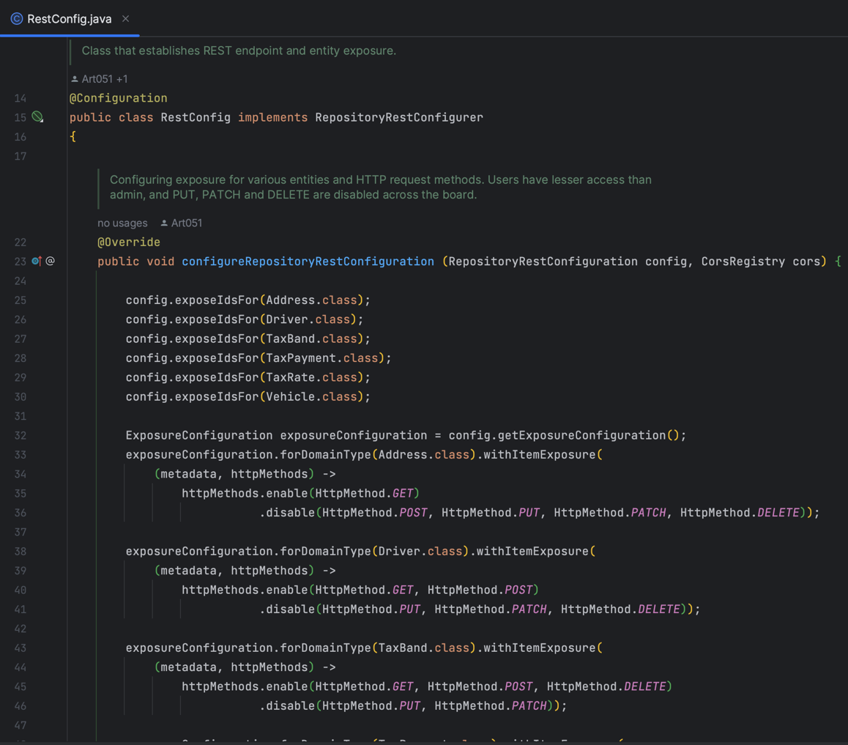
Figure 7 configureRepositoryRestConfiguration()-1
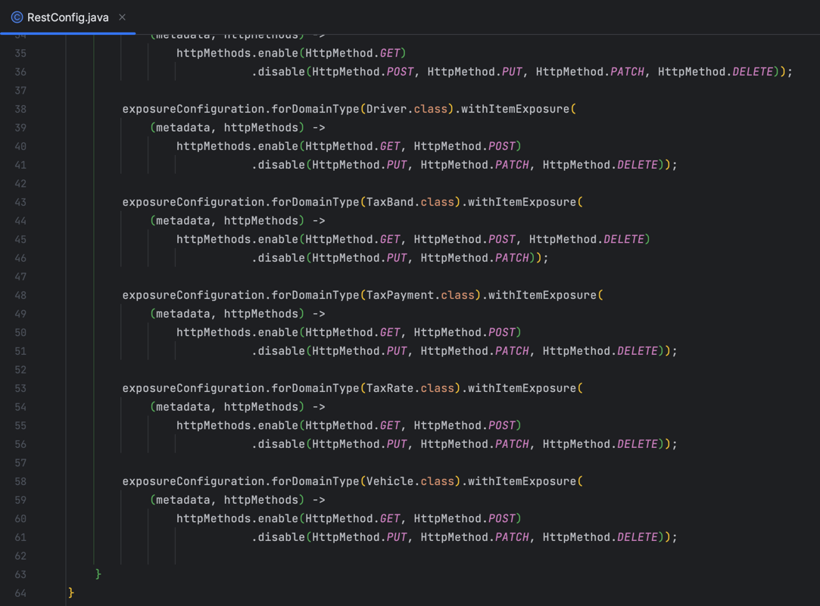
Figure 8 configureRepositoryRestConfiguration()-2

OpenApi-UI / Documentation
Default OpenAPI-UI documentation was built upon to further personalise the UI for this project. Figure 9 displays the application.properties which were used to add features to the UI such as displaying request times, and sorting endpoints, it also sets the OAuth settings to allow users to input their JWT to make authenticated requests to the API. Figure 10 then shows the setting of the top section of the UI, with Figure 11 then being the result in the UI.

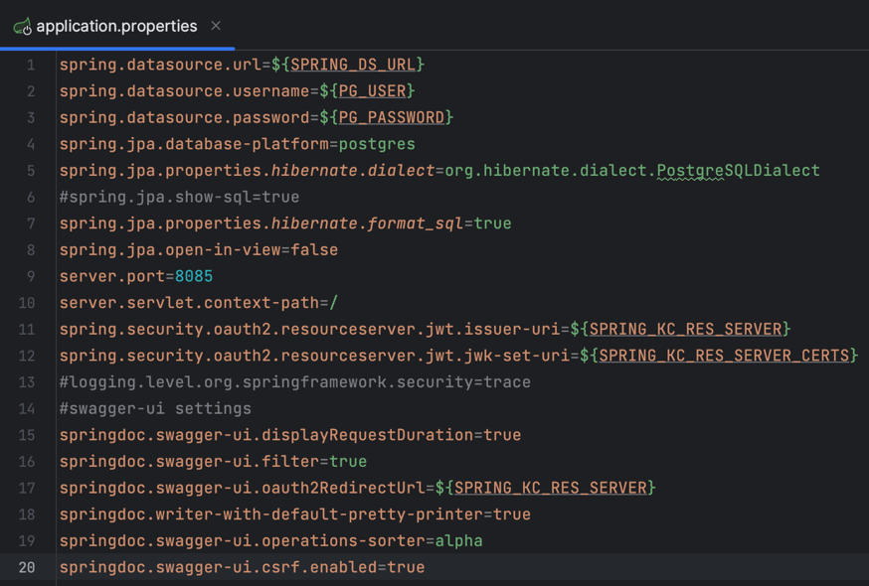
Figure 9 main application.properties
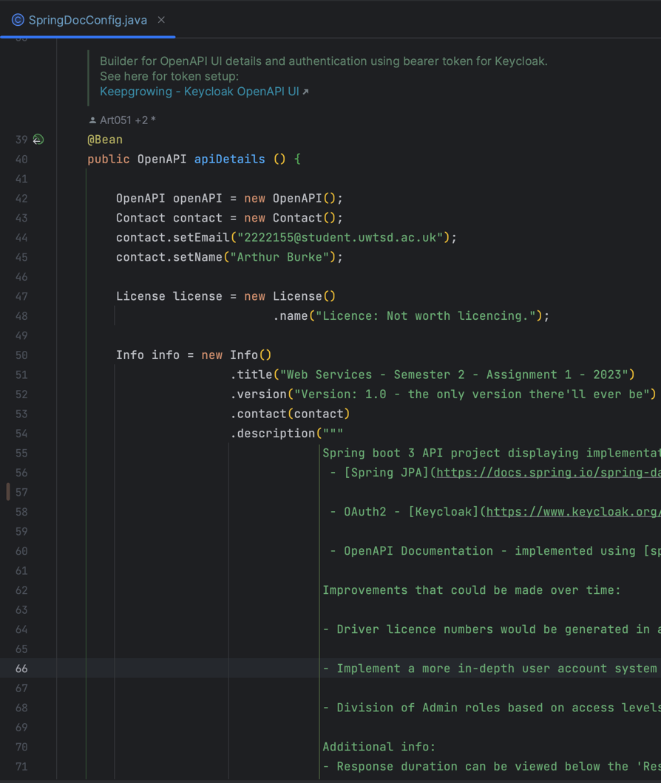
Figure 10 SpringDocConfig
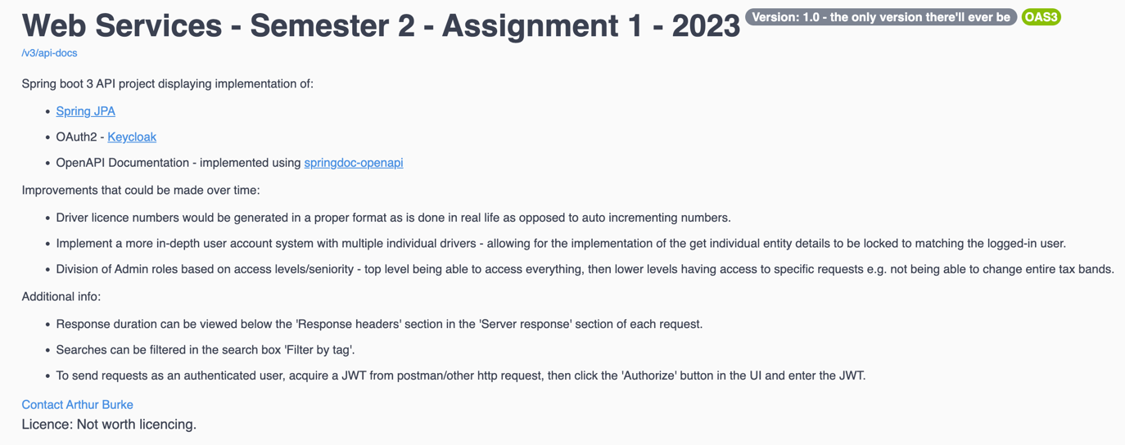
Figure 11 OpenAPI-UI information

The annotations visible in Figure 4 were used in order to provide information within the UI (see Figure 12).

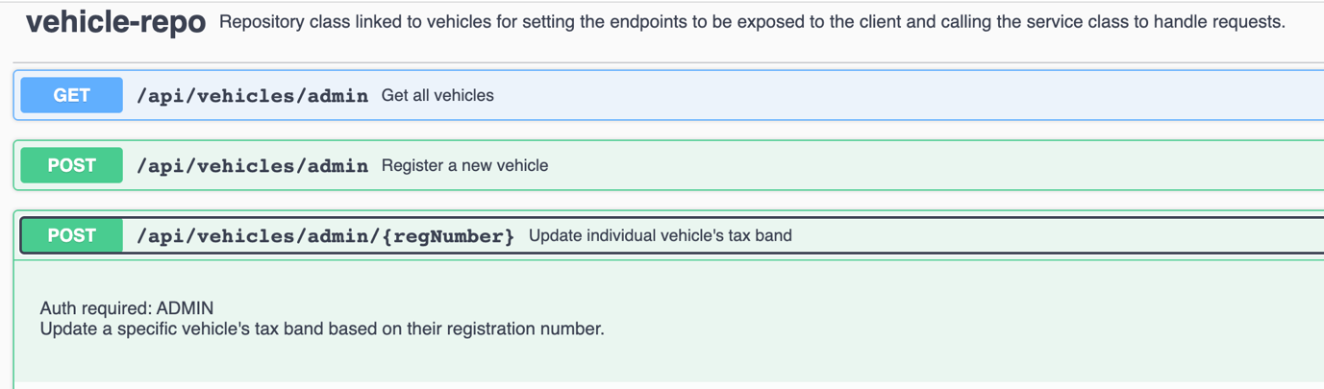
Figure 12 annotation-ui-result
Within the project's pom.xml is ' springdoc-openapi-javadoc' [4] - this enables the UI to automatically pick up standard Javadoc and include it within the UI, removing the need to retrospectively adapt existing Javadoc to appear in springdoc's annotation-based documentation style.

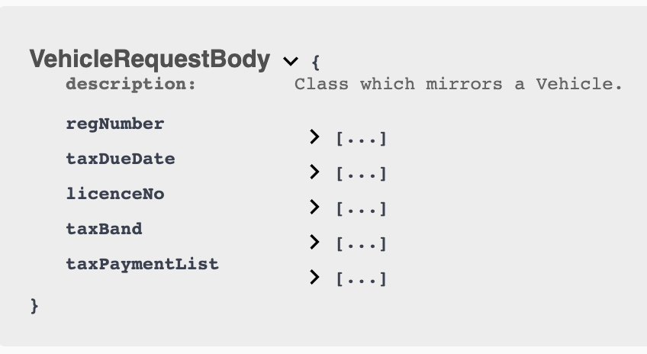
Figure 13 springdoc-openapi-javadoc-ui

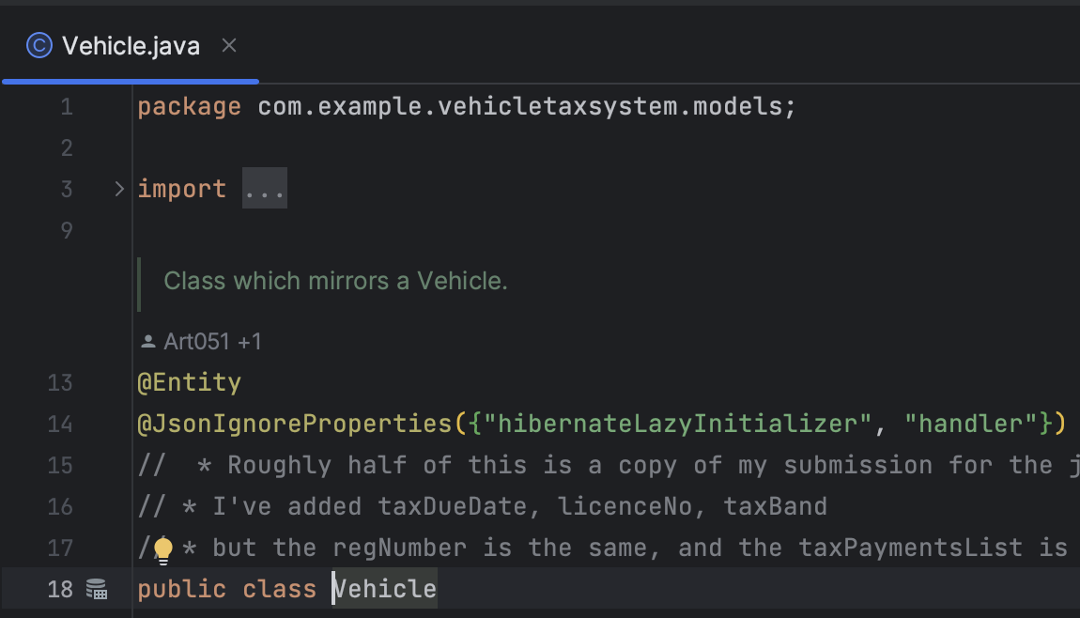
Figure 14 springdoc-openapi-javadoc-code

Testing
Tests are run inside their own isolated docker containers Figure 16 by using the testcontainers [5] dependency. This was chosen due to compatibility issues between H2 embedded database syntax and the naming of tables and fields in the Postgres initialisation script as well as the Java class names and fields. The choice of Postgresql database in testcontainers was due to the main application already using Postgresql. The configuration for the testcontainers can be seen in Figure 15 - the Postgresql version chosen was intentionally set to 15, the same version as is used in the application's docker-compose for the persistent database to achieve as accurate as possible testing where the databases have identical syntax and data handling implementations.
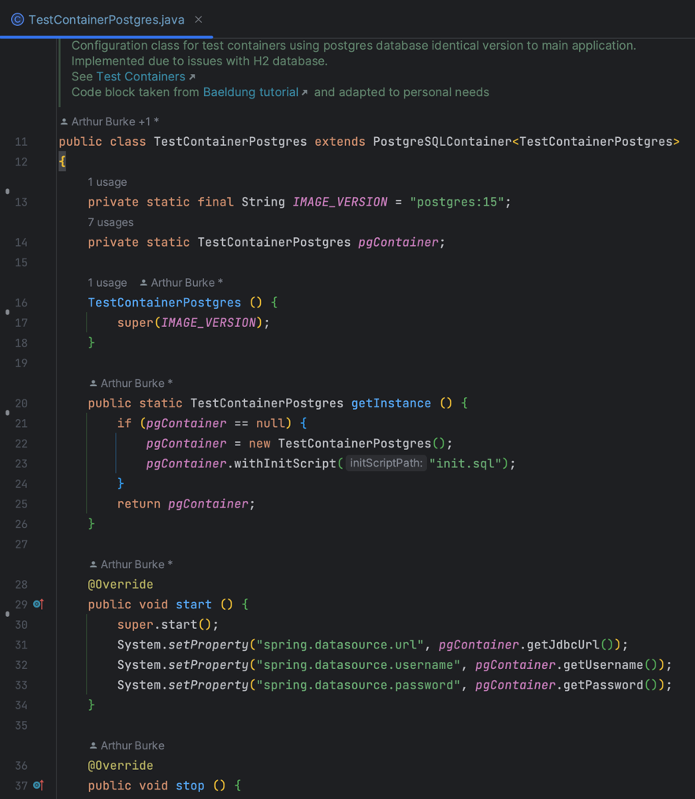
Figure 15 TestContainerPostgres
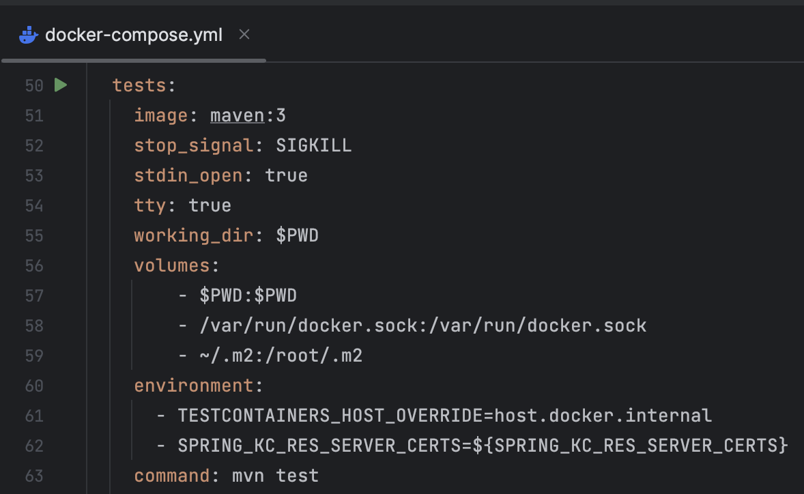
Figure 16 testcontainers - docker-compose
Of the 140 unit tests, 108 are within the ' SecurityConfigTest' class. I made use of the parameterised test annotation in order to provide test methods with lists of endpoints, from helper methods (Figure 17), with which to execute the test method (Figure 18) in order. The figures displaying this implementation are used to test unauthenticated requests, user requests, and admin requests for PUT, PATCH, and DELETE requests on each endpoint. Successful blocking of the requests depends on the configuration in Figure 7 and Figure 8.

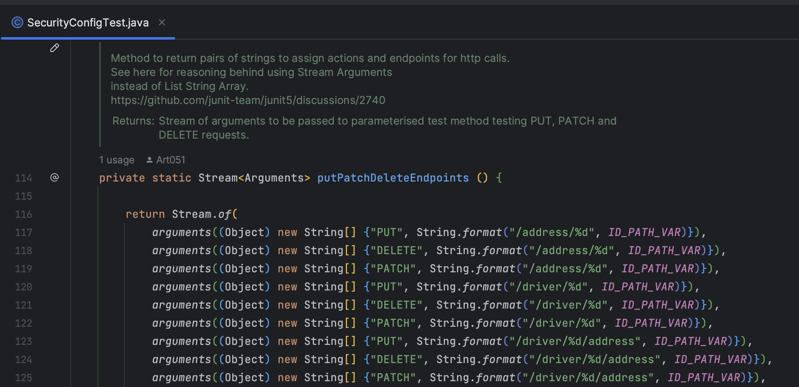
Figure 17 putPatchDeleteEndpoints() helper method
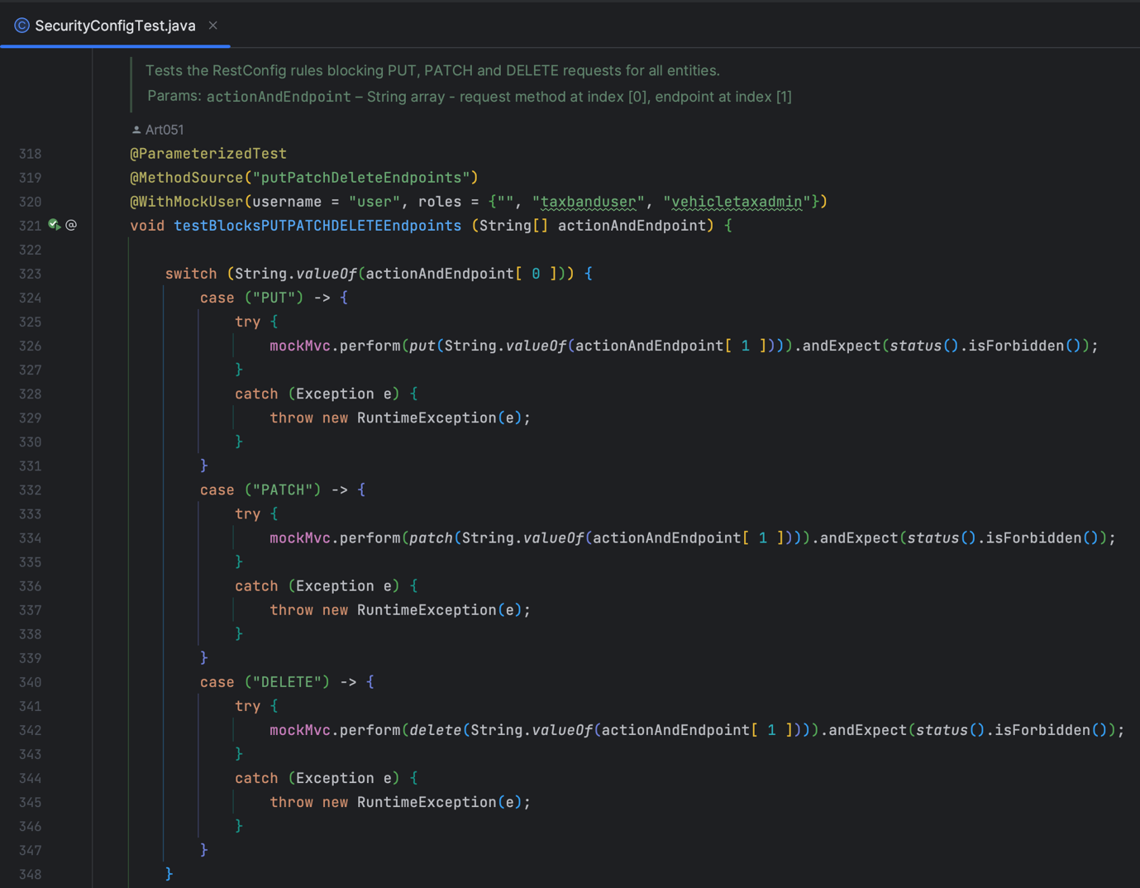
Figure 18 testBlocksPUTPATCHDELETEEndpoints() method

Future improvements
If further work was to be carried out on this application, I would aim to achieve the following:
- Implement a larger set of users and roles, including Individual user accounts linked to licences, enabling complete implementation of limiting id-based queries to specific users
- Implement logic to generate licence numbers to accurately reflect real licences.

Bibliography

[1] | DVLA, “Vehicle tax rates,” [Online]. Available: https://www.gov.uk/vehicle-tax-rate-tables.
[2] | DVLA, “information-on-driving-licences,” [Online]. Available: https://assets.publishing.service.gov.uk/government/uploads/system/uploads/attachment_data/file/1087046/ins57p-information-on-driving-licences.pdf.
[3] | Keycloak. [Online]. Available: https://www.keycloak.org/server/db.
[4] | springdoc, “springdoc,” [Online]. Available: https://springdoc.org/#javadoc-support.
[5] | “Testcontainers,” [Online]. Available: https://www.testcontainers.org/.

