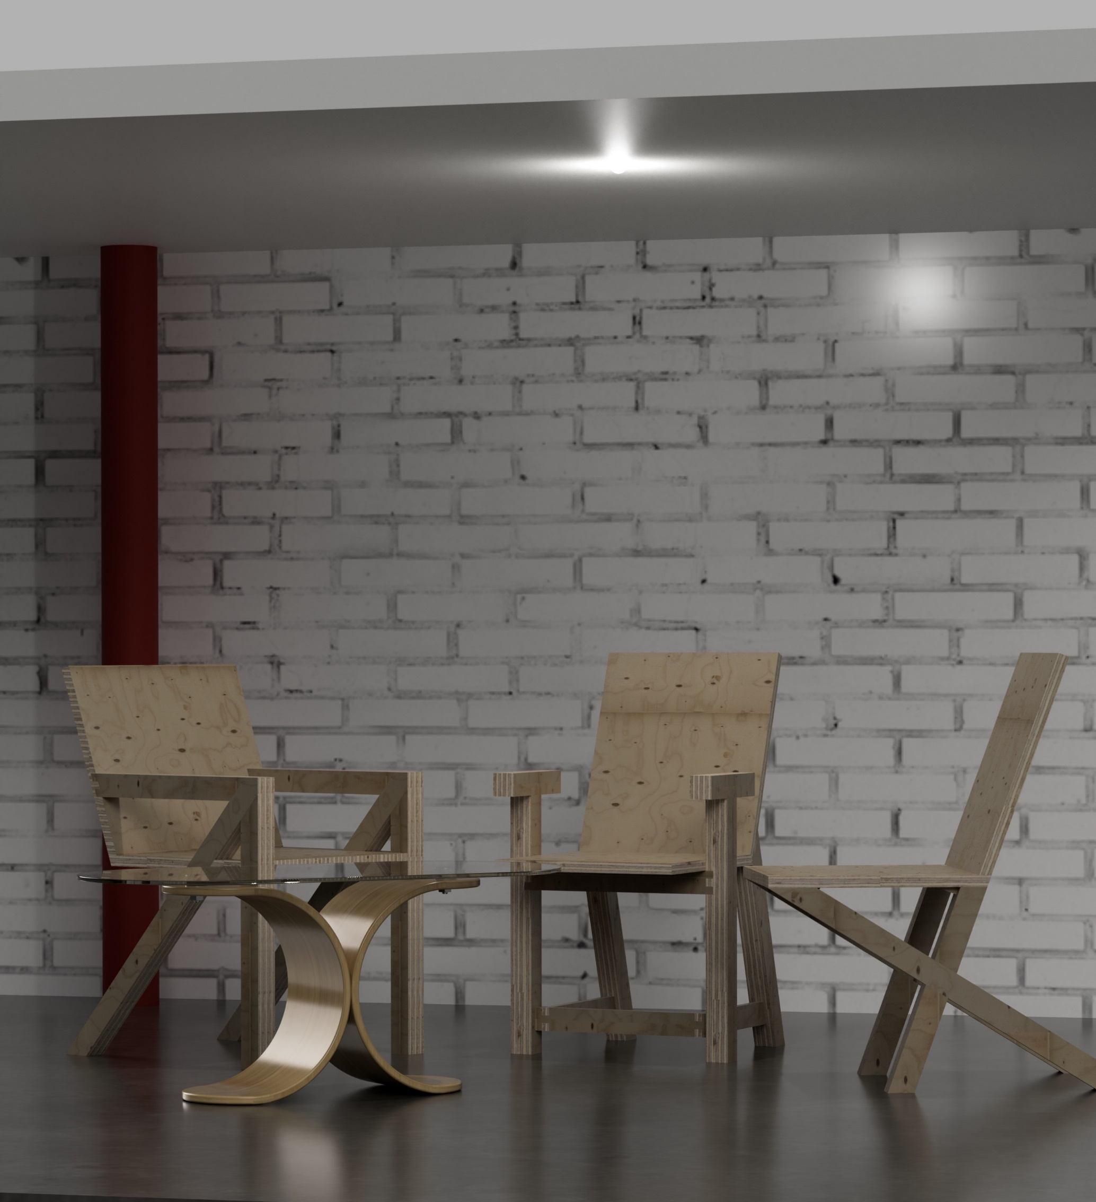
Design Evaluation for Major Project
George Edward Anderson
BA (Hons) Product Design
University of Wales Trinity Saint David
Swansea College of Art



Contents

Executive summary

Design Description and specification

Design Development and Realisation

Design specification comparison

Design description and specification

Evolve is a range of chairs that affords a practical outlet for people who are interested in an introduction to woodcraft. The consumer will receive a pack that consists of pre-cut material, example booklet and cutting jigs to aid with the final construction. The collection provides the freedom of universality of joints between components of the designed chairs. The opportunity to incorporate features of different styles for alternative combinations gives the consumer flexibility in choosing their outcome. By using clean geometric shapes inspired by Japanese woodcraft and syllabary, the design incorporates the aesthetic of simplicity while hiding the internal layers, contextually and physically. Deciding on the chairs feature style is made possible by the example booklet. The booklet shows predesigned furniture assembly outcomes; however, the consumer can choose their interpretation of the materials supplied and create their unique piece of furniture. To summarise, the design allows the consumer to create a chair that is personal to them.

Using birch plywood allowed me to achieve a strong and durable finish while creating a contrast between the face, edge and joinery. The chair and all its components have been designed using 18mm and 25mm plywood. Plywood was selected because of its ease in manufacturing and its availability to the consumer, if a mistake was made during their attempt of the assembly, they have the ability to try again at a low cost. The consumer has the opportunity to change the type of plywood for an alternative surface finish (oak, maple, birch, etc.) without changing the furniture design. The construction of the chair is designed to revolve around the use of 6 tools: saw, chisel, wood glue, mallet, sandpaper, and clamps, this minimal amount of tooling is cost effective and will act as an investment as the consumer progresses onto other projects.

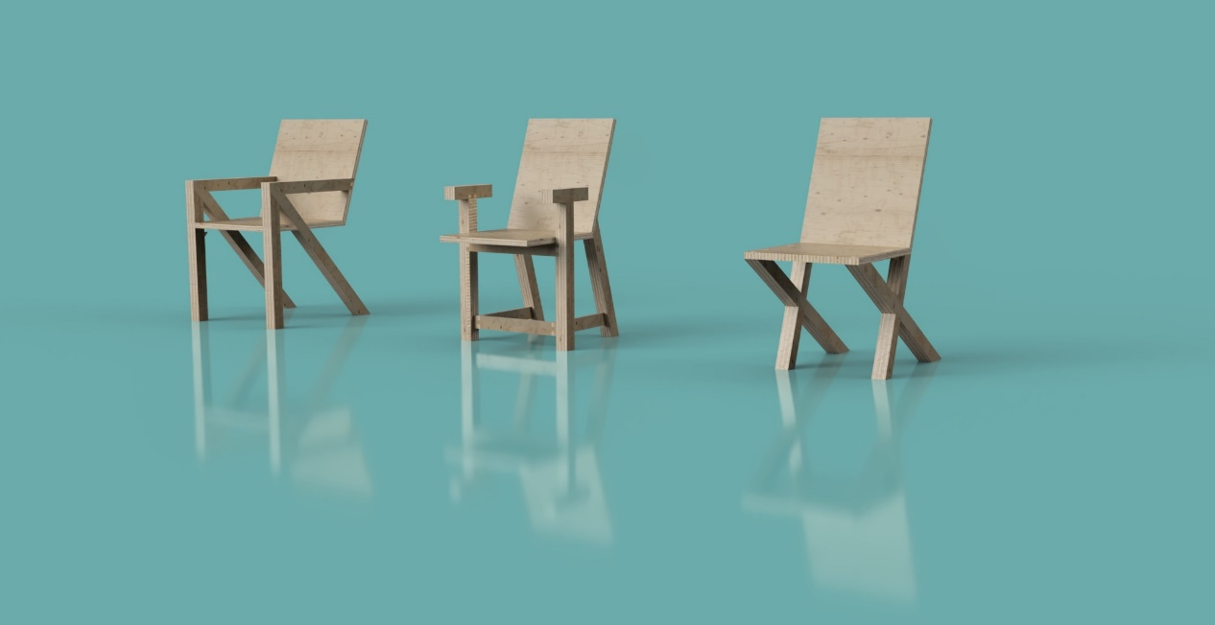

(Image 1, CAD model 3 types of chair)

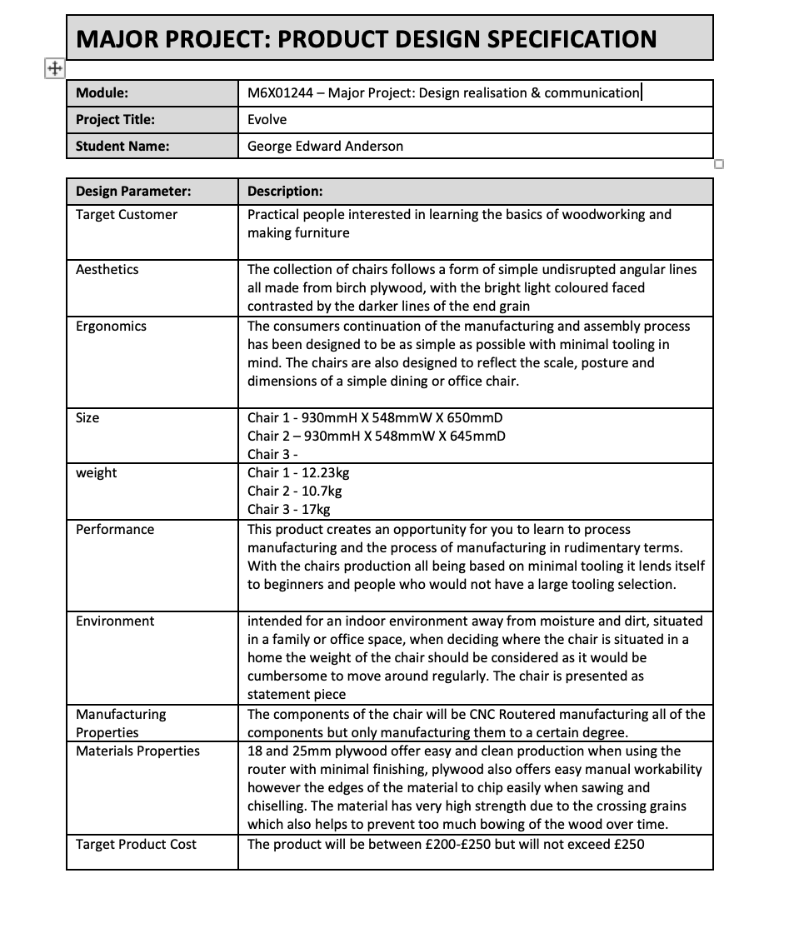

Design development
- Design conception and immediate feedback
  - My design was loose and fast, it had no real depth of thought and didn’t offer a clear picture of what would be designed
- Talk about the parts of the project that needed a major change, where the strengths of the concept were found within my idea and how that change my frame of mind of how I saw it
- Design language
- Development of joints and how they worked as individual and universal joints
- The development of the manufacturing process, ucworking the manual side vs the cnc side, how the CNC router was better a better basis to start from making from over making everything by hand
- Talk about how this was affected by the visual stimulus of seeing the project take shape early on

The initial project focus was creating an opportunity that gave all of the freedom and design challenges to the consumer, while still focusing on educating them through the process. This initial concept lacked direction and focus; it gave too much power to the consumer and did not offer any challenges from a design perspective. Moving the project in the direction of definition meant focusing on what is crucial to create an outcome. Basing these decisions on more prominent and promising values that a consumer would come to expect in a chair —upon moving forwards; I wanted to focus on human interaction and how that could be implemented into the manufacturing and also working on manufacturing more than one chair. From this point onwards, all of the designing focused on creating a product that offered simplicity in shape and construction. Parameters of this were as follows: simple production method and minimal tooling needed. This page of initial sketches shows an exploration of simplistic chair legs and arms. This process helped to inform a desired aesthetic, but it also allowed me to design without a predetermined idea of manufacturing and materials.
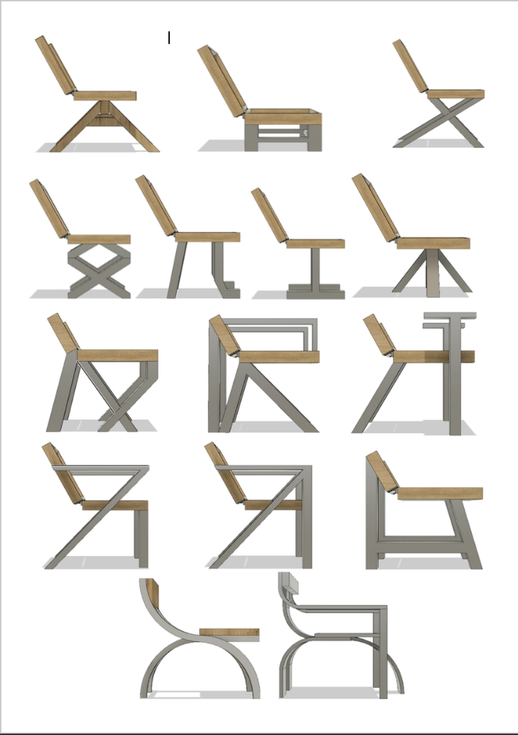
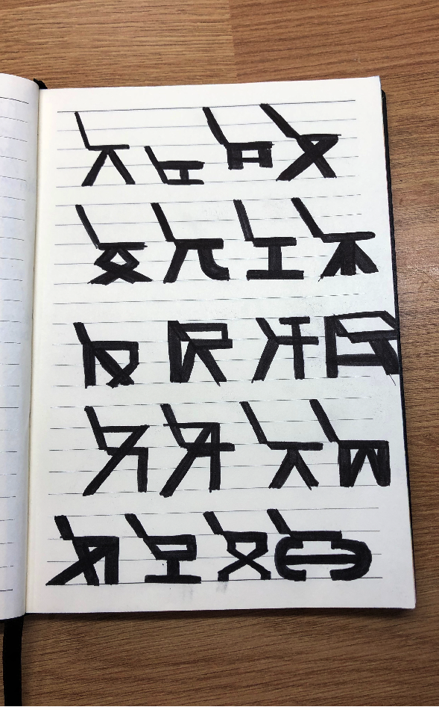
(image 2&3, sketches exploring chair legs & 3D models of each chair drawn)

I always started each sketch with the seat and back first. The intention of this being to create cohesion with all of the designs, pushing towards a more focussed idea of what I wanted my outcomes to be. In doing this, I found my desired style and created a design language; the chairs forms all had their similarities and differences, but they all look one of the same. This all became symbolic to me. Making me look deeper into the application of languages and how that translates into furniture and architecture. Looking specifically into languages like Katakana, which is one of the three syllabaries used in Japan. As an outsider to this culture and language, I was able to look on the lettering with an unbiased view and understanding of what the lines and forms meant.

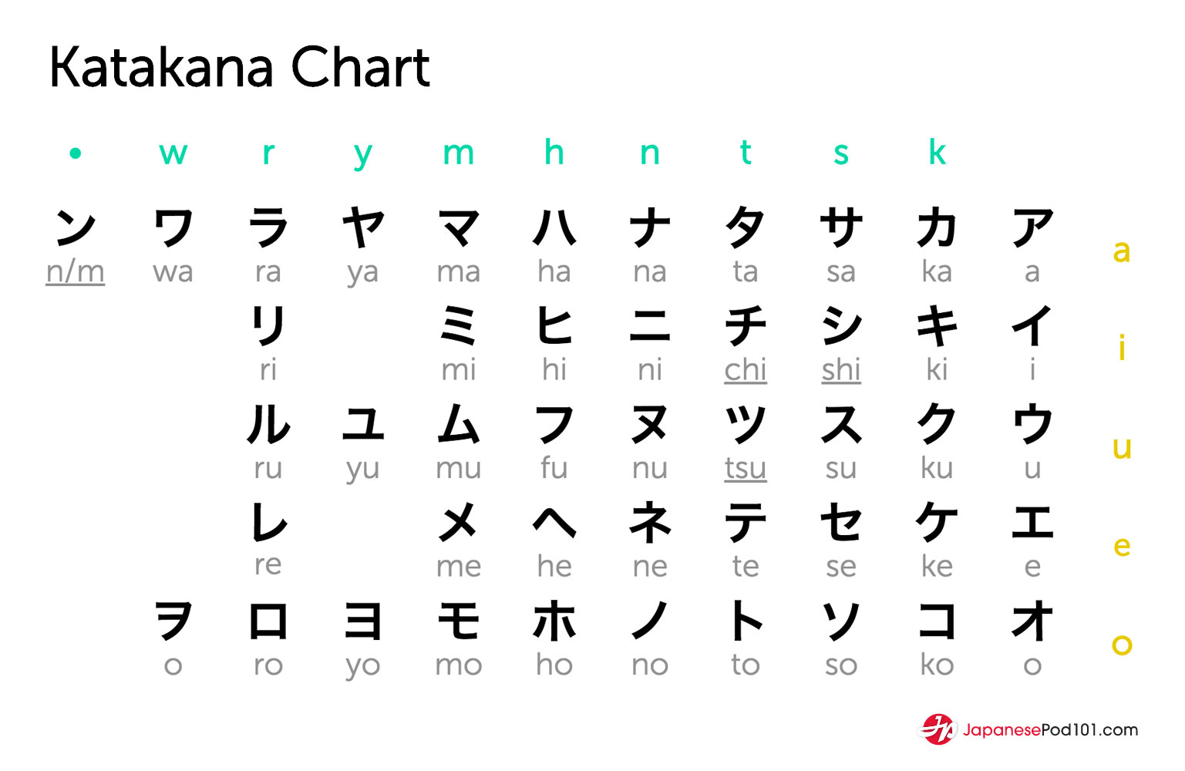
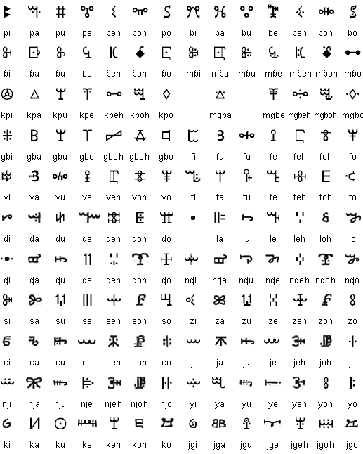

(Image 4 & 5 Vai and katakana syllabary)

Following on from this I created a 3D Cad model of each chair, focusing more on the manufacturing details, looking at the shape of the chairs and evaluating the feasibility of each chair, and what necessary additions would need to be made to take it from a sketch to an artefact.

Through the exploration of joinery and carpentry, I was looking into the contrast of traditional and modern techniques, following the same trend of foreign culture I looked into the complexity of Japanese kinetic wood joints against more modern techniques that can be achieved through up to date methods like CNC machinery. Japanese kinetic joinery showed me how complex joinery can be, with such small components playing a pivotal role.

Joint system
From previous research, I had identified in Japanese furniture and the joinery used was often embraced as a prominent feature of the design. These features are traditionally celebrated and highlighted, being both aesthetically pleasing and functional. I intended to mimic this in my own concepts during the design development phase. The joinery would be the focus of my project and essential throughout.

Following on from the above research, the furniture concept sketches looked similar to that of a knock down fitting with components attaching at the sides and ends of the main block. This type of joint is successful; however, I had realised that it did not offer a large amount of scope when introduced to complex furniture shapes and the accentuation of the joints would be limited.

I took my initial knock down fitting style model into CAD and focused on exploration of the form. After looking into k’nex and Lego I found that it was easier for me to create a family of joints for my products by using their philosophy as my template, creating a variety of shapes and components, all based around the same aesthetic however the application of these joints goes above and beyond their current use as they can be utilised in any orientation.

My approach to creating these joints by evaluating ad expanding on an aspect of a previous model allowed me to consider the manufacturing process of each shape and how that would impact the consumer. When designing this series of joints, it was important for me not to go overboard with shape and size and not consider the consumers ability, to help to test the joints and their complexity of manufacture I took several attempts at manufacturing the joints. From this I was able to deduce that whether the instruction was written and aimed at someone who has no skills in woodworking or not, mistakes and oversights should be expected.

This insight into the how difficult the process of hand manufacture and assembly actually is and showed me that a complete beginner would struggle greatly with this task, however, instead of the difficulty lying in the complexity of components it falls under the amount of work needing to be completed by hand with no guarantee that it would be completed to a standard high enough as to not compromise the strength of the chair.

To try to find the threshold of where industrial manufacture should end and manual assembly can begin I focused on manufacturing one type of joint however I attempted to complete each

looking to create more joints that acted as a connector.
I found that the connector was a better way to explore the applications of a joint as there is more variety in, utilising a connector within straight, square and angled joints rather than using a traditional static joint often creates a better marriage of the material and often an angled joint that is held together by pressure is stronger than a traditional joint.

allowed me to be less static with my placement of my joints

it for its shape and design and then broke it down into its most important components.

focusing on how I could create a more rigid shape that without over complicating the design by adding intricacies and

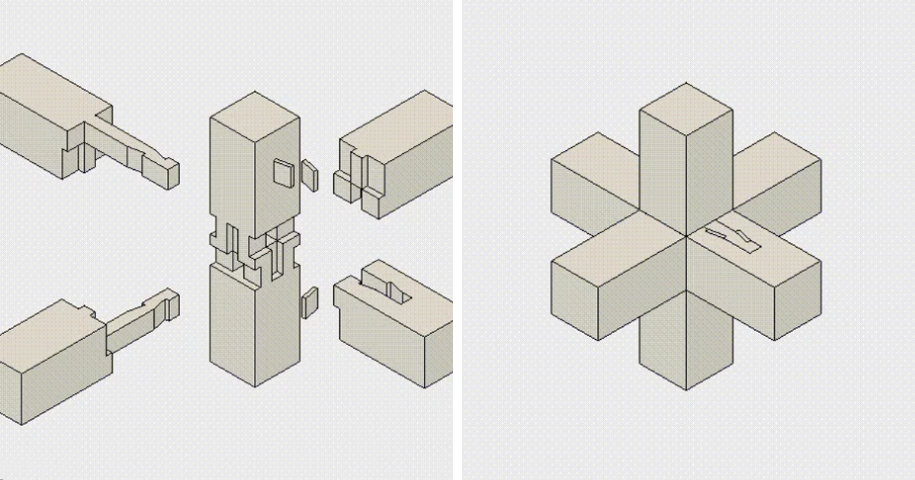
I based my project on the skills I could provide a consumer over what they would be receiving.

