Module Name: Financial Management
Module Code: BMIH5007
Module Leader: Tristan Hawkins
Student Name: Sorin Bindea
Student ID: 2246420
Total Word Count: 2087

Business Report Case Study
Comparison of Shangri-La Hotels and Premier Inn Hotels

Introduction
The hospitality industry is an ever-changing sector full of fierce competition by all the players who are trying to grab the market slice and customer loyalty (Gursoy and Chi, 2020). This report provides a comprehensive analysis and comparison of two prominent hotel chains: Shangri-La Hotels and Premier Inn Hotels focusing on their financial management strategies and practices from 2018 to 2024. It is aimed at choosing who has their best approaches in financial management, given key areas that may have a positive affect to their financial performance and sustainability.
The luxury accommodations and Asian hospitality are the signature of Singapore founding founded in 1971 (Shangri-La Group, 2024). Premier Inn, based in the United Kingdom and established in 1987 as a budget-friendly option, prides itself in providing quality stays at affordable prices (Whitbread PLC, 2024). Being in different markets, they both have issues in an evolving hospitality landscape that is similar.
It is a report which has been written through the combination of quantitative and qualitative research methods. In both companies’ financial data has been sourced from the most recent annual reports and financial statements. From reputable hospitality industry reports and academic journals, we have obtained market analysis and industry trends. Past CSR information was collected from company websites, sustainability reports and third-party assessments.
Analysis of Key Areas
Total Revenue
Shangri-La Hotels
From 2018 to 2024, the year-on-year revenue of the Shangri-La Group fluctuated, where the negative effects of COVID-19 were most evident (Shangri-La Asia Limited, 2018). In the year 2018, the group continued to post impressive performance with total revenue of $3.02 billion and $3.13 billion in the year 2019, representing an increase of 3.6% (Shangri-La Asia Limited, 2019). However, the pandemic led to a significant drop to $1.03 billion in 2020, that marks a 67% drop from the previous year (Shangri-La Asia Limited, 2020). The recovery from impacts of Covid-19 in 2021 was slow as the company generated $1.24billion revenue in 2021 before reaching $2.12bn in 2022 when restrictions in the region were eased (Shangri-La Asia Limited, 2021).
Despite recent global challenges, Shangri-La Hotels has shown resilience in its revenue generation. The revenue of the group in fiscal year 2023 was $1.24 billion, up from the previous year (Shangri-La Group, 2024). For the year 2024, the group expected to achieve $3.05 billion of revenue crossing the pre-COVID-19 level of 2019 (Shangri-La Asia Limited, 2022). This shows that the company bounces back from the aggressive impact of the pandemic very well post-2020.This recovery can be traced to the lifting of travel restrictions, as well as the increase in both leisure and business travel. Room revenue accounts for approximately 55% of total revenue and food and beverage sales generates approximately 35%, while other services, such as spa treatments, banquet facilities and retail operations, each contribute 10% to the company’s revenue (Shangri-La Asia Limited, 2023). Higher average daily rates (ADR) are crucial to Shangri-La's revenue model because it is a luxury positioning, with ADRs higher than mid-scale competitors. But it is also more likely to experience economic downturns, and changes to the luxury spending patterns.
Premier Inn Hotels
In the financial year of 2018/2019, Premier Inn made £2.05 billion in revenue that has risen only slightly to £2.07 billion in the financial of 2019/2020 (Whitbread, 2018). This was further brought down to £589 million in the financial year 2020/21 due to the lockdown measures and restrictions to trave (Whitbread, 2020) l. After the relaxation, revenue was recorded at £1.70 billion in the 2021/22 financial year.
In recent years, revenue performance from Premier Inn, part of Whitbread PLC, has been strong (Whitbread, 2023). Premier Inn, operated under Whitbread PLC, reported total revenue of £2.78 billion for the fiscal year 2023/24, up 35.8% over the previous year (Whitbread PLC, 2024). Room revenue (about 75% of total revenue) and food and beverage revenues from associated restaurants (about 25%) constitute this growth. Because Premier Inn’s revenue model is quick to market and has high occupancy rates and operational efficiencies, it can offer low prices and profitability (Whitbread, 2022). During turbulent economic times, travelers tend to go for more pocket friendly options and the business has held up well on focusing on the segment that is budget friendly.
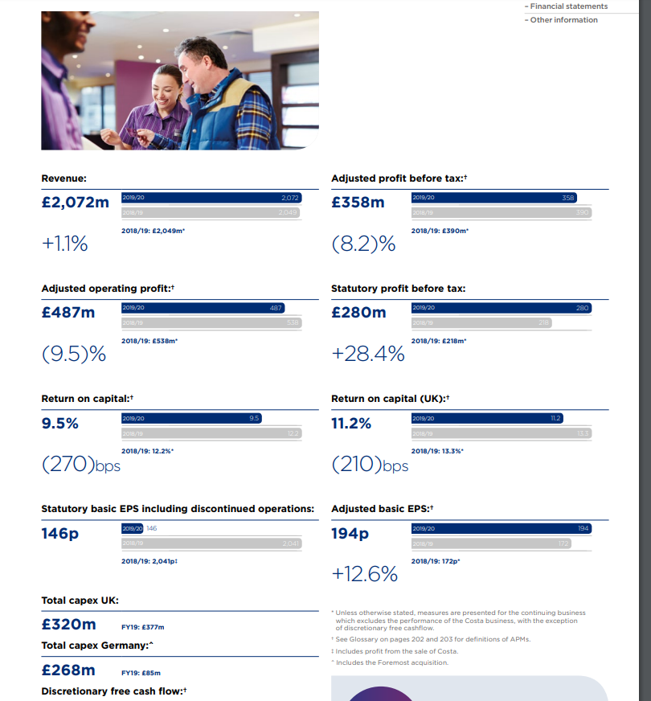
Source: (Whitbread, 2019)

Market Position
Shangri-La Hotels
Shangri-La Hotels occupies a strong place in the luxury segment of the hospitality market (Shangri-La Asia Limited, 2023). Especially in Asia Pacific regions, the brand is well established; North America and Europe are expanding. Shangri-La holds around 5 % of market share its luxury hotel segment in Asia, according to a Horwath HTL (2023) report. Among the key factors to the market position of Shangri-La are the recognition in its brand for luxury of the highest and the exceptional of service, the strategic locations in the main cities and touristic centers, as well as the loyalty among its customers, in particular among business travelers and rich leisure guests (Shangri-La Asia Limited, 2023). However, the brand of Shangri-La finds itself facing increasing pressure from existing brands offering luxury experiences, and from emerging boutique hotels satisfying the changing preferences of consumers for different, out of the ordinary stays.
Premier Inn Hotels
According to the PwC report (2024), Premier Inn today already dominates the UK market and is ahead of every competitor in the mid-scale hotel sector with a stated share of about 11%. The brand has also been diversifying its stores in Germany and in other countries in Europe (Whitbread PLC, 2024). Premier Inn’s market offering is positioned as affordable for business and leisure traveller, has high standard and similar product offering across UK, broad coverage across UK, and has well-established brand image and a loyal customer base (Premier Inn UK, 2023). However, the primary strategic management issue that facing Premier Inn relate with sustaining the company’s market dominance in the United Kingdom and effectively expanding its operations to other continents particularly Europe where it eager to compete with high-end domestic rivals (Whitbread PLC, 2024).
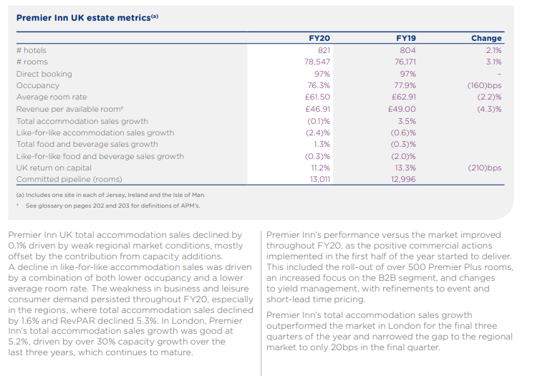
Source: (Whitbread, 2020)

Growth Potential
Shangri-La Hotels
Shangri-La's growth potential is primarily focused on:
- Expansion into new markets, particularly in Europe and the Americas
- Diversification of brand portfolio to capture different market segments
- Enhancement of digital capabilities to improve guest experiences and operational efficiencies
Industry analysts predict that growth in the luxury hotel market will reach a CAGR of 5.2 percent from 2024 to 2029 (Mordor Intelligence, 2024). Given Shangri-La's strong positioning to benefit from this growth, in particular in emerging markets where luxury travel is booming, it is clear why they are not all that concerned. Yet, it faces high development costs for luxury properties, more competition in key markets, and the potential economic unknowns that can often affect how much luxury spenders actually own.
Premier Inn Hotels
Premier Inn's growth strategy focuses on:
- Continued expansion in the UK market
- Aggressive growth in Germany and other European countries
- Investment in technology for improved operational efficiency and guest experience
- Exploration of new brand extensions to capture different market segments
The specific budget and mid-scale hotel segment are expected to grow at a CAGR of 4.7% for the period of 2024 to 2029 (Mordor Intelligence, 2024). This growth suits Premier Inn’s value proposition perfectly because as the journey evolves, people become more conscious about spending. Premier Inn facing issues in several areas: there are too many established players in the UK market, accustoming the company to work with different European markets, and competition from different forms of accommodation such as Airbnb (Whitbread PLC, 2024).
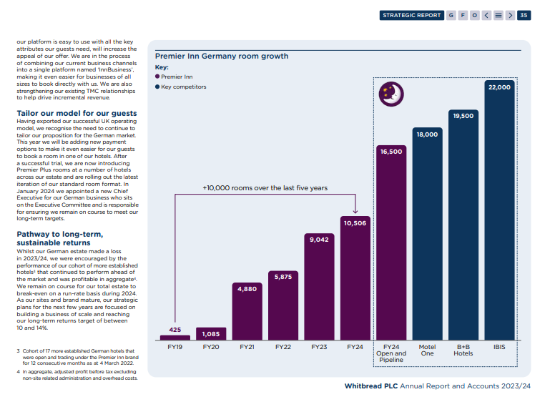
Source: (Whitbread PLC, 2024)

Financial Commitment to CSR
Shangri-La Hotels
In this particular area, Shangri-La has done an excellent job in the promotion of CSR programs. As of 2023, the CSR expenditure of the group was at around 2% of its pre-tax profit (Shangri-La Group, 2024). Key areas involve environmental and social issues which entail deployment of green energy to the organization and efficient models in management of wastes. This also comprises community involvement in the sponsorship of various local education and health related causes. In addition, another important supply chain management focus area is responsible sourcing, which cover commitment to sustainable seafood, as well as locally sourced products (Shangri-La Asia Limited, 2023). Organization CSR policies have been accredited more by sustainability indexes such as the Dow Jones Sustainability Index (DJSI) Asia Pacific.
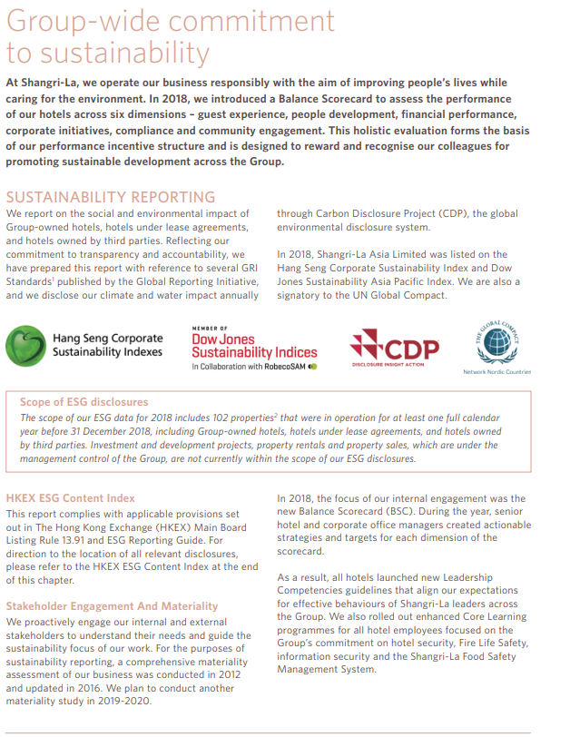

Premier Inn Hotels
Premier Inn, as part of Whitbread PLC, has fully integrated CSR into its business strategy. At £7.2 million, this figure depicts where the company spent in CSR initiatives in the fiscal year 2023/24 (Whitbread PLC, 2024). That includes carbon reduction, such as commitment to getting to net zero carbon emissions by 2040. It also includes responsible sourcing. For instance, they use 100% Better Cotton Initiative (BCI) certified cotton. Community support is also enhanced through partnerships programmed with local charities and employment initiatives. Whitbread, parent of Premier Inn, has been included in the FTSE4Good Index, which recognizes its strong Environmental, Social and Governance (ESG) practices (Whitbread PLC, 2024).
Comparison Table to Financial Commitment to CSR
Year | Shangri-La Hotels | Premier Inn Hotels
2018-2019 | Invested $2.5 million annually in community initiatives (Shangri-La Group, 2020) | Raised over £7 million for Great Ormond Street Hospital Children's Charity (Whitbread PLC, 2019).
2020 | Donated $3 million worth of in-kind support to local communities during the pandemic (Shangri-La Group, 2021). | Committed to net-zero carbon emissions by 2040 (Whitbread PLC, 2022).
2021 | Launched "Sanctuary, Shangri-La's Care for Nature" project (Shangri-La Group, 2022). | Committed to net-zero carbon emissions by 2040 (Whitbread PLC, 2022).
2022-2023 | Committed to eliminating single-use plastics and reducing carbon intensity by 50% by 2030 (Shangri-La Asia Limited, 2024). | Achieved 100% renewable electricity use in UK operations (Whitbread PLC, 2023). Diverted 99% of operational waste from landfill (Whitbread PLC, 2024).
2024 | Invested $5 million in sustainable tourism initiatives (Shangri-La Asia Limited, 2024). | Invested £10 million in community and environmental initiatives (Whitbread PLC, 2024).

Recommendations
For Shangri-La Hotels
Shangri-La should strengthen its position in the strategic development of the brand by expanding its brand portfolio. This could include creating a new top-skin target market mid-price brand that needs to be established to counter the growing ‘True North’ mass luxury brand market. Thus, Shangri-La could widen its client populace replies and, at the same time, insurance oneself against economic shifts contemplating the luxury segment. The market is less saturated in Europe and North America than in Asia therefore, there is the potential to grow in the market (Shangri-La Asia Limited, 2023). The company’s extensive brand image and cognizance in luxurious clientage render it capable of exploiting these regions. For the hotel to create value, it has to apply digital transformation strategies that align with the changing appetite of the luxury traveler and to attempt to compete effectively with the current traditional models of luxury originating from the western world.

For Premier Inn Hotels
For Premier Inn, there is a need to ramp up its investment on technology and data analytics as means for its ability to create better customer experience and to optimize business processes. As for the information about customers, Premier Inn can identify pricing policies and adjust the benefits for guests while offering the maximal company’s performance of the existing weak links. This technology-driven strategy will be imperative to sustain its position in budget and mid-scale segment while continuing the journey into the virgin geographies of Europe. The current budget hotel market in Germany is small and dispersed, making room for the market leader capitalized competitor like Premier Inn. Building a brand awareness is especially important if Premier Inn wishes to achieve the same results as on the British market in other countries (Premier Inn UK, 2023). The suggestion that the company can benefit from new sub-brand introduction is that this strategy can allow the cement its coverage of a broader market segment while relying on the existing operational skills and economy of scale.

Conclusion
Shangri-La Hotels and Premier Inn Hotels have proven to be outstanding performers in their own respective market segments. Shangri-La has been extremely successful in leading customer experience through the luxury route with a strong emphasis on Asian hospitality while Premier Inn has made its mark excelling in budget and mid-scale market with its value for money proposition. Their changeability to emerging customer preferences, the use of tech, and maintaining their dedication to sustainability and social responsibility will be the key to their future success in either chain. The implementing of the suggested strategies will help Shanggri La to strengthen its position on the market and Premier Inn to grow sustainably in the crowded hospitality environment.

References
Deloitte (2023) Global hospitality insights: Top 10 trends for 2023. Available at: https://www2.deloitte.com/global/en/pages/consumer-business/articles/global-hospitality-insights.html (Accessed: 10 October 2024).
Horwath HTL (2023) Global Hotel Market Sentiment Survey. [Online]. Available at: [URL] (Accessed: 10 October 2024).
Kucukusta, D., Luo, Y. and Li, H. (2021) 'The role of luxury hotels in promoting sustainable tourism development', Journal of Hospitality and Tourism Management, 47, pp. 217-228.
Mordor Intelligence (2024) Global Hotel Market - Growth, Trends, COVID-19 Impact, and Forecasts (2024-2029). [Online]. Available at: [URL] (Accessed: 10 October 2024).
Premier Inn (2024) About us. Available at: https://www.premierinn.com/gb/en/about-us.html (Accessed: 10 October 2024).
Premier Inn UK (2023) FY23 results. https://cdn.whitbread.co.uk/media/2023/04/Final-FY23-RNS-Final-Combined.pdf.
PwC (2023) UK hotels forecast 2023-2024. Available at: https://www.pwc.co.uk/industries/hospitality-leisure/insights/uk-hotels-forecast.html (Accessed: 10 October 2024).
Shangri-La Asia Limited (2018) Annual Report 2018. https://sitecore-cd.shangri-la.com/-/media/Project/Shangri-La-Group/Investor/Files/Public-Disclosures/Financial-Information/Financial-Reports/2018_Annual_Report.pdf (Accessed: October 13, 2024).
Shangri-La Asia Limited (2019) Annual Report 2019. https://sitecore-cd.shangri-la.com/-/media/Project/Shangri-La-Group/Investor/Files/Public-Disclosures/Financial-Information/Financial-Reports/2019Annual-Report-Eng.pdf.
Shangri-La Asia Limited (2020) Annual Report 2020. https://sitecore-cd.shangri-la.com/-/media/Project/Shangri-La-Group/Investor/Files/Public-Disclosures/Announcements-and-Circulars/2021/2021-04-26-AR_E.pdf.
Shangri-La Asia Limited (2021) Shangri-La Asia Limited Annual Report 2021. https://sitecore-cd.shangri-la.com/-/media/Project/Shangri-La-Group/Investor/Files/Public-Disclosures/Latest-Top-Publications/2021_Annual-Report_E.pdf.
Shangri-La Asia Limited (2022) Shangri-La Asia Limited Annual Report 2022. https://sitecore-cd.shangri-la.com/-/media/Project/Shangri-La-Group/Investor/Files/Public-Disclosures/Latest-Top-Publications/e0069_230418_AR.pdf.
Shangri-La Asia Limited (2023) Shangri-La Asia Limited Annual Report 2023. https://sitecore-cd.shangri-la.com/-/media/Project/Shangri-La-Group/Investor/Files/Public-Disclosures/Latest-Top-Publications/2023_Annual_Report_E.pdf.
Shangri-La Group (2024) Annual Report 2023. [Online]. Available at: [URL] (Accessed: 10 October 2024).
Whitbread (2018) Interactive PDF, Whitbread Annual Report and Accounts 2017/18. https://cdn.whitbread.co.uk/media/2021/02/15101527/Whitbread-Interactive-2018.pdf (Accessed: October 13, 2024).
Whitbread (2019) Annual Report & Accounts 2018/19, Whitbread Annual Report and Accounts. https://cdn.whitbread.co.uk/media/2021/02/15100612/Whitbread_18-19-Full-Report_Final_Final-1.pdf (Accessed: October 13, 2024).
Whitbread (2020) ANNUAL REPORT AND ACCOUNTS 2019/20. https://cdn.whitbread.co.uk/media/2021/02/03114406/2020-annual-report-and-accounts.pdf (Accessed: October 13, 2024).
Whitbread (2022) REST EASY WITH PREMIER INN Annual Report and Accounts 2021/22. report. https://cdn.whitbread.co.uk/media/2022/05/Whitbread_AR21-1.pdf(Accessed: October 13, 2024).
Whitbread (2023) Annual Report and Accounts 2022/23. https://cdn.whitbread.co.uk/media/2023/05/Whitbread_AR22_Interactive.pdf.
Whitbread PLC (2021) ANNUAL REPORT AND ACCOUNTS 2020/21. https://cdn.whitbread.co.uk/media/2021/05/05141427/23076_Whitbread_AR2020_web.pdf.
Whitbread PLC (2024) Annual Report and accounts 2023/24. https://cdn.whitbread.co.uk/media/2024/05/Whitbread-PLC-Annual-Report-and-Accounts-2023_Single_pages-1.pdf (Accessed: October 13, 2024).

