

Name: Azhda Ali
Student ID: 2436859
Module Code: LCHS4008
Module: Introduction to Public Health
Assignment Title: Report on a Health Issue
Lecturer: Hajra Mustasim

Submitted on: 18/11/2025

Table of Contents
- Introduction 3
Definition of whooping cough (pertussis)
Signs and symptoms
Global and UK incidence
- Consequences for the Community and NHS 4
Impact on infants and vulnerable groups
Hospital admissions, treatment costs, and NHS resource strain
Wider social and economic effects on families and communities
- Control of Whooping Cough 5
Vaccination programmes
Surveillance
Challenges

- Factors Influencing Health and Wellbeing 6
Clinical vulnerability
Psychosocial impacts on families and caregivers
Sociocultural influences
Structural inequalities
Application of COM-B model
- Limitations and Measurable Recommendation 7
- Conclusion 8
- Reference List 9

Whooping Cough (Pertussis)

Introduction

Whooping cough, medically known as pertussis, is a highly contagious respiratory infection caused by the bacterium Bordetella pertussis (CDC, 2024). It typically begins with mild catarrhal symptoms before progressing to paroxysmal coughing, a characteristic inspiratory “whoop,” post-tussive vomiting, and episodes of apnoea in infants (RCPCH, 2024). Although vaccine-preventable, pertussis stays a persistent global public health challenge because immunity wanes following vaccination or natural infection, and cases are often underdiagnosed (WHO, 2024). This report examines the consequences of pertussis for individuals, communities, and the NHS, evaluates control and prevention strategies, and explores factors influencing the health and wellbeing of affected families.

Globally, the World Health Organization estimates approximately 151,000 notified cases each year, but the true burden is likely higher due to underreporting and variable surveillance systems (WHO, 2024). In England, cases rose sharply in 2024, with 14,894 confirmed infections compared with 856 in 2023 to 1,600% increase and 11 infant deaths reported, highlighting significant national vulnerability (UKHSA, 2025; Pharmaceutical Journal, 2025).

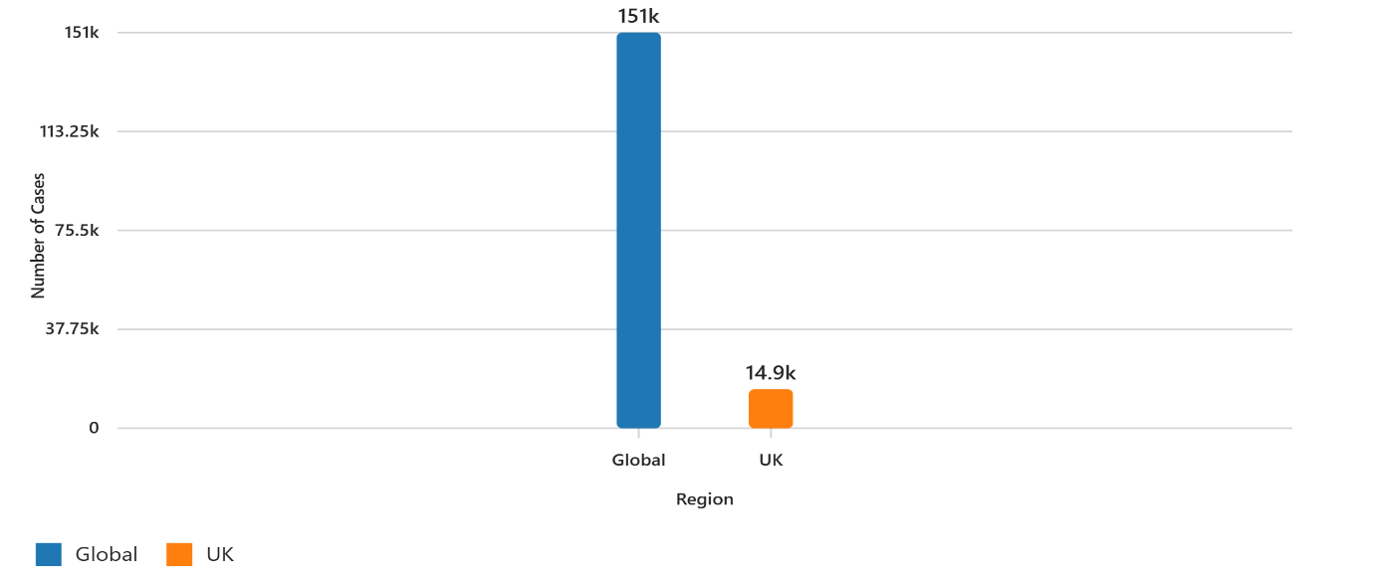
Figure 1. Global vs UK Pertussis Cases (WHO 2024, UKHSA 2025)

Consequences for the Community and NHS

Pertussis most severely affects young infants who have not yet completed the primary immunisation schedule, placing them at the highest risk of hospitalisation and death (RCPCH, 2024). Severe cases often require prolonged monitoring, oxygen therapy, or intensive care, which increases demand on paediatric and neonatal services. During the 2024 surge, paediatric and neonatal admissions rose by approximately 40% in English regions, with average hospital stays lasting 5–10 days (UKHSA, 2025). Each hospitalised case is estimated to cost the NHS between £3,500 and £5,000 in direct inpatient care, not including follow-up appointments and wider public health activities (NHS Digital, 2024).
These clinical pressures create significant financial and operational strain. Public health responses such as enhanced surveillance, contact tracing, post-exposure prophylaxis, and targeted vaccination campaigns require staff time, medication, communication resources, and often divert capacity from routine services (UKHSA, 2025). Families are also affected: parents often miss work to care for unwell children, leading to reduced income and wider productivity losses. Long-term complications such as pneumonia, seizures and, in rare cases, encephalopathy increase the need for follow-up, rehabilitation, and ongoing healthcare use (WHO, 2024).
Outbreaks also disrupt community functioning and reduce social trust. When schools or early-years settings experience increased cases, parents may withdraw children, cause lower attendance and rise anxiety. This can also affect engagement with routine healthcare, including childhood vaccination uptake (BMJ, 2024).
Figure 2 shows laboratory-confirmed pertussis cases in England from 2019 to 2025, with a marked peak in 2024. This increase highlights the scale of the outbreak and the need for strengthened surveillance, consistent public communication, and improved vaccination strategies (UKHSA, 2025).

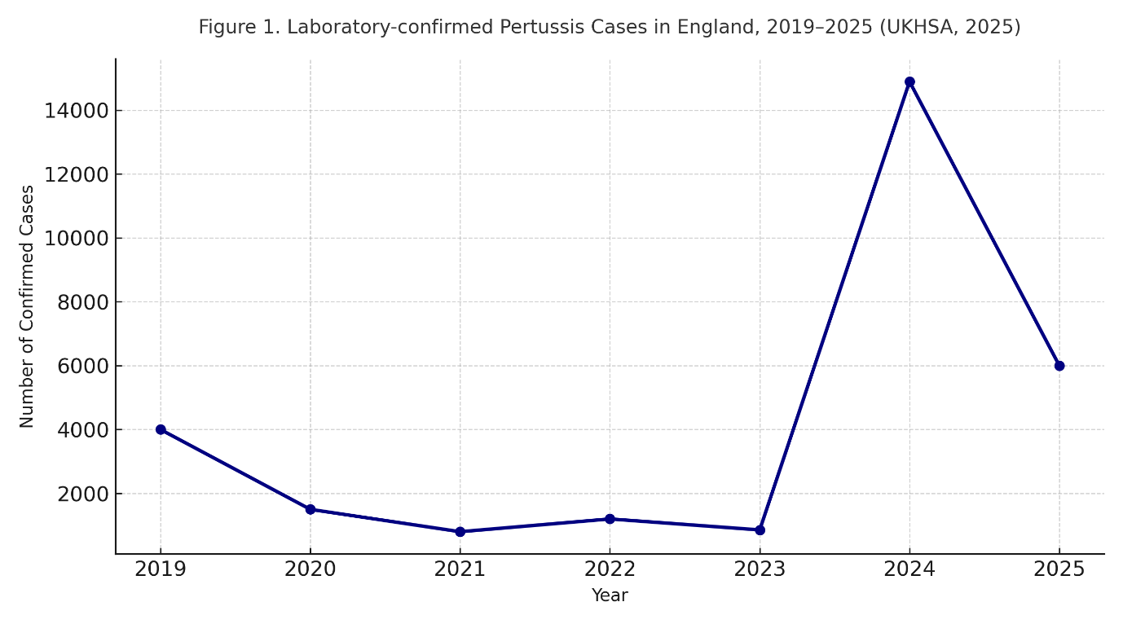
Figure 2. Laboratory-confirmed pertussis cases in England, 2019–2025 (UKHSA, 2025)
Alt text: Line chart showing pertussis cases in England, with a sharp rise in 2024.

The burden of pertussis is not evenly distributed. Social determinants such as poverty, overcrowded housing, limited transport access, insecure employment, and lower health literacy increase exposure risk and delay access to vaccination and treatment (Miller et al., 2023). These inequalities worsen the immediate impact of outbreaks and make them harder to control.

Control of Whooping Cough

Vaccination is the main method of preventing pertussis. In the UK, vaccines are given at 8, 12 and 16 weeks (primary series), followed by preschool and adolescent boosters. Since 2012, maternal vaccination during pregnancy has been recommended to provide passive protection until infants can receive their own vaccines (UKHSA, 2025). Evidence shows that maternal immunisation significantly reduces infant hospitalisations and deaths by transferring antibodies across the placenta (UKHSA, 2025).
Effective control also depends on strong surveillance. UKHSA provides epidemiological monitoring and outbreak guidance, while local public health teams coordinate contact tracing and post-exposure prophylaxis for close contacts (UKHSA, 2025). Internationally, WHO and UNICEF support global surveillance networks and advise on vaccination schedules adapted to changing epidemiology (WHO, 2024).
However, various challenges stay. Immunity, whether from vaccination or infection occur wanes after around 5–10 years, creating susceptible adolescents and adults who can pass infection to infants (CDC, 2024). Vaccine hesitancy, fuelled by misinformation, reduces uptake and weakens herd protection (BMJ, 2024). In low-income countries, limited vaccine supply and access difficulties set up global reservoirs of infection and hinder eradication efforts (WHO, 2024).
Comparative policy analysis suggests that combining approaches can improve outcomes. The UK’s maternal vaccination programme protects newborns effectively, while countries such as France use both maternal immunisation and adolescent boosters, reporting lower transmission among older children and young adults. This suggests that a life-course vaccination strategy could reduce community spread more effectively (Lancet Infectious Diseases, 2023). Operational measures - rapid identification of cases, isolation, prompt macrolide antibiotics for cases and contacts, and proportionate measures in educational settings - help limit spread but must be balanced with the need to keep normal schooling and minimise social disruption (UKHSA, 2025).

Factors Influencing Health and Wellbeing

Clinical vulnerability interacts with psychosocial and structural determinants to shape outcomes. Infants under three months, unvaccinated children, and those with comorbidities face the highest medical risk from pertussis (RCPCH, 2024). Families experience significant psychological stress when infants are hospitalised: fear of apnoea episodes, disrupted sleep, exhaustion, and worries about long-term effects can contribute to caregiver burnout and reduced family wellbeing (BMJ, 2024).
Sociocultural factors also influence vaccine acceptance and care-seeking behaviours. Trust in healthcare providers, past experiences with services, education, and community norms all shape decisions around maternal and childhood vaccination (UKHSA, 2025). Misinformation spreads more easily in areas with low health literacy or limited trust in institutions, while language and cultural differences can delay engagement with services (WHO, 2024; Miller et al., 2023). Structural inequalities - such as limited clinic hours, transport barriers, and insecure employment create opportunity costs for attending immunisation appointments and may delay presentation during illness.
Applying the COM-B behaviour model helps guide intervention planning. Improving Capability through antenatal education and staff refresher training addresses knowledge and skills gaps. Increasing Opportunity by extending clinic hours, offering mobile vaccination clinics, and collaborating with community partners reduces practical barriers. Strengthening Motivation through personalised counselling, SMS reminders, and myth-busting campaigns addresses beliefs and social influences that discourage vaccination. Together, these actions form an evidence-based strategy to increase maternal and infant vaccine uptake and reduce transmission (Michie, van Stralen and West, 2011; UKHSA, 2025).
Healthcare professionals have essential roles. Midwives should provide pertussis counselling and offer maternal vaccination during antenatal appointments. Health visitors should check infant immunisation status at the 6–8-week contact and arrange follow-up where needed. GPs can support uptake by using electronic prompts to recall unvaccinated patients and offering opportunistic vaccination (RCPCH, 2024; UKHSA, 2025). Community outreach, translated materials, and partnerships with schools, faith groups, and voluntary organisations can improve reach and trust, helping address local inequalities (Miller et al., 2023).
Practical steps also include strong interagency collaboration between NHS Trusts, local councils, and public health teams to support prompt information-sharing and outbreak control. Localised public awareness campaigns during seasonal increases can further improve engagement, especially when delivered through trusted community networks.

Limitations and Measurable Recommendation
Surveillance data underestimate the true incidence of pertussis because of underdiagnosis, variable testing, and inconsistent reporting. Cost estimates often focus only on direct inpatient care and do not include wider societal costs, such as lost productivity for families.
Conduct a six-month audit of maternal pertussis vaccine uptake by local authority ward. For the lowest-coverage 10% of wards, implement targeted outreach mobile vaccination clinics, translated leaflets, and support from community champions. Report uptake figures quarterly to UKHSA to check improvement.

Conclusion
Whooping cough is still a preventable yet persistent public health threat. The UK’s sharp increase in 2024 highlights continuing vulnerability, particularly among infants who depend on maternal antibodies and prompt immunisation for protection (UKHSA, 2025). Its impact extends beyond acute illness to psychological, social, and economic burdens that disproportionately affect disadvantaged communities (Miller et al., 2023).
Reducing the pertussis burden requires coordinated action is keeping high vaccine coverage across the life course, robust surveillance, rapid outbreak response, and targeted interventions to remove access barriers and counter misinformation (WHO, 2024). Integrating maternal immunisation with adolescent boosters, supported by practical measures - antenatal education, mobile clinics, reminder systems, and community partnerships and offers the best route to protect infants and reduce transmission. Healthcare professionals must deliver culturally sensitive, evidence-based communication and support to rebuild trust. Prevention through vaccination and inclusive public health practice stays the most effective strategy (UKHSA, 2025).

Reference List

ADPH London (2024) Whooping cough cases rise to over 10,000. Association of Directors of Public Health London. Available at: https://www.adph.org.uk (Accessed: 12 November 2025).
BMJ (2024) ‘Whooping cough rises sharply in UK and Europe’, BMJ, 387, p. 12.
CDC (2024) Pertussis in Other Countries. Centers for Disease Control and Prevention. Available at: https://www.cdc.gov/pertussis (Accessed: 12 November 2025).
Lancet Infectious Diseases (2023) ‘Adolescent pertussis booster campaigns in France: impact on incidence’, Lancet Infectious Diseases, 23(7), pp. 845–852.
Michie, S., van Stralen, M. and West, R. (2011) ‘The behaviour change wheel: a new method for characterising and designing behaviour change interventions’, Implementation Science, 6:42.
Miller, J., Patel, R. and Khan, S. (2023) ‘Social determinants and vaccine uptake in respiratory diseases’, Journal of Public Health, 45(2), pp. 210–219.
NHS Digital (2024) Hospital Episode Statistics: Pertussis Admissions and Treatment Costs. Available at: https://digital.nhs.uk (Accessed: 12 November 2025).
Pharmaceutical Journal (2025) Whooping cough cases increase by 1,600% in a year. Available at: https://pharmaceutical-journal.com (Accessed: 12 November 2025).
RCPCH (2024) Response to rise in whooping cough cases. Royal College of Paediatrics and Child Health. Available at: https://www.rcpch.ac.uk (Accessed: 12 November 2025).
UKHSA (2025) Pertussis epidemiology in England 2024. UK Health Security Agency. Available at: https://www.gov.uk (Accessed: 12 November 2025).
WHO (2024) Pertussis reported cases and incidence. World Health Organization. Available at: https://www.who.int (Accessed: 12 November 2025).

