University of Wales Trinity Saint David

BSc Health and Social Care

Living with Care: The Older Person
BMHP6009_BIRM

Lecturer: Joanne Davies

Shirley Obeng Asare
Student ID: 2021949

Table of Contents

Introduction 3
What is ‘Old Age? 3
The Changing Ageing Population 4
How have people changed? 5
Health and Social Care Provision 6
Conclusions and Recommendations 7
References 8

Introduction

People in most developed countries are living longer. This is probably because of the advanced technology, improved eating habits and lifestyle choices. When people grow, they have health problems, and these are inevitable with old. People in their old age look for proper care but these might have serious impact on finance. They are also concerned with the thought of losing family members or loved ones, expectation of quality of life, and battling with retirement and expectation of death. Older people around the world have had serious and complex healthcare needs than their younger adults. This is because older people require extra support due to a deterioration of functional illness, physical weaknesses, and psychological needs (Laslett, 1996). Usually lack of proper care to address the needs of older people may lead to increasing complications and even death.
The purpose of this report is to explain the principle of old age, and most importantly discuss the different support systems and interventions available, including policies, health, and social care provisions, as well as government and health service responses. The report will include the relevant ageing theories discussed in class and found elsewhere to support the discussion. The ageing theories provide a guide to nurse or health professional to assist how elderly patients go through the changes they experience (Laslett, 1996).

What is ‘Old Age’?

There is no simple definition of ‘Old Age’ as it may vary based on the culture and social group. According to Vincent (2003), proper definition for old age requires the one to define the boundaries for better appreciation of the concept. What makes the definition even more difficult is how to determine when old age begins which differs for every society. In our societies, children are known as “social and economic dependents”, so Roebuck (1979) believed that old age should be described and regarded in the same vein as they are not involved in any formal labour market and greatly depend on the support and help from hospital, social services, and family and friends Having said that the difference in the psychological, physical and financial state of people of over 60 years make this definition inconsistent or problematic. There is a general African adage that, “old age depends on how you feel in your bones”. As indicated in the Britannica Dictionary, old age could be the age nearing the life processes of a person, or an age representing a particular generation of the members of old age population (Britannica, 2023). The World Health Organisation (WHO) does not prescribe a definitive answer for old age but they agree with other authors that definition is problematic and depended on societies. However, the international organisation highlighted that old age is commonly associated with complex health issues such as the hearing loss, weakness, falls, physical imbalance, depression, dementia, diabetes, and general body pains (WHO, 2023). In support of these assertions, the British Geriatrics Society (BGS) argues that there is a need to redefine old age as evidence supports the fact that people of the 60 years and above refuse to accept or admit that they are old because of their very active and healthy life (BGS, 2017).

The Changing Ageing Population
Aging Population is defined as the changes in the structure of age distribution of a population giving rise to the percentage of older people (Land and Lamb, 2008). By the year 2050, percentage of older group will increase dramatically. The aging population is expected to affect all nations as shown in Figure below, and can have economic, social and political decisions (SmartStudy, n.d). The growing population could be due to decreasing fertility and improvement in mortality. Another factor for the aging population might be migration of people into and out of the country, which can mostly affect the structure of the population.
As previously indicated, ageing results from the gradual decline and deterioration of the molecules and cells that make up the body. It then leads to the reduction in mental capacity, physical capacity and emergence of diseases and finally death (WHO, 2023). According to WHO (2023), there is no positive or negative relationship regarding these difficulties with the age of the person, however, we could draw inference from the diseases and death of the segment of the population with the older person.
The ageing population of the modern society of Britain has changed fundamentally since over hundred years ago. In the 1980s, only a tenth of the population of the English society was aged over 60 years but by 1991, the figure had risen to about 20% (Laslett, 1996). Today, about 11 million people are over the age of 65 in the UK. This equates to around 19% of the UK population. Estimates suggest that in ten years this figure will increase to around 22% of the population being aged 65 or over in England (NHS, 2023). This issue is not only peculiar to England but is common amongst the many developed countries with significant rise in the ageing population as shown in the figure below:
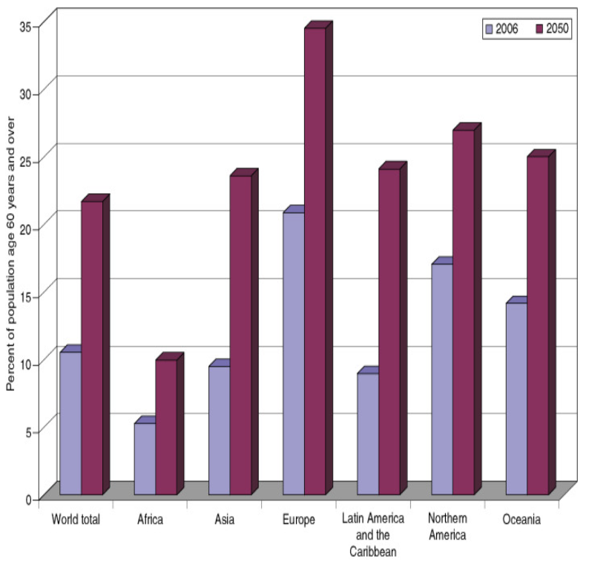
Source: K.C. Land, V.L. Lamb (2008)

It is also estimated that by 2050, 80% of people who are classified within the old age bracket will be found in the low- and middle-income countries (WHO, 2023), which makes the ageing population increase faster than it used to be in the past.

How have people changed?
The theories of ageing help us to understand how people change, and the way they interact with the wider society. It also allows us to address the issue of ageing on the basis of the society that the person belongs. So, for example, the theories make us treat older people differently and thereby address inequalities based on the culture and not put them all into one category (WHO, 2023). However, during the pandemic, older people were isolated from their families because of the possibilities of being affected by deady virus. As much as being a painful decision taken by governments, it was seen as the most efficient way of reducing high mortality rates amongst the older generation. Indeed, as people get older, they are exposed to different opportunities and activities on the basis that they are old. This issue is explained by the conflict theory of ageing, allowing us to address the issue of discrimination on the basis of age (Centre for Ageing Better, 2023).
As people grow and become older, they gradually withdraw and distance themselves from the wider society (SmartStudy, n.d.). This is in line with the Disengagement Theory of Aging. The theory argues that the reason for the gradual withdrawal from major activities is that because older people gradually lose their mental and physical capacity, they naturally distance themselves from things they are not capable of doing (Lange and Grossman, 2010). Though this theory is a widely accepted stance for old age, other people criticise the theory that not all people withdraw from major activities and society as it is being claimed (Allemand, Zimprich and Martin, 2008). In support of this, the Activity Theory of Aging assume that the elderly people would need to readjust themselves to conform to their new old age personalities. This is the reason why old people should be helped to engage and become more active through games, movies, communal activities so that they can be happy in their old age (Piggott and Woodland, 2016). Older people should not be left alone but engage in some activities, however, critics have argued that not all people have equal opportunities, activities, and access so some people are discriminated in a way.

Health and Social Care Provision
Health and social care problems and challenges have existed in the face of increasing life expectancy leading to a growing ageing population (Mortimer and Green, 2015). The increasing life expectancy has been leading to increasing number of older people with dementia and other old-age disabilities. It has been reported that more people require intensive care, though this has been difficult with austerity funding and pressures on the NHS in recent years (Lewis and West, 2019). In addition to this, the UK in particular have experienced shortage of Carers in recent times so the problem of formal care provision becomes a big challenge. It has also been reported that older people have unmet needs which require urgent care (EHCRC, 2020). There is an argument that older people are not likely to receive support regarding their individual care activities such as cooking, bathing, shopping, getting dressed, going to the toilet, etc as shown below:
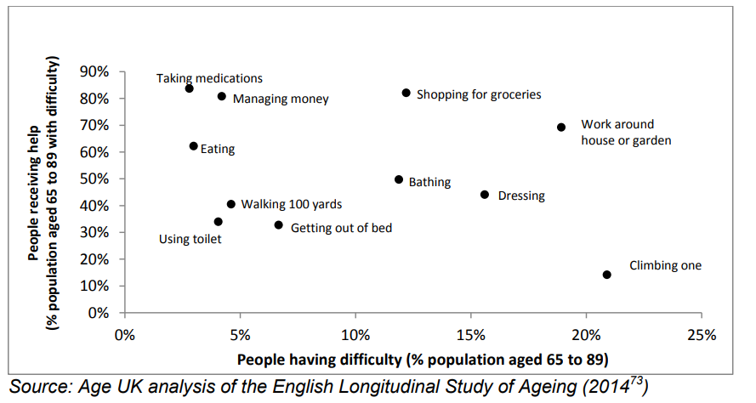

Over the years, policies and legislations such as the Human Rights Act (1998), Equality Act (2010), Care Act (2014), NHS policy- National and Regional, and the Centre for Policy on Ageing have helped to guide a proper framework for providing quality care for the aged. The Human Rights Act (1998), for example, ensures the basic human rights of older people are respected by everybody involved with the care, and that the dignity of the aged is respected (Equality and Human Rights Commission (EHRC), 2011). Whilst this is significant, the Act does not suggest who should be involved in the care or how care should be provided, and therefore there is lack of assurance of quality of care for older people.
The Care Act (2014), on the other hand, provides how adult social care should be given in England (CQC, 2023). In the Act, local authorities ensure that the people who receive the services and the people giving care are provided with enough information and resources to make good decisions (Clements, 2014). This includes providing assessment of the needs and eligibility and care planning, involving a range of health and care professionals. However, one challenge is that the potential carers do not receive the right and timely information from authorities to provide appropriate care. Practically, older people and their families are allowed, under the Care Act (2014) to fund part of their personal needs, meaning it would be difficult for some people with the financial support to access quality care. According to Cornes et al. (2018), policies developed by the government fail to provide tighter control and monitoring systems in which care givers can be made to comply with the goals and provisions within existing laws and regulations. Also, the Acts do not provide guideline for dealing with elder abuse.
However, the Health and Social Care 2012 protects service users, that is older people, so that the providers use appropriate vigorous processes and procedures so that service users including their visitors are not abused in any way (Denham, 2016). For example, providers and their carers do not mistreat or demean older people, such as disregarding the needs of the service users, including the use or threat of force.

Conclusions and Recommendations
The physical, social, and medical needs of the older people are more delicate and different than younger people. This is due to issues associated with aging and health-related factors that are relevant to the older people. All these factors are inter-linked so there is need for proper care to enhance the wellbeing and healthcare of older people. To address the gaps in the needs of older people, the ageing population, theories of ageing, enhanced health care provision and legislations must be understood to promote life-long health care.
There have been several challenges with the theories, health care provisions and legislations. However, the focus of the legislations should be all-inclusive and encouraging, and support the wellbeing of older people. It is the hope that the services provided will be inclusive and achieve the specific results for the service user. Obviously, the removal of institutional and funding impediments created in the new Health and Social Act will help to liberate the thinking and views of managers, care givers and providers of the service providers to the address their needs and the best ways to meet those needs. However, there is no need to suggest that the needs of older people are addressed fully to meet the priorities and goals of healthcare provision.
It is recommended that there should be need for integration and coordination of the health and social care policies and legislations. However, those amendments should consider the critical needs and priorities of older people when it is worth the funding by institutions.

References

- Allemand, M., Zimprich, D. and Martin, M. (2008). Long-term correlated change in personality traits in old age. Psychology and Aging, 23(3), p.545.

- Britannica (2023). Old Age. Available at: https://www.britannica.com/science/old-age.

- Centre for Ageing Better (2023). Ageing Population. Available at: https://ageing-better.org.uk/resources/living-longer-infographics?gclid=Cj0KCQjwn9CgBhDjARIsAD15h0AqyglrcyogS8mo4t-DA4EEMhFVCGa8tGWDmRBqYGCm3iTYcR9nvmAaAiA-EALw_wcB. (Accessed on 13 March 2023).

- Clements, L. (2014). The Care Act 2014 overview.

- Cornes, M., Ornelas, B., Bennett, B., Meakin, A., Mason, K., Fuller, J. and Manthorpe, J. (2018). Increasing access to Care Act 2014 assessments and personal budgets among people with experiences of homelessness and multiple exclusion: a theoretically informed case study. Housing, Care and Support, 21(1), pp.1-12.

- Denham, M. (2016) A Brief History of the Care of the Elderly Available at: https://www.bgs.org.uk/resources/a-brief-history-of-the-care-of-the-elderly (Accessed: 23 January 2023).

- EHCRC, (2020) Your Rights Under the Equality Act 2010 Available at: https://www.equalityhumanrights.com/en/advice-and-guidance/your-rights-under-equality-act-2010#:~:text=Under%20the%20Equality%20Act%2C%20there,gender%20reassignment (Accessed: 23 January 2023).

- Equality and Human Rights Commission (EHRC), (2011), Close to Home: An Inquiry into Older People and Human Rights in Home Care, London: EHRC

- Land, K.C and Lamb, V.L. (2008). International Encyclopedia of Public Health.

- Lange, J. and Grossman, S. (2010). Theories of aging. Gerontological nursing: Competencies for care, pp.41-65.

- Laslett, P. (1996). What is old age? Variation over time and between cultures. Health and mortality among elderly populations, pp.21-38.

- Lewis, J. and West, A. (2019). Re-shaping social care services for older people in England: policy development and the problem of achieving ‘good care’. Journal of social policy, 43(1), pp.1-18.

- Mortimer, J. and Green, M. (2015). Briefing: the health and care of older people in England 2015. Age UK.

- Piggott, J. and Woodland, A. eds. (2016). Handbook of the economics of population aging. Elsevier.

- Roebuck, J. (1979). When does" old age begin?: The evolution of the English definition. Journal of social history, 12(3), pp.416-428.

- StudySmarter (2023). Theories of Aging. Available at: https://www.studysmarter.co.uk/explanations/social-studies/social-institutions/theories-of-aging/. (Accessed on 10 March 2023).

- Vincent, J.A. (2003). Old age. Psychology Press.

- WHO (2023). Ageing and Health. Available at: https://www.who.int/news-room/fact-sheets/detail/ageing-and-health. (Accessed on 14 March 2023).

