Aisha Begum
2321254
Changemakers: Building your personal brand for sustainable employment.
Component 2
BMHP5015

Introduction
A police officer plays an essential role in safeguarding public safety, enforcing laws, and upholding the rights of individuals within the community. Within the realm of health and social care, police officers frequently join forces with healthcare professionals and social workers to provide critical support to vulnerable individuals, including those facing mental health crises, domestic abuse, or homelessness (College of Policing, 2023). Their presence not only offers immediate assistance but also ensures that those in distress receive the compassionate care and protection they urgently need.

I am deeply drawn to this role because it embodies the values of public service, problem-solving, and community engagement. My motivation arises from a profound commitment to helping others and fostering a safe and supportive environment for all (Home Office, 2022).
Job Description
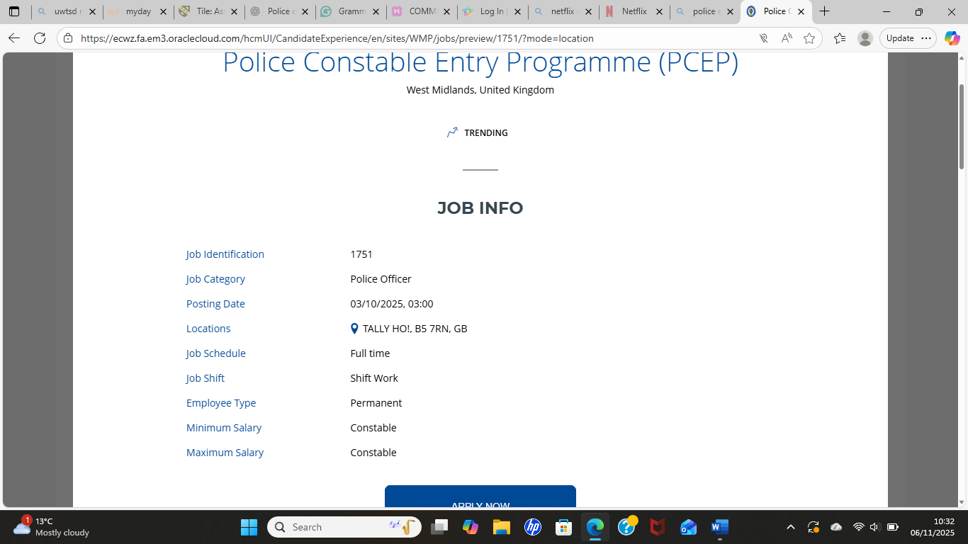 (West Midlands Police, 2019)

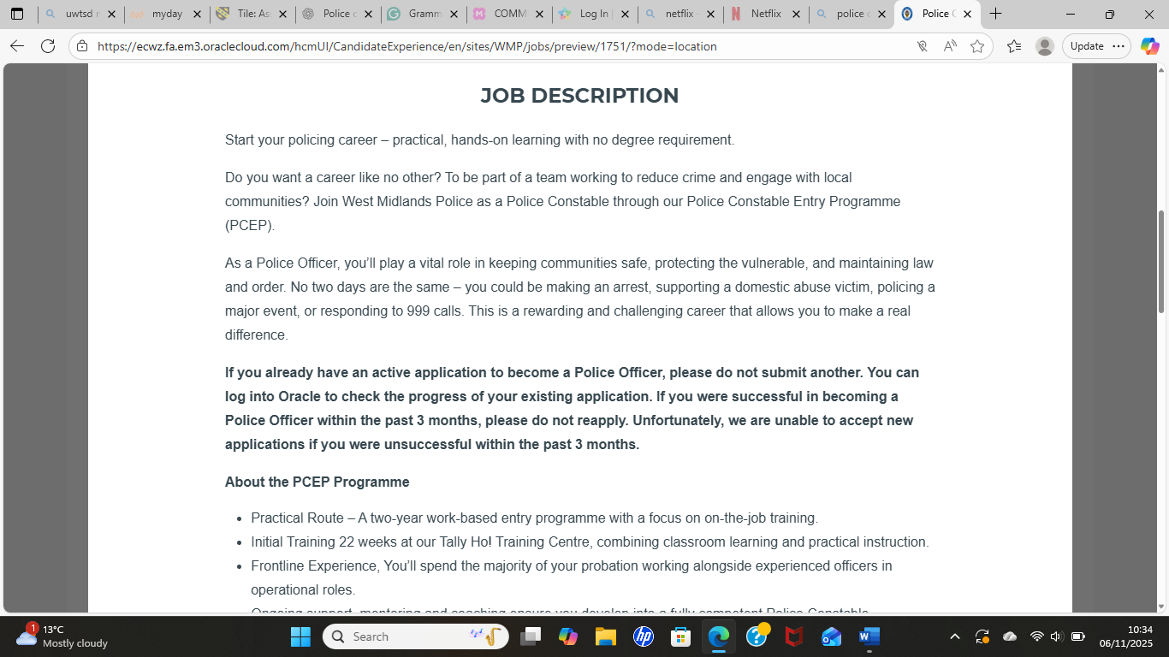 (West Midlands Police, 2019).

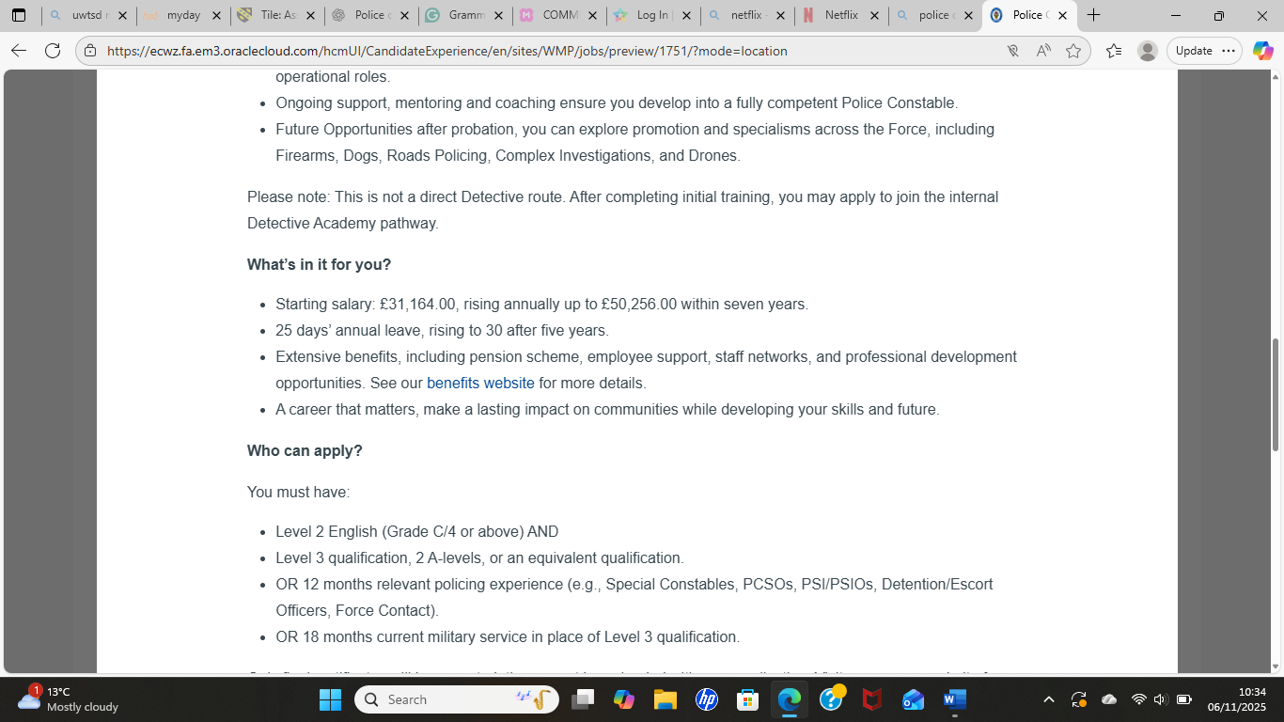 (West Midlands Police, 2019).

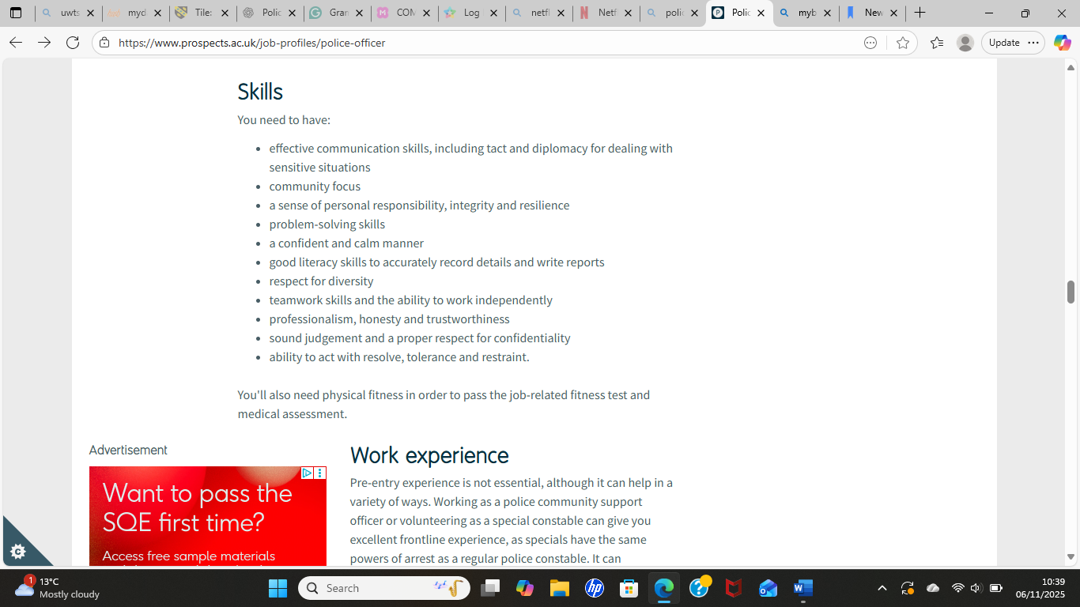 (PROSPECTS, 2015).

Job role employability skills

Employability Skills
A police officer must possess a diverse array of employability skills to perform their duties effectively and cultivate public trust.
Communication skills
Among these, communication stands out as paramount- both verbal and written. Officers are required to articulate information with clarity when interviewing witnesses, documenting reports, and engaging with colleagues or community members. Mastering communication skills not only facilitates accurate information exchange but also plays a crucial role in de-escalating conflicts and fostering positive relationships with the public (College of Policing, 2023).
Teamwork skills
Equally important is the skill of teamwork, as policing often necessitates collaboration with fellow officers, emergency responders, and professionals in health and social care. Effective teamwork allows officers to synchronize their efforts, share vital information, and provide mutual support in challenging and high-risk scenarios. This collaborative approach not only reinforces community safety but also enhances the protection of vulnerable individuals (Home Office, 2022).
Problem-solving
Furthermore, problem-solving is an essential competency in policing, as officers regularly confront complex and unpredictable situations. They must analyse evidence, evaluate risks, and make swift, sound decisions that are both lawful and ethically responsible. Strong problem-solving abilities enable officers to devise practical solutions to pressing issues, including antisocial behaviour, crime prevention, and public welfare. This proactive approach not only addresses immediate challenges but also contributes to the overall safety and well-being of the community they serve.
Time management skills
Effective time management is vital for police officers, who must adeptly navigate competing priorities such as responding to emergencies, completing essential paperwork, and following up on investigations. By mastering time management, officers not only enhance operational efficiency but also uphold the highest standards of performance.
Technical Skills
Moreover, technical skills have become indispensable in contemporary policing. Officers harness advanced digital tools including body-worn cameras, sophisticated communication systems, and data analysis software, to meticulously document evidence and manage information. This technological proficiency fosters transparency, accountability, and efficient law enforcement, ultimately strengthening community trust (National Police Chiefs’ Council, 2024).

In conclusion, employability skills encompassing communication, teamwork, problem-solving, time management, and technical competence are the cornerstone of a police officer’s success. These skills are not merely beneficial; they are essential for driving professional excellence, promoting ethical decision-making, and cultivating positive community relationships.

Evaluate you own skills

Pursuing a career as a police officer demands a robust set of interpersonal, practical, and reflective skills. My experiences in health and social care have provided me with a strong foundation that aligns seamlessly with the essential responsibilities of policing. For instance, through my volunteer work in community support settings, I have actively assisted vulnerable individuals and connected them with vital health and social care services. This hands-on experience has sharpened my communication skills, deepened my empathy, and boosted my confidence in engaging with people in distress—qualities that are indispensable in policing roles focused on safeguarding and crisis response (College of Policing, 2023).

Moreover, I have undertaken comprehensive training in safeguarding and mental health awareness, equipping me with the knowledge to identify risk factors, respond effectively, and collaborate with a range of professionals. These experiences resonate closely with the core duties of a police officer, particularly in terms of protecting vulnerable populations and partnering effectively with social care agencies (Home Office, 2022).

My strengths lie in my exceptional communication, teamwork, and problem-solving abilities. During my volunteer work, I consistently engaged with families, support workers, and healthcare staff to ensure individuals received the most appropriate care. This experience illustrates my effective communication skills and my ability to thrive within a multidisciplinary team—both of which are critical competencies for a successful policing career.

Furthermore, I have cultivated the ability to remain composed under pressure. In situations where individuals are experiencing anxiety or confusion, I have learned to listen actively, provide reassurance, and make well-considered decisions. This talent for maintaining calm in high-stress scenarios is a significant asset, given that police officers must navigate challenging situations with professionalism and care (National Careers Service, 2024).
In summary, my background and experiences uniquely prepare me to excel in a policing role, where I can contribute meaningfully to community safety and well-being.
I recognize that there are certain weaknesses and gaps in my experience. For instance, I do not yet have experience in handling confrontational situations or applying legal knowledge in real-life scenarios. Additionally, I lack advanced technical skills in using digital policing systems. While these gaps do not prevent me from pursuing the role, they indicate areas for development.

To improve, I can seek support from mentors within local community policing teams, career advisors, or training officers who can clarify the practical demands of the role, provide guidance on developing resilience, and recommend further training. Completing accredited courses—such as conflict management, first aid, or digital literacy—would also enhance my readiness.

Overall, my existing experience in health and social care provides a strong foundation for a career in policing, and ongoing learning combined with targeted support can help address my development needs.

Action plan and Timeline
To effectively cultivate the skills essential for a successful career as a police officer, it is crucial to engage in structured planning and establish clear, actionable objectives. Over the next five years, my primary focus will be on enhancing critical competencies such as communication, problem-solving, legal knowledge, and technical expertise. By developing a comprehensive action plan with well-defined short-term, medium-term, and long-term goals, I will ensure consistent and measurable progress (National Careers Service, 2024).

Short-term goals (0–12 months):
My foremost priority is to deepen my understanding of safeguarding, mental health, and community welfare. I am committed to completing vital training courses, including Level 2 Safeguarding, First Aid, and Mental Health Awareness, which will empower me to effectively engage with vulnerable populations. These skills are not only fundamental for frontline policing but also align with the high standards established by the College of Policing (2023). Furthermore, I will actively seek volunteer opportunities in health or social care environments to enhance my communication, teamwork, and conflict de-escalation skills. Additionally, I will implement a structured weekly fitness plan to ensure I am physically prepared for the rigors of the police fitness assessment, demonstrating my dedication to meeting the demands of this challenging profession.

Medium-term goals (1–3 years):
In the next few years, I am committed to developing advanced skills that will set me apart in the field of policing. I will actively pursue relevant courses, including Conflict Management, ICT and Digital Skills, and comprehensive training in Equality, Diversity, and Inclusion (EDI). As policing increasingly demands strong digital proficiency, enhancing my IT and data-handling capabilities will equip me to exceed the technical expectations set forth by the Home Office (2022). Furthermore, I plan to obtain a Level 3 Public Services qualification or similar program, which will deepen my knowledge of law, emergency response, and professional standards. I will also seek mentorship from experienced professionals—whether they are active officers or career advisors—to gain valuable insights into the recruitment process and pinpoint areas for further development.

Long-term goals (3–5 years):
My ultimate ambition is to be exceptionally prepared to apply for a police constable position. By this point, I intend to have accumulated meaningful volunteer or part-time work experience in health, care, or community sectors, which will allow me to demonstrate my commitment to service. I will actively participate in recruitment workshops and assessment centre preparation sessions to sharpen my interview techniques and problem-solving abilities. Prioritizing my physical fitness will be vital throughout this journey. If necessary, I will pursue additional qualifications—such as the prerequisites for the Police Constable Degree Apprenticeship (PCDA) or an access course—to ensure I meet all academic entry requirements.

By diligently following this action plan, I will cultivate the skills, experience, and unwavering confidence needed to advance my career in policing and make a meaningful impact in my community.

Building your personal brand
Building a powerful personal brand is crucial for advancing your career in health and social care, as it establishes your credibility, visibility, and trustworthiness in the field. A key strategy for achieving this is to cultivate a strong professional online presence through platforms like LinkedIn. This not only allows you to highlight your qualifications and relevant experience but also connects you with influential professionals in your industry. By regularly updating your profile, sharing your achievements, and engaging with pertinent sector content, you reinforce your identity as a dedicated and knowledgeable practitioner (National Careers Service, 2024).

Additionally, creating a personal website or digital portfolio can significantly enhance your brand. This platform can showcase case studies, reflective logs, certificates, and examples of your voluntary work, clearly demonstrating your skills and serving as a comprehensive hub for your professional accomplishments. Moreover, attending networking events, conferences, and health and social care workshops can further elevate your personal brand. These occasions offer invaluable opportunities to connect with peers, gain insights into industry trends, and forge meaningful relationships (Skills for Care, 2023).

Sharing your unique content—such as blogs, articles, or reflections on best practices—positions you as an expert and underscores your commitment to ongoing learning. Thoughtfully contributing to discussions on safeguarding, communication, and support for vulnerable groups not only showcases your awareness of professional standards but also highlights your dedication to continuous improvement (Cottrell, 2020).

In summary, by consistently leveraging digital tools and professional networks, you can build a compelling personal brand that paves the way for sustained career growth and impact in the health and social care sector.

Promoting your professional identity

Effectively promoting your professional identity is essential for attracting the attention of potential employers in the health and social care sector. A powerful strategy to achieve this is to craft a compelling cover letter that vividly highlights your most relevant skills, accomplishments, and experiences. By tailoring your cover letter to the specific role, you can showcase how your competencies—such as exceptional communication, strong teamwork, and a keen awareness of safeguarding—directly align with the requirements of the position. This is also your opportunity to convey your genuine motivation and your understanding of the organization’s values (Cottrell, 2020).

In addition to your cover letter, maintaining a robust online presence is equally vital. Regularly updating your LinkedIn profile with your qualifications, placements, volunteer work, and training courses provides employers with a clear picture of your dedication to professional development. Engaging with industry-related content by sharing insightful articles, posting thoughtful reflections, or participating in discussions not only demonstrates your expertise but also reveals your passion for the field (National Careers Service, 2024).

Further enhancing your professional identity can be achieved by creating a personal website or digital portfolio. This platform allows you to showcase your certifications, case studies, personal reflections, and evidence of ongoing professional development. A well-designed personal website makes your accomplishments readily accessible and enables employers to gain a comprehensive understanding of your skills and career aspirations (Skills for Care, 2023).

By implementing these strategies, you will not only communicate your strengths effectively but also position yourself as a confident and well-prepared candidate, ready to make a meaningful contribution to the health and social care sector.

Building a network for successful employment

Networking is an essential cornerstone of career development in the health and social care sector. It not only enables you to forge invaluable professional relationships but also equips you with critical industry insights and opens doors to new opportunities. By actively networking, you can learn from seasoned practitioners, stay abreast of best practices, and elevate your visibility to prospective employers. Moreover, it fosters personal growth by exposing you to diverse perspectives and real-world experiences that formal education alone cannot provide (Skills for Care, 2023).

Identifying potential mentors is a pivotal step in this journey. Mentors, whether they are senior colleagues, experienced support workers, nurses, social workers, or knowledgeable lecturers, can offer priceless guidance and share their career wisdom. They provide constructive feedback on your progress and help you navigate the complexities and expectations of this dynamic sector (Cottrell, 2020).

Joining professional associations is another powerful strategy to expand your network. Organizations like Skills for Care, the British Association of Social Workers (BASW), and the Royal College of Nursing (RCN) offer a wealth of opportunities including training events, webinars, conferences, and vibrant online communities. These platforms connect you with industry professionals and facilitate entry into specialized fields.

Attending networking events—such as career fairs, health and social care workshops, volunteering initiatives, and community support meetings—further enhances your chance to connect with employers and explore various roles (National Careers Service, 2024).

By engaging with mentors, becoming a member of professional associations, and participating in networking events, you can significantly boost your employability and confidently advance toward your career aspirations. Embrace these opportunities, and empower yourself to achieve your professional dreams.

Conclusion

In conclusion, this report has thoroughly examined the essential components necessary for a successful career as a police officer. It details the fundamental responsibilities of the role and underscores the critical employability skills required, including effective communication, teamwork, problem-solving, time management, and technical proficiency.

Through a reflective self-evaluation, I have identified key strengths gained from my experiences in health and social care—primarily in communication, empathy, and maintaining composure under pressure. Concurrently, I acknowledge areas needing improvement, such as conflict resolution and enhancing my technical skills. My action plan articulates a series of strategic, realistic steps—short-term, medium-term, and long-term—to develop these competencies through targeted training, voluntary service, relevant qualifications, and ongoing professional development.

The report also highlights the paramount importance of establishing a robust personal brand. By leveraging platforms such as LinkedIn, creating a personal website, and sharing valuable professional content, I can cultivate a clear and credible online presence that reflects my commitment and expertise to prospective employers. Additionally, networking through mentors, professional associations, and industry events will be instrumental in advancing my career by providing invaluable guidance, fostering connections, and offering opportunities to learn from established professionals in the field.

Overall, this journey has reignited my passion and determination to become a police officer. I am resolute in my commitment to continuously hone my skills, broaden my experiences, and take decisive, proactive steps toward achieving my career aspirations in public safety and community support.

Reference List
College of Policing (2023) Policing and vulnerability: Working with health and social care. Available at: https://www.college.police.uk/guidance/vulnerability-and-policing (Accessed: 6 November 2025).
Cottrell, S. (2020) Skills for success: Personal development and employability. London: Red Globe Press.

Home Office (2022) Modern policing priorities. Available at: https://www.gov.uk/home-office (Accessed: 7 November 2025).
Home Office (2022) The role of police in supporting vulnerable people. Available at: https://www.gov.uk/government/publications/policing-and-vulnerability (Accessed: 6 November 2025).
Home Office (2022) Working together to safeguard vulnerable people. Available at: https://www.gov.uk/home-office (Accessed: 7 November 2025).
Joiningthepolice.co.uk. (2025). Search your postcode to see which forces are recruiting | Join The Police. [online] Available at: https://www.joiningthepolice.co.uk/postcode-search/ [Accessed 6 Nov. 2025].
National Careers Service (2024) Building your professional profile. Available at: https://nationalcareers.service.gov.uk (Accessed: 7 November 2025).
National Careers Service (2024) Career guide: Police officer. Available at: https://nationalcareers.service.gov.uk (Accessed: 7 November 2025).
National Careers Service (2024) How to become a police officer. Available at: https://nationalcareers.service.gov.uk (Accessed: 7 November 2025).
PROSPECTS (2015). Police officer job profile | Prospects.ac.uk. [online] Prospects.ac.uk. Available at: https://www.prospects.ac.uk/job-profiles/police-officer.
Skills for Care (2023) Developing your career in social care. Available at: https://www.skillsforcare.org.uk (Accessed: 7 November 2025).
West Midlands Police. (2019). West Midlands Police Careers. [online] Available at: https://ecwz.fa.em3.oraclecloud.com/hcmUI/CandidateExperience/en/sites/WMP/jobs?mode=location [Accessed 6 Nov. 2025].

