Steven Wilkinson (P149872)

Investigation into the Stiffness and Damping of vehicle Tyres.



University of Wales Trinity Saint David
School of Engineering

Investigation into the Stiffness and Damping of vehicle Tyres.

Steven Wilkinson
P149872
Beng: Motorsport Engineering
Major Project: M6X00417
April 2020

Contents
1 Acknowledgements 5
2 Abstract 8
3 Introduction 9
3.1 Wider industry 9
3.2 Personal achievements with the project. 9
4 Project outcomes 10
4.1 Aims 10
4.2 Objectives 10
5 Project Timing plan. 11
6 Human interaction 13
6.1 Driver feeling and response 13
6.2 Age and driving experience 13
7 Tyre issues in the Real world 14
7.1 Tyre failures in motorsport 14
7.1.1 US Grand prix 2005 14
8 F1 case study for 2020 into the 2021 season 16
9 Tyre properties. 18
9.1 Tyre construction 18
9.1.1 Tread design. 18
9.1.2 Bias Ply tyres 19
9.1.3 Radial tyres 19
9.2 How a tyre generates grip 19
9.3 Slip angle. 20
9.3.1 Effects of slip angle. 20
9.4 Tyre contact patch. 21
9.4.1 Contact patch distortion 21
9.5 Temperature effects onto a Tyre 22
9.5.1 Lower tyre temperature 22
9.6 History of Tyre testing. 23
9.6.1 Static testing 23
9.6.2 Live testing 24
10 Tyre modelling 26
10.1 Empirical tyre modelling. 27
10.1.1 Magic Formula 27
10.2 Brush Tyre model 29
10.3 Fiala Tyre model. 30
11 Tyre stiffness 31
11.1 Comparisons of wheel sizes to tyre stiffness 31
11.2 Tyre stiffness Testing using a Hydraulic press. 33
11.2.1 Methodology 33
11.2.2 Issues with using the hydraulic press. 34
12 Tyre dampening 35
12.1 Hysteresis within a tyre. 35
12.2 Tyre stiffness testing using a damper dyno 36
12.2.1 Damper dyno methodology. 36
12.2.2 Issues with the dynamometer test. 37
13 Results Hydraulic press. 38
13.1.1 Similar tests. 38
13.1.2 Yokohama data 39
14 Results Damper dynamometer 40
14.1 Combining both testing methods. 42
15 Results of Tyre Damping force. 44
15.1.1 Importance of Tyre damping. 46
16 Evaluation and improvements 47
16.1 Evaluation 47
16.2 Improvements. 48
17 Epidemic impacts 49
18 Further work 51
19 Conclusions 52
20 Appendix 53
20.1 Hydraulic Press Method. 53
20.2 Damper Dynamometer Method. 54
20.3 Combined testing graphs. 55
20.4 Tyre Damping force. 57
20.4.1 10PSI 57
20.4.2 20PSI 59
20.4.3 25PSI 61
21 Bibliography 63

Acknowledgements

My Late Father (Donald Wilkinson 17/10/61 - 18/10/19) – For igniting an ever-lasting passion for motorsport and being the one who pushed me to pursue it. Thank You for always taking me to race meetings and encouraging me to pursue my dream.

Mark Sandford (Project Supervisor) - For the help and guidance throughout my 3rd year.

My Sister, Sara – For being brave enough to proofread all my work over the last three years and having to deal with some of my questionable sentence structures.

My Friends and Family – For supporting me and keeping me going when studying sometimes seemed impossible.

Figure 1: Project timing plan. 9
Figure 2: Pirelli F1 tyre comparisons. 14
Figure 3: Lateral force VS Slip angle. 18
Figure 4: Difference of inflation pressures. 18
Figure 5: Transition of Rubber. 19
Figure 6:Citroen DS PLR 21
Figure 7: HGV Tyre inside the PLR 21
Figure 8:Pacejka Magic Formula. 25
Figure 9: Brush tyre model. 26
Figure 10: Tyre assembly in Hydraulic press. 30
Figure 11: Hysteresis Graph 32
Figure 12: Dynamometer testing method. 33
Figure 13: Force vs displacement graph. 35
Figure 14: Tyre stiffness across different internal pressures. 37
Figure 15: Amplitude varies over different internal pressures. 38
Figure 16: Graph of comparison of testing methods. 38
Figure 17: Graph of Tyre damping force. 40
Figure 18: Front tyre stiffness variation with internal pressures. 50
Figure 19: 10PSI Combined testing graph. 51
Figure 20: 15PSI combined testing graph. 51
Figure 21: 25PSI Combined testing graph. 52
Figure 22: 10PSI rear tyre Damping force vs Velocity. 53
Figure 23: Dynamometer method of Force VS Velocity at 10PSI.. 53
Figure 24: Displacement VS Time for 10PSI rear tyre. 54
Figure 25: 20PSI rear tyre Damping force vs Velocity. 55
Figure 26: Dynamometer method of Force VS Velocity at 20PSI. 55
Figure 27: Displacement VS Time for 20PSI rear tyre 56
Figure 28: 25PSI rear tyre Damping force vs Velocity. 57
Figure 29: Dynamometer method of Force VS Velocity at 25PSI. 57
Figure 30: Displacement VS Time for 25PSI rear tyre 58

Table 1: Comparison of F1 Tyres. 18
Table 2: Tabled values of tyre stiffness. 40
Table 3: Comparison of testing methods. 43
Table 4: Tabled values of Tyre damping force. 46
Table 5: Hydraulic Press method for tyre stiffness 54

Abstract

In the highly competitive and often secret environment such as motorsport any advantage that can be gained on the competition is advantageous. A misunderstood and overlooked area of the vehicle is its tyres. This critical part providing the only link between the road surface and the driver.
To gain an insight into the performance characteristics of a road vehicle tyre, testing methods used will provide the stiffness and damping and will alter the tyre using graphical methods display the findings to show how increasing the internal pressures.

Introduction

Wider industry
The understanding of automobile tyres in everyday and motorsport application is arguably the most important key aspect to what would make or break a consumers appreciation of a vehicle.
Most complex electrical systems will end up using tyres for gathering their data such as ABS systems in the many sensors they use or the drivetrain which will transmit the power generated through the tyres and onto the road. Improper understanding of tyre dynamics would catastrophically impact the vehicles performance, something that manufacturers whether on the street or the racing circuit cannot allow.
Demands for a reduction or awareness of human environmental impacts of a vehicle has forwarded research for tyre construction to become more economical and sustainable. Vehicles are aimed to be more fuel efficient which has lead development down a path for more tyre longevity and reduction in drag increasing the mpg a vehicle uses in fuel.

Personal achievements with the project.
Vehicle dynamics and more importantly tyre dynamics are a topic area that requires a real passion and interest as it is an area of the automotive industry which has gained a lot of pressure for the need for excellence. It is interesting how a vehicle’s tyres perform under stressful conditions in a motorsport environment and how competition teams can get the best out of their tyres, even when compared to one another on a “spec tyre” which is very frequent in today’s motorsport climate.
Taking this interest and passion by investigating further the tyre behaviours and characterises of the tyres used in the sports 2000 championship as this could help Team MCR increase their knowledge of how the tyres are working during a given race weekend, this could in turn potentially give them an added edge.

Project outcomes

Aims

- Research into previous tyre testing techniques and how these have influenced the automotive and motorsport industries.
- To investigate tyre damping and how it affects a vehicle.
-To investigate tyre stiffness and how it affects a vehicle.
- Test different manufacturers of road tyres and potentially race tyres.

Objectives
- To conclude if smaller side walls on a tyre is beneficial for a vehicle and what are the positives and negatives in doing so.
- Prove this with my own findings from tyre testing backed up with my own research and critical analysis.
- Broaden my knowledge in vehicle dynamics and tyre stiffness and damping.

Project Timing plan.


Figure 1: Project timing plan.

The project was divided into the two semesters in academic year, the first semester was used to research into tyre testing methods and general background reading of the topic to allow for more insight and understanding. This would mean the later stages of the project were influenced by research findings and more focused to mean the maximum amount of answers could be reached in the limited time frame the project was set to.
The planned development of a CAD tyre model for the project was halted, its aim was to run a FEA study of the tyre and compare any findings to a physical test, however the difficulty in getting the CAD model to react with a surface and deform in a way that would simulate real life was proving too time consuming and proficiency in subject area not at suitable level to achieve it.
The study of lateral forces affecting a tyre was also halted and only research taking place, this was due to the difficulty on adapting the equipment to test and measure vertical as well as lateral forces. It became too great a task for the projects time frame and efforts were focused on only testing vertical forces.

The second semester saw the planned tyre tests undertaken to find out the stiffness and damping characterises of the Sports 2000 tyres, the results of the tests to be analysed shortly afterwards.
Changes to the equipment with the aim to a refine and develop the testing process however due to the Epidemic any further testing was unable to be achieved thus meaning any further alterations or improvements to the testing procedures to increase the results accuracy was not able to be carried out. During this period only validation through research and writing up what has been achieved could be conducted.

Human interaction

Driver feeling and response
Driving a car is a straightforward task which can be mundane if you are travelling the same routes with the same vehicle each day. However, to understand what is going on through the steering wheel and in the seat is a lot more complex to grasp.
Systems that make driving easier to do can mask what directly the driver feels, such as power steering. This reduces the effort needed to operate the steering wheel and less torque required to turn the wheels through an arc. Complex suspension systems such as active dampening, monitor and change damping rates allow for a smoother ride and a more comfortable driving experience.
Psychological aspects towards a steering rack ratio can create a sense of safety towards a driver when a steering system is set up to have a traditional 900 degree or 2.5 turns lock to lock this creates a progressive feel where the driver doesn’t feel “on edge”. However, the opposite to this would be a more “snappy or sharper” ratio where small slight hand adjustments mean the wheels change direction quicker.

Age and driving experience

When it comes to humans everyone is different, and when driving a vehicle this is no different. This can play a big part to how someone would feel in a vehicle and inexperience or no previous knowledge of how a vehicle is to behave on different surfaces, tyre pressures or tyre compounds.
A human’s instinct is to feel safe and have self-preservation of your own wellbeing. As you get older you become more aware of actions and consequences.
Young people are more likely to be involved in an accident that involves an element for example risk taking when driving or wanting to take the vehicle outside of its operating windows. (Møller, 2007)

Tyre issues in the Real world

Tyre failures in motorsport

US Grand prix 2005
The Infamous US grand prix of 2005 has been regarded as the biggest controversial grand prix in the modern times of Formula 1. The issues started in free practise two when Ralf Schumacher crashed his Toyota into the high-speed banking of turn 13 at Indianapolis motor speedway, the same corner he crashed at in the previous year. The 2005 accident resulted in him having to be replaced by test driver Riccardo Zonta who coincidentally crashed the replacement car into the wall again at turn 13.
The issue became apparent to Michelin, the tyre manufacture that supplied Toyota F1 that due to the nature of turn 13, it being a high degree of banking corner, matched up with its incredibly high speeds of 170 mph allowed for vast lateral loads to be transmitted through the tyres.
When a vehicle negotiates a turn the road surface resists this change in direction and pulls the contact patch in the opposite direction of travel. (The US Grand Prix 2005, 2018)
It is Lateral load that tyre manufactures need to understand when developing tyres, if there is a greater load applied to the tyre than it can withstand a failure will likely follow.
At IMS the banking is 9.2 degrees. This will add an additional component of mass to the already loaded up tyre, something that the manufacturer would have to take into consideration.

With the IMS not a F1 test circuit, Michelin had to rely on research and simulator data to gather intelligence and knowledge of the circuit. This is completely different to Bridgestone who smartly used data from their sister company Firestone who supplied tyres for Indycar. They used the data of their testing and Indy 500 held earlier in the year which also considered something that Michelin couldn’t, a resurfacing of the circuit.
This resurfacing included a road finishing technique called “Diamond grounding.” Diamond grounding is when the road surface is shaved flat of any bumps and oddities, this also makes longitudinal grooves in the road surface which would help acceleration and braking along with improving the drainage in wet conditions. This gave the surface a more toothed appearance which allowed for more area of the tyre to contact by adhering to the road profile and achieve even higher lateral loads, this is what took the tyres out of there safe operating window and caused the failures.

F1 case study for 2020 into the 2021 season

F1 will be undergoing the biggest rules and regulation changes it has seen in recent times ahead of the 2021 season, this has already caused quite a stir amongst teams, fans and engineers alike all having very different ideas and views on the imposed changes.
One of the most eye catching, and dramatic of the changes presented is the size increase of the front and rear rim sizes, the current 13-inch rim to be used for the last time in the 2020 season has a visually larger sidewall than its 2021 counterpart upsized to 18 inches.
The reason for the increase in the size of the tyres from 13 to 18 inch is a very straight forward one, and this is to improve the show for fans and promoters alike, this means its more striking and more relatable to most fans in the wider world who are not directly motorsport enthusiasts or no any technical aspects of a vehicle.
At present Formula 1 and its feeder series Formula 2 stand very much alone by their choice of tyres they use regarding sidewall thickness.
Other single seater series across the world such as IndyCar and Formula E (Another FIA sanctioned championship) use much larger rim diameters compared to sidewall thickness. F1 continuing to use 13” sets them apart in a negative way in the eyes of fans as Pirelli making the change to low profile tyres will make them more relatable to the fans. Development and in turn advertisement of the ‘P zero’ which is branded on the current 13” tyres is a backward way of thinking. A spectator can in theory buy the Pirelli P zero branded technology for their hatch back on the driveway.
It is also within the blanket of changes for of the FIA to introduce some form of cost capping into the sport. A cap of 175million per year, per team of two cars. Having reviewed the technical regulation for 2021 (Hatton, 2019) you can clearly see the attempt the FIA are trying to implement with a standard “off the shelf and spec” rim choice.
“10.7.5 Supply of wheel rims In accordance with the provisions of Article 17.4, the FIA will appoint a standard supplier for wheel rims and the Competitors will be required to use these rims.” (FIA, 2019)
Having a standard rim size across the entire grid will reduce cost of manufacturers designing their own style of racing rim for their cars.

Table 1: Comparison of F1 Tyres.
2020 Spec tyre 13” | 2021 spec tyre 18”
Entire wheel diameter 670mm  Mounting diameter 358mm | Entire wheel diameter 725mm  Mounting diameter 490mm
312mm sidewall of total sidewall thickness across the diameter of the tyre. | 235mm of total side wall thickness across the diameter of tyre.
156mm of sidewall thickness. | 117.5mm of side wall thickness.
This is a 32% in sidewall reduction and 8% larger overall wheel diameter. This means switching to low profile tyres with smaller sidewalls will lead to less tyre deformation. Stiffer sidewalls are needed to compensate for the 32% loss.

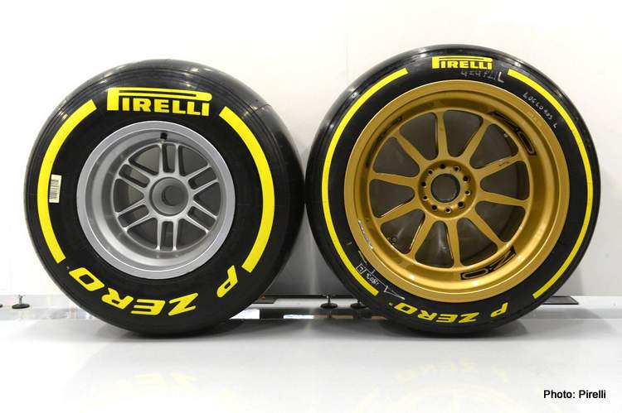

Figure 2: Pirelli F1 tyre comparisons.
More vertical travel will be now going through the suspension system and acting onto components in the system and this will mean F1 teams will have to allow for more control of the addition forces in their redesigns. (New Tyre Rules 2021, 2018) A massive positive for switching to lower profile tyres is that with more forces acting onto the suspension this will lead to greater need for small refined changes in setup during race weekends as the tyres are now not damping this extra force out.

Tyre properties.

Tyre construction

Prior to a tyres construction a careful design criterion needs to be thought out to maximise the potential of the tyre. This means designing a tyre to fit its needs or demands of its environment is potentially more important than overall grip. For example, its maybe more desirable to design a tyre for wear resistance, so its lifespan is increased rather than ultimate traction.

Tread design.
The design of how a tyre treat pattern is laid out is very carefully laid out across the entire contact patch. This means for a treaded tyre its grooves and channels are specifically cut to aid water evacuation out of the contact patch maximising potential grip for the driver.

Symmetrical tyres
Symmetrical tyres are the most common type of tyre on passenger vehicles. (Bridgestone, 2020) These feature the same tread patten across the width of the tyre and are also referred to as multi directional as they can be mounted to a rim in either direction.

Asymmetrical tyres
This type of tread pattern design combines different patterns onto one circumference of a tyre, when mounted to the vehicle the inner tread design serves the purpose of shifting water away from the contact patch and the inside uses larger tread blocks to deal with higher lateral forces during cornering.

Directional tyres
The treat pattern on directional tyres are cut in the direction the vehicle is heading and allows the vehicle to have better traction, meaning it is a good option for a winter tyre. The V shaped cuts into the tyre mean it can disperse standing water even at high speeds (Continental, 2020)
Asymmetric and directional tyres can only be fitted to the vehicle in the way marked on the tyre or direction of tread patten. Failing to do this will result in the tyre sub optimal grip and an increase in road vibrations.

Bias Ply tyres
Commonly called cross ply this type of tyres construction places each of its cords at a 40-degree angle across the centre line of the width of the tyre. These overlap each other to form a ridged but flexible carcass resulting in the whole tyre being able to flex over rough ground and be more comfortable for the occupants inside the vehicle.
A negative effect of the cross ply’s construction is that it naturally has a high rolling resistance and the drop of lateral forces acting through the tyre is more sudden and dramatic at high slip angles.

Radial tyres

The tyres cords are constructed radially 90 degrees to the centre line of the tyre this means the tyre has a very flexible sidewall, but it is independent to the belt of the tyre. This allows the contact patch to distort much less than a cross ply tyre therefore less rolling resistance and overheating affects. (Haney, 2003)

How a tyre generates grip
For a tyre to generate the required grip needed for an average road user or race car driver the compound with the tyre needs to be soft enough so that the road surface can make an indentation into the surface of the tyre. This is called mechanical keying (Deformation of the rubber) this leads to greater adhesion between tyre and road. If the load onto the tyre becomes greater, for example weight transfer through a corner an increase of force through the contact patch is produced.
On a wet road surface, the standing water blocks this process and reduces overall grip available as only the adhesion benefits are left. (SRO, 2019)
A tyre also generates friction by tearing, this is when the tyre takes hold of the road surface and stretches the polymers it is made from to the limit of their elasticity. If a tyre is taken over this tensile force it will start to break the bonds in the polymers and result in an increase in surface area contacting the surface of the tyre, allowing the tyre to absorb more energy and generate more friction. (SRO, 2019)

Slip angle.
When a vehicle applies acceleration or braking force during a corner the tyre will induce a slip angle, this is the angle between the actual point heading of the vehicle and where the tyres are positioning. (Milkins, 1995)
A tyre to generate a lateral force with a given slip angle this occurs when the driver turns the steering wheel from the straight-ahead position. The difference of the angle between the heading of the tyre and the vehicles heading this will generate a slip angle. (Haney, 2003)
The elastic properties of the tyre’s construction allows the vehicle to take the curvature path the driver desirers. This is because the leading edge of the tyre’s contact patch contacts the road surface, and this now pulls the rest of the tyre and ultimately the vehicle which follows a new heading rotating in yaw. (Dynamics, 2004)

Effects of slip angle.
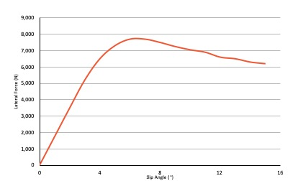
Lateral forces generated by slip angle starts with a lateral stress boundary (µP) this is the limit that the tyre and road surface resists sliding. Under this limit will not allow for sliding to commence. As the tyre rolls the tread within the contact patch undergoes this lateral stress which deforms the sidewalls.
With slip angle being dependent on lateral load acting upon the tyres independently of each other as each wheel could have a different slip angle even when compared to its corresponding axle pair.
When a vehicle slip angle is 0 and 4 degrees the vehicles available traction is linear irrespective on the increase of lateral force applied.
The breakaway point when no more force in the Y axis (Lateral force) is around 6 degrees of slip angle, motorsport racing slick tyres can have a breakaway point much higher allowing for larger lateral loads to be achieved.

Figure 3: Lateral force VS Slip angle.

Tyre contact patch.
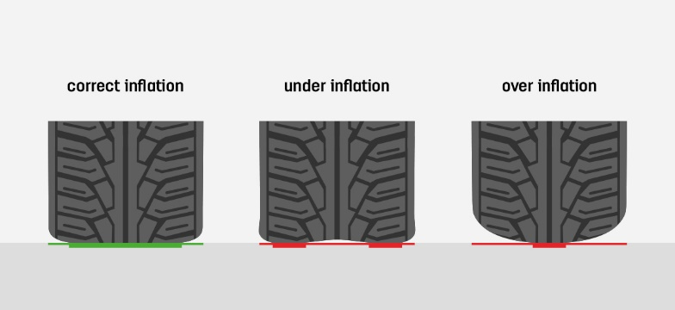
A vehicle tyre is not a solid body of rubber but in fact, it is ever trying to adapt and shift with the constant changing of forces applied to it. This is in conjunction with tyres being more like a vertical and lateral spring, as well as the first line of defence against combating any harsh feel in ride comfort.
There are a number of different ways in which a contact patch of a tyre can be manipulated. Firstly, with a change of internal pressures this will alter the footprint the tyre will have. Internal pressures can also increase the tyre stiffness. This will allow the tyre to resist more movement of the contact patch through the tyre during cornering, braking or accelerating. This affects the wear characterises of the tyre and how much of the available footprint of the tyre is in contact with the road surface.

.

Figure 4: Difference of inflation pressures.

Contact patch distortion

The vertical load of a vehicle acting onto a tyre is transferred through the sidewall and then into the contact patch. This distorts lowering the internal volume of that area of the tyre. (Haney, 2003) This is due to the tyre’s carcass deforming and the internal pressure of the tyre resisting creating tension the compression forces from the mass of the vehicle, this then forms a contact patch of an particular size in relation to the force applied to it, making it equal thus supporting the vehicle. (Patch, 2015)
If the compressive forces are greater than the tensile then the sidewalls of the tyres will be causing an increase of distortion and this will have a rise in temperature leading to a potential failure.

Temperature effects onto a Tyre

Lower tyre temperature

Harder compounds will lead to the tyre having a higher young’s modulus, the rubber compound of the tyre is much more ridged and less compliant meaning inducing temperature into the tyre via means of hysteresis will be much harder to achieve.
Temperature across the width of the tyre can change dramatically as a vehicle set up will play a big part to how a tyre heats up during a heat cycle.
As a tyre is made of elastic material a change in temperature will alter the young’s modulus of elasticity and it is this change that alters the cornering stiffness even in a matter of laps. (Haney, 2003)
With the young’s modulus of the rubber constantly changing as the tyre varies in temperature, this will alter the amount of energy loss within the tyre and will affect the level of available grip the driver can utilise depending on when they are at a given temperature.
If the tyres are too cold, then the rubber is hard and not malleable they will resist adhesion to the circuit. (Hatton, 2019)
Engineers and drivers aim to have their tyres at the peak point shown in figure 5, to allow for maximum grip via hysteresis and the properties of the tyre to be as elastic as possible to generate more friction.
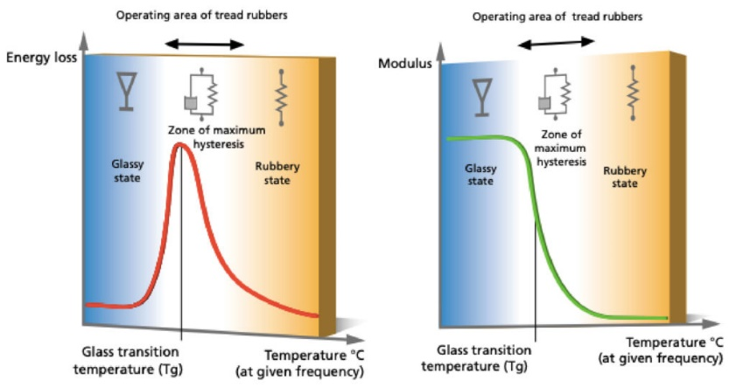

Figure 5: Transition of Rubber.

History of Tyre testing.
The knowledge of vehicle dynamics and specifically tyre dynamics has been an ongoing necessity of new discovery, as driving automobiles became more popular manufacturers became more competitive with one another and the need for greater understanding was required.

Static testing
When a tyre manufacturer is investing its resources to develop products one way to test the strengths and weaknesses of their tyres is to use custom-made equipment. This is designed to test the tyres above and beyond there recommended parameters.

Michelin tyre rolling road.
When testing a tyres properties Michelin use a test rig to put the tyre under stress whilst it is rotating on a rolling road. It is overloaded, pressured and cambered far higher than recommended on a real day to day road car. This allows the manufacturer to see graphically and physically what happens when a tyre is taken out of its operating window.
When the tyre is put under excessive load and steered through an arc the contact patch of the tyre shifts to the outside radius and depending on internal inflation pressures and sidewall stiffness or construction can vary the displacement.

MTS Tyre testing
MTS, an independent tyre testing company uses four independent road belts to test suspension along with fast/slow rebound and bump dampening during driving. This can also raise a single wheel to simulate an uneven road and rotate to induce a slip angle.

Live testing

Once a tyre has been designed and manufactured it is then tested in a live scenario on a test circuit and put under conditions more akin to what a consumer would put the tyres under in day to day running. This could include straight line testing or to negotiate a course to apply lateral loads onto the vehicle. This is the difference between static and live testing as the tyre is attached to the hub, suspensions systems and in some cases drive shafts. This will be fundamentally different to static testing.

Citron tyre tester
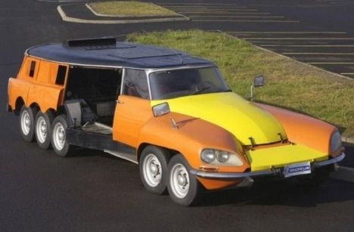
In 1972 Citroen and tyre manufacture Michelin collaborated to design and develop a live tyre testing rig inside a highly modified Citroen DS. It was used to test heavy good vehicle tyres in the same manner as static tests were carried out except the tyre was being observed in real condition.
Figure 6:Citroen DS PLR
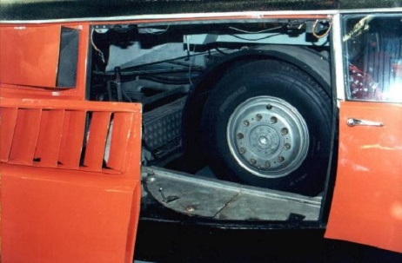
It achieved these tests by being powered with a pair of Chevrolets V8 engines, one for propelling the vehicle and the other rotating the test tyre. (UNSUNG HEROES - #24 - The Citroen PLR, 2018)
The test tyre was positioned in the middle of the vehicle and lowered onto the road during vehicle operation. It was then put through a steering arc at speeds of over 100MPH. This simulates understeer at high speed and creates large slip angles and ultimately large lateral forces acting through the tyres contact patch and sidewalls.

Figure 7: HGV Tyre inside the PLR

Steady state testing
Steady state testing is usually completed on a level skid pan which tests vehicle handling capability and physically observes the effects of lateral acceleration of a tyre.
This is achieved by propelling a vehicle around a prescribed circumference and increasing the speed while measuring the lateral forces and corresponding slip angles. (Milkins, 1995)
This testing process can be used so engineers can validate the data gained and compare it against existing simulation model data or hand calculations made in the design process of the tyre. This validates if the design has been successful in the manufactures criteria.
The data can be produced in a graphical form to be directly compared to the ‘theoretical’ simulation. Any changes can be made if flaws in the design have been identified as these could impact the safety of the tyre.

Tyre modelling

Tyre modelling is a way to taking data from a real-world test or the use of simple Mathematical equations to find out the forces and moments generated at the tyres contact patch. (Pacejka, 1987) This theoretically calculates the forces generated at the contact patch and they most required for parameters needed to build a tyre model are forces acting through the tyre in the X, Y and Z plane as this calculates the lateral, longitudinal and vertical loads being transferred through the tyre. (Pacejka, 2006)
These are then formed into a mathematical model to display data with the aid of coefficients to curve fit the model into a desired scenario or outcome.
Having a detailed tyre model allows engineers to save time and costs of continuous physical testing, however these tyre models must be developed to consider road interactions with the tyre as accurately as possible.
The modelling of contact patch forces is under a constant state of development as specific mathematical modelling techniques would be required for such parameters within a manufactures tolerance and given application. This means a tyre model can forgo some complexity and yet still be accurate enough to be inside tolerance thus speeding up calculating times.
Ways to represent tyre data are in the form of ‘look up tables’ (Interpolation methods) or graphical forms and formulae methods (Empirical methods)

Empirical tyre modelling.

This is a form of tyre modelling that uses the mathematical approach to measure the characteristics of the tyres behaviour to use formulae and coefficients to generate the equations.

Magic Formula
The work carried out by Hans. B. Pacejka in the 1980s has been instrumental in the understanding of vehicle tyre dynamics in road vehicles. His work has influenced and been used by other vehicle dynamists, and motorsport engineers alike to further refine and develop tyres to improve safety. The tyre modelling technique itself is not a predictive model but uses data calculated to represent the tyre forces and moments from mathematical calculations.
The research into lateral force curves with an increase in vehicle mass has allowed tyre manufacturers to have an insight into how much of a slip angle a vehicle needs before it understeers or breaks away. This has led to huge gains in the safety improvements and constraints implied within the construction of a road tyre.
For example, EU laws have introduced tyre performance ratings on any new tyre manufactured after 2012. This rates tyres on fuel efficiency, wet braking performance and road noise absorption. (Agency, 2020) this could not be achieved without tyre modelling validating the testing process.

$$y = D sin[C arctan\{(1 - E)Bx + E arctan(Bx)\}]$$
Equation 1: Magic formula equation.
D - Is the peak factor
C - Is the shape factor, this varies depending on desired outcome: 1.30 =lateral forces 2.40 =aligning moment and 1.65 Longitudinal forces being observed.
B - Is the corner stiffness and this is the gradient of the graphical data of D and C.
E - Is a curvature factor
(Pacejka, 1987)

A disadvantage of the magic formula method is that its coefficients have no significance in terms of tyre properties and the modelling requires careful curve fitting to generate any valid graphical data. (Dynamics, 2004)
The method is very detailed and will lead to a high level of valid data being calculated but this comes at a price of its complexity and will need vast amounts of time to be proficient in extracting data from the model.
Live Tyre data is still needed to be taken via a test rig or circuit to gather the various coefficients to be able to use the Magic formula.
The tyre modelling method is insufficient to be able to plot nonlinear and non-steady state driving situations it cannot also model thermal affects within the tyre’s carcass or interactions of heat transfer between tyre and road, it is not also suitable to model road imperfections or wear characterises. (Schmid, 2011)

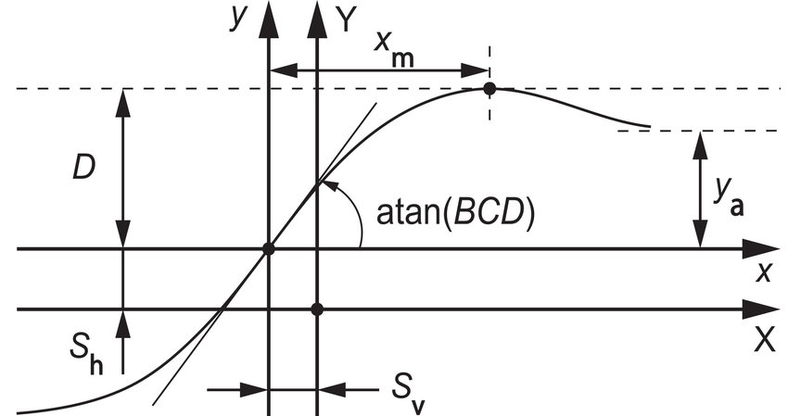

Figure 8:Pacejka Magic Formula.

Brush Tyre model
The brush model was very popular with engineers in the 1960/70s before more advanced empirical modelling techniques were formed and replaced it to explain tyre behaviour.
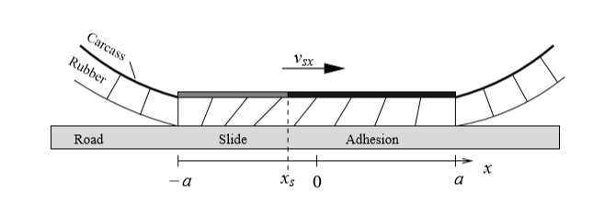
This form of tyre modelling consists of a row of elastic bristles that contact the road surface and deflect in a parallel direction. This simulates the tread contact behaviour of a real tyre.
As the tyre ‘rolls’ along the road the first bristle contacts the road surface and deforms. The tyre deformation is all the individual deforming bristles in each direction added together. (Salminen, 2014) It is this deformation that is assumed to be generating the forces in the model.
As the deflections of the tread bristles take place the forces and moments are generated from the velocity of the rolling tread and the difference in speed from the tread in adhesion. (Wittenmark, 2013) The adhesion will be grown linearly across the length of the contact patch as the tyre rolls across the road surface.

Figure 9: Brush tyre model.

The brush tyre model gives a good description of longitudinal forces through the tyre; however the general simplistic nature of the model means it will fall short when compared to ‘Magic formula’. If the application does not need extensive complexity, then the brush model can provide suitable accuracy.
Additional features and other mathematical equations such as camber can improve the model, but its complexity will increase also.

Fiala Tyre model.

Fiala tyre model was introduced in the 1950s and has been further developed by MSC ADAMS, in its initial form it is one of the simplest tyre models and only requiring as little as nine data parameters to form a working tyre model and be able to calculate steady state.
This means it is relatively easy to make a tyre model but it’s at a cost of complexity and detail.
The parameters used to create the Fiala method are taken from plots produced in tyre testing (Dynamics, 2004) and physical measurement of the tyre itself such as the tyres height and width.
A side from its simplistic nature the Fiala tyre model has other limitations such as it is not suitable for combined slip or its ability to assess camber thrust.
For the tests and experiments that will be carried out in this project it is believed that this method is suitable if a tyre model is to be created after testing data obtained. The reasons for this are that there is camber or slip being observed so the limiting factors are not affecting the outcome of the project.

Tyre stiffness

Comparisons of wheel sizes to tyre stiffness

Low profile tyres are becoming more popular on an increasing amount of road cars in recent years. This is not just high-end sports cars but more mid-ranged hatch back manufacturers are choosing to use a larger rim diameter for a given overall wheel size. The term Low profile when describing a tyre means a tyre that has a smaller sidewall or lower aspect ratio.
Profile = (Tyre height/ tyre width) x100

Having a smaller sidewall has many positive benefits to the overall driver satisfaction and tyre performance such as, a vehicle with low profile rims will have a more visually appealing and sportier look. With the increase diameter rim size this allows for larger brake assembly to be fitted easier to the vehicle. (Hammil, 2006)
Low profile tyres tend to have a faster response giving way to the impression that they have a better handling. This is subjective to the individual opinion of the driver and how they interpret “Better handling”
When a tyre uses low profile spec it will have increase rigidity in the sidewalls. This allows for predicable cornering as the sidewall swaying is less. This can be felt as more grip to the driver. This is most noticeable on smooth roads and high cornering speeds.
Negative impacts of a reduced sidewall are a decrease of ride quality felt by the driver. Low profile tyres are typically more susceptible to road noise vibrations and more shocks from road surfaces being felt by the driver as the tyres have less ability to dampen these out, which would be opposite in larger sidewall tyres.
Manufacturers may not have adapted their vehicles to accommodate the changes in tyre profile and the result would damage suspension components. This would have otherwise been protected from the ever-increased forces generating through the tyres. This is also typically an increased cost to more standard option of tyres with a larger sidewall.
Due to the smaller tyre height, this will give less protection against strikes from street furniture such as kerbs which a standard tyre would take the impact from.
A test conducted on an open racing circuit by “Tyre reviews” produced some interesting findings about how different tyre rim sizes relates to a driver’s feel and experiences.
The test was conducted on a test track using the same car and overall diameter of the same Goodyear tyre. The only variable in the test was the rim size ranging from 17Inch up to 19 inch in diameter. Testing was held on a dry circuit and on a wet skid pan. This allowed for all three tyres to be properly testing in conditions akin to an open road.
Dry handling.
It was found that the 19 inch was the fastest tyre over a timed lap, this was due to the decrease in side wall height which allowed for a sharp and precise feel to the drivers steering giving more confidence in how the Vehicle was behaving during a corner. It also made the driver experience a more fun and edgy steering. A negative with the 19-inch wheels was that with the increased Turn in response the vehicles tenacity to understeer became further increased into a corner. (Benson, 2017)
Wet handling.
On a wet circuit the 17-inch was fastest over a timed lap with its increase of sidewall profile, this was due to when the tyre deforms during a corner the tread pattens flex opening up more space to move additional water out of the contact patch. This led to a better feel in the wet with a reduction to snap oversteer, and a more progressive feel with transition of grip. ( 17, 18 and 19 inch tyres, 2018)
NVH
This test is very Subjective to individual people and what they themselves would consider harsh or uncomfortable, the steering wheel movement for 19-inch wheels on small imperfections on road surface is slightly worse compared to the others tested and much harsher over general potholes. The 17-inch wheel and tyre performed the best over poor road conditions, this was due to the increase in damping the tyre would now have compared against the other two tyres.

Tyre stiffness Testing using a Hydraulic press.

Methodology
To gather data for evaluating the tyre stiffness characteristics of a Sports 2000 race tyre a supporting jig was fabricated to support the rim and tyre as a compressive load was applied.
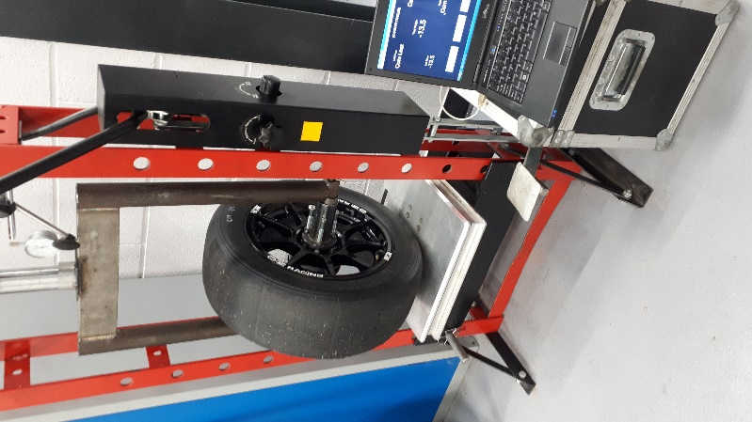
The tyre was held in position with a bar used to support through the centre of the axle which fitted together and screwed at each end attached to a frame in which will evenly distribute the vertical force across the tyre. This allowed for a more accurate reading to be taken as the vertical force will not be transferred directly onto the top of the tyre.
A pair of DTI gauges were used on each side of the hydraulic press to confirm that the tyre and jig assembly were level and then set to zero. This prevented the assembly being at an angle which potentially would affect the results generated. The DTI gauges also kept a measurement of vertical displacement for each reading.
Measuring the height from the centre of the wheel to the level bed of the press will allow for measurement of vertical displacement (x). This calculates how much force is needed to deflect the tyre 1mm. (N/mm) The force required was measured using a set of corner weight scales zeroed once the tyre has a small amount load applied to hold it safely into position.
The results recorded will be used to produce graphical data to visually see how a range of different tyre pressures used by team MCR in their race meetings effects the tyres in regards to the stiffness.
The test was carried out on a front and rear wheel in which the vertical loading was applied in accordance to Motec data that was kindly supplied by Team MCR from their previous racing season. This allowed more relevance to the test and what would be expected from the vehicle at rest and during complete weight transfer though cornering. Comparing the testing data with real Motec traces taken from a race weekend can validate the reliably of the testing procedure.
Figure 10: Tyre assembly in Hydraulic press.

Issues with using the hydraulic press.

- Tyre pressure not accurately measured.
- Some small amount of Air loss when removing the airline from the tyre valve.
- Hydraulic press is not easy to accurately pump to precisely 1mm each time.
- The equipment is not designed for this application so errors could easily happen which would interfere with the results.

Tyre dampening

Hysteresis within a tyre.
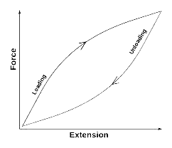
Within a motorsport tyre the difference in its construction can result in alternative amount of Hysteresis. This is the energy returned from being compressed during deformation.
Softer compounds = High Hysteresis.
Harder compounds = Low Hysteresis.
Figure 11: Hysteresis Graph
Rolling resistance of the tyre will be affected by hysteresis as the tyre deforms and rebounds over the road, this is called low frequency distortion.
Low hysteresis allows for lower rolling resistance meaning the tyre has a higher rebound force and the vehicle will have greater fuel economy.
In figure 10, the graph shows how the rubber molecules such as in a tread block of a tyre are put under compressive load and then unloaded, this sees a difference in forces depending if in compressive or tensile. This occurs when the tyre rolls and makes contact against the road surface and then is unloaded when that part of the tread block is past the point of contact.
Having a tyre subjected to higher hysteresis levels and an increase in frequency it will conforms around the gaps within the road surface and allows for better frictional contact.
As a tyre’s velocity increases the molecular properties of rubber behaves differently when cyclically stressed as in the case of a rotating wheel, this means more heat is generated when a high frequency is acting on the surface of the tyre.

Tyre stiffness testing using a damper dyno

Damper dyno methodology.

To calculate the combined stiffness and damping of the tyre a dynamometer was used, this allows the tyre to be put under compression and rebound damping phases and through a sweep of 25mm of vertical travel.
The test will be repeated across a range of internal pressures starting at 0PSI and increasing in 5PSI increments up to 30PSI.
Data provided by Team MCR in the form of excel files and Motec logs will allow for the observation of the tyres operating window and replicate what they experience on a race weekend can be seen be produced graphically.
Assessing the compression rates of the tyres and evaluate if a different internal pressure will affect the damping of the tyres. The test will use both front and rear tyres to compare any differences between them.
The same fabricated jig that was used in the hydraulic press will be used again on the dynamometer this means the areas of high loading and compressive force acting on the tyre will be the same and the tyre deflection where the ‘road surface’ would be simulated.
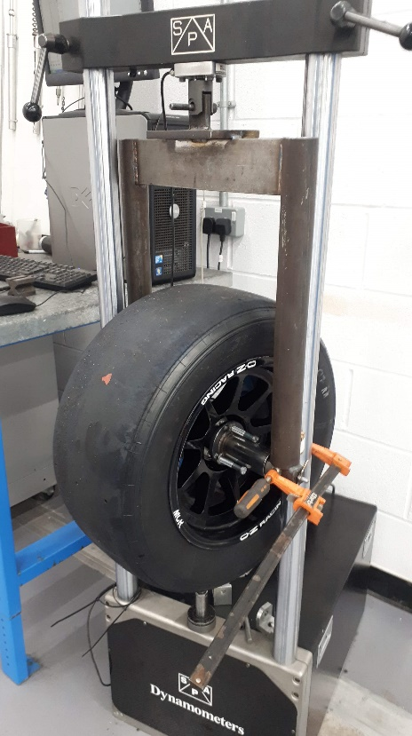
Once the tyre is in position in the rig lower the top arm onto the tyres assembly and tighten into place a degree of preload would be acting onto the tyre with this action.
The loadcell is now set to ‘zero’ and means all readings are a true indication of addition force applied to the tyre.
It is important that care is undertaken when checking if the tyre and its assembly do not touch any of the guideposts as this can interfere with results and damage the equipment.
To prevent the tyre from moving longitudinally (Fx) and creating false readings the whole of the jig must be manually steadied by using clamps to prevent movement.

Figure 12: Dynamometer testing method.

Issues with the dynamometer test.
- Potential air loss when removing the airline from the tyre valve.
- The accuracy of the pressure gauge could indicate a false reading in either under or over inflated.
- The Dynameter is design for vehicle dampers rather than tyres, this means the results are not completely reliable and can easily incur errors.
- Using human interaction when having to manually steady the tyre easily mean undetermined force is used to do so.

Results Hydraulic press.

Figure 13: Force vs displacement graph.

When observing the results taken from the hydraulic press method it shows that an increased deflection of the tyre also increases the amount of force generated. This means that the stiffness of the tyre increases proportionally to the rate of tyres deflection.
It is considered for the test undertaken that a 10% error has been made in what would have been the tyres true result. This could be due to the difficulty in operating the hydraulic lever and achieving exactly 1mm of deflection each time.

Similar tests.
When the results are compared to other similar tests that have been documented they hold a degree of similarity as (P.A.Narwade, 2016) results show a linear increase of stiffness when a load has been applied.
Another test similar is (Taylor, 2001) who also did have an increase when load is applied forcing the tyre to deflect more. The rig for this test was different to the one used for this project as it had steel arms protruding out which steadied the tyre. This would have benefited the results as the tyre would be unable to move longitudinally potentially altering the results.

Yokohama data

Data that was graciously supplied by Yokohama tyres of their previous spec tyre. Unfortunately, but understandably not of the one currently used by team MCR, however what this data shows is the same linear trend regarding vertical load (Fz) and tyre deflection as the test conducted. (Yokohama UK, 2020)
Having this official data to compare results with has helped give insight to validate the work carried out and aid identifying if the test will need to be undertaken again due to errors.

Table 2: Tabled values of tyre stiffness.
 | Hydraulic press method (N/mm)
Tyre deflection | 10PSI | 15PSI | 20PSI | 25PSI
1 | 122.62 | 156.96 | 166.77 | 176.58
5 | 573.88 | 667.08 | 671.98 | 789.7
10 | 1059.48 | 1334.16 | 1368.49 | 1662.79
15 | 1535.26 | 1976.71 | 2079.72 | 2535.88
20 | 1991.43 | 2707.56 | 2756.61 | 3448.21
25 | 2530.98 | 3296.16 | 3467.83 | 4336.02

A tabled value of the hydraulic press method shows the increase in force is relatively progressive. The full complete table can be found in section 17.

Results Damper dynamometer

Figure 14: Tyre stiffness across different internal pressures.

Figure 12 shows a graph of the difference internal pressures has on the amount of force generated by the increasing tyre deflection.
The rate of change increases as the pressure also increased suggesting that when the tyre inflation pressure is lower there is more contact patch to distribute the force however higher pressures the tyre’s sidewalls are more stiffer and resist deformation and compressing the contact patch, thus equating to a higher load applied for the same deflection.

Figure 15: Amplitude varies over different internal pressures.

The graph shows when the Dynamometer was set to 1HZ the amplitude of the wave increased with internal pressure as more force was generated. This is due to the stiffer sidewalls of the tyre with increase pressure meaning more force is needed to deflect the tyre. This also suggests that the most hysteresis occurs at maximum velocities when the rubber molecules are being compressed

Combining both testing methods.

Figure 16: Graph of comparison of testing methods.

When comparing the two testing methods against each other a distinct difference in the progression of the force being applied is seen between the two. It is believed that the Hysteresis within the rubber can be seen in the Dynamometer test giving the tyre is stiffness value higher that it really is. This finding is similar to (P.A.Narwade, 2016) who encountered hysteresis factoring into false results.
15PSI was chosen to be documented in the main body of the report as it is the clearest data from the pressures tested, the others have a difference in their final readings leading to potential errors in the results.

Table 3: Comparison of testing methods.
 | Force (N) |  |  | %
Tyre pressure (PSI) | Spring tester | Dyno Rig | Difference in force (N) | Percentage difference.
10 | 2530.98 | 2841.1 | 310.12 | 12.25
15 | 3296.96 | 3345.66 | 48.7 | 1.4
20 | 3467.85 | 4231.38 | 763.53 | 22
25 | 4336.02 | 4793.56 | 457.54 | 10.55

This shows the percentage difference in the maximum force generated between the two testing methods.
Allowing the tyre on the dynamometer to compress the tyre 25mm in a continuous sweep means Hysteresis can be graphically plotted however, the damping force is additional to the stiffness force and will need to be subtracted to calculate the damping force at a given pressure.
Hysteresis losses are more at lower pressures this is due to it being easier to deform the tyre at a given expenditure of force because the tyre is not as stiff.

Results of Tyre Damping force.

Figure 17: Graph of Tyre damping force.

To calculate the Damping force of the tyre the values from both tests need to be subtracted from each other.
This is because the Hydraulic press method does not allow for any tyre hysteresis to occur, but the Dynamometer method does due to its velocity changes exciting the rubber molecules.
$$Damper force=Dynamometer method-Hydraulic press method$$
Equation 2: Damper force equation.
Note that the higher damping forces occurs at maximum velocity of the testing procedure as this is where the highest frequency is apparent.
As the data is taken from two different methods of testing, results form an unconventional patten instead of in figure 10. If the data was drawn from using the same equipment for the two tests this would be significantly reduced and show a typical hysteresis graph.

Table 4: Tabled values of Tyre damping force.
Tyre deflection | Inflation pressure.
 | 10 | 15 | 20 | 25
1 | 14.81 | 35.1 | 16.7 | 29.7
5 | 6.7 | 7.9 | 195.2 | 143.1
10 | 173.3 | 128.3 | 410.3 | 334.1
15 | 335.02 | 219.34 | 620.3 | 445.3
20 | 455.4 | 147.1 | 775.4 | 477.1
25 | 295.5 | 57.7 | 721.1 | 323.3

The results on the table above show the highest levels of the damping forces during the mid-stroke of the dynamometer this is where the maximum velocities are.
Less damping force is recorded at higher pressures as the tyre’s carcass is now stiffer from the increased pressure resisting deformation. This allows for less hysteresis and more force that if in a real-life situation be transferred through suspension components and felt by the driver. (Suyabodha, 2017)
Typically, the damping should return back to zero when no compressive force is acting onto the tyre however as the table indicates this is not always the case for the experiment undertaken, this is due to movement of the tyre as it comes lose during movement from its secured position another possible reason is that the tyre is rebounding back from the forces applied and the internal pressure equalising.

Importance of Tyre damping.

When you compare the values from the tests of the tyre damping forces to the actual dampers found assisting suspension components. It’s interesting to see the significance of tyre damping and why it is important to understand its behaviours.
Through the 25mm of deflection the tyres were put under they were subjected to 75mm/s in the highest velocity speeds this would be when compared to a vehicle’s suspension damper be in low speed damping phase and typically only generate in the region of 70-150N of force. In contrast to the tyres damping force at the same velocities is much higher in the region of two or three times greater depending on pressure.
Increasing the speed of the dynamometer to 2Htz and exciting the tyre faster would be an interesting progression for the testing as dampers are velocity dependent would be beneficial to observes the tyre damping forces when at higher velocities into the highspeed damping phases (200mm/s)
Another point of interest when evaluating the results in table 4 are the progression and change in damping forces of the Sports 2000 tyre. For example, the team uses an operating pressure window of 13-22psi (MCR, 2019) and if the vehicle negotiates a corner which it is subjected to 10mm of tyre deflection from lateral weight transfer over the course of the tyre getting to operating temperature and pressures it would change from 128.3N to 410.3N.

Evaluation and improvements

Evaluation
The testing process as a preliminary test to seek out initial findings on which to improve and refine move forward with was largely a success.
It was initially discussed that graphically producing the hysteresis characteristics of the tyre would be difficult, the project has proven that it is entirely possible to do so. However, it does indeed have its challenges and is not a straightforward task.
Using two very different pieces of equipment to compare results and ultimately find the damping forces, believed to have hindered the project because they function in opposite ways. That being the hydraulic press acts downwards pressing the rig and tyre into the weighing scales and the Dynamometer acts in the opposite way simulating sinusoidal waveform or bumps in the road.
Using both tests on the Dynamometer would increase accuracy as any issues would be easily identified and retested.
It is worth planning time into the project to conduct the tests again. This would allow for comparisons of the new and existing data and find out if they are the same or different.
If conducting the tests again it would be advised to redesign the supporting rig surrounding the tyre this will secure the tyre better and reduce any unwanted movement or play once the tyre is under vertical load. This will then improve the results as the forces measured on the load cells is truer.

Improvements.
A digital pressure gauge to be used rather than a manual read out version. This will allow for more fine adjustments of inflation pressure. Which in turn means individual pressure increments to be observed rather than ever 5PSI this builds a more complete picture of the behaviours of the tyres as pressure increases.
Several additional tests of each method to be undertaken again on the dynamometer to improve the reliability of the result. A mean average of these results can then be taken to limit the number of errors found in the results.

Epidemic impacts

Overall, the impacts the epidemic has had on the project has been its unfortunate but necessary closure of the campus which prevented any opportunity to continue the physical testing and gaining of data for future aspects of the project.
Its restricted any possibility of a chance to validate the progression already made and any conclusions or answers currently drawn are unable to be fully explained due to the errors made when initially testing.
Any justifications that have been made have been difficult to do so against research found as the initial testing even though a breakthrough required more work to refine and improve the level of accuracy. As knowledge in the subject area grew, this would in turn have reduced the errors or inaccuracies and allowed for a clearer picture to be made, positively impacting the outcome of the project.

Further identifying the mechanical workings of the damper dynamometer would have revealed if it was possible to test an alternative diameter of the connector which raises/lowers the shaft.
If possible, it would have allowed a change of frequency to the dynamometer and if these velocity changes ultimately affected the levels of damping within a tyre.

Complete re-testing of the experiments, however focusing the projects efforts on the rear tyre only. Testing would be on the Hydraulic press and the Damper Dynamometer to see if any of the obscure results gained from the initial test appeared again in the second test.
This would allow either a mean average to be taken from the results or if the results are more reliable a better clearer idea moving forward.

When re-testing was completed evaluating the process of extracting of data from the software to align the graphs generated with the tabled data. This will reduce the time taken in accessing the data and avoid confusion of which was had during the first tests.
Using the Damper dynamometer, a test was planned to replicate what was achieved on the Hydraulic press. By compressing the tyre in 1mm increments this would allow a more accurate damping force to be calculated as both testing methods were using as similar process as possible.

Further work

If the project had more time in which to continue with the work currently achieved to further produce:
- Investigate lateral forces effects on a tyre and compare any difference to vertical stiffness.

- Build a rig that is designed to test Vertical and lateral forces acting onto a tyre.

- Test different tyres with multiple different sidewall profiles to compare against.

- Test different tyre compounds of tyres.

- Further investigation of tyre modelling and use data produced from the rig to build a tyre model for the MCR sports 2000 tyres using either a Brush tyre model or Fiala method.

- Using software such as MATLAB to produce graphical data and curve fits.

Conclusions

With the unfortunate timing of the Pandemic lead to most if not all of the practical aspects of the project to be halted this has impacted the overall outcome of the project by leaving much to be desired in the way of ultimately achieving a suitable level of completion.
However, some of the initial aims have been met which gives some insight to the direction that the project would have gone down for example, the investigation into the stiffness characteristics of a tyre has to an extend been resolved. It was found that an increase of internal pressure has led to an increase in stiffness of around 70% (comparing 10psi to 25psi). It would have been good to have been able to add my own findings into this to back up the information found from texts but unfortunately this was unable to be done.
In conducting the two testing methods a damping force has been found and it was identified that this force is largely velocity dependent.
To gain more knowledge and understanding of tyres behaviour when observing stiffness and damping forces more testing would be needed to validate the findings and refine the testing process to avoid quite obscure looking graphs.
There are a lot of different elements that now in hindsight would have been done differently over the course of this project, all of which would have benefited the outcome in maximising the result with the time available however, a main area for improvement would have been a more focused research stage. It was quickly found that the subject in and around tyre dynamics is seemingly endless and quite mind blowing in the fundamental science behind how a tyre behaves when cyclically stressed.
Having a more defined idea of the path and goals in what was to be achieved would have allowed more time available and perhaps the testing phase of the project brought forward in time thus avoiding being affected by the pandemic and in turn allowing questions that are still largely left unanswered a chance at being identified.

Appendix

Hydraulic Press Method.

Table 5: Hydraulic Press method for tyre stiffness
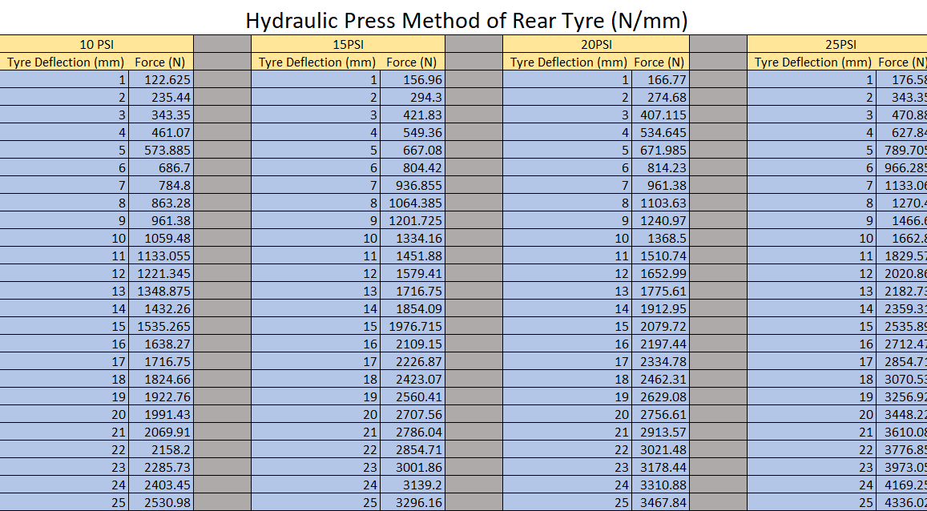

Damper Dynamometer Method.

Figure 18: Front tyre stiffness variation with internal pressures.

Combined testing graphs.

Figure 19: 10PSI Combined testing graph.

Figure 20: 15PSI combined testing graph.

Figure 21: 25PSI Combined testing graph.

Tyre Damping force.

10PSI

Figure 22: 10PSI rear tyre Damping force vs Velocity.

Figure 23: Dynamometer method of Force VS Velocity at 10PSI..

Figure 24: Displacement VS Time for 10PSI rear tyre.

20PSI

Figure 25: 20PSI rear tyre Damping force vs Velocity.

Figure 26: Dynamometer method of Force VS Velocity at 20PSI.

Figure 27: Displacement VS Time for 20PSI rear tyre

25PSI

Figure 28: 25PSI rear tyre Damping force vs Velocity.

Figure 29: Dynamometer method of Force VS Velocity at 25PSI.

Figure 30: Displacement VS Time for 25PSI rear tyre

Bibliography
17, 18 and 19 inch tyres. 2018. [Film] Directed by Tyre reviews. UK: Tyre reviews.
Agency, V. &. O. S., 2020. Categorisation of Defects, London: UKGov.
Benson, J., 2017. Tyre reviews. [Online]
Available at: https://www.tyrereviews.co.uk/Article/The-differences-between-17-18-and-19-inch-tyres.htm
[Accessed 2 April 2020].
Blundell, M., 2016. The Pneumatic Tyre – Understanding its Role and Modelling its Performance in Virtual Computer. Toronto, Coventry University.
Bridgestone, 2020. Tire tread patterns. [Online]
Available at: https://www.bridgestonetire.com/tread-and-trend/tire-talk/tire-tread-patterns
[Accessed 19 March 2020].
Chen, W., 2016. Intergrated Vehicle Dynamics. 1st ed. s.l.:Wiley .
Clark, S. K., 1971. Mechanics of pnumatic tyres. 1st ed. s.l.:SAE.
Continental, 2020. Tire tread patterns and their many uses. [Online]
Available at: https://www.continental-tires.com/car/tire-knowledge/tire-basics/tire-tread
[Accessed 20 March 2020].
cotton, A., 2018. Tyre torture at the Rolex 24 hours. [Online]
Available at: https://www.racecar-engineering.com/news/tyre-torture-at-the-rolex-24-hours/
[Accessed 8 march 2020].
Direct, S., 2020. Magic Formula Tire Model. [Online]
Available at: https://www.sciencedirect.com/topics/engineering/magic-formula-tire-model
[Accessed 31 March 2020].
Dynamics, M. s. a. t. V., 2004. M Blundel D Harthy. 1st ed. s.l.:British Libary .
engineering, R., 2019. How tyre rubber works. [Art] (Racecar engineering ).
engineering, R., 2020. TYRE DYNAMICS SLIP ANGLE VS LATERAL FORCE GRAPH. [Art] (Racecar engineering ).
FIA, 2019. Technical Regulations 2020. [Online]
Available at: https://www.fia.com/regulation/category/110
[Accessed 8 December 2019].
FIA, 2019. Technical Regulations 2021. [Online]
Available at: https://www.fia.com/regulation/category/110
[Accessed 8 December 2019].
gt-world-challenge-america, 2019. Tech Talk: Tires, Tire Warmers and How to Use this Tire "Tool". [Online]
Available at: https://www.gt-world-challenge-america.com/news/93/tech-talk-tires-tire-warmers-and-how-to-use-this-tire-tool
[Accessed 27 Febuary 2020].
Hammil, D., 2006. The sports &Kitcar suspension &Brakes high performance manual.. 3rd edition ed. London : British Library .
Haney, P., 2003. The Racing & Performance Tire. 1 ed. s.l.:SAE.
Hatton, G., 2019. How tyre rubber works. [Online]
Available at: https://www.racecar-engineering.com/tech-explained/how-tyre-rubber-works/
[Accessed 5 April 2020].
Hatton, G., 2019. What F1 in 2021 will look like.. [Online]
Available at: https://www.racecar-engineering.com/articles/f1-2021/
[Accessed 8 December 2019].
Howard, K., 2000. Michelin F1 radial. [Online]
Available at: https://www.motorsportmagazine.com/archive/article/november-2000/47/michelin-f1-radial
[Accessed 19 March 2020].
Jacobson, B., 2017. Vehicle Dynamics Compendium, US: Chalmers University.
Karnopp, D., 2004. Vehicle Stability. s.l.:Marcel Dekker INC .
MCR, T., 2019. Master log. Swansea: UWTSD.
Milkins, D., 1995. Race and vehicle Dynamics. 15th ed. USA: SAE.
Miss.P.Y.Mhaske, 2016. Stiffness analysis of passenger car tire using Nitrogen, Maharashtra, India: International Journal of Scientific and Research Publications.
Møller, M., 2007. Psychosocial function of driving as predictor of risk-taking behaviour, Link ¨oping, Sweden: Department of Health and Society.
Motorsport.com, 2016. Size comparison of 13inch and 18inch wheel. [Art] (Motorsport.com).
New Tyre Rules 2021. 2018. [Film] Directed by Stuart Taylor. UK: ChainBear.
one360.eu, 2012. Mille-Pattes Michelin Citroën DS. [Art] (one360.eu).
P.A.Narwade, P., 2016. Stiffness analysis of passenger car tire using Nitrogen, Maharashtra: International Journal of Scientific and Research.
Pacejka, H. B., 1987. SAE 870421. s.l.:SAE.
Pacejka, H. B., 2006. Tyre and Vehicle dynamics. UK: SAE.
Patch, 2015. The contact Patch. [Online]
Available at: https://the-contact-patch.com/book/road/c2020-the-contact-patch
[Accessed 5 April 2020].
SAE, 2001. Steering and suspension technilogy symposium. 1 ed. USA: SAE.
Salminen, H., 2014. Parametrizing tyre wear using a brush model, Stockholm: Royal Institute of Technology.
Schmid, M., 2011. Tire Modeling for Multibody Dynamics , Wisconsin: Simulation‐Based Engineering Laboratory .
Seward, D., 2014. Race car design. 1st ed. London: Palgrave.
Smiley, R. F., 1957. CONSIDERATIONS OF HYSTERESIS EFFECTS, Langley: NASA.
SRO, 2019. https://www.gt-world-challenge-america.com/news/93/tech-talk-tires-tire-warmers-and-how-to-use-this-tire-tool. [Online]
Available at: https://www.gt-world-challenge-america.com/news/93/tech-talk-tires-tire-warmers-and-how-to-use-this-tire-tool
[Accessed 20 March 2020].
Suyabodha, A., 2017. A Relationship between Tyre Pressure and Rolling Resistance Force under Different Vehicle Speed , Lak-hok: Rangsit University.
Svendenius, J., 2007. Tire Modeling and Friction estimation, Lund: Lund University.
Taylor, R. K., 2001. METHODS FOR MEASURING VERTICAL TIRE STIFFNESS, US: American Society of Agricultural Engineers.
Technologies, K., 2019. FAQ. [Online]
Available at: https://www.kaztechnologies.com/faq/#dampingcoefficient
[Accessed 18 March 2020].
The US Grand Prix 2005. 2018. [Film] Directed by ChainBear. uk: youtube.
Transport, D. o., 2015. Facts on Young Car Drivers, London: gov.uk.
Tsiotras, P., 2020. Pacejka's Magic Formula. [Art] (ResearchGate).
TYRE STRESS ON ROAD. 2012. [Film] Directed by S.Muthu Raja. s.l.: s.n.
TyreTech, 1992. TyreTech Confrence. Paris , Rapra tech LTD .
Uil, R., 2007. Tyre models for steady-state, Eindhoven: Eindhoven University of Technology.
UniRoyal, 2020. How to measure tyre pressure. [Art] (UniRoyal ).
UNSUNG HEROES - #24 - The Citroen PLR. 2018. [Film] Directed by HSG. UK: HSG Automotive.
Wittenmark, B., 2013. Brush tire model with increased flexibility, lund: lund university.
Wittenmark, B., 2014. BRUSH TIRE MODEL WITH INCREASED FLEXIBILITY. [Art] ( Lund Institute of Technology).
Yokohama UK, 2020. Yokohama, Bletchley : Yokohama.

