Project Initiation Document
University of Wales Trinity Saint David | Project Management (M5X00615) | Sue Maw
SmartPhone Application
Iestyn Williams (P147615)
2017
Table of Contents
Idea 1
Project Definition 1
Purpose 1
Desired result 1
Scope 1
Type of work 1
Type of clients 1
Type of problem 1
Geographical Area 2
Constraints 2
Authority 2
Project sponsor 2
Project Manager 2
Project organisation structure 2
Project organization chart 3
Objectives 3
Resources 3
Stakeholders 3
Team Roles 4
People 4
Hardware 4
Software 4
Area of work 4
Finances 4
Project definition System objectives 4
Risks 4
Project Plan 5

Idea
A smartphone/tablet application was chosen to be created for the small third sector organisation/charity, Ethnic Youth Support Team (EYST). We found out about EYST by researching into charities around Swansea. Firstly, the team thought of improving their website since it didn’t look very professional with black bars on the sides, social links weren’t linked correctly, and they didn’t have a mobile friendly website. Then we thought of creating an application for mobile devices that was mobile friendly, as this could potentially lead to more views than their current website and it would offer more features to help both the ethnic youth and the charity workers of the EYST.

Project Definition

Purpose
The creation of the application is for both the charity workers and ethnic youths to find out what is happening with the EYST, by reading about recent events, by planning for future events in their mobile device’s calendar, by chatting to each other through a messaging application, and more, all whilst on the move or in general with their mobile phones.

Desired result
The desired result would be that most of the ethnic youths using this application would be using this application at least once or twice a week and the charity workers would refer to it daily. Another result would be that the application popularises the charity, which would lead to more young ethnics around the Swansea area receiving further support.

Scope

Type of work
For the application, the team must contribute a great amount of work towards the programming and the designing of the app, to make it work without any issues and to make the app as appealing as possible and simple to use. Both will be done through software called ‘Swift’.

Type of clients
The application’s clients are the young ethnic people of Swansea and the charity workers for the EYST organisation.

Type of problem
The problem of not having an application for the charity is that it limits the amount of ways for young ethnics to connect with the charity. By creating the application, it will solve the limitation problems of a website.

Geographical Area
EYST only operates in the geographic area of Swansea city. The areas the charity doesn’t cover (or application) is the surrounding areas of Swansea in the county of Glamorganshire. A list of the surrounding areas NOT getting support are as follows:
- Gower
- Loughor
- Pontardawe
- Neath
- Port Talbot
- Llanelli

Constraints
The largest constraint that will influence the product’s deadline date is time. To make sure we use the time wisely a project plan will be created to schedule time slots for when the team can hold meetings and work together. The project plan will also have timeframes to create each feature for the app. A second constraint is resources, for example, the availability of the team members and the hardware/software provided by the university.

Authority

Project sponsor
The project sponsor of our mobile application project will be Susan Maw, the lecturer for the Project Management module.

Project Manager
The Project Manager for the project is Tom Evans because he’s vocal, good at time management and he has used ‘Swift’ (software) in the past. The responsibilities of the Project Manager include the organisation of meetings at times that suit all team members and the creation of a work plan which the team can follow to ensure that the application will be created by the set deadline.

Project organisation structure
The project will be governed by the following structure: Sue Maw (Sponsor), Tom Evans (Project Manager), Sophie Novak (Head Designer) and Iestyn Williams (Head Programmer).

Project organization chart

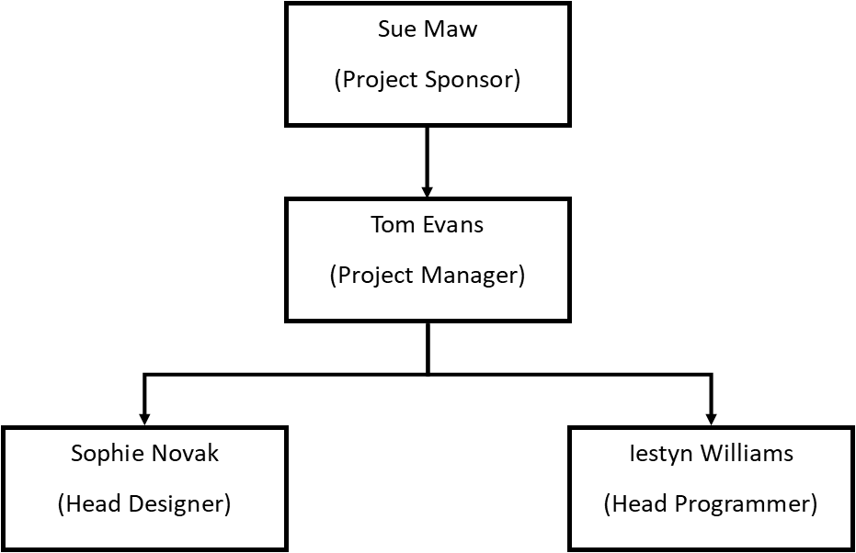

Objectives
Please see below a list of the proposed outcomes upon full release:
- An event logger will be incorporated which will set reminders for upcoming events on the phone’s calendar. To meet this objective, a test of holding down an event for 3 seconds will set the event’s details (Name, time, location etc.) automatically on the phone’s calendar.

- An eBook reader will be included to read the publications that the charity publishes (e.g. Annual reports). This objective will be tested by going to the publication tab, then downloading the publication and lastly being able to view the publication through a built-in PDF reader.

- A gallery feature will show the pictures that have been uploaded to the website on the application. This objective will be tested by firstly being able to display the existing photos from the website’s gallery tab, then by clicking on a picture to zoom in for a closer look.

- A simple messaging application will be included so that any ethnic youth can have a one to one chat with a charity worker of their choice. This will be tested by creating a messenger section, where an user can have a choice (using a drop-down list) of which charity worker they would like to talk to and then checking if the message has gone through to the correct person.

Resources

Stakeholders
Here is a list of stakeholders for the application:
- Project Sponsor
- Team Members
- Charity Workers
- Young Ethnics
- Funders and Supporters of the charity

Team Roles
The team roles and corresponding responsibilities have already been detailed in the Project Organisation Structures section. The other members’ responsibilities will be as follows: Sophie Novak will have more responsibility for the designing of the app and she will have some input to the programming of it, while Iestyn Williams’ duties will include mostly the programming of the app and he will give some feedback on the app’s designs. Tom Evans will be involved with both the programming and the designing of the app whilst also carrying out his project management duties.

People
Workforce:
- Tom Evans
- Sophie Novak
- Iestyn Williams

Hardware
- Mac
- Smartphone

Software
- Swift
Area of work
A meeting room will be provided by the University for planning and designing purposes.

Finances
Since this is a project for a charity and the work will form part of a module for the University, no costs will be charged.

Project definition System objectives
The application is created to solve the problem of not limiting mobile users to use an unfriendly mobile website to know what’s going on with the charity. The app also has many features e.g. an event logger, an e-book reader, a picture gallery and a messaging application.

Risks
Since the project has no financial resources, the risks are all based on time and resource risks. Here are the risks:
- Through proper planning and preparation, the deadline can be met, however a lack of urgency could lead to a deadline being missed.

- There is a limited amount of resources available as they are being provided by the University, thus the required software and hardware may not be available.

- Should a team member become ill, this will cause delays for their individual part of the project and this, in turn, could delay the project.

Project Plan



