Student Self Evaluation Form

PLEASE COMMENT ON AREAS IN WHICH YOU FEEL THAT YOU HAVE PERFORMED WELL | PLEASE COMMENT ON AREAS you feel that you need TO DEVELOP
- I designed and applied appropriate research methodologies demonstrating a critical understanding of the nature of educational research.  - I have read widely and made some interesting points regarding the significance of supporting pupil progress.  - I showed some originality in the application of appropriate research skills.  - I have gained a good understanding of 'pupil voice' throughout this assignment. | - I would like to develop some of my research skills further by conducting larger scale and longitudinal research studies in future.  - I could critically evaluate research evidence further.
Student’s Name | Rhianon Healy | Date | 29/05/18
Student’s Signature | R.C.Healy
Common Assessment Criteria Applied
Common Assessment Criteria Applied | REFER |  | D |  | C |  | B | A
 | OUTRIGHT FAIL | UNSATISFACTORY | SATISFACTORY | GOOD |  | VERY GOOD |  | EXCELLENT
1. Subject Knowledge and Understanding (which includes using research-informed literature and knowledge and understanding of the subject)
 |  |  |  | ✔
2. Intellectual Skills (Analysis)
2. Intellectual Skills (Analysis) |  |  |  |  |  | ✔
3. Pedagogic and Professional Applications (Practical Application and Deployment)
 |  |  |  | ✔
4. Key Transferable Skills
4. Key Transferable Skills |  |  |  |  |  |  |  | ✔

Supporting pupil progress: a detailed analysis of one child’s holistic development, with justification for the next steps in learning.’

The aim of this assignment is to analyse a child's holistic development, identifying the next steps in their learning by adopting the 'mosaic' approach of data collection (Clark and Moss, 2011). The term 'holistic' embraces a view of the whole child and refers to the general learning experience which involves all areas of development. (Lynch and Gregory, 2016). It could be argued that all aspects of learning are interlinked for young children as they do not compartmentalise their learning and understanding into curriculum areas (DCELLS, 2008). With this in mind, at the centre of the Foundation Phase framework (Welsh Government, 2015) lies the significance of holistic development which aims to encompass the developmental needs of all children.

The context in which I conducted my data collection took place in a traditional
red-brick primary school situated on the outskirts of Llanelli, it has around 200 pupils on roll. Around 15% of pupils are entitled to free school meals which is below average for primary schools in the local authority and in Wales (Estyn, 2016). The identity of the school and its pupils will be anonymised in order to ensure confidentiality and protect the child's identity at all times (UNCRC, 1990). Therefore, the school will be referred to as School H. As a trainee teacher completing my final teaching practice, I have been placed within a Year Two class. There are 33 pupils in the class, 5 of whom have been identified as having Additional Learning Needs and two of whom have English as an Additional Language. Upon consultation with the class teacher and completing initial observations of all pupils, I decided to base my research on the holistic development of Child M, a seven year old girl within the class. Child M is working within the higher ability group for Language and Literacy and she is working within the middle ability group for Maths. In order to form the 'mosaic' approach as identified by Clark and Moss (2011) I have conducted observations, taken photographs, completed a learning walk, included annotated samples of work and assessments as well as interviewing Child M and her teacher to inform my suggestions.

Data Collection

There are ethical considerations to consider whilst conducting any form of research, particularly within a school environment. Therefore, upon a discussion with the class teacher about the assignment, a letter detailing that permission and confirmation could be granted was then signed by her (see appendix one). This important step was taken to inform the school of the research aims and what it involved to ensure I abided by UWTSD's Research Ethics & Integrity Code of Practice 2017-2020 as well as BERA Ethical Guidelines for Educational Research (2011) in order to diminish potential ethical issues that could arise whilst conducting research.

As a researcher, building trust with the participant, entering the child's world and communicating all aspects of the research are essential factors to consider before undertaking observations (Department for children, schools and families, 2007). Therefore, I felt that it was my responsibility as the researcher to ensure anonymity of those taking part. Concurring with this, Sapsford and Abbot (1996) identify the idea that confidentiality can be seen as a promise that those involved will not be presented in an identifiable form. I explained to Child M that I would like to know what helps her learn in order to help me develop my teaching. I also explained that this could involve going on a learning walk, asking questions about her learning and taking photographs of work she produced. I mentioned that I would not include her name within my research. Additionally, I understand that it is crucial to inform the child and those taking part that if a child who has provided assent to participate in the research study decides not to proceed, then they have the right to fully withdraw from the study without any repercussions, which I did fully clarify to Child M. Taking on board these considerations ensures that I do not put my professional name at risk. Whilst on teaching practice I adhere to the school's safeguarding policy in all aspects of teaching and learning as well as the data collection. My interviews will be conducted with the class teacher present within an open area of the classroom. Doing so, means that I do not put my personal safety at risk.

The data collected aims to support justification for the next steps in learning following a detailed analysis of Child M's holistic development. For the purpose of this assignment, the 'mosaic' approach has been adopted as it acknowledges the importance of a framework for listening to a child's voice (Clark and Moss, 2011). In support of listening using the Mosaic approach, Brooker (2002, p.171) highlights that: 'unless adults are alert to children’s own ways of seeing and understanding and representing the world to themselves, it is unlikely that the child will ever manage to identify with the school’s and teacher’s ways of seeing’. Although the publication date of the book could be seen as outdated, it highlights a number of interesting points surrounding the success of a jointly owned culture in the classroom that could still be applied today. Supporting this, Donaldson (2015) states that the children and young people of Wales should be encouraged to take greater responsibility for their own learning. Therefore, providing opportunities for pupils to voice their views on themselves as learners may encourage a collaborative culture of high expectations within the classroom.

The significance of conducting regular observations within the early years has clearly been recognised throughout wider literature (Gifford 2004; Bruce 2011). Therefore, it could be
argued that as practitioners we must make careful observations of children in order to form an understanding of each child in a reflective way (Nutbrown, 2012). Similarly, Kolb's experiential learning theory (1984) identified reflection as an essential element of learning in order to make effective changes. It was decided that I would conduct the observations as a non-participant which meant that the information could be gathered without interacting directly with the target pupil and interrupting their natural behaviour (Kelly, 2006). However, as teachers, we must consider the idea that observations can be seen as 'snap shots' and therefore, we must not group the child on a narrow measure. Nonetheless, due to the scope of this assignment, it was not possible to undertake a large number of observations and therefore due to its small sample size, the findings cannot be generalised in any way.

Semi-structured interviews with the child and her class teacher were chosen as another method of data collection which aimed to play a role in piecing together the 'Mosaic approach' as it could be argued that children should not be seen as 'passive objects in the research project or in society in general' according to Clark and Moss (2011). Therefore, I felt that seeking the child's perspectives through this method allowed a flexible and fluid structure which enabled other questions to evolve from the dialogue between myself, as the researcher and the interviewees (Mason, 2004).
Furthermore, conducting qualitative methods of data collection such as interviews can bring about meaning and knowledge according to Kell (2004 cited in Allen, 2004). However, I have also considered limitations of conducting qualitative methods of data collection as it could be argued that the data could be more likely to be open to ambiguity in comparison to quantitative methods (Burton et al. 2008). Overcoming such barriers whilst conducting qualitative research can be difficult and therefore, as the researcher, I must ensure that Child M feels at ease whilst taking part in order to diminish any feelings of intrusion and anxiety (BERA, 2011).

Analysis of learner

Within this section of the essay I will be presenting the data I collected and analysing it to identify what this tells me about Child M, her current achievements as well as her attitude towards her own learning. Following this, I will be justifying the next steps in learning for Child M.

Rees et al. (2010) argue that wellbeing has evolved as an overarching concept which is generally held to describe the quality of people’s lives. Contrastingly, Statham and Chase (2010) identified a distinction between understandings of childhood wellbeing adopting either a developmental perspective or a children's rights perspective. Therefore, in order to gain a good understanding of Child M's well-being I consulted the class teacher who informed me that she is a ''confident and competent member of the class'. Child M is also a member of a local theatre group where she participates in acting, dancing and singing. Her interests also underpin some of the choices she makes when visiting the continuous and enhanced activities within the indoor and outdoor provisions. Appendix 2 shows Child M using the stage to perform a 'show' for her peers, she displays confidence and a positive attitude towards learning.

Upon completing a learning walk of the indoor and outdoor areas of the school with Child M, some interesting points came to light. Child M led the walk and covered the whole school. She was eager to show me a number of places deemed as important to her and her peers. The main concept that arose from this part of the study was the importance the pupil places on lessons being fun for the children in her class, both in the indoor and outdoor environments. A classroom display of an 'eco' lesson that involved litter picking in the local community prompted a discussion which highlighted the idea that Child M enjoyed learning through a range of real-life experiences as identified within the Personal and Social development, Well-being and Cultural Diversity Area of Learning within the Foundation Phase framework (Welsh Government, 2015). The framework highlights that children within the Foundation Phase should 'show curiosity and develop positive attitudes to new experiences and learning' (Welsh Government, 2015). In this instance, this was confirmed as Child M explained: 'I like it when we go outside to do things' and she continued to discuss how much she enjoyed doing drawing and writing in the 'learning village' which are a group of wooden huts containing resources such as role play areas, writing stations, a gardening area, and a stage within the outdoor provision.

The opinions she raised were most likely informed by the practical lessons that have recently been planned and delivered by myself within the learning village as prior to this the children were completing the Year 2 National Tests where a large amount of time was spent on focussed maths and reading activities within the classroom. This highlights that when presented with choices, Child M would choose to complete 'fun' activities outdoors. This point allows us to question the impact that the tests are having on children's self-esteem and dispositions to learn which could provide a potential limitation as Bertram and Pascal (2002) found that to be effective, teachers should be paying more attention to nurturing children's dispositions. In order to support these children, Dweck (2007) argues that we should be supporting and encouraging children to embrace challenges through a growth mindset approach, the belief that intelligence can improve over time and this can be done through classroom culture. Child M also mentioned that her favourite area in the classroom is the carpet area because she 'likes learning new things'. This data highlights Child M's understanding of the areas within the classroom as she is aware that the carpet area is a place where new topics and concepts are introduced to the whole class by the teacher. The significance of Child M's eagerness to learn suggests that she values the teacher's explanations of new concepts and she shows a willingness to please those around her.

Whilst conducting the semi-structured interviews, Child M displayed confidence in expressing her thoughts and opinions. When asked who she enjoyed playing with, she named three children in particular, all of which are female. However, whilst conducting the non-participant observations it was noted that Child M interacted with most children in the classroom, including boys and girls. Another non-participant observation was conducted at 'play time' on the playground. I watched how Child M imitated two of the girls from her class, as they began to demonstrate some of the exercises they had been learning in gymnastics club. Child M stated 'I can do that' as she attempted to copy the way the girls moved their bodies to perform a 'bridge' movement. This highlights the idea that social development can be seen as continuous and Bandura's social learning theory (1971) emphasies the idea that children learn from those around them, from direct experiences and observing behaviours. In this instance, Child M displayed an attitude of resilience whilst modelling her peers as she showed the ability to cope in a challenging situation, where she lacked experience in comparison to her peers (Nottingham, 2013). This data also suggests that the 'microsystem' surrounding the child, which includes the contact she has with family members and peers can have an influential impact upon their holistic development (Brofenbrenner, 1979). This data also suggests that there can be a competitiveness amongst children and Shamma (2014) identifies that any competition is nothing more than an enjoyable experience when it is created in a friendly atmosphere.

Appendix 3 shows a piece of writing completed by Child M with annotated comments from myself, as the trainee teacher. Within the ability groups set by the class teacher, Child M has been placed within the higher ability group for literacy and language. She has used her prior knowledge on the book 'Pigs might fly' which we have been studying in class 'to show understanding and express opinions about language, information and events in texts' as outlined within the Literacy, Language and Communication area within the Foundation Phase framework (2015). Child M displays confidence in completing language activities and she uses mostly correct letter formations within her writing, as identified within Outcome 5, Child M 'forms upper- and lower-case letters accurately, with consistent size and orientation'. This data along with discussions with the class teacher suggests that Child M is working towards Outcome 5 for writing and oracy. I regularly observed Child M read and she displayed enjoyment when visiting the 'book corner' within the classroom. Appendix 4 shows a completed reading record with the comments stating Child M 'shows good expression and excellent recognition of words and is working towards Outcome 5 for her reading skills. Whitehead (2010) argues that children need to be able to understand and should also enjoy stories, books, songs and rhymes which can expand their knowledge of the world and help to build up their vocabulary. Reflecting upon my observations at School H, I found that some boys seemed to spend less time in the reading area compared to some of the girls in the classroom. Nevertheless, I am not suggesting that this is a daily occurrence as my observations were merely snap shots. Similarly, Twist et al (2004) found that attitudes towards reading have declined, suggesting that a growing number of children do not enjoy reading. However, new research may suggest otherwise. Although, this may be true, the Foundation Phase (2015) states that children should be given opportunities to choose reading material and read individually and collaboratively.

Whilst completing the interviews with Child M and the class teacher, Child M stated that she does not enjoy maths 'because I always find it hard' (see appendix 6). The fact that Child M has identified Maths as an Area of Learning that she finds challenging suggests that she lacks confidence in her knowledge of mathematical concepts. This was confirmed whilst observing Child M complete a number of subtraction sums in her Abacus workbook, I noticed how she used her fingers as a counting strategy. As identified within the Mathematical Development Outcome 4 within the Foundation Phase framework (2014), children 'can perform simple addition and subtraction using their preferred strategy' (Welsh Government, 2015). However, I encouraged Child M to use her number line to support her whilst subtracting larger numbers. Concurring with this, Munn (1998) looked at support with counting, stating that teachers should ensure children understand the concept, make the purpose of counting clear and stimulate children to reach goals. It was interesting to observe Child M completing the tasks and I noticed her resilience in attempting questions that involved struggle and adjustment. Additionally, Roberts (2006) highlighted the idea that children learn best in situations which are neither undemanding nor overwhelming. Consequently, as teachers achieving the balance between the two is vital to ensure that children are suitably challenged within their zone of proximal development, the idea that a child's performance differs between situations in which a problem is solved alone and when a 'more knowledgeable other' assists them (Vygotsky, 1962).

Appendix 5 shows a piece of art work created by Child M during a planned 'Creative Development' session delivered by myself. She recognised her achievements in her work following peer assessment. The main concept that arose from this part of the study was the importance the pupil places upon gaining positive feedback from her peers and teachers. Supporting this point, during the lesson the teaching assistant implemented the 'What A Good One Looks Like' Assessment for Learning strategy to show Child M's art work to her peers and encouraged her to put a 'marble in the jar' which is seen as a class token reward. Gray and MacBlain (2012) highlighted that some schools have adopted a token scheme to reward children for their attendance, neatness and good work. As the pupil's behaviour improves, rewards are slowly replaced by verbal praise. Although this can encourage some children, including Child M to produce work that is of a high standard and meets the learning objective of the lesson. It could also be argued that for some children who receive praise indiscriminately, it may become meaningless which could have the opposite effect of developing a child's self-esteem (Roberts, 2006). Furthermore, Child M showed enthusiasm when being presented with the opportunity to 'make choices when choosing materials and resources' during the Creative Development session (Foundation Phase, 2015). This suggests that the carefully planned resources and environment has enabled her to be an 'active learner' which is fundamental within the Foundation Phase framework (Welsh Government, 2015).

Next steps

Following the analysis of Child M's learning, I am going to identify the next steps in order to support her progress, justifying pedagogical approaches, resources and activities which could support my teaching and pupil progress. Regarding pupil interests, I would consult the children in creating areas and engaging activities that provoke curiosity and independence within the classroom. This would create an inclusive environment which provokes a sense of belonging within the classroom. During my 'bridging' experiences within another large primary school in the Swansea locality I observed an activity which aimed to 'hook' the learners before studying a new topic. This involved asking the children to write down key words and images on post-it notes to inform the class teacher which areas of the topic they'd like to learn about within the term. I feel that this activity can engage children in the learning and allows them the opportunities to shape their learning experience and voice their opinions. Supporting this Estyn (2016) identified the idea that a strong pupil voice has clear benefits for both schools and learners. Children also gain self-confidence when being listened to and when taken seriously. For example, I feel that asking the children to devise a set of classroom rules suggests that they are more likely to buy into them if they are given the opportunity to create them by collaboratively working together to ensure the classroom rules are fair and achievable whilst promoting inclusion.

In light of the data obtained during the learning walk, I could aim to ensure that there are plenty of opportunities for outdoor learning to take place as Child M expressed enjoyment when working outdoors. It could also be suggested that this could have a positive impact upon her holistic development and well-being as the Foundation Phase (2015) highlights that children's physical development, enthusiasm and energy for movement should continually be promoted across all areas of learning, including indoors and outdoors. However, a limitation to consider could be parental views on outdoor learning. Concurring with this, Bentley et al. (2012) conducted a small study in Bristol and identified time, cost and lack of safe outdoor space were the key environmental barriers parents were highlighting in relation to their children's physical activity. Therefore, it is significant that the use of outdoor areas for teaching and learning are communicated with parents during parent evenings, informal discussions and welcoming an 'open-door' policy which encourages parents and carers to communicate with myself and the class teacher. I will also be sending home a letter addressed to parents to encourage the children to bring suitable clothing, footwear and sun cream if necessary, to school on Thursday's when we visit the 'learning village'. This aims to ensure that all children are dressed appropriately when we go outside and parents understand the nature of our outdoor learning experiences.

Child M identified three children as her friends, all being girls. I also noticed that she interacted with mostly girls within the classroom and during play times. Therefore, in order to develop her social skills even further, it is important that I ensure that I, as the trainee teacher, display positive relationships with all children, both male and females within the classroom as quite often teachers are seen as 'role models' and they can facilitate the development of children's values and moral-reasoning (Lumpkin, 2008). Therefore, I will provide opportunities for children to participate in problem-solving cross-curricular activities which aim to promote creative and collaborative learners as recommended by Donaldson (2015). As a trainee teacher, I feel that I should encourage interactions between different friendship groups to ensure children are not experiencing social exclusion. To achieve this, I will choose groups using 'lollipop sticks' which I commonly use as an Assessment for Learning strategy within my teaching practice as it means that children are split into groups fairly as opposed to being seated according to ability for Maths and Language lessons. Another form of 'play' which may have a positive impact upon developing social interaction could be the use of role play. Incorporating role play activities into lesson planning may be beneficial as role play can help to scaffold the social development of the child and may support children's development of interacting with others and switching freely between roles (Fein, 1991). Therefore, I aim to put the provisions in place to ensure Child M has access to the resources required to develop her social skills even further.

Although Child M shows that she is working at Outcome 5 for Language, Literacy and Communication Skills, there is still room to develop her writing skills further. I aim to ensure the mark-making area within the classroom is well-stocked with a range of resources such as: paints, chalks, paper, crayons, pens, pencils and mini whiteboards. A current limitation of this area within the classroom is that it lacks resources which can cause children to become 'bored' if the tools available to them are not stimulating. I have completed a continuous provision planning sheet (see appendix 8) as I have been given responsibility for improving the mark-making provision within the classroom. I aim to ensure that I am differentiating my lessons whether it is through the support provided, the learning objectives or the volume expected. This ensures that all pupils are suitably challenged and extend their thinking skills. Child M has been placed within a higher ability group for Language and she has been identified as a MAT pupil. Therefore, it is important that I provide Child M and other More Able and Talented pupils with extended opportunities to develop their skills. Going forward, I would like to encourage MAT pupils to write a section of the weekly newsletter for parents as I feel that this will positively impact upon Child M's achievement in Language and for those involved it will provide a sense of responsibility. Through my daily RAG tracking I aim to encourage these pupils to write for different audiences, produce more extended pieces of writing and achieve their learning targets (Welsh Government, 2015). As a result, my practice has the potential to improve. It was through my data collection that Child M shared key information about her interests which includes 'writing'. Doing so, enabled Child M to become an expert of her own learning.

In light of the data obtained, it could be argued that, in order for Child M to make appropriate progress in mathematical development I need to consider how I can put provisions in place to support her academic attainment. As she expressed a dislike for 'maths' I feel that I need to ensure that some lessons are seen as fun and practical. Doing so, may encourage her learning as she expressed enjoyment when learning outside, which could provide her with the opportunities to extend her maths skills. Supporting this, Pound (2006) suggested that the learning environment should be planned carefully and should be suitable for children as they investigate and develop their mathematical understanding, counting, patterns, shape space and measurements. It could also be suggested that in order for Child M to make progress in Mathematical Development I need to support her mental strategies, particularly in counting. I aim to ensure I use a range of visual displays and teacher modelling during the introduction to sessions as well as providing handouts to support the learning during focus activities. ESTYN (2009) states that 'Young pupils need to be able to count, calculate and work confidently with mathematical ideas.' Therefore, it could be argued that mathematical development is an active learning process. To achieve this, I will continue to observe and reflect upon the children's problem-finding and problem-solving in order to identify the strategies they are using and the progress they are making (Gifford et al., 2005). As previously identified, the children in my Year Two class have recently sat the National Reading and Numeracy Tests and therefore, the class teacher explained that they had been completing past papers in preparation for the test which goes against the ethos of the Foundation Phase framework (2015) which states that 'children learn through first-hand experiential activities'. The process caused visual stress for Child M and as she has shared this information with me I hope to improve her chance of success by removing barriers to her learning and helping her to reach her full potential.

Reflecting upon the data obtained during the Creative Development session, Child M displayed enthusiasm when she was provided with choices and the freedom to create something new (see appendix 7). It could be suggested that for Child M to make appropriate progress I need to consider how I can provide wider opportunities for Child M to work with peers to encourage her learning within the indoor and outdoor provisions. I feel that by using some of the art work created during Creative Development sessions I could create a display that aims to recognise effort rather than perfection. Therefore children can better understand that learning is a process of growth, not just a process of mastery. This aims to support their creativity and innovative traits which could have a positive impact upon Child M's holistic development. It could be argued that growth in creativity does not just happen, but is dependent on key factors which include the curriculum and the role of the adult (Dowling, 2009). Creativity is about taking risks and making connections and is strongly linked to play (Department for children, schools and families, 2007). Therefore, I feel that I need to ensure that the learning environment is stimulating, offers a wide range of experiences and activities and I encourage all learners to reflect upon their own work and the work of others as identified within the Creative Development Area of Learning. It could be argued that free play is as valuable as planned activities in terms of developing children's creativity and Elkind (2008) suggested how this basic children’s right has become sidelined which could be due to an increase in structured activities and busy school schedules. Overcoming such barriers will involve well-planned sessions which ensure there are opportunities for creativity which enable children to practise, repeat and refine their skills in a purposeful way. This would aim to promote cross-curricular links by ensuring a thematic aspect throughout focussed, enhanced and continuous challenges within the classroom.

Conclusion

In conclusion the data gathered in this study provides a valuable illustration on how a 'mosaic' approach can be used to encourage us, as teachers, to listen to pupil voice and perspectives on themselves as learners. This research study has enabled me to become conscious of an array of key issues that I would not always be conscious of within the classroom (Dudley, 2014). I also took into consideration that there are a number of difficulties practitioners may face whilst conducting observations as it can be problematic for teachers to step out of their role and become an observer (Thomas and Lewis, 2016). However, due to the scope of this assignment and time limitations I could not increase the number of observations, interviews and learning walks conducted which means that the findings cannot be generalised.

In particular, it will be remembered that this was a useful method of data collection as it has allowed me to analyse Child M's holistic development and justify the next steps in her learning which aim to support her progress. Reflecting upon the significance of assessment for learning I feel that going forward I will be able to implement a number of activities and well-planned resources within my practise as well as ensuring my pedagogical approaches meet the individual needs of the learners in my classroom. Doing so aims to encompass pupil voice throughout my teaching and provide opportunities for all learners to explore their interests and develop their skills. Overall this assignment has proved to be a valuable experience as it has allowed me to gain a deeper understanding of holistic development and identifying the next steps for learners within my teaching. However, I was also mindful of that fact my analysis of the observations may be affected by my own judgements and preferences as many observations carry the risk of bias (Cohen, Manion and Morrison, 2011).

References
Allen, J. (2004) Sociology of education: Possibilities and practices, South Melbourne: Thomson Social Science Press.
Bandura, A (1971) Social Learning Theory, New York: General Learning Press.
Bentley, G, Goodred, J, Jago, R, Sebire, S, Lucas, P, Fox, K, Stewart-Brown, S and Turner, K (2012) Parents’ views on child physical activity and their implications for physical activity parenting interventions: a qualitative study. [Online] Available at: https://bmcpediatr.biomedcentral.com/articles/10.1186/1471-2431-12-180 (Accessed: 29 April 2018)
Bertram, T, and Pascal, C. (2002) What counts in early learning. In Contemporary perspectives in early childhood curriculum, pp. 241–56. Greenwich, CT: Information Age.
Bronfenbrenner, U. (1974) Developmental research, public policy, and the ecology of childhood. Child Development, 45, 1-5.
Brooker, L. (2002) Starting school: Young children’s learning cultures, Buckingham: Open University Press, p. 171.
Bruce, T (2011) Early Childhood Education. (4th edn.) Maidstone: Kent.
Burton, N, Brundrett, M and Jones, M (2008) Doing your education research project. London: Sage.
Clark, A. and Moss, P. (2011) Listening to Young Children: The Mosaic Approach (2nd ed) London: National Children’s Bureau, [e-book] Available at: https://www-dawsonera-com.ezproxy.uwtsd.ac.uk/readonline/9781907969423.
Cohen, L, Manion, L and Morrison, K. (2011) Research Methods in Education. 7th edn. Oxon: Routledge.
Department for Children, Education, Lifelong Learning and Skills (2008) Learning and Teaching Pedagogy [Online] Available at: http://learning.wales.gov.uk/docs/learningwales/publications/130212ltpedagogyen.pdf (Accessed: 20 May 2018).
Department for Children, Education, Lifelong Learning and Skills (2008) Learning and Teaching Pedagogy [Online] Available at: http://learning.wales.gov.uk/docs/learningwales/publications/130212ltpedagogyen.pdf (Accessed: 20 March 2018).
Department for Children, Education, Lifelong Learning and Skills (2009) Foundation Phase Child Development Profile Guidance, Cardiff: Crown.

Donaldson, G (2015) Successful Futures, Independent Review of Curriculum and Assessment Arrangements in Wales. [Online] Available at: file:///C:/Users/Rhianon/Downloads/Donaldson%20Report%20-%20Successful%20Futures%20-%20Independent%20Review%20of%20Curriculum%20and%20Assessment%20Arrangements%20in%20Wales%20(2).pdf (Accessed: 21 May 2018)
Dowling, M (2009) Young Children’s Personal, Social and Emotional Development. 2nd edn. London: Sage.
Dudley, P. (2014). Lesson Study: Professional learning for our time. London: Routledge.
Dweck, C. (2007) The perils and promises of praise. Educational Leadership, 65(2), pp. 34–39.
Elkind, D (2008) ‘The power of play: Learning what comes naturally’, American Journal of Play, 1, 1, Summer, 1–6.
Estyn (2009) 'Best Practice in Mathematics for pupils aged 3-7 years' Available at: http://blackboard.uwic.ac.uk/bbcswebdav/pid-2393325-dt-content-rid-1302033_1/courses/EEC5001_YR_13/Best_practice_in_mathematics_for_pupils_aged_3_to_7_years_-_June_2009%5B1%5D.pdf (Accessed: 4th May, 2018).
Estyn (2016) ‘Pupil voice’ benefits pupils and helps schools to improve. [Online] Available at: https://www.estyn.gov.wales/news/%E2%80%98pupil-voice%E2%80%99-benefits-pupils-and-helps-schools-improve (Last Accessed: 27 May 2018).
Estyn (2016) Inspection report for ***** Primary School [Online] Available at: https://www.estyn.gov.wales/sites/default/files/documents/Inspection%20report%20----%20Primary%20School%202014%20%28English%20only%29_0.pdf.pdf.pdf.pdf.pdf.pdf.pdf.pdf.pdf.pdf.pdf.pdf.pdf.pdf.pdf.pdf.pdf.pdf.pdf.pdf.pdf.pdf.pdf.pdf.pdf.pdf.pdf.pdf.pdf.pdf (Accessed: 30 April 2018).
Fein, G (1991) The self-building potential of pretend play, or ‘I got a fish, all by myself’. In Woodhead, Carr & Light (Eds.), Becoming a person (pp.328–346). London: Routledge.
Gifford, S (2004) A new mathematics pedagogy for the early years: in search of principles for practice, International Journal of Early Years Education, 12, 2, pp.99-115.
Gifford, S. (2004) 'A new mathematics pedagogy for the early years: in search of principles for practice', International Journal of Early Years Education, 12(2), pp.99-115.
Gray, C and Macblain, B. (2012) Learning theories in childhood. London: Sage.
Kolb, D (1984) Experiential learning: Experience as the source of learning and development. Prentice Hall, New Jersey.
Lumpkin, A (2008) 'Teachers as role models, teaching character and model virtues', JOPERD, 72, 2, pp.45-49.
Lynch, T, and Gregory, J. (2016) Physical education, health and physical education, physical literacy and health literacy. Curriculum and Teaching Studies. [Online] Available at: https://www.tandfonline.com/doi/pdf/10.1080/2331186X.2016.1217820 (Last Accessed: 27 May 2018).
Mason, J. (2004), 'Semi structured Interview' [Online] Available at: http://srmo.sagepub.com/view/the-sage-encyclopedia-of-social-science-research-methods/n909.xml, (Last Accessed: 5 May 2018).
Munn, P. (1998: 89-96) Writing and number in Thompson, I (ed) (1998) Teaching and learning early number, The Open University Press.
Nottingham, J. (2013) Encouraging Learning. Oxon: Routledge [e-book]. Available at: https://www-dawsonera-com.ezproxy.uwtsd.ac.uk/abstract/9780203559079.
Pound, L (2008) Thinking and Learning About Mathematics in the Early Years. [online]. Routledge. Available from:http://www.myilibrary.com?ID=125983 (Last Accessed: 18 March 2018).
Rees, G., Bradshaw, J., Goswami, H., Keung, A. (2009) Understanding Children’s Well-Being: A national survey of young people’s well-being. London, The Children’s Society.

Roberts, R. (2002) Self-Esteem and Early Learning, key people from birth to school. London: SAGE.
Sapsford, R. J, and Abbott, (1996) Ethics, politics and research, London: Sage.
Sargent, P (2001) Real Men or Real Teachers? Contradictions in the lives of Men Elementary School Teachers. Harriman, Tennessee, USA: Men's Studies Press.
Shamma, T. (2014) “Competition and Collaboration in Translation Education: The Motivational Impact of Translation Contests”. In Handbook of Research on Teaching Methods in Language Translation and Interpretation, eds Ying Cui and Wei Zhao. IGI Global: Hershey, PA, 2014.
Statham, J, and Chase, E. (2010) Childhood Wellbeing: A brief overview. Childhood Wellbeing Research Centre. [Online] Available at: http://www.cwrc.ac.uk/documents/CWRC_Briefing_paper.pdf (Last Accessed: 17 May 2018).
The United Nations Convention on the Rights of the Child (1990) Convention on the Rights of the Child [Online] Available at: https://downloads.unicef.org.uk/wpcontent/uploads/2010/05/UNCRC_united_nations_convention_on_the_rights_of_the_child.pdf?_ga=2.256607883.1003445434.1507736216-573383444.1507736216 (Accessed: 13 May 2018).
Thomas, A and Lewis, A (2016) An introduction to the Foundation Phase Early Years Curriculum in Wales. London: Bloomsbury Academic.
Twist, L, Gnaldi, M, Schagen, I and Morrison, J (2004) Good readers but at a cost? Attitudes to reading in England, Journal of Research in Reading, 27(4) pp.387–400.
University of Wales Trinity Saint David (2017) Research Ethics & Integrity Code of Practice 2017-2020 [Online] Available at: http://www.uwtsd.ac.uk/media/uwtsd-website/content-assets/documents/research/research-ethics-integrity-code-practice.pdf (Accessed: 12 May 2018).
Vygotsky, L (1962) Thought and language. Cambridge MA: MIT Press.
Welsh Government (2015) Curriculum for Wales Foundation Phase Framework [Online] Available at: http://new.wales.gov.uk/dcells/publications/policy_strategy_and_planning/earlywales/whatisfoundation/foundationphase/2274085/frameworkforchildrene.pdf?lang=en - foundation phase (Last Accessed: 21 May 2018).
Welsh Government (2015) Review to identify more able and talented provision across Wales [Online] Available at: https://gov.wales/docs/dcells/publications/160106-mat-report-en.pdf (Last Accessed: 27 May 2018).
Whitehead, M (2009) Supporting Language and Literacy Development in the Early Years Maidenhead: McGraw Hill.

Appendix 1
Signed consent letter

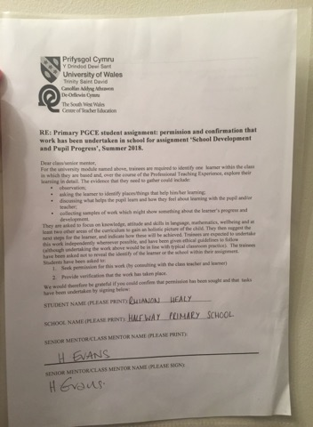

Appendix 2
Child M using the 'stage' in the outdoor learning village

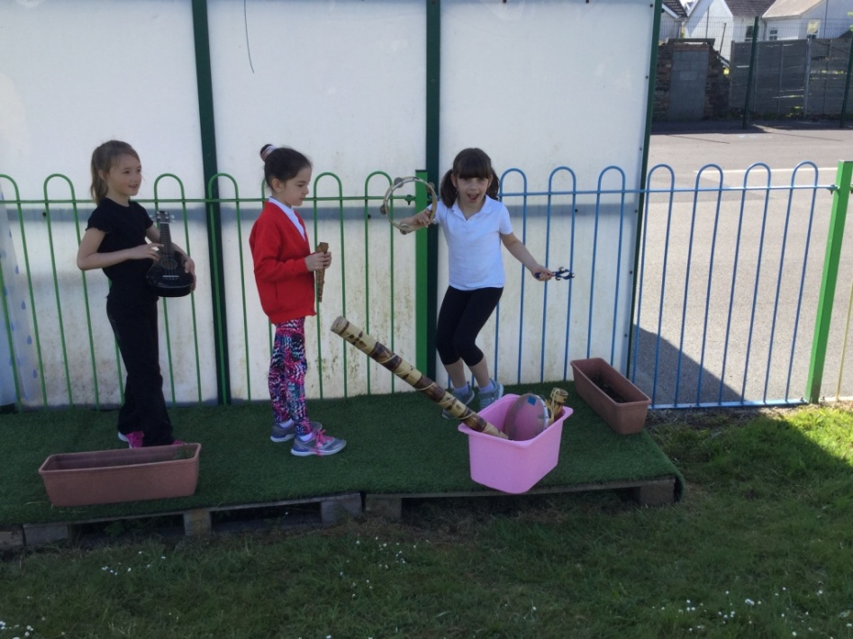
Child M

Appendix 3
A sample piece of literacy work completed by Child M
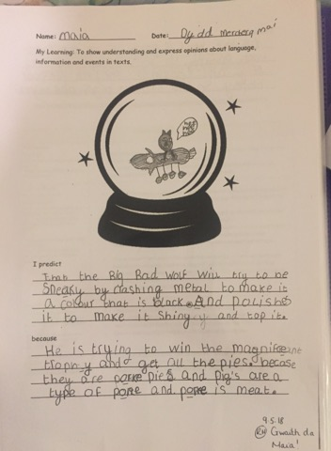

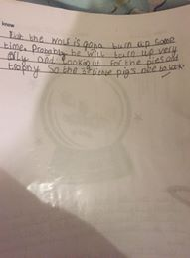
Appendix 4
Completed reading record

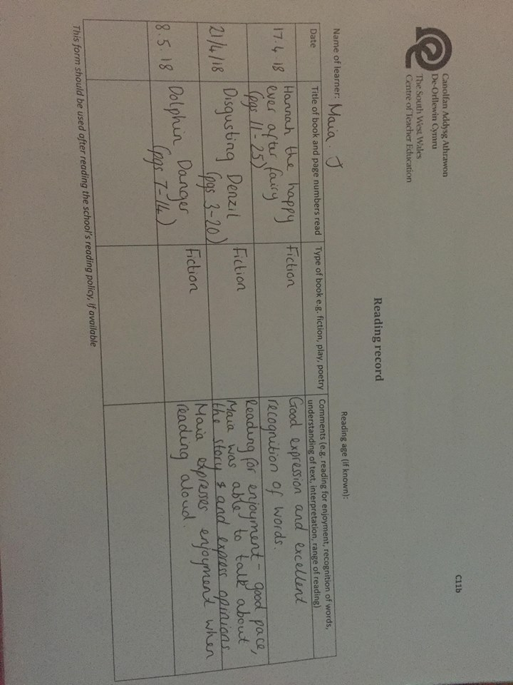

Appendix 5
A sample piece of Art work completed by Child M
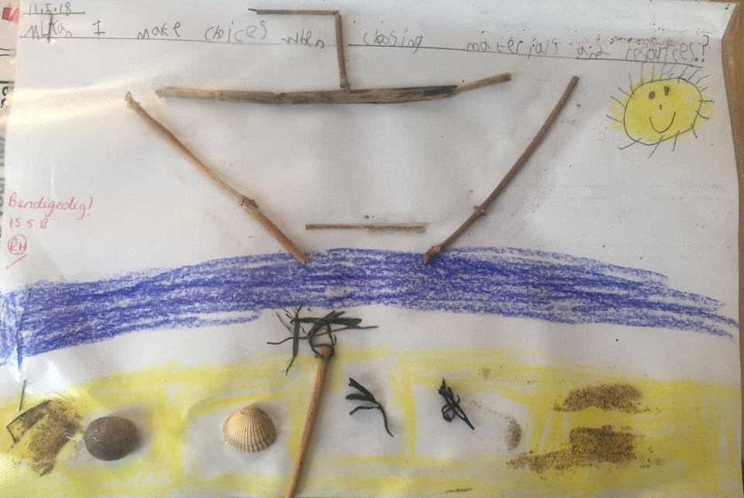

Appendix 6
Transcript of interview with Child M and the Class teacher
Semi-structured 'informal' interview with Class teacher and Child M
Location: Year 2 Classroom (Reading corner)
Time: 11:45am
I asked Child M where she would like Mrs.E and I to sit to talk about her learning and what she enjoys doing at school. She replied "can we sit in the reading corner?". I responded with "yes I think that's a lovely idea". All three of us sat on the bean bags in the reading corner. Child M smiled and said that she liked the reading corner "because it's cosy and colourful".
I asked Child M: " What helps you learn?" and she responded with: "My teachers" and pointed to myself and Mrs. E and then she continued "My mammy also helps me learn at home because she's a teacher too. She helps me with my reading and she tells me funny stories when I go to sleep." Mrs.E responded "I like funny stories too". Child M laughed.
I asked Child M "Could you tell me about your learning in school and the things that are important to your learning?" She responded "I like doing writing and drawing especially when we go outside because it's fun and we always do fun things outside but I don't like doing Maths because I find it hard and I'm not good at it." I reassured her and told her that she always tried her very best in maths and that meant she was making progress and improving. Child M said "I'm good at writing stories and drawing pictures and I do that at home too"
Child M looked around the classroom and mentioned that she liked the classroom because "it's colourful and pretty to look at."
She mentioned that she liked showing me all of the areas around the school and she'd like to be a teacher when she's older.
I asked Child M what she most liked about school and she responded "I like learning new things when we sit on the carpet" and "I like it when we do games and drawing outside."

Appendix 7
Learner observation form (Creative Development)

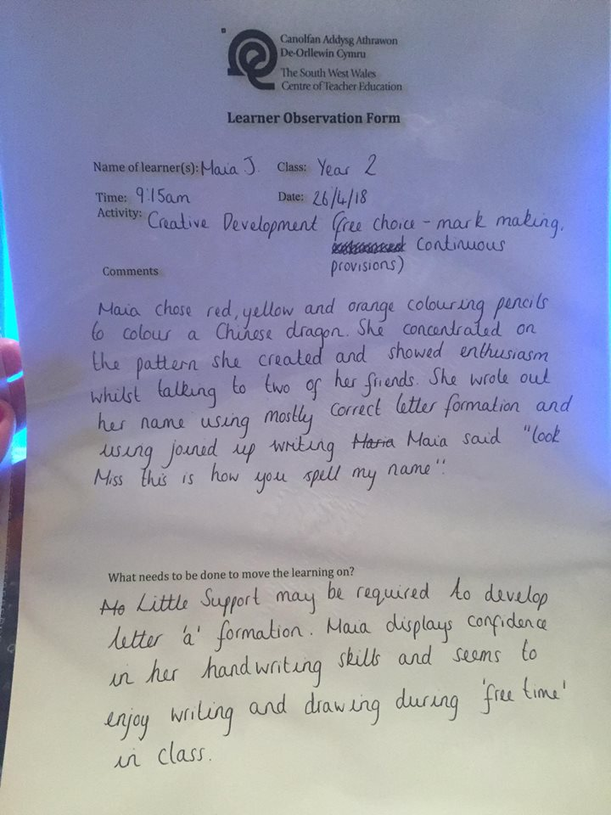

Appendix 8
Continuous provision planning sheet



