Aimee Thomas
HPHE6008
Museums, Heritage and Representation
Quentin Drew
University of Wales Trinity Saint David
18/01/26
Using one of the establishments visited, examine the strengths and weaknesses of their collection rationale.
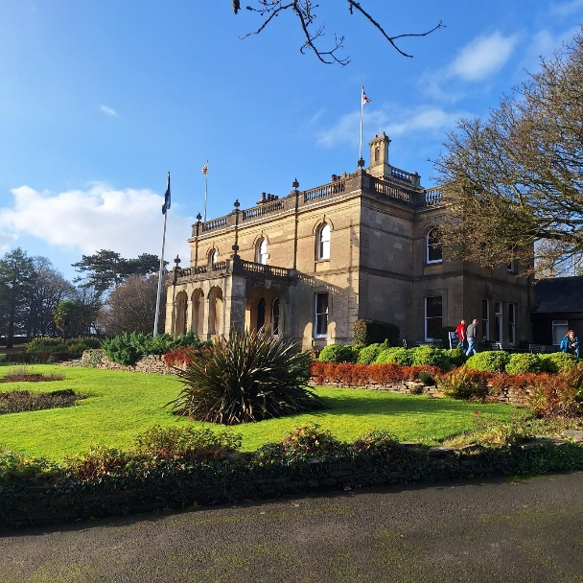
Image 1, Parc Howard Museum, Llanelli Carmarthenshire, taken by Aimee Thomas, 10 December 2025.
Parc Howard Museum is an establishment based in Llanelli, it is one of five museums that are part of CofGâr, an organisation that is based in Carmarthenshire that represents and cares for all five museums. Parc Howard was an ‘Italianate mansion’ estate that was previously owned by the Howard family. The house was then gifted to the community of Llanelli, by Lady Howard Stepney, in 1912 ‘as a hub for arts, culture and wellbeing at a time of high unemployment and social unrest’ and has been leased to the public for 999 years. The estate is currently funded and cared for by the Carmarthenshire County Council and Llanelli Town Council. According to the website the museum is described as having an atmosphere of inclusivity and is family friendly. It has the heart of the community’s history at its core and is presented as being a place of creativity and discovery. The following report examines and evaluates the strengths and weaknesses of the choices that curators have made for displaying and presenting the heritage of Llanelli, through the digital and physical collections.
Scholar Graham Black writes, ‘Museums have a commitment not only to collect, conserve and document material evidence of the past but also to make it publicly accessible’. This describes the purpose and structure of museums. Black further explains that with these collections, museums have an opportunity to ‘define what is or is not history’ through their interpretation and display of the evidence acquired, as ‘they construct and transmit meanings’. In the new age, museums have taken on a new approach to curating and reaching the wider population through digitalisation. The new media of digitalisation allows museums to reach the public via online exhibitions and access to collections. Parc Howard museum uses digitalisation through their website, it is simple and easy to navigate, providing visitors with information along with images and links to their collection.
The focus of the CofGâr website, specifically the one dedicated to Parc Howard museum, provides a narrative that is family friendly which is highlighted by the online collection. On first opening of the website, one is presented with a welcome banner stating, ‘Welcome to the Imaginarium’ in big letters and the statement ‘Inspiring our next inventors is our mission at Parc Howard Museum’.A key rationale of their online and in- person collections is the inventive, creative and entrepreneurial aspects of Llanelli’s past. On the home page there are three online links to stories of Llanelli’s past alongside the history of Parc Howard.
A key figure that is mentioned online is James Buckley in relation to the entrepreneurial aspects. The online information briefly explains the life of James Buckley, his entrepreneurship and his connection to Parc Howard. Alongside the information of Buckley, portraits of people are shown at the bottom of the page, although there are no names mentioned in relation to each portrait, it is assumed the images are related to Buckley and the family.
Alongside James Buckley, the website displays a section on ‘Llanelly Pottery’. This section highlights the entrepreneurship of William Chambers, a local businessman who started a pottery factory and was part of the Llanelli’s growing industrial community. This section also displays images of the pottery. Alongside, there is a separate link to a digital collection that provides three videos that contain an understanding of the impact of ‘Llanelly Pottery’ on the community, and its story. This allows for schools and visitors to engage with the information differently, rather than relying solely on words, the visual elements provide a more multisensory representation to the wider public.
The community connections of Parc Howard are further illustrated through a presentation of its role as a hospital and refuge during the Great War. There are images displayed at the bottom of the page of the grounds, when it was used as a hospital with images of soldiers recovering. The rationale of this collection of stories hangs together well and presents a clear picture showcasing the entrepreneurial aspects of the people of Llanelli, the creativity, and the role of Parc Howard as a community hub. The website helps to contribute an understanding of the collection before visiting the museum, and also provides a resource for further study following a visit. This would be particularly valuable for schools.
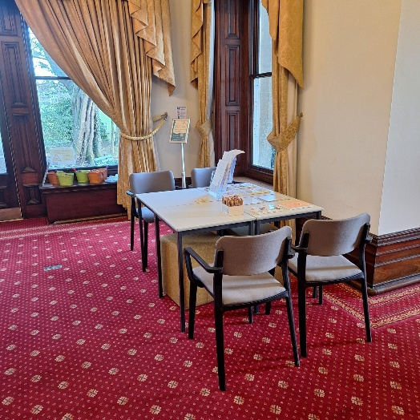
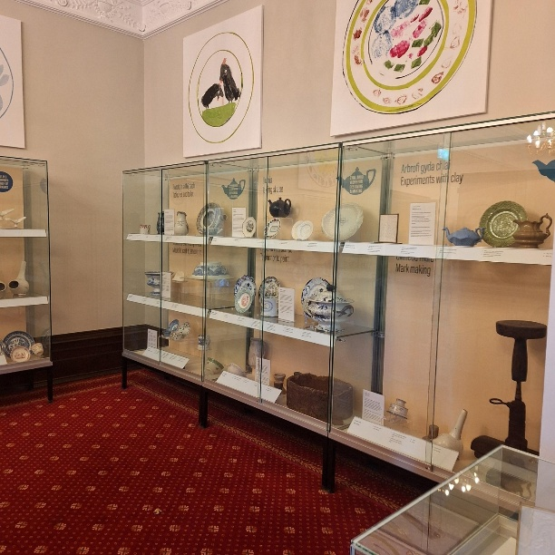
However, there is a difference between the online and in person collection. The website provided a brief description of Llanelli history and connection to pottery, but the in-person exhibition provides more tangible evidence for the visitor. Image two does not display the vastness of the room that holds a huge number of objects relating to pottery from Llanelli’s history. To compare the images shown online, the website provides an underwhelming expectation for the objects within the exhibit. Also, while the online collection provides clips for visitors to interact with, the exhibition continues the narrative of creativity and discovery with the section dedicated to arts and craft for children. Image three demonstrates an area for children to interact with replicas of the pottery that is displayed and to create their own designs, this allows them to become part of the story. The structure of the online display and the in-person exhibition provide a good connection and structure for the visitor to interact with the collection. The interactive elements support the educational aims of the museum and as Haywood and Cairns identify, the interactive displays positively enhance the educational experience.
Image 3, ‘Llanelly pottery’ exhibition, Parc Howard Museum, Llanelli, taken by Aimee Thomas, 10 December 2025.
Image 2, ‘Llanelly Pottery’ exhibit, Parc Howard Museum, taken by Aimee Thomas,10 December 2025.
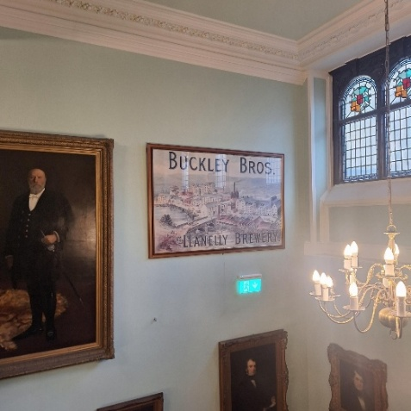
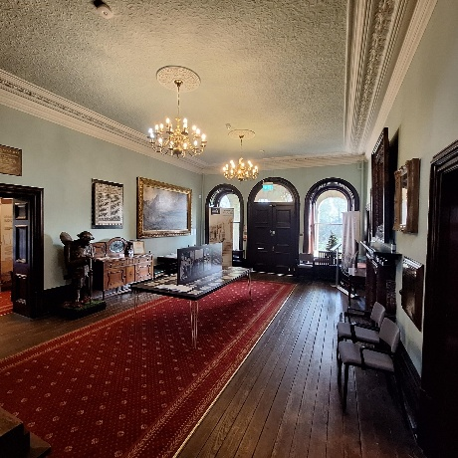
In relation to the other online stories, information on James Buckley and the history of Parc Howard is not dedicated to a single display but rather to a footnote. The key rationale for the collection is the essence of community, the entrepreneurial aspect and creativity in relation to Llanelli. From the website it seemed that James Buckley and the history of Parc Howard, during the first World War, would have a similar focus to Llanelli Pottery. Nevertheless, both stories are a footnote in other information throughout the estate. In Image four, the table stationed in the middle of the room contained information on Parc Howard with a mention of its involvement as a hospital. There is then no further comments on the subject around the estate. Similarly, James Buckley has a page of information on the website that details his life, briefly. Parallel to the information above, Buckley has a brief mention throughout the exhibits which is showed cased in image five. The online display and the exhibit of Llanelli pottery did set an expectation of what would be showcased throughout the museum. Although throughout the visit the expectation of seeing a display of Buckley’s and Parc Howard’s involvement in the Great War was merely to set a tone for the theme of community and inventions. This was showcased in the top floor room that was dedicated to Llanelli as a community and its entrepreneurial past, rather than one particular invention. To compare the online and the in-person collection, the rationale of the information presented online was aimed to demonstrate the intention of the museum rather than what would be displayed.
Image 5, Parc Howard Museum Staircase of an image 'Buckley Bros. Llanelly Brewery', Llanelli, taken by Aimee Thomas, 10 December 2025.
Image 4, Parc Howard Museum, ground floor display taken by Aimee Thomas, 10 December 2025.
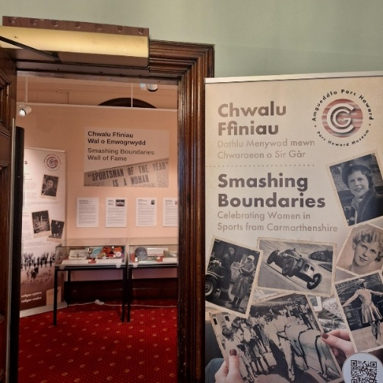
Parc Howard Museum is part of an organisation called CofGâr. CofGâr looks after five museums within the Carmarthenshire area with each page dedicated to individual museums. Despite of this, CofGar’s object online collection does not have a separate link dedicated to each museum. This is a clear weakness as visitors have no understanding what is available, or the nature of what is displayed at the other museums. The collection comments on the vastness of the physical collection available, ‘more than 50,000 years of Carmarthenshire’s history’. The site provides a few examples of what is available, although the rationale behind the highlights follows an entrepreneurial, inventive and creative aspect, similar to Parc Howard museum narrative. For example, an object highlighted is a ship compass that was constructed by Janet Taylor, a 19th century female inventor but, there is no indication of where or if it is displayed.
Image 6, 'Smashing Boundaries’ Exhibition, Parc Howard Museum taken by Aimee Thomas, 10 December 2025.
On the other hand, while touring Parc Howard there was an exhibition that was not highlighted on Parc Howard museum’s dedicated website. The exhibition portrayed women in sports from Carmarthenshire, the exhibit is called ‘Smashing Boundaries’, shown in Image six. The aim of the exhibition was to celebrate women’s achievement within the community and breaking boundaries in a male dominated field, particularly those in Carmarthenshire. This continues the rationale of the collection set up in Parc Howard, although the website made no indication that the exhibition was currently happening, as well as not utilizing the opportunity to entice the public who would be interested. The only reference made to the project appears on the collections page, which briefly describes the reason behind it, the intention and the hope for the project’s future with community engagement, especially with young people. The strength of this project being part of the collection allows people from Carmarthenshire to be inspired and proud of the accomplishments of those from their communities, particularly women.
A clear weakness of the project is the lack of advertisement, particularly not being displayed on the Parc Howard museum website, which would have strengthen the collection rationale. CofGâr has a somewhat clear intention and narrative focus dedicated to their collection, however the lack of organisation of what is available to the public in each museum, allows confusion and the opportunity to entice the wider public to enter each museum, to be wasted. The basic highlight of the collection’s objects, such as the compass, only partially demonstrate what is available. Also, the lack of advertisement of the projects, such as the ‘Smashing Boundaries’ exhibition, on the Parc Howard website hinders the chance for those who are interested in sports to visit the display, especially those who know of these women, and are inspired by their actions. Also, this would require visitors to research the website to find out about these projects and what objects are showcased in different museums across Carmarthenshire.
Throughout this report, there has been an examination of the strengths and weaknesses of the collection rationale. Parc Howard Museum primarily focuses on Llanelli’s entrepreneurial aspect with a focus of community and creativity. The website is an important factor in demonstrating the intention and narrative the museum has towards visitors. The rationale of the collection allows visitors to learn about the history of Llanelli, and it can inspire people from the community to be proud of their heritage and of the town they are from. The examples of the stories published online, and the use of digitisation allowed for an inclusive engagement for the public. Although, the online collection is disorganised as there is no clear indication of which objects are displayed in the museums or which objects are available to the public. Along with the lack of advertisement on Parc Howard’s page for the ‘Smashing Boundaries’ exhibit, it limits the scope of the museum’s collection and rationale online. Overall, the museum online and in-person collection is a different experience and expectation, but the rationale of the curators clearly engages with the narrative both online and in-person.

Bibliography
Axelsson, Bodil, and others, ‘Introduction’, in Bodil Axelsson and others, Museum Digitisations and Emerging Curatorial Agencies Online (Springer International Publishing, 2022), pp. 1–14, <Doi:10.1007/978-3-030-80646-0_1>.
Black, Graham, ‘Museums, Memory and History’, Cultural and Social History, 8.3 (2011), pp. 415–27, <Doi:10.2752/147800411X13026260433275>.

CofGâr:Smashing Boundaries: Celebrating Women in Sports from Carmarthenshire
[Exhibition]. (Parc Howard Museum, Llanelli. 10 December – ongoing, 2026).

CofGâr, Welcome to the Smashing Boundaries Project
(2025)<https://cofgar.wales/collections/smashing-boundaries/ >[accessed 8 January 2026].

CofGâr, The CofGâr Collection (2025) < https://cofgar.wales/collections/> [accessed 8
January 2026].

CofGâr, A ship’s compass (2025) <https://cofgar.wales/collections/selection-treasure- compass/> [accessed 8 January 2026].
CofGâr, From Buckleys to Parc Howard (2025) < https://cofgar.wales/parc-howard-museum- other/from-buckleys-to-parc-howard/> [accessed 7 January 2026].

CofGâr, Llanelly Pottery (2025) <https://cofgar.wales/parc-howard-museum-other/llanelly- pottery/> [accessed 7 January 2026].

CofGâr, Digital Pots (2025) < https://cofgar.wales/learn/online-resources/> [accessed 7 January 2026].
CofGâr, Home (2025) < https://cofgar.wales/> [accessed 13 January 2026].

Cofgar, Parc Howard Museum (2025) < https://cofgar.wales/venues/parc-howard-museum/> [accessed 15 December 2025].

Haywood, Naomi and Cairns, Paul, ‘Engagement with an Interactive Museum Exhibit’, in People and Computers XIX — The Bigger Picture, ed. by Tom McEwan, Jan Gulliksen, and David Benyon (Springer London, 2006), pp. 113–29, <Doi:10.1007/1- 84628-249-7_8>.

Howes, David , ‘Introduction to Sensory Museology’, The Senses and Society, 9.3 (2014), 259–67, <Doi:10.2752/174589314X14023847039917>.

Museums Association, Parc Howard Museum in partnership with Fusion (2020) <https://www.museumsassociation.org/campaigns/museums-change-lives/creating- better-places-to-live-and-work/parc-howard-museum-in-partnership-with-fusion/> [accessed 15 December 2025].

CofGâr, Home (2025) < https://cofgar.wales/> [accessed 13 January 2026].
CofGâr, Parc Howard Museum, (2025)< https://cofgar.wales/venues/parc-howard-museum/> [accessed 15 December 2025].
Museums Association, Parc Howard Museum in partnership with Fusion (2020) <https://www.museumsassociation.org/campaigns/museums-change-lives/creating-better-places-to-live-and-work/parc-howard-museum-in-partnership-with-fusion/> [accessed 15 December 2025].
CofGâr, Parc Howard Museum, 2025.
Graham Black, ‘Museums, Memory and History’, Cultural and Social History, 8.3 (2011), pp. 415–27 (p. 415), <Doi:10.2752/147800411X13026260433275>.
Black, ‘Museums, Memory and History’, p. 415.
Bodil Axelsson and others, ‘Introduction’, in Bodil Axelsson and others, Museum Digitisations and Emerging Curatorial Agencies Online (Springer International Publishing, 2022), pp. 1–14 (pp. 1–2), <Doi:10.1007/978-3-030-80646-0_1>.
CofGâr, Parc Howard Museum, 2025.
Ibid.
CofGâr, From Buckleys to Parc Howard (2025) < https://cofgar.wales/parc-howard-museum-other/from-buckleys-to-parc-howard/> [accessed 7 January 2026].
CofGâr, Llanelly Pottery (2025) < https://cofgar.wales/parc-howard-museum-other/llanelly-pottery/> [accessed 7 January 2026].
Ibid.
CofGâr, Digital Pots (2025) < https://cofgar.wales/learn/online-resources/> [accessed 7 January 2026]. David Howes, ‘Introduction to Sensory Museology’, The Senses and Society, 9.3 (2014), 259–67 (p. 262), <Doi:10.2752/174589314X14023847039917>.
Naomi Haywood and Paul Cairns, ‘Engagement with an Interactive Museum Exhibit’, in People and Computers XIX — The Bigger Picture, ed. by Tom McEwan, Jan Gulliksen, and David Benyon (Springer London, 2006), pp. 113–29 (pp. 1-2), <Doi:10.1007/1-84628-249-7_8>.
CofGâr, The CofGâr Collection (2025) < https://cofgar.wales/collections/> [accessed 8 January 2026].
CofGâr, A ship’s compass (2025) <https://cofgar.wales/collections/selection-treasure-compass/> [accessed 8 January 2026].
CofGâr:Smashing Boundaries: Celebrating Women in Sports from Carmarthenshire [Exhibition]. (Parc Howard Museum, Llanelli. 10 December – ongoing, 2026).
CofGâr, The CofGâr Collection (2025) CofGâr, Welcome to the Smashing Boundaries Project (2025)<https://cofgar.wales/collections/smashing-boundaries/ >[accessed 8 January 2026].

