Strategic Analysis Report
of
ZARA

Student Name (ID): | Chiang Chun Wah (2119645)
University of Wales Trinity Saint David – MBA
Module: | HKBM 7013 Assignment 1
Lecturer: | Dr. Terence Li

Executive Summary
This report aimed to analyze the ZARA’s strategies and business activities whether align with business objectives and goals. The mission, vision and values of ZARA were determined and had insight what their hopes to achieve and became in the future. The opportunities of online sales channel opportunities and threat of population ageing have been determined from macro-environmental analysis. Moreover, ZARA’s corporate and business strategies have been evaluated by balanced scorecard to measure the effectiveness. Finally, the recommendation was proposed to enhance the online channels and market strategies for responding population ageing.

Table of Contents
1. Introduction 4
2. Company Background 5
2.1. Brand History 5
2.2. ZARA Today 6
3. Macro-Environmental Analysis 8
3.1 PESTLE Analysis 8
3.2 Opportunities and Threats 10
4. Value Chain Analysis 13
5. Strategies Analysis 18
5.1 Corporate Strategies 18
5.2 Business Strategies 18
5.3 Evaluation of Strategies of ZARA 19
6. Conclusion 22
7. Recommendation 23
Reference List 25

Introduction
The strategic management is the organization that manage their resources to achieve the goals and objectives. It is significant because it facilitates the organization to identify the area that can be improved in their operations, gives overall guidance by creating action plans to make sure performance goals are fulfilled and the company keeps expanding, and then allocates resources to put the plans into effect (Victoria University, 2019). There are five key stages that can help businesses execute their strategies. Firstly, an organization establishes clear and realistic goals. Then, it determines external and internal factors affect their business and goals. Thirdly, an organization bases on the results of the external and internal factors analysis to develop its strategies. Once the strategies are defined, the organization follows the action plan to implementation. Finally, the organization evaluates the effectiveness of implemented strategies using defined metrics (Kenton, 2022).
This report was analysis ZARA’s strategic management in the above five stages. Understanding ZARA’s vision, mission, and value to determine company objectives and goals. The macro-environmental factors were analyzed for Hong Kong causal wear industry and explored the internal factors for contributing its business. Finally, ZARA’s strategies was analyzed and determined whether align with its objectives and goals, and then evaluated the effectiveness of their plan.

Company Background
Introduction of ZARA’s brand history with business milestones. It described the current situation of ZARA and its mission, vision, and value statement for understanding ZARA’s objectives.

2.1. Brand History
ZARA is one of the popular brands of fashion player in worldwide, was established in Spain in 1975 and is a member of the Inditex retail group. Amancio Ortega, a Spanish entrepreneur who also controlled Massimo Butti, Pull and Bear, Stradivarius, and Bershka, owned the ZARA brand. Figure 2.1 shows the ZARA’s timeline of business milestones.
Figure 2.1: ZARA’s milestones (Historydraft, no date). 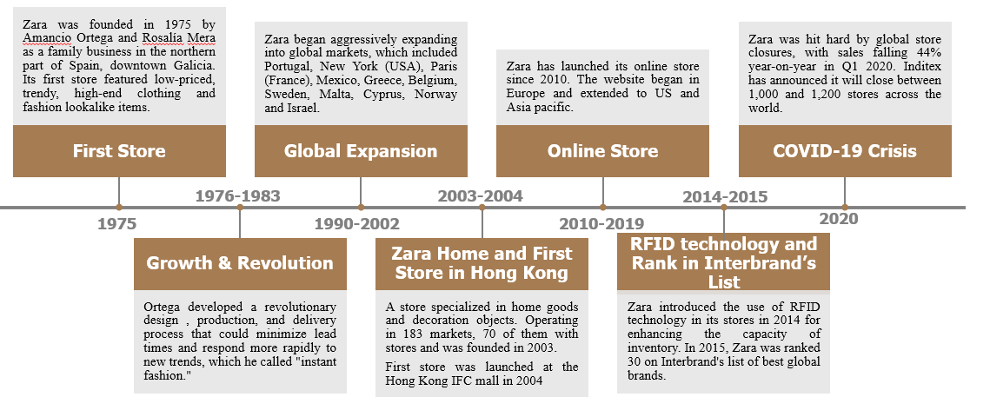
Ortega has developed the processes for designing, producing, and distributing the products in shorter duration in 1985. Moreover, it had capabilities to respond the new trends more quickly. It was referred known as "instant fashion" and evolved into "fast fashion" as we know it today. This relied on the information technology and the use of teams instead of individual designers for the critical components of the design. Over the next ten years, ZARA actively expanded into markets throughout the world, including those in the United States, the Middle East, and Asia Pacific (Martinroll, 2021).
ZARA wanted to attract a diverse range of customers from all ethnicities and different age groups. The ZARA brand included the collection of men, women, kids (ZARA Kids), as well as shoes and accessories. Youngsters may purchase edgier and fashionable products from the their sub-brand ZARA TRF (Martinroll, 2021). It not only developed its business vertically, but also horizontal expanded its business. It launched a new business line for home goods and decoration objects in 2003 (Historydraft, no date).
ZARA saw the potential commerce in online purchasing, and it was a general trends in society. In 2010, they expanded its online channels to include Ireland, Austria, Belgium, Netherlands, and Luxembourg in addition to Spain, the UK, Portugal, Italy, Germany, and France. From 2011 to 2019, online retailers rolled out to the US, Asia pacific, and Russia (Historydraft, no date).

2.2. ZARA Today
Today, ZARA has approximately 7,000 shops distributed across 88 countries, with rarely a developed nation without one (Kala, 2018). It was a top premium fashion brands and sells goods for men, ladies, beauty, kids, and the home. The goods included shoes, bags, accessories, knitwear, T-shirts, jeans, pants, tops, skirts, and accessories. It provided the one-stop shop to customer who wanted to purchase formal or informal dressing. ZARA has released the new designs over 10,000 per year, and their items were in style yet affordable (MBASkool, 2022).
ZARA was recognized as a leading fashion brand around the world. The company maintained this image through the passionate implementation of its focused mission and vision statements. It has set a clear, straightforward, and simple mission statement to guide its progress.
ZARA’s mission statement – “give customers what they want, and get it to them faster than anyone else.” (Samuel, 2021).
The mission statement pointed out two things that customer satisfaction was their top-most priority, and timely response. The first part of the statement showed that company needed to identify the trend of market and knew the customer what they want or interest. The second part of statement showed that company produced the fashionable products and pushed them into market before customers changed their mind and competitor rollout the same type of products.
ZARA’s vision statement – “To contribute to the sustainable development of society and that of the environment with which we interact.” (Samuel, 2021).
The vision statement was the outline of the long-term goals of company. It has showed how Zara prioritizes the wellness of society and the environment that included societal development and environmental sustainability.
ZARA’s Core Value – “Beauty, Clarity, Functionality, and Sustainability” (Martinroll, 2021).
ZARA has set its core values to be guided by the above four simple terms. These four terms guide the company in making comprehensive business decisions and even in the day-to-day running of the business. Beauty was applied in the fashion industry. The company ensures that aesthetics was well utilized and appreciated in the making of its products. Clarity was applied in all aspects of its communication, both on social media and the shop outlets. Functionality was applied in its products and services. It means that the clothes were wearable in all conditions and not only on the runways where they were displayed. Finally, ZARA has cultivated the image of sustainability in all areas of operation. The company has even set up eco-stores and ensured the production process is free of toxic waste.

Macro-Environmental Analysis
Macro-environmental analysis that focuses on variables outside of a company's control. The research was limited to the casual clothing market in Hong Kong, with the goal being to develop a strategy that makes the most of these external elements in ZARA's benefit (Vitez, 2022).

3.1 PESTLE Analysis
The PESTLE analysis is a method for identifying and evaluating the external influences that a ZARA must contend with. These pressures come from the political, economic, social, technical, environmental, and legal facets of the Hong Kong business environment (Buye, 2021).
Political
It was the most important factor for influencing the business environment in Hong Kong.
- At order to prevent COVID-19 from spreading into Hong Kong, the HKSAR government was one of the harshest of control cities that had experienced mandatory quarantine incoming tourist in a certified quarantine hotel. HKSAR has kept pace with the economic recovery world and has announced in September 2022 the reducing of compulsory quarantine requirement for inbound persons from overseas places (HKSAR, 2022b).
The latest arrangement increased the intention of visitors who wants to visit Hong Kong for tours or joining a business event that potentially created the opportunities for retail business in Hong Kong.
- HKSAR issued Consumption Voucher Scheme by phases and their aimed to stimulate economic in Hong Kong (HKSAR, 2022a). The government encouraged the Hong Kong residents to spend more to boost the economy in Hong Kong. Moreover, the people in Hong Kong almost were resuming normal activities at Post-pandemic environment. The social activities increased, and demand of clothing was also increased. It was another opportunity for caused wears retailer.
Social:
In the corporate world, and particularly in the case of ZARA, the social component was significant. ZARA has paid close attention to this area of the business as changeable social trends had a significant influence on both supply and demand for the company's goods, putting brands who neglected cultural components of business and marketing at danger of losing their consumers.
- ZARA emphasized customer co-creation that co-created its products leveraging its customers’ input for keeping a customer need and market trend.
The brand success was ZARA's unwavering commitment to the consumer. In 2015, the intriguing "pink scarf" tale revealed how Zara uses user feedback to co-create its goods. Miko, a woman, entered a Tokyo Zara shop and requested the salesperson for a pink scarf, but the store has no pink scarves. Giselle in Frankfurt, Elaine in San Francisco, and Michelle in Toronto all entered Zara shops at around the same time and requested similar items. Without purchasing any scarves, they all exited the shops. After seven days later, 500,000 pink scarves were sent store across more than 2,000 Zara locations worldwide began selling pink scarves. Within three days, they were all sold (Historydraft, no date).
- Additionally, ZARA empowered and educated its front-line workers to be especially attentive to client demands and desires. The front-line workers carefully listened to client feedback, made notes about suggestions for cuts, materials, or a new line, and kept an eye out for new looks that customers were sporting that may one day become distinctive Zara fashions (Martinroll, 2021).
- Moreover, senior population (aged 65 or over) was projected to increase from 22% in 2024 to 2034 in 2034 in Hong Kong and the percentage of senior population will increase continually to 2069 (censtatd, 2020). It is a threat for ZARA that was only focused on millennium generation and youngsters.
Economic:
Hong Kong was slowly resuming their economies after the outbreak. Unfortunately, US Federal Reserve System has the raised the interest rate by 2.25% from zero at the beginning of the 2022 (Rushe and Aratani, 2022). U.S. interest rate hikes impacted the Hong Kong directly and pushed up the interest rates. It increased the cost for mortgage on buildings and caused the intention of consumption decrease. Moreover, it has increased the cost of borrowing in the market, which increased the operating cost of companies. It affected the atmosphere for consumption in Hong Kong.

Technological:
Over time, technology has advanced quickly. The overall trend of society was driving businesses toward digitization and using technology to meet client requirements. The technology increased the efficiency of internal processes and increased customer satisfaction by online service through new technologies (e.g., A.I., machine learning, etc.). In Hong Kong, 67.1% of consumers used mobile applications to do their shopping (Kemp, 2021). Client happiness, the desire to use our financial services, and maintaining the customer relationship all depended on how convenient the online service was. ZARA has put their store online since 2010 and rollout to the other regions in ten years. Today, all famous causal wear retailers had their own online shopping channels to facilitate their customers.
Moreover, ZARA has deployed AI platform for predicting the fashion trends and customers' favorite in 2018, and implemented RFID to improve the products inventory and enhanced its traceability across the supply chain (Gosselin, 2020).
Environmental:
The customers’ environmental protection awareness increased, and this trend had not only in foreign but also in Hong Kong. The company's green policy was considered while evaluating its goods and services. Sustainability and being eco-friendly have grown in importance for the business sector.
ZARA has taken steps to reduce the impact of its operations on the environment. Greenpeace has called attention to ZARA's usage of hazardous materials in their production methods. ZARA pledged to eliminate all discharges of harmful chemicals from its entire supply chain and product line by 2020 nine days after Greenpeace's study was published. To promote the Detox Campaign, ZARA became the largest retailer in the world and moved to a completely toxic-free manufacturing process.

3.2 Opportunities and Threats
The above analysis was essential to consider the macro-environmental analysis for any brand to successfully run its business. The brand can carefully set strategies for the factors that can negatively impact their business to ensure their success. The above analysis for ZARA to identify the short-term and long-term opportunities and threats. ZARA should plan to take the advantage from opportunities and reduce impact from threats. Table-3.1 summarized the short-term and long-term opportunities and threats.
Table-3.1: ZARA’s short-term and long-term opportunities and threats.
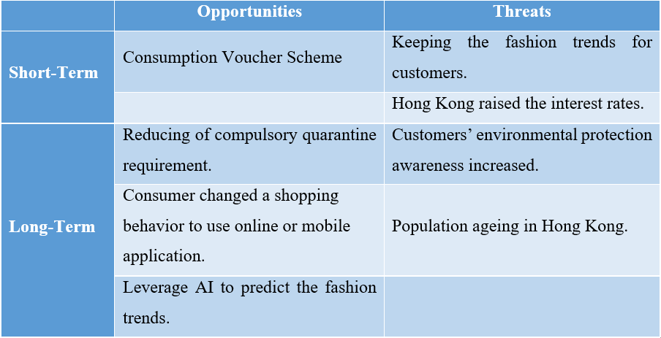 (Source: constructed by author)
The consumption voucher scheme is a short-term opportunity for ZARA. The resident of Hong Kong had the extra money from consumption voucher scheme and this aim was to stimulate the economy in the post-pandemic era. The intention of consuming on clothing is increased because the social activities were being resumed slowly. ZARA should catch up this opportunity in Hong Kong. Even through Hong Kong raised the interest rates as a short-term threat, but it only affected some of people who had mortgage loans. The overall is favor to ZARA. The other short-term threat was keeping fashion trends for customers. Otherwise, customers may be switching to the other brand or products. However, it is also the opportunities to enhance the internal processes for shortening the time-to-market, and AI's capabilities for predicting the fashion trends.
Hong Kong was resuming to normal in the post- pandemic era and the compulsory quarantine requirement had been reduced. The tourists and visitors visit Hong Kong intention that will be resumed in long-term. Moreover, the online and mobile shopping behavior, and leverage technology are long-term opportunities to reduce sales of cost, such as retail shop, labor. However, the communication channels with customers have been reduced if relies on technology too much. This is the threat that lose its customers’ input for keeping a customer need and market trend. The other threat was customers’ environmental protection awareness increased and the cost of sales may be increased to fulfil the compliance requirements of environmental protection. It was also the opportunities to gain the reputation of company from customers if the products were compliant with international standards on environmental ordinance. The population ageing in Hong Kong is the other long-term threat and ZARA should be plan it in advance to satisfy this population group. However, this is provided the opportunity to extend their target customers group for business expansion.

Value Chain Analysis
The internal analysis looked at internal aspects to see if they support and complement the business plan. For looking at internal aspects, Porter's Value Chain was used. It was a group of actions taken as part of the business's procedures and integrated to produce goods or services (Tarver, 2021). The main activities included Inbound logistics, operations, outbound logistics, marketing and sales, and service that made up the value chain. Four further support activities were divided into primary activities to support these five core activities.
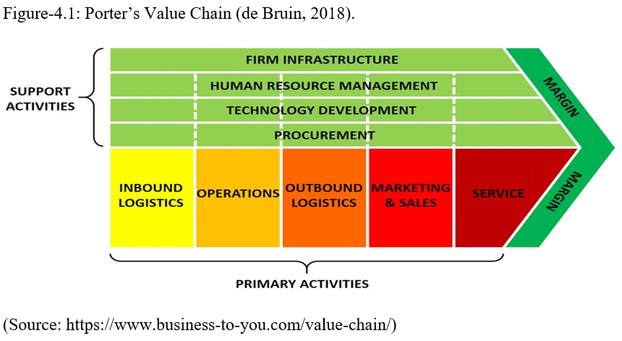
ZARA’s time-to-market (TTM) of fast fashion was around 15 days (swifterm, 2021). It needs very strong internal processes to support and correlated the processes with each other’s for achieving these capabilities. The Value Chain of ZARA was analyzed as follow and determined their Primary and Support Activities in Value Chain.
Inbound Logistics:
ZARA had extremely fast supply chain network. There was a sizable, highly automated distribution hub in the center of the ZARA supply chain. Only a few types of fabric were purchased in bulk by ZARA, and the company handled all in-house garment design, cutting, and dyeing. Fabric producers may quickly transport large amounts of fabric to ZARA's distribution facility in this way. The business bought unfinished fabric from vendors in Portugal, Greece, Spain, and Italy. These vendors can fulfill orders within five days after placement (Hugos, 2020). Eleven apparel manufacturers operated by ZARA are located close to a distribution center. Both completed items and raw materials flow via the distribution center on their way to the apparel manufacturers and the retail outlets. ZARA's plants may thus change their production rates swiftly (Hugos, 2020).
Outbound Logistics:
ZARA preferred to transport and distribute goods using cutting-edge technology. Everything goes through the distribution facility and was prepared for shipping. The business can quickly ship clothing to retail locations throughout the world: one day for Europe, two days for China and US, and three days for Japan. The goods were transported to Europe by trucks and were shipped to other markets by air freight. Transport was essential for completing supplies to outlets that would take two weeks (Hugos, 2020).
Operations:
The core design team for ZARA was based in its Spanish headquarters, where they could readily integrate with the procurement department to make quick revisions and choices. The men's, women's, and children's halls make up the design and production center. ZARA has made it a point to operate three concurrent but functionally separate product lines. For each garment line, various teams were in charge. The management information flow was direct, quick, and unaffected by issues with other product lines, which made the whole supply chain more efficiency and responsive (mbaknol, no date).

ZARA's primary activities developed a robust supply chain and benefited from several benefits. First, the supply chain enabled it to quickly respond to the fashion trends and provide the new products to clients a few weeks. Second, ZARA’s factories are closed to distribution center, so large numbers produced unnecessary. If the style did not perform as well as anticipated, Zara had not a significant loss because there was little stock that needed to be reduced. Thirdly, this supply chain approaches were more expensive, but the inventory can be reduced and overall increased the profits margins (mbaknol, no date).
The drawback of this supply chain was that because Zara controlled all of its distribution channels, it was impossible to grow to remote areas because it was so expensive to get these items there.

Marketing & Sales:
A wide range of clients were able to develop a passion for fashion thanks to ZARA. It had a brilliant marketing plan that allowed it to stand out and get more recognition as well as customer loyalty. ZARA was target for all age groups and marketing method focused on the customers that was their key strength (Avada, 2022). ZARA's primary consumer base is made up primarily of young people, particularly millennium generations. ZARA nimbly offers the latest trends at reasonable costs, realizing that customers wanted fashionable clothing that is both stylish and cost-effective. The employed cloth is still of a high enough caliber; yet the caliber was not diminished. ZARA has been successful in positioning its goods as a hip, reasonably priced, and quickly evolving fashion brand for the younger crowd.
Services:
ZARA had several ways to make the customer satisfaction. The customer did not need to wait for a long time and assistance was unnecessary in the shops. It is because the large portion of customers were youngster who wanted to complete the purchase as soon as possible. So, the staffs can provide the quick response for the other customer who had requests and enquiries (edrawmax, no date).
Technology Development:
ZARA's business strategy, which mainly relies on technical innovation and consumer experience, has been successful. To improve internal operations and the customer experience, ZARA implemented new technologies in a variety of areas such as artificial intelligence (AI), augmented reality (AR), and big data (Gosselin, 2020).
ZARA has released an AR app that was designed to make clothing come to life in shops. Users of the app may view virtual fashion models strutting their thing and fresh studio collection while you strolled about in the store by aiming cameras at sensors embedded in windows (Gilliland, 2018). The company used AI to facilities customer more quickly and efficiently navigate through the store to explore. The products were similar in color, pattern, shape that will be popped up to customer in one “click”. Moreover, AI and big data were used on fashion trends forecasting and measure clothing volume in boxes and improve stock inventory (wideeyes, 2018).
Procurement:
ZARA purchased raw materials through branch offices and regional divisions. Additionally, the corporation purchased several items and inputs from outside vendors that often operate in low-cost input marketplaces. As part of their business model, ZARA owns multiple factories and textiles in Spain that they use to quickly create their own created products. This allows them to maintain a steady supply of merchandise for sale (edrawmax, no date).
Human Resource Management:
The fast responsive and fashionable trends are keys strength of ZARA, human resource management (HRM) was facilities it in its business operations. Each store had a person in charge who was responsible for reporting on sales and all customer contacts, giving them the opportunity to act quickly. HRM presented a successful, up-to-date, and youthful impression of the business. Employees see their employer as innovative, which creates a specific profile that is strongly associated with the shop. Moreover, HRM motivated employees to skill up, continuous training, and attended shows and exhibitions for contacting with fashion trends (ukessays, 2019).
Firm Infrastructure:
Due to Zara's unique business strategy, which emphasizes rapid production and change, the organization has set up its infrastructure to adapt to and support this feature. The flat organizational structure of ZARA's business aids in maintaining a tight eye on its operations and level of quality. Vertical integration may bring a company and its customers closer together. It regulates input delivery timings, prices, and quality. It also regulates input access (mbaknol, no date).

ZARA’s Support Activities were supporting front-end operations. The procurement and firm infrastructure contributed them to control costs of inventory and fabric, and quality. ZARA’s were also skilling up their employees continuously to keep them fashionable sense. Their technology was catering the customer experience and made their satisfaction. However, ZARA’s have not too much focus on online shopping channel. Especially, the consumer behaviors have been changed after pandemic hit in world. The consumer moved to online channel to purchase their needs during pandemic. ZARA had online sales of 14% in 2019, 32% in 2020, and 25.5% in 2021 (Inditex, 2022). It is challenges to ZARA to sustain its business and global expansion.

Strategies Analysis
ZARA formulated the strategies in corporate and business level based on its intent (Vision, Mission, and Value), environmental factors, and competitive advantages. The follow was analysis ZARA’s corporate and business strategy was analyzed in follow and evaluated its effectiveness.

5.1 Corporate Strategies
ZARA is running growth strategies that was keeping their global expansion and diversified their products. It opened new stores in Shanghai (retailinasia, 2022)., Austria (Norman, 2022)., and Battersea in 2022 (Fish, 2022). Moreover, the Group was planning to integrate its online and offline operations for global expansion (McKinnon, 2021). ZARA’s products were not only causal wear, but also have suite, shoes, sport wear, accessories, home decoration, and cosmetic, etc. (zara, 2022).
ZARA's corporate strategies are in line with their vision statement and aim to appeal to and earn the loyalty of its customers across the world. It has helped society and the environment flourish sustainably. The Group invests over USD 50 million in social and community programs and projects per year. For instance, by offering more than 200 permanent work opportunities across 15 locations, its "for&from" program has made it possible for those with physical and mental impairments to integrate into society. The Group also made an effort to make sure that its operations' environmental effect complied with UN Sustainable Development Goals (UNSDGs). By 2025, it has promised to eliminate waste, consume less water, energy, and other resources, and solely market sustainable clothing. The Group has also been extending its waste reduction program, which currently includes 2,299 collection stations in 46 cities for consumers to drop off their gently used apparel, accessories, and footwear (Martinroll, 2021).

5.2 Business Strategies
ZARA combined several strategies in business-level strategies. ZARA has launched the first store in Hong Kong in 2004 that first mover of fast fashion in Hong Kong (HKSAR, 2004). Their major competitors UNIQLO and H&M has launched first store in Hong Kong in 2005 (HKSAR, 2005). and 2007, respectively (H&MGroup, 2007). It has gained the market share and position in the best locations. Moreover, their pricing became the price index of fast fashion in Hong Kong to customer. ZARA used four strategies for their competitors. The vertical integration strategy controls its operations that precise data acquisition and forecasting, seamless modifications, and reliable quality in its products. The supply-chain strategy was mentioned in previous section for reducing the cost and had shorter the lead times. These two strategies supported ZARA to use pricing strategy that was best pricing approaches. The short time-to-market (around 15 days) but offer clothing collections that are a combination of high quality and were affordable. The differentiation strategy was adopted by ZARA was creating a sense of scarcity with its products and its non-presence in fashion shows where fashion retails usually display their products.

5.3 Evaluation of Strategies of ZARA
The above strategies were adopted by ZARA for operating their business. The effectiveness of their strategies should be measure by financial and non-financial indicators, and examined the benefits delivered to all the ZARA’s stakeholders (EMBAPro, 2021).
Balanced Scorecard was subjective to evaluate the performance of strategies by considering financial and non-financial objectives. It was a collection of success objectives and results related to four success factors: financial, customers, internal process, and learning/growth (Tarver, 2022). The Balanced Scorecard was adopted for performance measurement of ZARA, which was an integrated approach to assess performance of business strategy. Figure-5.1 shows the measurement objective(s) of each factor.

Figure-5.1: Balanced Scorecard of ZARA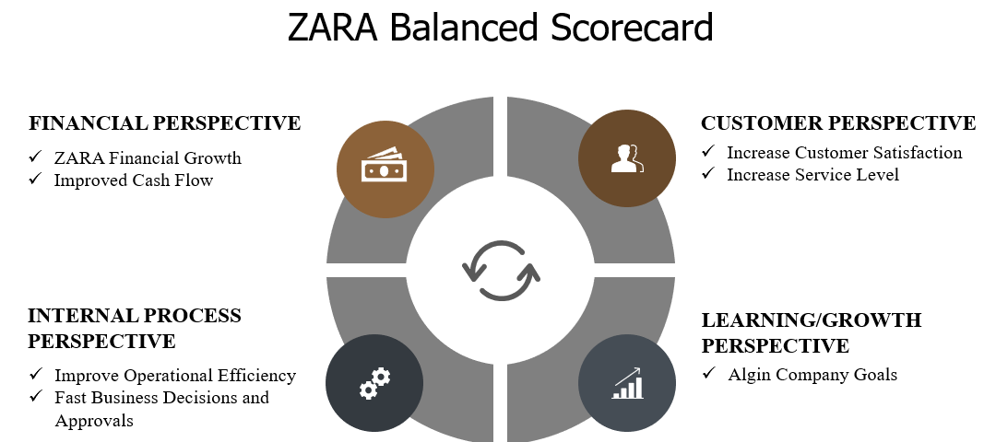
(Source: Constructed by Author)

Financial Perspective:
ZARA’s financial growth and cash flow improvement were used as criteria for evaluation from financial perspective. The profits, cash flow, ROE and ROCE were better than 2020 and almost same as pre-COVID-19 environmental (Inditex, 2022b). Table:5-1 compares the financial metric between pre-COVID-19 and post-COVID-19.
Table:5-1 Financial Metric over last four years (Inditex, 2022b).
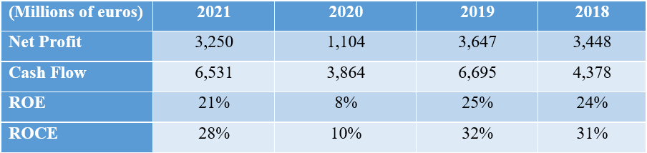 (Source: constructed by Author)
Customer Perspective:
The service level for responding to their customers was 98% in 2020, which 92%, 97% and 96% service level in 2020, 2019 and 2018, respectively. The percentage was better than last three years.
The figure of customers’ complaint was used for determining the customer's satisfaction. The Group have received 5,288 cases in Spain in 20221, which 4,814, 6,436 and 6,586 cases in 2020, 2019 and 2018, respectively (Inditex, 2022b). The complaint cases of 9.8% were higher than 2020. Keeping in mind the business was affected by pandemic in 2019, the number of orders decreased, and the number of complaints naturally have potential decreased. The figure was compared with pre-CONVID-19, the complaint cases of 17.8% lower than 2019. The overall customer satisfaction was increased.
Internal Process Perspective:
ZARA’s supply chain processes can be reacted quickly to new fashion trends and provided latest products to customers in few weeks’ times. Moreover, it never made the large numbers of quantities, so Zara had not a significant loss if the style did not sell as good as expected. ZARA’s time-to-market (TTM) of products was around 15 days (swifterm, 2021), while the industry standard was up to 6 months (Nguyen, 2020). It needed very strong correlation of internal processes and quick decisions in their operations to achieve these capabilities.
Learning/Growth Perspective:
The strategies of ZARA were aligned the company goals. Their products were produced by toxic-free materials to commit the sustainable development of society and environment. The vertical integration and supply chain strategies facilities the new products that were produced and distributed to store in 15 days. It committed to their customer get they want faster.

The above evaluation from financial and non-financial perspectives shown ZARA’s current strategies that overall benefits delivered to the organization’s stakeholder.

Conclusion
ZARA was a first mover of fast fashion player in Hong Kong. The Group’s corporate and business strategies facilitate the brand rapidly growth in Hong Kong and created the products differentiation from the other fashion player successfully. The macro-environmental analysis has been performed for determining the short-term and long-term opportunities and threat for ZARA. The organization has already used some opportunities for facilitating their business such as online shopping and AI technology on their fashion prediction. ZARA also was a pioneer of environmental protection in garment industry to address a long-term threat that is society’s demands for environmental protection.
There have recommendations to ZARA for enhancing and sustaining their business in the next section. It aims to use the opportunities while the economic was resuming in Hong Kong in post-pandemic era and reduce the impact from the threat. The contingency plan will be proposed if the global economy have any dramatically change in the future.

Recommendation
The economy of Hong Kong was resuming slowly and will gradually regain its economic growth momentum. The customer’s shopping behaviors had been changed to use online channel during the pandemic. ZARA should enhance the online channel to facilitate their customers. Firstly, speeding up their integration plan that integrates its online and offline operations (McKinnon, 2021). The store investment will continue to play an important role in the ZARA's strategy that is capacity to reach customers from the best locations worldwide. Secondly, ZARA was 70% increment in online sales from 2019 to 2021. The growth in online sales demonstrated the importance of the company. The virtual fitting mobile application is proposed for enhancing the customer’s online shopping experience on mobile. The customers are uncertain which one will fit themselves while are selecting the products on mobile application. The virtual fitting application can address this issue and reduce returns. Having the opportunity to try-before-you-buy online and increase the customer satisfaction for ZARA’s products.
Population ageing is the other issue in Hong Kong. ZARA’s should start to plan for senior age group and included into their marketing strategy. The segment needs to be enlarged for including senior age group in STP model, product, and promotion of 4Ps should cater senior age group.
Figure-7.1 shows the implementation plan of the above recommendations.

Figure-7.1: ZARA Implementation Plan for 3 Years.
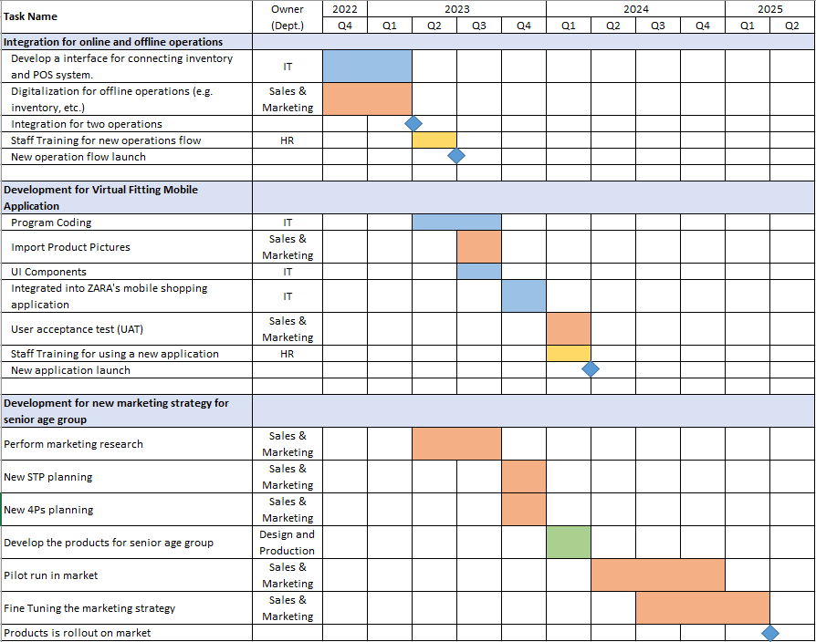(Source: Constructed by Author)

Contingency Plan:
The above recommendations are based on the economy continues to improve in worldwide. If economic do not predict as expect, ZARA needs to slow down the store investment and may need to close some stores that have low revenue in worst situation. The organization develop their online channel continuously because it had growth of sales in economic depression. It has potential to make the revenue in this situation and the operations cost is lower than store. The new marketing strategy for senior age group should be keeping continuously but ZARA can extend the projects schedule for slowing down the whole process, thereby reducing the investment in that situation.

Reference List
A New Era of Smart Banking (2017) Hong Kong Monetary Authority. Available at: https://www.hkma.gov.hk/eng/news-and-media/press-releases/2017/09/20170929-3/ (Accessed: July 1, 2022).

