Introduction to Web Development
  - Lecture 11 Lab Tutorial Exercise

Views with Related Content

Objectives
Last week, you created a new content type for specifying film show times available. Today, you will look at how to link these items together in a nested view and also set this view as the default content display page.

Exercise 1: Getting Started
- Open up your website.
- You will need the following additional module for this exercise: Views Field View. It allows you to create nested views.
- Download, install and enable this module.

Exercise 2: Creating a View for Film Show Time (Nested Child View)
- This exercise assumes that you have created the Film Show Times content type and added a few items.
- Go to the Views menu and select the option to Create a New View
- Give your view a name e.g. Film Show Times
  - Specify the following for the View Settings.
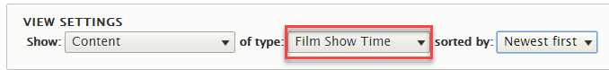
  - No need for a page Leave Page Settings unchecked.
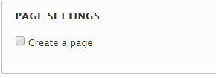
  - Create a block with the following options
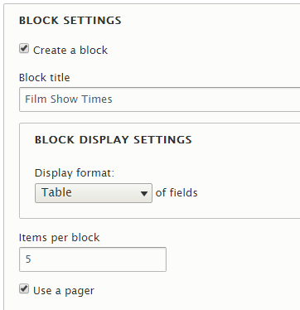
- Click Save and Edit
- Under the Fields section, click the Add button and add the following fields.
  - Note: that the Film field is hidden.
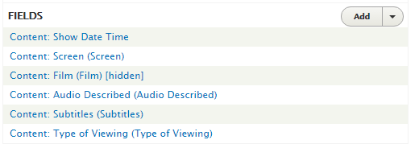
- The default sort criteria is based on the last modification date of the field. Under the Sort Criteria section, modify this as shown below (remove the default).
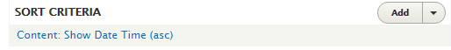
- Later on you will add additional Filter Criteria, but for now leave the defaults.
- Next, you need to provide a way to link this view to its parent view – a view for the Films, which you will create next.
- The way you link content is to use contextual filters.
- Expand the Advanced section on the right side of the page and click the Add button under Contextual Filters.
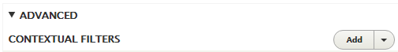
- The linking field between Film and Film Show times is the Film field in Film Show times. Do a search for film and select the following option.
- Click Add and configure contextual filters.
- Under the section WHEN THE FILTER IS NOT AVAILABLE, configure as follows. Leave the other settings and click the Apply button.
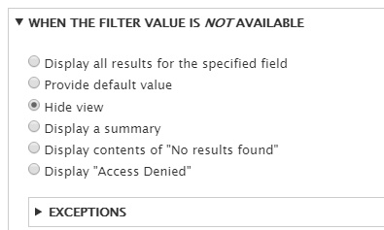
- Save your settings.
- If you scroll down, there should be a box to specify a test contextual filter (Film ID – the ID of the parent) to preview. Try a couple of ID values. IDs are numeric. You should get a preview of what the page looks like. It doesn’t look great, but we can leave that till another exercise.
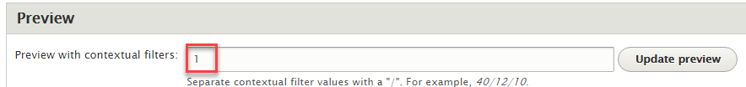

Exercise 3: Creating a View for Films (Parent View)
- Create another view to display Film Content
- Give your view a name e.g. Film Show Times
  - Specify the following for the View Settings.
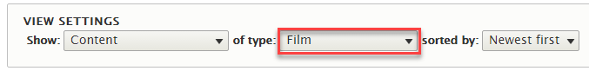
  - No need for a page Leave Page Settings unchecked.
  - Create a block with the following options.
    - You can give the block a title.
    - Note: Only display 1 item per block and do not include a pager
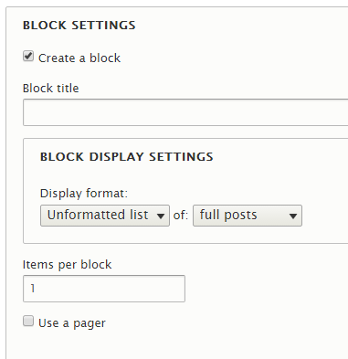
- Click Save and Edit.
- You also need to add a contextual filter to this view.
- Click the Add button under the Contextual Filters section.
- This time the linking field is the Film ID. Do a search for film and select the following option.
- Click Add and configure contextual filters.
- Configure the same as you did before for the section WHEN THE FILTER IS NOT AVAILABLE. Leave the other settings anford click the Apply button.
- Save your changes.
- For now, you do not need to add anything else.
- If you scroll down, there should be a box to specify a test contextual filter (Film ID) to preview. Try a couple of ID values. IDs are numeric. You should get a preview of what the page looks like. It doesn’t look great, but we can leave that till another exercise.

Exercise 4: Creating a View with Nested Content (Container View).
- Next, you are going to create a view containing the two views created in the last exercise.
- Create another view to display Film Content
- Give your view a name e.g. Film Display Container View
  - Specify the following for the View Settings.
  - No need for a page Leave Page Settings unchecked.
  - Create a block with the following options.
    - You can give the block a title.
    - Note: Only display 1 item per block and do not include a pager
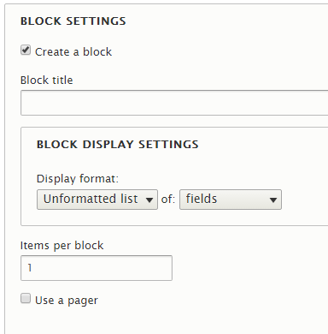
- Click Save and Edit
- Now here is the tricky part, adding the fields to display.
- Go to the Fields section.
  - By default, this will have the Title field. Remove this field. Click the little arrow on the Add button and select Arrange to remove.
- Now add the following fields instead.
  - Content ID: Every content on Drupal has a unique ID (identifier). This is what you will use to create the link to the child views.
    - Click Add and Configure field
    - In the next screen, select Exclude from display for this field.
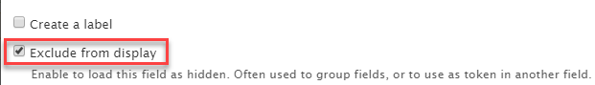
  - View: for the embedded view.
    - Click Add and Configure fields
    - In the next screen, you need to select the view to embed, as well as any contextual filters to display the right content. You to specify:
      - View: whatever you called the parent view in the previous exercise.
      - Display: Block
      - Contextual filters: If you expand the Replacement patterns, it provides you with possible options. Set as shown below and click the Apply button.
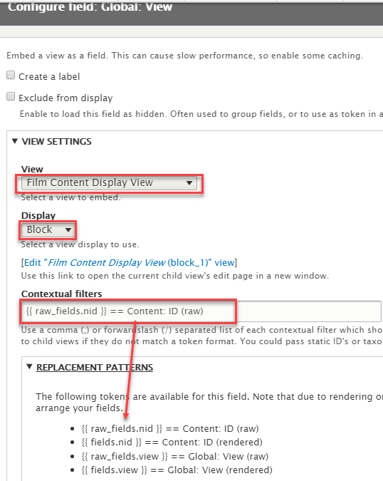

  - View: Now repeat the same as the last step to add the child view as another nested view.
- You also need to add a contextual filter for this view.
- Click the Add button and select the Content ID as you did before.
- This time you will configure something slightly different for when the filter is not available. You will tell it to get the Content ID filter from the URL reference instead e.g. for a URL http;//somewebsite.com/node/4 will set the value of the filter to 4.
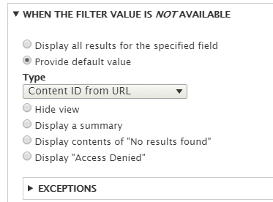
- Click Apply.
- Scroll down the page and test your contextual filters in the Preview section. Did it work?

Exercise 5: Changing the Default Page Used by a Content Type
In the next exercise, you will change the default display page for a content type.
- From the menu, go to Structure Pages.
- You should have two pages:
  - A custom page for the home page (if you completed that exercise)
  - A Node page (this is for all content types added to the site)
- Click the Edit button beside the Node view (yours may be slightly different from mine).
- You are going to create a new page variant (alternative display) to use for Film content types only.
- Click the Add variant option towards the top-right corner.
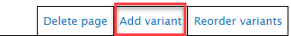
- In the window that displays, specify a label for the variant you are going to create and check the selection criteria box, so we can specify this is for film types only.
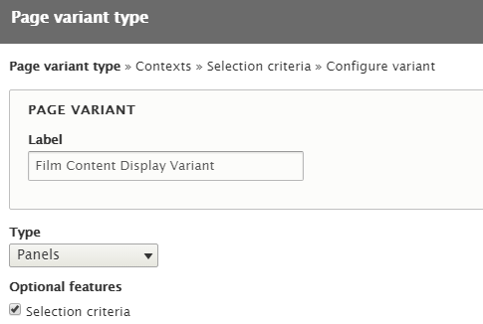
- In the next window (Selection criteria), select Content Type from the drop down and click the Add Condition button. Check the option for Film in the window that displays and click Save.
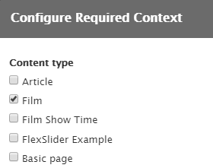
- Click Next and select In-place editor as your builder in the next window.
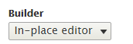
- Select a single Column Layout. You can change this later.
- Click Next.
- In the next screen:
  - You can give the page a title of your choice.
  - Click the Add new block and select the view containing the two nested views (Film Display Container View).
  - Add the block
- Click the Finish button.
- Click Update and Save to save all your changes.
- Now if you select a film from the home page, it should take you to the new custom page.
- That’s all for today.

