Johnson and Scholes’ Cultural Web Model

Accessed from : Johnson and Scholes' Cultural Web Model,1992 (businessballs.com) (12 October 2021)

Introduction
Strategy and development in an organisation are influenced heavily by the culture and environment.
This is often positive, but it can also act as a hindrance, or even a barrier to growth and success. When trying to drive change, managers and other figures of responsibility may find it difficult to break out of the systems, structures and routines embedded in the company’s culture, and politics or individual relationships often play a huge role in deciding strategy.
Published by authors and academics in the fields of business, leadership and management, Kevan Scholes and Gerry Johnson in 1992, the Cultural Web is a useful tool for analysing and altering assumptions surrounding the culture of a company. It can be used to highlight specific practices and beliefs, and to subsequently align them with your company’s preferred culture and strategy.

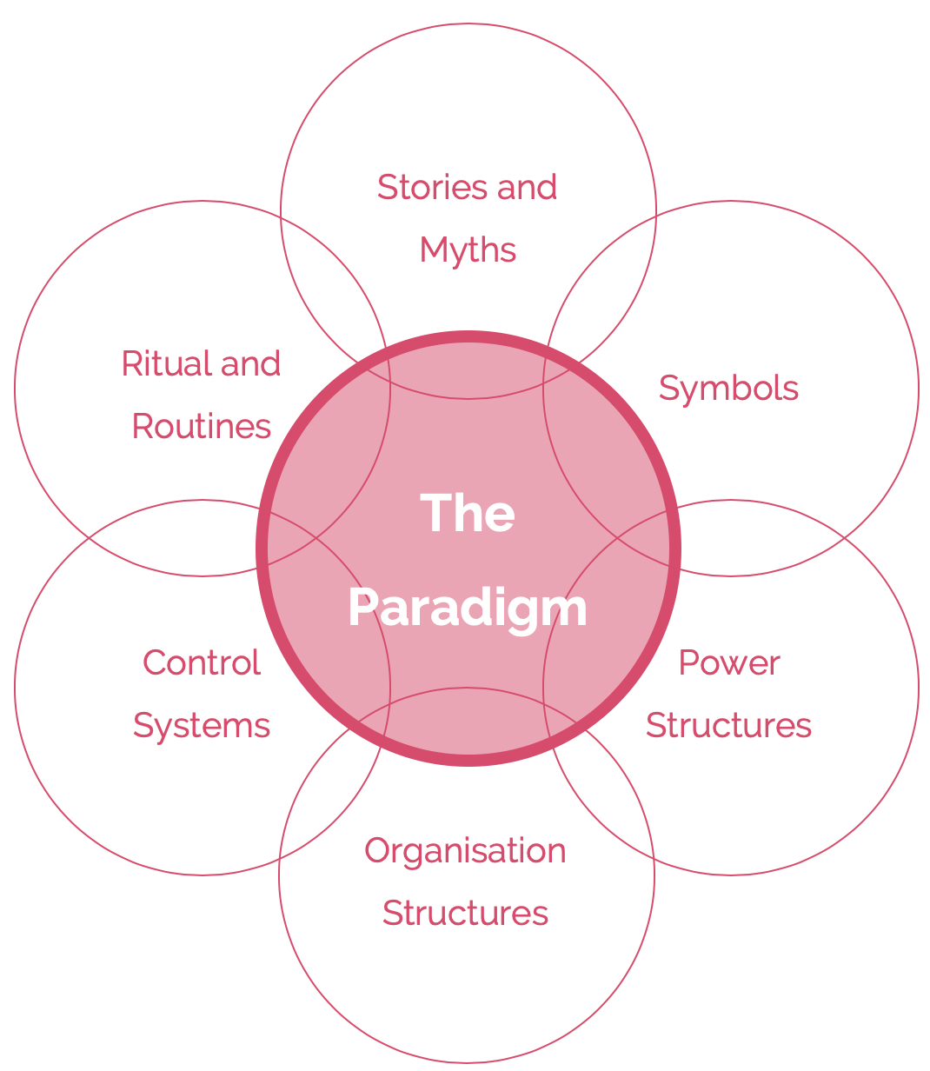

The Elements
Johnson and Scholes identified six distinct but interrelated elements which contribute to what they called the “paradigm”, equivalent to the pattern of the work environment, or the values of the organisation.
They suggested that each may be examined and analysed individually to gain a clearer picture of the wider cultural issues of an organisation. The six contributing elements (with example questions used to examine the organisation at hand) are as follows:
1. Stories and Myths
These are the previous events – both accurate and not – which are discussed by individuals within and outside the company. Which events and people are remembered by the company indicates what the company values, and what it chooses to immortalise through stories.
· What form of company reputation is communicated between customers and stakeholders?
· What stories do people tell new employees about the company?
· What do people know about the history of the organisation?
· What do these stories say about the culture of the business?
2. Rituals and Routines
This refers to the daily actions and behaviours of individuals within the organisation. Routines indicate what is expected of employees on a day-to-day basis, and what has been either directly or indirectly approved by those in managerial positions.
· What do employees expect when they arrive each day?
· What experience do customers expect from the organisation?
· What would be obvious if it were removed from routines?
· What do these rituals and routines say about organisational beliefs?

3. Symbols
This is the visual representation of the company; how they appear to both employees and individuals on the outside. It includes logos, office spaces, dress codes and sometimes advertisements.
· What kind of image is associated with the company from the outside?
· How do employees and managers view the organisation?
· Are there any company-specific designs or jargon used?
· How does the organisation advertise itself?
4. Control Systems
These are the systems and pathways by which the organisation is controlled. This can refer to many things, including financial management, individual performance-based rewards (both measurement and distribution) and quality-control structures.
· Which processes are strongly and weakly controlled?
· In general, is the company loosely or tightly controlled?
· Are employees rewarded or punished for performance?
· What reports and processes are used to keep control of finance, etc?
5. Organisation Structures
This refers to both the hierarchy and structure designated by the organisation. Alongside this, Johnson and Scholes also use it to refer to the unwritten power and influence that some members may exert, which also indicate whose contributions to the organisation are most valued by those above them.
· How hierarchical is the organisation?
· Is responsibility and influence distributed in a formal or informal way?
· Where are the official lines of authority?
· Are there any unofficial lines of authority?

6. Power Structures
This is the genuine power structures and responsible individuals within the organisation. It may refer to a few executives, the CEO, board members, or an entire managerial division. These individuals are those who hold the greatest influence over decisions, and generally have the final say on major actions or changes.
· Who holds the power within the organisation?
· Who makes decisions on behalf of the company?
· What are the beliefs and culture of those as the top of the business?
· How is power used within the organisation?

Cultural Web to Change
As above, the first step of changing the culture of the organisation is to analyse elements of the Cultural Web as they are in the present.
The next step is to repeat the process, examining each element, but this time considering what one would like the culture, beliefs and systems to be.
This can then subsequently be compared with the ideal culture, and the differences between the two can be used to develop achievable steps towards change within the company. One will likely only then realise the true strengths and weaknesses of the organisation’s current culture, what the various hindrances are to growth, and how to go about changing specific elements to develop and achieve success.
A new strategy can evolve from this by looking at introducing new beliefs, and prioritising positive reinforcement of current, successful ones. Hopefully, by integrating this system of analysis, managers can find themselves able to break free of ritual and belief systems within a company to achieve real change and innovation.

