Programme: BA (Hons) Leadership and Management Skills for the Workplace
Module: Research Methods for Business
STUDENT NAME: Eridan Saliasi
STUDENT ID:2324158

Module code: LCLM6004

TOPIC: EVALUATING THE RELATIONSHIP BETWEEN CUSTOMER RETENTION STRATEGIES AND FINANCIAL PERFORMANCE AT GOLDINBOX LTD

Table of Contents
1. Introduction and Business Problem Context 3
2. Research Aim, Objectives and Questions 4
3. Critical Literature Review 4
3.1 Customer Retention Strategies in B2B Wholesale Businesses 4
3.2 Employee and Customer Perceptions of Customer Retention Strategies 5
3.3 Customer Retention Strategies and Financial Performance 5
3.4 Working Capital Management, Liquidity and Customer Credit 6
3.5 Business Challenges Affecting Customer Retention and Financial Sustainability 6
3.6 Theoretical Framework 6
3.7 Conceptual Framework 7
3.8 Literature Gap 7
4. Research Methodology and Research Design 8
4.1 Research Philosophy 8
4.2 Research Approach 8
4.3 Data Collection 8
4.4 Sampling 8
4.5 Data Analysis 8
4.6 Ethical Considerations 8
5. Business Relevance and Practical Implications 9
6. References 11

Introduction and Business Problem Context

Goldinbox Ltd is a UK-based business-to-business supplier of furniture, carpet and lighting products and a service provider for warehousing and logistics within the commercial distribution chain. It is their job to support institutional clients with reliable stock availability, flexible credit terms, and rapid supply chain service (Govt.).UK, 2022). As the competition tightens in the wholesale market, the challenge for distributors has been enhanced both to hold onto customers and keep their finances afloat. At the same time, the UK furniture industry is worth around USD 29.69 billion in 2026, and it's expected to grow to USD 38.21 billion by 2031 (Mordor Intelligence, 2026). It is highlighting ongoing commercial opportunities as well as growing competitive pressures. In these market conditions, the challenge for wholesalers is to combine CRM and efficient working capital practices for profitability and a longer, sustainable operation.

The organisation is considering changes to the way they operate their warehouse and intends to cut its warehouse operation staff down from 20 to just 6 employees, all of whom will have the ability to perform all the warehouse processes themselves. Traditionally, staff members were trained to carry out specific jobs, giving rise to operational dependency, low staff turnover levels and low customer response when there was a shortage of staff or the demand for them changed. (BT Marketing, 2026) Evolving labour costs, more competition and a need for higher effectiveness have spurred organisations to implement multi-skilling and cross-training of their employees.
The World Economic Forum (2026) estimates that 39% of the abilities required for workers' basic tasks will shift by the year 2030, underscoring the critical need for ongoing workforce development. But if done on no provocation, restructuring the workforce can create employee resistance, workload, training expenses, and potentially cause disruption. As such, primary research is essential to management in order to gain insight into employee perceptions, identify potential implementation issues and guide informed options and decisions to ensure long-term organisational sustainability and productivity as they consider or proceed with the process of workforce redesign.

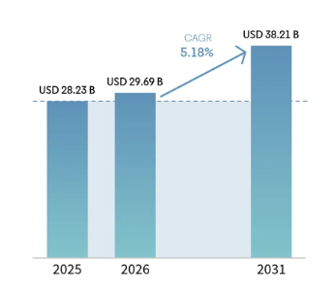
Figure 1: United Kingdom Furniture Market
(Source: Mordor Intelligence, 2026)
Goldinbox Ltd faces three major business challenges that threaten its customer retention and financial sustainability. First, the rising global prices of commodities have led to higher procurement, transportation, and warehousing costs, denting profitability and hence limiting pricing negotiations in a competitive wholesale market in the UK (Panya and Marendi, 2025). Second, the more stringent the rules of compliance, the more continuous investments that need to be made in the quality of products, financial governance, and transparency in the supply chain are increasing, adding complexity to the operations (Ahmed and McCarthy, 2023). Third, the emergence of fraud risks, such as payment fraud, cyberattacks and customer credit defaults, leads to financial losses and disruption of its cash-flow for the organisation (Chang, Duflos and Chalwe-Mulenga, 2026). All these issues together create severe liquidity, working capital management and long-term business development pressures, further worthy of investigation.
This research fills this great vacuum, not by providing only one of the two areas of interest, customer loyalty or financial performance, but by focusing on both. The results will become a tool for evidence-based decision-making, enabling Goldinbox to come up with new strategies for retaining its existing customers in a financially sustainable manner, as well as improve the efficiency of working capital and, indeed, the liquidity management system. Additionally, the study provides relevant insights that can be used in business-to-business wholesales in the UK in a market that has grown more competitive and likely to change quickly.

2. Research Aim, Objectives and Questions
Aim
The study aims to critically review the relationship between B2B customer retention strategies and financial outcomes for Goldinbox Ltd and create a financially viable strategy.
Research objectives
- To explore the views of the employees, provide more training for the employees and customers on existing customer retention strategies by Goldinbox.
- To assess the perceived value of current customer retention practices in Goldinbox Ltd. and the perceived risks that come with such practices.
- To be able to assess the major liquidity items of the credit and debit lines of the last year in quantitative terms.
- To enhance Customer retention with actionable strategic tactics, as Cash flows are safeguarded for the next 1 year.
Research question
- How does Goldinbox's Financial Performance and Liquidity affect through B2B Customer Retention Strategies?
- What are the main operational advantages and potential costs of current retention measures, suggested by the staff surveys?
- What are the customer retention mechanisms that are currently in place for Goldinbox for wholesale customers?
- How have the working capital and main liquidity metrics trends changed in Goldinbox, altering credit extensions?
- What are the resources that Goldinbox can leverage to achieve a balance between financial stability and commercial growth in improving customer retention strategies?

3. Critical Literature Review

3.1 Customer Retention Strategies in B2B Wholesale Businesses
The three main elements of B2B wholesale customer retention are optimizing account health, ensuring fulfillment consistency and offering digital autonomy. Reinartz (2025) suggest that by combining these elements in the right way, relationship marketing, Customer Relationship Management (CRM) and customer loyalty can reinforce the fidelity of customers over the long term by providing personalized interactions and ongoing value creation. However, Ali and Shabn (2024) argue that sustainable competitive advantage arises from the use of retention strategies only when the Customer Lifetime Value (CLV) exceeds the cost of maintaining business relations. Additionally, the Commitment–Trust Theory by Morgan and Hunt is focused on trust and commitment as key components of a successful B2B relationship, while transactional approaches mainly focus on the transactional process, emphasizing short-term sales rather than long-term relationships (Ferro-Soto et al., 2025). Hence, B2B wholesalers ought to apply relationship retention strategies to sustained valuable wholesale accounts in combination with the customer profitability analysis.

3.2 Employee and Customer Perceptions of Customer Retention Strategies
Feedback from usage and perception of the employee and customer is pivotal to the success of customer retention strategies, establishing a strong loyalty chain, wherein the satisfaction of the service provider reflects on the revenues generated by the service provider. Trust and commitment are suggested by Morgan and Hunt (2026) to positively influence the quality of the relationship by promoting long-term interactions and cooperation among organisations and customers. In support of this point, Salamah et al (2022) say that key factors of customer retention are service quality, effective communication and customer satisfaction. Therefore, effective customer retention relies on closely joining employee engagement to service driven by the customers needs and wants and sustaining business relationships by focusing on Relationship Marketing Theory and the Commitment–Trust Theory.

3.3 Customer Retention Strategies and Financial Performance
The boost to business profitability generated from improved customer retention is an obvious advantage to the business, as it is cheaper to retain customers than to acquire new ones. Kuštelega, Gregurec and Hrustek (2025) state that customer retention has many benefits for profitability as it increases the CLV, customer revenue and long-term return on investment via long-term customer relationships. On the other hand, Gao, Melero-Polo and Sese (2025) argue that retention policies lead to better financial outcomes if they invest in the right customers (those who can yield the highest profits) by means of predictive CLV models, instead of retaining every customer. This includes a more comprehensive customer retention that goes beyond just customer numbers to consider customer profitability. Hence, Goldinbox should combine customer retention efforts and customer segmentation using CLV in order to optimise their profitability and financial performance while ensuring sustainable allocation of their resources.

3.4 Working Capital Management, Liquidity and Customer Credit
WC Management involves the management of a firm's short-term assets and short-term liabilities. According to Yanney (2023), effective working capital management enhances liquidity by optimising cash flows, inventory and trade receivables, which ultimately boosts financial sustainability. While customer credit policies and having too many products in stock can help with customer retention, they can also have serious adverse consequences on liquidity and financial risk if the cash conversion cycles are extended too long, notes Umbrex (2025). The contrasting examples demonstrate the competing priorities between customer relationship building and focusing on the short-term return, and customer-specific long-term financial stability. Accordingly, Goldinbox need to implement a balance between customer retention efforts and well-managed working capital practices to ensure sufficient liquidity, profits and future survival.

3.5 Business Challenges Affecting Customer Retention and Financial Sustainability
Financial sustainability suffers due to poor customer retention, and it's been shown that new customer acquisition costs as much as five times more than existing customer retention. The use of relationship marketing in maintaining customers encourages trust and participation in the process of maintaining customers for the long term, even in business environments that are becoming more competitive (Albérico, Casaca, 2024). However, Kaya claims (2024), high supply prices, restricted liquidity and longer duration of customer credit will seriously impact the financial sustainability even though the buyer’s loyalty boosts. UDO (2024) highlights that increasing regulatory compliance obligations and fraud risks raise operational costs, constrain working capital and reduce organisational flexibility, particularly for business-to-business wholesalers operating with narrow profit margins. Therefore, it is sensible to use customer retention strategies in a manner that involves commercial relationship development and sound financial risk management that will lead to sustainable organisational performance.

3.6 Theoretical Framework
Predictive of successful long-term B2B customer relations is the Commitment–Trust Theory developed by Robert M. Morgan and Shelley D. Hunt, which can be useful to assess customer perception regarding customer retention and loyalty. However, theory has limited attention awarded to the financial considerations impacting relationship durability (Morgan and Hunt, 2026). The Working Capital Trade-off Theory complements this view by illustrating the relationship between a combination of other variables, namely customer credit, investment in inventories, liquidity and profitability, that are important aspects of the organisation's pursuit of the retention strategy (Voutsinas and Werner, 2025). These theories brought together an integrated framework that correlates the relationship quality with financial performance, directly supporting the research questions and research purpose of the study.
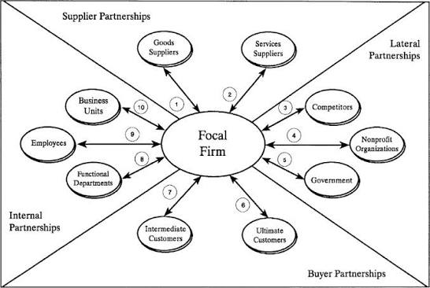
Figure 2: Commitment–Trust Theory
(Source: Morgan and Hunt, 2026)

3.7 Conceptual Framework
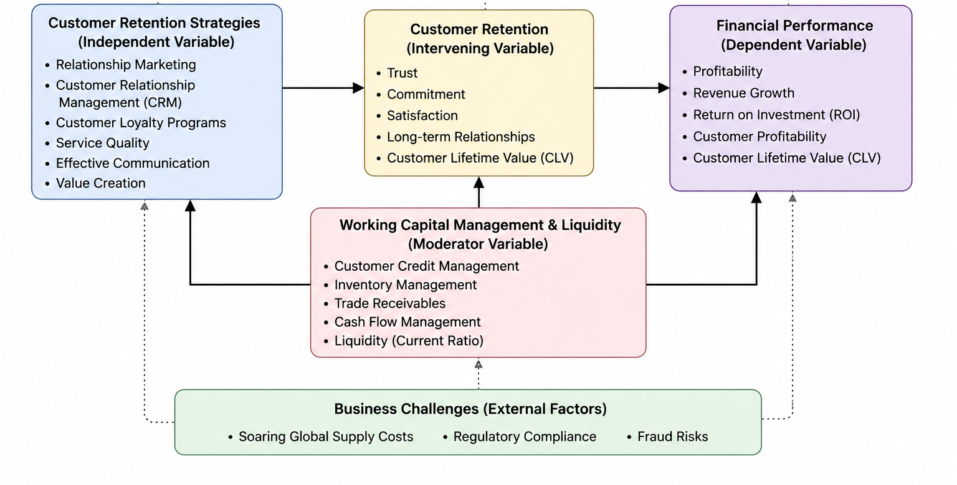
Figure 3: Conceptual Framework
(Source: Self-Made)

3.8 Literature Gap
The previous research focuses mainly on customer retention and financial performance or working capital separately, therefore leaving the B2B wholesale businesses with empirical, contextual, methodological and theoretical gaps. Goldinbox gives us a suitable case to work on integrating these relationships via a conceptual platform, beginning with customer retention strategies and ending with a study of liquidity and working capital, and the resulting impact on financial performance that produces some useful managerial insights.

4. Research Methodology and Research Design

4.1 Research Philosophy
The method used is positivist because the study aims to explain the relationship between each of the customer retention strategies and financial performance from the measurable evidence. When taking a positivistic approach, you prioritise the collection of objective data, hypothesis testing, hypothesis comparison and statistical analysis that allows you to evaluate customer perceptions and organisational performance objectively, while reducing researcher bias as much as possible.

4.2 Research Approach
The deductive approach is most suitable since it is based upon the testing of a theory, namely established theories of the Commitment – Trust Theory and Working Capital Trade-off Theory, which are taken for granted and are examined by empirical analysis of survey data. The theoretical model allows the researcher to investigate whether the theoretical relationships predict the customer loyalty, liquidity and financial performance at Goldinbox Ltd. Company.

4.3 Data Collection
Primary Quantitative Data Information Collection using a structured questionnaire and a 5-point Likert scale will be used in the study. Employees and B2B customers will provide feedback on customers' perception of customer retention initiatives, relationship quality and financial performance. Primary survey data use approaches which are standardised and quantifiable, allowing for comparisons between and within the respondent groups as part of an analysis of the data, and are directly focused on the research objectives and questions.

4.4 Sampling
The sampling technique used is purposive, as the participants have knowledge pertinent to Goldinbox's customer retention practices. Being representative of key work areas as well as the feasibility of the time and resources of the study, the sample includes 20 employees from key operational departments and 40 active B2B customers, providing informed answers.

4.5 Data Analysis
The data will be analysed quantitatively, including descriptive statistics, SPSS IBM Statistics package, reliability analysis and correlation analysis. SPSS allows for an accurate analysis of the relationship between the strategies and financial results, which generates factual statistical evidence to support objective interpretation and evidence-based recommendations regarding strategies for managers.

4.6 Ethical Considerations
The research will utilise informed consent, voluntary participation, confidentiality and secure storage of the data to adhere to the General Data Protection Regulation (GDPR). The participants will be provided with full study information and will have the right of withdrawal without any consequences, with ethical consideration and respect for individual privacy through the research process.

5. Business Relevance and Practical Implications
The research proposed will help to validate the findings for the development of customer retention strategies in Goldinbox Ltd, which is financially viable and will ultimately raise the overall performance of the organisation. The findings will help managers identify those customer retention practices that are profitable and enhance long-term customer connections without putting them at excessive customer credit risk or under increased liquidity stress. Moreover, the study will help with sound evidence, as the working capital management system will be improved by effective credit controls, inventory management and cash flow controls. This work will also help management to manage fraud risks better through better internal financial controls, enhanced customer verification processes, and so on. Besides, the findings can improve regulatory adherence in terms of making optimistic decisions on how customers are administered, in accordance with disclosures and commercial governance specifications. Therefore, the suggested findings will help Goldinbox to balance customer retention with profitability, enhance managerial decision-making, boost operational resilience and enable sustainable business growth in a highly competitive UK B2B wholesale market.
Research Activities | W1 | W2 | W3 | W4 | W5 | W6 | W7 | W8 | W9 | W10 | W11 | W12
Topic selection and proposal planning
Literature review and theoretical framework
Research methodology development
Questionnaire design and pilot testing
Ethical approval and participant recruitment
Primary data collection (Survey)
Data coding and SPSS statistical analysis
Interpretation of findings and discussion
Conclusions and recommendations
Editing, proofreading and final submission
Table 1: Project Plan
(Source: Self-made)

References
Ahmed, W.A.H. and MacCarthy, B.L. (2023). Blockchain-enabled supply chain traceability – How wide? How deep? International Journal of Production Economics, [online] 263(79), p.108963. doi:https://doi.org/10.1016/j.ijpe.2023.108963.
Albérico, R. and Casaca, J. (2024). Relationship Marketing and Customer Retention - A Systematic Literature Review. [online] ResearchGate. Available at: https://www.researchgate.net/publication/377346943_Relationship_Marketing_and_Customer_Retention_-_A_Systematic_Literature_Review.
Ali, N. and Shabn, O.S. (2024). Customer lifetime value (CLV) insights for strategic marketing success and its impact on organizational financial performance. Cogent business & management, 11(1). doi:https://doi.org/10.1080/23311975.2024.2361321.
BT Marketing (2026). Temporary Workers Agency Selection for Operational Stability. [online] RSS Inc. Available at: https://www.rssinc.com/manufacturing/temporary-workers-agency-selection-for-operational-stability/ [Accessed 8 July 2026].
Chang, S., Duflos, E. and Chalwe-Mulenga, M. (2026). Solutions to Protect Consumers from Fraud in Digital Finance. [online] CGAP. Available at: https://www.cgap.org/research/publication/solutions-to-protect-consumers-fraud-in-digital-finance.
Ferro-Soto, C., Padin, C., Lubbe, I., Svensson, G. and Nils Høgevold (2025). Determinants and outcomes of satisfaction in B2B sales relationships. Journal of Business and Industrial Marketing, 40(13), pp.61–76. doi:https://doi.org/10.1108/jbim-10-2022-0470.
Gao, L. (Xuehui), Melero-Polo, I. and Sese, F.J. (2025). The role of customer experience dimensions in expanding customer–firm relationships: A customer expansion journey approach. Journal of Retailing, 12(09). doi:https://doi.org/10.1016/j.jretai.2025.05.004.
Govt.UK (2022). GOLDINBOX LIMITED overview - Find and update company information - GOV.UK. [online] Service.gov.uk. Available at: https://find-and-update.company-information.service.gov.uk/company/13987695 [Accessed 4 Jul. 2026].
Kaya, O. (2024). The impact of late payments on SMEs’ access to finance: Evidence from credit rationing and loan terms. Economic Modelling, [online] 141(78), pp.106896–106896. doi:https://doi.org/10.1016/j.econmod.2024.106896.
Kuštelega, M., Gregurec, I. and Hrustek, L. (2025). The Impact of Customer Lifetime Value in Customer Relationship Management: A Bibliometric Analysis. TEM Journal, 13(7), pp.2711–2722. doi:https://doi.org/10.18421/tem143-72.
Mordor Intelligence (2026). United Kingdom Furniture Market | 2022 - 27 | Industry Share, Size, Growth - Mordor Intelligence. [online] www.mordorintelligence.com. Available at: https://www.mordorintelligence.com/industry-reports/united-kingdom-furniture-market.
Morgan, R.M. and Hunt, S. (2026). The Commitment-Trust Theory of Relationship Marketing. [online] ResearchGate. Available at: https://www.researchgate.net/publication/233894851_The_Commitment-Trust_Theory_of_Relationship_Marketing.
Panya, K.O. and Marendi, P. (2025). GLOBAL SUPPLY CHAIN DISRUPTIONS AND SHIFTS IN EXPORT STRATEGIES OF LOGISTIC FIRMS:AN EMPIRICAL REVIEW. Reviewed Journal International of Business Management [ISSN 2663-127X], [online] 6(1), pp.758–777. doi:https://doi.org/10.61426/business.v6i1.390.
Reinartz, W.J. (2025). Customer relationship management: past, present, and future. International Journal of Research in Marketing, 13(09). doi:https://doi.org/10.1016/j.ijresmar.2025.12.001.
Salamah, A.A., Hassan, S., Aljaafreh, A., Zabadi, W.A., AlQudah, M.A., Hayat, N., Al Mamun, A. and Kanesan, T. (2022). Customer retention through service quality and satisfaction: using hybrid SEM-neural network analysis approach. Heliyon, 8(9), p.e10570. doi:https://doi.org/10.1016/j.heliyon.2022.e10570.
UDO, A. (2024). REGULATORY COMPLIANCE AND ACCESS TO FINANCE: IMPLICATIONS FOR BUSINESS GROWTH IN DEVELOPING ECONOMIES. [online] ResearchGate. Available at: https://www.researchgate.net/publication/378506641_REGULATORY_COMPLIANCE_AND_ACCESS_TO_FINANCE_IMPLICATIONS_FOR_BUSINESS_GROWTH_IN_DEVELOPING_ECONOMIES.
Umbrex (2025). Efficiency & Working Capital Ratios. [online] Independent Management Consultants. Available at: https://umbrex.com/resources/financial-ratio-primer/efficiency-working-capital-ratios/.
Voutsinas, K. and Werner, R.A. (2025). Trade-off Theory vs. the Pecking Order Hypothesis: Japanese Evidence on Capital Structure under Financial Constraints. Structural Change and Economic Dynamics, 74(7), pp.944–962. doi:https://doi.org/10.1016/j.strueco.2025.06.004.
Yanney, A. (2023). Optimizing Working Capital Through Dynamic Cash Flow Analysis and Inventory Management in Manufacturing Firms. International Journal of Computer Applications Technology and Research, 12(12), pp.136–151.

