William Page
Student ID: 2113430
Research-Based Placement
Portfolio and reflective piece linked to a voluntary or work-based experience that utilises basic counselling skills

ECPS5010



Contents
Reflective Commentary…………………………………………………………………………………….. 2-5
Reference List…………………………………………………………………………………………………… 6
Evidence 1: Meetings
Section A……………………………………………………………………………………………… 7-8
Section B……………………………………………………………………………………………… 9-10
Section C……………………………………………………………………………………………… 11-12
Section D……………………………………………………………………………………………… 13 - 14
Evidence 2: Assessing Attitudes, Perceptions and Feedback
Section A………………………………………………………………………………………………. 15
Section B……………………………………………………………………………………………….. 16-17
Section C……………………………………………………………………………………………….. 18-20
Evidence 3: Project Development………………………………………………………………………. 21-22
Reference List…………………………………………………………………………………………………….. 23-24
Appendices………………………………………………………………………………………………………… 25-34

REFLECTIVE COMMENTARY

My placement was conducted within the psychology labs of the UWTSD IQ campus. During this placement I engaged in fact-finding, background research, informal interviews and facilitating group discussions in order to determine how different counselling and therapy processes could be further supported or enhanced within the digital medium. The task objective originated as determining a way for a client’s mental well-being to be recorded and self-reported in-between counselling or therapy sessions, during which time the data could be collated, reformed and presented in such a way that both the client and counsellor could engage with the information. This would not only create an interactive timeline of the progress or decline of an individual’s mental wellbeing, but also act as a preparatory aid for both the client and counsellor to identify key instances (times, dates, locations, and interactions) and patterns that correlate to any affect on mental health for focus and discussion in upcoming sessions. This brief was presented Ruth Groff and Kate Williams, who facilitated my placement and met with me every Wednesday afternoon so that we could summarise tasks completed thus far, share a briefing on setting the next objectives, assisting me by directing what research I should find to incorporate into my tasks and recommending other individuals I should discuss the project with in order to gain wider perspectives an expert views on various elements of the project.
With the support of the faculty, I was able to consolidate how certain areas of the project could be conducted in such a way that would allow me to engage with and practice counselling skills that would include active listening and even confirm understanding when sharing ideas through summarising (Midwinter & Dickson, 2015) (McLeod & McLeod, 2011). I primarily had these opportunities during one-to-one meetings in which my placement and the project would be discussed, and ideas could be developed while drawing from genuine practical experience. Furthermore, I was able to incorporate elements of contracting into these occasions. Though this was not done to the depth and standards as outlined by the BPS Code of Ethics and Conduct (2021), I was able to transfer the experience from practice sessions during counselling skills lectures into my introductions during these meetings that allowed me to pace and detail the aim of the meeting and what was to be expected not unlike contracting with a client. Finally, within the university setting, it was paramount that I presented myself professionally and confidently amongst those who were generous enough to spare their time to partake in the discussions. This afforded me the opportunity to further practice the SOLER method (Egan, 1975) by ensuring that I remained comfortably engaged with the conversation and ensured that there remained an atmosphere professionalism while maintaining a relatively informal discussion regarding the nature of my placement.
Once the aim of the project was set, I implemented an ongoing Gantt chart (Appendix A) that allowed me to plan weeks in advance and schedule meetings. During time between discussions and correspondences, my placement was directed toward finding research relevant to the integration of digital processes into counselling practices. Most practical reviews appeared to revolve around logistics as opposed to new approaches that involved digital systems. However, my attention was eventually directed toward the online therapy research of Dr. Terry Hanley, specifically his team’s work within mental health peer support in web-based forums (Banwell et al., 2022). Once I had acknowledged the vast depth of research into client/counsellor engagement through various digital processes, coupled with my ongoing findings of psychometric testing literature, such as MTQ-48 (AQR International, 2017), I began to question if there already existed any developments in continuous client self-reporting metrics within interactive digital applications. Therefore, I changed my focus from research literature to marketed software and found the app Moodfit. This application was in fact designed to create a timeline of mental-wellbeing progression through client self-reporting engagement between and during sessions. The application’s displays and graphs of collated well-being data appeared similar to the Canva designs of my own.
At this point during my placement, I was required to determine a different avenue to pursue within the field of integration of digital processes in counselling and therapy. The Gibbs Reflective Framework (Gibbs, 1988) became a crucial part of my process in developing ideas that I would want to pursue instead. Though, at first, the existence and success of the application had solicited a defeatist attitude, the reflective cycle enabled me to analyse carefully the application against all the literature I had already researched as well as the auto-generating response processes of various online psychometric tests. In tune with the Gibbs Framework, I evaluated this against my own experiences in self-reporting when applying for counselling and found a common factor which would become the new focus of my placement. The new emphasis had become identifying the causes of inaccuracy and dishonesty in digital self-reporting processes and determining how these issues could be mitigated.
My meetings with members of staff became focussed on determining what digital self-reporting processes are already used, and if, in their opinion, accuracy and honesty on behalf of the client was in fact a potential issue. Feedback provided to me included research into the CORE outcome measuring tool (Twigg et al., 2019) and determining a reformation for its use to be engaged with independently by clients between sessions while aiming to identify how the language used in the CORE-10 screening could possibly illicit inaccurate responses. Further meetings included facilitating group discussions to see if these notions could be recognised in other self-reporting forms as well as guidance through the process of online accessibility for clients to engage in self-reporting that could generate two-sided data that would be client-focussed and then relevant to the counsellor.
Ultimately, I felt challenged by presenting ideas that were continuously being developed and then needing to ingrate change from feedback. However, the interpersonal approaches, summarising of ideas, adapting to feedback, and reframing the questions presented by the objective were all accompanied and assisted by methods transferred from counselling skills.

REFERENCE LIST

AQR International. (2017). The MTQ48 Technical Manual.
https://aqrinternational.co.uk/evidencing-our-work

Banwell, E., Hanley, T., Barcia, S. D. O., Mindel, S., Kayll, T., & Sefi, A. (2022). The
Helpfulness of Web-Based Mental Health and Well-being Forums for Providing
Peer Support for Young People: Cross-sectional Exploration. JMIR Formative
Research, 6(9), 1-15. https://formative.jmir.org/2022/9/e36432

British Psychological Society. (2021). BPS Code of Ethics and Conduct.
https://www.bps.org.uk/guideline/code-ethics-and-conduct

Egan, G. (1998). The skilled helper: a problem-management approach to helping (6th
ed.). Brooks/Cole.

Gibbs, G. (1988). Learning by doing: A guide to teaching and learning methods.
Oxford: Oxford Further Education Unit.

McLeod, J., & McLeod, J. (2011). Counselling skills: A practical guide for counsellors
and helping professionals (2nd ed.). Open University Press.

Midwinter, R., & Dickson, J. (2015). Embedding counselling and communication skills;
A relational skills model. Routledge.

Twigg, E., Cooper, M., Evans, C., Freire, E., Mellor-Clark, J., McInnes, B. & Barkham,
M. (2016). Acceptability, reliability, referential distributions and sensitivity to
change in the Young Person's Clinical Outcomes in Routine Evaluation (YP-
CORE) outcome measure: replication and refinement. Child and Adolescent
Mental Health, 21 (2), 115-123.

PORTFOLIO OF EVIDENCE

Evidence 1: Meetings
Section A

Applying digitised mental wellbeing data to modern counselling

Through experience and involvement during a placement at the labs, I hope to formulate a digital application that will collate real-time data regarding the progress, improvement or decline of an individual’s mental wellbeing that can be interpreted by the client’s counsellor or any other relevant mental health practitioner.
I have experienced that before both online and in-person counselling sessions, the client is often required to complete a form prior to the beginning of the session detailing changes or continuations of their mental wellbeing. Though the simplicity of many of the questions and scales is somewhat elegant and the opportunity to discuss the displayed questions with the counsellor is extremely helpful, I believe that there may be a flaw to the expectation of a client scanning through the entire time between counselling sessions and compressing into a single document for the counsellor to evaluate. Even though the nature of counselling is to explore these experiences in detail, I believe more can be done to equip both the client and the counsellor more effectively prior to the session.
I hope to eventually begin research into the development of a mobile application that will allow clients to log all relevant information regarding their mental wellbeing throughout the entire interim between counselling sessions. While the client would have the option to enter more detailed information into the application, simple short form methods such as symbols or key words would also be included for the client to record feelings, events and moods while also recording time and location. Such information could then be collated into a scaled graph of the client’s mental wellbeing across time that, with the client’s permission, would be accessible to the counsellor at an appropriate time before the next counselling session. Through continued use, the application would eventually be able to identify patterns in occurrences, highlight and separate that data as imperative information for the viewer. Therefore, this could be used as a tool of self-reflection for the client while simplifying or even supporting processes such as journaling whilst also creating an abundance of client information for the counsellor to review to be potentially more prepared for the upcoming session.
The application would also include secondary features such as guided mindfulness techniques and personalised options to generate even more information and to assist in the client’s coping ability. The effectiveness of such techniques could be logged and interpreted in order to further tailor the client’s care.

Summary
This evidence is the initial brief of the project I aimed to develop and research during my placement that was submitted to support my application. Using this brief, I was able to highlight the areas of literature and processes I would aim to work on such as reports, articles and papers on digital therapy processes. The objective was of course changed to understanding the weaknesses of digital self-reporting processes.

Section B

Overview of meeting with Katie Ruddy 14/11/2022

I met with Katie for approximately half an hour to discuss her experiences and opinions on self-reporting processes. I introduced the original concept of creating accessible software for clients to input information between sessions to create a consistent timeline of mental health progress and how that idea has developed into critiquing various self-reporting formats in order to identify weakness and potential for development.
Katie explained how different modalities value self-reporting differently. She explained that within her expertise she encourages journaling for some of her clients and has experience in assisting prospective clients with initial counselling applications
We further discussed how information can be lost in the self-reporting process. She drew similarities with online counselling and therapy in terms of the limits of how much information the client can convey intentionally and unintentionally. Unless a client is able to very accurately articulate their feelings and experiences, such information is also lost through journalling.
I explained that I aimed to determine if the ‘speed’ of self-reporting scales could be combined with the depth and detail of journaling. Not necessarily to create an interface that is a product of both but rather to determine if scale/question wording can be formulated to give even more accurate representations of the client while avoiding such wording negatively affecting the client’s self-reporting or even current well-being.
Katie explained how her experiences with initial self-reporting can appear to lack a substance of ethics. Essentially, once an individual has self-reported, the process is over and must simply wait for an appointment. We contrasted this against how a lot of research includes follow up mindfulness exercises to return participants to their baseline mood.
In summary, crucial points from the meeting that will guide further research into this concept will include identifying modalities that involve various methods of self-reporting for clients, how different clients or prospective clients are expected to engage with self-reporting processes (age range, assistance, et.) and what limitations they may face, and if there exists a need to assist clients in returning to baseline after self-reporting.

Summary
This evidence is the summary of my meeting with Katie Ruddy. The purpose of this meeting was to determine how vital online self-reporting processes are based on her experience. The discussion developed into what issues the process may present and not only the client’s engagement must be considered but also if continuous self-reporting fits the counsellor’s or therapist’s modality.

Section C

Overview of meeting with Beverly Cole 28/11/2022

Firstly, I introduced the nature of my placement and the focus on determining digital aspects of counselling and therapy that would require more research and development, specifically self-reporting processes.
I then prompted a discussion regarding the CORE Measurement Tool and asked for Beverly’s opinions on how the resultant information from these forms might be inaccurate or dishonest. We discussed instances in which clients would be compelled to answer a certain way, on any form (specifically treatment application forms), based on their goals. One instance of discussion was that Beverly had noticed how some individuals perceive the income or physical health sections of documents (digital or physical). Beverly had identified that certain people would answer certain questions in the hopes of receiving continued financial support and would declare this a ‘pass’. This raised a connection between language presented/perceived on documentation and goals of the client. We continued the discussion in the scope of what research would have to be carried out to how effectively language, goals, and perceptions can be matched to create more honest and accurate reporting.
To narrow the discussion, I asked how CORE forms are collated when the results are assessed by the counsellor/therapist or shared with the client. Beverly informed me that she has only ever known the forms to remain the same and the data is not represented any differently. Returning to an earlier idea of simplifying how information between a counsellor/therapist and client is shared, I proposed that the client scores developed from the forms could be integrated into graphics and represented as data points on a graph with the length of time receiving treatment/sessions as the 𝑥 axis, and CORE scores as the 𝑦 axis. This would generate a continually developing graph of the client’s progress or decline and the data points could be selected to access the form that produced the score for that specific point. Beverly said she had not seen the information displayed that way before but said it had merit in its simplicity and accessibility for both the client and the counsellor. She also stated that it is possible some practitioners may already do something similar themselves, but there is not standard program aligned with COREs to create this this immediately and automatically. This created a more defined and realistic target for what I would like to research and possibly develop in the future.

Summary
This evidence is the summary of my meeting with Beverly Cole. The discussion focussed the possibilities of inaccuracy and dishonesty within digital self-reporting processes and if these issues could arise from subjective perceptions and ulterior motives when completing the CORE-10 measurement form (Appendix C). We further discussed how the scores from this measurement tool could be translated into a more engaging format for both the client and counsellor.

Section D

Overview of meeting with Zoe Cooke 07/12/2022

At the start of the meeting I introduced Zoe to my concept of developing a client self-reporting mental well-being measurement tool that reduces the potential for inaccuracy and dishonesty that could also easily be translated into a simplified graphic that would be accessible to both the counsellor and client.
From her experience, Zoe had explained that she was aware of measurement tools, specifically CORE-10, being utilised by counsellors before or during the session and client engagement would often be led by the counsellor. From here we discussed the viability of a process in which the counsellor would not need to be present. Therefore, the process would need to be as simple and self-explanatory as possible without overwhelming the client with too much instructional information. Continuing along the theme of potential issues, we discussed how promoting the independence of the client to not need to be led during the process could possibly be detrimental, specifically, how the client could interpret the resultant data when it is translated into the engageable graphic. We then proposed the possible solution of the client being able to engage with the self-reporting process as regularly as they wish, the data would then be continuously uploaded and integrated into the timeline graphic, however, the final graphic (progress/decline timeline graph) would not be accessible to the client until their counselling session. This could prevent the client from misinterpreting the data and even deter the possibility of forcing the information to create an inaccurate graph.
Zoe then talked me through her project and explained how I should consider each stage of development for my own project. Firstly, show presented how the webpage was designed to be as accessible as possible and how navigation did not only need to be clear but also elegantly display all relevant information without confusing the user. Secondly, how all reporting tools and measurements are labelled and displayed. Finally, the step-by-step process for outlining how the entire page was developed. I had not considered that the process of collating and reforming the information into accessible graphics would need to be supported by an overall user-friendly interface. Zoe displayed the early stages of the process for me to consider which would be to design a rudimentary layout of the webpage and then work with third-party developers to create the page and navigations and final product.

Summary
This evidence is the overview of my meeting with Zoe Cooke in which we discussed our own projects separately and then she guided me through the processes of development that I should consider for the future. During the discussion, other points for development were highlighted such as mitigating the possibility of the client incorrectly interpreting their own scores.

Evidence 2: Assessing Attitudes, Perceptions and Feedback

Section A

The submission of information from client to counsellor can be subject to varying degrees of honesty and accuracy. This is not to say that inaccurate information is the intent of the client. Instead, the question is how efficient are the existing preliminary counselling processes in promoting accuracy and honesty? Firstly, these processes being referred to include submission forms, completed by the client, when applying for counselling. Secondly, honesty refers to how open is the prospective client being when providing this information. Are they detailing the full experience that would require them to be supported, or omitting information for concerns of how they are presenting themselves as a prospective client? Finally, accuracy refers to not only whether or not the client is able to apply the detailed vocabulary to completely illustrate their experience and need for help, but also are they in a state which can allow them to connect to their range of emotions and experiences to explain them clearly when submitting this information?
Ultimately, the goal would be to redefine scaled and written responses to fully illustrate the prospective client’s mood and experience without the information being impacted or impacting the individual’s emotional state or condition.

Summary
This is the brief I developed and utilised as a guideline for myself when presenting the purpose of the group discussion. As I was previously reminded during my placement to remain focussed on a singular objective and not allow myself to become distracted or overwhelmed with excessive information, I found this brief very helpful in reminding myself and the student in the group discussion the aim of the forum.

Section B

Discussion points for MA students:

Why might it be difficult/uncomfortable for someone to complete and submit these forms?
How might that affect the information given?

What do you think would make the process easier?
Consider both emotionally and logistically.

As a counsellor/helper, would such information be of use to you?
Would it be simpler to deduce such information from sessions over time instead?
What if very accurate and honest information in the preliminary process contradicts what/how the client is presenting during a session?

Scenario
A family is required to isolate for an uncertain amount of time. However, one of the children has been partaking in therapy routinely prior to the isolation. Whilst the therapist/helper has been submitting suggestions to the parents for weekly activities for the child to partake in, they have also requested that the parents make observations of the child’s development, interactions, etc. and report this to the therapist/helper. What challenges or issues could we determine from this?

Points to consider:
How much guidance the parents would need in reporting/recording their observations?
Could the parents have concerns regarding how the information reflects upon themselves?
To what extent would parental concerns/responsibilities guarantee accurate declarations of information to the therapist/helper?

Summary
This evidence was the initial brief I had developed for when I would facilitate a group discussion among MA students to determine if there was a commonality among perceivable issues with the digital self-reporting process. The example form used was the Anxiety UK Therapy Referral Form (Appendix F). However, when this initial brief was presented to Kate Williams and Ruth Groff, they had made me aware that when I was to provide the students with their brief and discussion points, it should be simpler, clearer and allow room for more discussion between myself and the students and prevent any misinterpretation. I therefore used this brief to develop another that was more straightforward and would encourage more relevant feedback.

Section C

Overview – accuracy and honesty in self-reporting processes

This discussion is based around digital application forms for counselling or therapy.
The process itself includes a combination of scales, statements, and questions for the client to engage with. The goal of this research is to identify the limitations of digital self-reporting, the challenges it presents, and to understand how accuracy and honesty of information might be affected.

- Why might someone find the process of completing and submitting a digital form when applying for counselling difficult or uncomfortable?
How might the information given be affected?

- If someone is finding the process difficult or uncomfortable, how might they be supported throughout?
What could make the overall process easier?

- Is the efficiency of the process vital at all?
What can self-reporting tell us that a session with a counsellor/helper cannot?

Responses:

Group 1:
- Worries about who data is shared with.
- Limited opportunities to discuss issues on the form such as gender.
- Confidentiality.
- Medication question do not provide a space to discuss this and explain.
- Having to share personal information can feel uncomfortable.
- Worries around someone you know accessing the information.
- Difficulty explaining symptoms e.g. PTSD question, knowledge of PTSD or even what it stands for.

Group 2:
- Option for face-to-face or online.
- Form could be condensed.
- Counsellor/therapist can go through the form with the client.
- Phone or video call option.
- Feels like an assessment.
- Simplify household income form.

Group 3:
- Intrusive.
- Lack of confidentiality.
- Stress inducing to an already stressed/anxious individual.

Summary
This evidence is the redeveloped discussion brief for the MA students. Using feedback, I had made it clearer with more focus on the initial concept and focussed on encouraging feedback directly regarding the Anxiety UK Referral Form. The class was divided into three groups and asked to discuss one of the three discussion points provided for them. Each group presented their views and elements of the form regarding what they had noticed while comparing personal and professional experiences to how they would hope a client would engage in self-referral. The group responses were then collected and attached as the second page to the brief.

Evidence 3: Project Development

Figure1. Mental well-being and sleep record graph from the Moodfit application
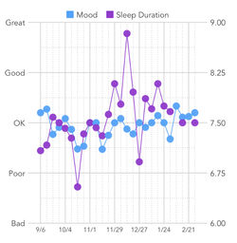 https://www.getmoodfit.com/

Figure 2. Mock graphic personally designed through Canva.
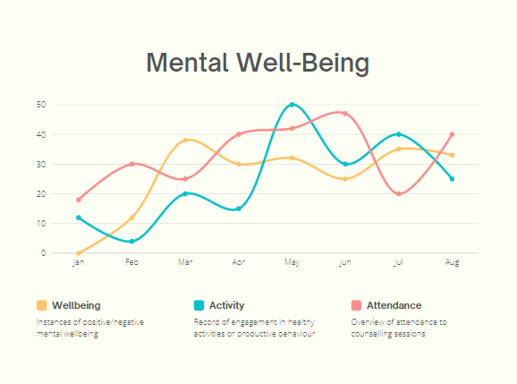

Summary
This display compares graphics from data results from the Moodfit app to a mock graphic I had developed to display the desired outcome of the original objective of the placement project. The idea was adapted as the interface and product were far too similar. However, this provided the opportunity to determine issues with this form of self-reporting and instead focus on more clinical self-reporting measures and converting the input information into a professional and interactive display from verified and currently used metrics such as CORE-10.

Reference List

Banwell, E., Hanley, T., Barcia, S. D. O., Mindel, S., Kayll, T., & Sefi, A. (2022). The
Helpfulness of Web-Based Mental Health and Well-being Forums for Providing
Peer Support for Young People: Cross-sectional Exploration. JMIR Formative
Research, 6(9), 1-15. https://formative.jmir.org/2022/9/e36432

Banwell, E., Salhi, L., Hanley, T., & Facey-Campbell, N. (2022). The use of goal-based
outcome measures in digital therapy with adults: What goals are set, and are
they achieved? Wiley, 1-11. DOI: 10.1002/capr.12584

Carrozzino, D., Patierno, C., Guidi, J., Montiel, C. B., Cao, J., Charlson, M. E.,
Christensen, K. S., Concato, J., Cuevas, C., Leon, J., Eöry, A., Fleck, M.,
Furukawa, T., Horwitz, R., Nierenberg, A. A., Rafanelli, C., Wang, H., Wiser, T.,
Sonino, N., Fava. G. A. (2021). Clinimetric Criteria for Patient-Reported
Outcome Measures. Psychotherapy and Psychosomatics, 90. 222-232.
DOI: 10.1159/000516599

Donabedian, A. (2005). Evaluating the Quality of Medical Care. The Milbank Quarterly,
83(4). 691-729.

Garcia, S. D. O., Salhi, L., Sefi, A., & Hanley, T. (2021). The session wants and need
outcome measure: The development of a brief outcome measure for single-
sessions of web-based support. Frontiers in Psychology, 12. 1-18.
https://doi.org/10.3389/fpsyg.2021.748145

Hanley, T. (2020). Researching online counselling and psychotherapy: The past, the
present and the future. Special Section Online Technologies. 493-497. DOI:
10.1002/capr.12385

Hou, Y., Liu, D., Zhou, S., Zhao-Ming, X., Xue-Ling, Y., Zhou, Y., & Xiao-Yuan, Z. (2021)
The capacity for psychotherapy process scale: development and psychometric
validation of patient self-reports. Psychotherapy Research, 31(2). 236-246.
https://doi.org/10.1080/10503307.2020.1769218

Mindel, C., Mainstone-Cotton, L., Garcia, S. D. O., Sefi, A., Sugarman, G., Salhi, L.,
Brick, H., Jackson, K., & Hanley, T. (2022). The design and development of an
experience measure for a peer community moderated forum in a digital
mental health service. Frontiers in Digital Health. 1-22.
https://doi.org/10.3389/fdgth.2022.872404

Tennent, R., Hiller, L., Fishwick, R., Platt, S., Joseph, S., Weich, S., Parkinson, J.,
Secker, J., & Stewart-Brown, S. (2007). The Warwick-Edinburgh Mental Well-
being Scale (WEMWBS): development and UK validation. Health and Quality
of Life Outcomes, 5(63), 1-13. http://www.hqlo.com/content/5/1/63

Vet, H. C. W., Terwee, C. B., & Bouter, L. M. (2003). Clinimetrics and psychometrics:
two sides of the same coin. Journal of Clinical Epidemiology, 56. 1146-1147.
doi:10.1016/j.jclinepi.2003.08.010

Appendix

Appendix A. Gantt chart logging my placement hours and tasks. Each session approximately 2-3 hours.
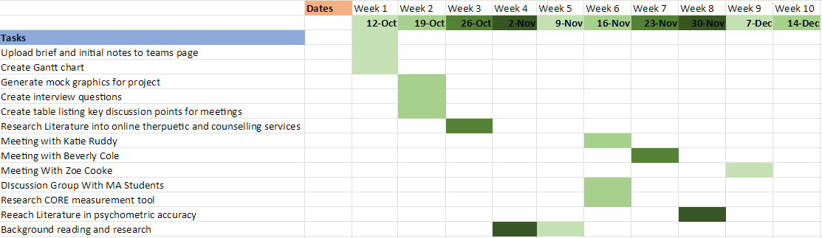

Appendix B. Email confirming placement.
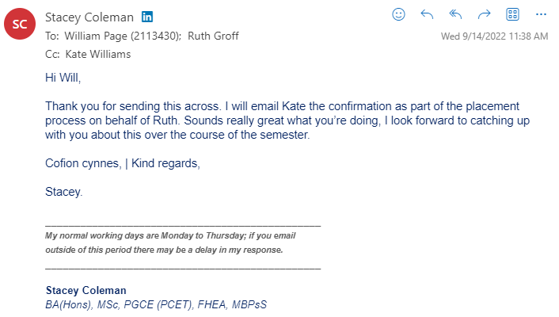

Appendix C. Example of the Core-10 measurement tool.
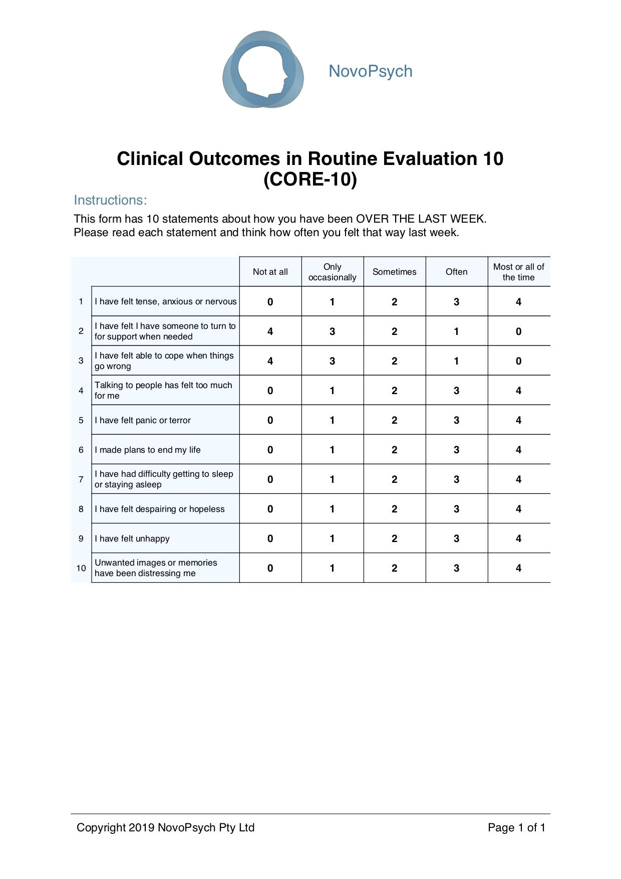

Appendix D. Example of the Warwick-Edinburgh Mental Well-Being Scale.

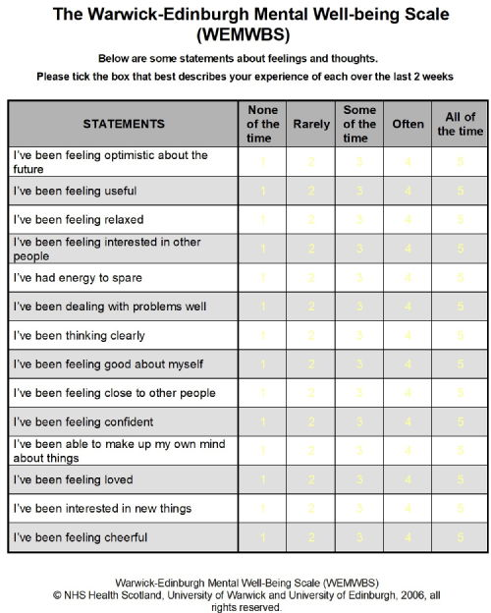

Appendix E. Placement application Form.
Placement Information Form
Name of Student: | William Page
Proposed Placement Setting and Address: | Psychology Labs  UWTSD, Swansea Campus
Proposed Dates of Placement: | 19/09/2022
Name of Contact for Venue:  Please also state their position: | Dr. Kate Williams  Programme Manager
Email Address: | kate.williams@uwtsd.ac.uk
Telephone Number for Contact at Placement: | 01792 481000
Is a DBS required for you to attend this placement? | No  If Yes, have you applied for this?  - Yes applied on _________________  - No
Explain how your role in this organisation/on this placement meets the criteria for the assessment for the module  (e.g., what duties/tasks will you be undertaking that are relevant for the module assessment) | This placement would help in my goal to assist in the development of technologies that would aim to support counselling professionals in their role as well as the mental wellbeing of individuals in counselling.

ALL information must be provided. Incomplete forms will be returned to the student.
Please return this form to Ruth Groff (ruth.groff@uwtsd.ac.uk) by Friday 1st July 2022.

Appendix F. Example of Anxiety UK Referral Form



