
University of Wales Trinity Saint David
Institute of Inner – City Learning – London Campus

Master of Business Administration (MBA)
LCMB7035 – MBA Dissertation

Exploring Consumer Trust in AI-Generated Advertisements: Impact of Authenticity and Transparency

Submitted by:
Minuddin Sarker
Student ID: 2503533

Supervisor:
Dr Jean Wang
Word count: 15542
Submission Date: 25 September, 2026

Declaration
I, Minuddin Sarker, declare that this dissertation has been composed by myself, that the work contained herein is entirely my own except where explicitly stated otherwise in the text, and that this work has not been submitted for any other degree or qualification, in whole or in part, except as specified.


Signature:

Date: 25/09/2026

AI Use Acknowledgement
I acknowledge the use of ChatGPT (ChatGPT) on 21 September 2026 to proofread my work using the prompt:
- Please check the following text for spelling, grammar and syntax.
I confirm that I have not presented any AI-generated text as my own work. I confirm that I have copies of my drafts, notes and other resources used before and after the use of AI tools, which I may be asked to provide as evidence.

Acknowledgements
I would like to express my sincere gratitude to my supervisor for their valuable guidance, constructive feedback and academic support throughout the development of this dissertation. Their advice was greatly appreciated in helping me complete the research successfully.
I would also like to thank all the participants who generously gave their time to complete the questionnaire. Their responses were essential to the completion of this study.
Finally, I am grateful to my family and friends for their continued encouragement, patience and support throughout my studies. Their support has been greatly appreciated during the completion of this dissertation.

Abstract
This dissertation examines the factors influencing customer trust in AI-generated advertising, focusing on perceived authenticity, transparency and AI disclosure, perceived usefulness, and perceived ease of use. The study is important because the increasing use of artificial intelligence in advertising creates opportunities for efficiency and personalisation while raising concerns regarding credibility, transparency and consumer trust. A positivist, deductive and quantitative approach was adopted using a cross-sectional online questionnaire. Data from 150 respondents were analysed in SPSS using descriptive statistics, reliability and validity assessment, Pearson correlation and multiple regression. The findings showed generally low levels of customer trust in AI-generated advertising. Perceived authenticity had a significant positive influence on customer trust, while perceived ease of use was also significant and represented the strongest predictor. In contrast, transparency and AI disclosure and perceived usefulness did not independently predict customer trust. Collectively, the four predictors explained 15.2% of the variance in customer trust. The findings therefore provide qualified support for the extended Technology Acceptance Model by demonstrating that trust depends on both technological and relational evaluations. The study concludes that organisations should prioritise authentic, credible and easily understandable AI-generated advertising while treating transparency as part of broader responsible communication rather than as a stand-alone mechanism for building consumer trust.

Contents
1 Chapter One: Introduction and Rationale 1
1.1 Research Background 1
1.2 Research Rationale 3
1.2.1 Theoretical Justification 3
1.3 Practical Justification 5
1.4 Research Contribution and Motivation 6
1.5 Research Aim, Objectives, and Questions 7
1.5.1 Research Aim 7
1.5.2 Research Objectives 7
1.6 Research Questions 8
1.7 Dissertation Structure 8
2 Chapter Two: Literature Review 9
2.1 Introduction 9
2.2 Thematic Overview of the Literature 9
2.2.1 Artificial Intelligence in Advertising: Evolution, Applications and Consumer Responses 9
2.2.2 Perceived Authenticity in AI-Generated Advertising and Customer Trust 11
2.2.3 Transparency, AI Disclosure and Customer Trust 14
2.2.4 Integrating Authenticity and Transparency to Explain Customer Trust in AI-Generated Advertising 16
2.3 Research Gap 18
2.4 Theoretical Foundation and Contribution 18
2.4.1 Technology Acceptance Model (TAM) as the Theoretical Foundation 18
2.4.2 Justification for the Theoretical Choice 19
2.4.3 Theoretical Contribution of the Study 19
2.4.4 Trust and Relationship Marketing Foundations 20
2.5 Perceived Usefulness, Perceived Ease of Use and Customer Trust 20
2.6 Conceptual Framework 21
2.7 Hypotheses Development 22
2.8 Conclusion 23
3 Chapter Three: Methodology 24
3.1 Introduction 24
3.2 Research Philosophy, Approach and Design 24
3.2.1 Research Philosophy 24
3.2.2 Research Approach 24
3.2.3 Research Design and Strategy 25
3.3 Justification for Quantitative Survey Methodology 26
3.4 Population, Sampling Strategy and Sample Size 27
3.5 Data Collection and Questionnaire Design 28
3.6 Variables, Measurement and Data Analysis 29
3.7 Research Quality, Reliability and Validity 30
3.8 Ethical Considerations 30
3.9 Summary 31
4 Chapter Four: Data Analysis 32
4.1 Introduction 32
4.2 Missing-Data Assessment 33
4.3 Demographic and Background Characteristics 34
4.4 Reliability Analysis 40
4.5 Construct Validity 41
4.6 Descriptive Statistics for the Study Constructs 45
4.7 Assessment of Distributions and Potential Outliers 46
4.7.1 Perceived Authenticity 46
4.7.2 Transparency and AI Disclosure 47
4.7.3 Perceived Usefulness 49
4.7.4 Perceived Ease of Use 50
4.7.5 Customer Trust in AI-Generated Advertising 52
4.8 Pearson’s Correlation Analysis 54
4.9 Multiple Linear Regression Analysis 54
4.10 Chapter Summary 58
5 Chapter Five: Discussion 59
5.1 Introduction 59
5.2 Discussion of RQ1: Influence of Perceived Authenticity on Customer Trust 59
5.3 Discussion of RQ2: Influence of Transparency and AI Disclosure on Customer Trust 61
5.4 Discussion of RQ3: Joint Influence of Authenticity and Transparency 62
5.5 Perceived Usefulness, Ease of Use and the Extended TAM 64
5.6 Contribution to the Research Gap and Practical Significance 64
5.7 Hypothesis Outcomes 65
5.8 Chapter Summary 66
6 Chapter Six: Conclusion 66
6.1 Introduction 66
6.2 Brief Summary of Key Findings 67
6.3 Theoretical Implications 67
6.4 Managerial Implications 69
6.5 Limitations and Directions for Future Research 70
6.6 Closing Statement 70
7 References 72
8 Appendices 82
8.1 Appendix A: Survey Link 82
8.2 Appendix B: Raw Data 82
8.3 Appendix C: SPSS Analysis 82
8.4 Appendix D: Questionnaire 83
8.5 Appendix E: Ethics Form 88
8.6 Appendix F: Participant Information Sheet 98
8.7 Appendix G: Consent Form 100

List of Figures
Figure 1: AI potential impact on the global economy (Chui et al., 2023) 1
Figure 2: Impact of AI Ad Disclosure on Consumer Purchase Likelihood (IAB, 2026) 2
Figure 3: Conceptual Framework for Customer Trust in AI-Generated Advertising 22
Figure 4: Research Onion adapted to the present study (Saunders, Lewis and Thornhill, 2019) 26
Figure 5: Age Distribution of Respondents 34
Figure 6: Gender Distribution of Respondents 35
Figure 7: Highest Educational Qualification of Respondents 35
Figure 8: Current Employment Status of Respondents 36
Figure 9: Approximate Annual Personal Income of Respondents 37
Figure 10: Frequency of Digital and Social-Media Platform Use 37
Figure 11: Respondents’ Familiarity with Artificial Intelligence and Its Use in Digital Advertising 38
Figure 12: Platforms on Which Respondents Most Frequently Encountered AI-Generated Advertisements 39
Figure 13: Scree Plot for the Measurement Items 44
Figure 14: Histogram of Perceived Authenticity 46
Figure 15: Normal Q–Q Plot of Perceived Authenticity 47
Figure 16: Histogram of Transparency and AI Disclosure 47
Figure 17: Normal Q–Q Plot of Transparency and AI Disclosure 48
Figure 18: Histogram of Perceived Usefulness 49
Figure 19: Normal Q–Q Plot of Perceived Usefulness 50
Figure 20: Histogram of Perceived Ease of Use 50
Figure 21: Normal Q–Q Plot of Perceived Ease of Use 51
Figure 22: Histogram of Customer Trust in AI-Generated Advertising 52
Figure 23: Normal Q–Q Plot of Customer Trust 53
Figure 24: Histogram of Standardised Regression Residuals 56
Figure 25: Normal P–P Plot of Standardised Regression Residuals 57
Figure 26: Scatterplot of Standardised Predicted Values and Standardised Residuals 58
List of Tables
Table 1: Missing-Data Assessment for the Measurement Items 33
Table 2: Perceived Authenticity 40
Table 3: Transparency and AI Disclosure 40
Table 4: Perceived Usefulness 40
Table 5: Perceived Ease of Use 40
Table 6: Customer Trust in AI-Generated Advertising 40
Table 7: KMO and Bartlett’s Test of Sampling Adequacy 41
Table 8: Anti-Image Correlation Matrix for the Measurement Items 42
Table 9: Initial Communalities for the Measurement Items 43
Table 10: Descriptive Statistics for the Composite Constructs 45
Table 11: Pearson’s Correlations Among the Study Constructs 54
Table 12: Multiple Regression Model Summary 54
Table 13: ANOVA Results for the Multiple Regression Model 55
Table 14: Multiple Regression Coefficients Predicting Customer Trust 55
Table 15: Collinearity Diagnostics for the Regression Model 56
Table 16: Hypothesis Outcomes 65

Chapter One: Introduction and Rationale

Research Background
Artificial Intelligence (AI) is changing the advertising and digital-marketing landscape, allowing organisations to automate creative production, individualise messages, and produce advertising content on a much bigger scale (Haleem et al., 2022). This is a strategic move as marketing and sales are among the areas of the company where generative AI is projected to generate the most economic value. According to Chui et al. (2023), generative AI could generate a value of US$2.6–4.4 trillion per year across identified use cases, with about 75% of this value stemming from customer operations, marketing and sales, software engineering, and R&D. Specifically, generative AI has the potential to boost marketing productivity by 5% to 15% of total marketing spend, which amounts to around US$463 billion per year (Chui et al., 2023). These estimates illustrate the importance of AI-powered advertising as a marketing tool, shifting from a novelty technology to a must-have capability.
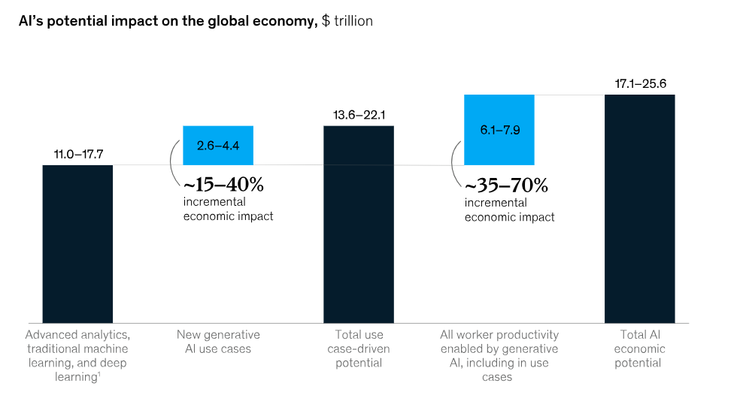
Figure 1: AI potential impact on the global economy (Chui et al., 2023)
However, the commercial opportunity comes with an important managerial challenge: increased technological capabilities do not automatically lead to increased consumer trust. AI-generated advertisements can offer quicker content creation, personalised communication, and decision-relevant information, but consumers need to evaluate the credibility, authenticity, and suitable transparency of such communication (Israfilzade, 2025). There are signs of this tension in the industry evidence. According to IAB (2026), a study conducted with over 500 Gen Z and Millennial consumers and 100 advertising executives, there is still a disconnect between advertisers' perceptions and consumers' attitudes toward AI-generated advertising. Over half of the consumers polled desired transparency when ads were entirely AI or if AI-generated video or images were used. Meanwhile, 73% said they would more likely or not be less likely to buy if they knew the ad was AI-generated, indicating that disclosure alone is not necessarily a negative but how it is done is important (IAB, 2026).
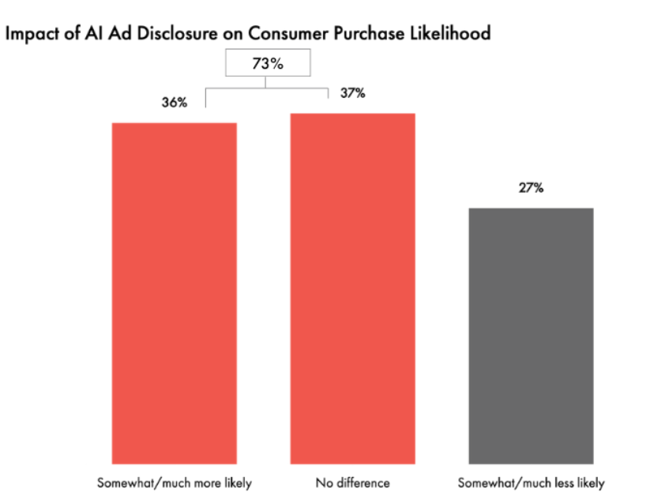
Figure 2: Impact of AI Ad Disclosure on Consumer Purchase Likelihood (IAB, 2026)
This creates a particularly important problem around authenticity, transparency and trust. Recent academic evidence does not provide a simple or uniform answer. For instance, Do et al. (2026) conducted an experimental survey with 300 digitally active consumers and discovered that transparency disclosure fostered trust and advertising credibility. Conversely, the study of AI service advertisements revealed that disclosure of AI may negatively impact trust and elicit less positive attitudes toward the ads (Cheng and Nam, 2026). Further, more recent studies show that the quality of disclosure is important: disclosure, when informative about the role of AI, can enhance the perceived credibility of the advertising-creation process, and disclosure is not a binary label (Lim and Kim, 2026).
There is also a regulatory aspect to the issue. In the UK, the Advertising Standards Authority and Committee of Advertising Practice highlights that advertising regulations remain the same regardless of whether content is made by a human or an AI, with a note that there are potential issues with misleading representation, harmful stereotypes and advertiser accountability arising from the use of AI-generated images and claims (ASA / CAP 2025). The regulator then reported seeing a rise in complaints in 2025 of ads created by AI (ASA and CAP, 2025), indicating that the concerns are no longer purely hypothetical ethical questions, but real-world problems in advertising practice.
Consequently, the strategic question for marketers is no longer simply whether generative AI can produce advertising efficiently, but what makes consumers trust AI-generated advertising. Existing evidence indicates that consumer responses depend on more than technological capability: authenticity, disclosure and functional evaluations can produce different or even conflicting effects. This unresolved tension provides the basis for investigating perceived authenticity, transparency and AI disclosure, perceived usefulness and perceived ease of use as potential determinants of customer trust in AI-generated advertising, while establishing the need for the more detailed theoretical gap developed in Section 1.2.

Research Rationale

Theoretical Justification
Existing research establishes that consumer responses to AI-generated advertising are shaped by both functional evaluations of the technology and relational judgements about the credibility of the communication. The functional dimension has been well established by the Technology Acceptance Model (TAM) which suggests two core evaluations (perceived usefulness (PU) and perceived ease of use (PEOU)) that shape technology acceptance (Davis, 1989). Yet, the trust in AI-driven ads goes beyond just the technological function, as consumers also judge the credibility and authenticity of synthetic communication and its ethical implications. The concept of source credibility perspectives implies that a perceived credible source is essential for persuasive communication, and that source cognitive and affective trust are the basis for differentiating competence and reliability from sincerity and goodwill (McAllister, 1995). In recent advertisement studies on AI (Do et al., 2026; Grigsby, Michelsen and Zamudio, 2025; Jung et al., 2025), authenticity, transparency and disclosure are thus added to the list of consumer evaluations together with trust. The empirical findings also suggest that the combined assessment of technological and relational evaluations is theoretically relevant for the examination of the role of verification and transparency signals in the process of forming trust in AI-generated advertisements (Do et al., 2026; Grigsby, Michelsen and Zamudio, 2025).
Nevertheless, the literature remains theoretically fragmented and empirically inconsistent. Most importantly, disclosure does not have a stable relationship with trust. In three experiments on service advertising, Grigsby, Michelsen and Zamudio (2025) discovered that AI disclosure led to a decrease in trust and the creation of less positive advertising attitudes. On the other hand, Do et al. (2026) conducted a vignette experiment with 300 digitally active consumers, and found that disclosure of transparency increased the perceived trust and advertising credibility. However, Le et al. (2026) offer a more qualified defence: more transparent disclosure of what the AI is doing enhances credibility but is not equally effective depending on disclosure motivation and the signals of compliance with regulations. These disparities call into question the notion that simply telling consumers that AI is involved is enough for them to trust it. Moreover, technology acceptance is not discussed specifically in terms of trust in AI-generated persuasive communication; thus, PU and PEOU are not necessarily direct mechanisms for trust building (Davis, 1989). Recent research often utilizes various theoretical perspectives and experimental settings to investigate disclosure, authenticity, credibility, and verification/behavioural outcomes, and the ways in which functional and relational evaluations interact in the formation of trust are less certain (Grigsby, Michelsen and Zamudio, 2025; Le et al., 2026).
Accordingly, the specific theoretical gap addressed by this research concerns the limited integrated understanding of customer trust in AI-generated advertising across both relational and technology-acceptance dimensions. While there is some existing evidence showing the importance of authenticity and transparency, there is also evidence of context-specific and conflicting disclosure effects and the direct relationship between the constructs of TAM (PU and PEOU) and advertising trust is relatively underdeveloped. Hence, this research does not consider disclosure, authenticity and technological functionality in isolation, but combines perceived authenticity, perceived transparency and AI disclosure, perceived usefulness and perceived ease of use as concurrent predictors of customer trust. This puts TAM in a trust-based advertising context and adds the notion of relational evaluations that TAM does not explicitly describe. The resulting framework highlights the fragmentation in existing research and examines whether functional utility and simplicity still have explanatory value in the context of authenticity and transparency. The study thus is a valuable contribution because it examines an integrated explanation for trust formation rather than assuming the theoretical equivalence of technological acceptance and customer trust.

Practical Justification
The theoretical uncertainty has direct managerial consequences because organisations are expanding AI-generated advertising while lacking equally settled evidence about how consumers interpret it. According to IAB (2026), 83% of advertising executives say they’ve used AI in the creative process, up from 60% in IAB's 2024 survey, and 86% of buyers are using or planning to use generative AI for video-ad creative. Yet IAB (2026) data revealed less than half of advertisers who are leveraging generative AI are consistently disclosing its use, suggesting a practical tension between deployment speed and transparent communication.
This tension is also commercially relevant because of its implications for consumer trust. Gartner's survey of 1,539 US consumers revealed that 50% showed a preference for brands that steered clear of consumer-facing advertising, messages and content created with GenAI, and 68% often doubted the authenticity of the content they saw (Gartner, 2026). Implementation is also not risk-free at the organisational level, as IAB (2025) reported that over 70% of the surveyed ad executives faced an incident with AI, including hallucinations, bias or off-brand content, with less than 35% intending to invest more in AI governance and brand-integrity oversight.
The opportunity cost of responding poorly is substantial because AI can simultaneously deliver considerable marketing value. According to Chui et al. (2023), the potential productivity savings from generative AI are around 5%–15% of total marketing spend, or some US$463 billion a year. Managers thus have a strategic dilemma: while the scalability of AI can help create efficiencies and personalisation, problematic authenticity, disclosure or usability impacts can erode the very trust that is needed for advertising effectiveness. Analysing these determinants collectively can offer managers insights to determine not only when to adopt AI-generated advertising, but also how to create and convey the ad to maintain customer trust.

Research Contribution and Motivation
This study makes a theoretical contribution by extending the Technology Acceptance Model (TAM) beyond its conventional emphasis on technology acceptance towards the formation of customer trust in AI-generated advertising. Although TAM proposes perceived usefulness (PU) and perceived ease of use (PEOU) as crucial evaluations influencing technology adoption (Davis, 1989), these functional perceptions do not sufficiently capture relational judgements concerning the genuineness, credibility or transparency of AI-generated brand communication. In addition to that, the study combines PU and PEOU with perceived authenticity and transparency/AI disclosure based on cognitive and affective views of trust (McAllister, 1995). This integration allows the study to examine the possibility of different explanations for functional and relational evaluations of trust, as opposed to assuming technology acceptance and trust are synonymous. This is especially true in light of the divergent findings regarding the impact of AI disclosure on consumer trust (Do et al., 2026; Grigsby, Michelsen and Zamudio, 2025; Le et al., 2026).
Empirically, the study adopts a primary quantitative, cross-sectional survey to examine the proposed relationships simultaneously. There are standardised scales to measure authenticity, transparency and AI disclosure, usefulness, ease of use and customer trust, which enables their relationship to be studied at the same time. Correlation and multiple regression give a systematic framework for determining if a proposed predictor is still significantly associated with the variable of interest after the other variables are considered. This fills a gap in previous research that has often studied AI disclosure, authenticity and related consumer evaluations under different experimental conditions or conceptual frameworks (Do et al., 2026; Grigsby, Michelsen and Zamudio, 2025).
Practically, the study is motivated by the need for advertisers to obtain the productivity benefits of generative AI without weakening customer confidence. Its findings can help managers determine whether investment should focus on authentic brand communication, meaningful AI disclosure, functional relevance or clarity and ease of interaction. The study's originality therefore lies not in proposing entirely new constructs, but in integrating established relational and TAM-based constructs within a single trust-centred framework for the rapidly developing context of AI-generated advertising.

Research Aim, Objectives, and Questions

Research Aim
The overarching aim of this research is to investigate how perceived authenticity, transparency and AI disclosure, perceived usefulness and perceived ease of use influence customer trust in AI-generated advertising.

Research Objectives
The study pursues the following four objectives:
- To examine the influence of perceived authenticity on customer trust in AI-generated advertising.
- To evaluate the influence of transparency and AI disclosure on customer trust in AI-generated advertising.
- To assess the influence of perceived usefulness on customer trust in AI-generated advertising.
- To determine the influence of perceived ease of use on customer trust in AI-generated advertising.

Research Questions
The study addresses the following research questions:
- RQ1: How does perceived authenticity influence customer trust in AI-generated advertising?
- RQ2: How do transparency and AI disclosure influence customer trust in AI-generated advertising?
- RQ3: How does perceived usefulness influence customer trust in AI-generated advertising?
- RQ4: How does perceived ease of use influence customer trust in AI-generated advertising?

Dissertation Structure
The dissertation comprises six chapters. Chapter One introduces the research context, rationale, aim, objectives and questions. Chapter Two critically reviews relevant literature and develops the conceptual framework. Chapter Three explains the research methodology. Chapter Four presents the empirical findings. Chapter Five critically discusses the findings against theory and literature. Chapter Six concludes the study and presents implications, limitations and future research.

Chapter Two: Literature Review

Introduction
The chapter critically examines the academic literature related to the study, to build theoretical and conceptual bases for the study of customer trust and AI-generated advertising. It examines how perceived authenticity and transparency influence customer trust in AI-generated advertising, furthering the research problem stated in Chapter 1. The review is based on literature identified in relation to Artificial Intelligence in advertising, Technology Acceptance Model (TAM), consumer trust, authenticity, transparency and AI disclosure, excluding literature related to broader applications of Artificial Intelligence outside of the advertising context. This chapter focuses on a critical comparison of different perspectives, an analysis of overlapping and opposing viewpoints and points of contention, as well as research gaps. It concludes with the theoretical foundation and conceptual framework that inform the methodology and subsequent empirical analysis.

Thematic Overview of the Literature

Artificial Intelligence in Advertising: Evolution, Applications and Consumer Responses
Artificial Intelligence (AI) has revolutionized advertising, making it more personal, automated, and data driven. AI advertising involves the use of machine learning, natural language processing, predictive analytics and generative AI to analyse consumer data, anticipate preferences and create tailored content in real-time (Lim et al., 2024; Rahman et al., 2026). This allows for more accurate targeting and quicker production and campaign optimisation as opposed to traditional advertising (Hasan, 2025; Khamoushi, 2024). These capabilities, however, account for efficiency, but not for consumer acceptance. An advertisement may be relevant and cost-efficient yet remain ineffective if consumers perceive its source, message or data practices as artificial, manipulative or untrustworthy. Consumer responses thus need to be analysed through the psychological evaluations that result in the building or erosion of trust in AI advertising.
The literature identifies several operational advantages of AI in advertising. Gao et al. (2023) associate AI with predictive targeting and automated content optimisation, while Islam et al. (2024) emphasise production efficiency, speed and scalability. Similarly, Teepapal (2025) and Rainy (2025) associate AI-enabled personalisation with stronger engagement and marketing returns. However, these studies predominantly evaluate AI from an organisational-performance perspective, meaning that improvements in targeting or efficiency should not automatically be interpreted as evidence of greater consumer trust. Their findings therefore demonstrate the operational value of AI more convincingly than its relational value to consumers.
This interpretation is compatible with the concept of relationship marketing, where trust is regarded as a basis for customer–brand relationships instead of as an immediate persuasive action. In this view, AI advertising makes a positive impact on relationship quality if and only if personalisation is combined with credible and ethical communication (Albérico and Casaca, 2024). Jung et al. (2025) have demonstrated that reactions to AI-created ads are influenced by perceived genuineness, trustworthiness and ethical creation, but not by technical quality. Therefore, the ability of AI is an enabler, while the formation of trust relies on what the consumers understand from the advertisement and the organisation that presents it.
Findings concerning consumer responses remain inconsistent. Mariadassou, Klesse and Boegershausen (2024) attribute negative responses partly to algorithm aversion, particularly where advertising is perceived to require creativity or subjective judgement, whereas Lee et al. (2026) emphasise reduced authenticity and emotional appeal in AI-generated visual content. Although both studies identify potential disadvantages of AI involvement, they suggest different mechanisms: the former concerns resistance to algorithmic involvement itself, while the latter concerns evaluations of the resulting content. This distinction is important because negative attitudes towards AI do not necessarily indicate that consumers perceive every AI-generated advertisement as untrustworthy. In contrast, Rajesh and Vijayashri Gurme (2025) suggest that negative reactions to AI vary according to technological familiarity, previous AI experience and individual innovativeness, while Gu et al. (2024) demonstrate that features of the advertising context can also shape consumer evaluations. Morales-Machucho and Ortiz (2025), meanwhile, place greater emphasis on fairness, governance and ethical responsibility. Taken together, these studies challenge explanations based solely on the presence of AI: consumer trust appears to depend on an interaction between individual characteristics, advertising design and organisational conduct. However, because these studies examine different contexts and outcomes, their findings cannot be treated as directly equivalent evidence of customer trust.
These conflicting findings could be due to methodological variations. However, much of the evidence is based on cross-sectional surveys and on subjective perceptions and hypothetical exposure to advertising, thus preventing causal inferences and providing limited evidence of trust or actual behaviour (Li et al., 2026; Liu et al., 2026). Platform-specific samples limit cross-cultural and cross-category and ad format transferability. Furthermore, studies report engagement and acceptance (or purchase intention) but do not report the cognitive and affective process that is involved in building trust. Conceptually, this evidence is also limited because favourable engagement should not be treated as equivalent to trust; consumers may interact with an advertisement because it is novel, entertaining or relevant without necessarily perceiving either the advertisement or the organisation behind it as trustworthy.
Overall, the central issue is not whether AI can enhance advertising production, but whether consumers perceive AI-generated advertisements as trustworthy. Perceived authenticity focuses on the question of whether an AI-generated ad seems authentic, whether it is authentic to the brand and whether it can be considered sincere, while transparency relates to whether organisations communicate correctly the processing of AI and data. Previous research has studied these factors in isolation, and there is little explanation of how all of them impact trust. This study therefore examines authenticity and transparency as distinct yet interconnected determinants of customer trust in AI-generated advertising.

Perceived Authenticity in AI-Generated Advertising and Customer Trust
Customer trust is well known as a key influence on customers' response to marketing communications as it helps to alleviate uncertainty and build confidence in organisational intentions. Trust, according to McAllister (1995), can be divided into two categories: Cognitive trust, which is based on perceptions of competence, credibility and reliability, and affective trust, which is based on emotional confidence and perceived sincerity. When it comes to AI-generated adverts, consumers initially assess whether the advertisement appears genuine and whether it is trustworthy. Thus, perceived authenticity serves as a psychological mechanism that reduces perceived deception, increases credibility and consequently boosts both cognitive and affective trust (Rixom and Rixom, 2023). This process of trust formation is also consistent with the Commitment-Trust Theory of Relationship Marketing, which positions trust as a central mechanism in developing stable and long-term customer–brand relationships (Morgan and Hunt, 1994). In AI-generated advertising, authenticity can strengthen this relational trust by signalling sincerity and consistency, while transparency can reduce uncertainty by demonstrating openness and accountability.
Perceived authenticity refers to the extent to which consumers perceive AI-generated advertising as sincere, genuine, credible, original and consistent with brand identity and values. Authenticity in AI-generated advertising is not only about correctness but also about emotional impact, originality, clear communication and perceived human creativity (Shi and Jiang, 2026). As a result, authenticity is not just a quality of the technology itself, but a consumer judgement, which is shaped by several aspects, such as sincerity, credibility, originality, consistency and genuineness. This is also the conceptual framework for this study to measure perceived authenticity in these dimensions.
Although it is widely accepted that authenticity is a contributor to customer trust, the body of literature is diffuse at the conceptual level as to how authenticity should be conceptualized in different instances of advertising. Although the literature generally associates authenticity with positive consumer reactions, there is limited consensus regarding its meaning in AI-generated advertising. Zafar and Hussain (2025) conceptualise authenticity primarily in terms of consistency between advertising messages and brand identity, but Gu et al. (2024) view it as a co-creation between humans and AI, which implies that consumers may trust AI more when it complements rather than replaces human creativity. Sarran and Datt (2026) place greater emphasis on verification signals, whereas Foroudi et al. (2025) reveal authenticity in a broader context as a precursor of trust, engagement and purchase intention. These views are not mutually exhaustive: brand consistency is message-brand consistency, human-AI co-creation is perceived human participation, verification is evidence of credibility. The use of authenticity as an undifferentiated concept can therefore mask the various channels through which it can affect customer trust.
However, empirical evidence regarding the authenticity of AI-generated advertising remains mixed. Jung et al. (2025) and Nguyen et al. (2026) associate AI-generated advertising with weaker authenticity perceptions, whereas Liu and Yim (2026) emphasise the importance of aesthetics and creativity in shaping evaluations. These differences suggest that reduced authenticity cannot be attributed solely to AI involvement. Baryshkov et al. (2026) indicate that technological familiarity and previous AI experience can reduce algorithm aversion, while Antsipava et al. (2025) highlight the influence of disclosure practices and advertising context. Therefore, authenticity appears to depend on interactions between consumer characteristics, advertising design and AI involvement.
However, there are significant methodological limitations. Recent studies typically use convenience samples, cross-sectional surveys, and rely on customer perception, which hinders the ability to establish causal links between customer perceptions of authenticity and customer trust from a temporal perspective (Liu and Yim, 2026; Jung et al., 2025). In addition, many studies focus on influencer marketing, branded content or human–AI co-creation, limiting the generalisability of the results to general AI-based advertising situations (Foroudi et al., 2025; Gu et al., 2024). Authenticity is also often studied as a standalone concept, and little research focuses on the psychological processes that underlie the emergence of cognitive and affective trust or on the relationships between transparency and authenticity, and between AI disclosure and authenticity. Thus, future studies should explore both authenticity and transparency to delve deeper into the understanding of how customers trust ads created with AI. This gap gives the foundation to the next section which critically examines transparency as a complementary antecedent of customer trust.
Perceived authenticity can be considered as four facets of sincerity, originality, credibility and human involvement. Sincerity relates to how authentic and sincere the AI-generated ad is, while credibility refers to how convincing and reliable the information or claims made in the ad are. Originality pertains to the non-imitative nature and distinctiveness of the content, whereas human involvement is in reference to the sense of human judgement and creativity that is perceived to be brought into AI-assisted advertising. The present study is interested in the dimensions of sincerity, credibility, originality, genuineness and consistency to brand values as these dimensions are directly reflected in the measurement of perceived authenticity. Human involvement is therefore treated as a contextual influence on authenticity rather than as a separately measured dimension.

Transparency, AI Disclosure and Customer Trust
Transparency is also one of the key principles of AI-generated advertising, impacting how consumers assess the credibility, fairness and ethical legitimacy of advertising messages (Kumar, Dayal and Of, 2025). Trust in the customer is built when customers can see the organisations are honest, competent and can be held accountable. McAllister (1995) distinguishes between cognitive trust based on credibility and reliability and affective trust based on the sense of sincerity and goodwill of an organisation. Transparency plays a role in this process as it helps to reduce information asymmetry, so that consumers can gain insight into the process of how advertisements are generated and how personal information is being used in AI-generated advertising. Transparency should not be limited to disclosure, however, but also refer to openness in relation to the use of AI, the explainability of the processes, the accountability of the responsible parties and responsible data practices (Wulf and Seizov, 2022). AI disclosure is a tangible way in which organisations can explicitly communicate with consumers that the advertising content has been generated or supported by AI technologies (Qiu et al., 2025). While transparency is considered a key pillar of responsible governance of AI, it is not universally accepted as a factor influencing customer trust.
The literature has provided a consensus that transparency increases customer trust as it helps to diminish uncertainty and increases organisational accountability. Transparency is an important antecedent of trust recognised by Williamson and Prybutok (2024), Esa, Rahman and Ahmad (2025), Sarran and Datt (2026), albeit defined differently. Williamson and Prybutok (2024) prioritise ethical disclosure while Regona et al. (2026) highlight institutional fairness and accountability. Explaining AI decisions, transparency as part of responsible governance of AI, and transparency in communication (Esa, Rahman and Ahmad, 2025) are all related to transparency. Sarran and Datt (2026) also show that disclosure plus verification signals boosts credibility, by lowering the perception of the risk of misinformation. Overall, these studies have indicated that transparency builds trust amongst customers, as it increases credibility, decreases uncertainty and allows consumers to make informed decisions about the intentions of the organisation. Transparent communication is also good for long term relationship quality as it demonstrates honesty, commitment and relational reliability (Morgan and Hunt, 1994) from a Relationship Marketing perspective. These findings suggest that consumer responses to AI advertising depend not only on technological evaluations but also on credibility, honesty and trustworthiness.
However, the effect of AI disclosure on customer trust is not uniformly positive because consumers may interpret the same disclosure in different ways. Where there is uncertainty, disclosure can help to build trust by alleviating information asymmetry, demonstrating organisational integrity and accountability, and assuring consumers that use of AI is not hidden. On the other hand, disclosure can lead to less trust if it triggers consumer scepticism regarding the reason behind the use of AI and the authenticity of the message. This is because, as mentioned by Qiu et al., (2025), when consumers become aware of AI's presence, they might become more aware of the advertiser's persuasive intentions to persuade and thus analyse the message more carefully. This increased persuasion knowledge may have a negative impact on credibility as consumers perceive that the content is produced by AI and lacks the information they desire and is instead, strategically persuasive. Likewise, Shi and Jiang (2026) propose that disclosure can be detrimental to perceived authenticity and emotional appeal when consumers appreciate human creativity. Algorithm aversion provides an additional explanation: consumers who already distrust automated systems may interpret an AI label as a negative cue rather than as evidence of transparency (Wang et al., 2026). Therefore, disclosure is more likely to strengthen trust when interpreted as evidence of honesty and responsible AI use, but may weaken trust when it triggers scepticism, persuasion awareness or concerns about automation, manipulation and reduced human involvement.
The conflicting findings appear to be partly attributable to differences in consumer and advertising contexts rather than representing a straightforward theoretical contradiction. Pierre, Rodriguez and Wang (2026) emphasise consumer-level conditions such as AI aversion and prior perceptions, whereas Saternus, Weber and Hinz (2022) demonstrate the importance of advertising exposure and platform-related conditions. Nawaz and Wagner (2024), although examining transparency in a broader marketing context, shift attention towards organisational reputation and established ethical values. Collectively, these perspectives indicate that transparency operates across consumer, message and organisational levels. However, evidence from broader marketing or platform contexts cannot automatically be generalised to AI-generated advertisements, reinforcing the need for advertising-specific empirical investigation.
Significant methodological constraints still exist, and despite the growing scholarly interest, they are still important. Prior studies have predominantly relied on cross-sectional surveys, convenience samples and self-reported consumer perceptions, limiting causal explanations of how transparency influences customer trust over time (Qiu et al., 2025; Shi and Jiang, 2026). Moreover, many studies only focus on specific contexts, such as social media or using AI tools for communication, and thus limit the transferability of the results to the broader advertising landscape (Saternus, Weber and Hinz, 2022; Nawaz and Wagner, 2024). Transparency is also often studied on its own; again, little consideration is given to the process of how transparency fosters cognitive and affective trust, nor the way in which transparency relates to perceived authenticity. As a result, further studies that consider transparency and authenticity together are needed to better understand how customer trust can be established through AI-generated advertising.

Integrating Authenticity and Transparency to Explain Customer Trust in AI-Generated Advertising
However, there is growing evidence in the literature that perceived authenticity and transparency should not be treated as stand-alone antecedents of customer trust, as they serve as a combined mechanism that drives consumers' perceptions of ads created by AI (Bandawaty, 2026). Customer trust is a multi-dimensional concept that includes cognitive trust, which is related to competence and credibility, and affective trust, which is related to emotional confidence and perceived sincerity (McAllister, 1995). The main benefit of transparency in AI-generated advertising is to eliminate uncertainty by clearly stating the use of AI and ensuring that advertising content is authentic, credible, and in keeping with the brand's values. Together, authenticity and transparency reduce perceived deception while strengthening cognitive and affective trust, thereby increasing overall customer trust. Similarly, Sarran and Datt (2026) state that disclosure is not enough if the ads are not seen as genuine. Monfort, López-Vázquez and Sebastián-Morillas (2025) further argue that consumers go beyond the technological sophistication and consider transparency, ethical production, and consistency with brand values as relevant factors, and Camilleri (2023) states that transparency without honest communication is not sufficient to build trust.
Empirical evidence remains unclear regarding how authenticity and transparency operate together. Montecchi et al. (2024) indicate that transparency is particularly valuable when it reinforces perceptions of brand credibility, whereas Qiu et al. (2025) show that explicit AI disclosure can increase scepticism by activating consumers' persuasion knowledge. Shi and Jiang (2026) offer a potential explanation for this apparent contradiction by demonstrating that authenticity influences responses to AI disclosure, suggesting that transparency may strengthen trust when the disclosed content remains perceived as genuine but weaken it when disclosure highlights the absence of human creativity. Haupt, Freidank and Haas (2024) similarly indicate that perceptions of human–AI collaboration influence algorithm aversion. The potential interaction can be explained as a complementary trust-formation mechanism. Transparency gives consumers information about the use of AI and how it is applied, which decreases the information asymmetry, while consumers can assess it based on their perception of authenticity. Transparent disclosure, combined with advertising that is perceived as sincere, credible and consistent with brand values can support the perception of organisational honesty, increasing the cognitive trust and affective trust (perceived sincerity). On the other hand, if the content created by AI is obvious and does not align with the brand's style and tone, transparency could amplify doubts and scepticism, potentially undermining trust. Authenticity may therefore shape whether transparency functions as a positive assurance signal or a negative cue, suggesting that trust formation depends on the combined interpretation of both constructs rather than their independent presence.

Research Gap
Existing literature shows significant progress in understanding the role of artificial intelligence in advertising and perceived authenticity and transparency are important factors in customer trust (Gao et al., 2023; Regona et al., 2026). But there is still limited and unclear evidence. Despite increasing research on AI-generated advertising, three related gaps remain. First, authenticity and transparency are frequently examined as independent predictors, providing limited explanation of whether transparent disclosure strengthens trust when AI-generated content is perceived as authentic, or instead intensifies scepticism when authenticity is already weak (Sarran and Datt, 2026; Qiu et al., 2025). Second, existing findings are theoretically inconsistent: disclosure is associated with accountability and credibility in some studies but with algorithm aversion and persuasion awareness in others (Qiu et al., 2025; Shi and Jiang, 2026; Wang et al., 2026). Third, differences in study populations, advertising formats and research designs make it difficult to determine whether these relationships are transferable across consumer groups and AI-advertising contexts. Consequently, the unresolved issue is not simply whether authenticity and transparency independently affect trust, but how consumers evaluate these signals together when forming trust in AI-generated advertisements.

Theoretical Foundation and Contribution

Technology Acceptance Model (TAM) as the Theoretical Foundation
The Technology Acceptance Model (TAM) developed by Davis (1989) is the model on which this study is based. According to TAM, users' behavioural intentions towards a technology are mainly determined by two cognitive beliefs: Perceived Usefulness (PU), which is the extent to which users perceive the technology to increase their performance and Perceived Ease of Use (PEOU), which is the extent they perceive the technology as easy to use (Davis, 1989). Such beliefs are the factors that influence users' attitudes and behavioural intentions and thus their technology acceptance. TAM has been broadly extended and tested in many digital settings such as e-commerce, artificial intelligence (AI), online services and digital marketing (Musa et al., 2024; Venkatesh and Davis, 2000). However, TAM alone is insufficient for explaining customer trust in AI-generated advertising because PU and PEOU primarily capture consumers’ functional evaluations of a technology rather than their judgements about whether AI-generated communication is genuine, credible or responsibly produced. An advertisement may therefore be perceived as useful and easy to understand without necessarily being trusted. Authenticity adds to TAM in the form of relational evaluations on elements such as sincerity, genuineness, credibility and consistency with brand values, and transparency includes elements such as disclosure, openness and organisational accountability of AI use. These constructs thus augment PU and PEOU, adding the relational and ethical considerations that play a key role in the development of trust in AI-assisted communication (Malodia et al., 2026). Thus, the present study draws on TAM’s PU and PEOU constructs and examines them alongside perceived authenticity and transparency to investigate customer trust in AI-generated advertising.

Justification for the Theoretical Choice
AI-generated advertising represents a developing technological application, making TAM relevant for examining consumers’ functional evaluations of its usefulness and ease of use. Based on previous studies, this research draws on TAM to capture consumers’ functional evaluations of AI-generated advertising, while authenticity and transparency are incorporated as additional factors relevant to customer trust (Davis, 1989). Consumers’ perceptions of authenticity and transparency can affect their assessment of whether AI-generated advertising is credible, ethical and trustworthy (Qiu et al., 2025; Shi and Jiang, 2026). While TAM was originally developed to explain technology acceptance, its PU and PEOU constructs provide a useful basis for examining functional evaluations alongside the relational factors associated with customer trust in AI-generated advertising.

Theoretical Contribution of the Study
This research applies selected TAM constructs to the context of AI-generated advertising and extends the framework by incorporating factors specifically related to customer trust. While some research has used TAM to study AI adoption in the context of digital marketing technologies (Yurder, 2025; Musa et al., 2024), the psychological factors by which consumers trust ads created with AI are relatively neglected. Most studies have examined perceived authenticity and perceived transparency separately, yielding mixed and at times contradictory results (Sarran and Datt, 2026; Regona et al., 2026). Integrating authenticity and transparency into the theoretical framework addresses an important limitation of relying solely on traditional TAM variables. Perceived usefulness and ease of use explain whether consumers regard a technology as functionally acceptable, whereas authenticity and transparency concern whether its communication outputs are perceived as sincere, credible and ethically responsible. The proposed framework therefore does not replace TAM but extends its explanatory scope by incorporating trust-related evaluations that are particularly relevant to AI-generated advertising.

Trust and Relationship Marketing Foundations
Although TAM explains consumers’ acceptance of new technologies, customer trust in AI-generated advertising also requires a relational and psychological explanation. McAllister (1995) differentiates between cognitive trust, which is founded on perceptions of competence, reliability and credibility, and affective trust, which is based on perceptions of sincerity, goodwill and emotional confidence. These dimensions apply to AI-generated advertising since transparency can be the main source of cognitive trust due to its disclosure, accountability and information clarity whereas authenticity can be the main source of affective trust due to its signalling genuineness and sincerity. The Commitment-Trust Theory of Relationship Marketing is another perspective that supports this viewpoint by highlighting that trust is one of the key foundations of long-term customer–brand relationships (Morgan and Hunt, 1994). These theories, together, have a more powerful foundation to explain the role of authenticity and transparency in affecting customer trust.

Perceived Usefulness, Perceived Ease of Use and Customer Trust
Perceived usefulness (PU) and perceived ease of use (PEOU) provide a functional explanation for how consumers may develop trust in AI-generated advertising. TAM proposes that users evaluate technologies partly according to their usefulness and the effort required to use them (Davis, 1989; Musa et al., 2024). In an advertising context, relevant, useful and decision-supporting AI content may signal competence and dependability, thereby strengthening cognitive trust through greater perceptions of credibility and reliability (McAllister, 1995). Similarly, advertisements that are clear, understandable and easy to interact with may reduce perceived complexity and uncertainty, increasing consumers’ confidence in AI-enabled communication.
However, functional acceptance should not be treated as equivalent to customer trust. An AI-generated advertisement may be useful and easy to understand while still being perceived as manipulative, inauthentic or ethically questionable. Recent AI research similarly indicates that technological evaluations operate alongside psychological assessments such as credibility, transparency and trustworthiness (Malodia et al., 2026). Therefore, PU and PEOU provide important functional foundations for trust, but authenticity and transparency remain necessary complementary evaluations. This supports their joint inclusion in the extended TAM framework.

Conceptual Framework
The conceptual framework integrates the literature review and illustrates the proposed influence of four independent variables on customer trust in AI-generated advertising. Drawing on the Technology Acceptance Model (TAM) (Davis, 1989), the framework incorporates perceived usefulness (PU) and perceived ease of use (PEOU) alongside perceived authenticity and transparency and AI disclosure. Perceived authenticity reflects sincerity, credibility, originality, consistency with brand values and genuineness (Foroudi et al., 2025; Sarran and Datt, 2026), while transparency encompasses AI disclosure, openness, explainability, accountability and responsible communication (Regona et al., 2026; Malodia et al., 2026). Consistent with TAM, perceived usefulness represents consumers’ perceptions of the value, relevance and effectiveness of AI-generated advertising, whereas perceived ease of use concerns its clarity, understandability and ease of interaction (Davis, 1989). Customer trust encompasses cognitive and affective dimensions, including perceptions of credibility, reliability, sincerity and confidence (McAllister, 1995). Accordingly, the conceptual framework aligns each independent variable with the corresponding research question, objective and hypothesis: perceived authenticity with H1, transparency and AI disclosure with H2, perceived usefulness with H3, and perceived ease of use with H4. Customer trust in AI-generated advertising is the dependent variable across all four hypotheses. This alignment provides a consistent basis for questionnaire development and subsequent hypothesis testing.
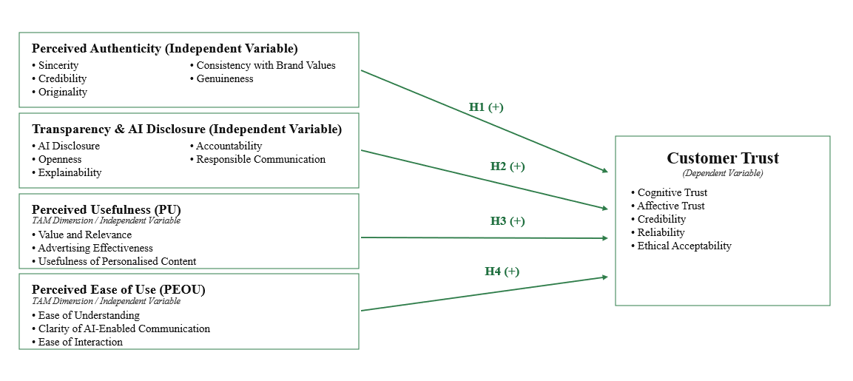
Figure 3: Conceptual Framework for Customer Trust in AI-Generated Advertising

Hypotheses Development
Based on the updated conceptual framework and reviewed literature, the following hypotheses are proposed:
- H1: Perceived authenticity has a positive and significant influence on customer trust in AI-generated advertising.
- H2: Transparency and AI disclosure have a positive and significant influence on customer trust in AI-generated advertising.
- H3: Perceived usefulness has a positive and significant influence on customer trust in AI-generated advertising.
- H4: Perceived ease of use has a positive and significant influence on customer trust in AI-generated advertising.

Conclusion
This chapter critically reviewed the literature on AI-generated advertising and examined the significance of perceived authenticity and transparency for customer trust. The review highlighted consensus and conflicting findings, with evidence in general being fragmented and largely having studied these constructs in isolation. The Technology Acceptance Model (TAM) was chosen as the main theory through which the phenomenon of customer trust in AI-generated advertising can be explained. The conceptual framework proposed is based on the main constructs found in the literature and is structured to explore the relationships among the constructs. Guided by these theories, the research methodology for the empirical study of the proposed framework and the testing of the study hypotheses is presented in Chapter 3.

Chapter Three: Methodology

Introduction
This chapter presents and justifies the methodology used to examine how perceived authenticity, transparency and AI disclosure, perceived usefulness, and perceived ease of use influence customer trust in AI-generated advertising. A positivist philosophy and deductive approach were adopted because the study tests theoretically derived relationships among predefined variables through H1–H4. A quantitative, cross-sectional survey design was used to collect primary data from consumers with prior exposure to AI-generated advertising. The chapter explains the research philosophy, approach and design, population and sampling strategy, questionnaire development, measurement of variables, statistical analysis, reliability and validity, and ethical considerations.

Research Philosophy, Approach and Design

Research Philosophy
The research philosophy adopted in this study was positivism, with the Research Onion used as a framework for aligning the research philosophy, approach, strategy and methods (Saunders, Lewis and Thornhill, 2019). Positivism assumes that relationships between measurable phenomena can be objectively examined using empirical data and statistical analysis. This philosophy was appropriate because the study examined predefined relationships between perceived authenticity, transparency and AI disclosure, perceived usefulness, perceived ease of use, and customer trust, rather than investigating individual lived experiences (Park, Konge and Artino, 2020). These constructs were operationalised through standardised questionnaire items, enabling consumer perceptions to be quantified and relationships between variables to be statistically analysed. Thus, positivism was consistent with the study objective of generating systematic and empirically testable evidence.

Research Approach
A deductive approach was adopted because the research proceeded from theoretically derived expectations towards empirical hypothesis testing (Fife and Gossner, 2024). The conceptual framework proposed in Chapter 2 draws on the Technology Acceptance Model (TAM), cognitive and affective trust perspectives, and Commitment-Trust Theory to explain the expected relationships between perceived authenticity, transparency and AI disclosure, perceived usefulness, perceived ease of use, and customer trust. The study hypotheses and questionnaire measures were derived directly from these theoretical expectations. Each hypothesis corresponded to a specific predictor construct measured in the questionnaire: perceived authenticity (H1), transparency and AI disclosure (H2), perceived usefulness (H3), and perceived ease of use (H4), with customer trust measured as the common dependent construct. Primary data were subsequently analysed using correlation and multiple regression to determine whether each hypothesised relationship was empirically supported. Given this, the study adopted a deductive approach with the conceptual framework and hypotheses drawn from the literature, and measurable constructs operationalised and subsequently examined using statistical analysis (Robinson and Bailey-Rodriguez, 2025).

Research Design and Strategy
Quantitative research can be used to measure the study constructs in a standardised manner and compare them between the respondents based on statistical analysis (Ghanad, 2023). The survey enabled data to be gathered efficiently and systematically from a relatively large group of consumers through a structured online questionnaire. A quantitative mono-method, cross-sectional survey design was adopted in accordance with the positivist philosophy and deductive approach. The cross-sectional design was appropriate because the study sought to capture consumers’ perceptions of AI-generated advertising at a single point in time and statistically examine the relationships among predefined constructs rather than track changes longitudinally (Lyu, Wang and Zhang, 2026). It also enabled data to be collected efficiently from a relatively large sample within the available research period. The design was therefore suitable for testing H1–H4 through correlation and multiple regression, although its single-time-point nature means that temporal or causal relationships cannot be established.
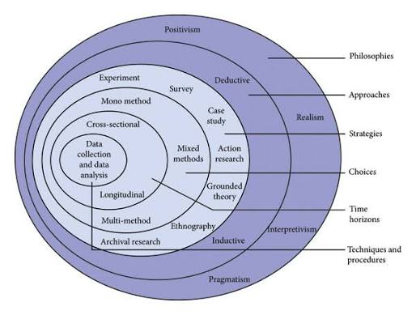
Figure 4: Research Onion adapted to the present study (Saunders, Lewis and Thornhill, 2019)

Justification for Quantitative Survey Methodology
The study aims to measure and statistically test the relationships between perceived authenticity, transparency and AI disclosure, perceived usefulness, perceived ease of use, and customer trust in AI-generated advertising through a quantitative survey approach. The research did not seek to explore individual experiences in depth; instead, it examined predefined constructs and the strength and direction of relationships among them. The research is well-suited for quantitative methods when the variables can be operationalised to measurable indicators, and the hypotheses can be tested via statistical procedures (Ma and Lee, 2026).
The survey strategy enabled standardised data to be collected from a relatively large number of consumers exposed to AI-generated advertising. The standardised Likert-scale statements enable perceived authenticity, transparency and AI disclosure, perceived usefulness, perceived ease of use, and customer trust to be measured consistently across respondents and subsequently examined through correlation and multiple regression analysis (Koo and Yang, 2025). This is especially significant, as past studies have shown varied consequences of AI disclosure and authenticity on consumers, suggesting a necessity for empirical examination of these connections (Qiu et al., 2025; Sarran and Datt, 2026).
Moreover, an online survey can be an effective way to connect with digitally engaged consumers that are bound to see AI-powered ads. However, structured surveys provide less contextual depth than qualitative methods and, when cross-sectional, cannot establish causality (Maier et al., 2023). Despite these limitations, the approach was appropriate for the hypothesis-testing objectives of the study.

Population, Sampling Strategy and Sample Size
The primary target population comprised Generation Z consumers aged 18–29 years who use digital or social-media platforms and have previously encountered AI-generated advertisements. This population was appropriate because participants required relevant digital exposure to meaningfully evaluate perceived authenticity, transparency and AI disclosure, perceived usefulness, perceived ease of use, and customer trust. The study focused specifically on Generation Z consumers aged 18–29 years, while individuals outside this age range were excluded from the final analysis. Individuals under 18 were excluded. Demographic and background information included age, gender, education, employment status, income, frequency of digital-platform use, familiarity with AI, and the platform on which AI-generated advertisements were most frequently encountered. Previous research indicates that technological familiarity and prior AI experience can influence consumer evaluations of AI-generated marketing communications (Gao et al., 2023; Regona et al., 2026).
A non-probability purposive sampling technique was used because the participation was determined based on specific characteristics related to the research question (Campbell et al., 2020). The participants had to be at least 18 years old, agree to informed consent for participation, and confirm their use of digital and social media platforms as well as previous exposure to AI-advertising. Eligible Generation Z respondents aged 18–29 years formed the final sample for analysis. Recruitment of participants was done via social media platforms, online consumer communities and university networks. This non-probability approach limits the generalisability of the findings beyond the study sample (Tajik, Golzar and Noor, 2024).
The study sought to obtain approximately 150–200 valid responses. The target sample size was considered appropriate for the planned reliability, correlation and multiple regression analyses involving four predictor variables, while allowing for the exclusion of incomplete or ineligible responses (Mursa et al., 2025). A power-based assessment further supported the adequacy of the sample. For multiple regression with four predictors, assuming a medium effect size (f² = .15), a significance level of .05 and statistical power of .80, approximately 85 participants would be required (Brydges, 2019). The final sample of 150 exceeded this benchmark, providing sufficient statistical power for the planned regression analysis.

Data Collection and Questionnaire Design
A structured online questionnaire administered through Google Forms was used to collect primary data. The mode of data collection was online because the respondents were digital and social media users, who would be exposed to AI-generated ads online. Google Forms is an accessible and economical way of sending out a standardised questionnaire to a wide range of geographically remote respondents, and to systematically collect the responses for statistical analysis (Adelia et al., 2021). The questionnaire link was distributed through social media platforms, online consumer communities and university networks to recruit eligible participants.
Participants were told about the study, the voluntary nature of participation, anonymity and the desired use of the information, and electronic informed consent was sought prior to them accessing the main questionnaire. The survey included the following screening questions: consent, use of digital platforms, use of social media, and prior exposure to AI-generated advertising. The questionnaire was developed systematically from the conceptual framework and relevant literature reviewed in Chapter Two. Measurement statements were selected and adapted to reflect the theoretical meaning of each construct within the specific context of AI-generated advertising. Perceived authenticity items captured sincerity, credibility, originality, genuineness and consistency with brand values (Foroudi et al., 2025; Sarran and Datt, 2026), while transparency and AI disclosure items addressed disclosure clarity, openness, explainability and accountability (Regona et al., 2026; Malodia et al., 2026). Perceived usefulness and perceived ease of use were operationalised in accordance with the Technology Acceptance Model, focusing respectively on relevance and decision-support value, and clarity, understandability and ease of interaction (Davis, 1989). Customer trust items reflected credibility, reliability, competence, sincerity and goodwill, drawing on cognitive and affective trust perspectives (McAllister, 1995). The wording of the items was adapted to maintain consistency with the AI-generated advertising context while preserving the conceptual meaning of the underlying constructs.
Construct items were measured using a five-point Likert scale ranging from 1 = Strongly Disagree to 5 = Strongly Agree. The five-point scale was appropriate for measuring attitudes and perceptions because it provided respondents with clearly ordered response categories, including a neutral option, while generating standardised data suitable for quantitative analysis (Koo and Yang, 2025). The complete questionnaire is provided in Appendix D.

Variables, Measurement and Data Analysis
The empirical analysis was structured according to the conceptual framework presented in Chapter 2. Perceived authenticity, transparency and AI disclosure, perceived usefulness, and perceived ease of use were specified as the four independent variables, while customer trust was the dependent variable. Perceived authenticity measured sincerity, credibility, originality, genuineness and consistency with brand values (Foroudi et al., 2025; Sarran and Datt, 2026). Transparency and AI disclosure captured disclosure clarity, openness, explainability, accountability and responsible communication (Regona et al., 2026; Malodia et al., 2026). Perceived usefulness assessed relevance, usefulness and decision-support value, whereas perceived ease of use measured clarity, understandability and ease of interaction, consistent with TAM (Davis, 1989). Customer trust incorporated cognitive trust, including credibility, reliability and competence, and affective trust, including sincerity, goodwill and emotional confidence (McAllister, 1995), alongside ethical acceptability in the AI-advertising context.
Following data collection, responses were exported from Google Forms to SPSS. Data screening addressed incomplete responses, missing values, coding errors and eligibility criteria. Composite scores were calculated from relevant Likert-scale items for each construct. Internal consistency was assessed using Cronbach's alpha, with values of approximately 0.70 or above considered acceptable (Hussey et al., 2025).
Descriptive statistics summarised demographic characteristics and construct responses. Pearson correlation examined relationships among the study variables (Schober and Boer, 2018). Multiple regression then assessed the simultaneous effects of authenticity, transparency, perceived usefulness and perceived ease of use on customer trust. Standardised beta coefficients and significance levels tested H1–H4, while R² and adjusted R² assessed overall explanatory power. Regression assumptions, including linearity, residual normality, homoscedasticity and multicollinearity, were also assessed before interpreting the model.

Research Quality, Reliability and Validity
Research quality was assessed through standardised measurement procedures and empirical evaluation of reliability and validity. Internal consistency was examined separately for each multi-item construct using Cronbach’s alpha. Values of approximately .70 or above were treated as indicating acceptable internal consistency (Hussey et al., 2025). Content validity was supported by developing and adapting measurement statements from relevant literature and mapping each set of items to its theoretically defined construct and corresponding hypothesis. Standardised wording, a common five-point Likert response format, anonymity and neutral question presentation were also used to promote measurement consistency and reduce potential response bias (Flake et al., 2022).

Ethical Considerations
The study followed the University’s ethical requirements, and data collection was undertaken only after the required ethical approval had been obtained. Participants were provided with clear information about the study and gave informed electronic consent before completing the questionnaire. Respondents under 18 years of age were not permitted to proceed with the study. Participation was voluntary, and respondents were free to decline participation or withdraw before submitting their responses. No unnecessary personally identifiable information was collected, and responses were anonymous and confidential. Research data were securely stored on password-protected systems, accessible only to the researcher, and retained or deleted in accordance with University requirements for data management.

Summary
This chapter presented the methodological framework used to analyse customer trust in AI-generated advertising. The methodology adopted a positivist philosophy, deductive approach and quantitative cross-sectional survey design, using purposive sampling and a structured online questionnaire. Four independent variables (perceived authenticity, perceived transparency – AI disclosure, perceived usefulness, and perceived ease of use) and a dependent variable (customer trust) were specified. The methodology included procedures for eligibility screening, construct measurement, data screening, reliability and validity assessment, descriptive analysis, and testing of hypotheses H1 to H4 using SPSS. Ethical precautions were integrated at the different stages of the research process. The next chapter presents the empirical findings and analyses them.

Chapter Four: Data Analysis

Introduction
This chapter presents the findings obtained from the quantitative analysis of survey responses using SPSS. The analysis examines how perceived authenticity, transparency and AI disclosure, perceived usefulness and perceived ease of use relate to customer trust in AI-generated advertising. The chapter begins with data screening, missing-data assessment and respondents’ demographic characteristics. It then evaluates the reliability and construct validity of the measurement scales before presenting descriptive statistics, distributions and potential outliers. Finally, Pearson’s correlation and multiple linear regression are used to examine the relationships among the constructs and test hypotheses H1–H4.

Missing-Data Assessment
Table 1: Missing-Data Assessment for the Measurement Items
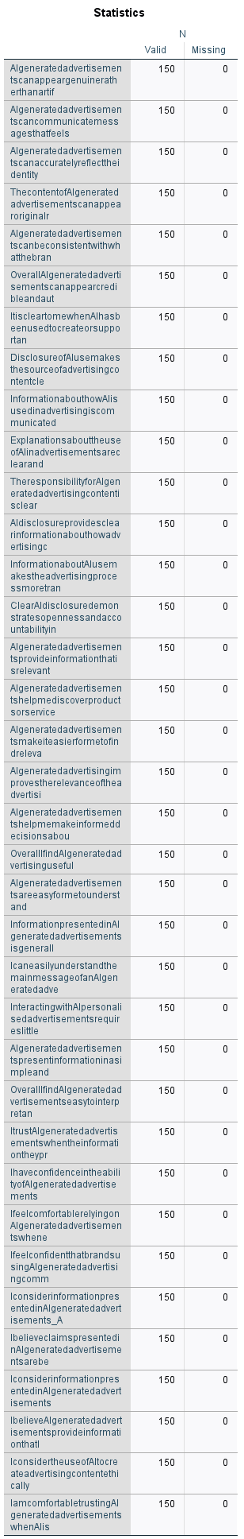
The missing data analysis revealed that all 36 measurement items had 150 valid responses and no missing data. Thus, the perceived authenticity, perceived transparency and AI disclosure, perceived usefulness, perceived ease of use and customer trust analyses employed the same full samples. An imputation/replacement procedure did not have to be used. However, data completeness alone does not establish response quality, reliability or validity.

Demographic and Background Characteristics
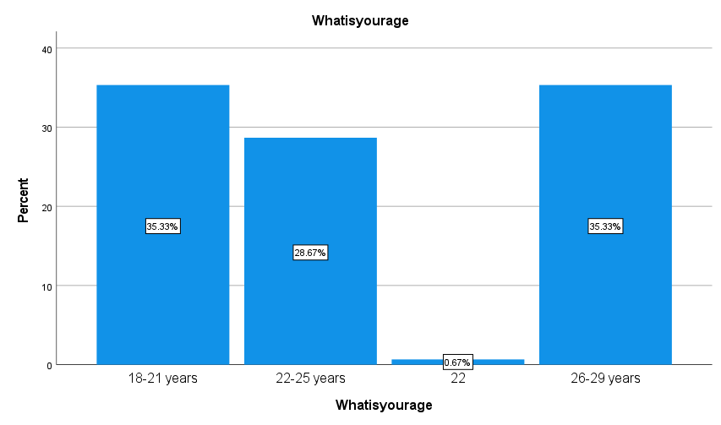
Figure 5: Age Distribution of Respondents
The results showed that respondents aged 18–21 and 26–29 each represented 35.33% of the sample (n = 53), while 28.67% (n = 43) were aged 22–25. One respondent (0.67%) appeared separately as “22,” indicating a coding inconsistency. Because age 22 falls within the 22–25 category, this response was recoded accordingly, increasing the category to 29.33% (n = 44). Following this correction, all 150 respondents fall within the intended 18–29 Generation Z population.
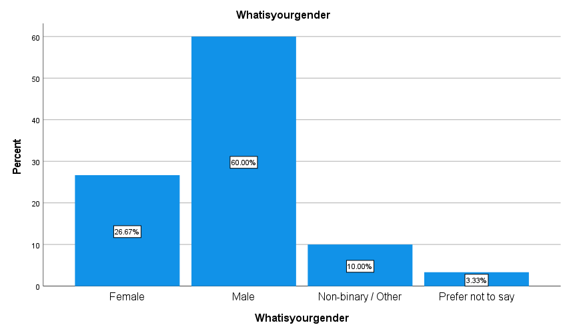
Figure 6: Gender Distribution of Respondents
The sample was predominantly male, with 90 respondents representing 60.00% of the sample. Female respondents accounted for 26.67% (n = 40), while 10.00% (n = 15) identified as non-binary or another gender. The remaining 3.33% (n = 5) preferred not to disclose their gender. The findings therefore reflect a gender-imbalanced sample and should be generalised cautiously.
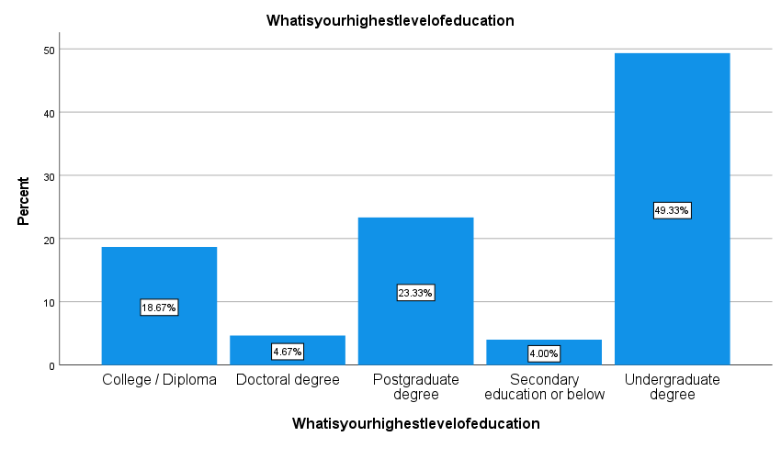
Figure 7: Highest Educational Qualification of Respondents
Almost half of the respondents held an undergraduate degree, representing 49.33% of the sample (n = 74). Postgraduate-degree holders accounted for 23.33% (n = 35), followed by college or diploma qualifications at 18.67% (n = 28). Doctoral-degree holders represented 4.67% (n = 7), while 4.00% (n = 6) had secondary education or below.
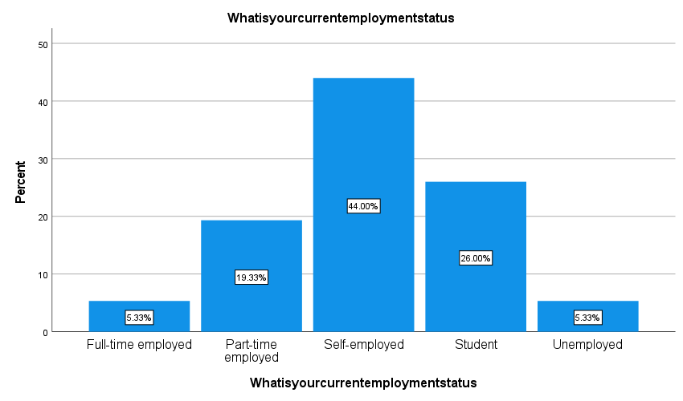
Figure 8: Current Employment Status of Respondents
Self-employed respondents formed the largest employment group, accounting for 44.00% of the sample (n = 66). Students represented 26.00% (n = 39), while 19.33% (n = 29) were employed part-time. Full-time employment and unemployment each accounted for 5.33% (n = 8). Thus, the sample was concentrated among self-employed respondents and students rather than full-time employees.
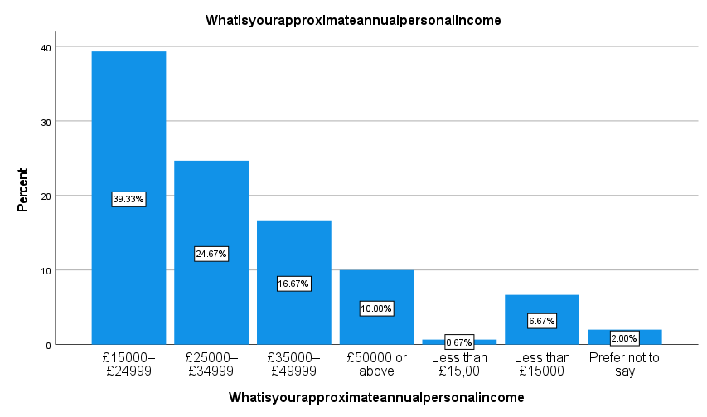
Figure 9: Approximate Annual Personal Income of Respondents
The largest proportion of respondents earned £15,000–£24,999 annually (39.33%, n = 59), followed by £25,000–£34,999 (24.67%, n = 37), £35,000–£49,999 (16.67%, n = 25) and £50,000 or above (10.00%, n = 15). The two “Less than £15,000” categories should be merged, producing 7.33% (n = 11), while 2.00% (n = 3) preferred not to disclose their income.
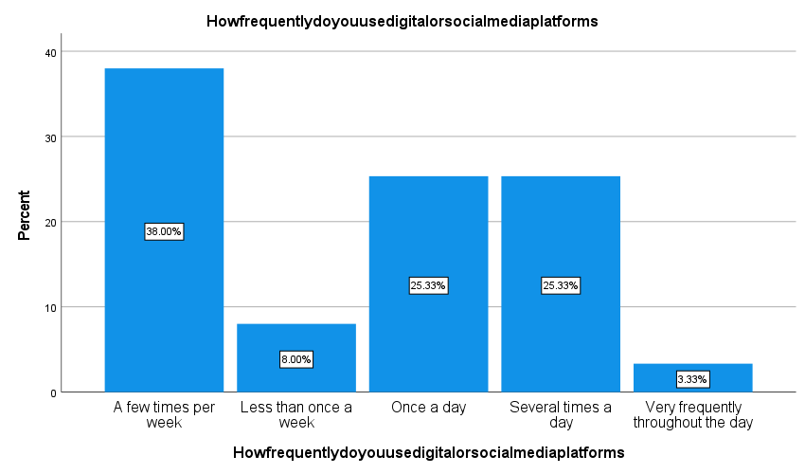
Figure 10: Frequency of Digital and Social-Media Platform Use
The largest group used digital or social-media platforms a few times per week, representing 38.00% of respondents (n = 57). Daily and several-times-daily users each accounted for 25.33% (n = 38). A further 8.00% (n = 12) used these platforms less than once per week, while only 3.33% (n = 5) reported using them very frequently throughout the day.
The results show that 54.00% of respondents used digital platforms at least once per day. Nevertheless, the largest individual category was “a few times per week,” indicating that digital engagement differed considerably across the sample despite all respondents meeting the digital-platform-use eligibility requirement.
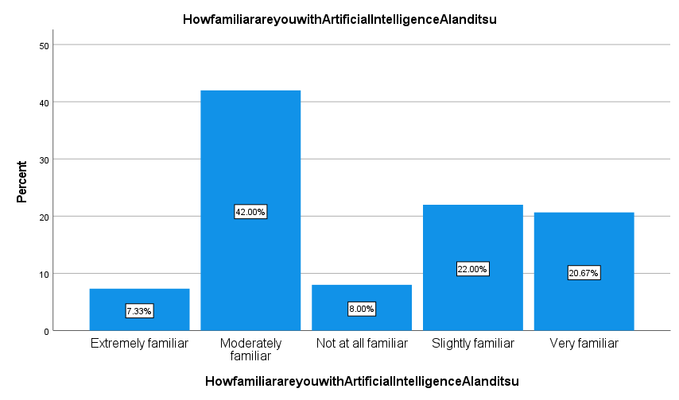
Figure 11: Respondents’ Familiarity with Artificial Intelligence and Its Use in Digital Advertising
Moderate familiarity with AI was the most common response, reported by 42.00% of participants (n = 63). Slight familiarity accounted for 22.00% (n = 33), while 20.67% (n = 31) were very familiar. Only 7.33% (n = 11) were extremely familiar, and 8.00% (n = 12) reported no familiarity. AI knowledge therefore varied substantially across respondents.
While all eligible respondents indicated that they had seen AI-generated advertising, 30.00% said they were only slightly or not familiar with AI. This distinction is important because exposure to AI-generated advertising does not necessarily indicate a strong understanding of the technology or its advertising applications.
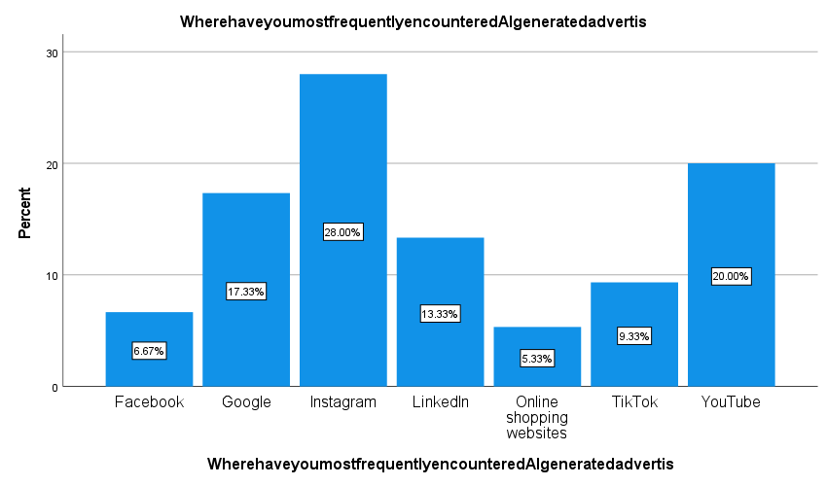
Figure 12: Platforms on Which Respondents Most Frequently Encountered AI-Generated Advertisements
Instagram was the most frequently reported platform for encountering AI-generated advertisements, accounting for 28.00% of responses (n = 42). YouTube followed at 20.00% (n = 30), while Google represented 17.33% (n = 26). LinkedIn accounted for 13.33% (n = 20), TikTok 9.33% (n = 14), Facebook 6.67% (n = 10) and online shopping websites 5.33% (n = 8).
Together, Instagram, YouTube and TikTok accounted for 57.33% of reported encounters, indicating that visually oriented social-media and video platforms were particularly important exposure settings. However, because respondents selected only the platform encountered most frequently, these percentages do not measure their total exposure across multiple platforms.

Reliability Analysis
Table 2: Perceived Authenticity
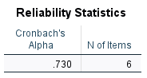
Table 3: Transparency and AI Disclosure
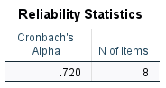
Table 4: Perceived Usefulness
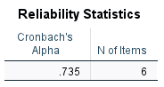
Table 5: Perceived Ease of Use
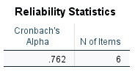
Table 6: Customer Trust in AI-Generated Advertising
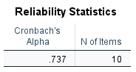
The reliability analysis demonstrated acceptable internal consistency across all five study constructs. Perceived authenticity recorded Cronbach’s α = .730, transparency and AI disclosure α = .720, perceived usefulness α = .735, perceived ease of use α = .762, and customer trust α = .737. As all coefficients exceeded the adopted .70 threshold, the scales were considered sufficiently reliable for subsequent composite-score analysis. Accordingly, no measurement items were removed solely on the basis of internal-consistency reliability.

Construct Validity
Table 7: KMO and Bartlett’s Test of Sampling Adequacy
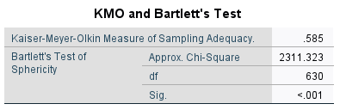
The Kaiser–Meyer–Olkin value was .585, indicating marginal rather than strong sampling adequacy because it fell below the preferred .60 threshold. Nevertheless, Bartlett’s test of sphericity was statistically significant, $χ^{2}\left(630\right)=2311.323$, $p<.001$, confirming that the correlations among the 36 items were collectively sufficient for factor analysis. Therefore, exploratory factor analysis was statistically possible, but the KMO value indicates that the measurement structure should be interpreted cautiously. The relatively weak sampling adequacy limits the strength of evidence for construct validity and means that the proposed measurement structure cannot be regarded as strongly confirmed by the factor analysis.
Table 8: Anti-Image Correlation Matrix for the Measurement Items

Individual sampling adequacy of the 36 measurement items was assessed by examining the anti-image matrix. Diagonal values are measures of sampling adequacy, and the off-diagonal values are partial correlations. The overall KMO value was relatively low (.585), indicating that there may have been items that did not share enough variance with the other items. The relatively low overall KMO (.585) suggests that some items may not share sufficient variance with the remaining measures. Any items with diagonal values below .50 therefore indicate weaker individual sampling adequacy and provide further reason for caution when interpreting the proposed factor structure.
Table 9: Initial Communalities for the Measurement Items
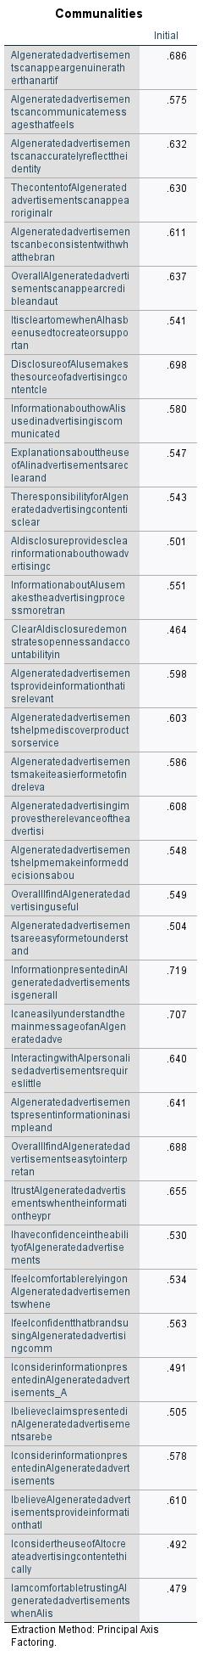
Initial communalities ranged between .464 and .719 and the amount of variance that items shared with the other variables varied moderately. The following were the highest values: .719 for information being generally clear in AI-generated advertisements and .707 for understanding the main message of the information. The lowest communality was .464 for the item concerning openness and accountability through clear AI disclosure. Most communalities were greater than .50, but the low communalities suggest that some of the items within each construct did not exhibit a comparable variance with the structure of the measurement system, further evidence of the need for a cautious interpretation of construct validity.
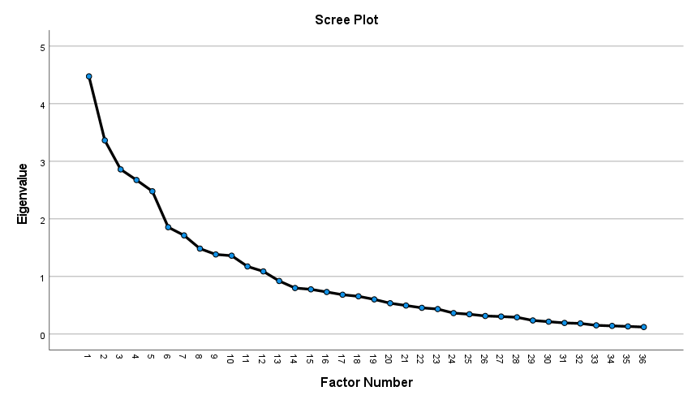
Figure 13: Scree Plot for the Measurement Items
The first eigenvalue in the scree plot was about 4.5 and the next four factors had consecutive eigenvalues of 3.4, 2.9, 2.7 and 2.5. About 12 factors had values of their eigenvalues greater than 1.00 and the curve levelled off thereafter. The plot did not clearly yield a five-factor solution that reflects the theoretically proposed constructs, suggesting that the empirical item structure might be more complex than the proposed theory.
Combined, the results of the KMO value, anti-image matrix, communalities and scree plot suggest that the construct validity was lower than anticipated. The factor analysis, in detail, did not provide a clear representation of the five constructs that were theoretically proposed. Despite this, constructs were still used in the subsequent analysis as it was defined a priori from literature and showed acceptable internal consistency. However, the factor results do not provide strong empirical confirmation of their distinct measurement structure. The regression and hypothesis-testing results should therefore be interpreted with this measurement limitation in mind.

Descriptive Statistics for the Study Constructs
Table 10: Descriptive Statistics for the Composite Constructs
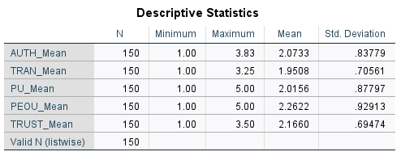
All five constructs contained 150 valid observations. Perceived ease of use recorded the highest mean (M = 2.2622, SD = .92913), followed by customer trust (M = 2.1660, SD = .69474), authenticity (M = 2.0733, SD = .83779), usefulness (M = 2.0156, SD = .87797) and transparency (M = 1.9508, SD = .70561). As every mean was below 3.00, respondents generally expressed unfavourable or low perceptions of AI-generated advertising.

Assessment of Distributions and Potential Outliers

Perceived Authenticity
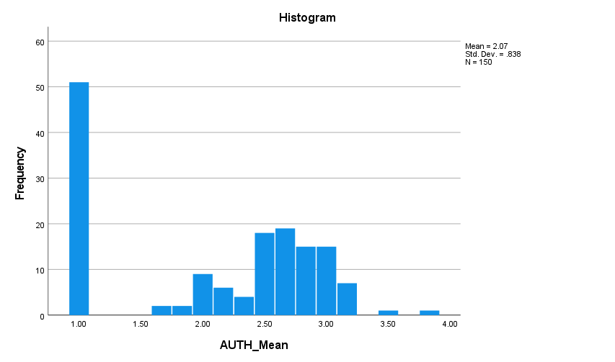
Figure 14: Histogram of Perceived Authenticity
Perceived authenticity had a mean of 2.07 (SD = .838) across the 150 respondents. There was a strong focus at the bottom of the range (1.00) and a second clumping effect around the 2.40–3.10 range. A few scores were above 3.20. This distribution was not normal but was positively skewed with generally weak perceptions of authenticity in AI-generated ads.
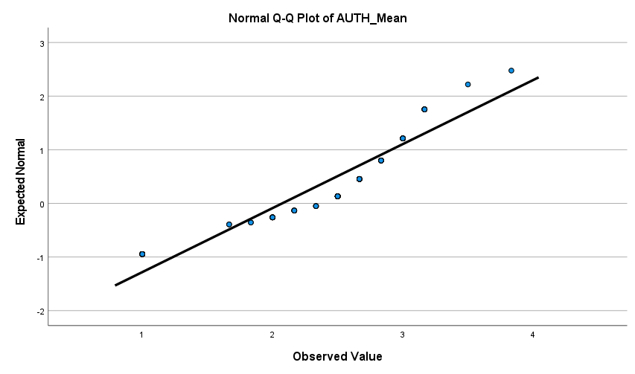
Figure 15: Normal Q–Q Plot of Perceived Authenticity
The Q–Q plot suggests that the authenticity scores were reasonably close to the reference line for some of the middle range scores. Visibly, there were differences at the low and high extremes, especially near the minimum score of 1.00, and above about 3.20. These deviations are related to the location of the minimum responses in the histogram. Thus, the perceived authenticity was not exactly normal, but the middle-range observations were generally linear.

Transparency and AI Disclosure
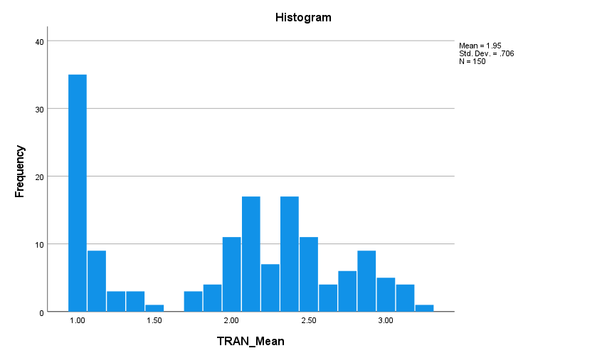
Figure 16: Histogram of Transparency and AI Disclosure
Transparency and AI disclosure had a mean of 1.95 (SD = .706) across the 150 respondents. A large proportion of the data in the histogram is clustered around the value 1.00, with a wider distribution between about 1.80 and 2.60. A relatively small number of respondents had scores of greater than 3.00. This is a pattern of generally low perceptions of transparency and a non-normal distribution with a strong floor effect and some positive skewness.
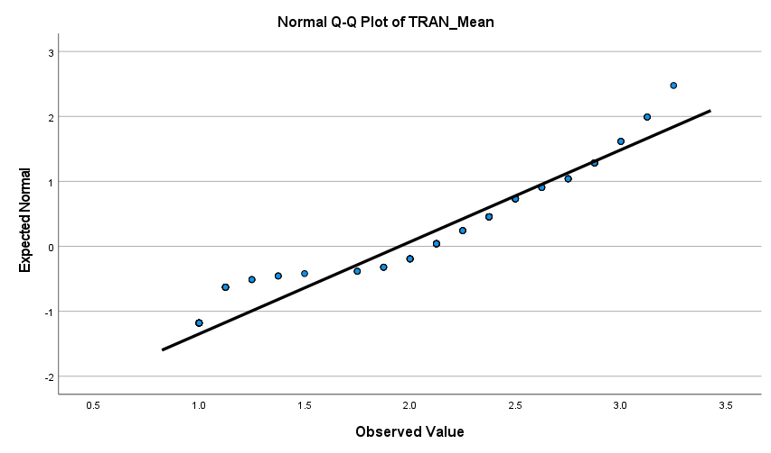
Figure 17: Normal Q–Q Plot of Transparency and AI Disclosure
The transparency Q–Q plot illustrates that the middle observations were mostly close to the diagonal reference line from about 1.80 to 2.90. Scores, however, deviated markedly from the line at both ends, and the largest deviations on the lower tail were those for the concentration at 1.00. The upper values also rose above the expected values. Thus, transparency showed good approximate linearity in the centre and significant non-normality at the extremes of the distribution.

Perceived Usefulness
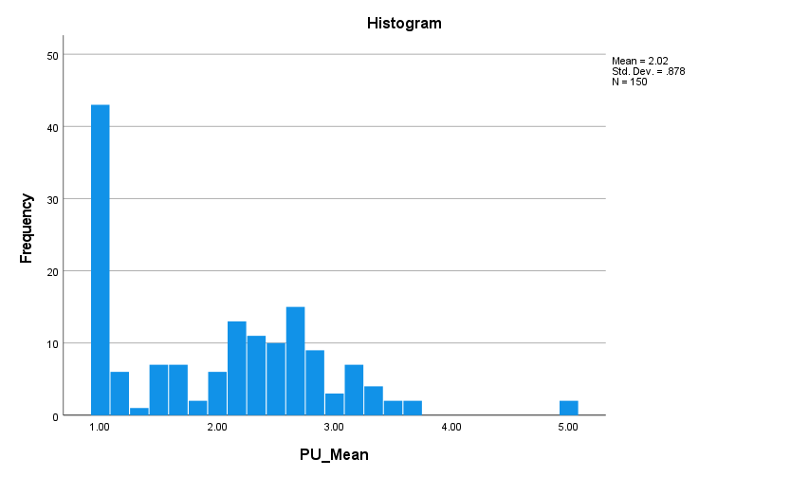
Figure 18: Histogram of Perceived Usefulness
The mean of perceived usefulness was 2.02 with standard deviation of .878 for 150 cases. The histogram indicates that there is a high number of responses at the lowest score (1.00), with the rest of the responses falling between about 1.50 to 3.50. Two observations were made at 5.00, which produced a long upper tail. Thus, usefulness scores were positively skewed, demonstrating a floor effect such that the respondents generally did not view the ads created by AI as very useful.
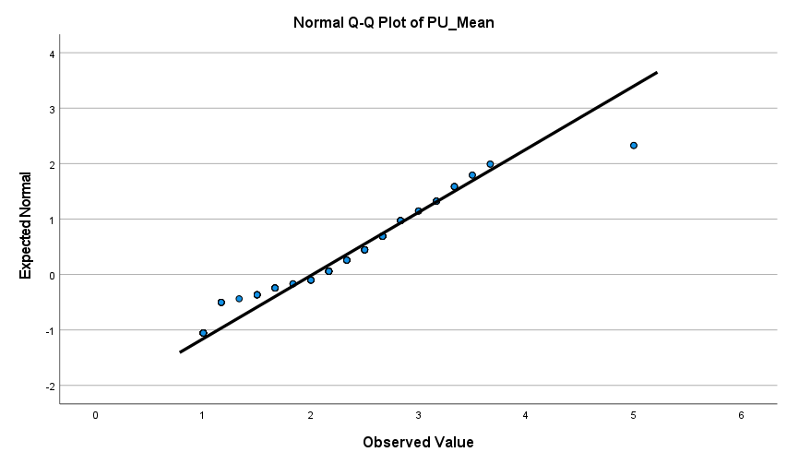
Figure 19: Normal Q–Q Plot of Perceived Usefulness
The usefulness Q–Q plot is very close to the reference line in the middle of the range, from 1.70 to 3.70. Several of the respondents scored 1.00 and this caused some to drop out at the lower end and 5.00 was significantly lower than the upper tail point, which caused departures at that end. The distribution showed reasonably central alignment and tail deviations, which did not satisfy the assumption of perfect univariate normality.

Perceived Ease of Use
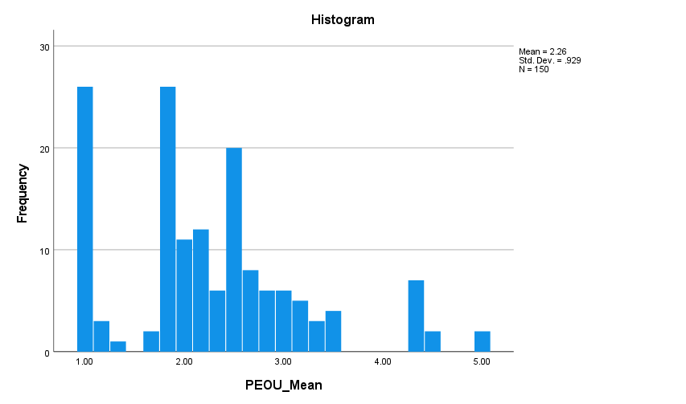
Figure 20: Histogram of Perceived Ease of Use
Perceived ease of use recorded the highest construct mean (M = 2.26, SD = .929) across the 150 respondents. The scores were bunched around 1.00, 1.80-2.60 and around 4.20, resulting in an irregular, multimodal distribution. Few achieved 5.00. The ease of use construct was rated higher than the other constructs, but its mean was slightly below the middle and its distribution was quite far from normal.
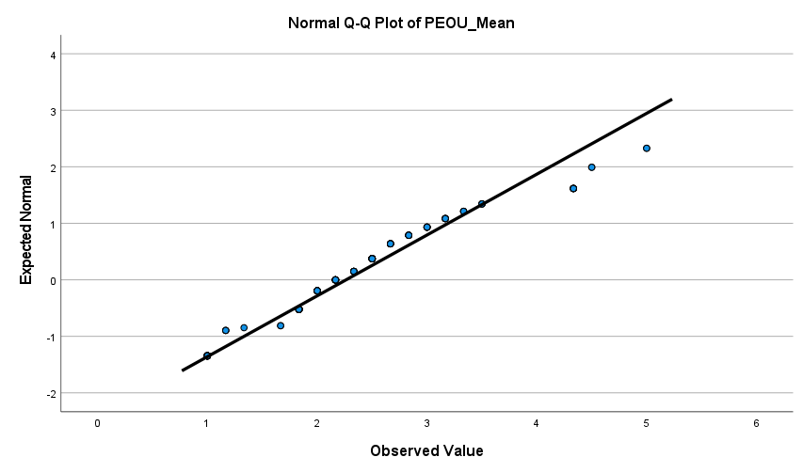
Figure 21: Normal Q–Q Plot of Perceived Ease of Use
The ease-of-use Q–Q plot shows that most middle-range observations were positioned relatively close to the reference line, especially between approximately 1.80 and 3.50. However, deviations appeared at the minimum score and became more pronounced for observations above 4.00. The highest score of 5.00 also departed from the expected pattern. Therefore, the central distribution was approximately linear, but upper-tail observations and clustered low scores weakened the assumption of normality.

Customer Trust in AI-Generated Advertising
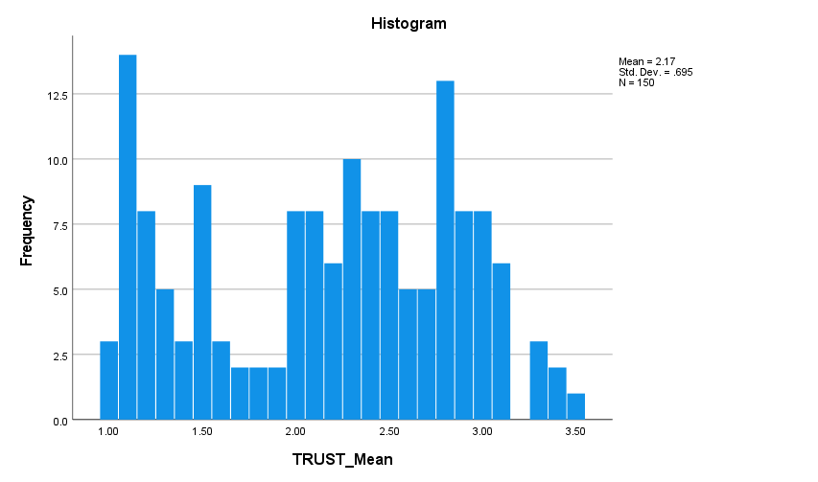
Figure 22: Histogram of Customer Trust in AI-Generated Advertising
Customer trust recorded a mean of 2.17 and standard deviation of .695 for 150 respondents. Scores extended from 1.00 to 3.50 and were spread across the range, although noticeable concentrations appeared near 1.10, 2.30 and 2.80. Very few scores exceeded 3.20. The distribution was irregular rather than fully bell-shaped, and the mean below the neutral midpoint indicates generally limited customer trust in AI-generated advertisements.
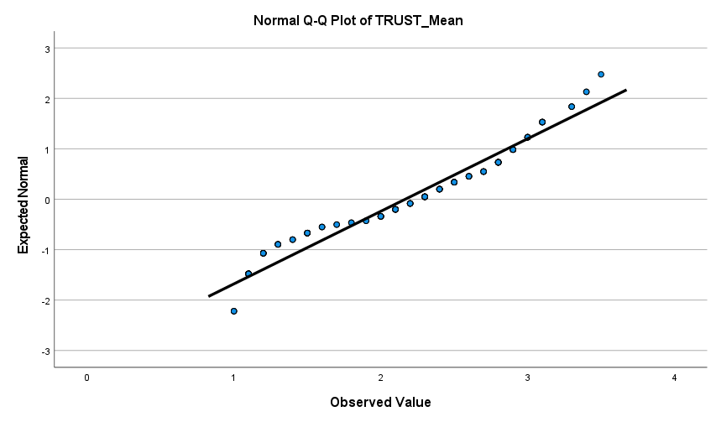
Figure 23: Normal Q–Q Plot of Customer Trust
The customer-trust Q–Q plot shows good agreement with the diagonal line over most of the middle distribution. However, the lowest observations fell below the reference line, while observations above approximately 3.00 increasingly deviated above it. These tail deviations indicated a lack of normal distribution of customer trust. However, its central values showed a more consistent linear trend, and only moderate deviations from expected normality when compared to a number of independent variables.

Pearson’s Correlation Analysis
Table 11: Pearson’s Correlations Among the Study Constructs
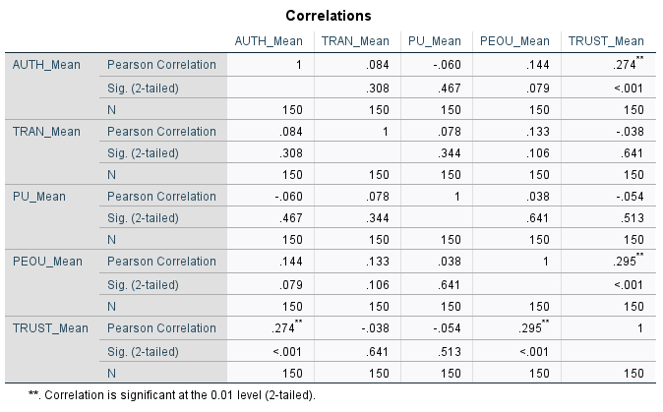
Pearson’s correlation analysis showed that perceived authenticity had a weak positive and statistically significant relationship with customer trust (r = .274, p < .001). Perceived ease of use also had a weak positive and statistically significant relationship with customer trust (r = .295, p < .001), representing the strongest observed association. Conversely, transparency and AI disclosure were not significantly related to customer trust (r = −.038, p = .641), and perceived usefulness was likewise nonsignificant (r = −.054, p = .513). Correlations among the four predictors were small and nonsignificant (r = −.060 to .144, p > .05), indicating no evidence of strong intercorrelations among the predictors.

Multiple Linear Regression Analysis
Table 12: Multiple Regression Model Summary
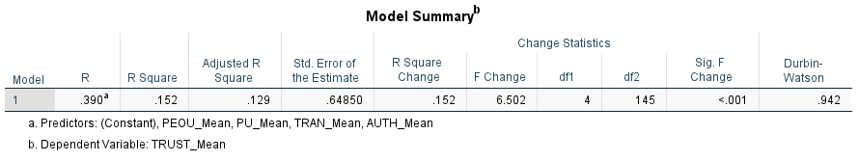
The model summary shows a multiple correlation of $R=.390$. The four predictors collectively explained 15.2% of the variance in customer trust ($R^{2}=.152$), while the adjusted $R^{2}$was .129. The standard error was .64850, and the model improvement was significant, $F\left(4 , 145\right)=6.502$, $p<.001$. However, the Durbin–Watson value of .942 suggests possible positive residual autocorrelation and should be acknowledged as an assumption concern.
Table 13: ANOVA Results for the Multiple Regression Model
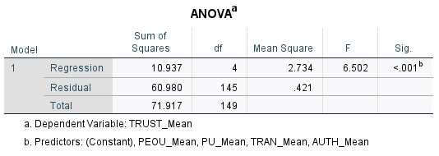
The ANOVA table confirms that the combined regression model was statistically significant, $F\left(4 , 145\right)=6.502$, $p<.001$. The sum of squares for regression was 10.937, the sum of squares for the residuals was 60.980, and the sum of squares for the total was 71.917. Authenticity, transparency, usefulness and ease of use thus collectively explained a significant amount of variance in predicting customer trust, although the four predictors in the model did not account for all of the variance.
Table 14: Multiple Regression Coefficients Predicting Customer Trust
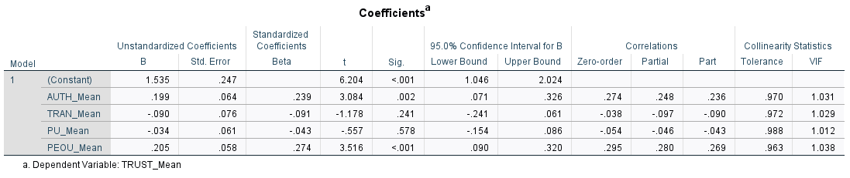
Authenticity positively predicted trust ($B=.199$, $β=.239$, $t=3.084$, $p=.002$, 95% CI [.071, .326]). Ease of use was the strongest significant predictor ($B=.205$, $β=.274$, $t=3.516$, $p<.001$, 95% CI [.090, .320]). Transparency ($B=-.090$, $p=.241$) and usefulness ($B=-.034$, $p=.578$) were nonsignificant. Thus, H1 and H4 were supported, whereas H2 and H3 were not supported.
Table 15: Collinearity Diagnostics for the Regression Model
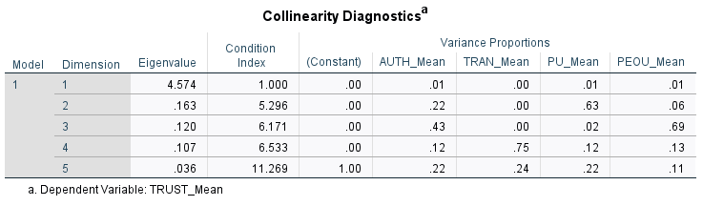
Multicollinearity was not an issue based on the collinearity diagnostics. The tolerance values of all variables were above the minimum acceptable level (from .963 to .988) and the VIF values were below 5 (ranging from 1.012 to 1.038). The highest condition index was 11.269, less than common levels of concern. Hence, the predictor coefficients might be interpreted separately with no evidence that strong overlap within the four independent variables led to bias in the regression estimates.
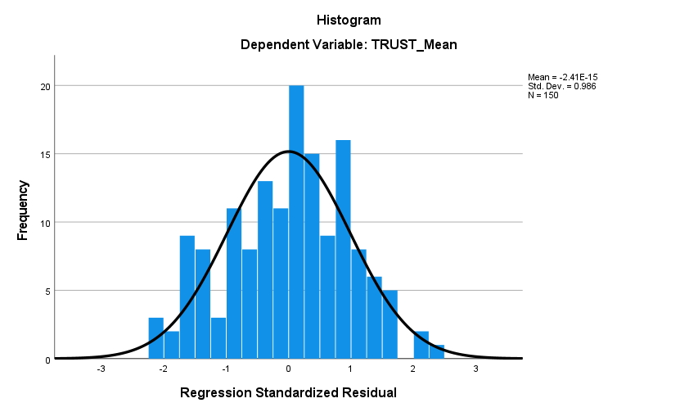
Figure 24: Histogram of Standardised Regression Residuals
The histogram of standardised residuals showed an approximately bell-shaped distribution centred near zero. The residual mean was effectively zero ($-2.41×{10}^{-15}$), with a standard deviation of .986 across 150 observations. Most residuals occurred between approximately −2 and +2, and no values appeared beyond ±3. Although minor irregularities were visible, the overall pattern broadly followed the superimposed normal curve and supported approximate normality of the regression errors.
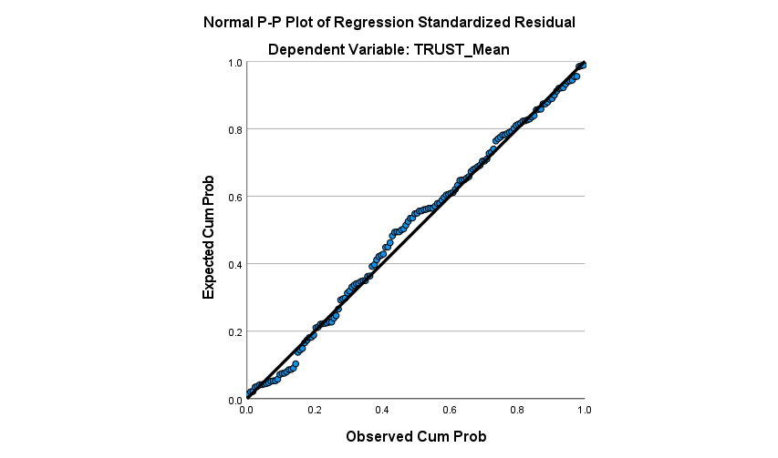
Figure 25: Normal P–P Plot of Standardised Regression Residuals
The normal P–P plot indicated that the plotted cumulative probabilities were reasonably close to the diagonal reference line. Minor deviations were visible in the lower and middle portions of the distribution, but no substantial or systematic departures from the reference line were evident. This shows that the standardised regression residuals had an approximately normal distribution. The assumption of residual normality was therefore generally met and the interpretation of the significance tests and confidence intervals given for the multiple regression coefficients was appropriate.
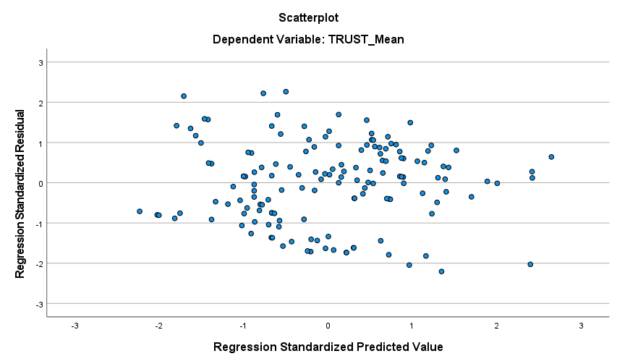
Figure 26: Scatterplot of Standardised Predicted Values and Standardised Residuals
The scatterplot showed residuals distributed around zero without a clear curved or funnel-shaped pattern. The spread remained broadly consistent across predicted values, providing reasonable support for both linearity and homoscedasticity. Some clustering was present, but no substantial systematic pattern was observed.

Chapter Summary
This chapter analysed 150 survey responses. All constructs demonstrated acceptable reliability, although construct validity was marginal. Respondents reported generally low perceptions of AI-generated advertising. Correlation and regression results showed that perceived authenticity and perceived ease of use were significant positive predictors of customer trust, supporting H1 and H4. Transparency and perceived usefulness were not significant predictors; therefore, H2 and H3 were not supported.

Chapter Five: Discussion

Introduction
This chapter interprets the findings concerning customer trust in AI-generated advertising and relates them to the research questions, hypotheses, theoretical framework and literature review. The study focused on the effects of perceived authenticity and perceived transparency on customer trust as well as the effects of perceived usefulness and perceived ease of use in the extended TAM. The main emphasis of the discussion is on the meaning and significance of the findings and not on restating the statistics. Particular attention is given to the contrasting effects of authenticity and transparency, the role of ease of use, and the study’s contribution to the identified research gap.

Discussion of RQ1: Influence of Perceived Authenticity on Customer Trust
The results address RQ1 and show that perceived authenticity was positively and significantly associated with customer trust in AI-generated advertising. When transparency and AI disclosure, perceived usefulness and perceived ease of use were included simultaneously in the regression model, perceived authenticity remained a significant predictor of customer trust. That suggests that consumers are not only evaluating AI-generated ads for their performance or functionality. They also evaluate whether the message appears authentic, sincere, believable and consistent with the brand’s identity and values.
The outcome underscores the difference between the operational and relational importance of AI. Gao et al. (2023) and Islam et al. (2024) demonstrate the potential of AI in improving targeting, production speed and campaign optimisation. However, operational efficiency should not be equated with consumer trust. The current findings indicate that the perceived credibility of AI-generated communication is positively associated with consumer trust. In this context, AI acts as a tool that can facilitate the creation of content, but authenticity contributes to the credibility of the content produced by AI.
This supports Rixom and Rixom (2023) who find a correlation between perceived brand authenticity and consumer credibility judgements and consumer confidence. This also supports the results of Foroudi et al. (2025) who state that the authenticity of AI is a predisposing factor for positive customer reactions. Advertisements that appear genuine and aligned with the brand's messaging can help alleviate concerns about AI's ability to mimic human interaction or deceive consumers. Authenticity thus acts as an assurance signal which in turn decreases the perceived deception and increases the level of confidence in the message and the organisation delivering it.
McAllister's (1995) distinction between cognitive and affective trust is another way of understanding the finding. An advertisement perceived as credible, consistent and reliable may foster cognitive trust, while perceived sincerity and genuineness may strengthen affective trust in the brand’s intentions. This dual role may explain why authenticity remained a significant predictor of customer trust even when the functional TAM variables were included in the regression model.
The result from a relationship-marketing point of view reinforces the arguments from Morgan and Hunt (1994) that trust is an integral part of stable customer–brand relations. AI-generated content may seem inauthentic and fail to resonate with a brand's voice, potentially harming the relationship. Conversely, AI-generated communication that remains recognisable, credible and aligned with the brand may help preserve customer trust. Thus, the finding is consistent with the position of Albérico and Casaca (2024) that besides personalisation and technological efficiency, credible and ethical communication is needed.
However, this result should not be interpreted as evidence that respondents generally considered AI-generated advertising highly authentic. Overall, the level of authenticity is low, showing that scepticism is still prevalent. The positive relationship, however, suggests that those who reported higher levels of perceived authenticity also reported higher levels of customer trust. This separation is significant: Authenticity accounted for differences in customer trust, and the sample tended to have low perceptions of authenticity in the advertising created by AI.
This finding seems to be in contrast with the results of the studies that have found a relationship between the use of AI-generated ad and authenticity perception as well as emotional appeal (Jung et al., 2025; Nguyen et al., 2026). However, these findings are not mutually exclusive. Previous studies suggest that AI involvement can reduce perceived authenticity, whereas the present findings indicate that higher perceived authenticity is associated with greater customer trust. The key issue may therefore be not whether AI is used, but whether its use preserves authentic, creative and brand-consistent communication.
Accordingly, H1 was supported. The evidence indicates that perceived authenticity is an important relational and psychological basis of customer trust in AI-generated advertising.

Discussion of RQ2: Influence of Transparency and AI Disclosure on Customer Trust
The results address RQ2 by showing that transparency and AI disclosure did not have a statistically significant independent effect on customer trust. This finding was somewhat surprising because transparency is often presented as a means of reducing information asymmetry, demonstrating accountability and enabling consumers to make informed assessments of AI-generated content (Wulf and Seizov, 2022; Esa, Rahman and Ahmad, 2025).
One possible explanation is that disclosure does not determine how consumers interpret AI involvement. Disclosure of AI use may signal organisational openness, but it may also draw attention to automation, reduced human creativity or the persuasive tactics used by the organisation. Disclosure may therefore produce different consumer reactions, which could help explain the absence of a significant overall effect on trust.
This is consistent with Qiu et al. (2025) who propose that AI disclosure triggers persuasion knowledge. Consumers might question the brand's intent and take a more critical look at the message when they realise that it was created or personalised with AI. Similarly, Shi and Jiang (2026) propose that disclosure could have a negative effect on emotional appeal when consumers see human creativity as a high priority. Furthermore, disclosures could exacerbate algorithm aversion in specific advertising scenarios, as implied in the studies by Wang et al. (2026) and Zhang and Hur (2025).
The findings therefore challenge the assumption that transparency automatically generates trust. In addition, Camilleri (2023) states that there needs to be responsible and honest communication as well as transparency. Sarran and Datt (2026) suggest that disclosure is more impactful when accompanied by verification signals. Consumers might need proof that an ad has been produced accurately, responsibly, and is accountable to the organisation, not just that AI was used.
The low transparency score provides further context. Overall, respondents reported low perceptions of transparency surrounding AI use. This suggests that respondents may not have perceived AI disclosure and related accountability signals as sufficiently clear or meaningful. In that case transparency would have less of a role to play in lowering uncertainty or raising trust. Pierre, Rodriguez and Wang (2026), Saternus, Weber and Hinz (2022) and Nawaz and Wagner (2024) all report context-specific variability, which is reflected in the finding. The impact of disclosure can vary based on the technological familiarity, platform conditions, prior brand perceptions and organisational reputation. A standard disclosure statement can thus be understood in a variety of ways dependent on the consumer, the type of advertising and the brand.
H2 was consequently not supported. However, this does not demonstrate that transparency is unimportant or undesirable. Rather, transparency and AI disclosure did not independently predict customer trust after perceived authenticity, perceived usefulness and perceived ease of use were controlled. Its effect may be indirect, conditional or dependent on the quality and framing of the disclosure.

Discussion of RQ3: Joint Influence of Authenticity and Transparency
The regression model examined the simultaneous additive effects of authenticity and transparency and revealed that authenticity contributed as standalone while transparency did not. This indicates that when both signals are considered together, authenticity is the more influential predictor of trust within the current sample.
The result provides a more qualified understanding of the integration proposed in the literature review. As Sarran and Datt (2026) and Bandawaty (2026) indicate, authenticity and transparency can operate together because disclosure is unlikely to reassure consumers when the underlying content does not appear authentic. The current evidence suggests that both constructs should be included at the same time but does not indicate that they are equally important. Consumers may welcome transparency about AI use, but their trust may depend more strongly on whether the advertisement appears sincere, credible and consistent with the brand.
This interpretation is consistent with Shi and Jiang (2026) view that authenticity can impact disclosure reactions. Transparency could enhance trust if the content disclosed is true but can also raise scepticism if the content disclosed is an indication of automation or decreased human involvement. Therefore, the link between transparency and transparency as a direct predictor may be complex. It could be related to its authenticity, its familiarity with AI or its brand reputation.
Importantly, the present regression tested additive effects of authenticity and transparency on customer trust, but not an interaction between the two predictors. Therefore, the results do not permit the conclusion that authenticity statistically moderates the relationship between transparency and customer trust. They demonstrate only that authenticity was significant whereas transparency was not when both predictors were entered simultaneously into the regression model. Future research directions include directly testing an authenticity-by-transparency interaction or examining the possible mediating role of authenticity in consumer reactions to transparency disclosure via AI.
The overall model was significant, suggesting that the overall model with both relational and functional variables explained customer trust better than an intercept-only model. However, when it is considered in terms of its explanatory power, it is determined that authenticity and transparency do not give a complete account of the process of creating trust. Privacy concerns, perceived manipulation, brand familiarity, prior experience with AI, advertising quality, product category and algorithm aversion may account for additional variation (Mariadassou, Klesse and Boegershausen, 2024; Rajesh and Vijayashri Gurme, 2025).

Discussion of RQ4: Perceived Usefulness, Ease of Use and the Extended TAM
The result showed that perceived usefulness was not significantly correlated with customer trust and H3 was not supported. This finding illustrates the distinction between perceived functional value and relational confidence. An AI-generated ad may provide the right information, or it may help find products, but lack authenticity, ethics and reliability. Usefulness might thus promote engagement or technology acceptance but may not lead to trust.
However, customer trust was strongly affected by perceived ease of use and it was the most important variable in the model, supporting H4. Ensuring that advertising is clear and easy to understand will reduce the effort required and uncertainty involved in consumers' decision-making. This could lead to higher cognitive trust because consumers are likely to be able to better evaluate the message and what the advertisement is saying. The results coincide with the theory of TAM which suggests that ease of use is responsible for acceptance (Davis, 1989; Venkatesh and Davis, 2000).
The contrasting results for usefulness versus ease of use, however, indicate that the classic TAM variables do not work in a consistent manner when the outcome is trust and not behavioural intention. Ease of interpretation may be more directly associated with reduced uncertainty, whereas usefulness may relate more closely to functional value or purchase-decision support. This supports extending TAM to include authenticity and transparency because functional beliefs alone are insufficient to explain trust in AI-generated communication (Musa et al., 2024; Malodia et al., 2026).

Contribution to the Research Gap and Practical Significance
The study addressed the identified gap by examining authenticity, transparency, usefulness and ease of use within one empirical model. Importantly, the findings demonstrate that the direct effects of authenticity and transparency on customer trust are not equivalent. Authenticity was related to trust while disclosure alone was not. Based on this, the research helps to understand the reasons behind the mixed results in previous studies of transparency.
The results indicate that disclosure should be viewed not as a whole solution, but as a part of a responsible communication strategy for advertisers. Brands should ensure that AI-generated content remains consistent with brand identity, that advertising claims are appropriately substantiated, and that adequate human oversight is maintained. Disclosure should be clear and meaningful and explain the role of AI and the responsibility of the organisation for the content produced.
Moreover, ease of use can shed light on the importance of being able to clearly convey the main message of the AI-generated advertisements. More complex personalisation, no explanation for recommendations or confusing interactive elements can add to uncertainty. A simple presentation and easy-to-understand explanations can help build confidence, especially among consumers who may not have a deep understanding of AI.

Hypothesis Outcomes
Table 16: Hypothesis Outcomes
Hypothesis | Proposed relationship | Outcome | Interpretation
H1 | Perceived authenticity positively influences customer trust | Supported | Authentic, sincere and brand-consistent AI advertising strengthens trust.
H2 | Transparency and AI disclosure positively influence customer trust | Not supported | Disclosure alone did not produce an independent trust effect.
H3 | Perceived usefulness positively influences customer trust | Not supported | Functional value did not independently establish relational confidence.
H4 | Perceived ease of use positively influences customer trust | Supported | Clear and easily interpreted AI advertising was associated with greater trust.

Chapter Summary
This chapter interpreted the findings in relation to the research questions, hypotheses and theoretical framework. Perceived authenticity contributed significantly to customer trust by reinforcing credibility, sincerity and relational confidence. There was no independent effect of transparency and AI disclosure on trust, suggesting disclosure needs authenticity, verification, and responsible implementation to have an impact. Ease of use was a factor in building trust, but usefulness was not. Overall, the findings extend TAM by indicating that customer trust in AI-generated advertising reflects both functional clarity and relational evaluations, with authenticity playing a particularly important role.

Chapter Six: Conclusion

Introduction
This chapter concludes the study by summarising the key findings and considering their theoretical and managerial implications for AI-generated advertising. It considers the implications of the results on the understanding of customers' trust and reviews the lessons for organisations before outlining the study’s limitations and directions for future research. This study explored the role of perceived authenticity, transparency and AI disclosure, perceived usefulness and perceived ease of use on customer trust in AI-generated advertising. The study adopted a positivist, deductive and quantitative cross-sectional design, with data from 150 respondents analysed using descriptive statistics, correlation and multiple regression in SPSS.

Brief Summary of Key Findings
The findings provide a differentiated explanation of customer trust in AI-generated advertising rather than suggesting that all proposed determinants operate equally. The survey revealed low levels of customer trust in AI-generated ads (M = 2.17) and the four predictors accounted for 15.2% of the variation in customer trust. While perceived authenticity had a positive and significant relationship with customer trust (H1 supported), highlighting the importance of communication that is perceived as genuine, sincere and consistent with brand values. The perceived ease of use was also significant and most strongly predictive (H4 supported), suggesting that consumers' confidence is affected by the clarity and ease of understanding. However, transparency and AI disclosure (H2) and perceived usefulness (H3) were not individually significant predictors of trust. The results indicate that disclosure alone is insufficient to build trust and that functional value cannot be equated with relational confidence. Overall, the findings suggest that trust relies more on the aspects of relational authenticity and functional clarity, thus offering qualified support of the study's extended TAM framework.

Theoretical Implications
The principal theoretical implication of this study is that customer trust in AI-generated advertising cannot be explained adequately through the traditional Technology Acceptance Model (TAM) alone. According to Davis (1989) and Venkatesh and Davis (2000), perceived usefulness (PU) and perceived ease of use (PEOU) are the two core cognitive evaluations in technology acceptance (TA) process proposed by TAM. The results of the present study revealed that PEOU was a significant predictor of customer trust, but not PU, and perceived authenticity was also significant. This qualifies the traditional TAM logic by demonstrating that functional value does not necessarily translate into relational trust. Rather, there seems to be a need for both functional clarity and relational credibility when it comes to trust in AI-generated advertising. This reinforces the view of extensions to TAM that focus on psychological measures including credibility, transparency and trustworthiness as well as functional measures (Malodia et al., 2026). The finding also aligns with McAllister's (1995) separation of cognitive and affective trust and with Morgan and Hunt's (1994) Commitment-Trust perspective since authenticity is a means to convey signals of sincerity and genuineness that go beyond perceptions of technological utility.
A second contribution concerns the boundary conditions surrounding transparency and AI disclosure. The lack of a significant direct effect of transparency suggests that disclosure does not lead to trust. On the one hand, disclosure has been linked to the reduction of information asymmetry and its role in accountability (Wulf and Seizov, 2022; Esa et al., 2025), and on the other hand, disclosure has been associated with persuasion knowledge, algorithm aversion and a decrease in perceptions of human creativity (Qiu et al., 2025; Shi and Jiang, 2026; Wang et al., 2026). The results of the present study corroborate this more nuanced view: disclosure can be required for responsible advertising but not as a stand-alone trust-building tool. It might be more of a function of existing brand perceptions, platform conditions, organisational reputation and familiarity with AI, or disclosure's quality or framing.
Third, the findings offer clues as to how trust might be developed. While navigating AI-generated content can be challenging, the possibility of perceived sincerity, credibility, and consistency with the brand through authenticity, might help minimize perceptions of artificiality, ease the creation of cognitive frames for understanding AI-generated content, and reduce uncertainty. Usefulness may enhance the functional value of an advertisement without establishing that either the message or the organisation is trustworthy. This distinction strengthens the argument that technology acceptance and relational confidence are two theoretically distinct outcomes (Davis, 1989; McAllister, 1995; Malodia et al., 2026).
Finally, the conceptual model is refined rather than rejected. Of the four proposed direct relationships, authenticity and ease of use are retained as empirically supported predictors, whereas direct links from transparency and usefulness to trust are not supported. The results do not justify removing transparency from the theoretical framework. Rather, they suggest that its direct relationship with consumer trust may depend on contextual or intervening factors. As discussed in Chapter Five, future research could examine whether authenticity mediates or moderates the relationship between transparency and customer trust; these mechanisms were not tested in the present study. Additionally, the implications must be generalised with caution since they were based upon data collected from a cross sectional consumer sample and perceptions of advertising produced by AI; prior literature in this field also notes that there are differences among consumers, advertising formats and platforms.

Managerial Implications
The findings translate into several practical actions for organisations using AI-generated advertising. First, managers need to focus on authenticity of the AI-generated content and not just on production efficiency. As authenticity was an important determinant of customer trust, AI advertisements should be sincere, credible and aligned with established brand identity. This could be done via human-based post-production, brand-style guidelines and checks before publishing. Relevant monitoring metrics could include brand-trust scores, perceived authenticity ratings, complaint rates and engagement quality.
Second, organisations should not consider AI disclosure as a stand-alone trust building measure. Labelling content as AI-generated was not a major independent factor that contributed to trust; transparency did not play a large role as an independent predictor of trust. Disclosure should rather be transparent, informative, with explanations of organisational responsibility, verification and human oversight. Disclosure comprehension, consumer trust scores, complaint volumes and perceived credibility should be monitored by managers.
Third, advertisers should improve the clarity and ease of interpretation of AI-generated advertisements. Trust was significantly predicted by perceived ease of use, suggesting that consumers' responses to messages are stronger when the messages are understandable and require less cognitive effort. Thus, companies need to streamline layouts, recommendations and AI-powered interactive elements, while testing and assessing for accessibility. Some of the most effective KPIs are comprehension rates, time to complete the task, abandonment rates and customer satisfaction.
Fourth, managers should not blindly assume that usefulness by itself leads to trust. Although personalised or relevant advertising may provide functional value, perceived usefulness was not a significant independent predictor of customer trust in this study. Therefore, functional value should be supported by credible claims, authentic communication and responsible AI practices.
Finally, organisations should establish AI-advertising governance structures that promote collaboration among marketing, legal, compliance and brand-management functions. This is significant because trust seems to be based on relational credibility in addition to functional performance. Governance measures should involve disclosure compliance, content accuracy, brand consistency, trust scores and reported AI-related issues.

Limitations and Directions for Future Research
This study has several limitations that should be considered when interpreting the findings. Firstly, the study adopted a cross-sectional quantitative survey approach; thus, causality between the constructs of authenticity, transparency, usefulness, ease of use and customer trust cannot be determined. Secondly, the study used non-probability purposive sampling and primarily targeted the Generation Z respondents (18-29), so the results of the study cannot be generalised to wider consumer groups. Third, although reliability was acceptable, there was only marginal construct validity, implying that some of the measurement items may not have captured the theoretical dimensions perfectly.
Future studies are therefore needed that involve larger and more varied samples, longitudinal or experimental designs, and studies that make comparisons between countries. Interaction or mediation effects between authenticity and transparency should also be examined directly in the studies, since only additive relationships were examined in the present regression. Combining survey data with behavioural measures such as click-through rates, engagement, conversion and controlled ad-exposure experiments could also strengthen future evidence.

Closing Statement
Overall, this study shows that customer trust in AI-generated advertising depends more strongly on authenticity and functional clarity than on disclosure or usefulness alone. By refining an extended TAM perspective, the research provides both theoretical and managerial insight into how AI advertising can be designed to support more credible and trustworthy consumer communication.

References
Adelia, A., Miftahurrahmah, M., Nurpathonah, N., Zaindanu, Y. and Ihsan, M.T. (2021). The role of Google form as an assessment tool in ELT: Critical review of the literature. ETDC: Indonesian Journal of Research and Educational Review, [online] 1(1), pp.58–66. doi:10.51574/ijrer.v1i1.49.
Al-kfairy, M., Mustafa, D., Kshetri, N., Insiew, M. and Alfandi, O. (2024). Ethical Challenges and Solutions of Generative AI: An Interdisciplinary Perspective. Informatics, 11(3), pp.58–58. doi:10.3390/informatics11030058.
Antsipava, D., van Reijmersdal, E.A., Strycharz, J. and van Noort, G. (2025). Can Blockchain-Based Authenticity Disclosures Increase Consumer Trust in Online Advertising? Journal of Advertising, pp.1–28. doi:10.1080/00913367.2025.2510233.
ASA and CAP (2025). Disclosure of AI in advertising: Striking the balance between creativity and responsibility. [online] Asa.org.uk. Available at: https://www.asa.org.uk/news/disclosure-of-ai-in-advertising-striking-the-balance-between-creativity-and-responsibility.html?dm_i=4PDW%2C11PFC%2C6YVK0U%2C4WMIO%2C1 [Accessed 14 Sept. 2026].
Bandawaty, E. (2026). Perceived Authenticity and Consumer Response to AI-Generated Content: A Human–AI Co-Creation Perspective. Manexia: Journal of Business, Management, and Creative Economy, 2(2), pp.95–118. doi:10.66203/manexia.02205.
Baryshkov, K., Kuzina, Y., Smuk, I. and Tkachuk, M. (2026). Consumer Trust in AI-Generated Marketing Content: A Systematic Literature Review and Research Agenda. American Impact Review, 1(1). doi:10.66308/air.e2026024.
Brydges, C.R. (2019). Effect size guidelines, sample size calculations, and statistical power in gerontology. Innovation in Aging, [online] 3(4). doi:10.1093/geroni/igz036.
Camilleri, M.A. (2023). Artificial intelligence governance: Ethical considerations and implications for social responsibility. Expert Systems, [online] 41(7). doi:10.1111/exsy.13406.
Campbell, S., Greenwood, M., Prior, S., Shearer, T., Walkem, K., Young, S., Bywaters, D. and Walker, K. (2020). Purposive sampling: Complex or simple? Research case examples. Journal of Research in Nursing, [online] 25(8), pp.652–661. doi:https://doi.org/10.1177/1744987120927206.
Cheng, X. and Nam, I. (2026). Understanding the influence of AI labels on consumer psychology: The moderating role of product type. Frontiers in Psychology, [online] 17. doi:10.3389/fpsyg.2026.1878095.
Chui, M., Hazan, E., Roberts, R., Singla, A., Smaje, K., Yee, L., Zemmel, R. and Sukharevsky, A. (2023). The economic potential of generative AI: The next productivity frontier. [online] McKinsey & Company. Available at: https://www.mckinsey.com/capabilities/tech-and-ai/our-insights/the-economic-potential-of-generative-ai-the-next-productivity-frontier#/auth-download/%2F~%2Fmedia%2Fmckinsey%2Fbusiness%20functions%2Fmckinsey%20digital%2Four%20insights%2Fthe%20economic%20p [Accessed 14 Sept. 2026].
Davis, F.D. (1989). Perceived usefulness, perceived ease of use, and user acceptance of information technology. MIS Quarterly, [online] 13(3), pp.319–340. doi:https://doi.org/10.2307/249008.
Do, T.Y., Pham, T.Q.A., Liao, Y.K., Huang, K.C. and Wu, W.Y. (2026). Transparency disclosure mechanisms for AI ‐generated advertising on online platforms: An empirical study of user trust and engagement. Internet Technology Letters, 9(4). doi:10.1002/itl2.70354.
Esa, N., Rahman, A.A. and Ahmad, N.A. (2025). The Impact of Ethical Transparency on Consumer Trust in AI-Driven Marketing: A Conceptual Framework ResearchGate, [online] pp.480–494. doi:10.35631/AIJBES.725032.
Fife, S.T. and Gossner, J. D (2024). Deductive qualitative analysis: Evaluating, expanding, and refining theory. International Journal of Qualitative Methods, 23(1), pp.1–12. doi:https://doi.org/10.1177/16094069241244856.
Flake, J.K., Davidson, I.J., Wong, O. and Pek, J. (2022). Construct validity and the validity of replication studies: A systematic review. American Psychologist, 77(4), pp.576–588. doi:10.1037/amp0001006.
Foroudi, P., Robson, M.J., Marvi, R. and Spyropoulou, S. (2025). Enhancing Customer Engagement Through Artificial Intelligence Authenticity. Journal of Product Innovation Management. doi:10.1111/jpim.70008.
Gao, B., Wang, Y., Xie, H. and Hu, Y. (2023). Artificial Intelligence in Advertising: Advancements, Challenges, and Ethical Considerations in Targeting, Personalization, Content Creation, and Ad Optimization. SAGE Open, [online] 13(4). doi:https://doi.org/10.1177/21582440231210759.
Gartner (2026). Gartner Marketing Survey finds 50% of consumers prefer brands that avoid using GenAI in consumer-facing content. [online] Gartner. Available at: https://www.gartner.com/en/newsroom/press-releases/2026-03-16-gartner-marketing-survey-finds-50-percent-of-consumers-prefer-brands-that-avoid-using-genai-in-consumer-facing-content0 [Accessed 14 Sept. 2026].
Ghanad, A. (2023). An overview of quantitative research methods. International Journal of Multidisciplinary Research and Analysis, [online] 6(8), pp.3794–3803. doi:10.47191/ijmra/v6-i8-52.
Grigsby, J.L., Michelsen, M. and Zamudio, C. (2025). Service ads in the era of generative AI: Disclosures, trust, and intangibility. Journal of Retailing and Consumer Services, [online] 84, p.104231. doi:10.1016/j.jretconser.2025.104231.
Gu, C., Jia, S., Lai, J., Chen, R. and Chang, X. (2024). Exploring Consumer Acceptance of AI-Generated Advertisements: From the Perspectives of Perceived Eeriness and Perceived Intelligence. Journal of Theoretical and Applied Electronic Commerce Research, [online] 19(3), pp.2218–2238. doi:10.3390/jtaer19030108.
Haleem, A., Javaid, M., Qadri, M.A., Singh, R.P. and Suman, R. (2022). Artificial intelligence (AI) applications for marketing: A literature-based study. International Journal of Intelligent Networks, [online] 3(3), pp.119–132. doi:https://doi.org/10.1016/j.ijin.2022.08.005.
Hasan, R. (2025). Artificial Intelligence in Digital Marketing Enhancing Personalization and Consumer Engagement. [online] doi:10.25163/business.3110209.
Haupt, M., Freidank, J. and Haas, A. (2024). Consumer responses to human-AI collaboration at organizational frontlines: Strategies to escape algorithm aversion in content creation. Review of managerial science. doi:10.1007/s11846-024-00748-y.
Hussey, I., Alsalti, T., Bosco, F., Elson, M. and Arslan, R. (2025). An aberrant abundance of Cronbach’s alpha values at .70. Advances in Methods and Practices in Psychological Science, [online] 8(1). doi:10.1177/25152459241287123.
IAB (2025). AI adoption is surging in advertising, but is the industry prepared for responsible AI? [online] IAB. Available at: https://www.iab.com/insights/ai-adoption-is-surging-in-advertising-but-is-the-industry-prepared-for-responsible-ai/ [Accessed 14 Sept. 2026].
IAB (2026). The AI ad gap widens. [online] IAB. Available at: https://www.iab.com/insights/the-ai-gap-widens/ [Accessed 14 Sept. 2026].
Islam, T., Miron, A., Nandy, M., Choudrie, J., Liu, X. and Li, Y. (2024). Transforming Digital Marketing with Generative AI. Computers, 13(7), pp.168–168.
Israfilzade, K. (2025). AI-generated versus human-created advertising: Effects on consumer trust and purchase intent. Equilibrium. Quarterly Journal of Economics and Economic Policy, [online] 20(4), pp.1301–1337. doi:10.24136/eq.4038.
Jung, T., Maksym, K., Lee, E. and Kwon, O. (2025). Artificial creativity in luxury advertising: How trust and perceived humanness drive consumer response to AI-generated content. Journal of Retailing and Consumer Services, [online] 87, p.104403. doi:10.1016/j.jretconser.2025.104403.
Khamoushi, E. (2024). AI in Food Marketing from Personalized Recommendations to Predictive Analytics: Comparing Traditional Advertising Techniques with AI-Driven Strategies. [online] arXiv.org. Available at: https://arxiv.org/abs/2410.01815 [Accessed 25 July 2026].
Koo, M. and Yang, S.-W. (2025). Likert-type scale. Encyclopedia, 5(1), pp.18–18. doi:10.3390/encyclopedia5010018.
Kumar, A., Dayal, M. and Of (2025). AI-Powered Marketing: A Content Analysis of Bias, Transparency, And Consumer Trust. [online] doi:10.5281/zenodo.15491261.
Le, K.B.Q., Khan, H., Li, F. and Kunz, W.H. (2026). More than saying “it’s AI”: How role disclosure transparency in AI‐generated ads influences persuasion. Psychology & Marketing, 43(10), pp.2532–2551. doi:10.1002/mar.70175.
Lee, G., Park, J., Kim, H.Y. and Manoj, D. (2026). Why Are Consumers Ambivalent About <scp>AI</scp> ‐Generated Images? The Moderating Role of Commercial Versus Noncommercial Content Type. Journal of Consumer Behaviour. doi:10.1002/cb.70145.
Li, F., Liu, Y., Yang, Y. and Yu, G. (2026). How Users Perceive and React to Labeled AI-Generated Content on Social Media: A Longitudinal Study of Cognitive and Emotional Effects. International Journal of Human–Computer Interaction, pp.1–22. doi:10.1080/10447318.2026.2618553.
Lim, C.V., Zhu, Y.-P., Omar, M. and Park, H.-W. (2024). Decoding the Relationship of Artificial Intelligence, Advertising, and Generative Models. Digital (Basel), 4(1), pp.244–270. doi:10.3390/digital4010013.
Lim, R.E. and Kim, S. (2026). AI disclosure in marketing: How transparency about AI’s role shapes consumer inferences and responses. Encyclopedia of Artificial Intelligence in Marketing, pp.1–11. doi:10.1007/978-3-031-75316-9_168-1.
Liu, M. and Yim, J. (2026). Content Quality Over Functionality: How Aesthetics, Authenticity, and Creativity Drive Designers’ Adoption of AI-Generated Video Advertising Tools. IEEE Access, [online] 14, pp.76584–76600. doi:10.1109/access.2026.3694681.
Liu, Q., Shen, Z., Rao, F., You, Y., Guo, H. and Ni, S. (2026). Mechanisms of AI-Empowered Social Media in Fostering Sustainable Consumer–Brand Relationships Among Generation Z. Sustainability, [online] 18(8), p.3906. doi:10.3390/su18083906.
Lyu, M., Wang, S. and Zhang, J. (2026). Unpacking the effects of brand authenticity on consumer trust and loyalty in nutrition: A psychological perspective. Frontiers in Nutrition, 12. doi:10.3389/fnut.2025.1731800.
Ma, T. and Lee, Y. (2026). Overview of Quantitative Research. Family Medicine, [online] 58(2), pp.81–87. doi:10.22454/fammed.2026.406133.
Machucho, R. and Ortiz, D. (2025). The Impacts of Artificial Intelligence on Business Innovation: A Comprehensive Review of Applications, Organizational Challenges, and Ethical Considerations. Systems, [online] 13(4), p.264. doi:10.3390/systems13040264.
Maier, C., Thatcher, J.B., Grover, V. and Dwivedi, Y.K. (2023). Cross-sectional research: A critical perspective, use cases, and recommendations for IS research. International Journal of Information Management, 70(70), p.102625.
Malodia, S., Shukla, Y., Sharma, K. and Bilgihan, A. (2026). Transparency Matters: Psychological Ownership and Trust as Mediators of Explainable Artificial Intelligence Effectiveness. Psychology &amp; Marketing. doi:10.1002/mar.70129.
Mariadassou, S., Klesse, A.-K. and Boegershausen, J. (2024). Averse to what: Consumer aversion to algorithmic labels, but not their outputs? Current Opinion in Psychology, 58, p.101839. doi:10.1016/j.copsyc.2024.101839.
McAllister, D.J. (1995). Affect and Cognition Based Trust as Foundations for Interpersonal Cooperation in Organizations. The Academy of Management Journal, 38(1), pp.24–59. doi:https://doi.org/10.2307/256727.
Monfort, A., López-Vázquez, B. and Sebastián-Morillas, A. (2025). Building Trust in Sustainable Brands: Revisiting Perceived Value, Satisfaction, Customer Service, and Brand Image. Sustainable Technology and Entrepreneurship, 4(3), p.100105. doi:10.1016/j.stae.2025.100105.
Montecchi, M., Plangger, K., West, D. and Ruyter, K. de (2024). Perceived Brand Transparency: A Conceptualization and Measurement Scale. Psychology & marketing, [online] 41(10). doi:10.1002/mar.22048.
Morgan, R.M. and Hunt, S.D. (1994). The Commitment-Trust Theory of Relationship Marketing. Journal of Marketing, 58(3), pp.20–38. doi:https://doi.org/10.2307/1252308.
Mursa, R.A., Patterson, C., McErlean, G. and Halcomb, E. (2025). How many is enough? Justifying sample size in descriptive quantitative research. Nurse Researcher. doi:10.7748/nr.2025.e1958.
Musa, H.G., Fatmawati, I., Nuryakin, N. and Suyanto, M. (2024). Marketing research trends using technology acceptance model (TAM): A comprehensive review of researches (2002–2022). Cogent Business & Management, 11(1).
Nawaz, R.R. and Wagner, R. (2024). Disclosing transparency: A review of B2B marketing and supply chain research. Industrial Marketing Management, [online] 124, pp.73–94. doi:10.1016/j.indmarman.2024.11.011.
Nguyen, K.M., Phan, T.M., Tran, Y.N.N., Nguyen, A.T., Nguyen, T.L.N., Hoang, G.H., Tran, T.T. and Nguyen, N.T. (2026). Evaluating the efficacy of AI-Generated advertising: A cross-national analysis of customer responses on brand perceptions and customer engagement with evidence from Vietnam and Australia. Journal of Global Scholars of Marketing Science, pp.1–49. doi:10.1080/21639159.2026.2617659.
Park, Y.S., Konge, L. and Artino, A.R. (2020). The positivism paradigm of research. Academic Medicine, [online] 95(5), pp.690–694. doi:10.1097/ACM.0000000000003093.
Pierre, L., Rodriguez, V.C.Z. and Wang, J.J. (2026). Measuring Consumer Aversion Toward <scp>AI</scp> in Marketing Communication and Assessing Its Relationship to Brand Perceptions and Purchase Intention. Journal of Consumer Behaviour. doi:10.1002/cb.70163.
Pires, P.B., Prisco, M., Delgado, C. and Santos, J.D. (2024). A Conceptual Approach to Understanding the Customer Experience in E-Commerce: An Empirical Study. Journal of Theoretical and Applied Electronic Commerce Research, [online] 19(3), pp.1943–1983. Available at: https://www.mdpi.com/0718-1876/19/3/96 [Accessed 25 July 2026].
Qiu, X., Wang, Y., Zeng, Y. and Cong, R. (2025). Artificial Intelligence Disclosure in Cause-Related Marketing: A Persuasion Knowledge Perspective. Journal of theoretical and applied electronic commerce research, 20(3), pp.193–193. doi:10.3390/jtaer20030193.
Rahman, A., Khan, M.A., Mahmud, F.U., Bishnu, K.K., Rahman, A., Mridha, M.F. and Hossen, Md.J. (2026). A Systematic Literature Review on the Impact of Generative AI in Digital Marketing: Advancements, Opportunities, and Challenges. Computers, Materials &amp; Continua, 0(0), pp.1–10. doi:10.32604/cmc.2026.071029.
Rainy, T.A. (2025). International Journal of Scientific Interdisciplinary Research. International Journal of Scientific Interdisciplinary Research, [online] 06(01), pp.28–59. doi:10.63125/0k4k5585.
Rajesh, D. and Vijayashri Gurme (2025). Artificial Intelligence and Consumer Behaviour on Social Media: A Study of Personalization, Trust, and Privacy. Measurement Digitalization, [online] pp.100021–100021. doi:10.1016/j.meadig.2025.100021.
Regona, M., Yigitcanlar, T., Hon, C. and Teo, M. (2026). Building Trust in Artificial Intelligence: A Systematic Review through the Lens of Trust Theory. ACM Computing Surveys. doi:10.1145/3789256.
Rixom, J.M. and Rixom, B.A. (2023). Perceived brand authenticity: Examining the effects of inferred dedication and anticipated quality on consumers” purchase intentions and actual choices. Journal of Consumer Behaviour, 22(3), pp.721–737. doi:10.1002/cb.2156.
Robinson, O.C. and Bailey-Rodriguez, D. (2025). Deductive qualitative research: An integrative approach to designing studies. Qualitative Research in Psychology, pp.1–16. doi:10.1080/14780887.2025.2604773.
Rosário , A. and Casaca , J.A. (2023). Relationship marketing and customer retention - A systematic literature review. Studies in Business and Economics, 18(3), pp.44–66. doi:10.2478/sbe-2023-0044.
Ruan, Y. (2024). Exploring multiple regression models: Key concepts and applications. Science and technology of engineering, chemistry and environmental protection, 1(7). doi:10.61173/yjpt3s59.
Sarran, D. and Datt, V. (2026). Consumer Trust and Purchase Intentions in AI-Generated Advertising: The Role of Verification Signals. Computers in Human Behavior Reports, p.101112. doi:10.1016/j.chbr.2026.101112.
Saternus, Z., Weber, P. and Hinz, O. (2022). The effects of advertisement disclosure on heavy and light Instagram users. Electronic Markets, 32. doi:10.1007/s12525-022-00546-y.
Saunders, M., Lewis, P. and Thornhill, A. (2019). Title: Research methods for business students author. [online] Available at: https://amberton.edu/wp-content/uploads/2024/07/RGS6035_E2_Fall2024.pdf [Accessed 21 Sept. 2026].
Schober, P., Boer, C. and Schwarte, L.A. (2018). Correlation coefficients: Appropriate use and interpretation. Anesthesia & Analgesia, [online] 126(5), pp.1763–1768. doi:10.1213/ANE.0000000000002864.
Shi, Y. and Jiang, Z. (2026). Consumer Responses to AI Disclosure Labels: The Role of Novelty and Authenticity. Sage Open, 16(1). doi:10.1177/21582440261417793.
Syaputra, R. and Azhar, A. (2025). The Effectiveness of Personalized Advertising on Consumer Engagement Through Emotional Attachment on Social Media. [online] 2(1), pp.101–113. doi:10.70574/5v2pd952.
Tajik, O., Golzar, J. and Noor, S. (2024). Purposive sampling. Purposive Sampling, [online] 2(2), pp.1–9. doi:10.22034/ijels.2025.490681.1029.
Teepapal, T. (2025). AI-Driven Personalization: Unraveling Consumer Perceptions in Social Media Engagement. Computers in Human Behavior, [online] 165, p.108549. doi:10.1016/j.chb.2024.108549.
Venkatesh, V. and Davis, F.D. (2000). A Theoretical Extension of the Technology Acceptance Model: Four Longitudinal Field Studies. Management Science, 46(2), pp.186–204.
Wang, Z., Li, J., Zhang, W. and Guo, X. (2026). When capability hurts: Strategic adoption and disclosure of artificial intelligence in creator competition. Expert Systems with Applications, [online] 311, p.131406. doi:10.1016/j.eswa.2026.131406.
Williamson, S.M. and Prybutok, V. (2024). The Era of Artificial Intelligence Deception: Unraveling the Complexities of False Realities and Emerging Threats of Misinformation. Information, [online] 15(6), p.299. doi:10.3390/info15060299.
Wulf, A.J. and Seizov, O. (2022). “Please understand we cannot provide further information”: Evaluating content and transparency of GDPR-mandated AI disclosures. AI & SOCIETY, [online] 39. doi:10.1007/s00146-022-01424-z.
Yurder, Y. (2025). Revisiting the Technology Acceptance Model in the Age of Artificial Intelligence: A Bibliometric Analysis of TAM in Business and Marketing Literature. Journal of Research in Business, [online] 10(2), pp.497–517. doi:10.54452/jrb.1615746.
Zafar, A. and Hussain, S. (2025). Exploring Consumer Engagement with AI Generated Ads vs. Human-Created Ads: Analysis of Perceived Creativity and Effectiveness in Online Advertising. Human Nature Journal of Social Sciences, [online] 6(4), pp.151–164. doi:10.71016/hnjss/j9gk6455.
Zhang, L. and Hur, C. (2025). The Impact of Generative AI Images on Consumer Attitudes in Advertising. Administrative Sciences, 15(10), pp.395–395. doi:10.3390/admsci15100395.

Appendices

Appendix A: Survey Link
https://forms.gle/7SBCXMqMt2ngHEQ7A

Appendix B: Raw Data


Appendix C: SPSS Analysis
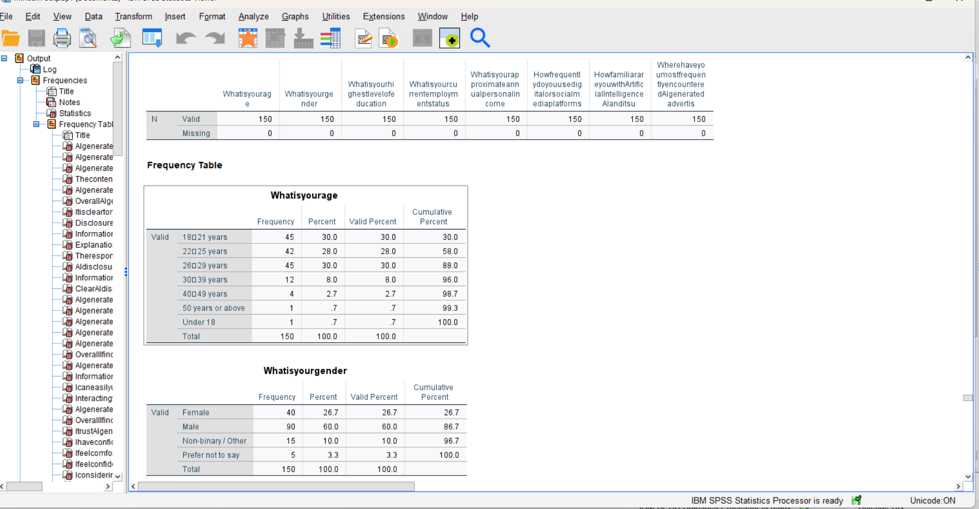

Appendix D: Questionnaire
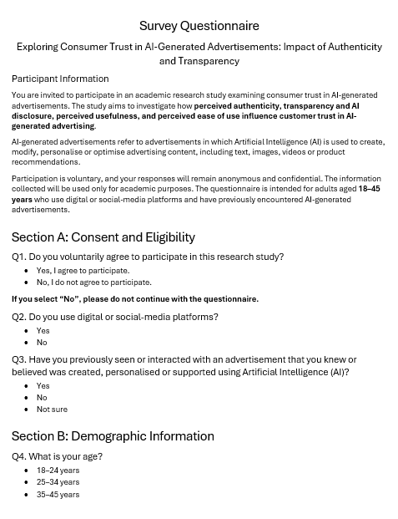
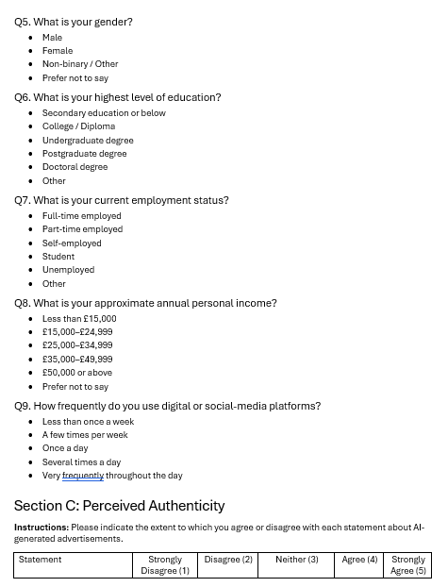
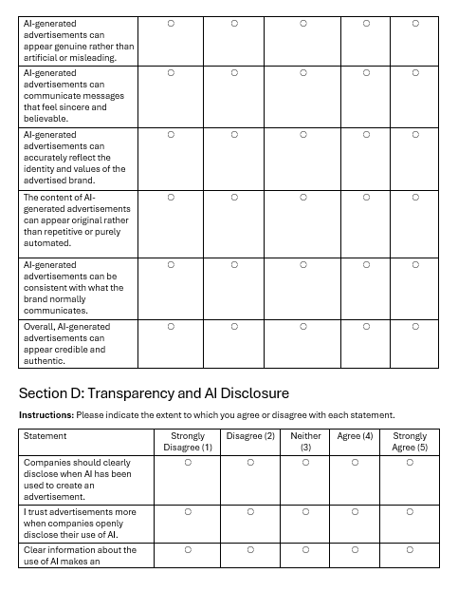
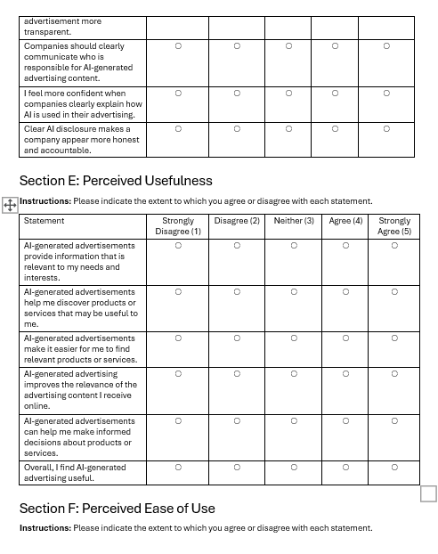
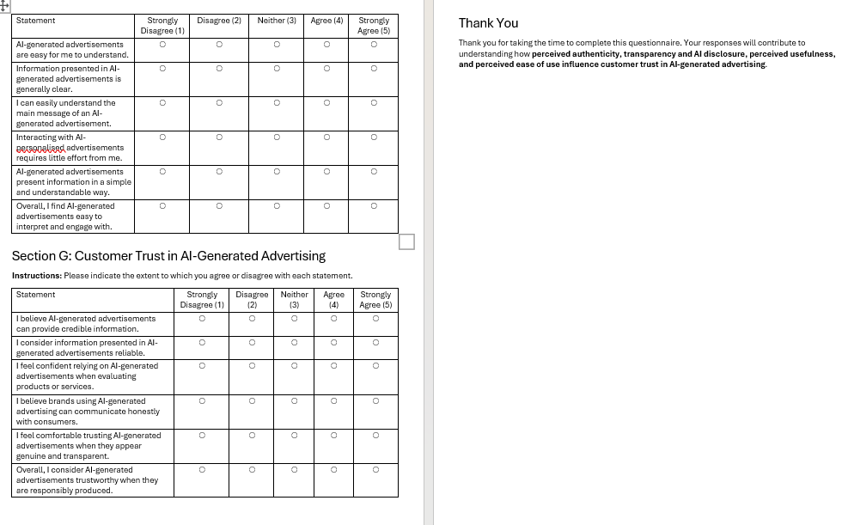

Appendix E: Ethics Form

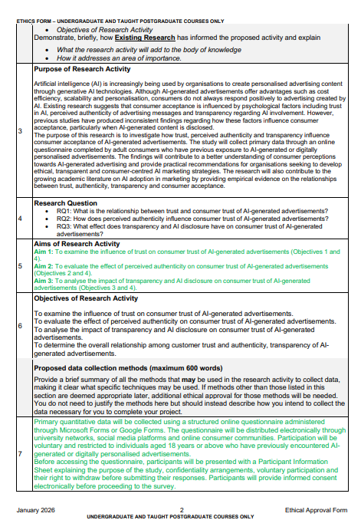
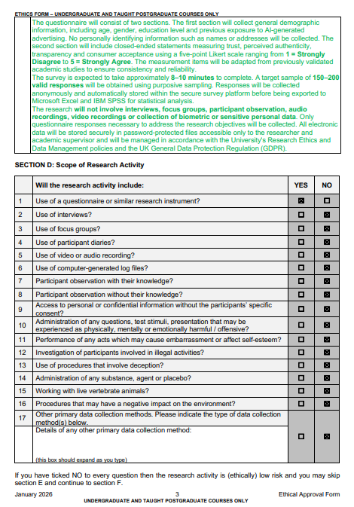
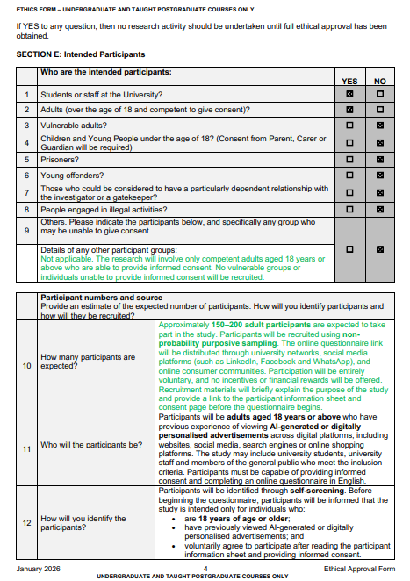
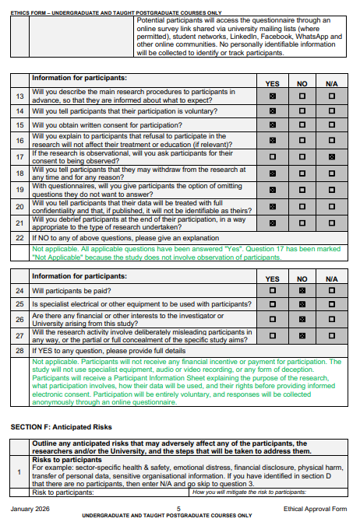
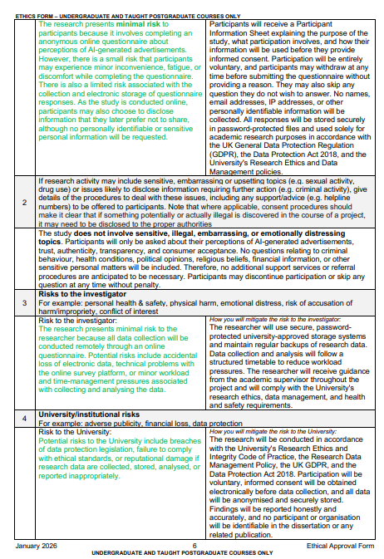
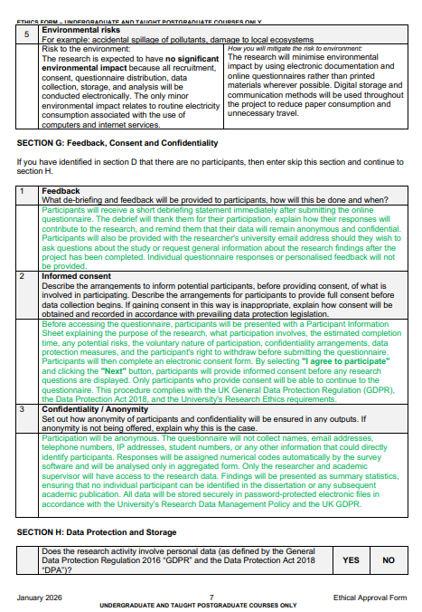
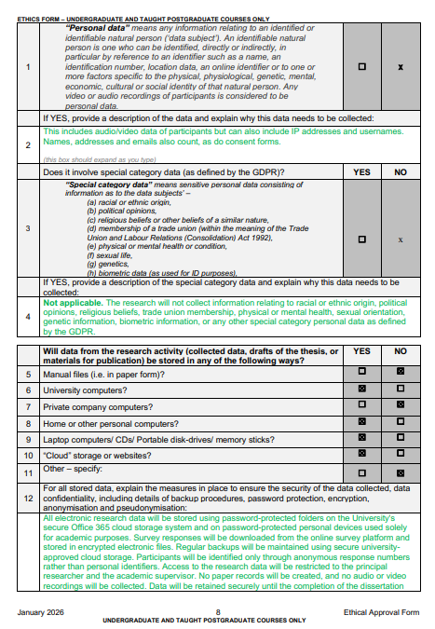
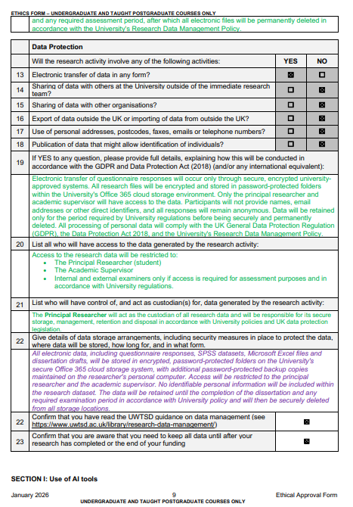


Appendix F: Participant Information Sheet
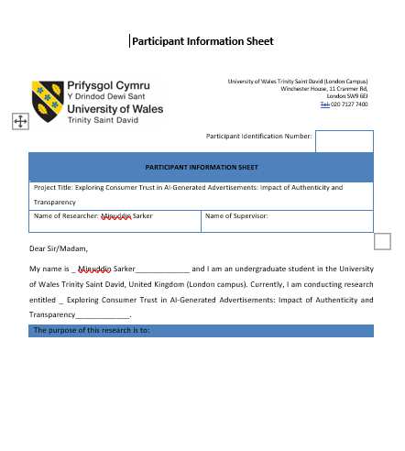
Dr Jean Wang
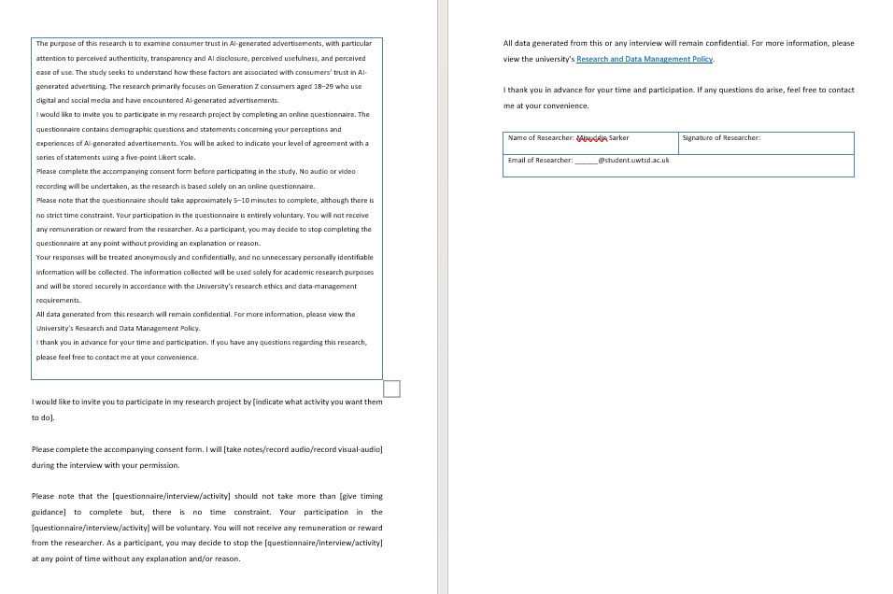

Appendix G: Consent Form
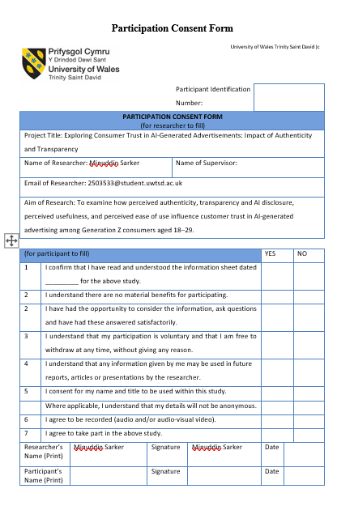
Dr Jean Wang


