
INTRODUCTION TO HEALTH AND SOCIAL CARE: MRS MANN CASE ANALYSIS
STUDENT ID:
STUDENT NAME:
Table of Contents
Introduction 3
Section 1: Importance of effective communication 3
Section 2: Importance of good administrative skills within professional practice in context to the case 5
Section 3: Importance of working collaboratively with other professionals in context to the case 7
Conclusion 8
Reference List 9

Introduction
Health and social care is all about providing essential support to the overall well-being based on their physical and mental wellness. Accordingly, this assignment is focused on the case study of Mrs Mann who was recently discharged from the hospital after her hip replacement surgery. After this she has been receiving medical services from the domiciliary care agency. Due to her lack of knowledge in English she has her daughter working as an interpreter.
This further creates a barrier to interact directly with Mrs Mann about her problems. In addition, there have been concerns where it was noted that she had inconsistent documentation and missed communication took place delaying her medical treatment. This case study further reveals how effective communication is important along with good administrative skills. Fahimeh Barghi Shirazi et al., (2024) share the idea on the importance of knowledge and skills that can be helpful for the upcoming administrators in the healthcare system. Likewise the administrator would get to learn about crisis management, communication and much more in terms of maintaining effectiveness in the social and health care giving practices. This study identifies the importance of effective communication and good administrative skills in context to Mrs Mann’s care.

Section 1: Importance of effective communication
Proper transfer of information is important between the healthcare workers and the patients. This is what forms trust between the two individuals making it easier for the patient to receive better care. Communication helps in forming proper bonds with the patients and forming therapeutic relationships that often benefit patient centred outcomes (Sharkiya, 2023). Berlo’s communication model is quite suitable in this case as it teaches appropriate methods to manage the communication system within any organisation. As stated by Muyanga, (2021) Berlo’s communication model shows how an organisation can deliver the right information to both internal and external public. For example, in multicultural schools often with proper framework of communication the organisation have to face issues to understand each other properly.
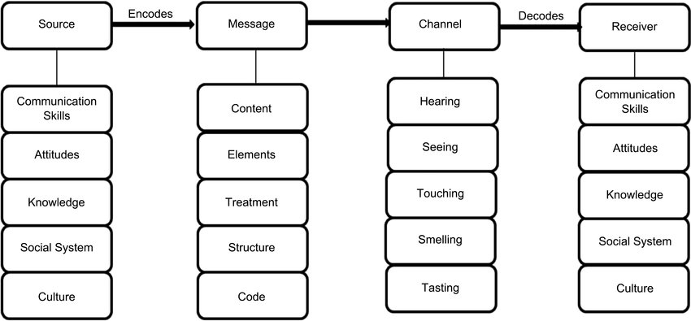
Figure 1: Berlo’s Communication model
(Source: Phiri, 2021)
In the case of Mrs Mann, she has a crucial language barrier due to her lack of knowledge in English and fluency in her native tongue. This gives a window to the challenges like misinterpreting her and misses any type of documentation system. The Berlo’s model identifies the perfect solution for issues like the language barrier faced by Mrs Mann. Kusumalatha, (2023) stated that there are mainly four components needed for better communication; Source, Message, Channel and Receiver; which builds two more elements that are feedback and Context. The above diagram from figure 1 identifies the four components but the major thing in this case is that the message will only reach the receiver when they hold the same features as the source. The health advisors in Mrs Mann can form a common ground and structure the message related to her treatment to form more clarity in communicating directly.
Based on this context, the Shannon Weaver model of communication can provide proper insights to solve the management issue related to communication and administrative skills. Antari et al. (2024) stated that based on several factors like patient empathy, patient physical and mental state can affect the message encoding system. Based on the theory, this can impact the information delivery channel, message decoding process and handle the feedback delivery system. Further adherence to the Equality Act 2010 will mandate reasonable adjustments for avoiding discrimination by using visual aids or interpreters besides involving Mrs. Mann's daughter in the translation process.
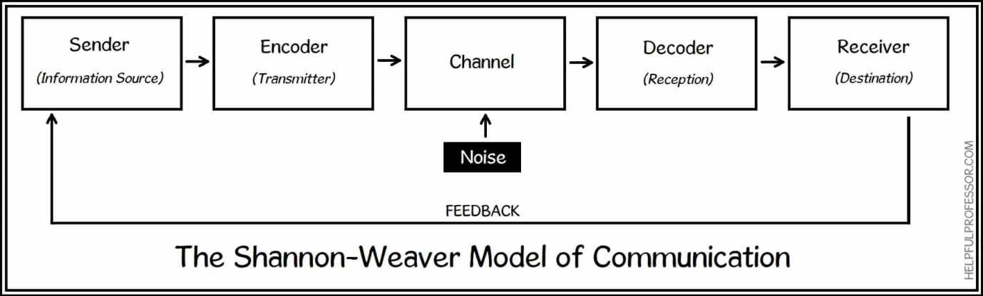
Figure 2: Shannon Weaver Model of communication
(Source: Self-developed)
Shannon's model also highlights the role of LLM (Large Language models) that often is used in the healthcare system. Geantă et al. (2024) stated that LLM can help the doctors to encode the use of complex oncological problems into more accessible language which potentially simplifies the treatment options and understanding to the patients. In the case of Mrs Mann the LLM model from Shannon’s model is beneficial as the health advisors can summarise the services that they are going to provide and interact with her directly. Elshin et al. (2024) shares the fact that the LLM model gives access to a large amount of high quality text in multilingual languages not only limited to English and Russian. The health advisors will be able to formulate a proper document for communicating with Mrs Mann directly. Based on both theories the Equality Act 2010 stands as the guardian to avoid any cultural biasing and maintain equal rights for her (Pyper and Uwazuruike, 2024). The Equality Act will give patients like Mrs Mann a proper opportunity to share her own feelings about the treatment and seek for satisfactory help regarding her health.

Section 2: Importance of good administrative skills within professional practice in context to the case
Documents needed in the professional practice of the healthcare system are important as it defines the history and current medical condition of the patient. In the modern world, data accuracy in the healthcare system has become a necessity as the rise of technical tools is increasing every day. Alowais et al. (2023) stated that the use of AI tools can reduce the cost, increase accuracy and save a lot of time. In the case of Mrs Mann the use of AI tools can help the care giver to arrange the documents without any error.
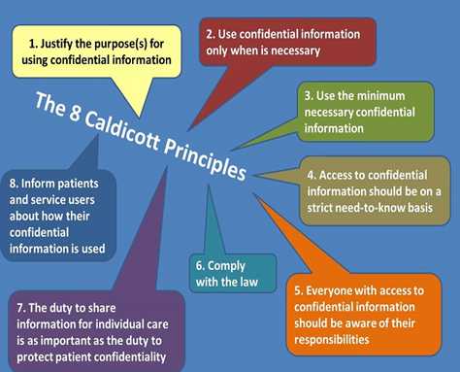
Figure 3: Caldicott principles
(Source: NHS, 2025)
Caldicott principles are based on 8 principles that are being applied to all the data collected with respect to the health care activities. Based on the principles, the data must be kept safe and arranged properly for further use (UK Government, 2025). For instance, Mrs Mann did face issues with the documentation system due to lack of knowledge the care giver had. The caregiver can focus on the principles and learn the methods of keeping the data safe. Data Protection Act 2018 can be implemented in case as it displays the set of data protection rules based on storage use and access to proper personal data (Davey et al., 2021). The Data Protection Act can be used to keep the data of Mrs Mann taken for medical purposes secure and private.
The care giver of Mrs Mann can go through the data rules to frame healthcare data security practices. In addition to this NMC codes maintain a good medical practice and practice methods that are scientifically proven to be effective when it comes to person cantered care approach. Delivering quality care and patient rights are the two things that are considered to be the major part of the NMC codes (NMC, 2023). In addition to this the caregiver of Mrs Mann can focus on proper training to improve his or her skill in the documentation process and creating boundaries to protect the data of the patient.
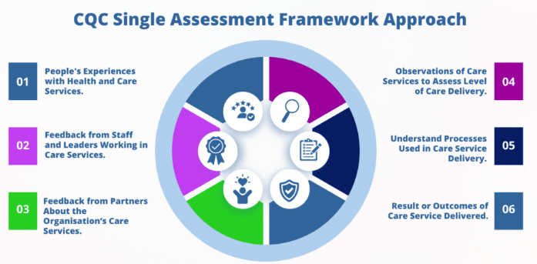
Figure 4: CQC framework system
(Source: Caring for Care, 2024)
The CQC system is focused on person-cantered care, proper visit, and showing dignity to the patient under treatment (Caring for Care, 2024). The caretaker of Mrs Mann can gain benefit from this by taking training on person cantered-care and improving the quality of care given in context to care management. Compliance to all the standards will help with domiciliary care records by detailing regular interventions, incidents concerning Mrs Mann’s condition.

Section 3: Importance of working collaboratively with other professionals in context to the case
The cross departmental approach can be effective as it gives people from different departments work together and shares their own ideas. Din et al. (2024) stated that cross-disciplinary collaboration within the healthcare system is the potential strategy to enhance patient outcomes and improve efficiency based on the care delivery system. In the case of Mrs Mann, the caregiver would be able to form a shared care plan and build specific goals with other caregivers from different departments for high quality service. In case of multi-agency working or collaborating with other departments there are different types of issues that Mrs Mann might be facing. The issues like the team of care givers not able to formulate the right plan or the caregivers not having sufficient patience to discuss the complex problems. There might be structural challenges and issues regarding cultural practices which can have negative impact on Mrs Mann’s services as with lack of structure the care giver would not have a definite goal to work on.
Jørgensen et al. (2025) stated that there are barriers related to the collaboration system and structural challenges like problems regarding the legislative and funding mechanisms. Mrs Mann might have to face an issue as the care giver would fail to make a proper plan for her. The mentioned issue can be mitigated with proper training. The care giver can be provided short term training on how to handle patients like Mrs Mann. A team of collaborating care givers can be taught to handle the resources properly and make a shared care plan for the patient. Henceforth Caldicott principles can be used in this case to teach the healthcare givers to collaborate and form a better plan for taking care of the patients.

Conclusion
The above analysis suggests that Mrs Mann needs a proper cross departmental team who would have multiple skills to handle a patient like her. The communication and administrative issues can be mitigated with the use of Caldicott principles. The principles give structured ideas on the goal of healthcare plans and protect the data based on online end-to-end encryption initiatives. Caldicott principles can be considered to be the beneficial practice that the caregiver should work on and based on which they can gain training to work with people from different departments. Thus it can be concluded that multi-agency or cross departmental collaboration can help Mrs Mann form a proper network of communication and recover from her current health issues.

Reference List
Alowais, S.A., Alghamdi, S.S., Alsuhebany, N., Alqahtani, T., Alshaya, A.I., Almohareb, S.N., Aldairem, A., Alrashed, M., Bin Saleh, K., Badreldin, H.A. and Al Yami, M.S., (2023). Revolutionizing healthcare: the role of artificial intelligence in clinical practice. BMC medical education, 23(1), p.689. https://link.springer.com/article/10.1186/s12909-023-04698-z
Antari, N.P.U., Hastama, R., Noviyanti, A.A.V. and Juanita, R.A., (2024). Enablers and Barriers to Effective Communication about Drug Information: A Qualitative Study. Indonesian Journal of Pharmacy, pp.340-354.https://journal.ugm.ac.id/v3/IJP/article/view/6620
Caring for Care (2024). CQC Single Assessment Framework (SAF) | Caring For Care. [online] Caring For Care. Available at: https://caringforcare.co.uk/cqc-single-assessment-framework/ (Accessed: 14 November, 2025)
Davey, M.G., O’Donnell, J.P.M., Maher, E., McMenamin, C., McAnena, P.F., Kerin, M.J., Miller, N. and Lowery, A.J. (2021). General data protection regulations (2018) and clinical research: perspectives of patients and doctors in an Irish university teaching hospital. Irish Journal of Medical Science (1971 -), [online] 191(4). Available at: https://pmc.ncbi.nlm.nih.gov/articles/PMC9308580/ (Accessed: 14 November, 2025) .
Din, B.R.U., Anjum, F. and Malik, A., (2024). Cross-disciplinary collaboration in healthcare: Enhancing outcomes through team-based care. Multidisciplinary Journal of Healthcare (MJH), 1(1), pp.11-19. https://www.researchcorridor.org/index.php/mjh/article/view/43
Drew, C. (2023). 7 Key Concepts | the Shannon-Weaver Model of Communication. [online] The Helpful Professor. Available at: https://helpfulprofessor.com/shannon-weaver-model/ (Accessed: 14 November, 2025) .
Elshin, D., Karpachev, N., Gruzdev, B., Golovanov, I., Ivanov, G., Antonov, A., Skachkov, N., Latypova, E., Layner, V., Enikeeva, E. and Popov, D., (2024), November. From general LLM to translation: How we dramatically improve translation quality using human evaluation data for LLM finetuning. In Proceedings of the Ninth Conference on Machine Translation (pp. 247-252).https://aclanthology.org/2024.wmt-1.17/
Fahimeh Barghi Shirazi, Maryam Soleimani Movahed, Shandiz Moslehi, Mohammad Barzegar Rahatlou and Hesam Seyedin (2024). Knowledge and Skills Needed for Future Health Administrators: A Systematic Review. Iranian journal of public health. [online] https://doi.org/10.18502/ijph.v53i5.15582.
Geantă, M., Bădescu, D., Chirca, N., Nechita, O.C., Radu, C.G., Rascu, S., Rădăvoi, D., Sima, C., Toma, C. and Jinga, V., (2024), August. The potential impact of large language models on doctor–patient communication: A case study in prostate cancer. In Healthcare (Vol. 12, No. 15, p. 1548). MDPI.https://www.mdpi.com/2227-9032/12/15/1548
Jørgensen, K., Jørgensen, K.B. and Karlsson, B. (2025). Cross-Sectoral Collaboration Between Mental Health Hospitals and Municipalities: A Scoping Review. Issues in Mental Health Nursing, [online] pp.1–15. Available at: https://www.tandfonline.com/doi/full/10.1080/01612840.2025.2478419?scroll=top&needAccess=true#abstract (Accessed: 14 November, 2025) .
Kusumalatha, D.V., (2023). Extension Communication Models and Strategies. Chief Editor, 41.https://www.researchgate.net/profile/Tanvi-Sharma-29/publication/378067789_Economic_Problems_and_Financial_Support_to_Elderly_Women_in_Rural_and_Urban_Areas_of_Haryana/links/65c4e7661bed776ae3379b8b/Economic-Problems-and-Financial-Support-to-Elderly-Women-in-Rural-and-Urban-Areas-of-Haryana.pdf#page=47
Muyanga, C.C., (2021). Assessment of effective communication in international schools in Lusaka based on BERLO'S SMCR MODEL (Doctoral dissertation, The University of Zambia).https://dspace.unza.zm/items/f445fb63-b8af-41a9-a48d-056a6dc9429e
NHS (2025). Caldicott Guardian. [online] Shropscommunityhealth.nhs.uk. Available at: https://www.shropscommunityhealth.nhs.uk/caldicott-guardian (Accessed: 14 November, 2025).
NMC (2023). NMC GROUP CODE OF CONDUCT AND ETHICS. [online] Available at: https://nmc.ae/assets/NMCCodeofConduct_2023_online_HL.pdf (Accessed: 14 November, 2025)
Phiri (2021). Assessment of Effective Communication in International Schools in Developing Countries Based on the Berlo’s SMCR Model. [online] Available at: https://www.researchgate.net/figure/Berlos-SMCR-Model-1960_fig1_348841548 (Accessed: 14 November, 2025)
Pyper, D. and Uwazuruike, A. (2024). A short introduction to equality law. [online] House of Commons Library. Available at: https://commonslibrary.parliament.uk/research-briefings/cbp-9448/ (Accessed: 14 November, 2025)
Sharkiya, S.H. (2023). Quality communication can improve patient-centred health outcomes among older patients: A rapid review. BMC Health Services Research, [online] 23(1), pp.1–14. https://doi.org/10.1186/s12913-023-09869-8
UK Government (2025). The Caldicott Principles. [online] GOV.UK. Available at: https://www.gov.uk/government/publications/the-caldicott-principles (Accessed: 14 November, 2025)

