Moise-Alex Stoican
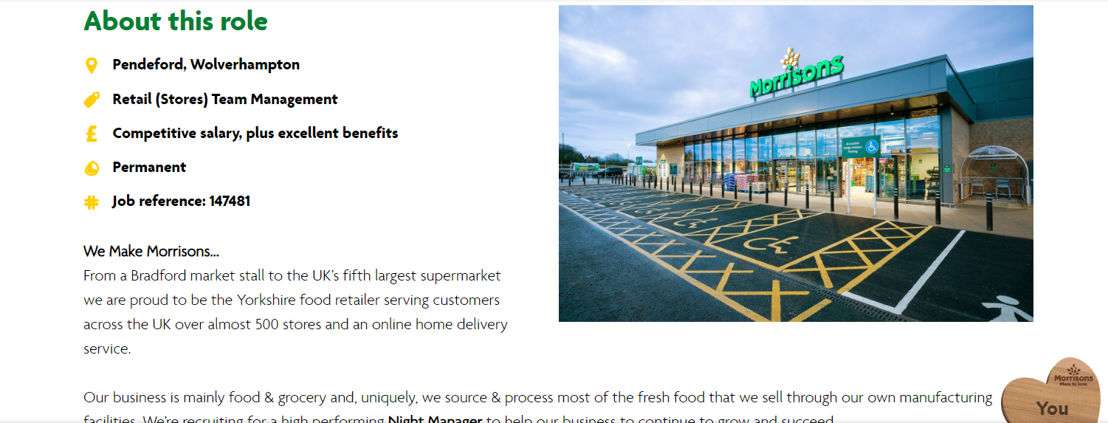
https://www.morrisons.jobs/jobs/night-manager-in-wolverhampton.11331

Moise-Alex Stoican
Morrisons Manager
Summary
I am an enthusiastic and motivated individual excited to apply for the Night Manager position at Morrison’s. Although I am early in my management career, I bring strong customer service skills, a proactive attitude, and a willingness to learn.In previous roles, I have gained experience in team collaboration, problem-solving, and handling customer needs in fast-paced environments. I am confident in my ability to manage store operations and maintain high standards during the night shift.I am eager to contribute to Morrison’s reputation for excellent service while continuing to develop my leadership skills in a supportive environment.
During my time at Morrison’s, I gained valuable experience working night shifts, where I managed restocking, inventory checks, and ensured store standards were met. I handled customer queries, resolved issues efficiently, and ensured smooth handovers to the morning team. This role strengthened my problem-solving, leadership, and communication skills, preparing me for the Night Manager position.
Education
- GCSEs (or equivalent) – including English and Maths.
- Relevant Retail/Management training ( NVQ Level 2/3).
- Health & Safety / First Aid certification
- Any relevant Leadership or Customer Service training.

Key Skills:
- Leadership: Managing and motivating teams.
- Communication: Clear staff coordination and customer service.
- Problem-Solving: Resolving issues quickly and effectively.
- Time Management: Prioritizing tasks efficiently.
- Customer Service: Ensuring a positive customer experience.
- Health & Safety: Maintaining a safe environment.
- Stock Management: Overseeing inventory and restocking.
Reference: Available on Request

Hiring Manager
Morrison’s [Wolverhampton ]
Dear Hiring Manager,
I am writing to express my interest in the Night Manager position at Morrison’s. As a motivated and dedicated individual with experience in retail and customer service, I am eager to bring my leadership and problem-solving skills to your team.
In my previous roles, I have developed strong communication, team management, and time management skills, which are crucial for overseeing store operations during night shifts. I am confident in my ability to manage inventory, supervise staff, and ensure high standards of customer service, even during quieter, off-peak hours.
What excites me about working for Morrison’s is the company’s commitment to providing excellent customer service, as well as its reputation for supporting staff development. I am enthusiastic about the opportunity to contribute to this environment, ensuring that the store operates smoothly overnight while maintaining a positive experience for both customers and team members.
I would welcome the opportunity to discuss how my skills and experiences align with your needs for this role. Thank you for considering my application. I look forward to the possibility of joining the Morrison’s team.
Sincerely,
[Moise-Alex Stoican]

