Project Planning for Construction (ACBA5025)
Project Risk Management
Produced For- Rhodri Thomas
By- Thomas Caddell (221714)

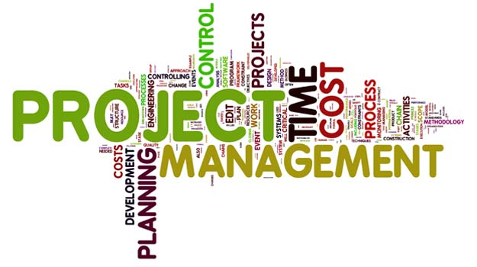

1) Introduction 3
1.1) Introduction to Risk Management in Construction 3
2) Quality in Risk Management 4
2.1) Identifying Quality Risks in Construction 4
2.2) Assessing and Analysing Quality Risks 5
2.3) Mitigating Quality Risks 6
2.4) Monitoring and Continuous Improvement 7
3) Environmental Risk Management in Construction 8
3.1) Types of Environmental Risks in Construction 8
3.2) Strategies for Managing Environmental Risks 10
3.3) Regulatory Compliance and Best Practices 11
4) Risk Management in Construction: Focus on Health & Safety 12
4.1) Identifying Health and Safety Risks 12
4.2) Assessing and Controlling Risks 13
4.3) Training and Safety Culture 13
4.4) Technology in Health and Safety Risk Management 14
4.5) Regulatory Compliance and Legal Considerations 14
5) Conclusion 15
References 16

1) Introduction

1.1) Introduction to Risk Management in Construction
Risk management is a critical aspect of construction project management, ensuring that potential threats to project success are identified, assessed, and mitigated. The construction industry is inherently risky due to its complexity, long timelines, financial investments, and reliance on multiple stakeholders. Risks can arise from various sources, including design errors, material shortages, labour disputes, weather conditions, regulatory changes, and unforeseen site conditions. Failure to address these risks can lead to project delays, cost overruns, legal disputes, and even safety hazards. (Villanueva, 2023) (Malsam, 2024)
Effective risk management in construction follows a structured process that involves identifying risks, analysing their likelihood and impact, developing response strategies, and monitoring risks throughout the project lifecycle. Risk identification requires input from engineers, architects, contractors, and clients to ensure that all potential hazards are considered. Once risks are identified, they are analysed based on their probability and severity, allowing project teams to prioritize which risks require immediate attention. (Kenton, 2024) (Ellis, 2021)
There are several strategies for managing construction risks, including risk avoidance, transfer, mitigation, and acceptance. Avoidance involves changing project plans to eliminate a risk, while transfer shifts the risk to another party, such as through insurance or subcontracting. Mitigation involves taking proactive steps to reduce the likelihood or impact of a risk, such as improving safety training or using more durable materials. In some cases, project teams may accept a risk if its impact is minimal or if mitigation costs outweigh the potential damage. (Schwartz, 2025)
Technology and data analytics have also enhanced risk management in construction, with tools such as Building Information Modelling (BIM), artificial intelligence, and predictive analytics helping project managers foresee and address risks more effectively. By integrating risk management into every phase of a construction project, stakeholders can improve efficiency, reduce financial losses, and ensure the successful completion of projects. (CIOB, 2022)

2) Quality in Risk Management
Quality risk management is a crucial aspect of construction project management, ensuring that projects meet required standards, comply with regulations, and fulfil client expectations. Poor quality in construction can lead to structural failures, costly rework, safety hazards, legal disputes, and reputational damage. Therefore, identifying, assessing, and mitigating quality-related risks is essential for the successful completion of any construction project. (H+M Industrial, 2021)

2.1) Identifying Quality Risks in Construction
Quality risks in construction can arise from various sources, including design flaws, substandard materials, poor workmanship, inadequate supervision, and ineffective project planning. Some common quality risks include:
- Design Deficiencies: Errors in architectural or engineering designs can result in construction defects, requiring costly modifications or leading to safety hazards.
- Material Defects: Using low-quality or non-compliant materials can compromise the durability and performance of a structure.
- Workmanship Issues: Poor construction techniques due to unskilled labour, lack of training, or inadequate supervision can affect the quality of the final product.
- Non-Compliance with Standards: Failing to adhere to building codes, industry standards, or client specifications can result in legal issues and project delays.
- Lack of Quality Control Processes: Without proper inspections, testing, and quality assurance measures, defects may go unnoticed until they cause significant problems.
(ConSIG CWG, 2022) (Sravya, 2023)

2.2) Assessing and Analysing Quality Risks
Once quality risks are identified, they need to be assessed based on their likelihood and potential impact. A risk assessment matrix is often used to categorize risks as low, medium, or high priority. High-priority risks require immediate mitigation, while lower-priority risks are monitored to ensure they do not escalate; as seen in the supporting figures below-
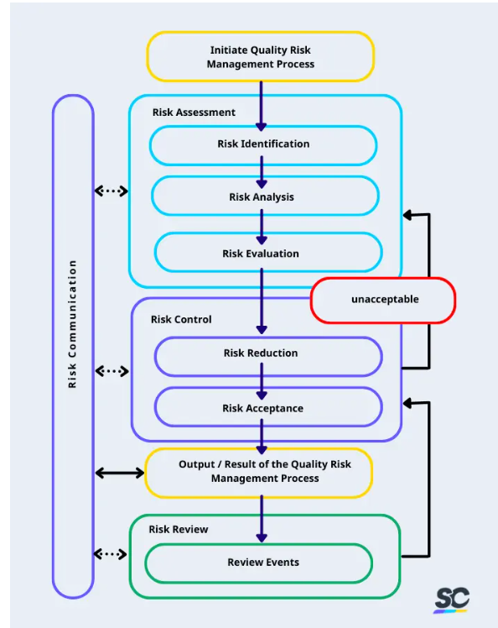
Figure 2- Matrix- (Safety Culture Content Team, 2024)
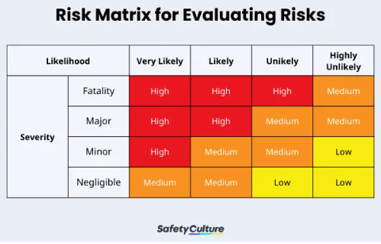
Figure 1- Process- (Safety Culture Content Team, 2024)

2.3) Mitigating Quality Risks
Several strategies can be employed to minimize quality-related risks in construction:
- Comprehensive Design Reviews
Conducting thorough design reviews and peer checks before construction begins helps identify potential issues early. Using Building Information Modelling (BIM) can assist in detecting design clashes and inconsistencies.

- Strict Material Selection and Testing
Ensuring that all materials meet industry standards and conducting quality tests before use can prevent failures and defects. Suppliers should be vetted to ensure they provide certified and durable materials.

- Skilled Workforce and Training
Employing qualified professionals and providing continuous training to workers helps improve workmanship quality. Proper training on the use of tools, equipment, and construction techniques enhances precision and reduces errors.

- Quality Control Inspections and Audits
Regular site inspections, third-party audits, and non-destructive testing (NDT) help in identifying defects early. Implementing a robust quality assurance (QA) and quality control (QC) process ensures adherence to project specifications.

- Clear Communication and Documentation
Well-documented construction plans, specifications, and quality checklists help maintain consistency in execution. Clear communication between project stakeholders, including architects, engineers, contractors, and clients, helps prevent misunderstandings that could lead to quality issues.

- Use of Technology in Quality Management
Digital tools such as drones, artificial intelligence (AI), and construction management software enable real-time monitoring of construction quality. Predictive analytics can also help forecast potential quality risks and address them proactively.
(Safety Culture Content Team, 2024) (Milestone PLM Solutions, 2024)

2.4) Monitoring and Continuous Improvement
Quality risk management is an ongoing process throughout the construction lifecycle. Regular performance evaluations, feedback mechanisms, and lessons learned from past projects help improve future quality standards. Implementing a culture of quality within an organization ensures that all team members are committed to maintaining high standards.
By integrating robust quality risk management practices, construction firms can reduce rework, enhance safety, improve project efficiency, and ensure client satisfaction.

3) Environmental Risk Management in Construction
Environmental risk management is a crucial aspect of construction project planning and execution. The construction industry significantly impacts the environment through land use, resource consumption, emissions, and waste generation. Failing to manage environmental risks properly can result in regulatory penalties, project delays, reputational damage, and long-term ecological consequences. Therefore, construction companies must adopt proactive strategies to identify, assess, and mitigate environmental risks throughout the project lifecycle. (Construction Leaders, 2022)

3.1) Types of Environmental Risks in Construction
- Soil and Water Contamination
Construction activities such as excavation, drilling, and material storage can lead to soil and water contamination. Hazardous substances like oil, chemicals, and construction waste can seep into the ground, polluting local water sources and harming ecosystems.
- Air Pollution and Dust Emissions
Heavy machinery, transportation, and construction processes generate significant air pollution, including dust, particulate matter, and emissions from diesel engines. Poor air quality can impact worker health and the surrounding community while contributing to global climate change.
- Waste Management Issues
Construction generates large amounts of waste, including concrete, wood, metals, and plastics. Improper disposal of waste materials can lead to landfill overflow, pollution, and resource depletion. Sustainable waste management strategies, such as recycling and reusing materials, are essential for minimizing environmental impact.
- Biodiversity Loss and Habitat Destruction
Clearing land for construction can destroy natural habitats, leading to loss of biodiversity. Protected species may be displaced, and local ecosystems may suffer long-term damage. Construction firms must conduct environmental impact assessments to avoid disrupting sensitive areas.
- Climate Change and Extreme Weather Events
Construction projects are increasingly vulnerable to climate change risks, including extreme weather events such as floods, hurricanes, and heatwaves. Rising temperatures can also impact material durability, worker safety, and project timelines. (Edgell, 2020)
Figure 3 below visually shows the impact the environment has upon risk management in constriction; showing remediation costs against cubic yards and how soil contaminants can have a clear impact on costs within a project. As we can see Excavation of hazardous materials is 0.5 times greater than non-hazardous materials.

Figure 3- Cost against yards of material- (Environmental Risk Professionals, 2020)
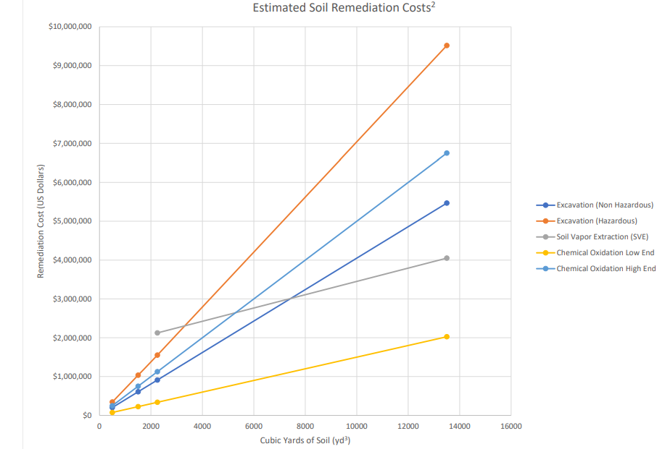

3.2) Strategies for Managing Environmental Risks
- Environmental Impact Assessments (EIA)
Before beginning a project, an Environmental Impact Assessment (EIA) should be conducted to evaluate potential environmental risks. This process helps identify areas of concern and develop mitigation strategies to minimize damage.
- Sustainable Construction Practices
Using eco-friendly materials, energy-efficient machinery, and green building techniques can reduce environmental harm. Strategies such as rainwater harvesting, solar panel installation, and sustainable sourcing of materials contribute to a lower carbon footprint.
- Pollution Control Measures
  - Dust Suppression: Water spraying, dust barriers, and covering materials can minimize airborne dust.
  - Emission Reduction: Using low-emission vehicles, electric equipment, and alternative fuels can decrease air pollution.
  - Water Protection: Installing sediment barriers and proper drainage systems prevents pollutants from entering water bodies

- Waste Reduction and Recycling
Implementing a waste management plan ensures efficient use of resources. Strategies include:
  - Reusing materials like concrete, bricks, and metals.
  - Partnering with recycling facilities.
  - Adopting modular construction techniques to minimize on-site waste.

- Biodiversity Protection
Construction near environmentally sensitive areas require careful planning. Measures such as relocating wildlife, preserving green spaces, and restoring damaged ecosystems help mitigate biodiversity loss.

- Climate Adaptation and Resilience
To address climate-related risks, construction firms should design infrastructure that withstands extreme weather. This includes using flood-resistant materials, heat-resistant coatings, and robust drainage systems to prevent water damage.
(Strong, 2024) (Newman, 2024)

3.3) Regulatory Compliance and Best Practices
In the UK, environmental risk management in construction must comply with regulations such as the Environmental Protection Act 1990 and the Construction (Design and Management) Regulations 2015. Best practices include conducting Environmental Impact Assessments (EIAs), implementing waste management plans, controlling emissions and runoff, and following guidance from the Environment Agency to ensure sustainable and legally compliant project delivery. (Hodgson, et al., 2022) (Contrasol, 2023)

4) Risk Management in Construction: Focus on Health & Safety
Risk management in construction is essential for ensuring the health and safety of workers, stakeholders, and the public. Due to the nature of construction work, which often involves heavy machinery, working at heights, exposure to hazardous materials, and physically demanding tasks, health and safety risks are among the most significant concerns in the industry. Without proper risk management, accidents, injuries, and even fatalities can occur, leading to financial losses, legal liabilities, and reputational damage for construction firms. (HSE, 2024) (Mckinnon, 2024)

4.1) Identifying Health and Safety Risks
The first step in risk management is identifying potential health and safety hazards on-site. Common risks include:
- Falls from Heights – Working on scaffolding, ladders, or rooftops presents a high risk of falls, which can cause severe injuries or fatalities.
- Struck-By Accidents – Workers can be hit by moving vehicles, falling tools, or heavy equipment if proper safety measures are not in place.
- Electrical Hazards – Exposed wiring, faulty equipment, and improper handling of electrical components can lead to electrocution.
- Manual Handling Injuries – Lifting, carrying, or moving heavy materials can result in musculoskeletal disorders.
- Exposure to Hazardous Substances – Dust, chemicals, asbestos, and other materials can cause respiratory problems and long-term health issues.
(Chazal, 2025) (Russell, 2024) (HSE, 2024)

4.2) Assessing and Controlling Risks
Once risks are identified, they must be analysed based on their likelihood and severity. Risk assessments help prioritize which hazards require immediate action. Control measures are then implemented using the Hierarchy of Controls, which includes:
- Elimination – Removing the hazard entirely (e.g., using prefabricated components to reduce on-site work at heights).
- Substitution – Replacing hazardous materials or processes with safer alternatives.
- Engineering Controls – Implementing physical barriers, safety nets, guardrails, or ventilation systems to minimize exposure.
- Administrative Controls – Establishing safety policies, training programs, and clear procedures to reduce risks.
- Personal Protective Equipment (PPE) – Providing helmets, gloves, harnesses, and masks to protect workers when other controls are insufficient.

4.3) Training and Safety Culture
A strong safety culture is essential for risk management in construction. Employers must ensure workers receive proper training on hazard recognition, safe work procedures, and emergency response. Toolbox talks, safety briefings, and continuous learning initiatives help reinforce best practices. Encouraging workers to report hazards and near-misses fosters a proactive safety culture, preventing accidents before they occur.
(HSE, 2024) (ConSIG CWG, 2022)

4.4) Technology in Health and Safety Risk Management
Advancements in technology have significantly improved health and safety risk management in construction. Some key innovations include:
- Building Information Modelling (BIM) – Helps identify safety hazards during the planning phase by simulating site conditions.
- Drones – Used for site inspections, reducing the need for workers to access dangerous areas.
- Wearable Technology – Smart helmets, vests, and sensors monitor workers’ health and detect potential hazards in real time.
- AI and Predictive Analytics – Analyses historical data to predict potential risks and recommend preventive measures.
(Plan Radar, 2023) (Westmorland, 2024)

4.5) Regulatory Compliance and Legal Considerations
Construction firms must comply with health and safety regulations, such as the Occupational Safety and Health Administration (OSHA) standards in the U.S. or the Construction (Design and Management) Regulations (CDM) in the U.K. Regular audits, inspections, and documentation ensure compliance and help identify areas for improvement.
By prioritizing health and safety risk management, construction companies can protect workers, reduce accidents, and improve overall project efficiency, creating a safer and more productive work environment.
(CITB, 2023) (Bilding Safety Wiki, 2024)

5) Conclusion
Health and safety risk management is not just a regulatory obligation in construction—it is a fundamental responsibility that directly impacts the well-being of workers, project success, and the reputation of construction firms. Given the high-risk nature of construction activities, proactive and systematic management of health and safety risks is essential to prevent injuries, illnesses, and fatalities on site. Through careful identification, assessment, and control of hazards, companies can significantly reduce the likelihood of accidents and foster a safer working environment.
Implementing a comprehensive risk management strategy involves more than just compliance; it requires cultivating a strong safety culture, investing in training, and engaging workers at all levels. When employees are educated, informed, and empowered to report unsafe conditions, the entire project benefits from a more vigilant and responsible workforce. Moreover, technological advancements such as BIM, drones, wearables, and predictive analytics offer powerful tools to enhance safety monitoring and decision-making, allowing for earlier intervention and more efficient control measures.
Ultimately, managing health and safety risks in construction leads to tangible benefits: reduced downtime, fewer legal disputes, lower insurance costs, and improved worker morale and productivity. It also demonstrates a company’s commitment to ethical practices and social responsibility. By embedding safety into every phase of the construction process; from planning and design to execution and completion organisations not only meet legal requirements but also contribute to a more sustainable and considerate construction industry. Effective health and safety risk management is, therefore, both a strategic advantage and a moral imperative.

References
Bilding Safety Wiki, 2024. CDM 2015. [Online]
Available at: https://www.designingbuildings.co.uk/wiki/CDM_2015
[Accessed 02 May 2025].
Chazal, E., 2025. Health & Safety in Construction: All You Need to Know. [Online]
Available at: https://www.skillcast.com/blog/health-safety-construction-everything-you-need-know
[Accessed 28 April 2025].
CIOB, 2022. Risk management. [Online]
Available at: https://www.designingbuildings.co.uk/wiki/Risk_management
[Accessed 10 April 2025].
CITB, 2023. Construction (Design and Management) Regulations. [Online]
Available at: https://www.citb.co.uk/about-citb/partnerships-and-initiatives/construction-design-and-management-regulations-2015/cdm-regulations/
[Accessed 02 May 2025].
ConSIG CWG, 2022. Risk assessment. [Online]
Available at: https://www.designingbuildings.co.uk/wiki/Risk_assessment:_a_quality_perspective
[Accessed 11 April 2025].
Construction Leaders, 2022. INTRODUCTION TO QUALITY RISK MANAGEMENT AND CONSTRUCTION DEFECTS. [Online]
Available at: https://constructionleaders.in/introduction-to-quality-risk-management-and-construction-defects/
[Accessed 12 April 2025].
Contrasol, 2023. Environmental Regulations in the Construction Industry. [Online]
Available at: https://www.contrasol.com/blog/environmental-regulations-in-the-construction-industry/
[Accessed 16 April 2025].
Edgell, P., 2020. Environmental risks in construction projects. [Online]
Available at: https://www.pbctoday.co.uk/news/planning-construction-news/environmental-risks-in-construction-projects/81868/
[Accessed 12 April 2025].
Ellis, G., 2021. Top 6 Construction Risks – And How to Reduce Them. [Online]
Available at: https://www.autodesk.com/blogs/construction/reduce-construction-risks/
[Accessed 10 April 2025].
Environmental Risk Professionals, 2020. Managing Environmental Risk in the Construction Industry. [Online]
Available at: https://www.envriskpros.com/Content/Doc/Managing-Environmental-Risk-in-the-Construction-Industry.pdf
[Accessed 12 April 2025].
H+M Industrial, 2021. Managing Quality Risks in Construction. [Online]
Available at: https://www.hm-ec.com/blog-posts/managing-quality-risks-in-construction-hm
[Accessed 11 April 2025].
Hodgson, F., Essen, M. & Coxon, H., 2022. Construction Waste and the Environment Act 2021. [Online]
Available at: https://www.womblebonddickinson.com/uk/insights/articles-and-briefings/rebuild-construction-waste-environment-act-2021
[Accessed 16 April 2025].
HSE, 2024. Construction health risks: Key points. [Online]
Available at: https://www.hse.gov.uk/construction/healthrisks/key-points.htm
[Accessed 28 April 2025].
HSE, 2024. Managing construction health risks: Control. [Online]
Available at: https://www.hse.gov.uk/construction/healthrisks/managing-essentials/control-the-risks.htm
[Accessed 16 April 2025].
Kenton, W., 2024. What Is Risk Management in Finance, and Why Is It Important?. [Online]
Available at: https://www.investopedia.com/terms/r/riskmanagement.asp
[Accessed 10 April 2025].
Malsam, W., 2024. Construction Risk Management: An Introduction. [Online]
Available at: https://www.projectmanager.com/blog/construction-risk-management
[Accessed 10 April 2025].
Mckinnon, I., 2024. The CHAS Guide To Risk Management In Construction. [Online]
Available at: https://www.chas.co.uk/blog/chas-guide-risk-management-construction/
[Accessed 16 April 2025].
Milestone PLM Solutions, 2024. A Comprehensive Construction Risk Management Toolkit. [Online]
Available at: https://www.designingbuildings.co.uk/wiki/A_Comprehensive_Construction_Risk_Management_Toolkit
[Accessed 11 April 2025].
Newman, O., 2024. How to Complete an Environmental Risk Assessment. [Online]
Available at: https://www.astutis.com/astutis-hub/blog/environmental-risk-assessment-guide
[Accessed 12 April 2025].
Plan Radar, 2023. Tech-optimized construction risk management: Maximizing project success. [Online]
Available at: https://www.planradar.com/sa-en/construction-risk-management-technology-optimisation/#:~:text=Digital%20tools%20such%20as%20construction,evaluation%2C%20analysis%2C%20and%20control.
[Accessed 02 May 2025].
Russell, J., 2024. Managing Health and Safety in the Construction Industry. [Online]
Available at: https://www.british-assessment.co.uk/insights/managing-health-and-safety-in-the-construction-industry/
[Accessed 28 April 2025].
Safety Culture Content Team, 2024. A Guide on Quality Risk Management (QRM). [Online]
Available at: https://safetyculture.com/topics/quality-risk-management/
[Accessed 11 April 2025].
Schwartz, B., 2025. The Risk Management Process in Project Management. [Online]
Available at: https://www.projectmanager.com/blog/risk-management-process-steps
[Accessed 10 April 2025].
Sravya, 2023. How Construction Risk Management Contributes to Quality Assurance. [Online]
Available at: https://www.tocobrick.com/blog/quality-assurance-in-construction/
[Accessed 11 April 2025].
Strong, C., 2024. Mitigating environmental risk in construction. [Online]
Available at: https://www.wtwco.com/en-gb/insights/2024/09/mitigating-environmental-risk-in-construction
[Accessed 12 April 2025].
Villanueva, E., 2023. Risk Management 101: Process, Examples, Strategies. [Online]
Available at: https://auditboard.com/blog/risk-management-101
[Accessed 10 April 2025].
Westmorland, J., 2024. Construction risk management: The tech advantage. [Online]
Available at: https://www.constructiondive.com/spons/construction-risk-management-the-tech-advantage/713513/
[Accessed 02 May 2025].

