

RESULT

BACHELORS DEGREE ASSIGNMENT SPECIFICATION

Student name: | Matteo Grattarola | Student P number: | 2011667
Programme: | Built Environment Programmes – Level 4. BSc (Hons) Construction Management; BSc (Hons) Quantity Surveying; BSc (Hons) Building Surveying; BSc (Hons) Civil Engineering. HNC and HND pathways.
Module: | Managing Health, Safety and Welfare in Construction | Module Level (4, 5, 6): | 4
Module code: | ACBA4003 | Contribution to Overall  Module Assessment (%): | 50%
Lecturer: | Dr Deborah Hughes | Internal Verifier: | Allan Nantel
Assignment Title: | Managing Health and Safety in a project | Assignment No (x of x): | 2 of 2
Hand Out Date: | Week Commencing 6/10/20 | Submission deadline: | 24/11/20

Referencing: | In the main body of your submission you must give credit to authors on whose research your work is based. Append to your submission a reference list that indicates the books, articles, etc. that you have read or quoted in order to complete this assignment (e.g. for books: surname of author and initials, year of publication, title of book, edition, publisher: place of publication).
Disclosure: | I declare that this assignment is all my own work and that I have acknowledged all materials used from the published or unpublished works of other people. All references have been duly cited.
Student’s Signature: | Assignments will not be accepted without a signature here | Date:

Turnitin: Lecturer totick to indicate if an electronic version of the assignment must be submitted to Turnitin. Note: the Turnitin version is the primary submission and acts as a receipt for the student. Both electronic and paper versions MUST be submitted by the same deadline. No marks will be released until both submissions are received. Late submission of either the electronic or paper version will result in a late penalty mark. Penalties for late submission: Up to one week late, maximum mark of 40%. Over one week late, Refer. Only Year Tutors and the Programme Director may grant an extension. | YES | √
 | NO

Learning Outcomes tested  (from module syllabus) | Assessment Criteria. To achieve each outcome a student must demonstrate the ability to:
Interpret the application of Construction Design and Management (CDM) regulations and the wider Health and Safety legislation whilst working with clients, contractors and other professionals.  Determine how Health, Safety and Welfare legislation influences working practices in the construction industry, how it is managed on site and the potential impacts that this might have. | Produce detailed work programmes, method statements and risk assessments.  Identify specific project related hazards and risks.  Identify specific roles and responsibilities under current Health & Safety legislation
- Please submit the assignment parts in a suitable report folder– not in poly-pockets.
- This form (ALL PAGES) MUST be at the front of the paper submission. Assignments will not be accepted without this form as it is a requirement that you sign the disclosure regarding referencing convention.
- DO NOT put this form into Turnitin or it will match many similarities with other students’ submissions.

TASK DESCRIPTION

Coursework

Please note this is an academic assessment that relates specifically to the module studied. It is a fictional proposal.
You will need to choose ONE of the following scenarios to address.

- You are to assume that the University has received planning consent for a single, two storey detached domestic building with a loft room. [See attached floor plans and elevations].
The University want to build it adjacent to the new student accommodation on the SA1 site with access directly on to a public highway. This will be accommodation for a full time caretaker and their family.
The proposed foundations are concrete strip to a depth of 1m with standard cavity wall construction; block and block with partial fill cavity insulation and a smooth render externally. Plinths, soldier courses over all openings and porch pillars are to be natural sandstone.
There is to be a suspended concrete beam and block ground floor and upper floors are to be traditional solid timber with particleboard sheet covering.
Doors and windows are to be light oak wood effect uPVC with sealed Double-glazed units.
Roof structure is to be trussed rafters at a 40⁰ pitch with a natural slate covering and closed eaves.
Work is proposed to start on 6th May 2020.
- You are to assume that NPTCBC has received planning consent for a bridge to link two halves of an industrial estate. [See attached drawings. Further drawings available on Moodle].
NPTCBC want to build it to provide access from one industrial estate to another over a small railway line. This is to improve the economic viability of the area.
The proposed foundations are piles as described in the drawing. The piers are reinforced concrete and the
Deck is to be manufactured off site.
Work is proposed to start on 6th May 2020.
The following tasks are allocated a percentage to emphasise the suggested time you should spend on each individual task. Marks will be allocated against the set Marking Criteria indicated on page 6.

- Produce a detailed Construction Phase Plan for all the major activities related to this project – from start until completion. (25%)
- Produce specific Method Statement for the three major work activities identified. (25%)
- Develop, evaluate and produce site specific Risk Assessments for three of the work activities. Highlighting significant hazards, control measures and mitigation. (25%)
- Identify which Health & Safety legislation, based upon this construction project, is relevant and identify who is the responsible person/duty holder under those separate regulations. (25%)

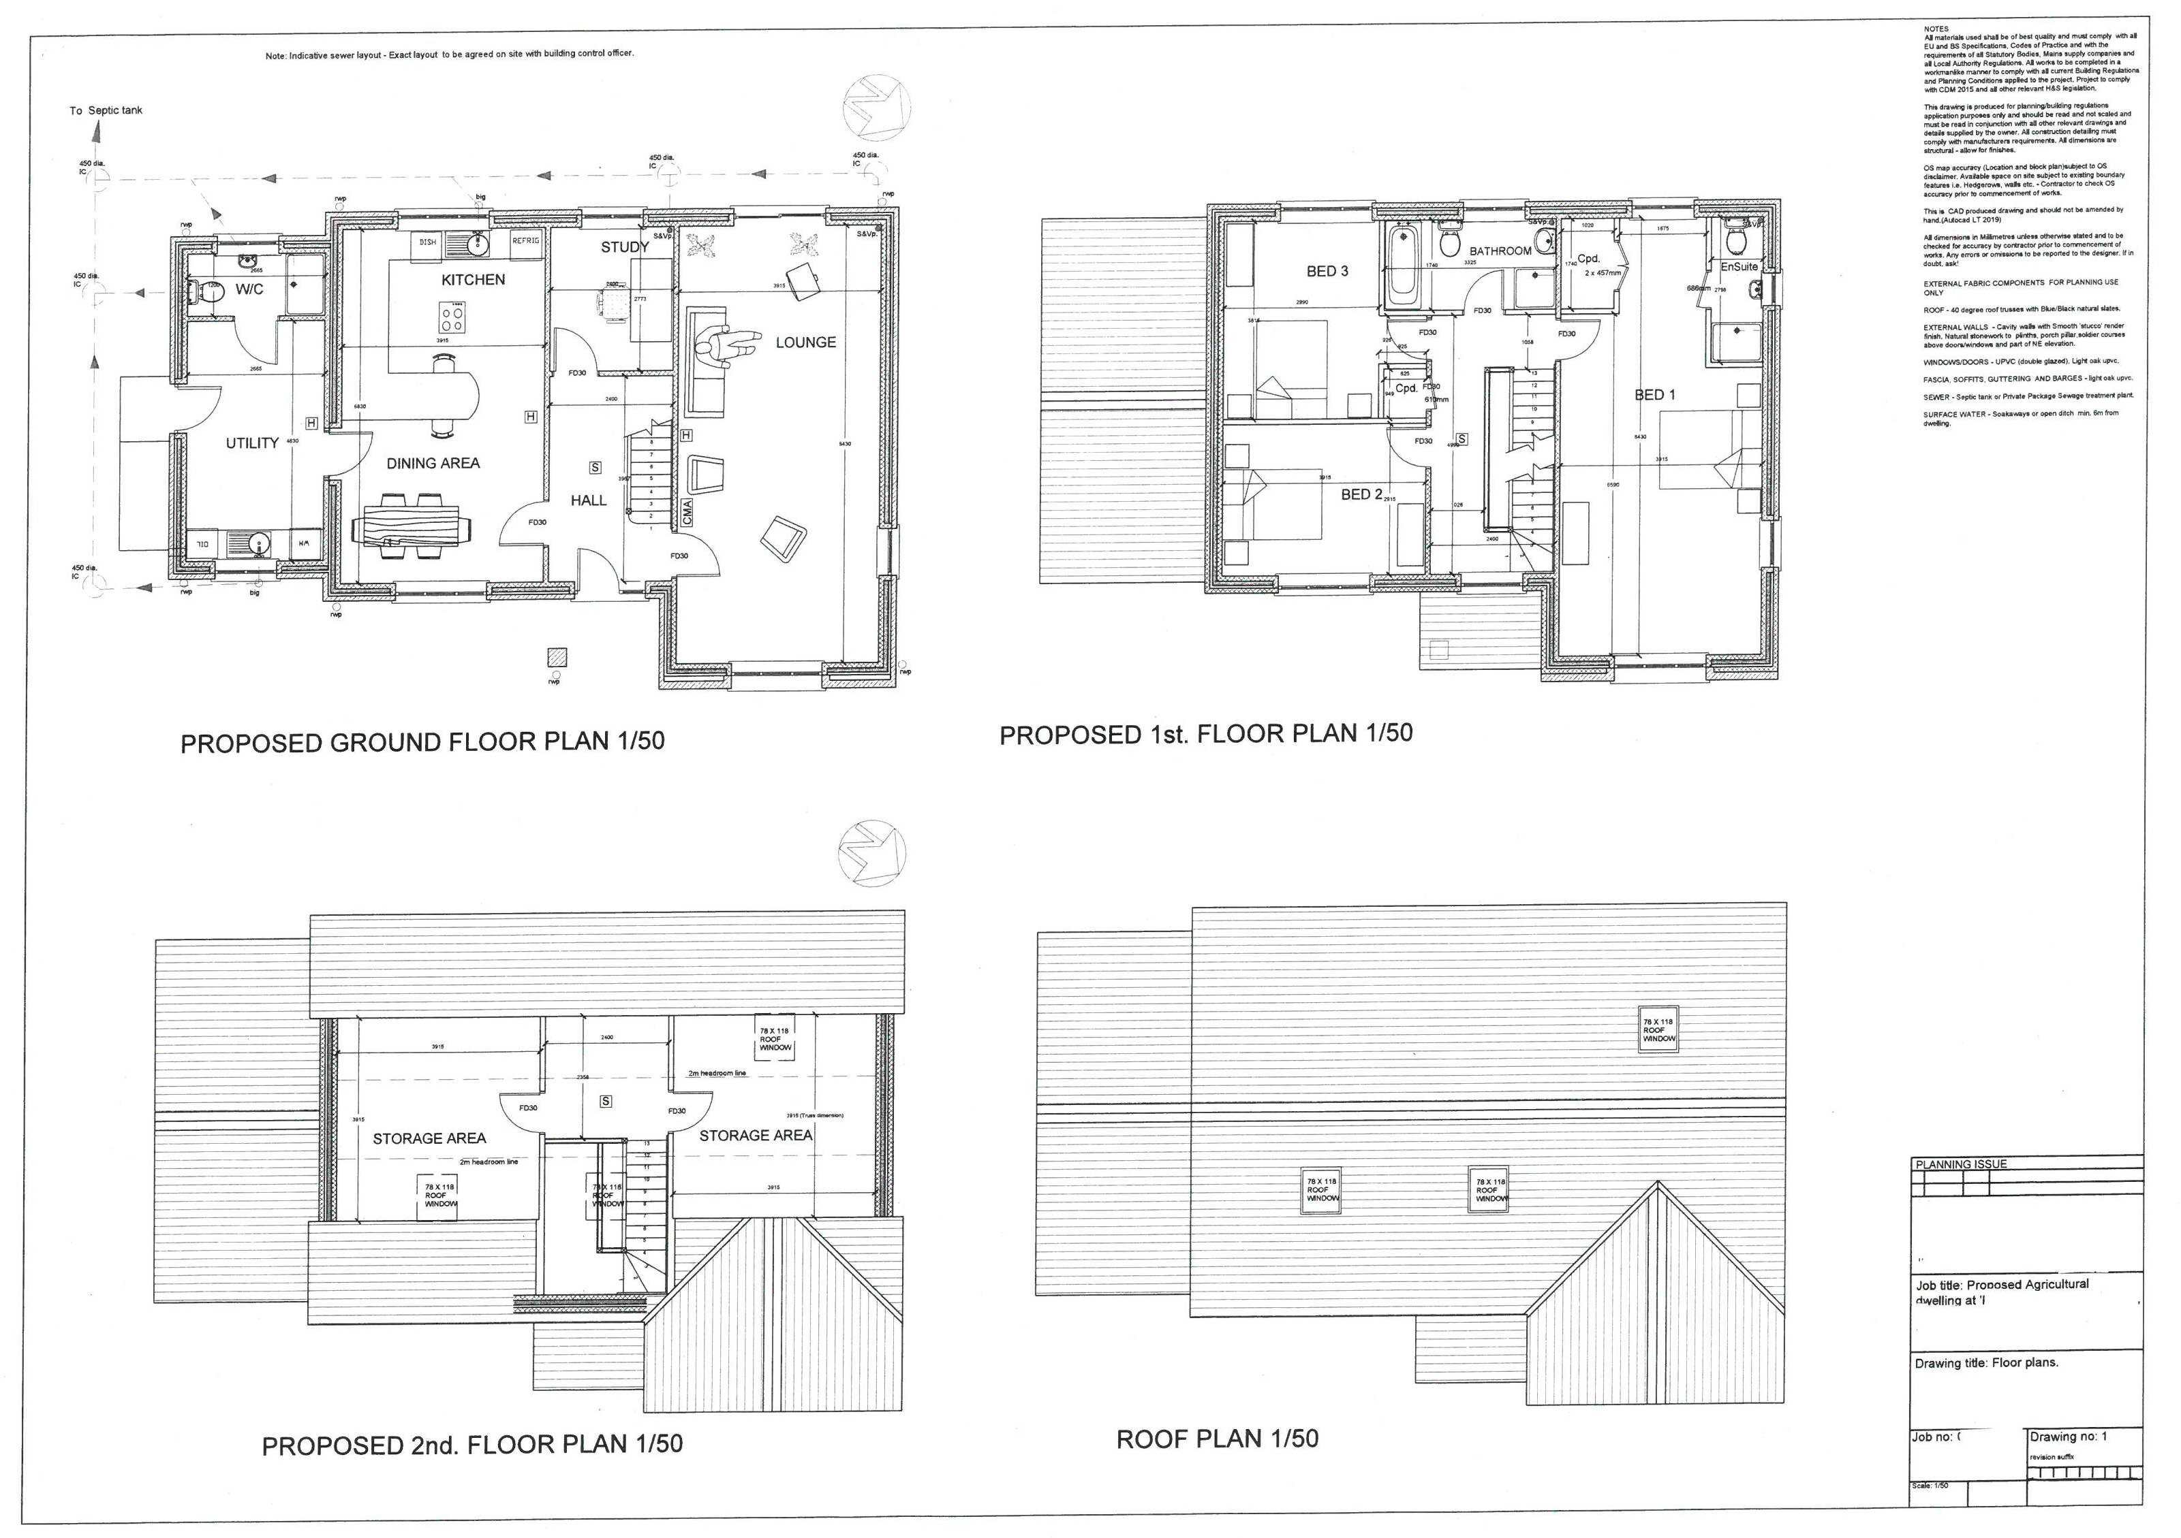

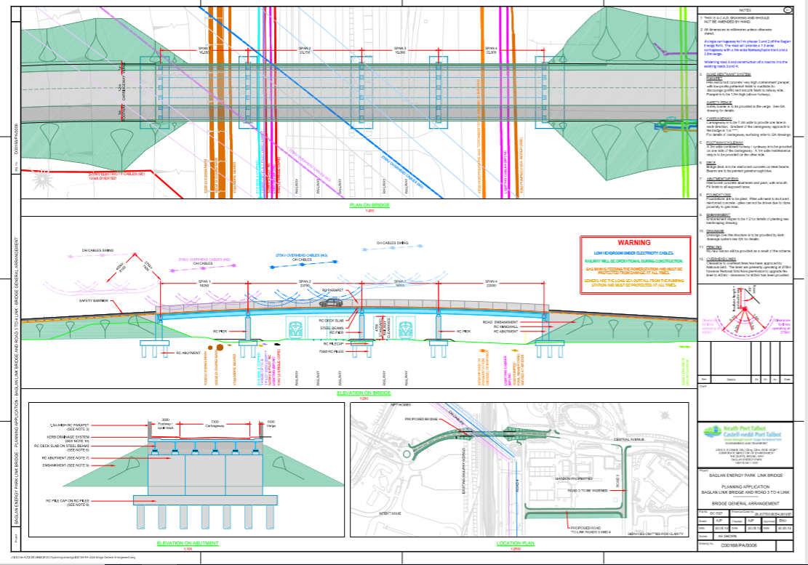
GUIDANCE FOR Students IN THE COMPLETION OF TASKS

Requirements
- You are required to widely research the topic area, reviewing course notes and power-points; and content resulting from attendance at lectures and tutorials.
- There is much guidance written on this topic and you should read widely, seeking out appropriate sources.
- Tables, spreadsheets or flowcharts must be clearly identified and referenced within the text and must be your own work, applied to the case study context and must not simply be scans of standard text books and internet images.

You will be assessed against the five common assessment criteria as follows:

1. Research Informed Literature
- This will be assessed via the quality of the literature sourced and reviewed. You need to show an understanding of current legislation relating to health and safety. The Moodle content outlines some of the core reading material. The Construction Information Service (CIS) located on the Swansea On-line Library electronic database (see the IHS database entry) contains a wealth of more detailed information that can be researched, and which is produced by expert organisations such as: The Health & Safety Executive (HSE); the Construction Industry Training Board (CITB).

2. Knowledge and Understanding of subject
- This will be assessed by the depth and awareness of a professional context. You need to show you can produce a construction phase plan.

3. Analysis
- This will be assessed by the quality of your evaluation and conclusions. You need to show you can analysis a hazard and produce a suitable risk assessment suitable for a health and safety file.

4. Practical Application and Deployment
- This will be assessed via the simulation. You need to show you can produce method statements.

5. Skills for Professional Practice
- This will be assessed via the written and presentational quality of your report.

marking criteria and Student FEEDBACK
Common Assessment Criteria Applied | Marks available | Marks  awarded
1. Research-informed Literature
Extent of research and/or own reading, selection of credible sources, application of appropriate referencing conventions.
 | 10
2. Knowledge and Understanding of Subject
Extent of knowledge and understanding of concepts and underlying principles associated with the discipline.
 | 30
3. Analysis
Analysis, evaluation and synthesis; logic, argument and judgement; analytical reflection; organisation of ideas and evidence
 | 20
4. Practical Application and Deployment
Deployment of methods, materials, tools and techniques; application of concepts; formulation of innovative and creative solutions to solve problems.
 | 30
5. Skills for Professional Practice
Attributes in professional practice: individual and collaborative working; deployment of appropriate media; presentation and organisation.
 | 10

Assignment Mark (Assessment marks are subject to ratification at the Exam Board. These comments and marks are to give feedback on module work and are for guidance only until they are confirmed. ) | Late Submission Penalties (tick if appropriate) |  | %
 | Up to one-week late |  | %
 | Over one week late |  | %

COMMON ASSESSMENT AND MARKING CRITERIA
 | OUTRIGHT FAIL | UNSATISFACTORY | SATISFACTORY | GOOD | VERY GOOD | EXCELLENT | EXCEPTIONAL
Assessment Criteria | 0-29% | 30-39%* | 40-49% | 50-59% | 60-69% | 70-79% | 80-100%
1. Research-informed Literature  Extent of research and/or own reading, selection of credible sources, application of appropriate referencing conventions | Little or no evidence of reading.  Views and findings unsupported and non-authoritative.  Referencing conventions largely ignored. | Poor evidence of reading and/or of reliance on inappropriate sources, and/or indiscriminate use of sources.  Referencing conventions used inconsistently. | References to a limited range of mostly relevant sources. Some omissions and minor errors.  Referencing conventions evident though not always applied consistently. | Inclusion of a range of research-informed literature, including sources retrieved independently. Referencing conventions mostly consistently applied. | Inclusion of a wide range of research-informed literature, including sources retrieved independently.  Selection of relevant and credible sources. Very good use of referencing conventions, consistently applied. | A comprehensive range of research informed literature embedded in the work. Excellent selection of relevant and credible sources. High-level referencing skills, consistently applied. | Outstanding knowledge of research-informed literature embedded in the work. Outstanding selection of relevant and credible sources. High-level referencing skills consistently and professionally applied.
2. Knowledge and Understanding of Subject  Extent of knowledge and understanding of concepts and underlying principles associated with the discipline. | Major gaps in knowledge and understanding of material at this level. Substantial inaccuracies. | Gaps in knowledge, with only superficial understanding. Some significant inaccuracies. | Evidence of basic knowledge and understanding of the relevant concepts and underlying principles. | Knowledge is accurate with a good understanding of the field of study. | Knowledge is extensive. Exhibits understanding of the breadth and depth of established views. | Excellent knowledge and understanding of the main concepts and key theories. Clear awareness of challenges to established views and the limitations of the knowledge base. | Highly detailed knowledge and understanding of the main theories/concepts, and a critical awareness of the ambiguities and limitations of knowledge.
3. Analysis  Analysis, evaluation and synthesis; logic, argument and judgement; analytical reflection; organisation of ideas and evidence | Unsubstantiated generalisations, made without use of any credible evidence. Lack of logic, leading to unsupportable/ missing conclusions. Lack of any attempt to analyse, synthesise or evaluate. | Some evidence of analytical intellectual skills, but for the most part descriptive. Ideas/findings sometimes illogical and contradictory. Generalised statements made with scant evidence. Conclusions lack relevance. | Evidence of some logical, analytical thinking and some attempts to synthesise, albeit with some weaknesses.  Some evidence to support findings/ views, but evidence not consistently interpreted.  Some relevant conclusions and recommendations, where relevant | Evidence of some logical, analytical thinking and synthesis. Can analyse new and/or abstract data and situations without guidance.  An emerging awareness of different stances and ability to use evidence to support the argument.  Valid conclusions and recommendations, where relevant | Sound, logical, analytical thinking; synthesis and evaluation. Ability to devise and sustain persuasive arguments, and to review the reliability, validity & significance of evidence. Ability to communicate ideas and evidence accurately and convincingly.  Sound, convincing conclusions / recommendations. | Thoroughly logical work, supported by evaluated evidence. High quality analysis, developed independently or through effective collaboration.  Ability to investigate contradictory information and identify reasons for contradictions.  Strong, persuasive, conclusions, justifiable recommendations. | Exceptional work; judiciously selected and evaluated evidence. Very high quality analysis, developed independently or through effective collaboration.  Ability to investigate contradictory information and identify reasons for contradictions.  Highly persuasive conclusions
4. Practical Application and Deployment  Effective deployment of appropriate methods, materials, tools and techniques; extent of skill demonstrated in the application of concepts to a variety of processes and/or contexts; formulation of innovative and creative solutions to solve problems. | Limited or no use of methods, materials, tools and/or techniques.  Little or no appreciation of the context of the application. | Rudimentary application of methods, materials, tools and/or techniques but without consideration and competence. Flawed appreciation of the context of the application. | An adequate awareness and mostly appropriate application of well established methods, materials, tools and/or techniques.  Basic appreciation of the context of the application. | A good and appropriate application of standard methods, materials, tools and/or techniques.  Good appreciation of the context of the application, with some use of examples, where relevant. | A very good application of a range of methods, materials, tools and/or techniques.  Very good consideration of the context of the application, with perceptive use of examples, where relevant.  Evidence of some innovation and creativity. | An advanced application of a range of methods, materials, tools and/or techniques.  The context of the application is well considered, with extensive use of relevant examples.  Application and deployment extend beyond established conventions. Innovation and creativity evident throughout. | Outstanding levels of application and deployment skills. Assimilation and development of cutting edge processes and techniques.
5. Skills for Professional Practice  Demonstrates attributes expected in professional practice including: individual initiative and collaborative working; deployment of appropriate media to communicate (including written and oral); clarity and effectiveness in presentation and organisation. | Communication media is inappropriate or misapplied.  Little or no evidence of autonomy in the completion of tasks.  Work is poorly structured and/or largely incoherent. | Media is poorly designed and/or not suitable for the audience.  Poor independent or collaborative initiative.  Work lacks structure, organisation, and/or coherence | Can communicate in a suitable format but with some room for improvement.  Can work as part of a team, but with limited involvement in group activities.  Work lacks coherence in places and could be better structured. | Can communicate effectively in a suitable format, but may have minor errors.  Can work effectively as part of a team, with clear contribution to group activities.  Mostly coherent work and is in a suitable structure. | Can communicate well, confidently and consistently in a suitable format.  Can work very well as part of a team, with very good contribution to group activities.  Work is coherent and fluent and is well structured and organised. | Can communicate professionally and, confidently in a suitable format.  Can work professionally within a team, showing leadership skills as appropriate, managing conflict and meeting obligations.  Work is coherent, very fluent and is presented professionally. | Can communicate with an exceptionally high level of professionalism.  Can work exceptionally well and professionally within a team, showing advanced leadership skills.  Work is exceptionally coherent, very fluent and is presented professionally.
This section details the assessment criteria. The extent to which these are demonstrated by you determines your mark. The marks available for each criterion are shown. Lecturers will use the space provided to comment on the achievement of the task(s), including those areas in which you have performed well and areas that would benefit from development/improvement

Student Self Evaluation Form
Student name: |  | Student P number:
Programme: |  | Year of programme
Assignment Title:

This section repeats in brief the common assessment criteria detailed on previous pages. The extent to which these are demonstrated by you determines your mark. Using these criteria, tick the box that best indicates the level of achievement you feel you have achieved with regard to each of them.
Common Assessment Criteria Applied | Level of Achievement
Common Assessment Criteria Applied | REFER |  |  | 3rd |  | 2:2 |  | 2:1 | 1st | 1st
 | OUTRIGHT FAIL | UNSATISFACTORY | SATISFACTORY |  | GOOD |  | VERY GOOD |  | EXCELLENT | EXCEPTIONAL
1. Research-informed Literature | 0-29% | 30-39% | 40-49% |  | 50-59% |  | 60-69% |  | 70-79% | 80-100%
2. Knowledge and Understanding of Subject | 0-29% | 30-39% | 40-49% |  | 50-59% |  | 60-69% |  | 70-79% | 80-100%
3. Analysis | 0-29% | 30-39% | 40-49% |  | 50-59% |  | 60-69% |  | 70-79% | 80-100%
4. Practical Application and Deployment | 0-29% | 30-39% | 40-49% |  | 50-59% |  | 60-69% |  | 70-79% | 80-100%
5. Skills for Professional Practice | 0-29% | 30-39% | 40-49% |  | 50-59% |  | 60-69% |  | 70-79% | 80-100%

PLEASE COMMENT ON AREAS IN WHICH YOU FEEL THAT YOU HAVE PERFORMED WELL | PLEASE COMMENT ON AREAS you feel that you need TO DEVELOP

Student’s Name |  | Date
Student’s Signature

Assignment 1

You are to assume that NPTCBC has received planning consent for a bridge to link two halves of an industrial estate. [See attached drawings. Further drawings available on Moodle].
NPTCBC want to build it to provide access from one industrial estate to another over a small railway line. This is to improve the economic viability of the area.
The proposed foundations are piles as described in the drawing. The piers are reinforced concrete and the
Deck is to be manufactured off site.
Work is proposed to start on 6th May 2020.

The following tasks are allocated a percentage to emphasise the suggested time you should spend on each individual task. Marks will be allocated against the set Marking Criteria indicated on page 6.

1. Produce a detailed Construction Phase Plan for all the major activities related to this project – from start until completion. (25%)
2. Produce specific Method Statement for the three major work activities identified. (25%)
3. Develop, evaluate and produce site specific Risk Assessments for three of the work activities. Highlighting significant hazards, control measures and mitigation. (25%)
4. Identify which Health & Safety legislation, based upon this construction project, is relevant and identify who is the responsible person/duty holder under those separate regulations. (25%)

Task 1

Major construction phase plan.

What are you the main dangers on site | Hazard present? | Control measures
Falling from height | Injury from falling from height | make sure ladders are in good condition, at the right angle as secured.
Collapse of structures | Injury with potential for fatality form falling debris | Make sure supports are in placed and secured with a competent person
Electricity | Electric shocks and burns | 1)Turn electricity supply and other services off before drilling into walls  2)Do not use excavators or power tools near suspected buried services
Risks to members of the public, the client and others | 1)Falling into trenches  2)Exposer to chemicals  3)Injury from falling objects | 1)Keep the site secure to prevent unauthorised access  2) Net scaffolding  3) Use rubbish chutes
Exposure to building dusts | Respiratory based discomfort and dieses | Prevent dust by using wet cutting and vacuum extraction on tools; use a  vacuum cleaner rather than sweeping; use a suitable, well-fitting mask
Activities or workers requiring supervision | Self-inflicted injury or unnecessary damage to tools or building | Have a competent person surprise
Falling objects | Injury or potential fatality from falling object | 1)Have no one underneath or near what is being moved  2) have lights and buzzers to indicate something is being moved

Task 2

The first part of the plan is to find where the foundations will be going, its clearly located on the plans and from this the site manager knows where to dig. From the drawing it looks like deep pile foundations with a raft on top, with the five sections of foundations they act like pad foundations but on a larger scale. Its most likely that the site will be closed off to prevent people from wondering in and getting hurt.

The start of the foundations is removing the soil and rocks in the way, an excavator will be used to remove the raft section of the foundation, this is the flat part at the top which is below the ground level. When handling top soil gloves must be warn to prevent any contamination in the soil getting into the person’s body through their hands. When using the excavator, they must be wearing driving gloves to enough proper grip of the wheels and levels within the cockpit of the machine.

Also, when using the excavator, the operator must look out for any persons that the vehicle could hit or any object which it could collide with. In addition, when working with hydraulic systems when ever system needs to be checked the engine and pump must both be turned off to prevent high pressure oil injections.

Then a hydraulic arguer is used to removed the area where the pile foundations will go, this takes a bit of time because the arguer bit is only so long so once they reach the depth of the arguer bit, they add attachments to increase the shank length therefore increasing the overall depth the arguer can reach.

The soil and rock that has been removed is moved to a part of the site and stored. When working with arguer drills, it is important that the shank is removed with a chain and then added back on with the extension with the chain, this is to prevent physical contact with the arguer or shafts which could be hot or fall over.

Now that the holes have been dug, they can be filled. These are very large and have to have a continues pour. Rebar will be installed first, for a site this large the chances are that the rebar will be delivered and will be welded on site, this is mainly due to the expensive of off-site manufacturing cost and delivery of these, the rebar also bent into shape on site too. When working welding equipment, it must have surge protectors, the worker but have a natural attacked to the work and must also be grounded with thick rubber welly.

In addition to this the gasses involved in welding are dangerous and cause respiratory discomfort and potential dieses, so work in a well-ventilated area, also thick heat resistant PPE must be warn at all time to prevent burns. Furthermore, due to the arc cause UV and UB light a protective welding mask must be warn to filter out the light, also black out curtains must be put up to prevent the glare from the arc effecting other workers.

Once the skeleton structure of rebar has been made, this is placed into position on top of a DPC. The concrete is delivered in cement trucks, it would take a lot of trucks to make this one continuous pour, potential upwards of 20 cement trucks would be used in this pour, perhaps even 30 in one day. Some rebar will be sticking out so the next structure can be built. The concrete will be mixed inside the trucks so no hard from the dust and mixing will come to the workers. However, when pouring the concrete full PPE must be warn to prevent the concrete from getting on the persons skin. Also only have essential workers in the pouring area to minimise collision and increase vison of the working area.

As the foundations are being poured the steel is being delivered. The steel comes in small sections that are either riveted or welded together, the steel needs to be specially welded. The welding will be done outside because of the size of the sections. The same welding paramotors will be maintained.

Once all of the sections have been welded a large crane can be used to lift it into place. Everyone will be moved to a safe distance where if the bridge did fall it wouldn’t land on anyone. In addition to this if the bridge is to be lifted over any buildings or cabins then they must be evacuated from the site to enough no one gets hurt. People with radios will be littered over the site to ensure the driver has all views covered and doesn’t damage anything, this is crucial as the bridge at this point will weigh well over 100 tonnes and if it fell it would cause a lot of damage.

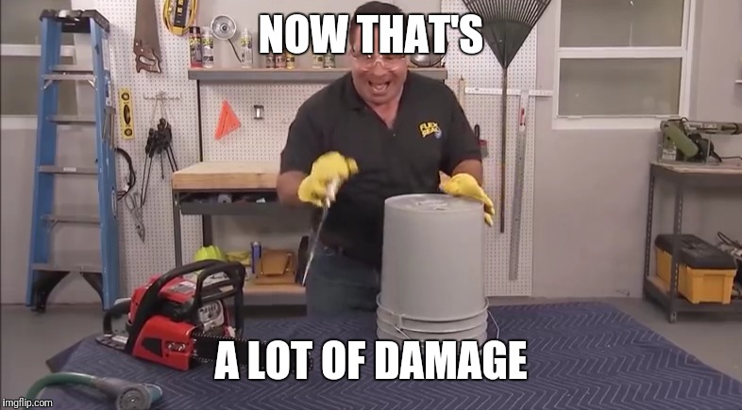

( image one )

This would have to happen at night due to the main road and railway being underneath, this minimises the disruption of the rail lines and road users, also there could be planned maintenance which could coincide with the construction of the bridge which would be nice for the rail line as the interruption would have already been calculated and the trains diverted.

Once the steel is in place the gaps would be covered with ply wood or OSB and the second concrete pour can begin. This also will be reinforced with rebar and this too will be manufactured on site. Once it has been laid out the pour can begin, I’m not sure if they need to close the roads and rail line there but I’m assuming they do. This will be working at height so scaffolding will be used to make a stable base for the men to work on, in addition nets will also be added to catch people if they fall and to prevent unauthorised people from coming into the site. Ladders will be placed on the inside of the scaffolding, these ladders will be secured at the right heigh and angles to prevent unnecessary strain on the scaffolding and the ladder.

This is a pretty big pour so again they will need serval trucks and then the concrete is polished and small sections are cut into the concrete to help prevent cracking from temperature change and seasonal change. The same measures for the previous pour will be used in this pour, in addition this will be dome at height so the measures in the previous stamen will also be kept.

After the concrete has been poured, the tarmac is then made, placed and levelled on the bridge. A roller is used to evenly flatten the surface and produce a nice smooth continuous surface which will be nice to drive on and gentle on the vehicle being driven. When working with heated asphalt, recommended PPE includes chemical goggles, loose clothing with closed collars and buttoned cuffs, thermally insulated gloves with gauntlets that extend up the arm, and boots with tops at least 6 inches high. Also, workers should also wear safety shoes and barrier creams.

After the road surface has hardened the hand rails, road surface markings and street lamps are put into place. When working with thermoplastic paint gloves and loose clothing should be warn to prevent the paint from getting on any skin and hair.

The bridge is finally completed and the site can now be deconditioned, this will entail removing all the cabins, any equipment left, the removal of any left-over sand, gravel and top soil. If any shrubbery is put in this happens just before the fencing around the site is pulled down.

Task 3

Risk assessment 1

to be Assessed |  |  |  |  |  |  |  |  |  |  |  |  |  |  |  |  | Assessment Number
Lifting bridge |  |  |  |  |  |  |  |  |  |  |  |  |  |  |  |  | 100000001
Persons undertaking or affected by the activity
 |  | x | Employees |  | x | Contractor |  |  |  | Public |  |  |  |  | Service User
Activity
 |  |  | Other …………………………………………………………………………………………….
Identified Hazards and Associated Risks |  |  |  |  |  |  |  |  |  |  | Likelihood /5 |  |  |  |  |  | Severity /5 |  |  |  |  | Risk Level /5
1 | Object falling |  |  |  |  |  |  |  |  |  | 3 |  |  |  |  |  | 5 |  |  |  |  | 4
2 | Object turbulence from wind |  |  |  |  |  |  |  |  |  | 4 |  |  |  |  |  | 4 |  |  |  |  | 4
3 | Object collision |  |  |  |  |  |  |  |  |  | 4 |  |  |  |  |  | 5 |  |  |  |  | 4.5
4 | Cables snapping and result object falls |  |  |  |  |  |  |  |  |  | 3 |  |  |  |  |  | 5 |  |  |  |  | 4
5 | Crane toppling over |  |  |  |  |  |  |  |  |  | 4 |  |  |  |  |  | 5 |  |  |  |  | 4
6
Existing Control Measures / Additional Control Measures Required
1 | The crane is be either anchored or bolted to the ground
2 | Everyone is to be moved to a safe location during the lift
3 | Competent individuals will be dotted around the site to give the driver a better view and they will also be given radios and bright torches.
4 | Cables to be inspected in advance and before the lift
5 | Ensure all building including cabin and mobile offices are to be evacuated during the lift
6 | If the wind is more than 20 mph the lift is called off
Reassessment of Activity Hazards |  |  |  |  |  |  |  |  |  |  | Likelihood |  |  |  |  |  | Severity |  |  |  |  | Risk Level
1 | Object falling |  |  |  |  |  |  |  |  |  | 1 |  |  |  |  |  | 5 |  |  |  |  | 5
2 | Object turbulence |  |  |  |  |  |  |  |  |  | 3 |  |  |  |  |  | 4 |  |  |  |  | 5
3 | Object collision |  |  |  |  |  |  |  |  |  | 1 |  |  |  |  |  | 5 |  |  |  |  | 5
4 | Cables snapping |  |  |  |  |  |  |  |  |  | 1 |  |  |  |  |  | 5 |  |  |  |  | 5
5 | Crane toppling over |  |  |  |  |  |  |  |  |  | 1 |  |  |  |  |  | 5 |  |  |  |  | 5
6
Name Matteo Grattarola  Position civil engineer ( trainee ) |  |  |  |  |  |  | Signed  M.G |  |  |  |  |  |  |  |  |  | Date of Completion:  20/11/2020
Reviews |  |  |  | Key
Review Date: |  |  |  | Likelihood |  |  |  | Severity |  |  | Severity of Injury |  | 5 | 5Y |  |  |  | 10R |  | 15 |  |  | 20 |  | 25
Reviewed by: |  |  |  | 1 very unlikely  2 unlikely  3 likely  4 very likely  5 certainty |  |  |  | 1 nuisance  2 minor  3 medical treatment  4 major  5 fatal |  |  |  |  | 4 | 4 |  |  |  | 8 |  | 12 |  |  | 16 |  | 20
Review Date : |  |  |  |  |  |  |  |  |  |  |  |  | 3 | 3 |  |  |  | 6G |  | 9 |  |  | 12 |  | 15
Reviewed by: |  |  |  |  |  |  |  |  |  |  |  |  | 2 | 2 |  |  |  | 4 |  | 6Y |  |  | 8 |  | 10Y
Review Date : |  |  |  |  |  |  |  |  |  |  |  |  | 1 | 1 |  |  |  | 2 |  | 3 |  |  | 4 |  | 5G
Reviewed by: |  |  |  |  |  |  |  |  |  |  |  |  | 0 | 1 |  |  |  | 2 |  | 3 |  |  | 4 |  | 5
Review Date : |  |  |  |  |  |  |  |  |  |  |  |  |  | Likelihood of Injury
Reviewed by: |  |  |  |  |  |  |  |  |  |  |  | Low Risk |  |  |  |  |  |  | Medium Risk |  |  |  |  | High Risk

Risk assessment 2

to be Assessed |  |  |  |  |  |  |  |  |  |  |  |  |  |  |  |  | Assessment Number
Asphalting the road |  |  |  |  |  |  |  |  |  |  |  |  |  |  |  |  | 100000002
Persons undertaking or affected by the activity
 |  | x | Employees |  | x | Contractor |  |  |  | Public |  |  |  |  | Service User
Activity
 |  |  | Other …………………………………………………………………………………………….
Identified Hazards and Associated Risks |  |  |  |  |  |  |  |  |  |  | Likelihood /5 |  |  |  |  |  | Severity /5 |  |  |  |  | Risk Level /5
1 | Skin contact, may cause burns |  |  |  |  |  |  |  |  |  | 3 |  |  |  |  |  | 4 |  |  |  |  | 3.5
2 | Prolonged exposure dermatitis and malignant warts |  |  |  |  |  |  |  |  |  | 3 |  |  |  |  |  | 4 |  |  |  |  | 3.5
3 | Eye contact, may cause irritation |  |  |  |  |  |  |  |  |  | 2 |  |  |  |  |  | 4 |  |  |  |  | 3
4 | When cutting, drilling or planning the hardened asphalt the dust can cause repository discomfort |  |  |  |  |  |  |  |  |  | 4 |  |  |  |  |  | 5 |  |  |  |  | 4.5
5
6
Existing Control Measures / Additional Control Measures Required
1 | Ware loose clothing with closed collars and buttoned cuffs, thermally insulated gloves with gauntlets that extend up the arm, and boots with tops at least 6 inches high
2 | Ware chemical goggles
3 | Wet the surface and continue adding water when performing cutting, drilling or planning
4
5
6
Reassessment of Activity Hazards |  |  |  |  |  |  |  |  |  |  | Likelihood |  |  |  |  |  | Severity |  |  |  |  | Risk Level
1 | Skin contact, may cause burns |  |  |  |  |  |  |  |  |  | 1 |  |  |  |  |  | 2 |  |  |  |  | 1.5
2 | Prolonged exposure dermatitis and malignant warts |  |  |  |  |  |  |  |  |  | 1 |  |  |  |  |  | 2 |  |  |  |  | 1.5
3 | Eye contact, may cause irritation |  |  |  |  |  |  |  |  |  | 1 |  |  |  |  |  | 2 |  |  |  |  | 1.5
4 | When cutting, drilling or planning the hardened asphalt the dust can cause repository discomfort |  |  |  |  |  |  |  |  |  | 2 |  |  |  |  |  | 2 |  |  |  |  | 2
5
6
Name Matteo Grattarola  Position civil engineer ( trainee ) |  |  |  |  |  |  | Signed  M.G |  |  |  |  |  |  |  |  |  | Date of Completion:  20/11/2020
Reviews |  |  |  | Key
Review Date: |  |  |  | Likelihood |  |  |  | Severity |  |  | Severity of Injury |  | 5 | 5Y |  |  |  | 10R |  | 15 |  |  | 20 |  | 25
Reviewed by: |  |  |  | 1 very unlikely  2 unlikely  3 likely  4 very likely  5 certainty |  |  |  | 1 nuisance  2 minor  3 medical treatment  4 major  5 fatal |  |  |  |  | 4 | 4 |  |  |  | 8 |  | 12 |  |  | 16 |  | 20
Review Date : |  |  |  |  |  |  |  |  |  |  |  |  | 3 | 3 |  |  |  | 6G |  | 9 |  |  | 12 |  | 15
Reviewed by: |  |  |  |  |  |  |  |  |  |  |  |  | 2 | 2 |  |  |  | 4 |  | 6Y |  |  | 8 |  | 10Y
Review Date : |  |  |  |  |  |  |  |  |  |  |  |  | 1 | 1 |  |  |  | 2 |  | 3 |  |  | 4 |  | 5G
Reviewed by: |  |  |  |  |  |  |  |  |  |  |  |  | 0 | 1 |  |  |  | 2 |  | 3 |  |  | 4 |  | 5
Review Date : |  |  |  |  |  |  |  |  |  |  |  |  |  | Likelihood of Injury
Reviewed by: |  |  |  |  |  |  |  |  |  |  |  | Low Risk |  |  |  |  |  |  | Medium Risk |  |  |  |  | High Risk

Risk assessment 3

to be Assessed |  |  |  |  |  |  |  |  |  |  |  |  |  |  |  |  | Assessment Number
Welding steel structure segments together |  |  |  |  |  |  |  |  |  |  |  |  |  |  |  |  | 100000003
Persons undertaking or affected by the activity
 |  | x | Employees |  | x | Contractor |  |  |  | Public |  |  |  |  | Service User
Activity
 |  |  | Other …………………………………………………………………………………………….
Identified Hazards and Associated Risks |  |  |  |  |  |  |  |  |  |  | Likelihood /5 |  |  |  |  |  | Severity /5 |  |  |  |  | Risk Level /5
1 | exposures to metal fumes causing repository discomfort, Prolonged exposures causing repository dieses |  |  |  |  |  |  |  |  |  | 4 |  |  |  |  |  | 5 |  |  |  |  | 4.5
2 | Electrical shock |  |  |  |  |  |  |  |  |  | 3 |  |  |  |  |  | 5 |  |  |  |  | 4
3 | UV and UB radiation |  |  |  |  |  |  |  |  |  | 4 |  |  |  |  |  | 4 |  |  |  |  | 4
4 | Arc causing damage to eye and vison |  |  |  |  |  |  |  |  |  | 5 |  |  |  |  |  | 4 |  |  |  |  | 4.5
5 | Burns from slag and heated metal |  |  |  |  |  |  |  |  |  | 4 |  |  |  |  |  | 4 |  |  |  |  | 4
6
Existing Control Measures / Additional Control Measures Required
1 | PPE – welding helmet with side shields to protect worker from UV radiation, particles, debris, hot slag and chemical burns
2 | Respirators to be warn and in addition a well-ventilated area or fume hood to safely filter or dispose of the gages
3 | Fire resistant clothing i.e leather gloves, apron and jacket
4 | Have surge protectors installed and wear thick rubber welly
5
6
Reassessment of Activity Hazards |  |  |  |  |  |  |  |  |  |  | Likelihood |  |  |  |  |  | Severity |  |  |  |  | Risk Level
1 | exposures to metal fumes causing repository discomfort, Prolonged exposures causing repository dieses |  |  |  |  |  |  |  |  |  | 2 |  |  |  |  |  | 2 |  |  |  |  | 2
2 | Electrical shock |  |  |  |  |  |  |  |  |  | 2 |  |  |  |  |  | 4 |  |  |  |  | 3
3 | UV and UB radiation |  |  |  |  |  |  |  |  |  | 1 |  |  |  |  |  | 3 |  |  |  |  | 2
4 | Arc causing damage to eye and vison |  |  |  |  |  |  |  |  |  | 1 |  |  |  |  |  | 3 |  |  |  |  | 2
5 | Burns from slag and heated metal |  |  |  |  |  |  |  |  |  | 2 |  |  |  |  |  | 3 |  |  |  |  | 2.5
6
Name Matteo Grattarola  Position civil engineer ( trainee ) |  |  |  |  |  |  | Signed  M.G |  |  |  |  |  |  |  |  |  | Date of Completion:  20/11/2020
Reviews |  |  |  | Key
Review Date: |  |  |  | Likelihood |  |  |  | Severity |  |  | Severity of Injury |  | 5 | 5Y |  |  |  | 10R |  | 15 |  |  | 20 |  | 25
Reviewed by: |  |  |  | 1 very unlikely  2 unlikely  3 likely  4 very likely  5 certainty |  |  |  | 1 nuisance  2 minor  3 medical treatment  4 major  5 fatal |  |  |  |  | 4 | 4 |  |  |  | 8 |  | 12 |  |  | 16 |  | 20
Review Date : |  |  |  |  |  |  |  |  |  |  |  |  | 3 | 3 |  |  |  | 6G |  | 9 |  |  | 12 |  | 15
Reviewed by: |  |  |  |  |  |  |  |  |  |  |  |  | 2 | 2 |  |  |  | 4 |  | 6Y |  |  | 8 |  | 10Y
Review Date : |  |  |  |  |  |  |  |  |  |  |  |  | 1 | 1 |  |  |  | 2 |  | 3 |  |  | 4 |  | 5G
Reviewed by: |  |  |  |  |  |  |  |  |  |  |  |  | 0 | 1 |  |  |  | 2 |  | 3 |  |  | 4 |  | 5
Review Date : |  |  |  |  |  |  |  |  |  |  |  |  |  | Likelihood of Injury
Reviewed by: |  |  |  |  |  |  |  |  |  |  |  | Low Risk |  |  |  |  |  |  | Medium Risk |  |  |  |  | High Risk

Task 4

- The Health and Safety at Work Act 1974

It is an employer's duty to protect the health, safety and welfare of their employees and other people who might be affected by their business. Employers must do whatever is reasonably practicable to achieve this.

- Management of Health and Safety at Work Regulations 1999

Business owners and employers are legally responsible for health and safety management.

- Lifting Operations and Lifting Equipment Regulations 1998

The dutyholder will be the subcontractor company whom own the crane, they have the legal responsibility.

- Personal Protective Equipment at Work Regulations 1992

The standard makes clear that employers cannot require workers to provide their own PPE and employer needs to provide applicable PPE.

- Control of Noise at Work Regulations 2005

The employer is asses what noise levels each task with deem in advance in order to make those tasks in a less disruption fashion.

- The Pressure Systems and Transportable Gas Containers Regulations 1989 (SI 1989 No2169)

The vender is under egal responsibility until after they have handed over the gas bottles, once this has happened the company whom has taken hold becomes legally responsible.

- MANUAL HANDLING OPERATIONS REGULATION (1992)

The employer has a duty of care to provide applicable training for the employs, however if the employ doesn’t conform to the training then the employ themselves are responsible.

References

Image one

https://www.google.com/url?sa=i&url=https%3A%2F%2Fimgflip.com%2Fi%2F251r3m&psig=AOvVaw32R5V8in6CMqoNzsgbDVT2&ust=1605971054195000&source=images&cd=vfe&ved=0CAIQjRxqFwoTCLjirMWyke0CFQAAAAAdAAAAABAD

date – 20/11/2020

https://www.hse.gov.uk/pubns/cis80.pdf

date – 20/10/2020

https://www.tarmac.com/media/958045/aa-asphalt-safety-datasheet_proof.pdf

date – 20/11/2020

