
Cloud computing architecture
ACCA6025

FEDERICO GELATI
2112906
24-04-2024

Table of Contents
Cover Page 1
Table of Content 2
Introduction 3
TCO Calculator 3
Azure File Storage 8
Different type of Azure Databases 10
Backup and Disaster Recovery in Azure 14
References 19

Introduction
This assessment seeks to examine how the migration of the servers, hosting use profiles course materials and administrative system are running on-premises at the Global Learning Institute to Azure Cloud. As a Cloud Architect of the institute, I will be providing the examination of the platform and provide the benefit that the Institution might meet if they decide to move to Azure.

TCO Calculation process

Azure has a beautiful feature called TCO calculator, this tool provides an understanding of how much your migration will cost to you.
Microsoft's Azure Total Cost of Ownership (TCO) Calculator does more than just calculate the cost of Azure services. This tool helps you make decisions by estimating the possible savings you could have by moving your apps from your own data canters to the Azure cloud platform. It considers hidden costs that are frequently missed in conventional cost analysis. Hardware, software licensing, electricity for running servers, and IT personnel devoted to maintaining of your on-premises infrastructure are all included in this. Your present expenses are shown more comprehensively by the TCO calculator by accounting for these recurring charges. This important data helps companies to determine if switching to an Azure pay-as-you-go cloud model can result in appreciable long-term cost savings and improved efficiency.

The Global Learning Institute (GLI) wants to investigate cloud computing! Its present on-premises servers are having difficulty keeping up with the increasing quantity of online courses and certifications available. These servers require costly maintenance and upgrades, and GLI is operating on a limited budget. A cloud platform called Microsoft Azure might have the solution. Azure provides scalability, which allows it to expand in response to GLI's needs and may even result in cost savings. We'll utilize the Azure Total Cost of Ownership Calculator, a unique tool, to find out. This tool will examine GLI's current server, database, storage, and internet expenses and contrast them with the costs associated with using comparable Azure services.
Additionally, Azure offers a free tier, which may help GLI save money while transitioning things over. We can design an affordable plan to move GLI to the cloud by combining the free tier with the TCO Calculator. By doing this, they will not only save money but also guarantee that they have the resources required to continue expanding and enrolling more students in their courses.

Here can be an example of the expenses that the GLI can probably afford having on premises like the servers, storages, networks, and maintenance.
On-premises Costs
Servers: 5 x (£2,000/server/year) = £10,000/year (hardware cost)
(£5,000/server/year) x 5 = £25,000/year (maintenance contracts)
Estimated electricity and IT staff costs: £20,000/year.
Databases: £10,000/year (licensing and maintenance)
Storage: £10,000/year (hardware, software licenses, electricity)
Network: £5,000/year (internet bandwidth and equipment)
Total On-premises Cost: £80,000/year.

Azure Service and Cost Estimation
The first step in using the Azure TCO Calculator is specifying your current workload. This entails describing the type of programs you're using, such as web servers, databases, or virtual machines.
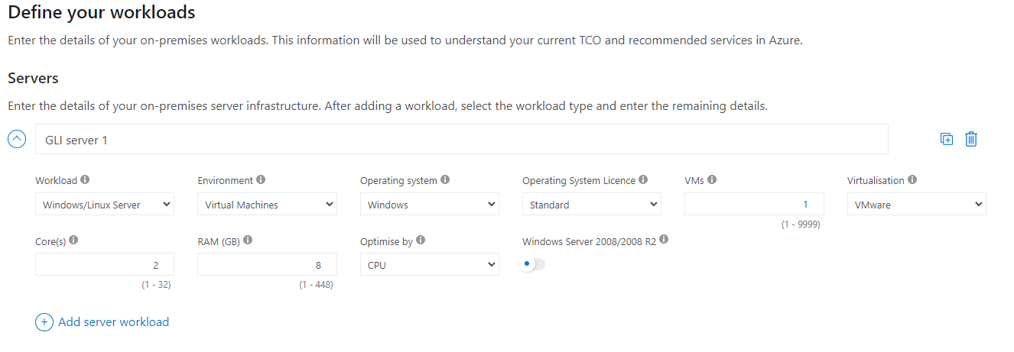
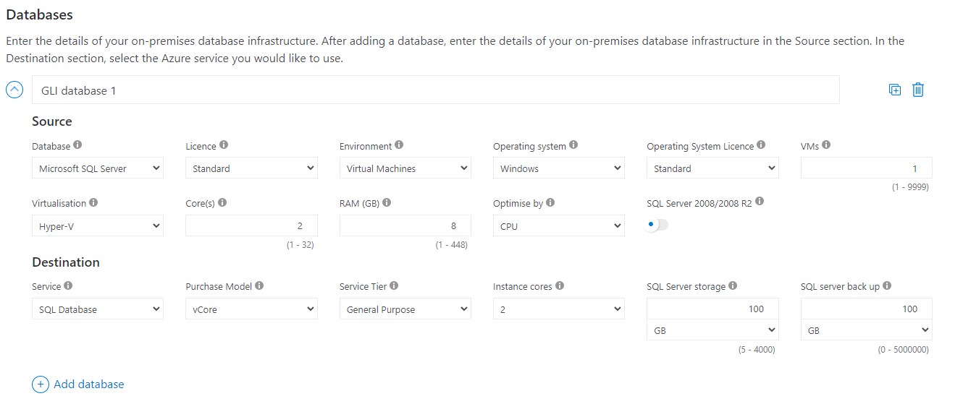
In these screenshots are showing a probability of the software and hardware the GLI might need to support their needs.
First, we decide a Server that runs a single virtual machine with Windows as operating system, 2 Cores and 8 GB RAM will be given to the machine. The Database will be set with SQL Server on virtual machine and windows has operating system much easy to use that Linux but less secure considering the OS. Then 2 Cores, 8 GB of RAM and 100 GB of Storage will be enough to support all the requirements. Among the available alternatives there are Azure Database for MySQL, Azure Database for PostgreSQL, and others, each with its own set of features and functionality.
The next step is to allocate storage space on your server. This involves choosing the desired tier for optimal performance, which has a direct impact on processing capabilities and energy consumption expenses. To achieve the best possible balance, the performance benefits must be carefully weighed against the associated expenses.
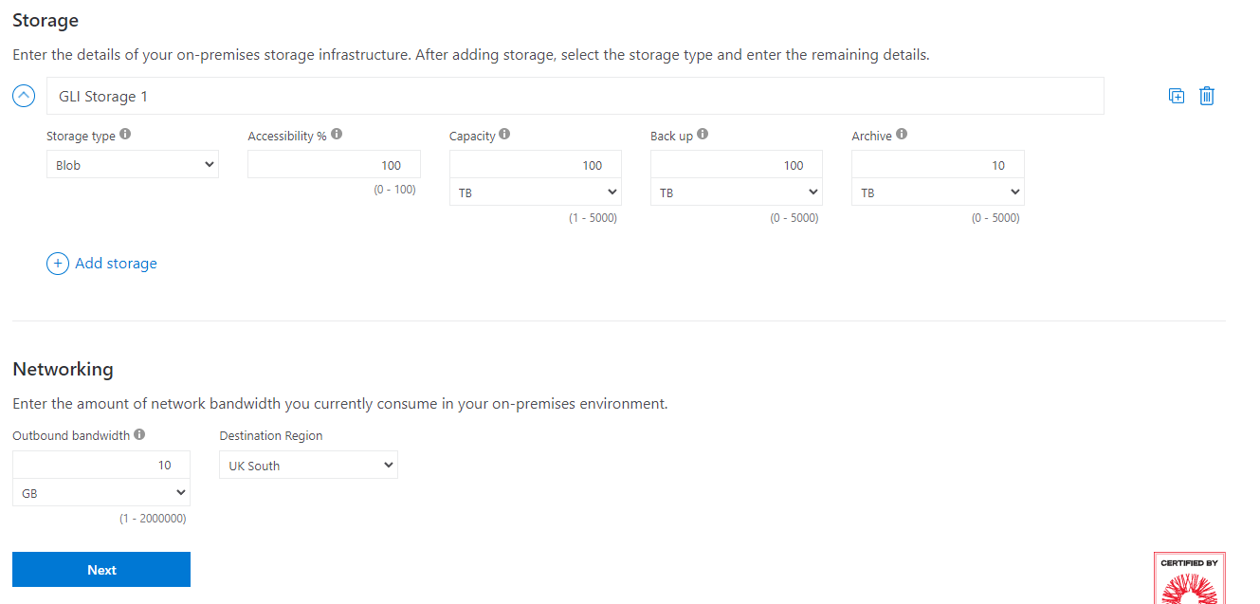
Furthermore, strong backup and disaster recovery practices are essential for protecting sensitive data and ensuring company continuity. By establishing defined policies for data backup and recovery, you may reduce the risk of data loss and the effect of potential disruptions. This complete database management strategy not only improves operational efficiency but also strengthens the durability of your infrastructure. Finally, by properly setting your database infrastructure and creating strong contingency plans, you can confidently support your organization's objectives and respond to changing business needs.
The next setting it’s possible to set your networking option, Outbound bandwidth refers to the amount of data transferred from Azure services to destinations outside of the Azure datacentres. This includes traffic sent from Azure virtual machines, storage accounts, databases, and other services to users, clients, or other networks over the internet. Outbound bandwidth usage is typically measured in gigabytes (GB) or terabytes (TB) of data transferred per month. The cost of outbound bandwidth varies depending on the amount of data transferred and the destination region.
Azure offers tiered pricing for outbound data transfer, with lower rates for higher volume usage. The destination region refers to the geographical location of the network endpoints or services that receive the outbound data traffic from Azure. Azure operates datacentres in multiple regions worldwide, allowing you to deploy resources closer to your users or target audience for reduced latency and improved performance. When estimating outbound bandwidth costs in the TCO calculator, you may need to specify the primary destination regions for your data traffic based on the location of your users, customers, or business operations. This helps to accurately calculate the data transfer costs associated with delivering content or services to different regions globally.
Providing this information enables the calculator to estimate the equivalent Azure resources needed to operate your applications in the cloud. Based on this estimate, the calculator can determine the associated expenses of using Azure services.
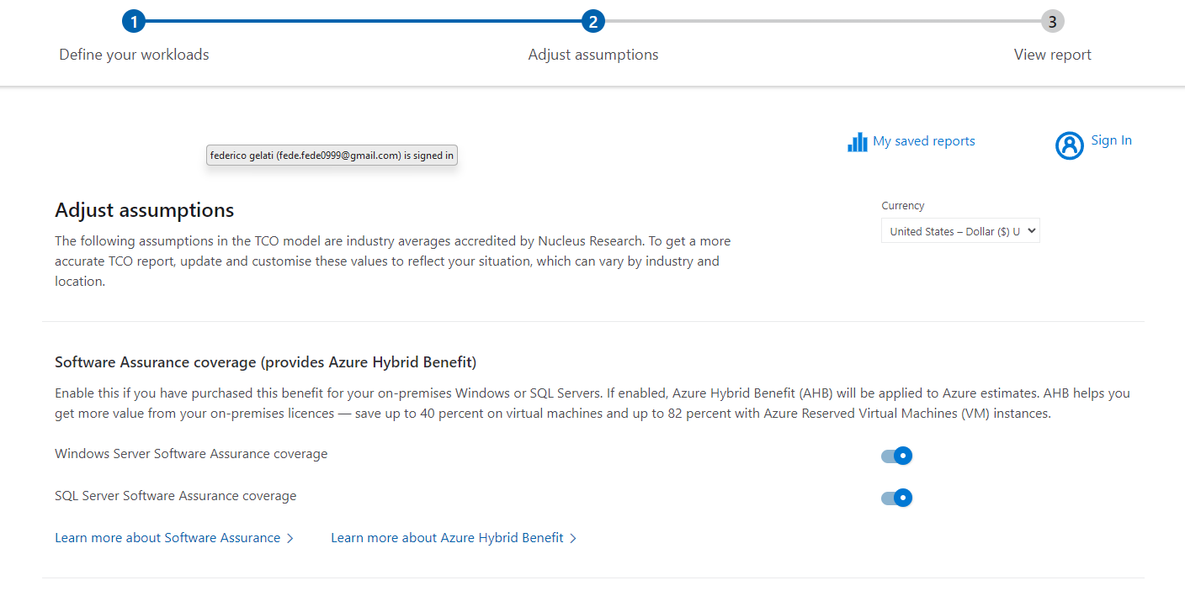
The Adjust Assumptions function allows users to optimize characteristics such as usage, geography, discounts, resource lifespan, and cost variables. Users can set up expected consumption patterns for services like virtual machines, storage, databases, and networking. They can also choose deployment zones, use discounts such as reserved instances, and specify resource lifespans. They can also modify cost factors like inflation and discount rates. These customizations provide more precise cost estimates tailored to specific demands, allowing for informed decision-making and efficient cloud expenditure management inside the Azure environment.

The screenshots that follow show the highest level of our TCO (Total Cost of Ownership) calculator—a critical tool in our analysis. This is the final step in our careful process. In the upcoming report, we will go over the cost breakdown in detail, looking into each component to acquire a more nuanced picture of the financial situation.
Our focus is on assessing the potential consequences of transferring data to the Azure platform for the prestigious Global Learning Institute. It is a vital crossroads in which we must consider not only the financial concerns, but also the broader implications and benefits of such a transition. At the centre of our analysis is the total cost figure, which was methodically determined from the TCO calculator. This comprehensive figure includes not only the direct costs of operating on-premises technology, but also the frequently neglected maintenance costs. This picture spans a predicted five-year period, giving a solid foundation for our assessment and strategic planning.

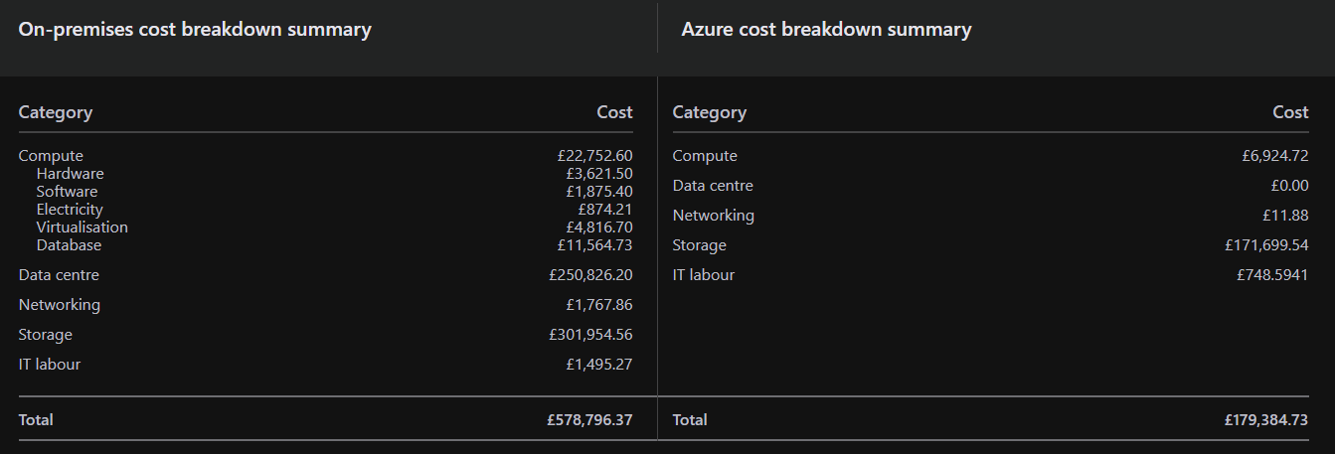
As we examine the comparison across categories, it becomes clear that switching to Azure results in significant savings, particularly in data centre and networking expenditures. This reduction not only results in significant monetary savings, but also relieves the Institute of the burden of ongoing maintenance costs. This critical migration to Azure not only reduces operational overhead, but it also frees up resources that may be allocated toward strategic goals and innovation.
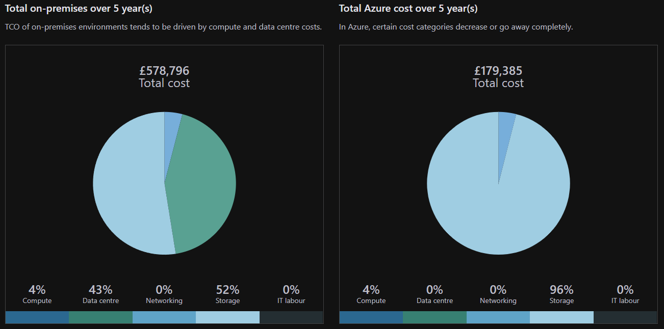
Finally, based on my experience as a Cloud Architect working with GLI, I strongly support accelerating the cloud migration. This strategic approach promises to improve the institute's future trajectory while also lowering the inherent risks involved with data management. By adopting the cloud, GLI strengthens its resilience to potential data loss scenarios, providing continued database functionality and uninterrupted operations.

Azure File Storage

Containers in Azure
Azure offers different types of options to selects on your best needs, for the GLI needs we are going to discover the potential of a few of them. Azure Blob Storage appears as the best fit for Global Learning Institute's storage requirements. Blob Storage is designed to handle large amounts of unstructured data such as photos, videos, and documents while remaining scalable and cost-effective. Its tiered storage choices suit a variety of access patterns, allowing GLI to optimize expenses based on data usage. Furthermore, Blob Storage connects smoothly with Azure services, offering effective management and security for GLI's course materials and administrative documents. By adopting Azure Blob Storage, GLI not only handles its immediate storage needs, but also provides the groundwork for future expansion and innovation in its educational programs.
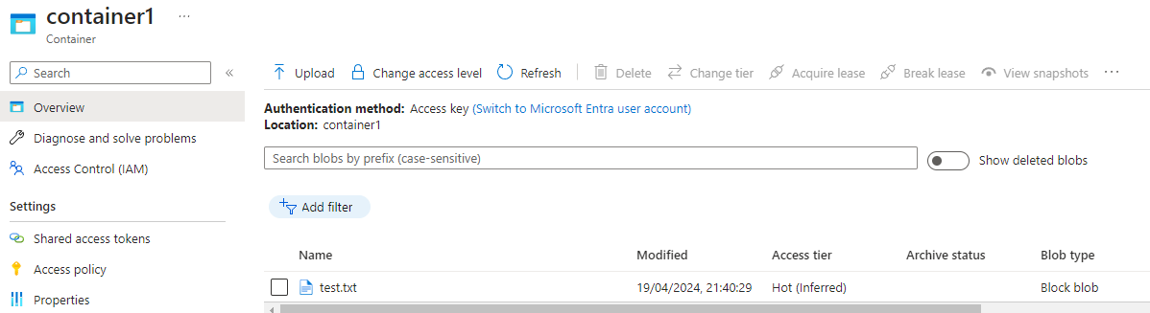
The hot access tier is appropriate for frequently requested data that requires low latency, albeit at a greater storage cost. In contrast, the cool access tier provides lower storage costs for infrequently visited data, but slightly higher access costs. Finally, the archive access tier is suitable for infrequently accessed or long-term retention material, with the lowest storage costs but higher access charges and longer retrieval times.

File Storage in Azure
Azure File Storage provides fully managed file shares accessible via the Server Message Block (SMB) protocol, making it simple to migrate on-premises file shares to the cloud or implement new file storage solutions. Organizations can save upfront hardware costs by using Azure File Storage, where they simply pay for the storage they use. The SMB protocol allows users to access Azure file shares from any location with an internet connection.
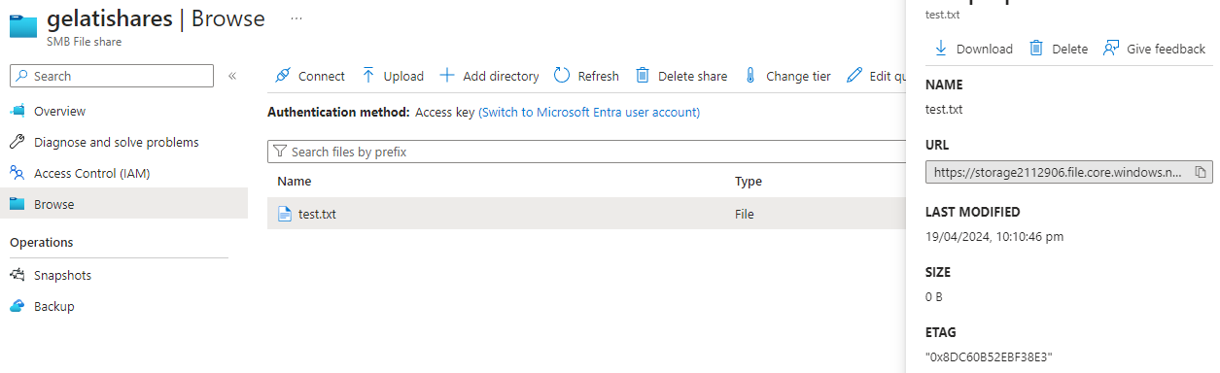

Replication Strategies
Azure provides a variety of replication strategies to maintain data redundancy and high availability inside Azure Storage, including Locally Redundant Storage (LRS) and Zone-Redundant Storage.
Locally Redundant Storage (LRS) replicates data within a single Azure region, providing protection against hardware failures or data centre outages. By storing several copies of data across three storage clusters in the primary region, LRS provides redundancy and reliability at a low cost. This method is appropriate in circumstances when high availability within a single area fits organizational requirements.
Zone-Redundant Storage (ZRS) takes redundancy to a new level by replicating data across different availability zones in a single Azure region. Availability zones are separate data centres with their own infrastructure, providing data availability even in the case of a data centre failure or disaster. ZRS is appropriate for mission-critical workloads that require increased availability and durability.[1]

Different type of Azure Databases

Azure SQL Database
Azure SQL Database, a managed cloud database service offered by Microsoft Azure, is essentially SQL Server running in the cloud. It reduces the load of database management by handling operations such as upgrades, patching, backups, and monitoring. This allows you to focus on your apps and data.
Flexibility is a significant feature of Azure SQL Database. You can opt to deploy a single database with its own set of resources, which is suitable for applications with specific performance requirements. Alternatively, you can use pooled databases in an elastic pool. This option distributes resources across numerous databases, making it cost-effective for scenarios involving fluctuating workloads. Azure SQL Database supports a variety of data formats. It can store structured data in traditional tables with rows and columns, as well as semi-structured data like as JSON and non-relational data. Built-in intelligence dynamically optimizes performance, reliability, and data security based on your application's data access patterns.
Security is a top priority, with features like as encryption, access limits, and threat detection to protect your sensitive information. However, as a cloud-based service, you lose some control over the underlying infrastructure when compared to maintaining your own servers.[2]
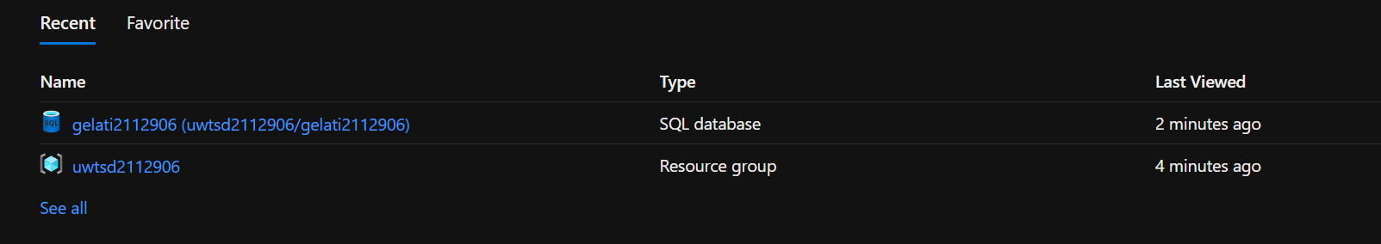
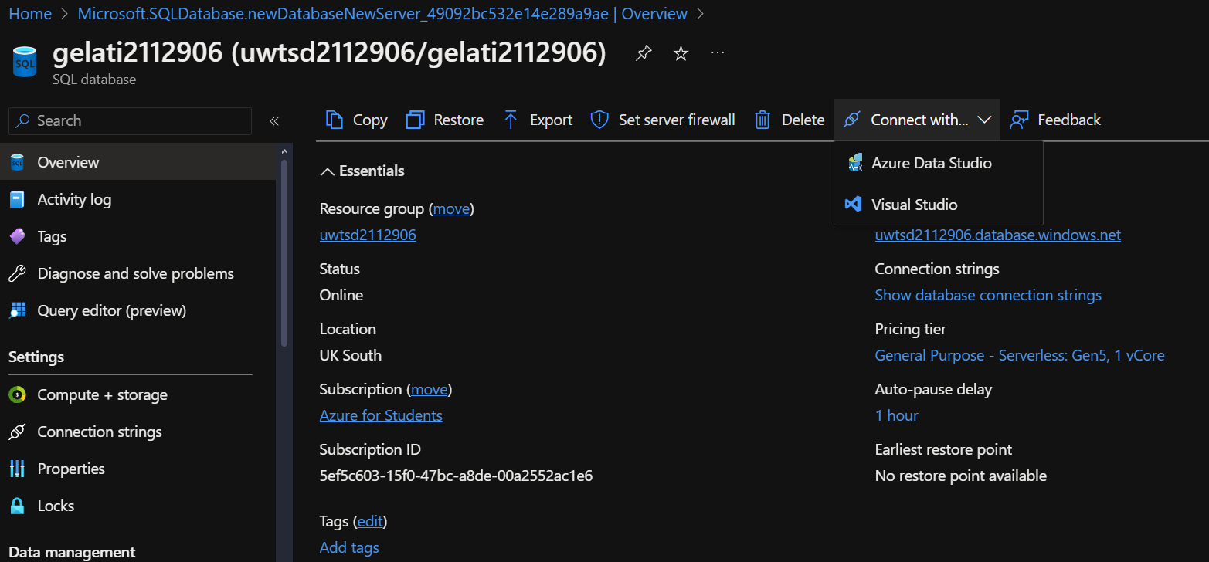
The first step involves creating a resource group named "uwtsd2112906" to house the SQL Database named "gelati2112906." Creating a resource group is a quick process. Users define the subscription, resource group name, and a suitable region. Additionally, tags can be added for better organization within the organization. Finally, the user simply needs to review and create the resource group.
After creating the resource group, the SQL Database can be created. When creating the SQL Database, users have several options available, including defining basic settings, configuring networking, setting up security, exploring additional settings (if needed), and adding tags for organization.

Azure Database for MySQL
Azure Database for MySQL is a cloud-based relational database service, it effectively allows you to run MySQL databases in Azure without having to manage the underlying infrastructure yourself. Microsoft handles server configuration, software installation, and maintenance tasks including as backups and upgrades, allowing you to focus on application development. Azure Database for MySQL provides two deployment options: Single Server for simple workloads and Flexible Server for more granular control and scalability. There are various advantages of using Azure Database with MySQL. For starters, it's a fully managed service, so you won't have to deal with the difficulties of database administration. This allows you to focus more efforts on developing your applications. Furthermore, Azure Database for MySQL provides high availability through built-in redundancy and disaster recovery solutions, ensuring up to 99.99% uptime for your critical databases. Cost-effectiveness is another advantage. With multiple pricing tiers, you just pay for the resources you utilize, making it an affordable solution. Data security is a critical concern, and Azure Database for MySQL addresses this by including built-in security capabilities such as threat detection and access controls to keep your data safe.
However, there are some possible downsides to consider. Vendor lock-in is a risk, as transferring your database from Azure to another cloud provider can be difficult. Because it's a managed service, you have less control over certain features of the database than if you ran it yourself.[3]
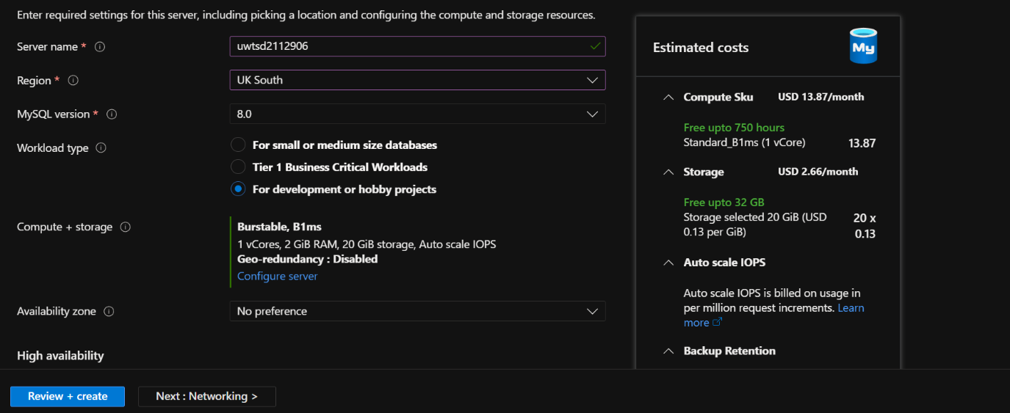
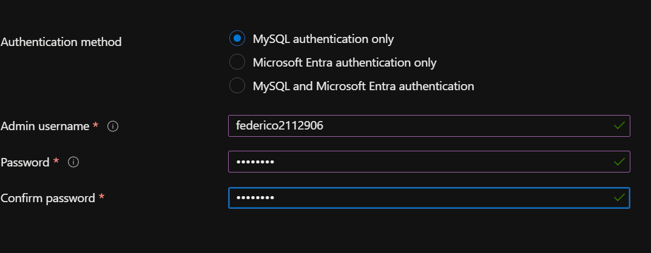
This option provides common settings for basics, networking, and security, just like other database creation techniques. However, it offers more flexibility: you may choose the server configuration that best meets your requirements like defining the workflow you want, high availability it’s also available and create an admin account and password for future changes. Additionally, Azure provides an expected cost before deployment, allowing you to avoid any surprises.

Azure Database for PostgreSQL
Azure Database for PostgreSQL is a fully managed database service. This eliminates the need for you to handle the fundamental servers and infrastructure, allowing you to concentrate on the applications. Scaling your database storage and compute resources is made easy with Azure Database for PostgreSQL. You can easily change them up or down to meet the needs of your applications. This service is highly available, with a service-level agreement (SLA) ensuring up to 99.99% uptime. This results into almost constant accessibility for your applications. Security is another important strength. PostgreSQL includes built-in security features like firewalls and encryption to keep your data secure. There are extra PostgreSQL deployment options available on Azure. If you're developing cloud-native applications that need a high-performance PostgreSQL database, consider Azure Cosmos DB for PostgreSQL. In contrast, Azure Arc-enabled PostgreSQL, which is currently in preview, enables you to manage and deploy PostgreSQL databases in hybrid and multi-cloud environments.[4]
To build Azure resources, you must first set up your environment and ensure that you have the relevant rights. Then, depending on your workload type, you will define server parameters such as resource group, location, server name, and administrator credentials, as well as optionally configure extra options. Workload type relates to the expectations placed on your database, such as high-performance requirements or changing workloads. Finally, you'll choose your desired authentication mechanism, either traditional username and password or Microsoft Entra for centralized identity management. Once everything is set up, you can use the relevant command or deploy the ARM template to provision your Azure Database for PostgreSQL server.

Most suitable Database for storing user profiles
As a Cloud Architect helping the Global Learning Institute (GLI) with their Azure migration, one critical choice is determining the best database for user profiles. While Azure provides several possibilities, Azure SQL Database stands out as the most appropriate solution. GLI's user data, which is likely to include structured elements such as names, IDs, emails, and course registration information, is well aligned with SQL Database's relational model. This framework provides familiarity to existing IT professionals with SQL experience, reducing the learning curve during migration. Security is critical for user data, and Azure SQL Database has robust features such as role-based access control to guarantee that only authorized individuals have access to sensitive information. Scalability is another critical factor. Azure SQL Database provides adequate scalability for a medium-sized institution such as GLI. It can handle expected increases in user base and data volume without requiring significant architecture changes. In essence, Azure SQL Database offers a familiar, safe, and adaptable solution for managing user profiles in the cloud, making it an excellent choice for GLI's easy migration to the Azure platform.

Azure Backups

Azure is intended to provide enterprises with dependable and scalable data protection for both on-premises and cloud workloads. GLI can use Azure Backup to automatically offload backup tasks to the cloud, reducing the need for complex on-premises backup infrastructure. It will go over the key features and benefits of Azure Backup, such as its ability to protect both on-premises and Azure Infrastructure as a Service (IaaS) virtual machines, as well as its scalability, data security measures, centralized monitoring and management capabilities, and customizable retention policies.
Azure Backup provides a complete set of options for backing up different types of data and workloads, catering to both on-premises and cloud-based systems. For on-premises data, Azure Backup allows for seamless backup of files, folders, and entire servers, simplifying data protection without the need for sophisticated infrastructure. Virtual machines (VMs) operating on Azure architecture as a Service (IaaS) may be safely backed up in the cloud, providing resilience against data loss or corruption within your cloud architecture. Additionally, Azure Backup enables backing up Azure Files, which protects file shares stored in Azure, whether they are used for application data, user files, or other information. Azure Backup provides powerful backup solutions for SQL Server for enterprises who use it for data management. Azure Backup now supports Azure Blob Storage, allowing enterprises to backup and preserve their object storage workloads, including blob data saved for a variety of apps and services. Azure Backup's diverse capabilities enable enterprises to establish complete data protection plans, securing key data assets across hybrid and cloud environments with ease and trust, that will be a very strong recommendation for the GLI.
Azure Backup not only provides a wide range of data backup features, but it also allows for flexible storage replication options. Locally Redundant Storage (LRS) replicates data three times within a single datacentre region, providing resilience to local hardware failures. The default option, Geo-Redundant Storage (GRS), duplicates data to a backup location, increasing durability even in the face of regional failures. Zone-Redundant Storage (ZRS) replicates data across availability zones within the same region, ensuring minimal downtime and continued operation.[5]

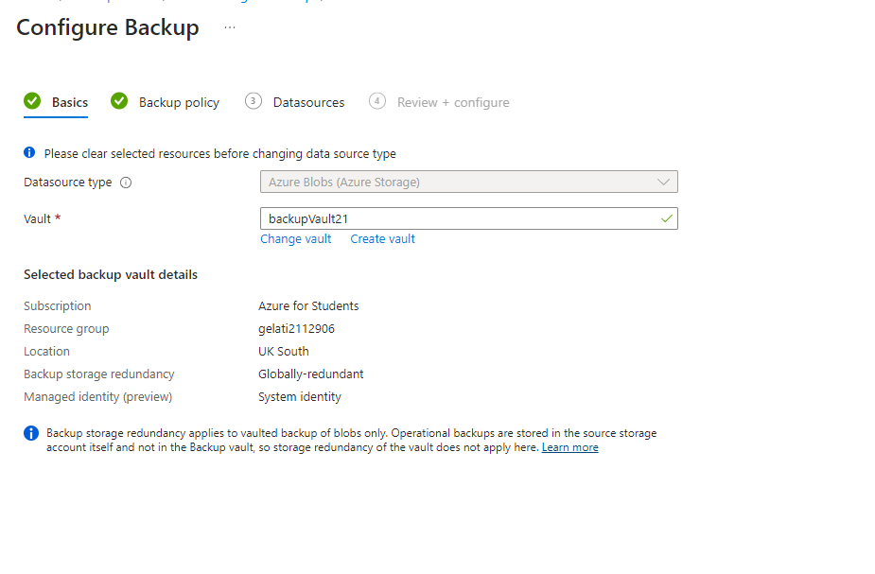
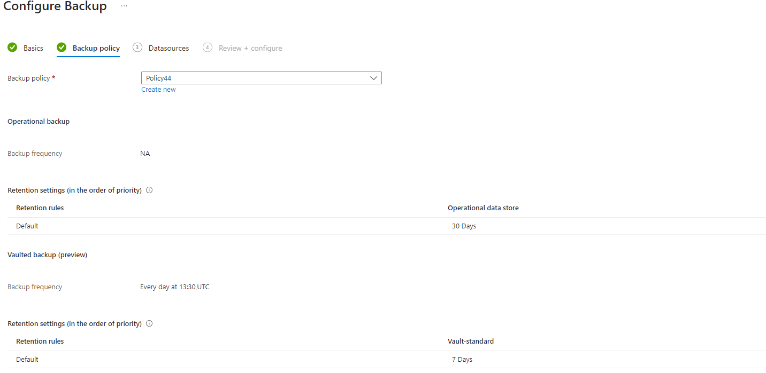

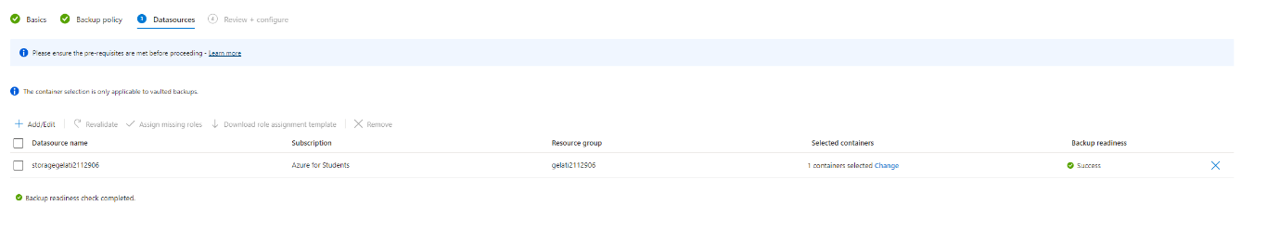

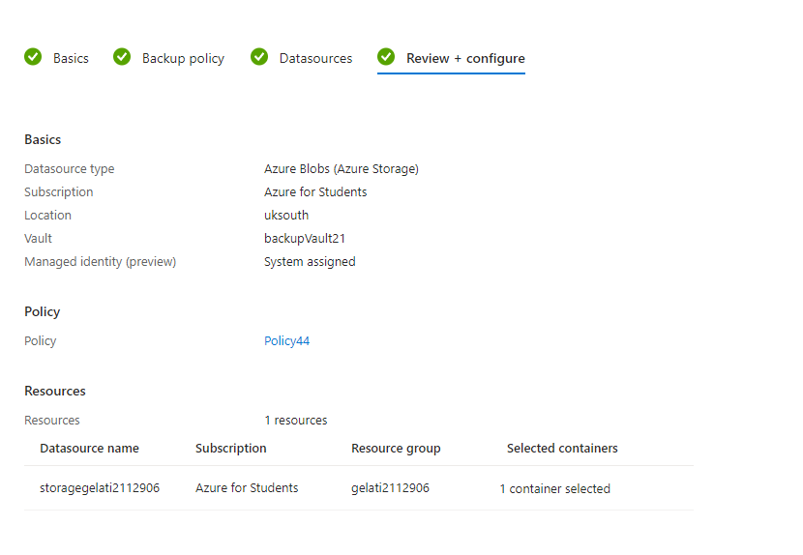
The Vault's backup configuration is seen in the screenshot above. When you select the backup option, you will be given several options, including blobs, VMs, SQL databases, and files. The next stage is to develop a policy that is specific to your company's needs and objectives. Users can select the individual container, queue, or file to back up from the data source selection. Once verified, the backup procedure can begin, providing assurance and security to your data assets.

This is the link of video created of deployment of the backups : https://youtu.be/yvzq3y3dObw

Azure Site Recovery

Azure Site Recovery is a complete disaster recovery service provided by Microsoft Azure that ensures business continuity and data protection in the case of a disruption or outage. It enables enterprises to replicate their on-premises workloads and virtual machines to Azure, so offering an alternative site for failover and recovery. Azure Site Recovery supports a wide range of workloads, including VMware, Hyper-V, and physical servers, providing flexibility for a variety of IT settings. Azure Site Recovery's automatic failover features and choreographed recovery plans provide rapid recovery times, reducing downtime and data loss. In addition, it enables continuous health monitoring and customisable recovery plans, as well as a strong and scalable solution for assuring resilience and continuity in the event of unanticipated disruptions.

Recovery Point Objective (RPO) and Recovery Time Objective (RTO) are two key metrics that serve as the foundation of every disaster recovery and business continuity strategy.
RPO refers to the greatest amount of data loss that an organization is ready to endure during a disruption. It denotes the point at which data must be retrieved to restart normal activities without serious effects. For example, if an organization's RPO is one hour, it means that in the case of a failure, they can only afford to lose one hour's worth of data. Achieving a low RPO often entails performing regular data backups or continuous replication to minimize data loss.
On the other hand, RTO specifies the maximum permissible downtime for recovering operations following a disturbance. It indicates the time required to recover and restore systems, applications, or services to avoid substantial business disruption. For example, if an organization's RTO is four hours, it suggests that in the event of a failure, they will try to recover and restart operations within four hours to minimize disruptions. Achieving a low RTO frequently necessitates effective recovery methods, predetermined workflows, and automated failover systems in place.

The ideas of primary and secondary regions, as well as geo-redundant storage, are critical for assuring resilience, high availability, and disaster recovery.
The primary region is the principal geographic area where an organization's essential data, applications, and services are hosted or deployed in a cloud architecture. This core area acts as the primary operational environment, ensuring user access, data processing, and business continuity on an ongoing basis. Companies typically choose a major area based on proximity to users, regulatory requirements, and the availability of required resources and services.
The secondary region acts as a backup or failover site, offering redundancy and disaster recovery capabilities in the event of a disruption to the primary region. It is physically separated from the major region to reduce the risks associated with localized outages, natural catastrophes, and other unanticipated incidents. The secondary region stores synchronized copies of data, applications, and configurations, allowing for speedy failover and uninterrupted operation in the case of a primary region failure. Geo-redundant storage (GRS) is a data replication mechanism provided by cloud providers like Microsoft Azure that improves data durability and availability across several geographic locations. GRS replicates data asynchronously to a secondary data centre in a separate area, providing redundancy and resilience against data loss caused by hardware failures, site outages, or catastrophic events impacting the first data centre. GRS often provides higher levels of data durability and availability than traditional replication methods, making it ideal for critical workloads and regulatory compliance needs.

Hot and warm sites refer to varying levels of preparedness and resource allocation for ensuring business continuity in the event of a disaster or disruption.
A hot site is a fully operating backup data centre that is always active and ready to take over primary operations at a moment's notice. It is effectively a clone of the original site, complete with the technology, software, and data backups required to restart operations almost promptly after a disaster or outage. Because a hot site is continuously active and up to date, it has the shortest recovery time objective (RTO) and minimal data loss, making it ideal for mission-critical applications and services that require near-zero downtime.
A warm site is a partially furnished secondary facility that needs to be set up and configured before it can function. It may have infrastructure and resources in place, such as servers, networking equipment, and power sources, but it lacks a hot site's real-time synchronization and data replication capabilities. A warm site situation often involves a delay in moving operations from the primary site to the secondary site, resulting in a longer RTO and perhaps greater data loss than a hot site. Warm sites, on the other hand, provide a good blend of cost-effectiveness and recovery capabilities, making them ideal for enterprises with less essential workloads or fewer budgets. [6]

References

[1] "Introduction to Azure Storage." Microsoft Azure. https://learn.microsoft.com/en-us/azure/storage/common/storage-introduction
[2] "Microsoft Azure SQL Database." geeksforgeeks. https://www.geeksforgeeks.org/microsoft-azure-azure-sql-database/
[3] "Microsoft Azure – Introduction to Azure Database For MySQL." geeksforgeeks. https://www.geeksforgeeks.org/microsoft-azure-introduction-to-azure-database-for-mysql/
[4] "Microsoft Azure – Database For PostgreSQL." geeksforgeeks. https://www.geeksforgeeks.org/microsoft-azure-database-for-postgresql/
[5] "What is the Azure Backup service?" Microsoft. https://learn.microsoft.com/en-us/azure/backup/backup-overview
[6] "About Site Recovery." Microsoft. https://learn.microsoft.com/en-us/azure/site-recovery/site-recovery-overview



