
12/12/2019
i
Flywheel Energy Lab Report
engineering Science 1 M4X00385
Nathan Myer 1801800
School of Engineering
BEng Motorcycle Engineering

University of Wales Logo: https://www.uwtsd.ac.uk/

Contents
1 | Introduction 1
2 | Procedure 1
2.1 | Set Up 1
2.2 | Procedure 1
3 | Results 3
4 | Analysis 4
4.1 | Data culling 4
4.2 | Calculations 4
4.3 | Analysis 6
5 | Conclusion 8
6 | Evaluation 8
7 | Further Work 9
8 | References 10

1 | Introduction

In this laboratory experiment, a range of weights connected to a flywheel are dropped from a set height, and experimenters record timing and rebound height for each trial. By conducting this exercise, experimenters may gain a better understanding of the mechanism by which flywheels store and regulate energy, as well as the attendant energy losses. Additionally, they will be able to compare the resultant body of data to previously given details about the mechanism’s components to validate their calculations and experimental procedures.

2 | Procedure

2.1 | Set Up

Materials needed for this experiment are:
- Flywheel
- Pulley block
- Cord
- Weight Hanger
- Weights (10g masses)
- Ruler
- Backing plate
Making sure the backing plate is set up in a stable vertical position, the pulley block should be attached firmly near the top, and the flywheel attached to the pulley shaft. One end of the cord must be attached to the pulley shaft, and the other to the weight hanger, with enough length to allow for at least 280mm of unobstructed freefall of the hanger. Next, with the hanger and cord at their lowest point, fix the ruler to the backing plate such that the bottom of the weight hanger is at 0. To complete setup, add enough weights so the hanger assembly is at 100g. The completed setup should resemble figure 1.

2.2 | Procedure

Wind up the flywheel and pulley apparatus so that the bottom of the weight hanger is at the 280mm mark on the ruler. Experimenters should be careful to keep their heads level with the apparatus to ensure accurate height measurements. Then release the flywheel and record the amount of time taken for the weights to drop and reach apogee of the rebound. The rebound height should also be recorded. Record three trials for each mass, going up to 500g in 100g increments.
Experimenters should make effort to record time and rebound height as accurately as possible; they should also take care to drop each mass from the same 280mm height, and not to impart any accidental forces on the flywheel when releasing it. Any conditions that may compromise the accuracy of a given trial should be corrected, and the trial redone.
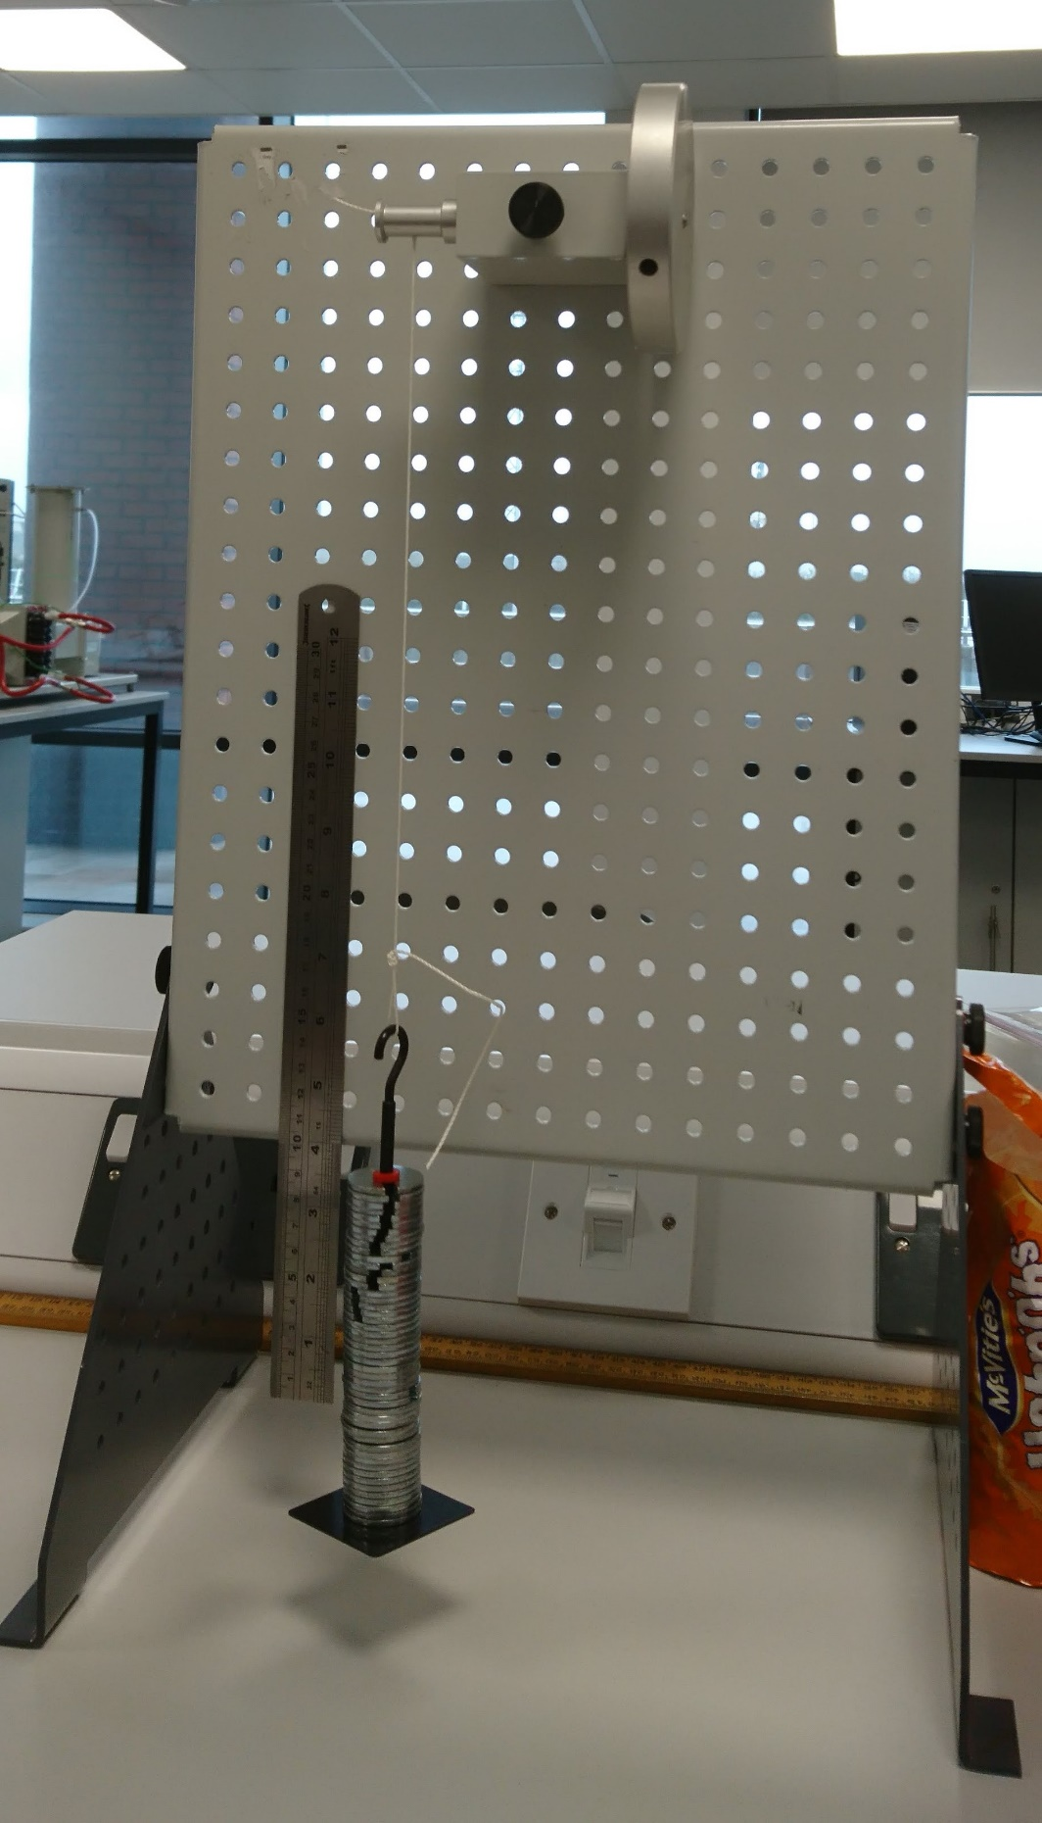
Figure 1: Pulley and hung mass setup at 500g, BDC (Author, 2019)

3 | Results
Table 1: raw data

During this experiment, two trials resulted in measurements outside expectations, and were redone. The discarded trials are included in table 1, but were omitted from further analysis. The raw collected data is displayed in table 1.
As can be seen in the table, both the 200g and 300g sets have four trials instead of the standard three; these are the sets which contain the two likely erroneous trials.

4 | Analysis
Table 2: Culled raw data

4.1 | Data culling

To avoid introducing inaccuracies to the average values used for further calculations, the data in table 1 had two trials removed, one each from the 200g and 300g sections, to create table 2. To select which data to remove, first an average rebound height and time was found for the four trials in the 200g and 300g sections. Next, each trial was compared to the average value to get a variance as seen in table 3.
Table 3: Data variances
Finally, the trials with the largest variances were discarded from table 2. The 300g height variances were all very similar, so the largest time variance, trial 2, was selected for removal. Selection for the 200g mass trials was more difficult. Trial 1 has the highest total variance; however the reliability of the height measurements was entered into question. As can be seen in table three, the height variances for 200g had a much larger range than that of the 300g mass section. Therefore, considering the unreliability of height measurements, the decision was made to give more weight to time variances and trial 2 was selected for removal.

4.2 | Calculations

From the corrected raw data in table 2, average values for time and rebound height were calculated for each mass section and put into table 4. Next, potential energy was calculated via the equation $PE=m×g×h$ [equation 1] where m is the mass attached to the flywheel, g is the acceleration from gravity, and h is the initial drop height of .28m. To get potential energy loss, equation 1 was again used, however with h being the rebound height instead of initial drop height. The resulting
Table 4: Processed data
value was then subtracted from Potential Energy to give potential energy loss. Adjusted potential energy loss is the energy lost purely in downward motion; it was found via the equation $Adj. PE loss=PE loss ×h1/(h1+h2)$ [equation 2], where h1 is the initial drop height and h2 is the rebound height. It can be noted that the adjusted potential energy loss is in all cases slightly over half the total loss; this means that most of the energy loss is coming from friction in the pulley block as the initial drop, having the largest linear displacement, would have moved the pulley and flywheel through more radians than the rebound.
Falling time was found with: $Fall time=t×h1/(h1+h2)$ [equation 3], where t is the total time, h1 is the initial drop height and h2 is the rebound height. Mg, the downward force, was found by multiplying the mass times acceleration from gravity. Similarly, the linear acceleration was found by dividing the initial drop height of .28m by the square of the falling time to get units in m/s². Linear velocity was calculated via $v=at_{f}$ [equation 4], where a is the acceleration and t_{f} the falling time. From there, linear velocity was converted to angular velocity by multiplying it by 2π divided by the circumference of the pulley.
The torque acting on the pulley was found by the equation $T=\left(mg-ma\right)r$ [equation 5] where m is mass, g is acceleration from gravity, a is linear acceleration, and r is the radius of the pulley. The angular acceleration, a/r, is the linear acceleration divided by the pulley radius. Finally, kinetic energy was calculated by multiplying the total moment of inertia of the pulley and flywheel system by the square of the angular velocity, and dividing by half.

4.3 | Analysis

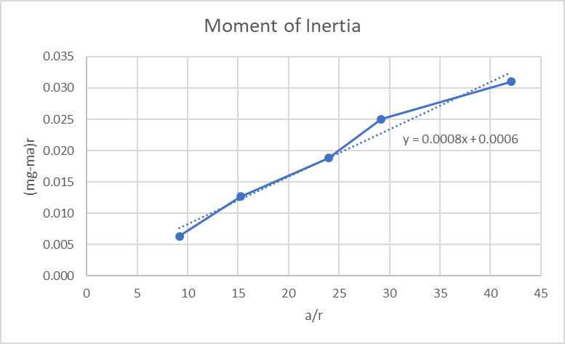
Using the data calculated in table 4, Torque can be plotted against angular acceleration (a/r) to give a value for the moment of inertia of the pulley and flywheel. Figure 2 shows the resulting line, the slope of which is the moment of inertia. As can be seen, the slope of the line of best fit determines that the moment of inertia of the pulley and flywheel system is 0.0008 kgm². However, the given values in the provided guidance notes (Tecquipment ltd, 2012) add up to only 0.00047 kgm².
Figure 2: Moment of inertia
Such a large discrepancy between results and expected values indicates a flaw somewhere within the experiment. Perhaps the most obvious culprit might be the mathematics by which the graph in figure 2 was derived. Upon initially receiving the 0.0008 kgm² result, these mathematics were checked and redone both by hand and by outside parties, all resulting in identical or similar values. Given this and the fact that other experimenters performing the same procedures came up with similar figures for the moment of inertia, it seems less likely that the cause of this discrepancy was mathematical error.
Another explanation for the discrepancy might be replacement of parts. As moment of inertia is particularly sensitive to changes in mass and radius, it is possible that one or both of the spinning components might have been replaced with parts of different size or mass. In such a case, the given values would no longer apply to the components used in the experimental procedures.
It is also possible that the data collected is simply of low quality. As can be seen in figure 2, the data points in the top right region have fairly large variance even compared to those in the lower left. Additionally, table 3 has also shown rather large variances from the average in the raw data. Factors causing low data quality will be discussed later.
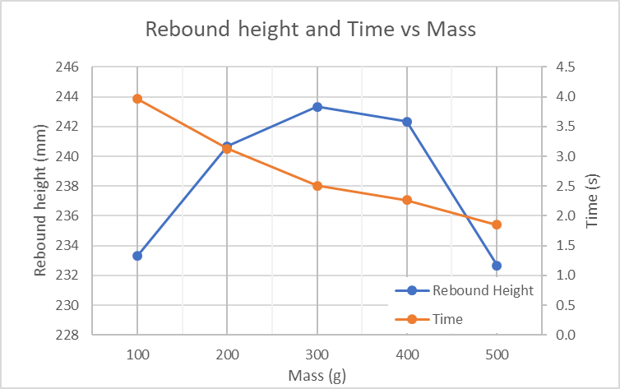
Aside from the discussion on moment of inertia, another interesting relationship to note is that between time, rebound height, and mass. Figure 3 shows both plotted on the same graph; of particular interest is that rebound height increases as mass approaches 300g, then decreases to approximately its initial values as mass approaches 500g. As mentioned earlier, there is some doubt as to whether the values provided in the guidance notes are correct, however if they are, one explanation for this increase and decrease in rebound height could be because the mass of the flywheel and pulley system itself is listed as approximately 390g (TecQuipment ltd, 2012). As the rebound height is directly determined by the amount of energy stored in the flywheel, it could be that a mass roughly equivalent to the flywheel mass causes a sweet spot between kinetic energy in the flywheel and potential energy (given by mgh) which maximizes height.
Figure 3: Rebound height and time vs mass
By contrast, time decreases as mass increases, meaning as potential energy increases, so too does acceleration and by extension the rate of energy transfer between the hung mass and the flywheel. From the data collected, it appears the relationship between time and mass is asymptotic. Though what the lower limit on this relationship might be is unclear from the available data, the relationship itself does make sense, as a linear one would eventually have time equivalent to and less than zero seconds which is impossible.

5 | Conclusion

Though the gathered data did not supply the moment of inertia value that was expected, the mathematical process by which the moment of inertia was calculated would seem to be correct. As the flywheel and pulley remained constant throughout the procedures, it can be assumed that moment of inertia would likewise remain constant. Therefore, the slope of the line that defines moment of inertia should remain constant—in other words linear—and this is exactly what is shown in figure 2. By another method, moment of inertia can be found by dividing torque by angular acceleration (Khan Academy, 2019), which when done to the values in table 4 (a/r representing angular acceleration) results in table 5, where we see that the I values for each mass are in fact close to the I value found by the graph.
Table 5: Calculated Moment of Inertia
Further exploring the relationship between mass and time in figure 3, the equation $T=Iα$ [equation 6] may be substituted into the equation for rotational motion $ω_{2}=ω_{1}+αt$ [equation 7] which, assuming the apparatus starts from rest, gives the resulting equation $ω=\frac{T}{I}t$ [equation 8]. As torque is the product of force and distance from the axle (Tipler, 2004), and knowing that force itself is the product of mass and acceleration, we can modify equation 8 such that $ω=\frac{mar}{I}t$ [equation 9], where m is the hung mass, r is the pulley radius and a is the downward acceleration. This can be rearranged to $t=\frac{ωI}{mar}$ [equation 10], where it is clearly seen that all else remaining constant, increases in m mass will result in diminishing returns of t time. This would seem to support the theory that the relationship between mass and time is asymptotic in nature.

6 | Evaluation

Despite aforementioned discrepancies between calculated and expected I values, the experiment can be considered largely a success. While the values themselves may be incorrect, the relationships they have are clear and logical, indicating that the processes deriving them are correct.
As for factors bringing data quality down, the data collection methods are most likely the main cause. Particularly with heavier masses, the rapid acceleration at the bottom of the weight hanger’s travel caused pronounced wobbles in the hung masses, making accurate collection of rebound height data exceptionally difficult. Similarly, releasing the flywheel assembly by hand may have occasionally imparted backwards or forwards moments on the rotating parts, thus throwing off both time and rebound height data points for those trials. Reasons such as this are likely what caused the two outliers which were removed from the initial raw data; it is entirely possible that additional erroneous trials with less pronounced deviation remained in the body of data.

7 | Further Work

Initially, further work should be focused on improving the experimental procedures, particularly data collection. Ideally, both time and rebound height would be collected electronically by monitoring the motion of the flywheel. Depending on the sensors used, an extremely accurate time value could be taken by measuring the time from when the flywheel starts moving to when it stops and reverses direction, indicating that the hung weight has reached rebound apogee. Rebound height could be taken with relative accuracy by measuring the rotational displacement of the flywheel, converting it to linear displacement using the radius of the pulley, and then subtracting the initial drop height. In a similar effort to limit human error, a mechanical release mechanism, perhaps a quick release friction brake, could be attached to the flywheel and pulley system so that no forward or backward impulses are imparted on the system when it is let go.
To enhance the experiment further, multiple mass and diameter flywheels should be used to explore the accuracy of the mathematical processes at determining moment of inertia. It would also be enlightening to see the relationships between hung mass and rebound height for different flywheels to further define what kind of connection, if any, lies between flywheel mass, hung mass, and rebound height.

8 | References

Khan Academy (2019) Rotational Inertia. Available at: https://www.khanacademy.org/science/physics/torque-angular-momentum/torque-tutorial/a/rotational-inertia. (Accessed: 11th December 2019).

TecQuipment Ltd (2012) ‘Potential and Kinetic Energy Kit ES9, 3. Energy in a Flywheel’, Engineering Science Worksheets, pp.13.

Tipler, Paul (2004). Physics for Scientists and Engineers: Mechanics, Oscillations and Waves, Thermodynamics (5th ed.). W. H. Freeman.

