Module: Digital Skills and Research Methods
Module code: BMSW4003
Module Leader: Koushik Modak
Assignment Title: DSR Assessment 2
Individual Report
Student name: Shawaiz Ahsan
Student ID: 21344042
Table of Contents
Introduction 1
Description of virtual learning environment 1
Impact of virtual learning on learners 2
Research aim and objectives 3
Methodology 3
Research Philosophy 3
Research approach 3
Research method 3
Data collection 3
Sampling method 4
Data analysis 4
Primary research 4
Secondary Research 12
Findings 14
Conclusion 15
References 16

Introduction
The report aims to gain an understanding of the impacts of the virtual learning environment (VLE) on students. A virtual learning environment is a way to digitalize teaching and learning activities by increasing the use of a computer, the internet, and other technologies to deliver learning and gain learning (Axinn, 2021). So, the report will include a description of the virtual learning environment, the impacts of the virtual learning environment on learners, methodology, primary research, secondary research, and findings.

Description of virtual learning environment
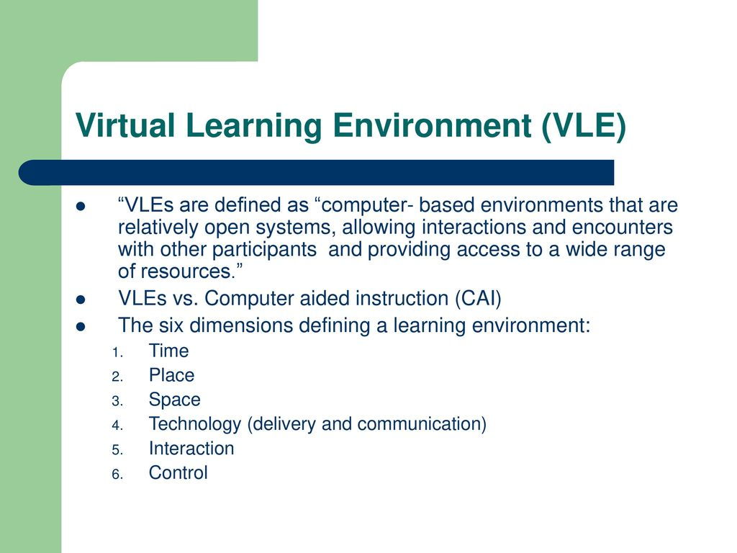
Figure-1: Virtual Learning Environment.
Source: (Bansal, 2020).
According to Brown (2020), a virtual earning environment enables better delivery of learning and brings better learning outcomes by enabling teachers and learners to use digital technologies to engage in teaching and learning activities. A virtual learning environment provides the opportunity to involve in a digital learning environment by using the technologies to get learning from the teachers (Cardiff, 2019). For example, computer, the internet, smartphones, and smartwatches like Samsung Galaxy Gear provides many facilities to get virtual learning opportunity. So, learners will be able to cover up their academic activities in critical situations such as the pandemic because the virtual learning environment also provides the opportunity for distance and flexible learning.

Impact of virtual learning on learners
Increase motivation: Virtual learning environments motivate learners t to involve in learning activities by positively impacting learners learning understandings. For example, when teachers use multimedia classrooms by using a projector, computer, and internet that inspire the teachers to provide learning to the learners by showing the images, videos, and pictures on a specific topic that helps the learners to understand learning easily that motivate them to involve in the learning activity (Chen, 2021).
Improve technical skills: Virtual learning environments positively impact learners by increasing their technical skills to use digital technologies because virtual learning environments mostly also learners use tab, smartphones, computers, the internet, and so on to get instructions and learn from teachers (Crane, 2019). That habituated the learners to using digital technologies to complete their tasks and assignments and communicate with teachers.
Increase learner’s engagement: According to De Freitas (2021), a virtual learning environment increase the engagement level of learners by increasing their presence by 72% within the classroom along with online classes. Because learners find it interesting to attend online classes and to learn within a virtual learning environment by getting learning through digital technologies that help the learners to keep the learning within their minds for long-term.
Improves discipline among learners: Virtual learning environment help to increase the engagement of learners in their learning activities that is positively impacting the self-discipline of the learners because they pay concentration to the learning activities that demotivate them to create noise within the class (Kalaysi, 2021). So, the virtual learning environment is enhancing the learner’s soft skills which are significant for a learner to get success in life.
Improving learning experiences: Virtual learning environment improves the learning experiences of the learners by involving them in learning activities enabling digital technologies that make the way easy to gain learning (Kiecolt, 2019). For example, before enabling the introduction the technologies in the field of education learners had to suffer to collect essential information. But the invention of technologies like the Samsung smart watch which provides the facilities to search for information, video recording, and so on helps the learners to complete their tasks within the classroom by searching for information using their watch (Livingstone, 2020). This is improving the learning experience of learners because learners get their essential information easily within the virtual learning environment.

Research aim and objectives
Research aim
- The research aims to identify the impacts of the virtual learning environment (VLE) on students.
Research objectives
- To identify the need for a virtual learning environment in an educational institution.
- To evaluate the impacts of the virtual learning environment on learners.
- To analyse how technologies used in virtual learning environments help learners to improve their skills.

Methodology

Research Philosophy
Realism: The realism research approach refers to getting ideas, information, and data that rely on reality from the human mind and rejects the data and information collected through mythical ways (Parsons, 2019). The researcher will follow the realism research philosophy to collect the data from a scientific approach. Because realism relies on real data that will help the researcher to deliver the most reliable and realistic information about the impact of VLE on students.

Research approach
Deductive approach: Deductive research approach refers to collecting data typically associated with scientific investigation (Postavaru, 2019). So, the researcher will follow the deductive research approach because it refers to collecting data by analysing the existing theories and models done by others and also inspiring to collect data from real-world observation.

Research method
Mixed method: Mixed method of research refers to the integration of both the qualitative and quantitative data that avoid the limitation of using one research method (Pulford, 2020). So, the researcher will follow the mixed method of research to collect both qualitative data like theories and concepts and quantitative data like statistics and measures.

Data collection
Primary data collection: Primary data collection is the process to collect data by performing interviews, surveys, observations, and so on (Shandilay, 2020). So, the researcher will perform the survey by preparing a questionnaire to ask the respondents to meet the objectives of the research. So, the researcher will prepare 8 questionnaires to perform the primary research to collect primary data and the respondents will answer the questionnaire on a five-liker scale like agree, strongly agree, not sure, disagree, and strongly disagree.
Secondary data collection: Secondary data collection refers to collecting data from journals, case studies, news articles, and sources where the data is collected by other experts and professionals (Shandilay, 2020). So, the researcher will collect secondary data from both professional source and academic sources. The researcher will collect data from the practitioner sources like the journals, news articles, and websites. Also, the researcher will collect secondary data from traditional media sources new media sources like social media, and so on.

Sampling method
Simple random sampling: Simple random sampling refers to selecting a group of participants from a large population (Sudman, 2020). Simple random sampling is a probability sampling method. So, the researcher will follow the simple random sampling method to select the group of participants. The researcher will select a group of participants of 20 members to perform primary research.

Data analysis
Data mining: Data mining s the set of the data collection, preparation, and modelling of data to get meaningful insights (Sun, 2021). So, the researcher will follow the data mining to get insights from the data collected through the primary and secondary research by using the Excel spreadsheet.

Primary research
- To what degree do you agree that virtual learning environments (VLE) increase students’ satisfaction to study and education centres?
Options | Frequency | Percentage | Cumulative percentage
Strongly disagree | 1 | 5‬%
Disagree | 1 | 5‬%
Not sure | 2 | 10‬%
Agree | 7 | 35%
Strongly agree | 9 | 45% | 100%
Total | 20 | 100%

The table and graph are showing that approximately 80% of respondents support that VLE increases students’ satisfaction to study and education centres but 20% is not supporting this fact.
- To what degree do you agree that virtual learning environments increase the engagement level of learners within academic activities?
Options | Frequency | Percentage | Cumulative percentage
Strongly disagree | 2 | 10‬%
Disagree | 1 | 5‬%
Not sure | 3 | 15%
Agree | 8 | 40%
Strongly agree | 6 | 30‬% | 100%
Total | 20 | 100%

The table and graph are showing that approximately 70% of respondents support that VLE increases the engagement level of learners within academic activities but 30% is not supporting that VLE increases learner engagement level.
- To what degree do you agree that a virtual learning environment positively impacts to motivate students to attend classes?
Options | Frequency | Percentage | Cumulative percentage
Strongly disagree | 2 | 10‬%
Disagree | 1 | 5‬%
Not sure | 1 | 5‬%
Agree | 9 | 45%
Strongly agree | 7 | 35% | 100%
Total | 20 | 100%

The table and graph are showing that approximately 80% of respondents support that VLE positively impact motivating students to attend classes but 20% is not supporting that VLE increases class attendance of learners.
- To what degree do you agree that a virtual learning environment positively impacting on enhancing learners’ soft skills?
Options | Frequency | Percentage | Cumulative percentage
Strongly disagree | 3 | 15%
Disagree | 2 | 10‬%
Not sure | 1 | 5‬%
Agree | 9 | 45%
Strongly agree | 5 | 25‬% | 100%
Total | 20 | 100%

The table and graph are showing that approximately 70% of respondents support that VLE positively impacting on enhancing learners’ soft skills but 30% is not supporting that VLE positively impacting on enhancing learners’ soft skills.
- To what degree do you agree that a Virtual learning environment enhances a learner’s community and relationship-building skills?
Options | Frequency | Percentage | Cumulative percentage
Strongly disagree | 4 | 20%
Disagree | 1 | 5‬%
Not sure | 1 | 5‬%
Agree | 8 | 40%
Strongly agree | 6 | 30‬% | 100%
Total | 20 | 100%

The table and graph are showing that approximately 70% of respondents support VLE enhancing learners’ community and relationship-building skills but 30% is not supporting that VLE enhancing learners’ community and relationship-building skills.
- To what degree do you agree that a virtual learning environment enhances the technical skills of learners?
Options | Frequency | Percentage | Cumulative percentage
Strongly disagree | 2 | 10‬%
Disagree | 1 | 5‬%
Not sure | 3 | 15%
Agree | 9 | 45%
Strongly agree | 5 | 25‬% | 100%
Total | 20 | 100%

The table and graph are showing that approximately 70% of respondents support VLE enhancing the technical skills of learners but 30% is not supporting that VLE enhancing the technical skills of learners.
- To what degree do you agree that virtual learning environments reduce the dropout of learners from university?
Options | Frequency | Percentage | Cumulative percentage
Strongly disagree | 1 | 5‬%
Disagree | 2 | 10‬%
Not sure | 3 | 15%
Agree | 7 | 35%
Strongly agree | 7 | 35% | 100%
Total | 20 | 100%

The table and graph are showing that approximately 70% of respondents support that VLE reduces the dropout of learners from university but 30% is not supporting that VLE reduces the dropout of learners from university.
- To what degree do you agree that a virtual learning environment improves learners’ interest to search for information to complete their academic tasks?
Options | Frequency | Percentage | Cumulative percentage
Strongly disagree | 4 | 20%
Disagree | 3 | 15%
Not sure | 1 | 5‬%
Agree | 8 | 40%
Strongly agree | 4 | 20% | 100%
Total | 20 | 100%

The table and graph are showing that approximately 70% of respondents support that VLE improves learners’ interest to search information to complete their academic tasks but 30% is not supporting that VLE improves learners’ interest to search information to complete their academic tasks.

Secondary Research
According to Tai, Chen and Todd (2020), a virtual learning environment positively impacting on learners that are increasing learners’ engagement levels by 30% within classroom activities. Because of the characteristics of the virtual earning environment that make the subjects easy to understand by sharing videos, images, links to websites, and so on by using the internet and other technologies that increase learners’ interest in education.
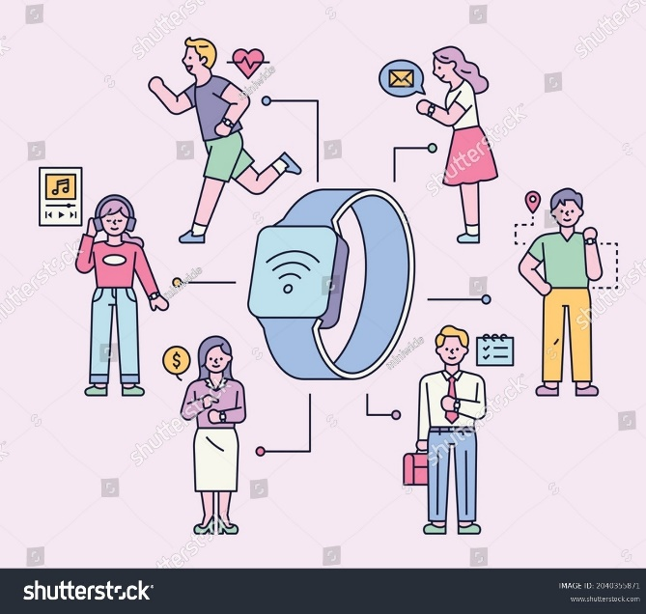
Figure-2: Use of Samsung Galaxy Gear for the virtual learning environment.
Source: (Axinn, 2021).
According to the survey conducted by Bansal (2020) on 100 learners of different universities identified that approximately 57% of learners are using Samsun Galaxy Gear smartwatch to get the opportunity of a virtual learning environment which is positively impacting them by increasing their engagement level by 25% within online classes. Because they could join the class at any time from any place by using the Samsung Smartwatch because the Samsung Galaxy Gear smartwatch has the facility to use the internet and has a camera that helps learners to join video classes.
An interview conducted by Brown (2020) on 200 learners of universities within the UK identified that approximately 89% of learners respond that the virtual learning environment impacted them positively by motivating them to attend classes without being absent class which helped them to acquire good marks within examinations.
An observation conducted by Cardiff (2019) on 10 UK’s top universities identified that during the COVID-19 pandemic the Universities created virtual learning environments for the learners by connecting with the learners through the internet. That identified approximately 40 learners who have attended virtual learning classes during the COVID-19 pandemic 45 which shows the virtual learning environment positively impacts students’ satisfaction and inspires them to attend classes.
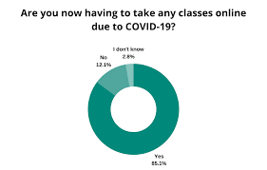
Figure-3: VLE classes during COVID-19 pandemic.
Source: (Chen, 2021).
A survey conducted by Crane (2019) on 30 Universities in the UK identified that approximately 85,2% of universities implemented virtual learning classes within the campus by enabling personal computers and the learners and ensuring internet connection because of the high demand for virtual learning among learners. That is showing that approximately 91% of their learners attend virtual learning classes that positively impact improving the technical skills of learners that are impacting positively build a successful career for them. Because nowadays all sectors refer to the knowledge and skills of using digital technologies.

Findings
The findings from the primary research are showing that most of the respondents approximately 70% to 80% of respondents support that the virtual learning environment (VLE) is positively impacting learners by improving their engagement level in academic activities and increasing satisfaction levels. Also, reducing drop out of college, increasing soft and technical skills that are significant for learners' careers, and improving learners' community and relationship-building skills.
The findings from the secondary research identified that a virtual learning environment is increasing learners' engagement by 30% more than before, implementation of a virtual learning environment encourages 40 learners among 45 to attend classes. Also, approximately 57% of learners use the Samsung Galaxy Gear smartwatch which is part of VLE inspiring learners to attend classes from any place at any time.

Conclusion
The findings of the report successfully meet the objectives of the research by identifying that VLE increases learners' engagement in class which is the need of educational institutions and learners to gain learning. Another objective meets by identifying that VLE is reducing the dropout of learners from Universities and increasing their satisfaction to study. And the third objective is met by the findings of that VLE that a virtual learning environment positively impacting on learners by enhancing their technical and soft skills.

References
Axinn, W., 2021. Mixed method data collection strategies. New York: Cambridge University Press.
Bansal, A., 2020. Survey sampling.
Brown, B., 2020. Evidence-Based Research. Maidenhead: McGraw-Hill International (UK) Ltd.
Cardiff, 2019. Appendix A Documents Pertaining to the Collection of Primary Data. Soviet Sociology, 9(1-2), pp.316-333.
Chen, Z., 2021. Learning about Learners: System Learning in Virtual Learning Environment. International Journal of Computers Communications &amp; Control, 3(1), p.33.
Crane, L., 2019. Student Experiences with Mobile Electronic Updates from a Virtual Learning Environment. International Journal of Mobile and Blended Learning, 4(3), pp.16-33.
De Freitas, S., 2021. Learning as immersive experiences: Using the four-dimensional framework for designing and evaluating immersive learning experiences in a virtual world. British Journal of Educational Technology, 41(1), pp.69-85.
Kalaysi, S., 2021. Students’ Attitudes Towards Collaborative Tools In A Virtual Learning Environment. EDUCATIONAL PROCESS: INTERNATIONAL JOURNAL, 4(1-2), pp.71-86.
Kiecolt, K., 2019. Secondary analysis of survey data. Beverly Hills, Calif.: Sage Publications.
Livingstone, D., 2020. From Multi-User Virtual Environment to 3D Virtual Learning Environment. Research in Learning Technology, 16(3).
Parsons, D., 2019. A Virtual World Workshop Environment for Learning Agile Software Development Techniques. International Journal of Virtual and Personal Learning Environments, 3(1), pp.37-54.
Postavaru, G., 2019. A participatory research approach.
Pulford, B., 2020. The influence of advice in a virtual learning environment. British Journal of Educational Technology, 42(1), pp.31-39.
Shandilay, D., 2020. Virtual Learning Environment Scenario in Higher Education (Web-based Learning). International Journal Of Management And Economics Invention, 04(05).
Sudman, S., 2020. Applied sampling. New York: Academic Press.
Sun, R., 2021. The effect of a virtual reality learning environment on learners’ spatial ability. Virtual Reality, 23(4), pp.385-398.
Tai, T., Chen, H. and Todd, G., 2020. The impact of a virtual reality app on adolescent EFL learners’ vocabulary learning. Computer Assisted Language Learning, 35(4), pp.892-917.

