LCBB5001 ENTREPRENEURSHIP
By Stefani Stefanova 2028009
Table of Contents
Introduction 3
Entrepreneurial skills, behaviours and trait 3
SWOT analysis 4
Skill Audit 6
PEST analysis of the UK macro environment 8
Conclusion 9
References 10
Appendices 12
Appendix A 12
Appendix B 16
Appendix C 18
Appendix D: Leadership skill test 19
Appendix E: Decision-making skill test 20
Appendix F: Time management skill test 21
Appendix G: Critical thinking skill test 22
Appendix H: Collaboration skill test 23
Appendix I: Active-listening Skill 24
Appendix J: Problem-solving skill test 25
Appendix L: Data analytical skill test 26

Introduction
This study generally includes a detailed analysis of crucial traits, behaviours and skills of successful entrepreneurship. Evaluating my own strengths and weaknesses this study will evaluate how I can develop my own skills to get relevant advantages in entrepreneurship. Additionally, in the following, there will a detailed analysis of the UK’s macro-environment factors by PEST analysis which will help to be prepared for the marketing conditions of the UK and ensure better entrepreneur skills based on current market conditions of the UK. Hence, this study will help to get relevant ideas regarding how proper entrepreneurship can be achieved through proper preparation and market research.

Entrepreneurial skills, behaviours and trait
Skills
The entrepreneurial midland set generally includes some specific skill sets that help to conduct daily business activity at the entrepreneurial level. Those specific skill sets include problem-solving skills, good communication skills and critical thinking ability [Refer to Appendix A]. An entrepreneur has to make relevant communication with the entire organisation’s employees and management team to get the desired productivity from the organisation. Due to that reason communication is the most essential skill for an entrepreneur. According to Listiningrum et al. (2020), critical thinking ability and problem-solving skills are generally interlinked with each other and due to effective critical thinking, an individual can solve the relevant problem more effectively. Due to that reason these mentioned skills are the most prior consideration that supports entrepreneurial decisions.
Behaviour
The main behavioural characteristics of a successful entrepreneur include their ability to bootstrap providing their assistance based on their necessity and understanding affordable losses. The go-for-it attitude, openness to challenge and risk-taking mindset generally make an entrepreneur perfect to guide their organisation towards success [Refer to Appendix A]. Due to these referred behavioural characteristics, an entrepreneur can effectively measure their ability to accept new challenges and how they can identify their relevant opportunities to challenge their limits to overcome problems. Fauzi et al. (2021) stated that without proper creativity, professionalism and passion towards the work an individual cannot gain success in entrepreneurship.
Traits
The success of an entrepreneur includes some particular combination of behaviours which can be categorised as their traits. Those combinations can be categorised as visionary, multitasking and identification of opportunities [Refer to Appendix A]. The behavioural traits generally indicate some particular responsive approach towards the business activities by which they can ensure the overall success of their business. A successful entrepreneur’s traits include ambition, motivation, willingness to learn always, learning from failure, determination to succeed and financial knowledge. According to Anwar et al. (2021), entrepreneurial traits determine an entrepreneur’s intentions and attitudes towards problems and their solution. Hence, the traits of the entrepreneur should reflect their ability to gain relevant solutions for problems and how they can motivate others through those skills. On the other hand, an entrepreneur always has to have some idea regarding the financial condition of their business. Due to that reason, an entrepreneur’s financial knowledge is very crucial to understand how resources should be managed and distributed in the proper position to get relevant profit throughout the business activity. The financial knowledge trait is that neglected gem which can turn out to be the main key factor in entrepreneurship.

SWOT analysis
Strength | Weakness
- I can efficiently perform collaboration, leadership and decision-making skills.  - I have undertaken different skill tests as unique resources [Refer to Appendix].  - Others can see my ability to take relevant and strategic decisions and lead the team members as my strongest point of mine.  - I have scored well and gained scores between 45-75, which indicates that I can make a collaboration with the team members. | - From the problem-solving test, I have identified that I am unable to solve critical problems [Refer to Appendix j]  - In addition, I am not proficient in active listening skills, data analytics, time management and critical thinking skills [Refer to Appendix I, K, G, F ].  - I have a dearth of resources to develop my data analytics skills.  - Others can see my incompetency of to complete my tasks within the time limit or period.  - As I have scored only 4 out of 10 on the critical thinking skill test, it can be seen as my inability to delve into critical aspects of the business situation [Refer to Appendix G].  - It can be assumed by others that I can not apprehend or understand all the outcomes of the business situation.  - I can mess out in critical situations as I am unable to solve problems in complex business situations.
Opportunities | Threats
- I have opportunities to improve my weaknesses as well as to work further on my strengths to make these aspects more robust characteristics.  - I can turn my strength into opportunities by engaging myself in group activities, and by being the group leader in the project.  - I can take advantage of short offline crash courses or online courses to develop and increase my decision-making skill. | - Since, from the skills test, it has been identified that I am inefficient in solving critical issues and managing my limited time setting, so it can impose significant threats while developing new business.  - Other entrepreneurs are creating new business ideas and taking potential risks to establish their business ideas in the present competitive business market situation.  - I become expose to my weaknesses from the skills test. In the present competitive scenario of entrepreneurship, I would not be able to sustain my business ideas as I have fewer competencies in a data analytics role.  - I would not be able to handle the consequences of a negative business situation, since I am unable to rectify my business problems with my own ability.
Table 1: SWOT Analysis
(Source: Self-Developed)

Skill Audit
Skills I have | Example
Collaboration Skill (strength) | The collaboration skill test helped me to categorise this skill as my strength as is reflected in the score I gained on the test [Refer to Appendix H]. This strength will help me in future to properly collaborate within a team to get desired outcomes as it describes how efficiently I can work within a team.
Leadership Skill (strength) | The leadership skill test helped me to categorise this skill as my major strength [Refer to Appendix D]. This test generally depicts that I have relevant skills to lead a team towards a desired goal which will be beneficial for the entire team and organisation. Leadership skill helps an individual to get relevant ideas about how they can contribute to a team as a leader (Guzmán et al. 2020). It helps to guide a team and show them an easier path to achieve relevant outcomes related to an activity.
Decision-making Skill (strength) | The decision-making skill test helped me to categorise this skill as my strength [Refer to Appendix E] This skill will help me to make relevant decisions that will be beneficial for the greater good of an individual. Through this skill, I can hope that I will make effective decisions which will guide an organisation towards success.
Skills I’d like to improve | How? Example?
Active-listening Skill (weakness) | Based on the active listening skill test it can be categorised as my weakness [Refer to Appendix I]. This specific skill can be improved through some relevant activities. According to Saydullayeva and Juraeva (2022), active listening skills can be developed through listening without judging.
Problem-solving Skill (weakness) | The problem-solving skill test helped me categorise this skill as my weakness [Refer to Appendix J]. The problem-solving skills can be improved by incorporating some analytical activities. The analytical activities include identifying relevant problems, visualising the problem and brainstorming creative solutions (Hasibuan et al. 2019).
Data-analytical Skill (weakness) | Based on the data-analytical skill test I got to know that this particular skill can be categorised as my weakness [Refer to Appendix K]. The data analytical skills through maintaining a clear framework regarding the analysis. According to Stoller (2022), data analytical skills can be improved through practising analysis with relevant tools on a daily basis.
Time management Skill (weakness) | I categorised time management skills as my weakness due to the score on the time management skill test [Refer to Appendix F]. This specific skill can be improved by prioritising the overall work that needs to be done in a specific timeline.
Critical thinking Skill (weakness) | The critical thinking skill test helped me to categorise this specific skill as my weakness [Refer to Appendix G]. This skill can be improved by developing better foresight of the situation. According to El Soufi and See (2019), the critical thinking process improves through the incorporation of proper creativity in problem-solving factors.
Table 2: Skill audit table
(Source: Self-developed)

PEST analysis of the UK macro environment
Political factors: The corruption index of the UK has reached 81.60 points from 1995 to 2021 (Clark, 2022). In 2021 the corruption index was 78 points. The high corruption index of the UK suggests that there are higher chances of bribery taken by public service workers, state funds embezzlements, low effectiveness of government policies and reduced adherence to government laws. With high corruption index, it can be very difficult for new start-ups to compete within the market and gain protection with the help of government policies.
Economic factors: The consumer prices index of the UK increases by 8.8% in the last twelve months till September 2022 (ONS, 2022). The increase was from 8.6% in august which further increase since July (ONS, 2022). the inflation of many goods and services has increased since the pandemic. The higher rates of inflation in the UK mean more revenue loss for the small and medium enterprises in the UK. as a result of high inflation rates the upcoming business in the UK can face difficulty in sourcing raw materials from the manufacturers and in turn might not be able to meet consumer demands. High inflation rates also mean higher cost of goods production and low opportunities for international trade. Moreover, due to high inflation rates goods manufactured in the UK may become will become costly and hence export and import business can be very difficult
Social factors: On 1st April 2022, the cost-of-living rate in the UK increased up to 54% which is to 1,971 pounds per annum (UK parliament, 2022). Till august 2022 the rate increased to 80% which is to 3549 pounds (UK parliament, 2022). Hence, the cost of living has been constantly increasing in the UK. The high cost of living and expenditure in the UK is making it difficult for new businesses to enter UK's market. With the high cost of living, it can also be difficult for new entrepreneurs to settle in the country and expand their businesses. High living cost leads to increased cost of products and services for business in the UK.
Technological factors: The innovation index of the UK is 59.8 points (The Global Economy, 2022). The average innovation index of 132 countries is 34.30 compared to which the UK has a better innovative index (The Global Economy, 2022). The innovation index of the UK has been improving during the pandemic and therefore, can be quite useful for new businesses. The higher rate of innovation indicates that the UK has great opportunities for growth in terms of technology. Businesses can use technological innovations to yield better business results and as a result, can reach out to target markets. The country yield scope for new innovation and more growth for all businesses.

Conclusion
It can be concluded that overall UK’s external factors are suitable for the upcoming business in the UK. Further, this essay has discussed the political, economic, social and technological factors of the UK which can impact business growth. The skill audit has also been performed for an entrepreneur. Through conducting some online tests regarding skill sets which are crucial for entrepreneurial decision-making this study includes some detailed information regarding my strength and weakness in the forms of skills. Based on that the skill audit is constructed in the above section which helped to ascertain where I have to work more to be efficient enough to be an entrepreneur. Strength factors will be beneficial for me to gain success as entrepreneur while I have to work on my weaknesses.

References
Anwar, I., Jamal, M.T., Saleem, I. and Thoudam, P., 2021. Traits and entrepreneurial intention: testing the mediating role of entrepreneurial attitude and self-efficacy. Journal for International Business and Entrepreneurship Development, 13(1), pp.40-60.
Clark., D. 2022. Corruption perception index UK 2021, Statista. Available at: https://www.statista.com/statistics/868971/corruption-perception-index-in-the-uk/ (Accessed: November 9, 2022).
El Soufi, N. and See, B.H., 2019. Does explicit teaching of critical thinking improve critical thinking skills of English language learners in higher education? A critical review of causal evidence. Studies in educational evaluation, 60, pp.140-162.
Fauzi, M.A., Martin, T. and Ravesangar, K., 2021. The influence of transformational leadership on Malaysian students' entrepreneurial behaviour. Entrepreneurial Business and Economics Review, 9(1), pp.89-103.
Guzmán, V.E., Muschard, B., Gerolamo, M., Kohl, H. and Rozenfeld, H., 2020. Characteristics and Skills of Leadership in the Context of Industry 4.0. Procedia Manufacturing, 43, pp.543-550.
Hasibuan, A.M., Saragih, S. and Amry, Z., 2019. Development of Learning Materials Based on Realistic Mathematics Education to Improve Problem Solving Ability and Student Learning Independence. International electronic journal of mathematics education, 14(1), pp.243-252.
Listiningrum, H.D., Wisetsri, W. and Boussanlegue, T.C.H.A.B.L.E., 2020. Principal’s entrepreneurship competence in improving teacher’s entrepreneurial skill in high schools. Journal of Social Work and Science Education, 1(1), pp.87-95.
ONS, 2022. Inflation and price indices. Available at: https://www.ons.gov.uk/economy/inflationandpriceindices#:~:text=The%20Consumer%20Prices%20Index%20including,returning%20to%20July's%20recent%20high. (Accessed: November 9, 2022).
Saydullayeva, D. and Juraeva, I., 2022. Listening as an Interactive Process: Improving Listening Proficiency. Central Asian Journal of Literature, Philosophy and Culture, 3(10), pp.1-4.
Stoller, A., 2022, September. The Assessment of Data Analytics Skills and Business Knowledge for Finance Professionals in Context of Business Analytics. In Global Business Conference 2022 Proceedings (p. 169).
The Global Economy, 2022. United Kingdom Innovation Index - Data, Chart. Available at: https://www.theglobaleconomy.com/United-Kingdom/GII_Index/ (Accessed: November 9, 2022).
UK parliament, 2022. Rising cost of living in the UK (no date). https://commonslibrary.parliament.uk/research-briefings/cbp-9428/#:~:text=In%20February%202022%20the%20regulator,3%2C549%20from%201%20October%202022. Available at: https://commonslibrary.parliament.uk/research-briefings/cbp-9428/#:~:text=In%20February%202022%20the%20regulator,3%2C549%20from%201%20October%202022.

Appendices

Appendix A
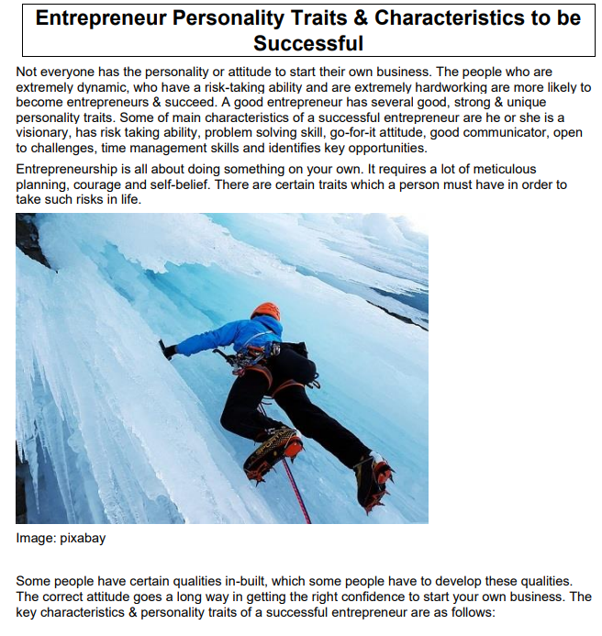
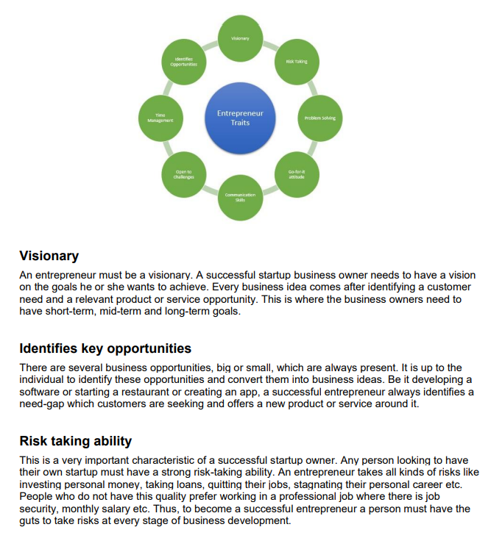
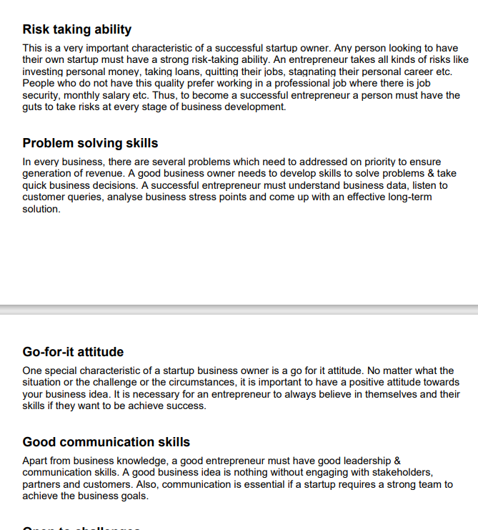
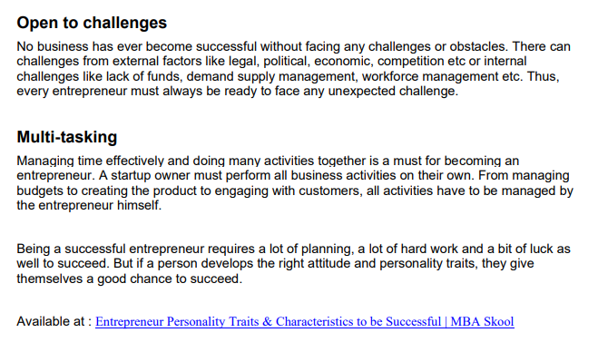
(Source: Provided)

Appendix B
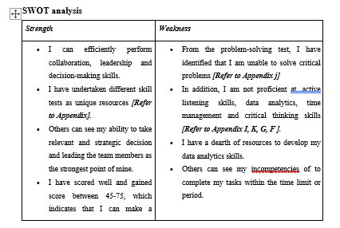
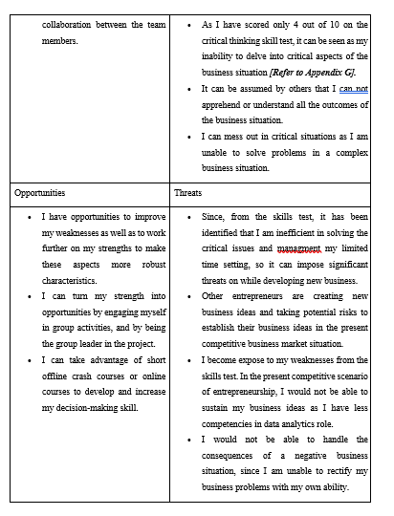
(Source: Self-Developed)

Appendix C
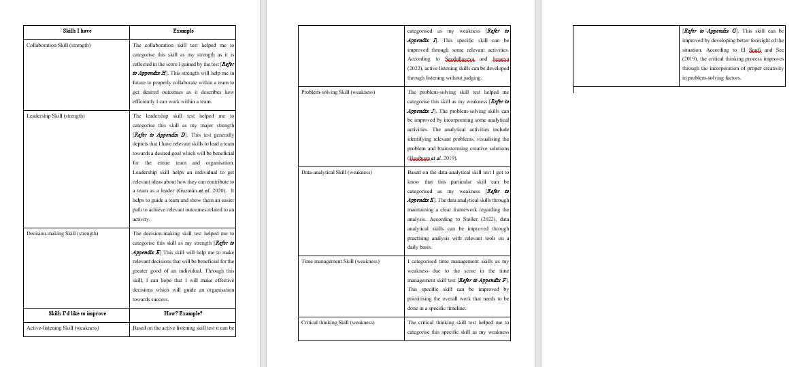
(Source: Self-developed)

Appendix D: Leadership skill test
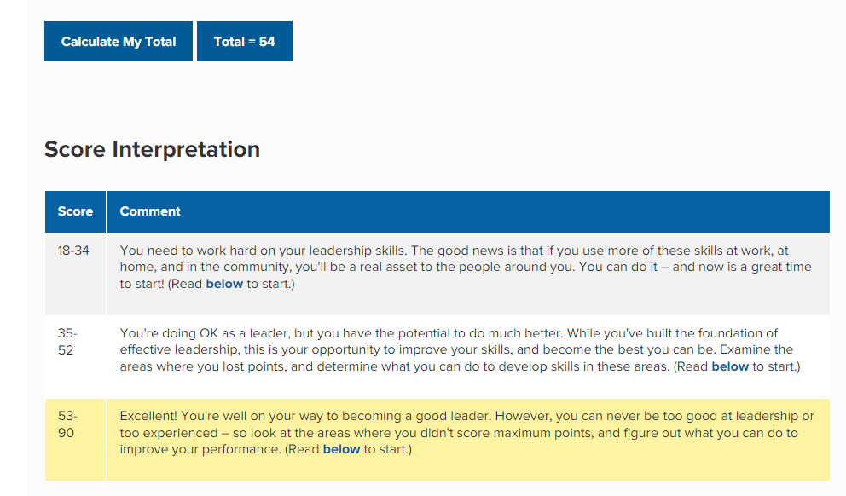
(Source: https://www.mindtools.com/pages/article/newLDR_50.htm)

Appendix E: Decision-making skill test
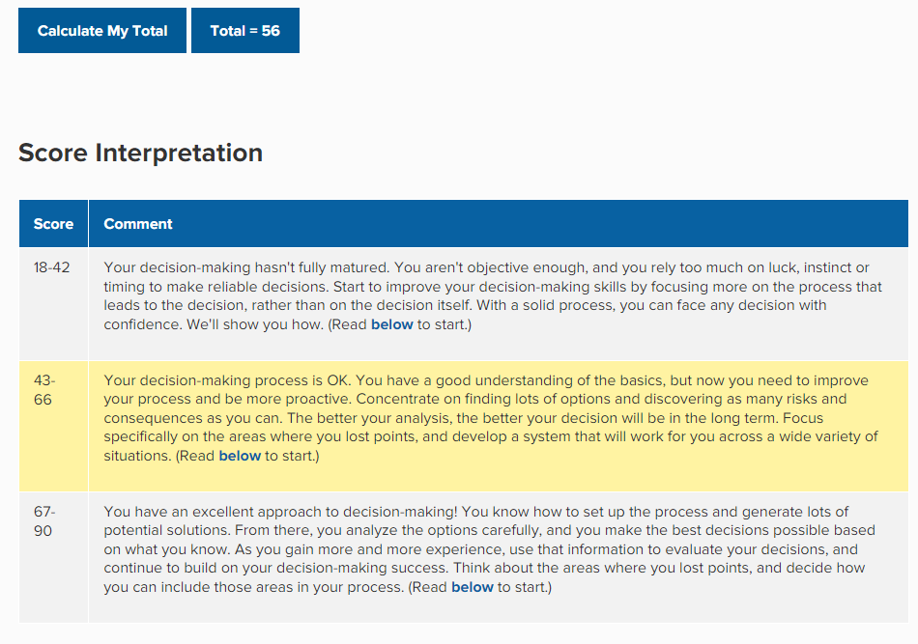
(Source: https://www.mindtools.com/pages/article/newTED_79.htm)

Appendix F: Time management skill test
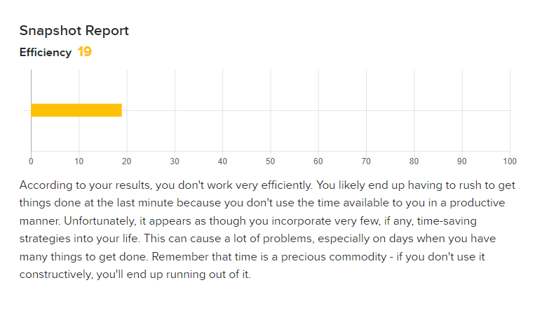
(Source: https://psychologytoday.tests.psychtests.com/bin/transfer)

Appendix G: Critical thinking skill test
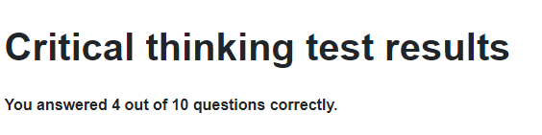
(Source: https://www.123test.com/critical-thinking-test/id=DVP4VRVABGE4&version=)

Appendix H: Collaboration skill test
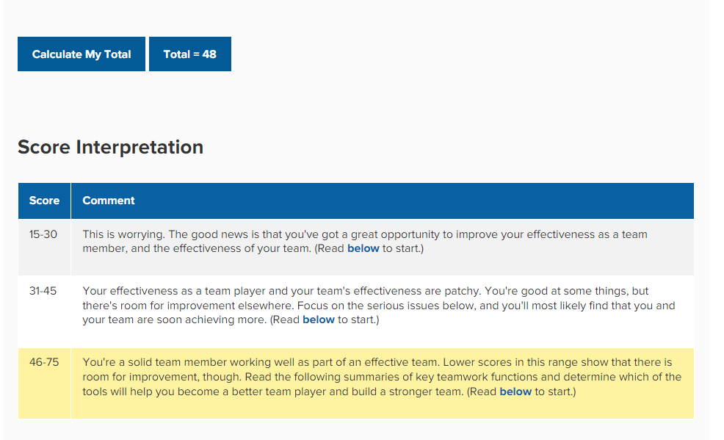
(Source: https://www.mindtools.com/pages/article/newTMM_84.htm)

Appendix I: Active-listening Skill
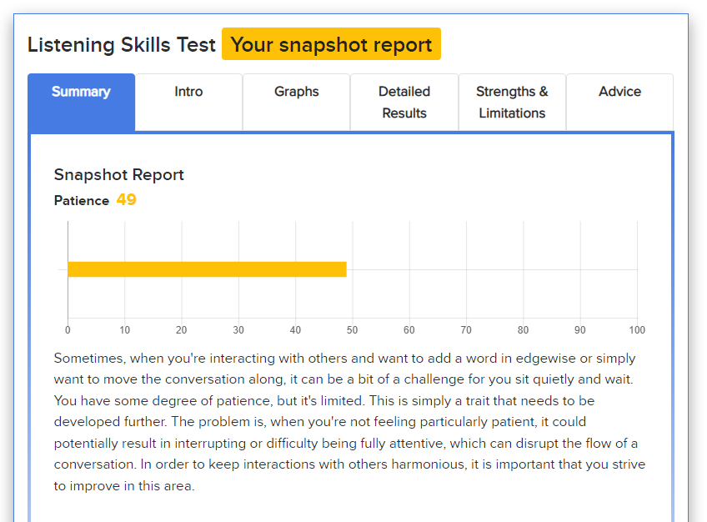
(Source: https://psychologytoday.tests.psychtests.com/bin/transfer)

Appendix J: Problem-solving skill test
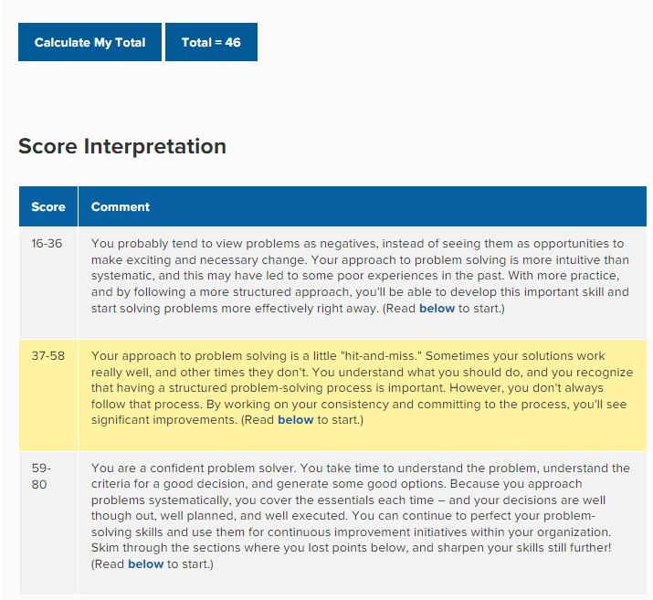
(Source: https://www.mindtools.com/pages/article/newTMC_72.htm)

Appendix L: Data analytical skill test
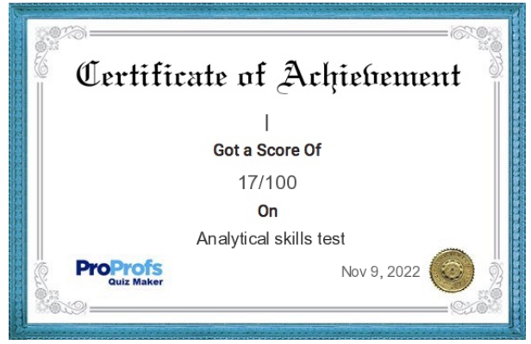
(Source: https://www.proprofs.com/quiz-school/quizreport.php?title=analytical-skills&sid=298884993)

