

L5 – ADVANCED SOFTWARE DEVELOPMENT (ACCB5011)

Maze Pathfinding Implementation

Applied Computing
Kawam De Oliveira (2412430)
2412430@student.uwtsd.ac.uk

Report
Dijkstra’s Algorithm
Description
Dijkstra’s algorithm computes the shortest paths from a single source node to all other reachable nodes in a weighted graph, provided that all edge weights are nonnegative [1]. The algorithm begins by assigning a distance value to every node. The source is initialised with a distance of zero, while all other nodes are set to infinity to indicate that no route has yet been identified.
The algorithm then iteratively selects the unvisited node with the smallest tentative distance and marks it as visited, meaning its shortest distance from the source is finalised. Next, it examines each neighbour of the current node and computes an alternative distance by adding the connecting edge weight to the current node’s distance. If this alternative distance is smaller than the neighbour’s recorded value, the neighbour’s distance is updated. This update step is known as relaxation [1].
The process continues until all reachable nodes have been visited or until a specified destination is reached. The algorithm’s correctness depends on the nonnegative edge weight condition, since only in this case can a finalised shortest distance be guaranteed not to improve through a later discovery [1].
Dijkstra’s algorithm is commonly used as a baseline shortest path method in empirical evaluations, including studies on grid based and OpenStreetMap environments and benchmarking across different graph topologies, where time and memory trade-offs are analysed [3], [4].
A* Algorithm
Description
The A* algorithm is a pathfinding and graph search method designed to identify the shortest path between a start node and a specified goal node [2]. Unlike uninformed search techniques, it incorporates heuristic information to guide exploration more efficiently towards the destination, which is particularly advantageous when a single target is known in advance [2]. Each candidate node is evaluated using the function f(n)=g(n)+h(n), where g(n) represents the accumulated cost from the start node to the current node and h(n) represents a heuristic estimate of the remaining cost to reach the goal [2]. The heuristic is typically designed to be admissible, meaning it does not overestimate the true remaining cost. Under this condition, A* can guarantee an optimal solution while often reducing unnecessary exploration [2].
Operationally, A* maintains an open list containing nodes pending evaluation and a closed list containing nodes that have already been processed. At each iteration, the algorithm selects the node in the open list with the lowest f value for expansion. Its neighbouring nodes are then examined, and cost values are updated if a shorter route is discovered. To enable reconstruction of the final route once the goal is reached, each node stores a parent reference indicating the predecessor through which it was most efficiently reached [2]. The search continues until the goal node is expanded or until no nodes remain in the open list, indicating that no path exists [2].
Comparison Between Dijkstra’s Algorithm and A* Algorithm
Dijkstra’s algorithm and the A* algorithm both address shortest path problems in weighted graphs, but they differ fundamentally in how they prioritise node exploration. Dijkstra’s algorithm is uninformed with respect to the goal. It selects the next node to process solely based on the smallest known distance from the starting node, which results in a broadly uniform outward expansion across the graph. This behaviour makes it particularly suitable when shortest paths to many or all nodes are required, as it systematically confirms distances in increasing order [1].
In contrast, the A* algorithm is explicitly goal oriented. It ranks candidate nodes using the function f(n)=g(n)+h(n), where g(n) represents the cost already travelled from the start and h(n) represents an estimated cost to the goal [2]. By incorporating heuristic guidance, A* prioritises nodes that appear more likely to lead efficiently towards the destination. When the heuristic is admissible and informative, A* typically explores fewer nodes than Dijkstra while still guaranteeing an optimal solution [2].
These design differences lead to distinct efficiency profiles. Dijkstra’s lack of goal awareness may result in substantial exploration of regions unrelated to the final route when only a single destination is of interest [1]. A* can reduce unnecessary exploration by focusing the search direction, although its effectiveness depends on the quality of the heuristic and the structure of the graph. Empirical studies on grid based and OpenStreetMap environments demonstrate that the relative performance of A* and Dijkstra varies by scenario and modelling assumptions [3]. Broader benchmarking across diverse graph topologies further shows that time and memory trade-offs are context dependent rather than universal [4].
Overall, Dijkstra’s algorithm provides robust general shortest path coverage, whereas A* is often preferable for single goal searches when suitable heuristic information is available [1], [2]. Empirical evaluations further indicate that performance differences depend on the environment and graph structure and should therefore be interpreted in context rather than assumed to be universal [3], [4].

Development and Implementation Process

Reflection
The implementation process aimed to deliver a reliable A* navigator for a fixed 20 by 20 grids, while maintaining clarity and compatibility with the existing GridNavigator framework. Because the algorithm relies on the game’s grid API, the first requirement was to derive the start and goal positions dynamically. This was achieved by scanning the entire grid and locating the cells marked as player and target (Figure 1). This design keeps the navigator data driven and resilient across different layouts.

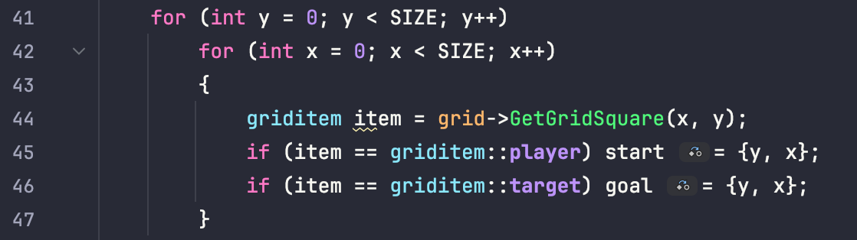
Figure 1. Start and goal discovery by scanning the grid [5]
The core of the implementation follows standard A* bookkeeping. Two 2D arrays store per cell costs. g_cost[y][x] holds the best-known travelled cost from the start, measured in unit steps due to four directional movement. f_cost[y][x] stores the estimated total cost f = g + h. All costs are initialised to std::numeric_limits<int>::max() to represent unknown distances, while parent[y][x] records predecessors for path reconstruction (Figure 2). This avoids storing full paths during the search and enables deterministic reconstruction once the goal is reached.
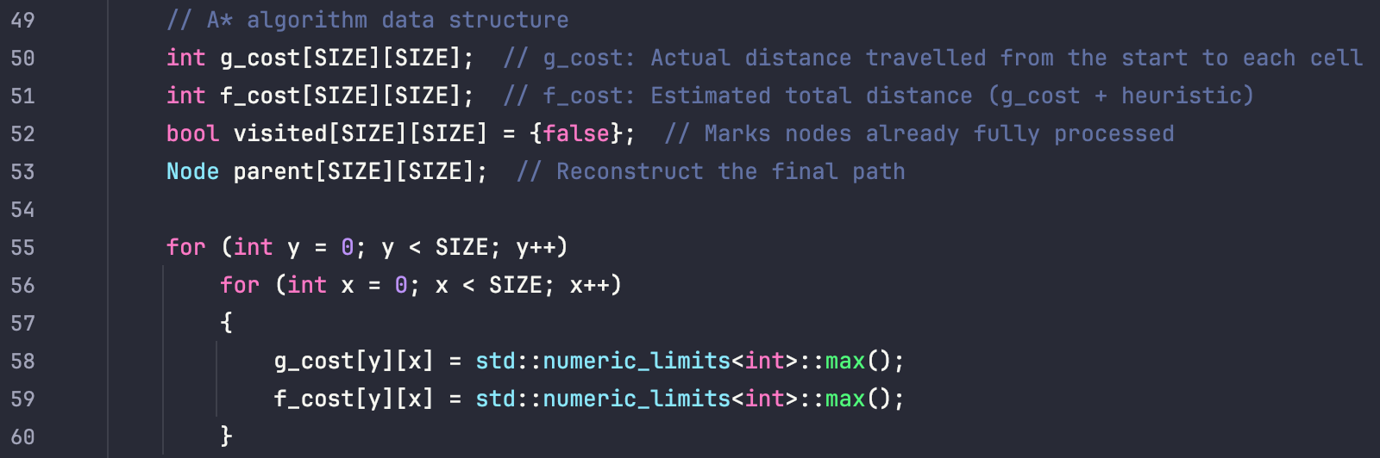
Figure 2. A state structures and initialisation*
A distance heuristic was selected because movement is restricted to up, down, left, and right. The heuristic biases exploration towards the target while remaining aligned with grid geometry (Figure 3).
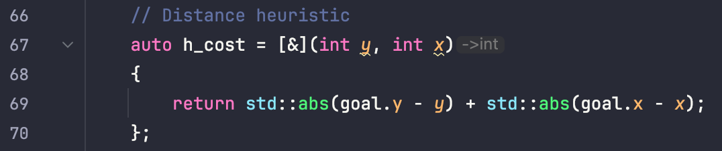
Figure 3. Manhattan distance heuristic
To retrieve the next best node efficiently, the open list was implemented using std::priority_queue. Since this container is a max heap by default, a wrapper node and comparator were introduced so that lower f values have higher priority (Figure 4). This directly determines expansion order and reduces overhead compared with scanning a vector for the minimum.
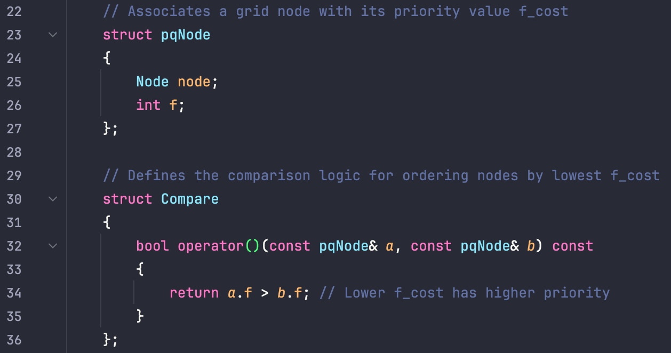

Figure 4. Priority queue wrapper and comparator
During execution, correctness depends on three checks. Outdated queue entries are skipped using visited, blocked or invalid neighbours are ignored via bounds and cell type checks, and relaxation updates a neighbour only when a strictly shorter route is found. The relaxation step commits the best-known route; updates parent and pushes the neighbour back into the open list (Figure 5). After reaching the goal, the parent links are followed backwards, reversed, and converted into movement commands.
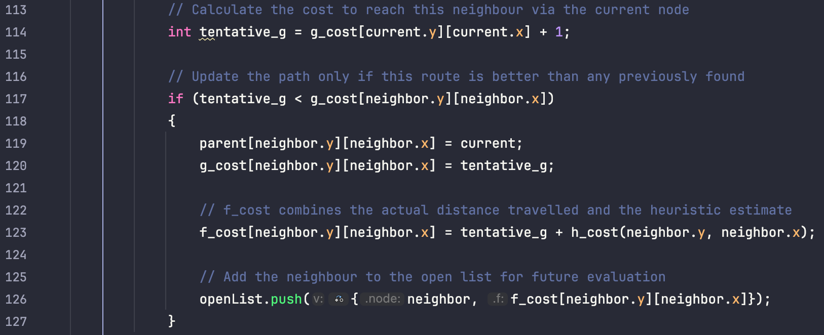
Figure 5. Relaxation step and frontier update
The results indicate that the A* navigator behaves consistently in both testing modes. In a single automatic run, the algorithm achieved moves with grid accesses and zero wall hits, showing that obstacle checks and neighbour validation prevented invalid movement (Fig. 6). Across 10,000 benchmark runs, performance remained stable, with wall hits consistently reported as zero throughout. During benchmarking across 10,000 runs, the behaviour remained stable, with wall hits consistently reported as zero, which supports the robustness of the implementation rather than reliance on a single favourable run (Fig. 7). Overall, the outputs indicate that the navigator repeatedly finds valid routes when available and executes them safely, with effective heuristic guidance towards the target.
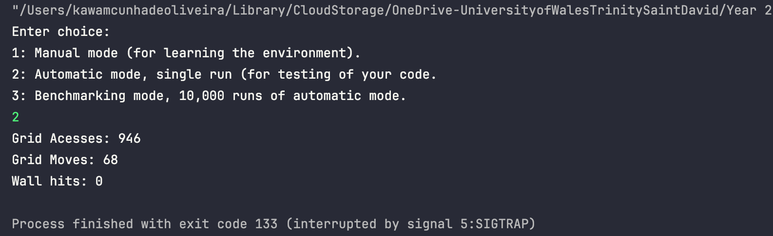
Figure 6. Output of a single automatic run showing successful navigation without collisions
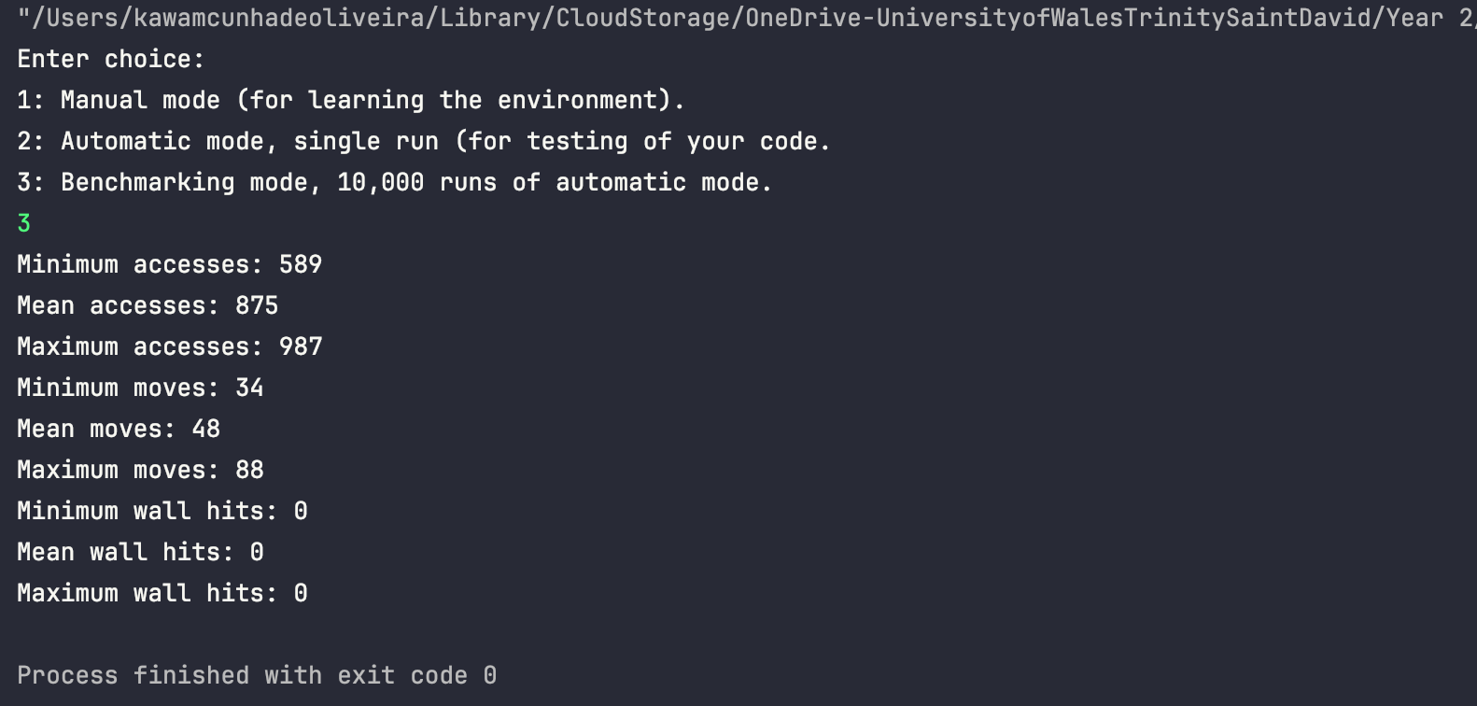
Figure 7. Benchmarking results over 10,000 automatic runs demonstrating stable and collision-free behaviour.
Note: The implementation was developed and tested in CLion [5] and compiled using a toolchain that supports at least the C++17 standard, as required by the specification.

References:
[1] W3schools, “DSA Dijkstra’s Algorithm,” www.w3schools.com, 2025. [Online]. Available: https://www.w3schools.com/dsa/dsa_algo_graphs_dijkstra.php [Accessed: Jan. 2, 2025].
[2] Codecademy, “A* Search Algorithms,” Codecademy, Oct. 12, 2024. [Online]. Available: https://www.codecademy.com/resources/docs/ai/search-algorithms/a-star-search [Accessed: Jan. 2, 2026].
[3] Z. Yusuf, S. Mohamad, and W. Suhaifiza, “Performance Comparison of A* and Dijkstra Algorithms with Bézier Curve in 2D Grid and OpenStreetMap Scenarios,” Journal of Applied Engineering Design and Simulation, vol. 5, no. 2, pp. 79–89, Sep. 2025. [Online]. Available: https://jaeds.uitm.edu.my/index.php/jaeds/article/view/94/90 [Accessed: Jan. 2, 2026].
[4] N. Aldhafferi, “Time and Memory Trade Offs in Shortest Path Algorithms Across Graph Topologies: A*, Bellman–Ford, Dijkstra, AI Augmented A* and a Neural Baseline,” Computers, vol. 14, no. 12, p. 545, Dec. 2025. [Online]. Available: https://doi.org/10.3390/computers14120545 [Accessed: Jan. 2, 2026].
[5] CLion [Software], ver. 2025.2.6, Prague, Czech Republic: JetBrains s.r.o., 2025. [Online]. Available: https://www.jetbrains.com/clion/ [Accessed: Jan. 5, 2026].
Google Translate, private communication, Jan. 2026. [Accessed: Jan. 2, 2026].
OpenAI’s ChatGPT, private communication, Jan. 2026. [Accessed: Jan. 2, 2026].

