Student name: Laura Balu (2232556)
Module name: Foreign Languages & Cultural Awareness
Module code: BMIH5003
Lecturer name: Heidi Prosser

Intercultural Leadership Challenges in the Hospitality Industry: A Comparative Analysis of England and Japan

Executive Summary
The recently hired Assistant General Manager of the five-star Inclusivity Hotel & Spa in London has been assigned the duty of generating an extensive report on the issues related to multiculturalism that the hotel personnel face. The main cultural distinctions between Japan and England will be highlighted in this study, along with an analysis of each country's cultural styles via the framework of the GLOBE Project. The report will also cover issues unique to the hospitality industry and offer helpful suggestions for getting past these obstacles.

Table of content

Intercultural Leadership Challenges in the Hospitality Industry: A Comparative Analysis of England and Japan 1
Executive Summary 1
Table of content 2
1. Introduction 3
2. Culture Overview: England vs. Japan 3
2.1. Language and Communication: 3
2.2. Social Structure and Etiquette: 4
2.3. Cultural Values: 4
2.4. Values and Beliefs: 4
3. GLOBE Project's Model: An Analytical Framework 5
3.1. GLOBE Project Analysis 5
3.1.1. Cultural Practices: 5
3.1.2. Cultural Values: 6
4. Challenges of Intercultural Leadership in Hospitality 7
5. Recommendations 7
6. Conclusion 7
References: 8

1. Introduction
Due to its global operations, the Inclusivity Hotel & Spa requires strong multicultural leadership and communication. Successful management in a multicultural workplace requires an understanding of cultural habits. Let's examine the cultural distinctions between Japan and England and how they affect hospitality leadership.

2. Culture Overview: England vs. Japan
Building on this theoretical basis, we will examine the cultural characteristics of Japan and England, clarifying how these variations appear in the areas of individuality, communication styles, context dependence, and timeliness. This dual approach aims to give a comprehensive understanding of the intercultural dynamics at work in our international hospitality environment by first building the analytical model and then applying it to cultural situations.

2.1. Language and Communication:
Japan:
Japanese culture is an intriguing balance of heritage and modernity, and its language and communication style reflect this distinction. When interacting with Japanese people, anticipate indirect communication, nuanced subtleties, and contextual signals. Verbal statements have greater weight than written words, and implicit standards are depending on social standing and rank.
Their language is a complex form of communication that values hierarchy and politeness highly. “Bowing is one of the most important nonverbal cues for expressing respect and social position” (Kaunismaa, (2014).
England:
On the other hand, the art of communication thrives in England, where it is represented by a diverse range of genres. English, spoken with a variety of accents, floats over discussions. From the flowing tones of Yorkshire to the clipped elegance of Received Pronunciation, each accent tells its own story.

Courtesy, a highly valued virtue, enhances interactions. However, unlike the Japanese hierarchical system, where politeness follows predefined courses, English politeness is adaptable. It adjusts to people, situations, and personal quirks.
“In England's language symphony, politeness takes many shapes, harmonising with the fluctuating circumstances of daily life” (Kawai, 2013).

2.2. Social Structure and Etiquette:
Japan: The collectivist character of the country is reflected in the ancient traditions such as tea ceremonies, which highlight communal harmony within the Japanese social framework. (Cross, 2009).
England: In contrast, England emphasises individuality and social hierarchy more than other countries. In many social contexts, the value of manners is evident. (Lukes, 2024)

2.3. Cultural Values:
Japan:
According to Adam (2018), the notions of harmony (wa), loyalty, honour, and a feeling of responsibility (giri) are among the deeply ingrained cultural values of Japan. It maintains a careful balance between tradition and adaptation, emphasising reverence for the environment, community well-being, and perfectionism

England:
English culture is a dynamic fusion of global influence, local customs, and urban-rural linkages that is expressed via social mobility, a wide range of contributions, and beloved holidays like Christmas and Remembrance Day. Courtesies, tolerance, and fair play are important virtues in England. The cultural importance of institutions such as the monarchy helps to shape national identity. (Colls, 2002)

2.4. Values and Beliefs:
Japan:
“In Japan, people maintain traditional ideals of peace, respect, and endurance (gaman), honour kami (spirits) via ceremonies at shrines, and honour their ancestors at festivals like Obon”. (Martinez & Van Bremen, 1994)

England:
In England, there is a blend of traditional and modern values. The society is secular, accommodating diverse beliefs and reflecting a rich cultural tapestry. (Barnes, 1994).

3. GLOBE Project's Model: An Analytical Framework
Before getting into the specific cultural differentiating factors, we must determine the analytical framework that will guide our investigation. The GLOBE Project, which aims to improve leadership effectiveness via organisational behaviour, offers a useful framework for comprehending cultural aspects and how they affect leadership. “This model outlines important factors that influence leadership styles and values across cultural borders include power distance, uncertainty avoidance, individualism against collectivism, and others. Dickson, Aditya, & Chhokar, 2000)

The GLOBE Project model is very useful for our investigation since it provides a broad and detailed view of cultural processes. Using this paradigm, we may investigate how cultural factors impact leadership styles in Japan and England in a methodical manner. Thus, a deeper comprehension of the cross-cultural difficulties the Inclusivity Hotel & Spa faces will be possible.

3.1. GLOBE Project Analysis
The GLOBE Project (2004) identifies cultural dimensions relevant to leadership. Let’s compare England and Japan:

3.1.1. Cultural Practices:
- Assertiveness:
England tends to value assertive leadership, emphasizing direct communication and expressing opinions openly. Japan tends to have a lower score in this dimension, indicating a preference for indirect communication and harmony.
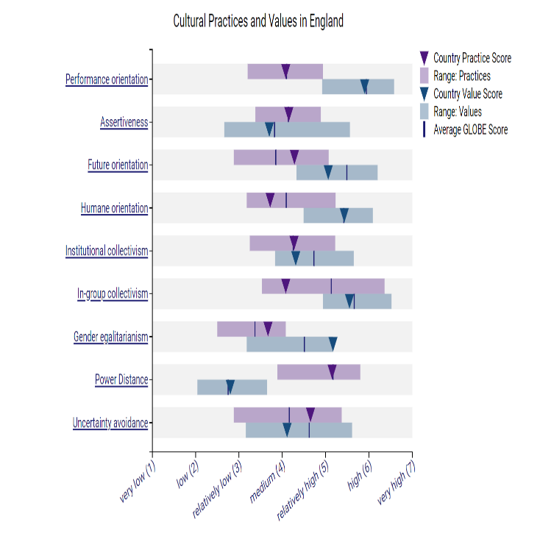
- Performance Orientation: With a score of 5.9 in this dimension England focuses on achievement, emphasizing competition, ambition, and success. Japan values loyalty and long-term relationships, emphasizing group harmony and commitment.
- Gender Egalitarianism: England is more egalitarian, striving for gender fairness and equal opportunities. Japan’s score is relatively low, indicating that adheres to more traditional gender roles, where distinct roles for men and women are highlighted.
Global project (2004)

3.1.2. Cultural Values:
- Individualism: England emphasizes individual achievement, valuing personal goals and autonomy. Japan has a high score emphasizing collective success and harmony.
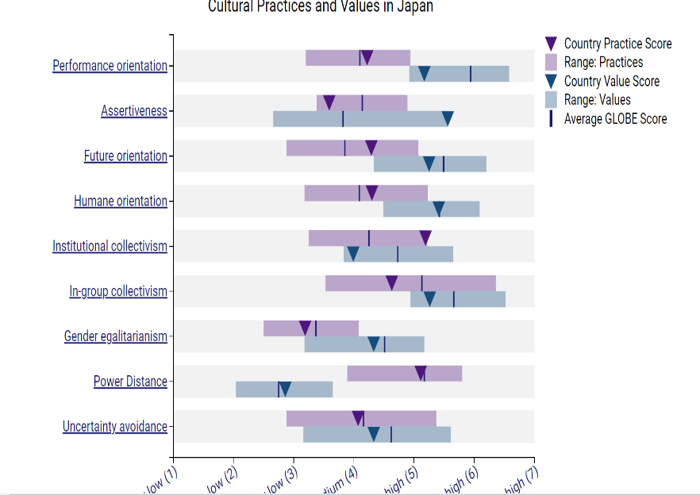
- Power Distance: Both England and Japan have low power distance, meaning they accept less hierarchical authority. In both cultures, there is a preference for more egalitarian relationships and a willingness to question authority. While Japan values egalitarian relationships, cultural inertia and societal expectations can perpetuate traditional gender norms.
Global project (2004)
- Uncertainty Avoidance: With a relatively close score of 4.11 in England and 4.33 in Japan and a similar cultural range. Both cultures exhibit a balanced approach to uncertainty, but Japan leans slightly more toward stability

4. Challenges of Intercultural Leadership in Hospitality
- Communication Styles: The Japanese hotel reception staff often gives feedback in a more indirect way, which the English staff may take as a sign of disengagement. Putting in place cross-cultural training helps facilitate comprehension of various communication styles, which can assist close this gap.
- Making Decisions: In team meetings, Japanese team members could favour a more consensus-driven approach, whereas English team members might voice their viewpoints honestly and frankly. Achieving equilibrium between these methods is essential to prevent future disputes and guarantee efficient decision-making.
- Team Dynamics: The Inclusivity Hotel & Spa's cleaning staff is made up of individuals from a variety of ethnic backgrounds, each with their distinct work habits and standards. To build a unified work environment, managing these various teams calls for a nuanced approach to leadership.

5. Recommendations
- Cross-Cultural Training: Provide cultural sensitivity training for staff to understand and appreciate differences.
- Leadership Development: Train managers in adaptive leadership to navigate diverse teams effectively.
- Regular Feedback: Encourage open dialogue to address cultural misunderstandings promptly.

6. Conclusion
Intercultural leadership in hospitality requires empathy, adaptability, and a commitment to learning. By embracing cultural diversity, the Inclusivity Hotel & Spa can create a harmonious and successful work environment.

References:

- Adam, H. (2018, December 5). Exploring The Japanese Culture Of Wa And Harmony.
- Ashkanasy, N. M. (2002). Leadership in the Asian century: Lessons from GLOBE. International Journal of Organisational Behaviour, 5(3), 150-163.
- Barnes, L. P. (1994). Education, Religion and Diversity: Developing a New Model of Religious Education. London: Routledge. DOI: 10.4324/9781315815220.
- Britannica. (n.d.) England - Culture, Traditions, Heritage
- Choi, S., & Kim, J. (2013). Culture and Leadership Across the World: The GLOBE Book of In-Depth Studies of 25 Societies.
- Cross, T. (2009). The ideologies of Japanese tea: Subjectivity, transience and national identity. Global Oriental.
- Davies, R. J., & Ikeno, O. (2011). Japanese mind: Understanding contemporary japanese culture. Tuttle Publishing.
- Dickson, M. W., Aditya, R. N., & Chhokar, J. S. (2000). Definition and interpretation in cross-cultural organizational culture research: Some pointers from the GLOBE research program. In N. M. Ashkanasy, C. P. M. Wilderom, & M. F. Peterson (Eds.), Handbook of Organizational Culture and Climate (pp. 447-464). Thousand Oaks, CA: Sage Press.
- GLOBE Project. (n.d.) United Kingdom Results - Culture and Leadership Data.
- GLOBE Project. (n.d.)Japan Results - Culture and Leadership Data.
- Grobelna, A. (2015). Intercultural Challenges Facing the Hospitality Industry. Implications for Education and Hospitality Management. Journal of Intercultural Management, 7(3), 101-117³ ²:
- Haugh, M. (2004). Revisiting the Conceptualisation of Politeness in English and Japanese. Multilingua, 23(1), 57–79.
- Hinaka. (2021, July 4). Communication Style and Japanese Culture. Yamabuki Japan
- Kaunismaa, A. (2014). The Role of Nonverbal Communication in Japanese-Finnish Negotiations: Finnish Negotiators' Perspective. [ Accessed 22/02/2024]
- Kawai, M. (2013). The Application of Politeness Theory into English Education in Japan. Linköping University. Faculty of Language and Culture in Europe
- Kim, Y. (2018). Intercultural Communication Competence and Cross-Cultural Training for Global Leaders in Hospitality and Tourism Industry. Journal of Tourism and Hospitality Management, 6(1), 1-10²
- Luka, N., et al. (2013). Culture and Leadership Across the World: The GLOBE Book of In-Depth Studies of 25 Societies.
- Lukes, S. M. (2024). Individualism | Definition, History, Philosophy, Examples, & Facts. Britannic
- Martinez, D. P., & Van Bremen, J. (Eds.). (1994). Ceremony and Ritual in Japan: Religious Practices in an Industrialized Society. London: Routledge. DOI: 10.4324/9780203429549.
- Nicholls, S. (2011). Culture and Leadership Across the World: The GLOBE Book of In-Depth Studies of 25 Societies.

