
International Business (SBMA7122D)
An international business plan for Gazprom
Assignment 2
Student ID: 1602134
Daina Veprauskiene
30/04/2018
International Business (SBMA7122D)

Table of Contents

Executive summary of international business plan 3
Introduction 4
Corporate global vision and goals 5
International business/ organizational structure 5
PEST (Political, Economic, Social and Technological) 5
SWOT (Strengths, Weaknesses, Opportunities and Threats) 6
TOWS 7
QUEST (Quick Environmental Scanning Technique) 8
Porter’s five forces analysis 9
Porter’s diamond 10
Foreign market research 11
Risk assessment 14
Country analysis dimensions for International Business 14
Risk summary 18
International business strategy 19
International marketing plan 20
Marketing strategy 21
Market entry plan and strategy 21
Recommendations 24
Conclusion 24
References 26

Executive summary of international business plan
Gazprom is a globally renowned organization for providing high quality natural gas supply to commercial and private consumers in more than 100 countries. The company is known as one of key market players in global gas industry. Apart from gas, Gazprom also deals with petrochemicals and petroleum products. In this report, a foreign market plan is established for Gazprom for UK in order to expand the business. Different analytical tools and frameworks are used to assess the internal and external environment of Gazprom and UK and test feasibility of one for another. SWOT, TOWS, QUEST, PEST, Porter’s diamond and porter’s five forces model along with 8Ps of market entry plan and a thorough country analysis of UK is also included in the paper. It is concluded that Gazprom can enter the market by adopting subsidiary performance approach i.e. the monitoring of existing GM&T subsidiary and then launching the main business unit. Market penetration strategy should be adopted to conduct marketing for the launched business. A well-researched homework before taking the implementation decision of launch will minimize the risk and increase chances of business success in the foreign market.

Introduction
Gazprom is a Russian company that was found in 1989. It is one of leading companies in gas and energy sector that manufactures, refines, sells and trade the gas supply all over the world. Gazprom is led by Victor Zubkov and is run by dedicated and committed workforce of 462,400 employees. The total revenue of Gazprom is US$91.1 billion (2016). Key products of Gazprom are natural gas, petroleum products, and petrochemicals. Gazprom contributes to world’s 17% gas production with 517.3 billion cubic meters production on daily basis. The following illustration shows some key facts about Gazprom (Deresky, 2017).
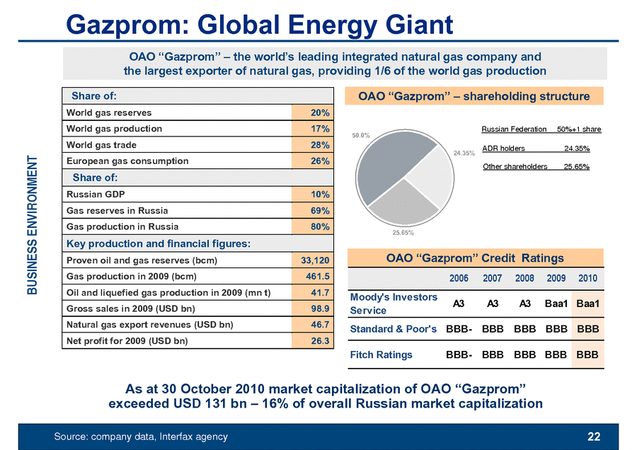
In this report, a foreign market entry plan for UK is prepared for Gazprom through a thorough and detailed analysis. The report entails the analysis tools, strategies, and assessments that helps to conclude the appropriate market entry strategy for Gazprom with least risk of failure.

Corporate global vision and goals
The vision of Gazprom is to compete with global energy companies in terms of trading, supply, and marketing
The mission of Gazprom is to ensure high quality energy resource supply to customer, to fairly conduct the business, take care of employees, and maintain their position with continuous quest for improvement in the energy and gas sector.

International business/ organizational structure
Gazprom is conducting business successfully in more than 100 countries of the world that involves developed, developing and under developed countries. The organizational structure of Gazprom is therefore, designed in semi-flat manner in order to adhere to all requirements of decision making, problem solving and strategic goal achievement. In order to begin with the international plan development, it is essential to look into key business factor analysis by using analytical tools and models.

PEST (Political, Economic, Social and Technological)
Political: Gazprom conducts business operations in more than 100 countries of the world with gas exploration and refining activities in all continents. The political influence is evident that affect the business of Gazprom. Tax, regulations, rules, and export laws for international companies vary in every country that are determined by ruling political officials. Hence, Gazprom establish business strategy according to host country’s political scenario.
Economical: Gazprom is financially established company and minor setbacks do not put impact on the organization’s business scenario. The downfall of energy sector since 2015 did not put any effect on the operations of Gazprom. However, change in oil prices are considered closely by the company to take feasible decisions.
Social: Gazprom remains unaffected by the change in social trend because of business product nature and service necessity for citizens. Gas and petroleum products are necessities of life and the social change or unrest does not create negative impact on the company. However, the $497 million fine on ExxonMobil was a damaging experience for company’s moral standing in the industry.
Technological: Technological changes urge Gazprom to indulge in advanced field practices i.e. refining, exploration, production and supply handling. Gazprom invest on latest oil exploration techniques and establish technology based databases that record, retrieve, and secure information in all regional offices of the company.

SWOT (Strengths, Weaknesses, Opportunities and Threats)

Strengths  - Established and leading market position in natural gas production  - Financial stability  - Expertise in supplier and in-field services  - Well-maintained gas transport service network | Weaknesses  - maturing field of gas exploration and supply  - Growing need of gas and petroleum is challenging for Gazprom to keep its position in the industry with prompt policies and customer market demand
Opportunities  - advancement in technology that facilitate less cost and high efficiency business  - Methane gas extraction investment opportunity  - Latest agreements between science and technology companies | Threats  - Changing laws and rules of countries to allow foreign business activities  - Changing weather conditions change the working time and duration too  - Unexpected changes in crude oil and natural gas prices

TOWS

Strength/opportunity  - Introduce new technologies to company’s business operations and achieve new milestones  - The methane gas extraction should be seen as an opportunity to strengthen position in the industry with distinct business activity | Weakness/opportunity  - In order to mitigate the oil price change, growing need of customers, the company should increase the market share in global business  - The gas transport and network system can used as a tool to fight weather conditions
Strength/threats  - Decrease the dependence on natural gas field and divide the emphasis on other business areas too  - Investment for R&D (Research & Development) activities | Weakness/threats  - New technology and increased market share can mitigate the risk of market share loss and shortage of Gazprom demand in the market

QUEST (Quick Environmental Scanning Technique)

The internal and external environmental scanning of Gazprom conducted through SWOT analysis show the feasibility for organization to grow and develop in the industry.
The QUEST Analysis determine the high feasibility for firm to be compatible with the change in external environment i.e. industry and direct customer market, in order to change the organizational strategy and plan accordingly.
Example: The change in oil prices affect the business of Gazprom but due to financial strength, the organization is capable of fighting the issue and prepare contingency plan to meet customer demands and market expectations.
QUEST also points out towards the globally expanded business of Gazprom that helps company to increase reliability and dependability on more than one country’s internal and external market conditions. Moreover, the versatile fields of natural gas and petroleum widens the business of Gazprom and increase their product line offerings.

Porter’s five forces analysis
Bargaining power of suppliers: Moderate
Government regulations hinder the bargaining power of suppliers to become very high. However, license to explore natural gas resources are helpful to achieve the company’s supplier goals.
Bargaining power of customers: Low
Consumers need to buy natural gas sources due to which countries need to establish strategic contact with companies that can provide natural and refined gas sources to their system.
Threat of new entrant: Low
Huge financial investment is needed to launch a business of natural gas exploration, refinement, and supply. The threat of new entrant is also low as legal obligations, requirements, formalities and permissions are required in the form of agreements, license, terms of trade, etc. all these processes need not only financial investment but also require workforce of expert and dedicated people who are competent and capable of company launch in the market.
Threat of substitute: Moderate
Nuclear energy, solar energy system, coal, hydropower and wind energy are some substitute to gas product line of Gazprom
Rivalry within the industry: High
Saudi Arabian Oil Company with revenue of $3458 billion, national Iranian oil $154 billion, ExxonMobil $467 billion are some major competitors of Gazprom. The rivalry within the industry (in global scenario) is very high

Porter’s diamond
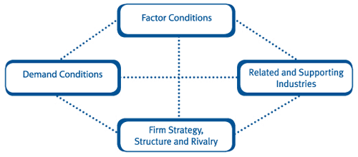
Adapted from (Porter, 2011)
Factor conditions: physical resources such as land, weather, and minerals are influential on the business of Gazprom. For example, bad weather conditions can decrease the oil exploration activities and other field jobs. Very high temperature can reduce productivity rate and cause health issues among workers. Therefore, the working hours are limited by the company in those days or the work is completely shut off.
Demand conditions: Demand conditions are perfect for Gazprom. Natural gas is needed as a basic life necessity and its demand can never be completely alleviate from the market even in the presence of aforementioned substitutes (please see threat of substitutes in porter’s five forces analysis).
Related and supporting industries: The working of Gazprom is not on a single source rather it is a combination of multiple resources such as international laws of business outsourcing, supplier network in all continents, legislative structure to conduct research and development activities, financial resources, roads and infrastructure, etc. therefore, the impact of related and supporting industries is high.
Firm strategy, structure, and rivalry: Firm strategy, structure, and rivalry are vital to company’s success. The strategy of Gazprom to continuously expand the business is working efficiently. the rivalry within the industry is very high as there are key leading companies such as ADNOC (UAE), Iranian national oil company (Iran), Saudi Arabian oil company (Saudi Arabia), etc.

Foreign market research
The foreign market expansion plan for Gazprom is dependent on the “demand” of the product and services being offered by the company. If the specific demand is not present in the target market, the business can meet failure. Therefore, some key facts are collected to study the current situation of UK market of gas and petroleum products.
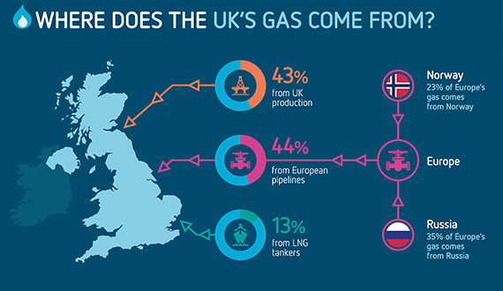
Source: (BritishGas, 2018)
- 25 million homes in UK i.e. 80% of total UK homes, are powered by natural gas supply. The country’s on quarter of electricity is produced by utilizing gas-fired power stations. The generation of electricity is made possible by using gas plants as one of most favorable source of renewable energy because of their fast sped of providing power during high demand periods.
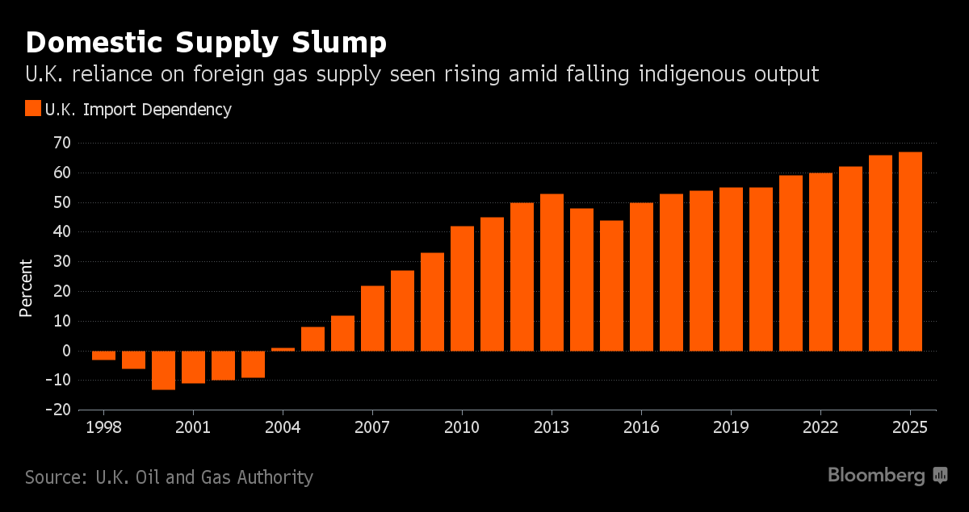
Source: (Anna & Kelly, 2017)
Past, current, and future demand of gas in UK
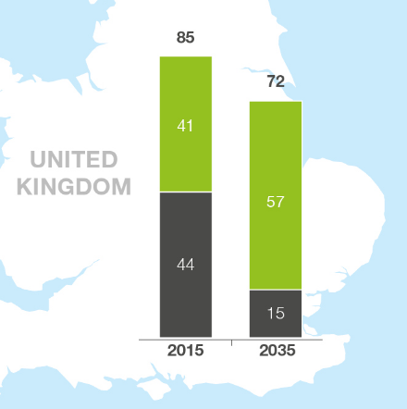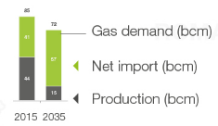
Based on Prognos: Current Status and Perspectives of the European Gas Balance [Prognos 2017]
[Adopted from NordStream2 2017]

- In UK’s energy mix, wind, solar and nuclear energy are used in much lesser ratio than the use of gas in homes.
- The Western European market (including Turkey) consumes the bulk of Russian exports. In 2016, Gazprom Export delivered 146.2 billion cubic meters of gas to markets in the region
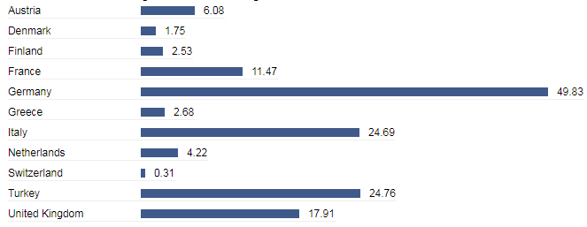
Consumption of gas supply in UK

Risk assessment
In order to assess the level of risk prone by UK to Gazprom, it is important to have an insight to UK’s home conditions for the business of gas supply and petroleum products. The country analysis provides a comprehensive yet succinct outcome to understand the feasibility of UK for Gazprom business.

Country analysis dimensions for International Business

Political Environment  - Form of government  UK has constitutional monarchy system which is headed by the Queen. The political situation is stable but the decision of Brexit has imposed some legal and foreign trading implications on UK market (Bartlett & Beamish, 2018).  - Political stability  The general stability in political system is a feasible condition for Gazprom to take the decision of company expansion.  - Foreign policy  UK foreign policy has changed due to Brexit. Gazprom needs to analyze the foreign policy before taking the expansion decision (Buckley & Casson, 2007)  - State companies  UK is comprised of four countries i.e. England, wales, Scotland and north Ireland. The expansion decision is specific to wales that is subjected to develop with the success in one country.  - Role of military  The role of military is negligible to Gazprom since the company is not doing any business function that is risky for UK’s safety or dignity.  - Level of terrorism  The wave of terrorism experienced by UK in past five years pose a threat for Gazprom. A damage to gas supply pipelines can cause loss of revenue to Gazprom (Cuervo-Cazurra & Ramamurti, 2014).  - Restrictions on imports/exports  Brexit has changed the trade and foreign direct investment for international companies. The change in taxation policy, visa policy, and regulatory compliance for multinational companies operating outside UK affects the Gazprom business launch in UK. | Economic Environment  - Economic system  UK’s economy is stable with GPD us$43,321. The economic system is feasible to incorporate a foreign national business to run operations.  - State of development  The development system of economy has changed over the years. UK is becoming more dependent on tourism, development and other industries (Buckley, et al., 2018).  - Economic stability  Economic stability is guaranteed for the system of UK which depicts a feasible support to the Gazprom business.  - GNP  UK’s gross national product (GNP) is $2.763 trillion. This is an appropriate and feasible figure to operate an international business (HaroonMumtaza & AngelikiTheophil, 2017).  - International financial standing  UK’ economy is a major economic contributor of world’s economic scenario. It is reflected by the post-Brexit and pre-Brexit reaction and responses given by other countries towards’ UK’s changing economic structure.  - Monetary/fiscal policies  Monetary policy is designed to make conditions suitable for the new business. Fiscal policies are developed to ensure the achievement of long term and short term goals.  - Foreign investment  Foreign investment in UK is still attractive for multinational companies due to undeniable position and stature (in political, trading, tourism fields) of UK in the continent as well as in the whole world.
Regulatory Environment  - Legal system  Legal system of UK is based on home benefit. The rules, laws and taxation policies are designed to ensure that UK’s own benefit is kept at the optimal position.  - Prevailing international laws  UK’s constitutional and international laws association govern the process of law implication and amendments in UK e.g. UK’s corporate governance code 2002 and international law of commerce (Omesto & Yusuf, 2017).  - Protectionist laws  Her majesty stationary office (HMSO) is the official entity of designing and implication of protectionist laws. Tariffs, quotas, embargoes, subsidies and administrative systems are some administrative protectionist laws defined by UK.  - Tax laws  The basic income tax rate is 20% on every earning of £0 to £32000 which makes £11000 or £43000 of total earned income.  - Role of contracts  The role of contracts is monitored by UK contractor’s association. Legal support and guidance is provided to local people as well as expatriates to combat external difficulties.  - Protection for proprietary property  Intellectual property act 2014 is the major law of protecting properties and provide assistance for dealing with legal issues.  - Environmental protection  Environment protection act 1990 is implied to ensure environmental sustainability in all business operations (Gooderham, et al., 2013) | Technological Environment  - Level of technology  UK’s technological environment is advanced and up to date. Leading consumer electronics manufacturers such as Samsung, LG, Apple Inc. and Microsoft keep UK on the priority list to launch their products for the first time.  - Availability of local technical skills  Local technical skills are available. UK’s talent workforce in IT sector is growing at the rate of 16% every year (Collinson, et al., 2016).  - Technical requirements of country  Being a central location for tourism, business and political activities, UK’s technical requirements is very high.  - Appropriability  Gazprom’s appropriability for UK business is high as the country is enriched with feasible rudiments to launch the international business.  - Transfer of technology  The transfer of technology from UK is rapid. Big companies such as Apple Inc. and Microsoft have also established their direct sales locations in UK which is a show of UK’s ability to transfer technology.  - Infrastructure  UK is run by monarchy system that increases the power distance and maintain individualism.

Risk summary
Political concerns include possible sanctions pressure, however they do not affect deliveries of gas and payments for them. NHS and other state and private large organizations supplied almost entirely by Gazprom could cause concerns due to UK political attitudes towards Russia. Britain's energy and particularly gas security being a bit weaker due to large single supplier could cause concerns, but again mostly political, but UK could mitigate through pipeline suppliers such as Norway and also other suppliers of LNG deliveries. Green proponents can cause continuous pressure to substitute carbon fuels for greener and renewable sources

International business strategy
International business strategy selection is dependent on the type of business and its requirements in the host country. The selected business strategy to enter into foreign market, must adhere to the core mission and values of the company. There are following types of international business strategies for foreign market entry (Daniels, et al., 2017).
Licensing: Licensing is a way to enter foreign market by giving out the “license”, a legal permission to utilize the name of brand, company’s expertise, or technology without investing into set up of the business for tangible or intangible assets.
Franchising: Franchising is the entry mode in which the company provides all sort of facilitation and expertise and manage all key facets of business to be done in another market. The management of the franchise is controlled by the franchise owner. The operations of franchise are ought to follow the standards of the organization (Cuervo-Cazurra, et al., 2014).
Turnkey contracts: This strategy is for large business activities such as launching a manufacturing unit. In Turnkey contracts, the plant or business unit is not handed over to the owner.
Strategic alliances: strategic alliances are usually made for shared business activities such as sharing research and development activities, distribution alliances, marketing agreements and shared manufacturing. These are non-equity based agreements in which the company remains individual and separate.
Joint ventures: New Company is formed by joining a proportion of business with another company to enter into a new market.
Exporting: Exporting is of two types i.e. direct and indirect exporting. The direct exporting is conducted by importing distributors and sales representatives. Indirect exporting is conducted by export trading companies (ETCs), export management companies (EMCs), export merchants, conforming houses, and non-conforming purchasing agents.

International marketing plan
Gazprom has a strategic relation with Centrica. The acquisition of large corporate commodity is the most favorable option. However, the £10 billion investment of Centrica in 2006 is a depiction of uncontrolled system caused by political unrest in Westminster which caused the sale of a major domestic seller for energy supplier. A subsidiary of Gazprom, Gazprom marketing and trading (GM&T) is a big interface for Gazprom’s major launch in UK (Salygin & Kaveshnikov, 2014). This venture can be seen closely to know about the response rate of local market and business return on investment. The GM&T’s Gazprom energy arm can be established in Manchester to ensure provision of services and products to private as well as commercial consumer market.
The sales mode can be selected by brokers, partners, advantageous system of Gazprom that has undercut rivals on prices, the Gazprom energy customer market can also offer for flexibility in client for meeting business needs. The positioning on moderate rate of energy plan that can meet the customer’s buying decision expectations and add value to their money would be the key to success for Gazprom. The Gazprom energy must aim to become the pan-European leader by utilizing all opportunities in hand. The good performance in UK should be the settlement for the new progress and developmental opportunities for Gazprom.

Marketing strategy
The selected market entry mode is based on market penetration strategy. Gazprom will penetrate in the existing market by using the extensive marketing technique on industrial basis. In order to do this, it is essential to have detailed data about local customer preference and the complete process of invading to existing customer market. The market penetration strategy is selected since the position of existing suppliers, industry leaders, and customer’s preferred organizations is hard to break. The GM&T service would be used as a base to establish all marketing activities. The marketing strategy is based on the idea of slowly but steadily changing the buying trend and adopt a top to bottom approach for reaching customer market (Jong & Warmelink, 2017).

Market entry plan and strategy
The market entry plan and strategy is briefly planned according to 8 P’s framework.
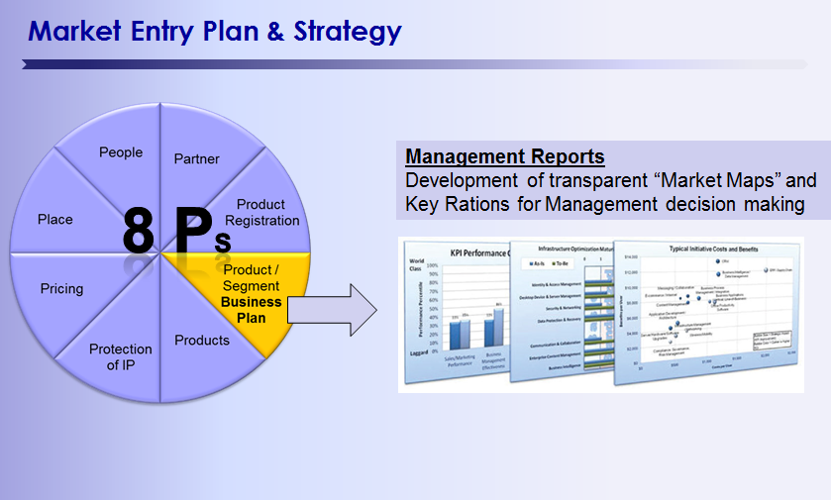
Source: (Enz, 2010)
People: Gazprom will contribute to the UK unemployment rate of 16% by hiring local people in filed and outfield jobs. The market entry plan and strategy would be implied by hiring specialized and capable people from UK preferably in order to cut down the recruitment cost and other Human resource management features.
Partner: Gazprom would make partnership with suppliers and transport officials in order to ensure the timely delivery of products to customers.
Product registration: The product registration would be done according to UK tax, trade and selling laws i.e. both business and protectionist laws.
Product segment: Product segment would be done on gas, chemical and petrochemical product lines as per the conventional practice of Gazprom.
Products: Gazprom will mainly sell gas supply to UK homes and commercial sector. The establishment of business would lead towards business planning and launching of other product segments.
Protection of IP: The intellectual property (IP) of Gazprom will be protected under UK law of multinational business investors. The legislative protection will be established in the initial stage of business launch (Schneider & Barbera, 2014).
Pricing: Gazprom will set reasonable price for customers. Household customers will not be charged more than the existing competitor market. The emphasis would be on the market capture but not through high price but by quality.
Place: Placement is the most difficult stage for Gazprom since the existing UK market of gas supply is well-established and has a strong position in the industry. It is difficult for Gazprom to deal with the challenges of placement. Integrated product placement strategy is recommended to Gazprom in which all benefits of products are clearly delivered to customers so that brand identity is developed and the customer sustains the buying decision consistently (Marinova, et al., 2016).
Ethical approach
The ethical approach contains following features:
Customer treatment: Gazprom promises to treat customers fairly. Gazprom needs dedication and customer support to all business and energy sector customer market regardless of the business energy contracts or sale.
Gazprom energy and the parent company is supporting the modern slavery act 2015. The slavery and human trafficking statements are official and maintain implication in all business endeavors.

Recommendations
In spite of wide spread business of Gazprom and various undeniable strengths held by the company, there are some recommendations that can work for company’s growth and success in UK market.
Domestic competition is intensifying in all countries. Competitor companies are launching new policies and techniques to meet customer needs and respond to change in oil prices and other calamities. The main target to work on this recommendation should be to beat NOVATEK, Russia’s largest gas producer.
LNG (liquefied natural gas) is a new way to earn opportunities for business expansion. Gazprom can excel in the field of LNG by taking revolutionary measures to diversify business and improve market share.
Western sanctions and low oil prices should be combat with the help of strategic pricing and intensified marketing strategies that should meet and exceed expectations of customers. The business should expand the horizon towards new dimensions by seeking sanctions as opportunities to maintain the business developmental progress in the industry.

Conclusion
Gazprom is a renowned natural gas producer, manufacturer, the seller, and transporter for gas and petrochemical producers. The company intends to expand the business to UK in order to widen the business scale and explore new boundaries to earn profit. A subsidiary of Gazprom is already working in UK that is feasible to monitor for anticipating success chances in UK. The report has studied the UK market from various perspectives and analyzed the feasibility of country and company by using different analytical tools such as SWOT, TOWS, QUEST and others.
A brief study on foreign market entry mode settled the Gazprom’s main entrant strategy. The market penetration strategy is selected to conduct an extensive marketing plan and adhere to customer needs and existing competition with strategic approach. The market entry needs to follow all aspects of existing UK market in order to avoid failure of major expansion decision and establish a strong position in the market in a short time. The report has concluded that successful market entry strategy can lead to massive success or failure if the company adopts an appropriate approach towards the business expansion and rely on current feasibility information only.

References
Anna & Kelly, 2017. Why Britain Has to Be Really Nice to Norway and Russia. [Online]
Available at: https://www.bloomberg.com/news/articles/2017-06-20/u-k-at-mercy-of-global-gas-market-as-giant-storage-site-shuts
[Accessed 21 March 2018].
Bartlett, C. A. & Beamish, P. W., 2018. Transnational Management. s.l.:Cambridge University Press.
BritishGas, 2018. Where does UK gas come from?. [Online]
Available at: https://www.britishgas.co.uk/the-source/our-world-of-energy/energys-grand-journey/where-does-uk-gas-come-from
[Accessed 21 March 2018].
Buckley, P. J. & Casson, M., 2007. The Future of the Multinational Enterprise, 2nd ed. s.l.:s.n.
Buckley, P. J., Enderwick, P. & Cross, A. R., 2018. International Business. s.l.:Oxford University Press.
Collinson, S., Narula, R. & Rugman, A. M., 2016. International Business. s.l.:Pearson Education Limited.
Cuervo-Cazurra, A., InkpenAldo, A., Musacchio & Ramaswamy, K., 2014. Governments as owners: State-owned multinational companies. Journal of International Business Studies, 45(8), pp. 919-429.
Cuervo-Cazurra, A. & Ramamurti, R., 2014. Understanding Multinationals from Emerging Markets. s.l.:Cambridge University Press.
Daniels, J., Radebaugh, L. H. & Sullivan, D. P., 2017. International Business. s.l.:Pearson .
Deresky, H., 2017. International Management: Managing Across Borders and Cultures, Text and Cases (9th Edition) 9th Edition. 9th ed. s.l.:Pearson education .
Enz, C. A., 2010. The Cornell School of Hotel Administration Handbook of Applied Hospitality Strategy. s.l.:sage publications.
Gooderham, P., Gooderham, P. N. & Grøgaard, B., 2013. International Management: Theory and Practice. s.l.:Edward Elgar Publishing.
Jong, M. d. & Warmelink, H., 2017. An Intercultural Role-Playing Simulation Game to Recognize Cultural Dimensions. Simulation & Gaming, 48(2).
Marinova, S., Larimo, J. & Nummela, N., 2016. Value Creation in International Business: Volume 1: An MNC Perspective. s.l.:Springer.
Porter, M. E., 2011. Competitive Advantage of Nations: Creating and Sustaining Superior Performance. s.l.:Simon and Schuster.
Salygin, V. I. & Kaveshnikov, N. Y., 2014. Gazprom on the European Market: in search of the balance between the principles of competition and energy security. 37(4).
Schneider, B. & Barbera, K. M., 2014. The Oxford Handbook of Organizational Climate and Culture. s.l.:Oxford University Press.

