Tutorial: Entering Data

Open a new data sheet File > New > Data
Usually each column will represent each question of the survey.

Variable names:
- Must start with a letter, and may contain numerals
- No spaces or symbols
- Keep them short

Variable labels:
- Click in the cell under the Values column , a Define Variable box opens
- Enter a value in the Value box
- Type an appropriate label in the value label
- Click Add
You have surveyed international tourists in Hong Kong International Airport to understand their trip profile to Hong Kong. You have collected data on the variables in the following table.
Gender | Length of stay in Hong Kong | Main purpose for visiting Hong Kong | Is it your first time to Hong Kong?
Male | 1 | Vacation | Yes
Male | 3 | Business | Yes
Male | 4 | Visiting friends | No
Female | 2 | Business | No
Female | 3 | Vacation | No
Male | 5 | Visiting friends | Yes
Male | 8 | Visiting friends | No
Male | 2 | Business | No
Female | 3 | Vacation | No
Female | 5 | Vacation | No
Female | 2 | Business | No
Female | 1 | Business | Yes
Female | 3 | Business | No
Male | 5 | Vacation | No

- Given the above data, your task is to crate a data file in SPSS. In this exercise, you need to define each variable, allocating appropriate variable and value labels. Data must be entered into a SPSS data file.
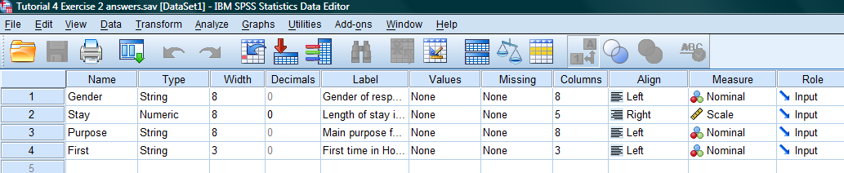

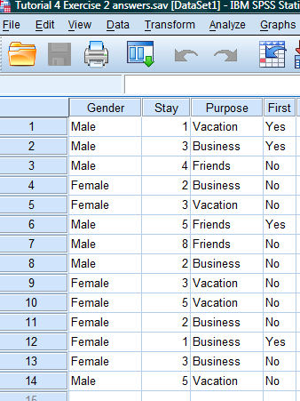
- What percentage of the tourists were men/women and first-time/repeat visitors? (Hint: use frequencies)
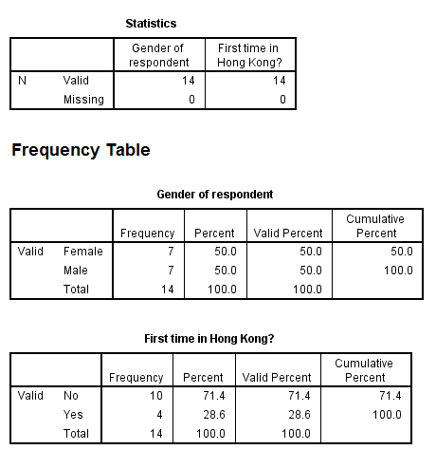
- What was visitors’ average length of stay in Hong Kong?
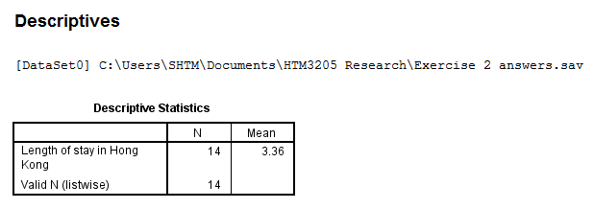

- Using the Compare Means - Means procedure, find the means of length of stay for men, for women, for various travel purposes and for first-time visitors and repeat visitors.
- 

