MODULE SYLLABUS

Methods and Approaches for Classics
CLSK5002
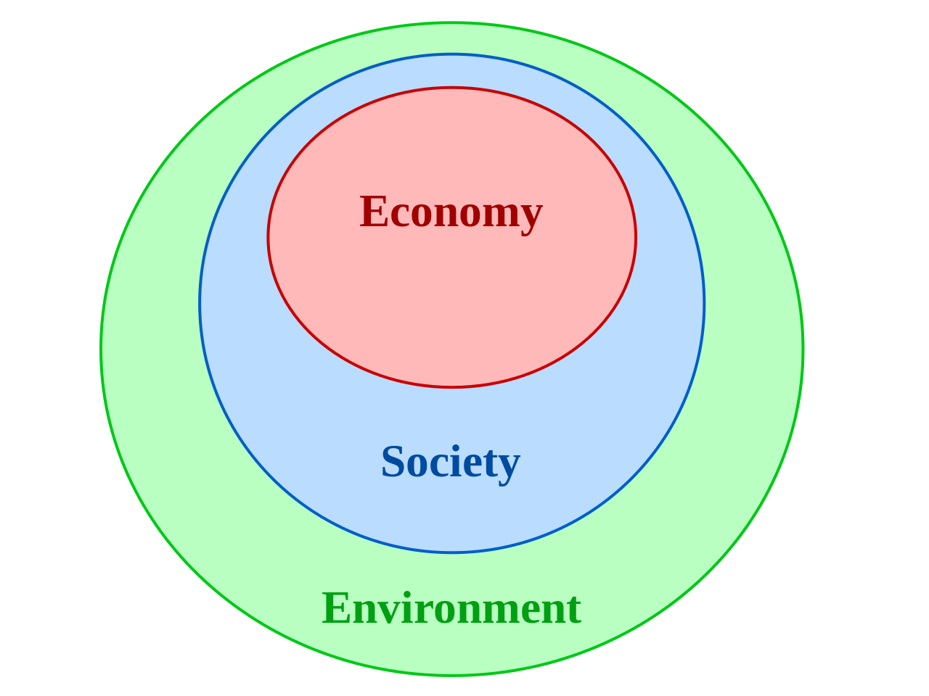

MODULE CODE: CLSK5002

TITLE: Methods and Approaches for Classics: Exploring Sustainability in the Ancient World
DATED: 04/07/2014

LEVEL: 5
CREDITS: 20

JACS CODE: Q800

GENERAL INFORMATION
Methods and Approaches for Classics is designed to advance students on from the Study Skills for Classics module taken at level 4 by introducing them to a variety of practical, conceptual and methodological techniques to enable them to undertake both group and independent study at level 6. The module will explore a variety of generic research skills and approaches during an initial two-day event, and includes such topics as critical thinking, information gathering and presentation, interdisciplinary research, and the application of IT to research. Alongside instruction on generic skills, Schools will also provide more subject specific guidance to research approaches and methodologies through a study of various case studies on the theme of sustainability and the environment. The module should suitably equip students with the requisite skills to undertake group project work, independent work-based learning and a dissertation at level 6, as well as enhancing their knowledge of how their discipline relates to contemporary issues surrounding sustainable development.

LEARNING OUTCOMES
By the end of this module students should be able to:
- demonstrate an understanding of various techniques for acquiring, handling, organising and communicating different types of data;
- demonstrate an understanding of various methodologies and approaches necessary for undertaking scholarship and research;
- demonstrate an ability to critically evaluate different concepts and theories and apply them to a student’s own work;
- demonstrate an understanding of environmental and sustainable issues as they relate to each student’s academic discipline;
- demonstrate an ability to plan, design, manage and deliver a group research project.

OFFICE HOURS/HOW TO CONTACT ME
Please feel free to come and see me if you would like to discuss any problems you may have concerning this module. Try, if at all possible, to come during my office hours. My office hours are Mondays 2-3pm, Thursdays 3-4pm and Fridays 10-11am. If you come to see me at another time and I am not in because of teaching or other commitments, please email me (e.bissa@uwtsd.ac.uk). You can also ask questions (not confidential) in the discussion board available in the Moodle space for this course.

STRUCTURE AND ORGANISATION
This 20-credit module has 30 contact hours. Attendance is compulsory for ALL lectures, seminars and workshops. If you cannot make a class because of illness or other good reason, you need to inform me by e-mail at e.bissa@tsd.ac.uk .

Lectures and workshops take place Mondays 11am-1pm in the Mac Lab, and Fridays 9-10am in the Mac Lab.

Course Outline:

The purpose of this module is to train you in the use of types of sources and theories that students of the ancient world need for any type of advanced work. We will be covering manuscripts and transmission, theory and scholarship, epigraphy, iconography and objects, terrain, remains and experimentation.

ASSESSMENT

The assessment for this module is in two parts:

- 500 word individual conference paper abstract 25%
- Group conference poster exhibition and presentation 75%

Understanding the assessment
Throughout the module you will work in your assessment groups. You will decide
on your groups, and area of assessment, in the first week of the semester. You will need to sign up on Moodle. You will need to sign up to a group by 02/10/15.

Assessment Topics
Your poster exhibition, and your conference paper abstract, will be on one of these topics.
You need to decide as a group which one of these will be your topic, and what exactly will be your title as a group. Then each member of the group will need to concentrate on a specific aspect of the title, which will be what your INDIVIDUAL abstract will be about.

- Sustainability of Empires
- Economic sustainability
- Classics as a sustainable subject
- Sustainable heritage
- Sustainability of ideas
- Environment and sustainability
- Sustainability of oppression
- Sustainability of social cohesion

- You will need to have decided on a draft title, and draft areas for each poster by the end of the second week of the module.
- You will need to post your draft titles, and draft areas on the Group Forum on Moodle by the end of the second week of the module!

Posters and Groups
The poster is a group assessment. This means that the mark is contingent upon the performance of the GROUP as much as your individual work.
It is assumed that while individuals will work on specific parts of the poster, ALL members of a group bear responsibility for the completed poster exhibition.
REMEMBER to include your name in the poster you are responsible for.
Quite simply you are creating a poster exhibition together. For the poster exhibitionto be good you need to work together.

Relationship of Abstract to Poster Exhibition
- The abstract is an individual piece of work, but it is connected with your group-work.
- For the poster exhibition, each group will need to create an exhibition of as many A1 posters as the group has member.
- Your abstract will be on your part of the exhibition.

Relationship of Module to Abstracts and Poster Exhibition
- Your poster exhibition will need to clearly and obviously utilise the methods and sources that we cover in this course.
- So, you will need to include:
  - Literary sources
  - Epigraphic or other documents
  - Iconography and materials
  - Archaeological material and evidence

POSTERS and the GROUP discussion forum
The GROUP DISCUSSION FORUM is there for you to communicate in the specific groups for the poster exhibition. You are expected to use the discussion forum for that purpose. Part of the work that we do in the seminars will be specifically relevant to the POSTER and your group work. My observation of you working as a group will be part of the marking for your work.

WORKING in a GROUP
You are expected to work in a group for this assessment. This means that you all have to work on this.
You are expected to use the Discussion Forum to conduct at least part of the discussion. When you have meetings, you should post a quick summary of the meeting in the discussion forum.
The Discussion Forum is a means not only for you to communicate but also to provide a reflection of the group’s work on the poster exhibition.
GROUP problems
Working in a team is a necessary part of life. However, working in a team can be difficult.
It is your responsibility to work together in order to create a good poster exhibition.
The Discussion Forum is a reflection of your work as a group.
If there are problems in your group, then you should contact us immediately. The Discussion Forum posts and reports will be used to judge any issues within the group.
If you do not participate in the group work, then you will be penalised.
POSTER MARKING
- Each person is marked individually, but 50% of the mark relates to their group-work.
- So, you need to work as a group from the beginning and throughout.
- Your group-work mark is based upon:
  - My observations in class
  - Your group meeting minutes on Moodle
  - The overall cohesion of your poster exhibition and argument
- A group meeting minutes template is available on Moodle.

DEADLINES

Abstract submission: 10/11/15
Poster submission (electronic): 05/01/15. Remember that your electronic submission must be the same as the A1 copies that you submit during the exhibition. The format of the electronic submission must be PDF!!!
Poster exhibition: To be confirmed during the semester. Will probably be week beginning 05/01/15. Remember that you need to provide A1copies of all the posters in your exhibition.

General assessment information: coursework
Coursework submission for this module will be through Moodle. Please follow the instructions on the module’s Moodle page for how to submit your work. The deadline for submission will be at 3 pm on the day given above.

Word count
Please be aware that if you go significantly over or under the word limit (i.e. more than 10%), you may be penalised. REMEMBER that the word count includes everything apart from the bibliography, titles or captions. You must provide the word count clearly on the cover sheet.

Welsh First language
If your first language is Welsh and you would like to submit any assessed coursework in Welsh, please see the Faculty Office as soon as possible to make arrangements for this.

Special needs / requirements
If you have any special needs (e.g. dyslexia, visual impairment) that need to be taken into account for the teaching of this module, please make sure that our Welfare Officer, Dr Ruth Parkes (R.Parkes@uwtsd.ac.uk), is made aware of this so that we can make sure that we fully support you in your studies.

Returning of work
Detailed feedback is given on Turn-It-in but if you would like to discuss your work in more detail, do come and see me during one of my office hours (see times given above).

Bibliography
A bibliography is provided in the Moodle space for this course.

Unfair Practice
All essays and gobbets will be submitted through Turn-It-In. You can submit a draft of your work and read the Turn-it-In report in advance of the deadline. You need to follow the regulations regarding unfair practice and academic integrity as they can be found in the University’s Academic Quality Handbook and the Programme of Study Handbook. If you have questions about unfair practice, and how to avoid it, do not hesitate to ask me.

