Name: Katie Rees
Student ID: 1903413
Date: 13/06/2020

Database design (the book store)
Information Engineering

Contents
1/ Introduction 2
2/ Main Menu 2
3/ Customer Details 3
4/ Staff Details 4
5/ Supplier Details 5
6/ Check Availability 6
6.1/Check Availability Report 7
6.2/ Check Availability Macro 7
6.3/ Check Availability Query 8
7/ Place Customer Order 9
8/ Place Stock Order 9
9/ Produce Invoice 10
9.1/ Invoice Report 11
9.2/ Invoice Macro 12
9.3/Invoice Query 12
10/ Entity Relationship Diagram 14
11/ Enhancements 14
11.1/ Design 14
11.2/ Functional 14
12/ Conclusion 14

1/ Introduction
The following database has been designed for a book store that wishes to maintain a high level of customer satisfaction where an ever increasing demand on popular and classic book titles exists. This report will focus on the main aspects on the database that has been designed and will discuss the functions that can be performed by their users.

2/ Main Menu
The first requirement includes a menu driven database. As you can see below in Figure 1, as soon as the database is opened, a menu is displayed.

Figure 1. Main Menu
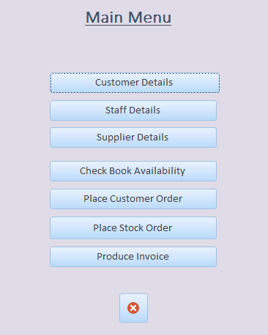

The main menu will allow the user to access all functions of the database, including customer orders and stock orders as well as checking book availability. To navigate, around the system, the user will need to select the relevant button which will open a new screen. To exit the system entirely, they can select the ‘X’ at the bottom of the main menu.

3/ Customer Details
If a user wishes to insert or view any customer details, the ‘Customer Details’ button must be selected from the main menu. Once selected, the following screen should display:-

Figure 2. Customer Details
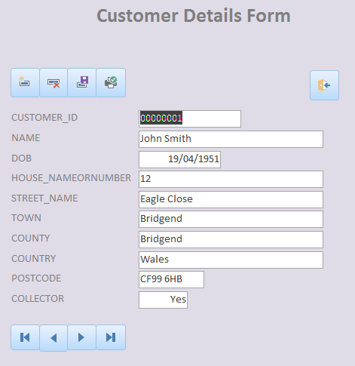

As you can see above in Figure 2, the customer details form allows the user to view details such as a name, address and select whether the customer is considered a ‘Collector’. The user has an opportunity to edit any field on this screen and then select the save  button. They can use the navigation buttons at the bottom of the screen to navigate through all customer records on the database. To add a new record, the ‘Insert’ button  is at the top of the screen and this will open up a new blank form allowing the user to enter a new record. Not only this, they can delete a record  and print a record  also. The ‘Exit’ button  is at the top right corner and will navigate the user back to the main menu. These buttons are consistent throughout the system, which improves usability.

The customer details table has been created using the SQL query in Figure 3.

Figure 3. Customer Details Table SQL Query
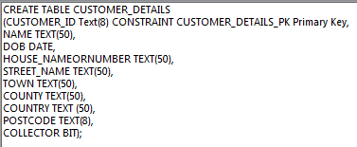

4/ Staff Details
The second button on the main menu is labelled ‘Staff Details’. Similarly to Customer Details, this allows the user to insert, amend, delete and print any Staff Details. The design is displayed in figure 4.

Figure 4. Staff Details
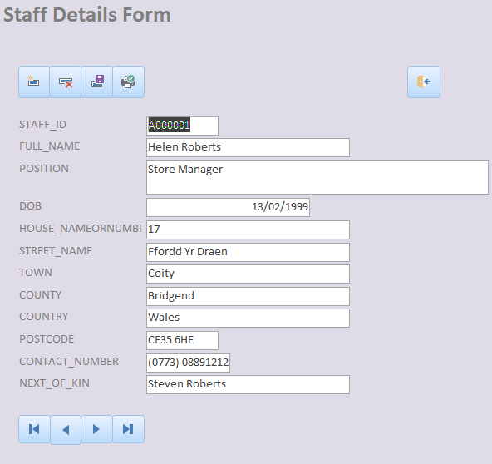

As you can see, the staff details form contains several details including their position and next of kin. They also have their own Staff ID which will be used when they place a stock order. This ID is mandatory and must be unique.

The staff details form was created using the SQL query in Figure 5.

Figure 5. Staff Details Table SQL Query
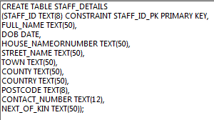

5/ Supplier Details
The Supplier Details form allows staff to insert the details of their suppliers. Again this form allows users to insert, amend, delete and print any Supplier Details and also allows them to navigate back to the main menu at any time. Figure 6 below shows the layout of this form.

Figure 6. Supplier Details
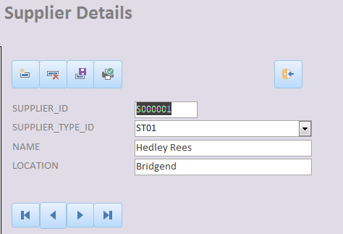

This form holds less information that the customer details and staff details however it does hold a unique supplier ID which will be used when staff select which supplier they would like to order stock from.

The supplier details table was originally created using the SQL in Figure 7.

Figure 7. Supplier Details SQL
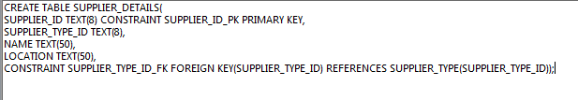

Test data was also inserted using the SQL in Figure 8.

Figure 8. Insert Values into Supplier Details SQL

6/ Check Availability
The check availability option allows a user to search for a book by type. For example, if the customer is interested in first editions only, then the user could create a report which shows all first edition books that the book store stock. They can also filter by in stock only by selecting the ‘In Stock?’ flag. Figure 9 shows the design of this screen.

Figure 9. Check Availability
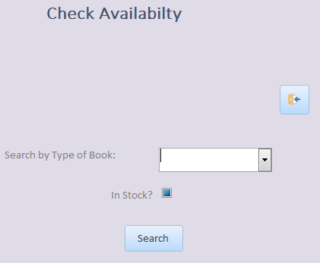

If the user wishes to check availability of a certain type of book, they can use the ‘Search by Type of Book’ drop down which allows them to select either ‘First Edition’, ‘New Best Seller’ or ‘Classic Title’. Once the user selects the ‘Search’ button, this will filter the returned results by their desired book type. The user also has the added bonus of being able to filter by those books which are already in stock by using the ‘In Stock?’ flag. Once selected this will work with the Search by Type of Book option and return only those books which are in stock. If their desired book is not in stock, then staff can then made an order with the supplier using the ‘Stock Order’ form.

6.1/Check Availability Report

The returned results will be displayed as shown in figure 10.

Figure 10. Availability Report

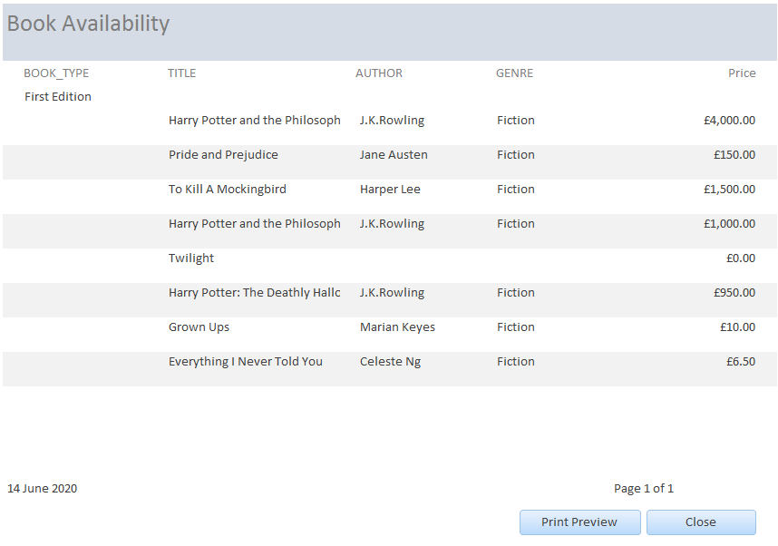
As shown above the report also contains two further buttons. ‘Print Preview’ allows the user to view the report as a preview and eventually print. ‘Close’ will allow the user to return to the main menu if they do not wish to print the report.

6.2/ Check Availability Macro
For the ‘Search’ button to create a report, a macro had to be designed as shown in figure 11.

Figure 11. Check Availability Macro
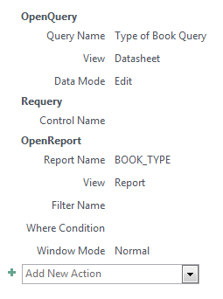
As soon as the user selects the ‘Search’ button, the system will first open the ‘Check Availability’ query. This query is shown in figure 12. It then re-queries the ‘Check Availability’ query and prints the returned results (if any) on the Availability Report (see figure 11).

6.3/ Check Availability Query

Figure 12. Check Availability Query
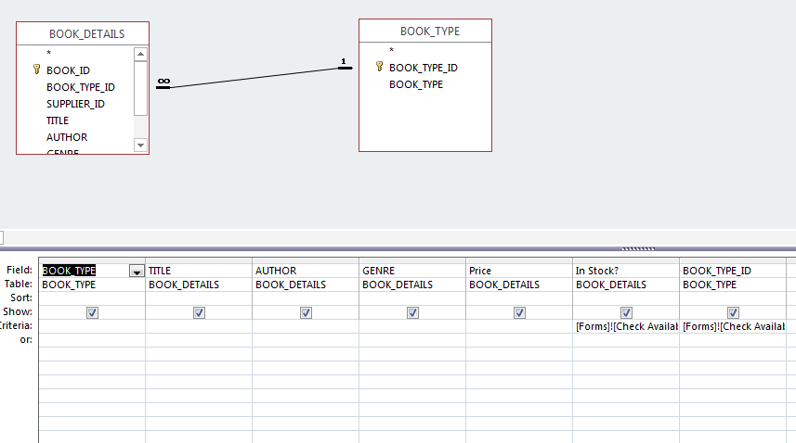

Figure 12 shows that the query wants to view data from the ‘BOOK_DETAILS’ and ‘BOOK_TYPE’ tables. The only criteria it is interested in however, is that of the ‘In Stock?’ field in BOOK_DETAILS and the BOOK_TYPE_ID field in the BOOK_TYPE table. As both of these fields are variable dependant on what the user inserts, they have been linked to the ‘Search by type of book:’ and ‘In Stock?’ field’s on the ‘Check Availability’ form using the ‘Builder’ function on MS Access.

7/ Place Customer Order
The ‘Place Customer Order’ tab allows users insert, amend, delete and print customer orders. They are also able to view any customer order and navigate back to the main menu. This is displayed in the design in Figure 13.

Figure 13. Customer Orders
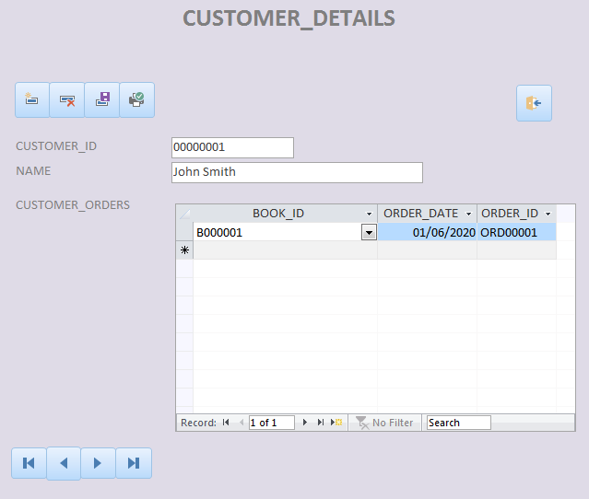

As you can see above, this form displays the customer’s name and ID from the customer details table and then contains a sub-form from the customer order’s table.

This table was created using the SQL in Figure 14.

Figure 14. Customer Orders SQL

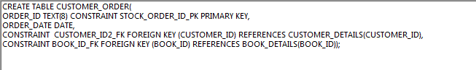

8/ Place Stock Order
The ‘Place Stock Order’ tab allows users to insert, amend, delete and print stock orders. They are also able to view any stock orders already made and navigate back to the main menu at any time. The design is portrayed in figure 15.

Figure 15. Place Stock Order
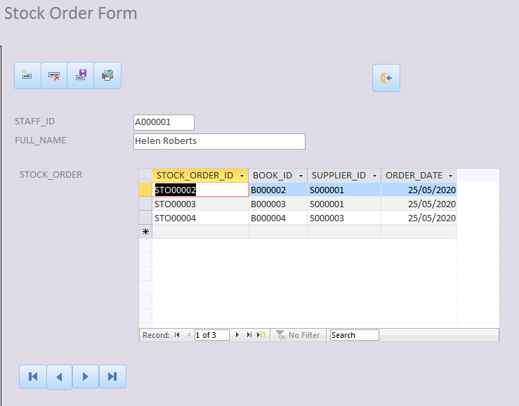

Figure 15 shows that this form includes the staff name and ID along with any stock orders they have made with the suppliers.
The Stock order table was created with the SQL in figure 16.

Figure 16. Stock Order SQL
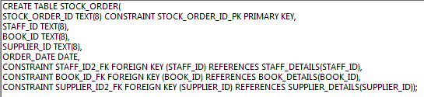

9/ Produce Invoice
The ‘Produce Invoice’ tab allows the user to produce a system-generated invoice. The screen design is shown in figure 17.

Figure 17. Produce Invoice Screen

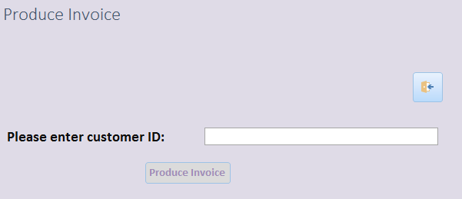

The user is able to insert the customer ID into the ‘Please enter customer ID:’ field. Once they select the ‘Produce Invoice’ button, a report will produce which will display the price of the book that the particular customer ordered. An example invoice is shown in figure 18.

Figure 18. Invoice
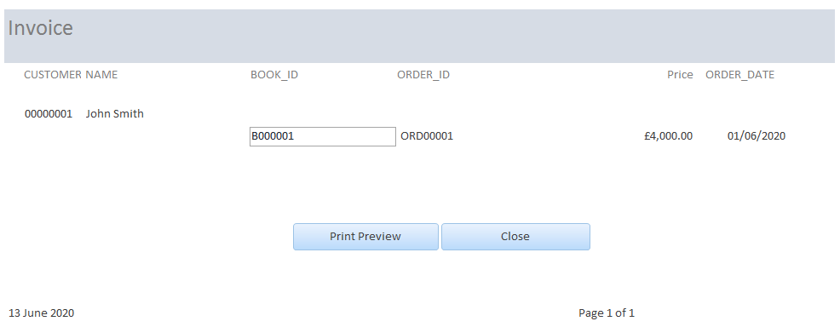

9.1/ Invoice Report

The report in figure 18 allows staff to provide customers with an invoice. The report includes, the customer’s ID, name, Book ID, Order ID, Order Date and the Price. At the bottom of the screen display two further buttons. ‘Print Preview’ once selected will send users to be able to preview their report before printing. From here they are able to print out the invoice. If the user decides they do not need to print the invoice and would like to be returned to the main menu, then they are able to select the ‘Close’ button.

9.2/ Invoice Macro
To produce this report, the ‘Produce Invoice’ button must be linked to a macro. This macro is shown in figure 19.

Figure 19. Invoice Macro
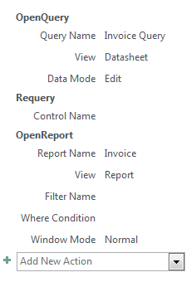
As soon as the user selects the ‘Produce Invoice’ button, the system will first open the ‘Invoice’ query. This query is shown in figure 20. It then re-queries the Invoice query and prints the returned results (if any) on the Invoice Report.

9.3/Invoice Query

Figure 20. Invoice Query
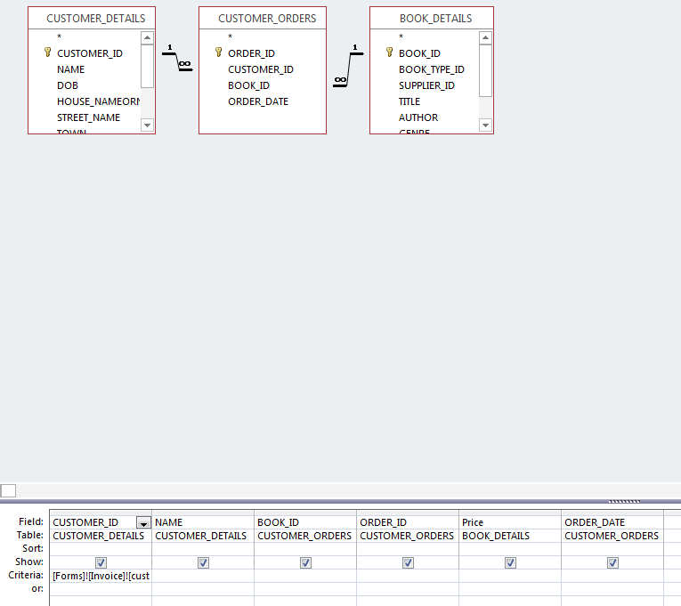

Figure 20 shows that the query wants to view data from the ‘CUSTOMER_DETAILS’, ‘CUSTOMER_ORDERS’, and ‘BOOK_DETAILS’ tables. The only criteria it is interested in however, is that of the CUSTOMER_ID in the CUSTOMER_DETAILS table. As this is a variable field dependant on what the user inserts, it has been linked to the ‘Please insert Customer ID:’ field on the ‘Invoice’ form using the ‘Builder’ function on MS Access.

10/ Entity Relationship Diagram
An Entity Relationship Diagram (ERD) should be produced at the start of any database design to show the relationship between the entities within your database. According to Smartdraw [1] an ERD can improve the understanding of the system in hand. It can help create a vision for the database builder on how the data can and will connect. Figure 21 below shows an ERD as created on Visio.

Figure 21. The Book Store ERD
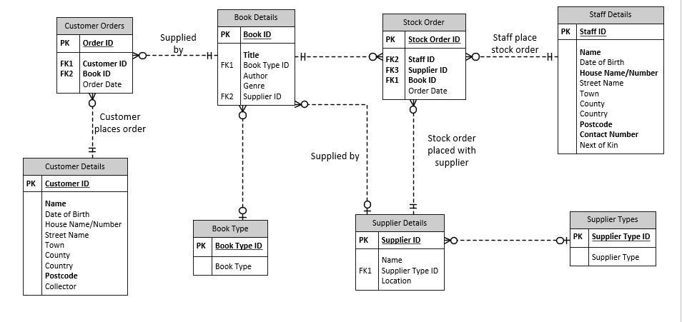
Above outlines all entities within the Book Store database. The ERD allowed for the creator to define the business needs and processes to create a suitable database. It shows how the entities within the database are linked which maximises the design and flow of the database.

11/ Enhancements
Although the database meets the basic requirements as supplied by the book store, it could benefit from several enhancements which could improve usability.

11.1/ Design
Consistency throughout the forms was of paramount importance to the creator. However, the forms could benefit from cosmetic enhancements as the colours are a little bland.

11.2/ Functional
Functional enhancements could also be beneficial such as allowing the users to search using further filters than just ‘type of book’. It could for example include a filter by Author, Price, or Genre.

12/ Conclusion
To conclude, although the database meets basic requirements, it could benefit from further enhancements making the database more desirable by the book store users.

References

[1] | smartdraw, “Entity Relationship Diagram,” Smart Draw , [Online]. Available: https://www.smartdraw.com/entity-relationship-diagram/#ERDUses. [Accessed 14 June 2020].

