University of Wales Trinity Saint David
Wales Institute of Science and Art


Electronic Circuits Testing and
Applications
Electrical Control Systems
ACHA4010

Alfie Morgan
2206510
16/03/2023
Contents
1 Task 1 1
1.1 A 1
1.2 B 1
1.3 c (i) 1
1.4 c (ii) 1
1.5 c (iii) 1
1.6 c (iv) 1
1.7 d 1
1.8 e 1
1.9 f 1
1.10 g 1
2 Task 2 2
2.1 Scope Time Division Calculations 2
2.2 Function Generator output sine wave 2
2.3 Unsmoothed Rectifier Wave 2
2.4 Smoothed Rectifier Wave 2
2.5 Drop in Voltage Question 2
2.6 Rectifiers use in Automotive applications Question. 2
2.7 Probing Question 2
3 Task 3 3
3.1 Scope Time Division Calculations 3
3.2 Function Generator output sine wave 3
3.3 Capacitor charge and discharge wave marked at correct points. 3
3.4 Basic Capacitor Calculations 3
3.5 Capacitor discharge table 3
3.6 Gradient Plot and calculations 3
3.7 Inaccuracies Question 3
4 References 4

Task 1

A $Voltage=Current×Resistance= V=I×R$
$$r=\frac{V}{I}=\frac{12}{0.5}=24Ω$$

B $I_{a}+I_{b}+I_{c}=I_{t}=0.3A+I_{b}+I_{c}=0.5A$ $I_{b}=I_{c}$ $I_{b,c}=\frac{(0.5-0.3)}{2}$
$I_{b}=0.1A$ $I_{c}=0.1A$

c (i) $Power={Current}^{2}×Resistance=P=I^{2}×R$

$R=\frac{P}{I^{2}}=\frac{0.9}{{0.3}^{2}}$=10Ω

c (ii)$V_{a}=\frac{P}{I}=\frac{0.9}{0.3}=3V$ $R_{b,c}=\frac{V}{I}=\frac{3}{0.3}=30Ω$

c (iii) $V_{a}=V_{b}=V_{c}=3V$ $∴V_{T}=3V$

c (iv) $V_{D}=5-\left(3+0.6\right)=1.4V$ $R_{d}=\frac{1.4}{0.5}=2.8Ω$

d $I_{r}=\frac{I_{T}}{4}=\frac{0.5}{4}=0.125A$ $V_{T}=12+5+3=20V V_{r}=20+2=22V$
$$R_{r}=\frac{V}{I}=\frac{22}{0.125}=176Ω R_{t}=\frac{1}{\frac{1}{176}+\frac{1}{176}+\frac{1}{176}+\frac{1}{176}}=44Ω$$

e $R_{f}=6Ω$ $I=0.5A V=IR=6*0.5=3V$

f $R_{T}=R_{a,b,c}+R_{D}+R_{e}+R_{F}+R_{4r}$
$R_{d}=2.8Ω R_{e}=24Ω R_{f}=6Ω R_{4r}=44Ω$

$$R_{a.b.c}=\frac{1}{\frac{1}{10}+\frac{1}{30}+\frac{1}{30}}=6Ω ∴ R_{T}=6+2.8+24+6+44=82.8Ω$$

g EMF=22V

Task 2

Scope Time Division Calculations $T=\frac{1}{F}=\frac{1}{10}=100ms$ minimum

Function Generator output sine wave
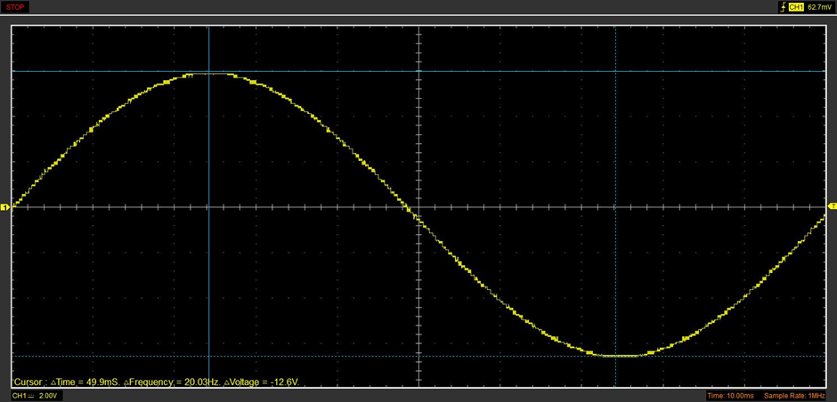

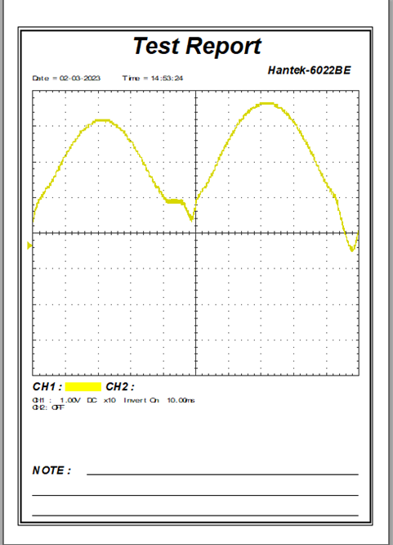
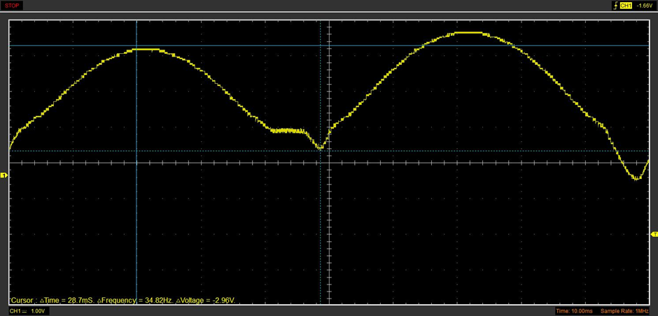
Unsmoothed Rectifier Wave

Smoothed Rectifier Wave
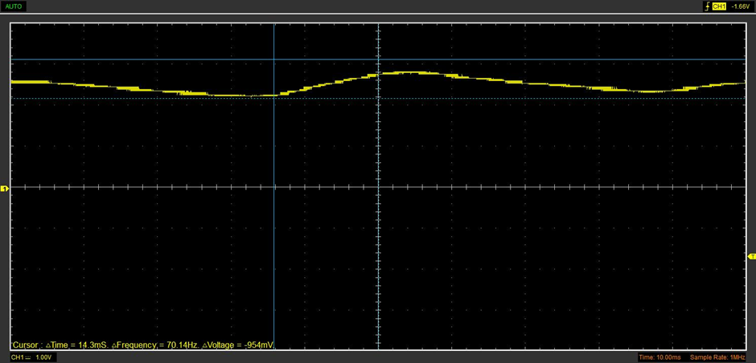

Drop in Voltage Question,

The rectifier DC output is lower than the peak of the sinewave input the key explanation to this phenomenon is the inclusion of a diode. “A forward-biased diode” which is used in this circuit “conducts current and drops a small voltage across it”(all about circuits-2022). “Due to the action of the depletion region formed by the P-N junction under the influence of an applied voltage”(all about circuits-2022). This essentially means in a forward biased diode the voltage will effectively be blocked by an insulating area called the depletion region, hence voltage is lost here.

Rectifiers use in Automotive applications Question.
A key area in which a rectifier is used in vehicle application are in a cars Alternator. “The output of an alternator is direct current (DC). When the alternator pulley is rotated, alternating current (AC) passes through a magnetic field and an electrical current is generated. This is then converted to DC via the rectifier.”(autoelectro-2023) This conversion from AC to DC is needed as current must only flow in one direction to allow a vehicles electronic systems to run correctly. The alternator is vital to a car running as it is what powers all the electronics on a running vehicle, without it nothing would work.
In electric vehicles rectifiers become even more important, as it transfers AC current into DC current, “Its normal function is charging batteries and keeping them in optimum conditions while, at the same time, providing DC power for other loads.”(jema-2021) This becomes such a key part of the vehicles running as it is the rectifier responsibility to endure the batteries powering the vehicle are performing in an optimum range. It “continuously evaluates the status and temperature of the batteries to guarantee stable voltage and low ripple.”(Jema-2021) This allows the vehicle to run in its most stable and efficient condition as much as possible.

Probing Question
When looking at the probing of the function generator and the rectifier output, readings can only be taken one at a time. This is due to the fact that the Hantek oscilloscope only has the capability to probe one circuit at a time, it cannot carry out two simultaneous probes as there is only one probe set to give a wave output hence only one reading can be taken at any given time.
In order to take simultaneous readings, a multi-channel oscilloscope must be used. “Multichannel Oscilloscope is used for evaluating signal shape and instant value measurement. It is possible to simultaneously display several signals within the same period, each having their own units of measurement.”(ZETLAB-2022).With a multichannel scope the simultaneous readings can be shown on a singular graph with independent values. Some of the main features of this are that it allows “automatic scaling of oscillograms, both simultaneously and separately”(ZETALAB-2022).

Task 3

Scope Time Division Calculations
$T=RC=100 x \left(4.7 x {10}^{-6}\right)=4.7 x {10}^{-4}s$ 1 Time Period
To see full charge and discharge, minimum 2o time periods required:
$$\left(4.7 x {10}^{-4}\right)x 20=9.4 x {10}^{-3}s∴aproximatly 10ms minimum period required for full charge+discharge$$

Function Generator output sine wave
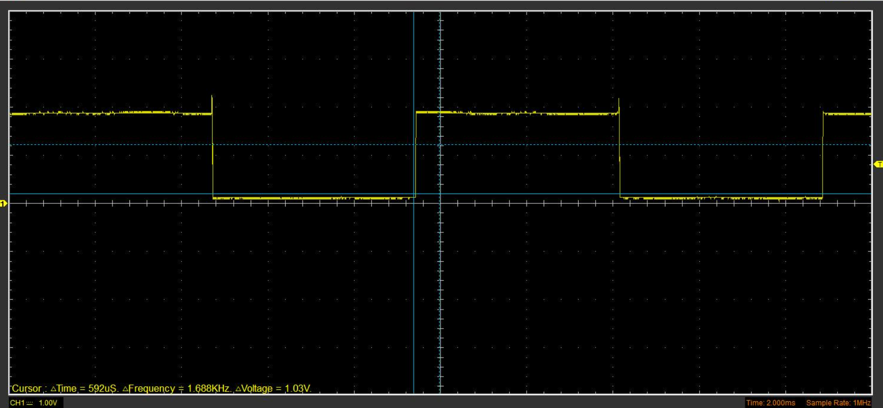

Capacitor charge and discharge wave marked at correct points.
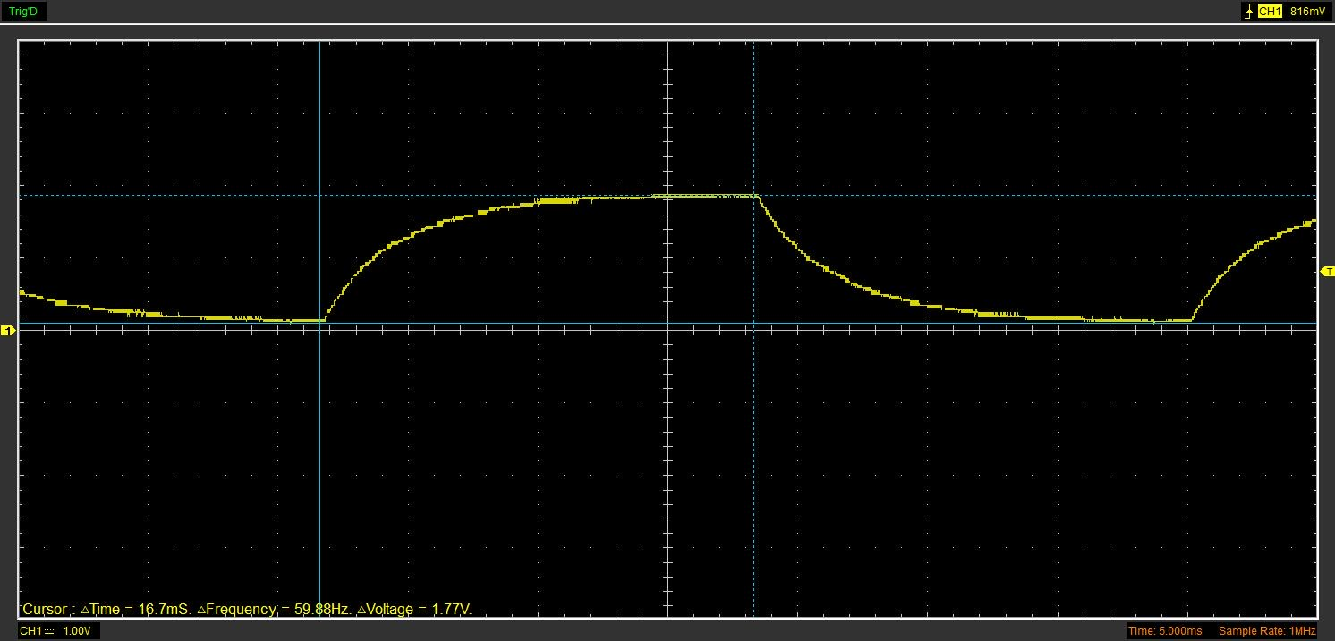

Basic Capacitor Calculations
Cannot calculate due to not taking readings

Capacitor discharge table
220 ohm resistor

Gradient Plot and calculations

$T=RC=\frac{1}{-M}=\frac{1}{234.96} C_{m}=\frac{1}{(234.96 x 100)}=4.26 x {10}^{-5}F$ $C_{c}=4.7 x {10}^{-6}F$
Due to the error of values being x10 from each other Cm will be reduced to x10^-6 to generate a delta difference. The x1o off is due to the wrong setup of the oscilloscope wave generator.
$∴difference in values=0.44 x {10}^{-6}F \% difference=\frac{4.26 x {10}^{-6}}{4.7 x {10}^{-6}}x 100=$90.64% accurate

Inaccuracies Question
Inaccuracies within this experiment will come from the likes of equipment standard and input values. Equipment used had tendency to be inaccurate and vary output values, “measurement instruments like oscilloscopes, the ground (or LO input) is connected to the earth terminal.”( meettechniek-2014) due to this a ground loop can be formed, this can then cause “unwanted ground currents”(meettechniek-2014) to be generated leading to a degree of inaccuracy throughout. Other reasons for inaccuracy can be through inputs in the wave generator. Everything must be set up in the right periods and recorded data way vary from what was actually measured at the time, theses mistakes come down to personal fault and is a key area to improve to ensure maximum efficiency in data and calculations.

References
- Rectifiers, D. (2022) Introduction to diodes and rectifiers: Diodes and rectifiers: Electronics textbook, All About Circuits. Available at: https://www.allaboutcircuits.com/textbook/semiconductors/chpt-3/introduction-to-diodes-and-rectifiers/#:~:text=A%20forward%2Dbiased%20diode%20conducts,leaving%20none%20for%20the%20lamp. (Accessed: March 28, 2023).
- Electro, A. (2023) How alternators work, How Alternators Work. Available at: https://www.autoelectro.co.uk/alternators#:~:text=The%20rectifier%20is%20used%20to,DC)%20during%20the%20charging%20process. (Accessed: March 28, 2023).
- Energy, J. (2021) Rectifiers / Battery Chargers, JEMA Energy. Available at: https://www.jemaenergy.com/en/producto/rectifiers-battery-chargers/#:~:text=A%20rectifier%20transforms%20alternating%20current,DC%20power%20for%20other%20loads. (Accessed: March 28, 2023).
- Alferink, F. (2014) Measurement errors, Measurement errors :: Electronic Measurements. Available at: https://meettechniek.info/measurement/faults.html (Accessed: March 30, 2023).

