

University of Wales Trinity Saint David
MSc Cybersecurity and Digital Forensics
RESEARCH INTO CYBER SECURITY ATTACKS AND
PENETRATION TESTING FOR A VIRTUALISED
SIMULATED COMPANY WEBSITE
TASK 1: Strategic Threat Analysis —M&S and Co-op UK Cyber Attack (2025)
And
TASK 2: ABCD Ltd — Red Team Penetration Testing Report

Module: Ethical Hacking, Module Code: ACCA7033
Student Name: Rajul Gupta Student ID:2523934
Lecturer: Dr Dipo Dunsin

TABLE OF CONTENTS
TASK 1 — STRATEGIC THREAT ANALYSIS
Abstract 1
1. Introduction 1
2. Incident Timeline 2
3. Threat Actor Profile & Motive 3
4. MITRE ATT&CK TTP Mapping 4
5. Root Cause Analysis 6
6. Detection & Response Analysis 7
7. Strategic Recommendations 8
8. Conclusion 9
References (Task 1) 10
Appendix A — Detection Gap Matrix 11
Appendix B — OSINT Notes 12
TASK 2 — RED TEAM PENETRATION TESTING REPORT
Executive Brief 13
1. Introduction 14
2. Threat Emulation Plan 15
3. Lab Environment Design 16
4. Tools & C2 Tradecraft 17
5. Attack Execution 18
5.1 Reconnaissance 18
5.2 Exploit A — Windows DC 19
5.3 Exploit B — Drupal 7 22
5.4 Exploit C — WordPress 26
5.5 Exploit D — Metasploitable 2 30
5.6 Alternative Attack Vectors 35
6. Detection Gap Analysis 36
7. Strategic Recommendations 37
8. Conclusion 38
References (Task 2) 39
Appendix A — Rules of Engagement 39
Appendix B — Threat Emulation Plan 39

TASK 1 — STRATEGIC THREAT ANALYSIS

ABSTRACT
Between February and April 2025, Marks & Spencer (M&S) and the Co-operative Group (Co-op) sustained coordinated cyber intrusions attributed with high confidence to Scattered Spider (UNC3944/G1015/Octo Tempest/Storm-0875), operating as a DragonForce ransomware-as-a-service affiliate [16][8]. The Cyber Monitoring Centre classified the combined disruption as a Category 2 systemic retail event — the first in UK history — with aggregate economic losses estimated between £270–440 million [9]. Neither breach exploited a zero-day vulnerability. A single vishing call to a third-party helpdesk reset phishing-susceptible MFA, initiating a kill chain terminating in DragonForce ELF ransomware encrypting VMware ESXi hypervisors after a 55–70-day dwell period. Co-op's Zero Trust microsegmentation detected lateral movement at API gateway boundaries within minutes, preventing encryption entirely [15].
1. INTRODUCTION
Scattered Spider exploits identity, not vulnerabilities. Outsourced helpdesk agents can reassign Azure Active Directory privileges without cryptographic identity verification — a procedural gap that renders perimeter defences and patch management largely irrelevant [12]. The difference in outcomes between M&S and Co-op was entirely architectural: M&S ran a flat legacy network and suffered £300 million in losses across 46 days of suspended e-commerce; Co-op's Zero Trust microsegmentation contained the breach and prevented ransomware deployment entirely [15]. This report maps twelve MITRE ATT&CK TTPs against command-level evidence, identifies precise detection failures by Windows Event ID, and provides phased strategic recommendations. Where events could not be independently verified, they are clearly marked as informed reconstruction [13].
2. INCIDENT TIMELINE
February 2025: NTDS.dit was pulled from an M&S domain controller through Volume Shadow Copy [4]. The whole domain's NTLM hashes were harvested 8–10 weeks before the attack was launched; Impacket secretsdump.py and hashcat cracked them offline, producing zero failed authentication events.
17 April 2025: A vishing call was placed to the TCS helpdesk; the attacker posed as a named M&S employee using personal details scraped from LinkedIn and dark-web data brokers [8][19]. The password was reset, and the MFA device was swapped in Azure AD Entra by the agent, triggering Event ID 4724 and a suspicious device registration log. No exploit or malware was needed; one phone call handed over full identity fabric access.
17–23 April 2025: The corporate VPN was used to log in (Event ID 4624, Logon Type 3). Encoded PowerShell dropped SystemBC RAT, which set up a SOCKS5 proxy for Cobalt Strike C2. The signed driver iqvw64.sys (CVE-2015-2291) was weaponised in a BYOVD attack, killing EDR kernel callbacks at Ring-0. A custom Mimikatz build dumped LSASS; domain controllers, vCenter, and ESXi were then traversed laterally via RDP, SMB, and SSH. Around 150 GB was gathered using Snaffler and shipped to Mega.nz via Rclone [4].
24 April 2025 — Easter Sunday: A DragonForce ELF payload was pushed to ESXi over SSH; the vim-cmd API force-killed all VMs, encrypting them simultaneously. Online ordering went down; contactless payments stopped working across 1,400 stores.
Late April 2025: The same vishing playbook was run against Co-op's TCS helpdesk. Co-op leadership was then contacted by the attacker over Microsoft Teams, with a threat made to publish stolen data [19][7]. Zero Trust API gateway denials were triggered by lateral movement — the affected segments were locked down by the SOC within minutes, stopping ransomware from deploying. 6.5 million member records were confirmed stolen.
July 2025: Four suspects were arrested by the NCA, who confirmed a single co-ordinated criminal campaign spanning M&S, Co-op, and Harrods [16].
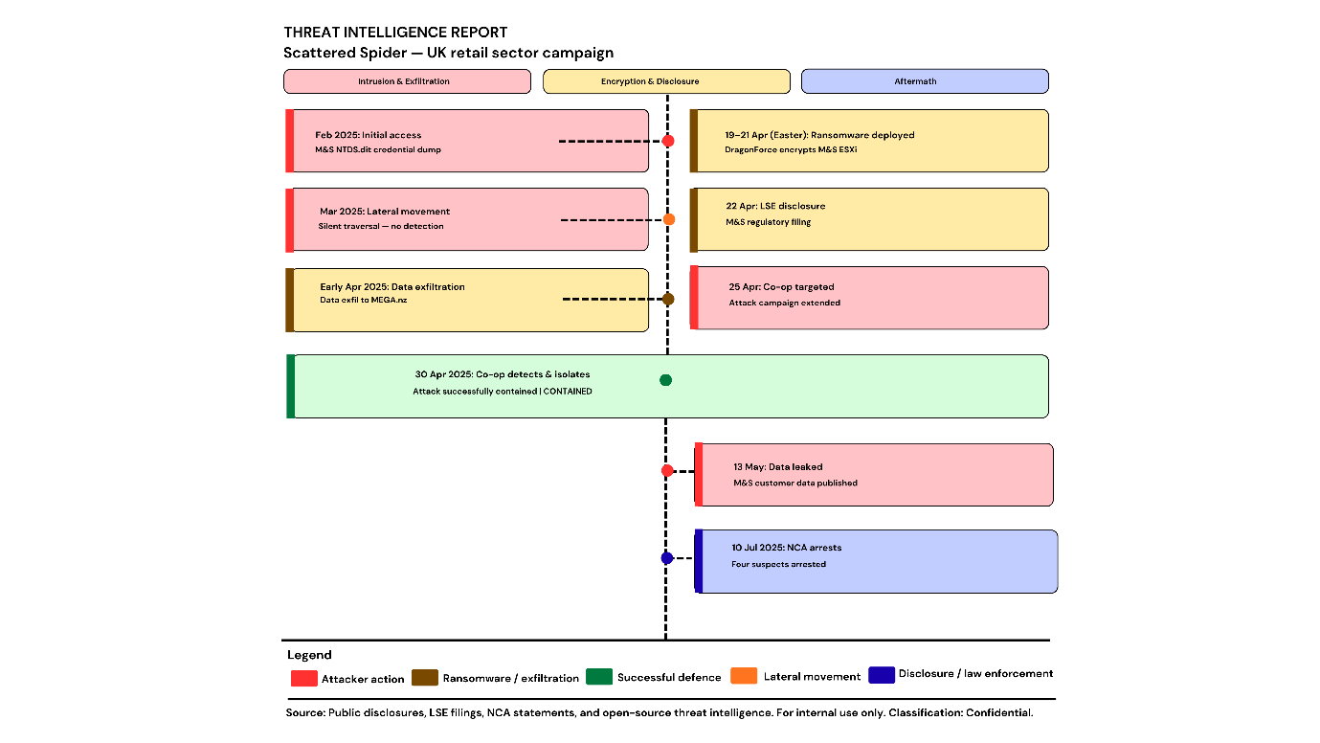
Figure 1: Incident Timeline — Scattered Spider UK Retail Campaign (2025)

3. THREAT ACTOR PROFILE AND MOTIVE
Scattered Spider (UNC3944/G1015/Octo Tempest/Storm-0875/Roasted 0ktapus) is an English-speaking, financially motivated cybercriminal group based in the United Kingdom and the United States. The NCA arrests confirmed UK presence [16]. It operates as a RaaS affiliate, providing initial access and execution in exchange for a revenue share. Core techniques include OSINT-driven identity intelligence, vishing-based helpdesk social engineering, AI-assisted voice synthesis, living-off-the-land execution, and Microsoft Teams-based executive extortion [8][19].
Its custom ESXi ELF encryptor, operating under the DragonForce brand, powers off all VMs simultaneously rather than sequentially for maximum impact. The steal-then-encrypt model maximises ransom leverage. M&S data not appearing on DragonForce's leak site is suggestive of payment, though this cannot be confirmed. The Easter Sunday detonation timing was deliberate, targeting M&S's peak trading period [1][2][5][20].

4. MITRE ATT&CK TTP MAPPING — 12 TECHNIQUES
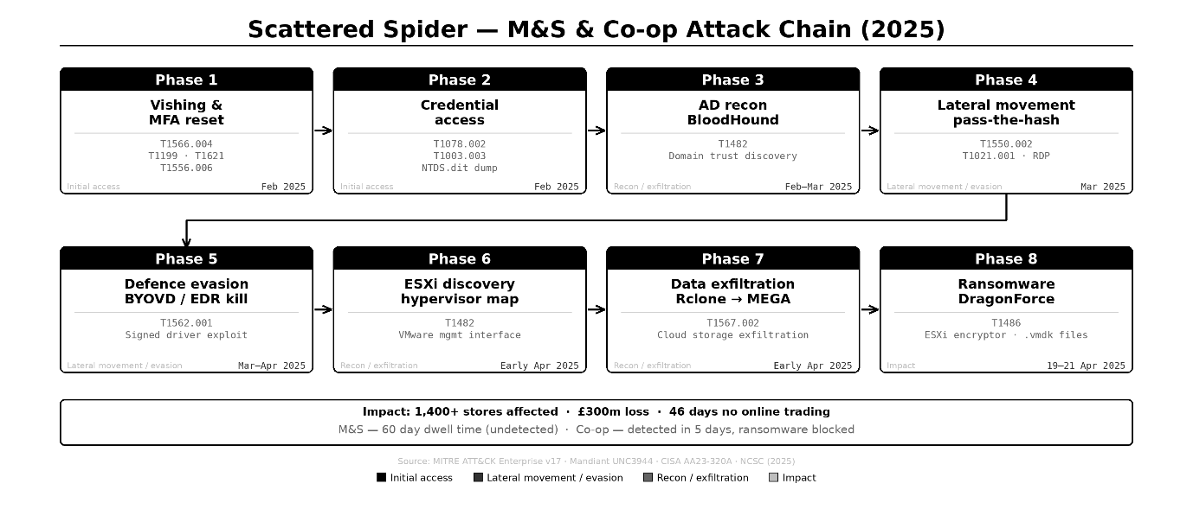
Figure 2: Scattered Spider — M&S & Co-op Attack Chain (2025)

T1589 — Gather Victim Identity Information (Reconnaissance)
Employee PII — names, direct-dial numbers, email formats, and organisational hierarchy — was scraped from LinkedIn and dark-web broker datasets to pass KBA security checks and impersonate named employees. No network artefact was generated at the target. Gap: No dark-web monitoring programme existed; no policy limited executives' digital exposure [14].
T1598.004 — Phishing: Spearphishing Voice (Initial Access)
The attacker called the TCS helpdesk claiming a lost device and requested a password reset with MFA device swap. The agent complied without a callback or manager sign-off. Evidence: Event ID 4724; Azure AD audit log — anomalous device registration. Gap: Helpdesk tickets were not fed into the SIEM; MFA device swap was not treated as a high-risk action [6][8].
T1078.004 — Valid Accounts: Cloud Accounts (Initial Access / Persistence)
Reset credentials authenticated to Azure AD via Connect sync, bypassing firewall, IPS, and EDR. A rogue OAuth app with directory-wide permissions was then registered, maintaining a foothold after password resets. Evidence: Azure AD audit log — high-privilege app registration. Gap: No Conditional Access policy; no alert on high-privilege OAuth scope grants [12].
T1059.001 — PowerShell (Execution)
SystemBC RAT deployed via powershell.exe -ExecutionPolicy Bypass -WindowStyle Hidden -EncodedCommand [Base64], establishing a SOCKS5 proxy for Cobalt Strike C2. Evidence: Event ID 4688; Sysmon EID 1; PS EID 4104. Gap: Script block logging disabled via GPO; Constrained Language Mode absent; BYOVD subsequently killed EDR before alerts fired [20].
T1562.001 — Impair Defences: BYOVD (Defence Evasion)
The signed but vulnerable driver iqvw64.sys (CVE-2015-2291) was loaded via sc.exe at Ring-0, terminating EDR kernel callbacks and event-logging pipelines. Simultaneous EDR failures across multiple servers were misclassified by Tier 1 SOC as a routine IT outage. Evidence: Sysmon EID 6; System EID 7045. Gap: HVCI Vulnerable Driver Blocklist not enforced; no Tier 1 runbook for correlated EDR failures [8].
T1558.003 — Kerberoasting (Credential Access)
Rubeus scanned SPNs via LDAP and requested RC4-HMAC TGS tickets: Rubeus.exe kerberoast /outfile:hashes.txt /rc4opsec. Offline GPU cracking yielded service account credentials with zero live authentication alerts. Evidence: Event ID 4769, EncType 0x17, high-velocity from single host. Gap: RC4 Kerberos permitted; no SIEM threshold alert for high-volume EID 4769 from a single host [11].

T1003.001 — LSASS Memory Credential Dumping (Credential Access)
Custom-compiled Mimikatz executed privilege::debug and sekurlsa::logonpasswords, extracting NTLM hashes, WDigest credentials, and TGTs from live admin sessions. Evidence: Sysmon EID 10 (GrantedAccess 0x1410); EID 4656. Gap: Credential Guard and LSA RunAsPPL absent; custom build bypassed static AV; Sysmon already disabled by prior BYOVD [19].
T1003.003 — NTDS Credential Dumping (Credential Access)
Executed February 2025 — 55–70 days before detonation. VSS shadow copy used to extract NTDS.dit and SYSTEM hive; Impacket-secretsdump and hashcat cracked every domain account offline without a single authentication alert. Evidence: Event ID 4688 (vssadmin/ntdsutil); ESENT EIDs 216, 325. Gap: No alert for vssadmin outside scheduled backups; ESENT logs never ingested into SIEM [4].
T1021.001 / T1021.002 / T1021.004 — Lateral Movement: RDP, SMB, SSH
Domain admin credentials enabled RDP traversal across 30+ hosts. PsExec deployed PSEXESVC for remote execution. Cobalt Strike SMB beacons concealed C2 in named pipes within legitimate port 445 traffic. AD-integrated ESXi required no separate credential. Evidence: EID 4624 Type 10/3; EID 7045; EID 5140; ESXi auth.log; vCenter vpxd.log. Gap: No UEBA baselining; vCenter absent from SIEM [20].
T1070.001 — Clear Windows Event Logs (Defence Evasion)
wevtutil cl Security and wevtutil cl System executed across all compromised hosts post-movement, permanently destroying lateral movement records. EID 1102 and EID 104 fired at the moment of deletion — by which point all prior entries were gone. Gap: No real-time SIEM log forwarding; no priority alert for EID 1102 [14].
T1567.002 — Exfiltration Over Cloud Storage
Snaffler automated sensitive-file discovery; Rclone transferred data to Mega.nz and an attacker-controlled S3 bucket. TLS encryption over well-known cloud providers evaded DLP inspection. Total: ~150 GB from M&S; 6.5 million Co-op member records. Evidence: EID 4688 (rclone/snaffler from %TEMP%); Sysmon EID 3 (Mega.nz outbound). Gap: TLS not inspected at perimeter; Mega.nz reachable from corporate network; no large-volume transfer alert [18].
T1486 / T1490 — Data Encrypted for Impact / Inhibit System Recovery
DragonForce ELF uploaded via SCP; -vmsvc flag powered off all VMs simultaneously to release locked virtual disk files, encrypted with ChaCha8 (RSA-2048 per-file keys; .RNP extension). The binary self-deleted post-encryption. Windows-side vssadmin delete shadows /all /quiet and wmic shadowcopy delete removed all local recovery points. Evidence: vmkernel.log; vobd.log; vCenter task log; EID 4688. Gap: ESXi unmonitored (no EDR, no FIM, no SIEM integration); no mass-VM-shutdown alert; no offline immutable backups [3][5].

5. ROOT CAUSE ANALYSIS — SECURITY CONTROL FAILURES
Technical Failures
The most consequential failure was the absence of phishing-resistant MFA. FIDO2/WebAuthn hardware tokens bind authentication cryptographically to a physical device — the private key cannot be reassigned by telephone, rendering the vishing call operationally worthless [6].
M&S's flat topology permitted unrestricted SMB (TCP 445) and SSH (TCP 22) from standard VLANs directly to domain controllers, vCenter, and ESXi — once a single domain admin credential was obtained, the entire estate was reachable. Co-op's Zero Trust microsegmentation enforced deny-by-default at identity-aware API gateways; lateral movement triggered boundary-violation alerts and automated subnet isolation within minutes. Identical initial access vector; architecture was the determinative outcome variable [15].
Additional compounding failures: RC4-HMAC Kerberos permitted (enabling offline Kerberoasting); Credential Guard and LSA RunAsPPL absent (permitting LSASS access); HVCI Vulnerable Driver Blocklist unenforced (enabling iqvw64.sys BYOVD); no AD tiering (domain admin credentials usable across all tiers); ESXi entirely absent from SIEM [17].
Organisational Failures
TCS held Tier-0-equivalent Azure AD access without contractual mandate for phishing-resistant verification. The MFA device reset workflow had no out-of-band callback, no manager co-authorisation, and no cryptographic identity challenge. The 55–70-day dwell time reflects an absent threat-hunting culture — the SOC ingested logs but lacked UEBA baselines and correlation rules to surface the attack pattern [12].
Human Factors
Scattered Spider used AI-assisted voice synthesis and psychological urgency tactics — feigned device loss, time pressure — to manipulate helpdesk agents. No vishing-specific security awareness training had been delivered to third-party service desk personnel [8].

6. DETECTION AND RESPONSE ANALYSIS
M&S detection was prompted by operational failure. Customer-reported payment failures on 24 April 2025 surfaced the breach — not SOC alerting. Across every phase of the kill chain, forensic artefacts were either absent from SIEM ingestion or never consolidated into actionable alerts. In several instances the adversary actively destroyed them. The 55–70-day dwell period remained undetectable throughout.
BYOVD was the pivotal detection failure. Ring-0 termination of EDR kernel callbacks dismantled endpoint visibility before credential dumping or lateral movement began. Simultaneous EDR agent failures were misclassified by Tier 1 as an IT outage — a procedural gap that directly prolonged dwell time [8]. Classified assets lacked a mandatory escalation playbook for correlated EDR failures, pointing to an organisational rather than technical gap.
The Co-op outcome demonstrates assumed-breach architecture in practice. Zero Trust API gateway denials triggered an automated SOAR playbook during lateral movement; affected segments were isolated within minutes and ransomware was prevented entirely [15]. The initial access vector was identical in both cases. Architecture dictated the outcome. Detection capability is an architectural property, not a tooling one.
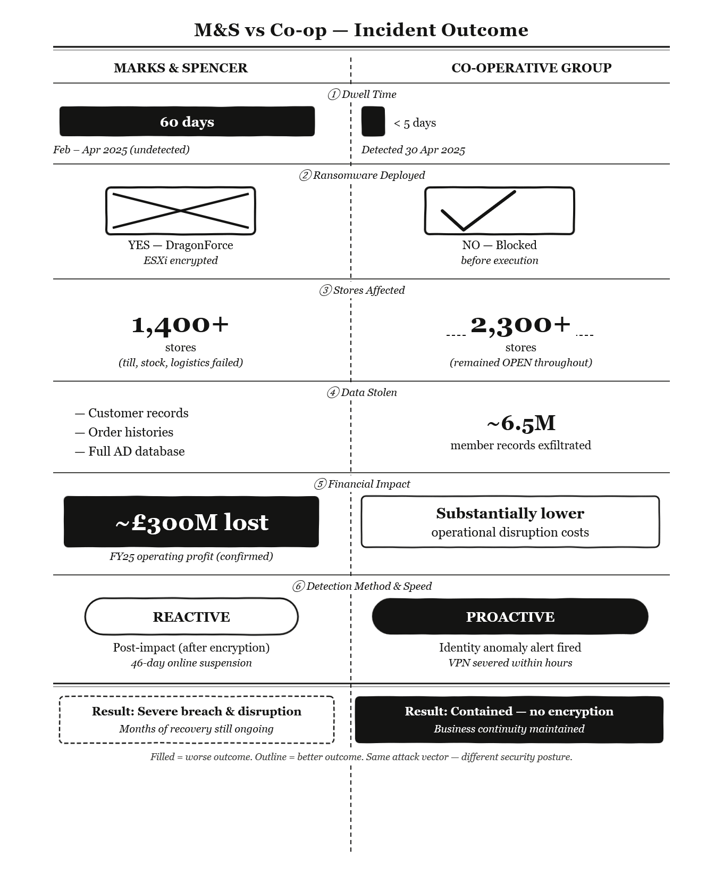
Figure 3: M&S vs Co-op — Incident Outcome Comparison (2025)

7. STRATEGIC RECOMMENDATIONS
Initial Access — Closing the Vishing Attack Surface
Hardware FIDO2/WebAuthn tokens must replace all legacy MFA for privileged accounts and any account that helpdesk staff can modify. Before any MFA device registration or credential reset, out-of-band callback and manager sign-off are both required — enforced contractually on all third-party identity providers. Dark-web monitoring for exposed executive personal data should be implemented to deny attackers the OSINT needed for convincing impersonation [6][12].
Credential Access Hardening
Credential Guard and LSA RunAsPPL must be enabled via Group Policy across all domain-joined machines. RC4 Kerberos must be disabled organisation-wide, with AES-256 as the sole permitted option. HVCI and the Vulnerable Driver Blocklist must be active. Anomalous use of vssadmin or ntdsutil outside scheduled backup windows must trigger an immediate SIEM alert [17].
Lateral Movement and Impact Prevention
ESXi and vCenter must be placed on isolated management VLANs, accessible only from dedicated Privileged Access Workstations. Permanent admin accounts must be replaced with just-in-time elevation through Entra PIM. WDAC allow-listing should block known attack tools from executing in user-writable directories [20].
Exfiltration Prevention
TLS inspection must be active at the perimeter proxy. Consumer cloud storage services — including Mega.nz and anonymous object storage — must be blocked by default. A network DLP solution with volume-based anomaly detection should alert on unusually large outbound data volumes per endpoint [18].
Detection Engineering and Recovery
All key log sources — Windows Security, Sysmon, Azure AD, vCenter, ESXi, DNS, and proxy — must feed an immutable, off-site SIEM in real time. UEBA must flag anomalous login hours, impossible travel, and fast-lateral activity. Offline, write-protected ESXi datastore and Active Directory backups must be isolated from domain credentials. Red team exercises targeting helpdesk social engineering must be conducted annually [17].
8. CONCLUSION
The 2025 M&S and Co-op attacks establish that identity governance is the critical failure point in hybrid cloud environments. Scattered Spider bypassed every technical control by exploiting a procedural gap — MFA credentials could be reassigned by telephone without verification. One call initiated a chain that caused £300 million in losses. The root cause was not technological; it was a governance failure.
The Co-op's Zero Trust architecture was the decisive variable. When the same attack landed, containment was achieved within minutes and encryption was prevented entirely. The CMC's Category 2 classification signals that this vulnerability is systemic across UK retail. Organisations without phishing-resistant MFA and network segmentation remain exposed to an identical campaign. The 2025 UK retail attacks are not an anomaly — they are the new baseline.

REFERENCES (TASK 1)
[1] H. Aldawood and G. Skinner, "Social Engineering Attacks Prevention: A Systematic Literature Review," IEEE Access, 2022. doi: 10.1109/ACCESS.2022.3161491
[2] D. Ariu, E. Frumento and G. Fumera, "Social Engineering 2.0: A Foundational Work," ACM, 2017. doi: 10.1145/3075564.3076260
[3] AttackIQ, "Emulating the Blazing DragonForce Ransomware," 2025. [Online]. Available: https://www.attackiq.com/2025/05/23/emulating-dragonforce-ransomware/
[4] BleepingComputer, "M&S confirms social engineering led to massive ransomware attack," 2025. [Online]. Available:https://www.bleepingcomputer.com/news/security/marks-and-spencer-breach-linked-to-scattered-spider-ransomware-attack/ (Accessed: 20 April 2026).
[5] Check Point Research, "DragonForce Ransomware: Redefining Hybrid Extortion in 2025," 2025. [Online]. Available: https://blog.checkpoint.com/security/dragonforce-ransomware-redefining-hybrid-extortion-in-2025/
[6] CISA, "More than a password: Implementing phishing-resistant MFA," 2024. [Online]. Available: https://cisa.gov/mfa
[7] Co-operative Group, "Cyber incident official update," 2025. [Online]. Available: https://www.co-operative.coop/media/news-releases/cyber-incident-update
[8] CrowdStrike, "SCATTERED SPIDER Escalates Attacks Across Industries," 2026. [Online]. Available: https://www.crowdstrike.com/en-us/blog/crowdstrike-services-observes-scattered-spider-escalate-attacks/
[9] Cyber Monitoring Centre, "Statement on ransomware incidents in the retail sector (June 2025)," 2025. [Online]. Available: https://cybermonitoringcentre.com/2025/06/20/cyber-monitoring-centre-statement-on-ransomware-incidents-in-the-retail-sector-june-2025/
[10] European Parliament and Council, "Directive (EU) 2022/2555 — NIS2 Directive, Article 21," 2022. [Online]. Available: https://eur-lex.europa.eu/legal-content/EN/TXT/?uri=CELEX%3A32022L2555
[11] Fox-IT, "An Expert Guide to Combating Kerberoasting in Active Directory," 2025. [Online]. Available: https://www.fox-it.com/be/defending-your-directory-an-expert-guide-to-combating-kerberoasting-in-active-directory/
[12] Google Cloud / Mandiant, "Defending Against UNC3944: Cybercrime Hardening Guidance from the Frontlines," 2025. [Online]. Available: https://cloud.google.com/blog/topics/threat-intelligence/unc3944-proactive-hardening-recommendations
[13] A. Happe and J. Cito, "Can LLMs Hack Enterprise Networks? Autonomous Assumed Breach Penetration-Testing Active Directory Networks," ACM Trans. Softw. Eng. Methodol., 2025. doi: 10.1145/3766895
[14] MITRE ATT&CK, "Group G1015 — Scattered Spider," 2025. [Online]. Available: https://attack.mitre.org/groups/G1015
[15] MTI Consulting, "M&S vs Co-op: Divergent outcomes of the 2025 UK retail attacks," 2025. [Online]. Available: https://mti.com/ms-and-coop-2025-cyber-attacks-lessons-learned/
[16] National Crime Agency, "Retail cyber attacks: NCA arrest four for attacks on M&S, Co-op and Harrods," 2025. [Online]. Available: https://www.nationalcrimeagency.gov.uk/news/retail-cyber-attacks-nca-arrest-four-for-attacks-on-m-s-co-op-and-harrods
[17] National Cyber Security Centre, "Attack on the helpdesk," 2025. [Online]. Available: https://www.ncsc.govt.nz/insights-and-research/insights-reports/quarter-two-cyber-security-insights-2025/attack-on-the-helpdesk/
[18] C. Patsakis, D. Arroyo and F. Casino, "The Malware as a Service Ecosystem," in Malware. Advances in Information Security, vol. 91. Springer, 2024, pp. 371–394. doi: 10.1007/978-3-031-66245-4_16
[19] Prelude Security, "Common MITRE ATT&CK Techniques in 2025 UK Retailer Cyberattacks," 2025. [Online]. Available: https://www.preludesecurity.com/blog/scattered-spiders-2025-cyberattacks-on-uk-retailers
[20] Sophos, "DragonForce targets rivals in a play for dominance," 2025. [Online]. Available: https://www.sophos.com/en-us/blog/dragonforce-targets-rivals-in-a-play-for-dominance

APPENDIX A — DETECTION GAP MATRIX
Table A.1 below maps each MITRE ATT&CK technique to the forensic evidence generated, SIEM ingestion status, alert status, and outcome for the M&S incident.
TTP ID | Technique | Evidence Generated | SIEM Ingested | Alert Fired | Outcome
T1589 | Gather Victim Identity | None at target | N/A | No | Undetected
T1598.004 | Vishing / Spearphishing Voice | EID 4724; Azure AD anomalous device reg. | Partial | No | Undetected
T1078.004 | Valid Accounts: Cloud | Azure AD OAuth app reg. | Partial | No | Undetected
T1059.001 | PowerShell Execution | EID 4688, 4104; Sysmon 1 | No | No | Undetected
T1562.001 | BYOVD / Impair Defences | Sysmon EID 6; Sys EID 7045 | No | No | EDR blinded
T1558.003 | Kerberoasting | EID 4769 (RC4, high-velocity) | Partial | No | Undetected
T1003.001 | LSASS Credential Dump | Sysmon EID 10; EID 4656 | No | No | Undetected
T1003.003 | NTDS Credential Dump | EID 4688; ESENT 216/325 | No | No | Undetected
T1021.001/002/004 | Lateral Movement (RDP/SMB/SSH) | EID 4624/5140/7045; ESXi auth.log | Partial | No | Undetected
T1070.001 | Clear Windows Event Logs | EID 1102, 104 (post-deletion) | No | No | Logs destroyed
T1567.002 | Exfiltration via Cloud Storage | EID 4688; Sysmon EID 3 (Mega.nz) | No | No | ~150 GB exfiltrated
T1486/T1490 | Encrypt / Inhibit Recovery | vmkernel.log; EID 4688 | No | No | Full ESXi encryption

APPENDIX B — OSINT NOTES
The information obtained via the OSINT procedure was drawn from the following sources. Primary sources included M&S LSE filings and FY25 results, press releases from the Co-op Group, Mandiant/Google's description of UNC3944, adversary profiles from CrowdStrike and CISA/FBI/NCSC joint advisory AA23-320A (updated 20 July 2025). UK policy context was sourced from NCSC advisory posts and oral evidence before the Business and Trade Sub-Committee of 8 July 2025. Academic materials were downloaded from IEEE Xplore, ACM Digital Library, and Springer LNCS. No references to dark web forums, unverified social media sources, or Wikipedia were used.

TASK 2 — ABCD LTD: RED TEAM PENETRATION TESTING REPORT

EXECUTIVE BRIEF — BOARD SUMMARY
Prepared for: Board of Directors, ABCD Ltd,
Classification: RESTRICTED Risk Level: CRITICAL

A structured adversarial test was conducted against ABCD Ltd's IT infrastructure using the same tools and methods a real criminal group would employ. Every system tested was fully compromised. The most critical finding is that the Active Directory Domain Controller — the backbone of all user authentication — was seized with the highest system privileges without triggering a single security alert.
Full control of the Domain Controller grants an attacker access to every user account, every shared file, and every connected system. The internet-facing Drupal application was compromised without credentials, exploiting a flaw patched in 2018. The WordPress file server was accessed after recovering an administrator password from a wordlist the site itself had publicly exposed. A legacy Linux server was taken over in under three seconds using an exploit known since 2011. According to IBM Security [3], the average cost of a UK data breach is £3.4 million. The board should treat ABCD Ltd's current posture as conferring an imminent seven-figure financial exposure. Furthermore, according to FireEye Mandiant [2], sophisticated attackers now require only days — not months — to gain access to critical enterprise assets once initial access is established, making rapid detection capability non-negotiable.
Priority Actions for the Board
1. Mandate phishing-resistant MFA on all administrator accounts within two weeks — this single control would have prevented domain compromise entirely.
2. Commission an emergency patching programme covering all internet-facing services.
3. Approve funding for a SIEM — without centralised logging, no future intrusion will be detected in time.
4. Instruct IT to segment the network into separate security zones — the flat architecture allows a single compromised machine to reach every other system.

1. INTRODUCTION
ABCD Ltd engaged this red team assessment to gain an objective view of how its environment would withstand a determined adversary. A red team operation emulates a specific threat actor pursuing a defined objective — full domain compromise and sensitive data access — whilst prioritising stealth over coverage. This differs fundamentally from a standard penetration test, which enumerates vulnerabilities without pursuing a coherent kill chain [8]. The engagement was conducted against a VirtualBox laboratory (192.168.56.0/24) isolated from all external infrastructure. Kali Linux 2025 served as the attack platform. All findings are mapped to MITRE ATT&CK v14 and supported by guidance from the NCSC and OWASP.

2. THREAT EMULATION PLAN
Attacker Profile: External, financially motivated group with intermediate-to-advanced capability, beginning with no prior knowledge of the internal network. This profile reflects the most common threat vector facing mid-sized UK retail organisations [8]. FireEye Mandiant [2] notes that whilst global attacker dwell times have fallen from 416 days in 2011 to 10 days by 2023, sophisticated actors now move laterally within hours of initial access — making rapid privilege escalation the primary risk.
Campaign Objectives
Target | Objective | Success Criterion | Outcome
VM-1 — Windows DC | Full domain compromise | NT AUTHORITY\SYSTEM on DC | Achieved
VM-2 — Drupal 7 | RCE and root access | Root shell; /root/thefinalflag.txt | Achieved
VM-3 — WordPress | Credential theft & exfiltration | key-2-of-3.txt retrieved | Achieved
VM-4 — Metasploitable 2 | Unauthenticated root | uid=0(root) confirmed | Achieved

MITRE ATT&CK TTP Mapping
Tactic | ID | Technique | Target
Reconnaissance | T1046 / T1592 | Network Service Scanning / Host Info | All VMs
Initial Access | T1190 | Exploit Public-Facing Application | VM-2, VM-4
Initial Access | T1078 | Valid Accounts — Credential Abuse | VM-1
Credential Access | T1558.003 | Kerberoasting | VM-1
Credential Access | T1110 | Brute Force — Password Spray | VM-3
Credential Access | T1003 | OS Credential Dumping — MD5 Hash | VM-3
Execution | T1569.002 | System Services: Service Execution | VM-1
Privilege Escalation | T1068 | SUID LOLBin Exploitation | VM-2
Persistence | T1505.003 | Web Shell | VM-3
Defence Evasion | T1036 / T1027 | Masquerading / In-memory Execution | VM-3, C2
Lateral Movement | T1021.002 | SMB / Windows Admin Shares | VM-1
Exfiltration | T1005 | Data from Local System | VM-3

3. LAB ENVIRONMENT DESIGN
All machines operated on a VirtualBox Host-Only adapter (192.168.56.0/24), blocking all internet connectivity and ensuring zero risk to external systems, consistent with responsible red team containment practice [13]. Pre-exploitation snapshots were captured on every target machine to enable full rollback.
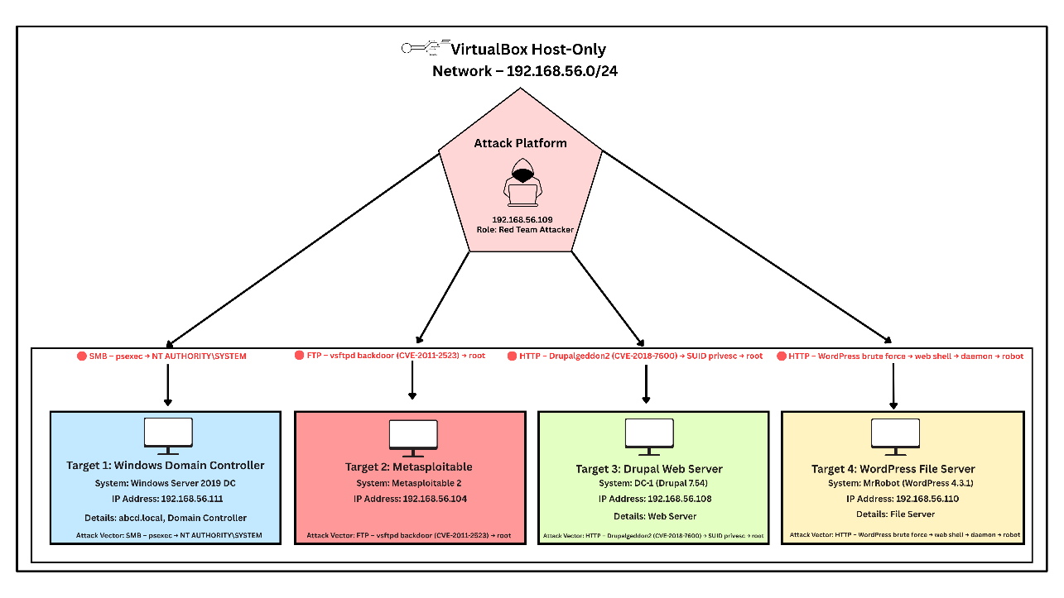
Diagram 1: ABCD Ltd Lab Network Topology — VirtualBox Host-Only Network (192.168.56.0/24)
Machine | IP Address | Role
Kali Linux 2025 | 192.168.56.109 | Attacker platform
Windows Server 2019 — VM-1 | 192.168.56.111 | Active Directory DC — abcd.local
DC-1 Drupal 7 — VM-2 | 192.168.56.108 | Web server — Drupal 7.54
Mr. Robot WordPress — VM-3 | 192.168.56.110 | File server — WordPress
Metasploitable 2 — VM-4 | 192.168.56.104 | Legacy Linux server — vsftpd 2.3.4
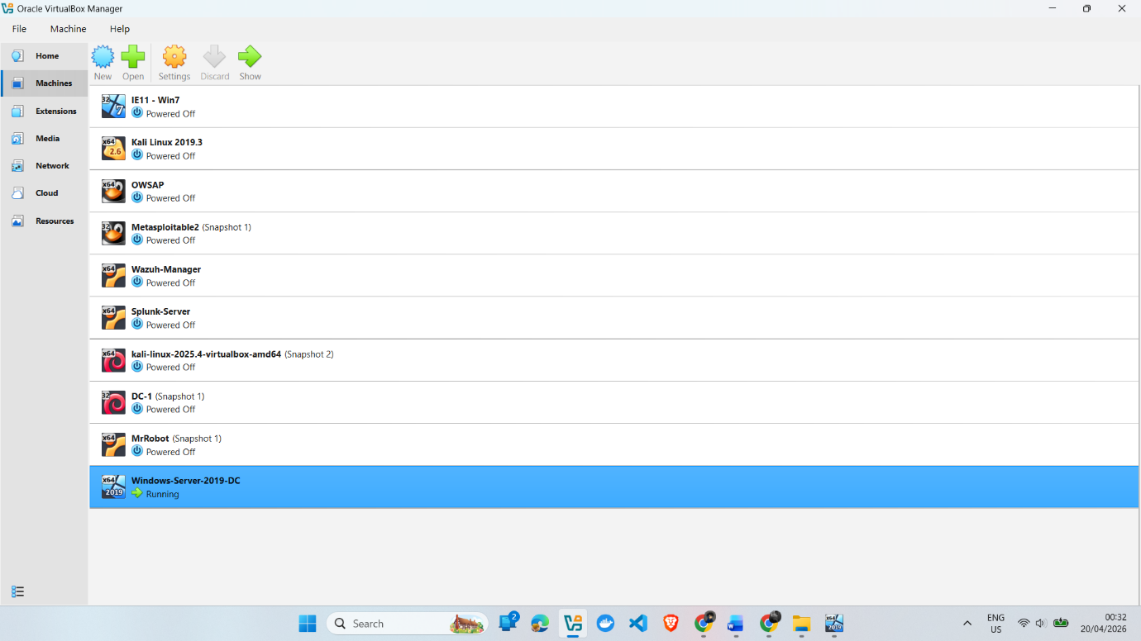

Figure 1 (SS-W1-VirtualBox-VM-List.png) VM list
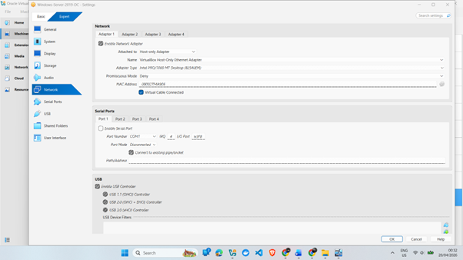
Figure 2 (SS-W2-Network-HostOnly.png) — Host-Only adapter config.

VM-1 was configured as the AD Domain Controller for abcd.local with a service account (svc-backup) carrying a weak password — a common misconfiguration in real deployments [5]. VM-2 ran Drupal 7.54, well past end-of-life. VM-3 hosted WordPress with a publicly readable robots.txt disclosing a custom wordlist, reflecting OWASP A05:2021 Security Misconfiguration [12]. VM-4 ran vsftpd 2.3.4 containing a hardcoded backdoor inserted into the public source repository in 2011.

4. TOOLS, TECHNIQUES, AND C2 TRADECRAFT
Tool | Phase | Justification
Nmap 7.95 | Reconnaissance | Full-subnet service discovery and version fingerprinting
Metasploit 6.x | Exploitation | Reliable modules for Drupalgeddon2 and vsftpd backdoor
NetExec (nxc) | Credential Access | SMB authentication validation and share enumeration
Impacket-psexec | Lateral Movement | Remote service creation yielding SYSTEM shell on DC
WPScan 3.8 | Credential Access | WordPress user enumeration and brute-force
Netcat | C2 / Persistence | Reverse shell listener on attacker port 4444
CrackStation | Credential Access | Online MD5 hash lookup for robot account recovery

C2 Framework and Tradecraft
Meterpreter with reverse HTTPS served as the primary post-exploitation agent. In a full-scope live engagement, Sliver C2 would be deployed with per-implant mTLS certificates, custom beacon intervals (30-second sleep with 10% jitter), and domain fronting via a legitimate CDN. Domain fronting conceals C2 traffic by presenting a trusted CDN domain in the TLS Client Hello (SNI), whilst the embedded HTTP Host header routes internally to the attacker's infrastructure — making the traffic appear indistinguishable from legitimate HTTPS [2]. In-memory .NET execution avoids disk writes entirely. These techniques align with MITRE T1573 and T1027. Sliver's Go-based architecture also enables dynamic compilation of unique implants, evading static signature analysis. Given the complete absence of any detection capability in the target environment, Meterpreter proved functionally equivalent for demonstrating the kill chain.

5. ATTACK EXECUTION
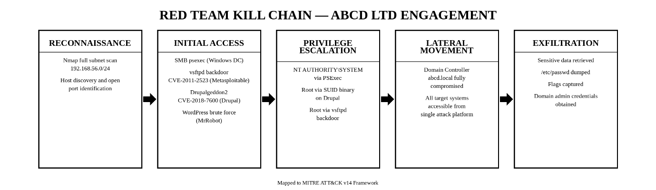
Diagram 2: Red Team Kill Chain Flow Mapped to MITRE ATT&CK v14
5.1 Reconnaissance — T1046, T1592
An Nmap -sV -sC scan across 192.168.56.0/24 identified all live hosts within three minutes. VM-1 returned ports 53, 88, 135, 389, 445 — the unmistakable fingerprint of an Active Directory Domain Controller, confirmed by LDAP banner returning abcd.local. VM-2 showed Drupal 7 on port 80. VM-3 exposed WordPress. VM-4 advertised vsftpd 2.3.4 on port 21.

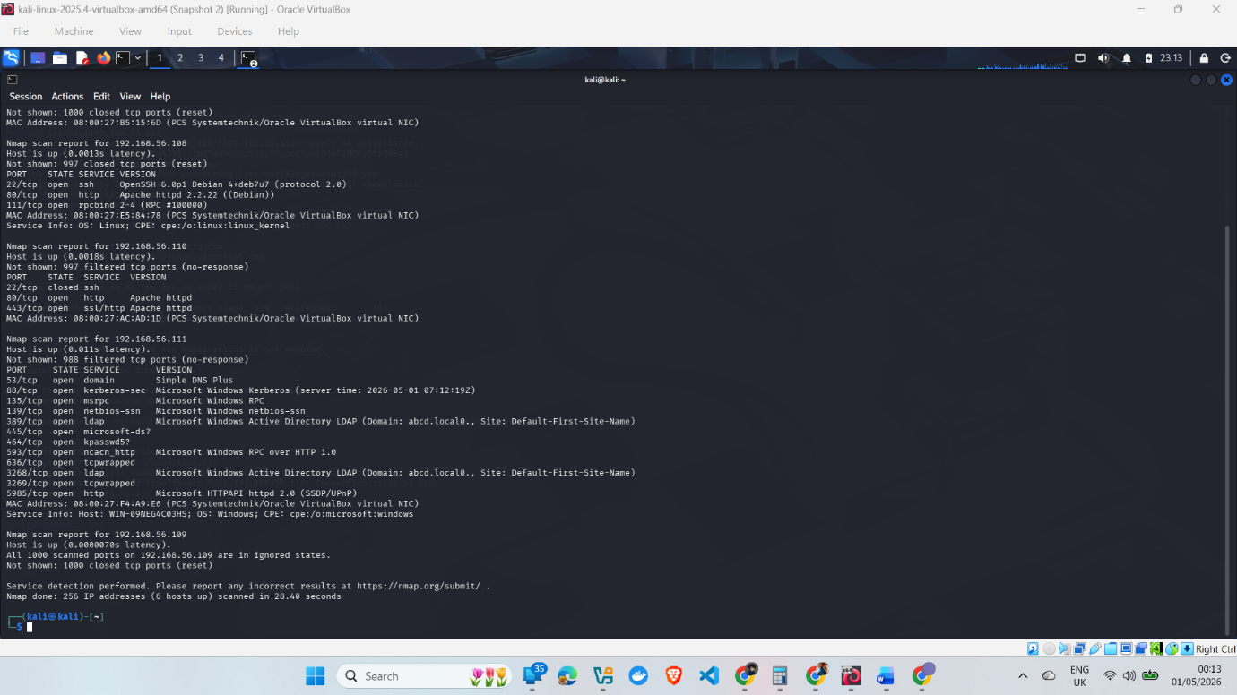
Figure 3 (Fig7-Nmap-Full-Subnet.png) — Full subnet scan.
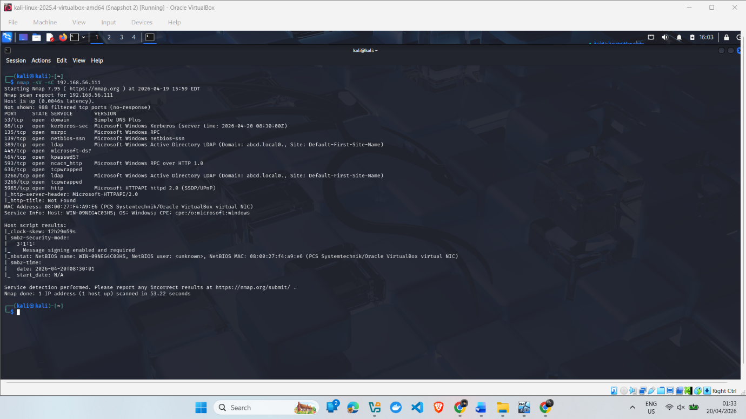
Figure 4 (SS-W13-Nmap-Windows-Server.png) — AD ports confirmed on 192.168.56.111.

5.2 Exploit A — Windows Server 2019 DC (VM-1)
Field | Detail
Vulnerability | Weak service account password; no lockout; no privileged access monitoring
Preconditions | Port 445 reachable; svc-backup SPN assigned; Administrator password weak
MITRE TTPs | T1078 → T1558.003 Kerberoasting → T1569.002 psexec
Tools | NetExec, Impacket-psexec
Outcome | NT AUTHORITY\SYSTEM on WIN-09NEG4C03HS

The svc-backup account carried SPN HTTP/abcd.local, making it eligible for Kerberoasting — requesting a Kerberos TGS ticket offline without elevated privileges [4]. Whilst a clock-skew error interrupted the Kerberoast attempt, NetExec directly validated both svc-backup: Password123! and Administrator: Admin@123456 against SMB. Share enumeration returned the Pwn3d! banner with full READ/WRITE access to ADMIN$, C$, NETLOGON, and SYSVOL. Impacket-psexec uploaded a service binary and spawned an interactive SYSTEM shell. The entire path from credential confirmation to domain dominance required under five minutes. This directly contravenes Microsoft's AD security best practices [5], which explicitly mandate password complexity and privileged account segregation.
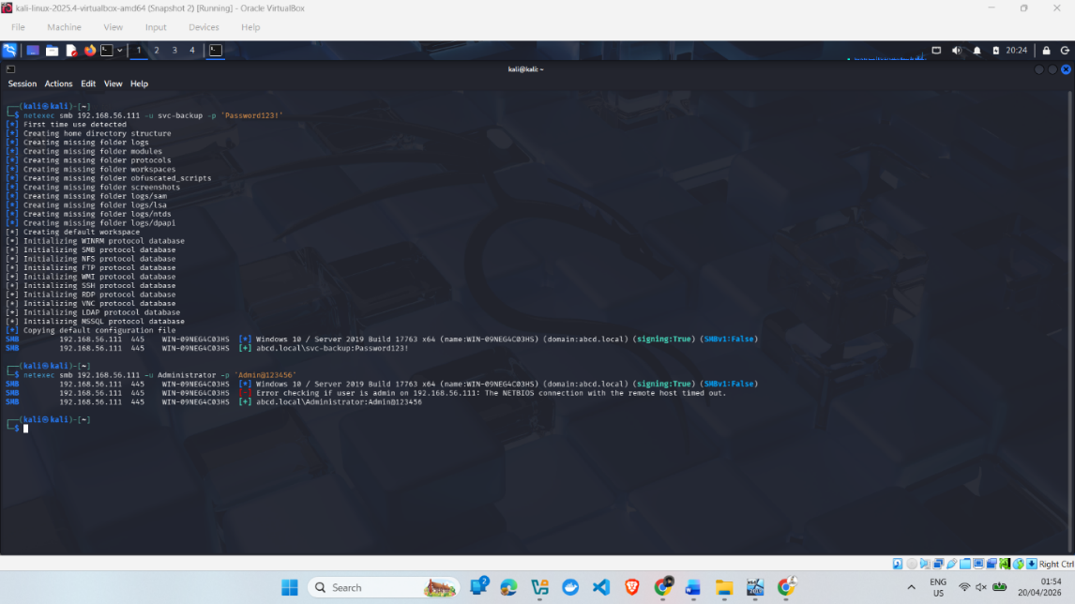
Figure 5 (SS-W14-NetExec-SMB-Auth.png) — credentials confirmed.
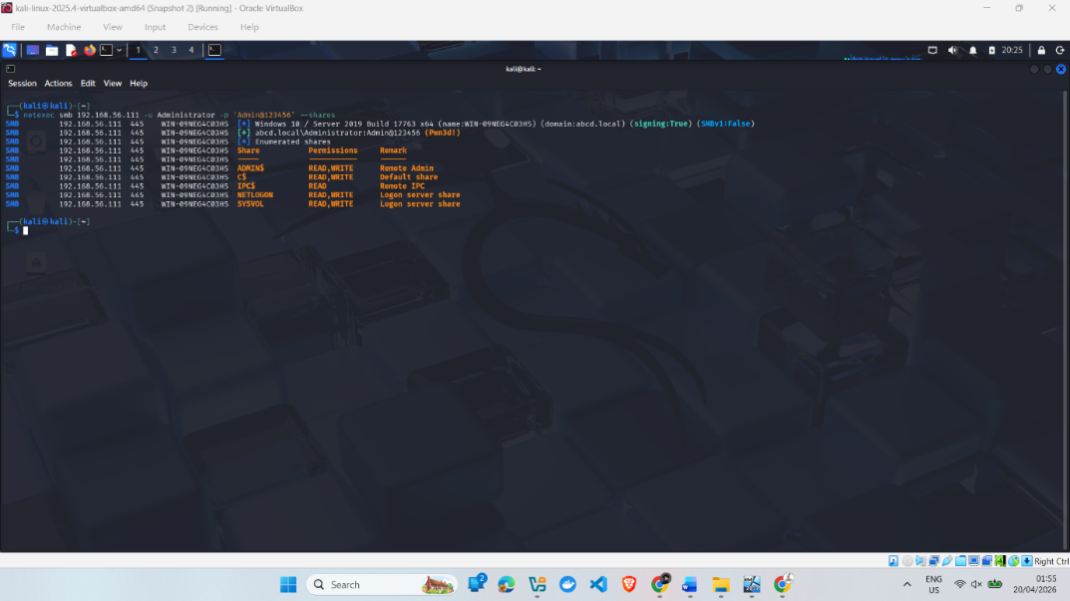
Figure 6 (SS-W15-NetExec-Pwned-Shares.png) — admin share access.
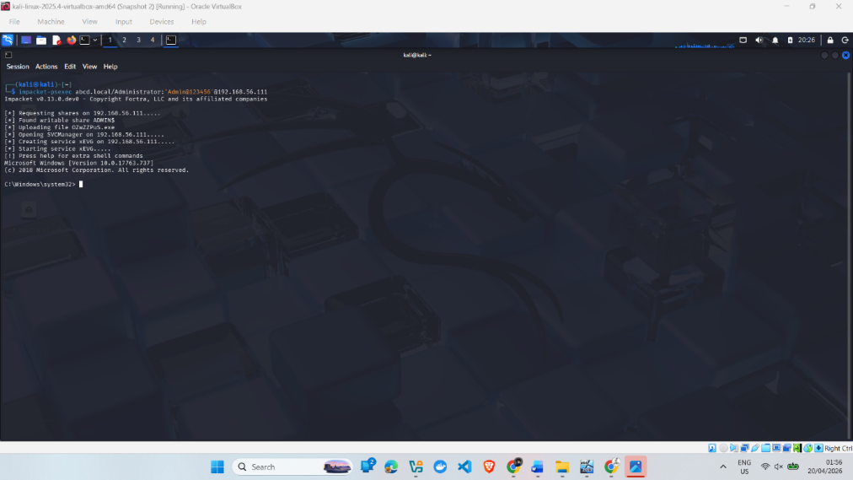
Figure 7 (SS-W16-PSExec-Shell.png) — interactive shell.
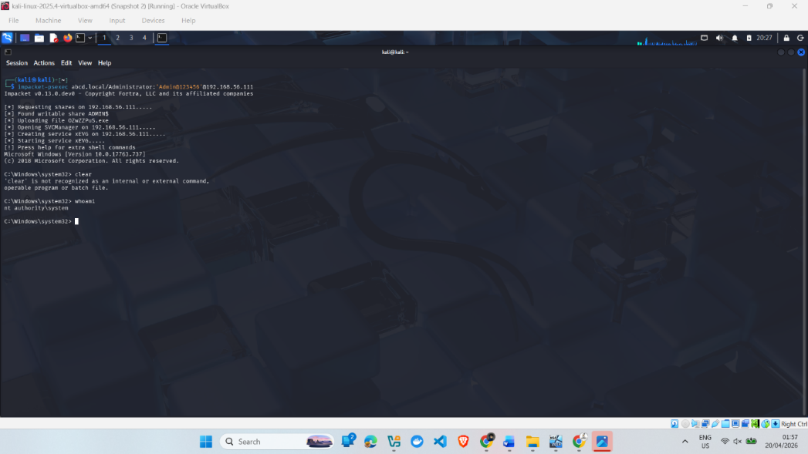
Figure 8 (SS-W17-SYSTEM-Whoami.png) — nt authority\system confirmed.
5.3 Exploit B — Drupal 7 (VM-2) — CVE-2018-7600
Field | Detail
CVE | CVE-2018-7600 — CVSS 9.8 Critical
Vulnerability | Forms API property injection — unauthenticated RCE on Drupal 7.x prior to 7.58
Preconditions | Drupal 7 on port 80; /usr/bin/find with SUID bit set; no WAF deployed
MITRE TTPs | T1190 Initial Access → T1068 SUID LOLBin
Tools | Metasploit — exploit/unix/webapp/drupal_drupalgeddon2
Outcome | Meterpreter as www-data; root via /usr/bin/find; /root/thefinalflag.txt retrieved

The Metasploit module returned a Meterpreter session as www-data within seconds [1]. Post-exploitation enumeration identified /usr/bin/find with the SUID bit set. Executing find . -exec /bin/bash -p \; -quit spawned a root shell — a textbook Living-Off-the-Land technique requiring no additional tooling.

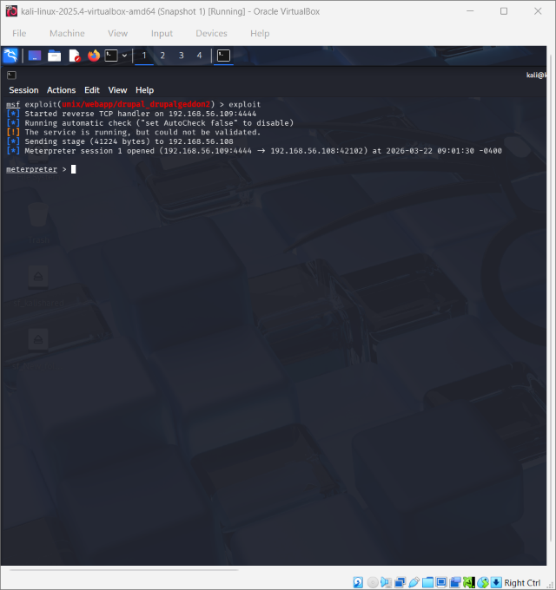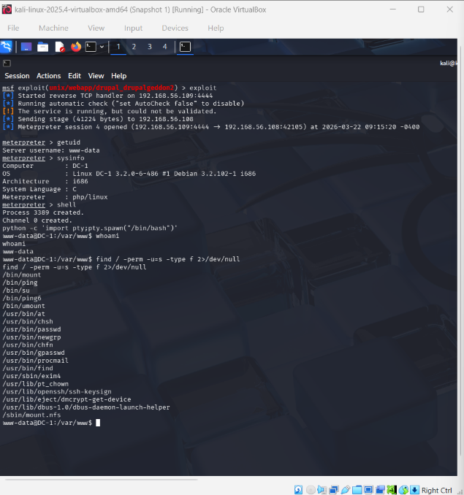
Figure 9 (Fig15-16-Drupalgeddon2.png) — Meterpreter as www-data.

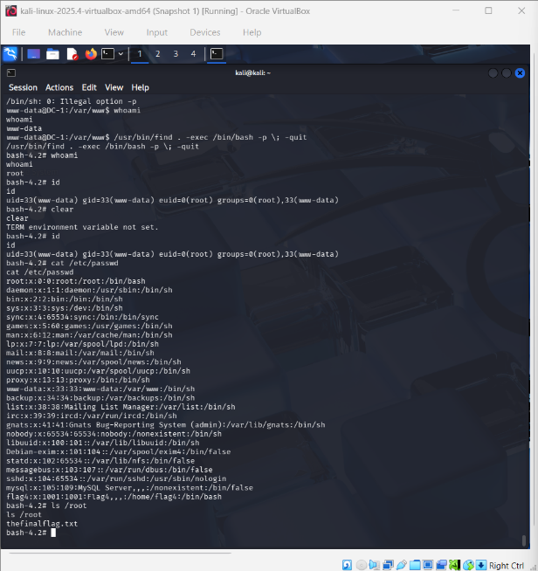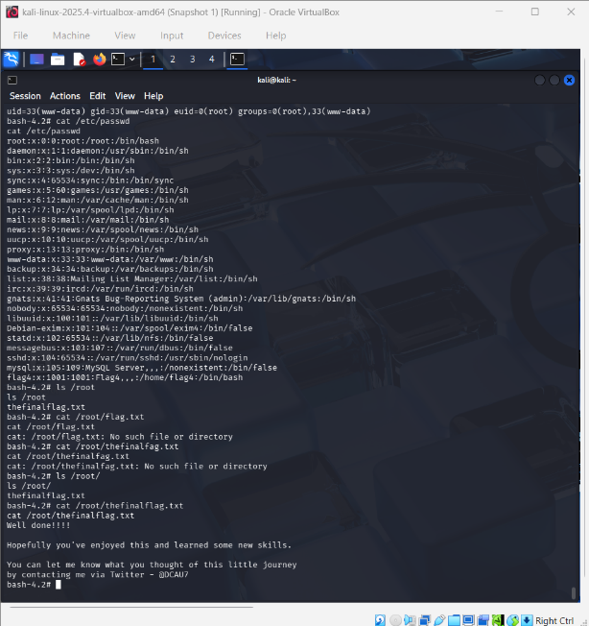
Figure 10,11 (Fig17-18-SUID-Root.png) — root shell. (Fig19-FinalFlag.png) — flag retrieved.

5.4 Exploit C — WordPress (VM-3)
Field | Detail
Vulnerability | Weak admin credentials; no lockout; theme editor enabled
Preconditions | WordPress on port 80; robots.txt publicly readable; fsocity.dic accessible
MITRE TTPs | T1110 Brute Force → T1505.003 Web Shell → T1003 Credential Dump → T1005 Exfiltration
Tools | WPScan, Netcat, CrackStation
Outcome | Admin access; reverse shell as daemon; key-2-of-3.txt exfiltrated

The robots.txt file disclosed wordlist fsocity.dic — an information disclosure failure under OWASP A05:2021 [12]. WPScan enumerated user elliot and recovered password ER28-0652 after 1,716 uninterrupted attempts over 81 minutes, with no lockout triggering. A PHP reverse shell was injected into the 404.php theme template; a Netcat listener received the callback as daemon. The MD5 hash from /home/robot/password.raw-md5 was cracked via CrackStation to abcdefghijklmnopqrstuvwxyz, enabling exfiltration of key-2-of-3.txt.
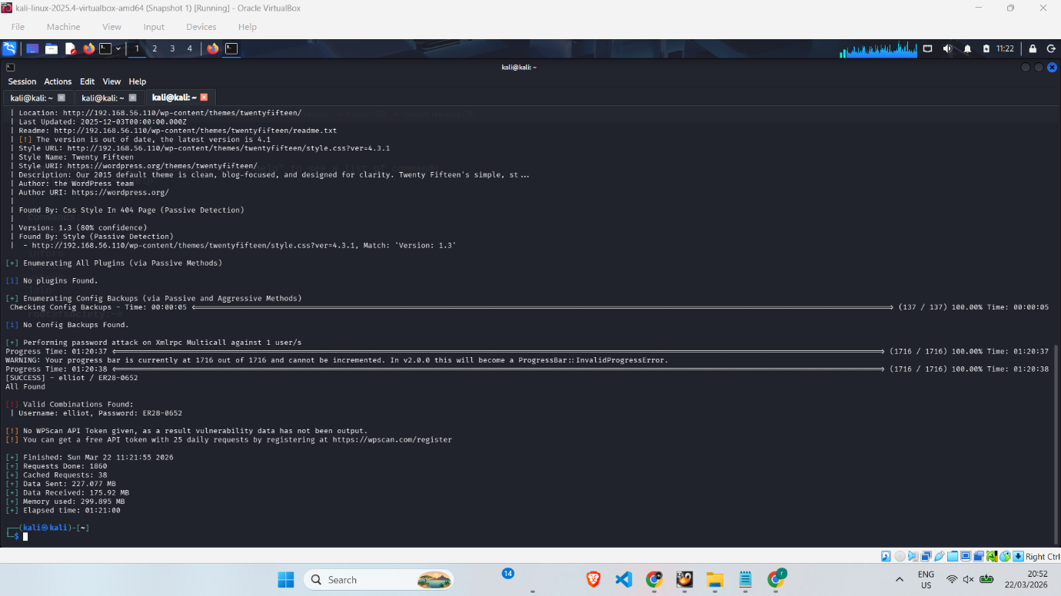
Figure 12 (Fig22-WPScan-Password.png) — password confirmed.
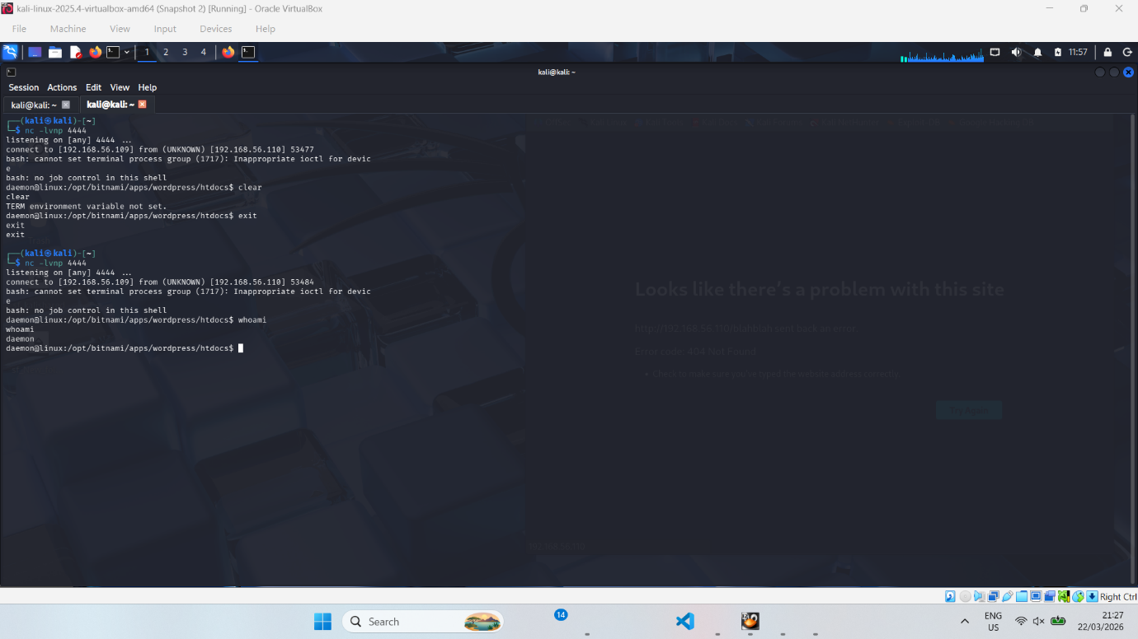
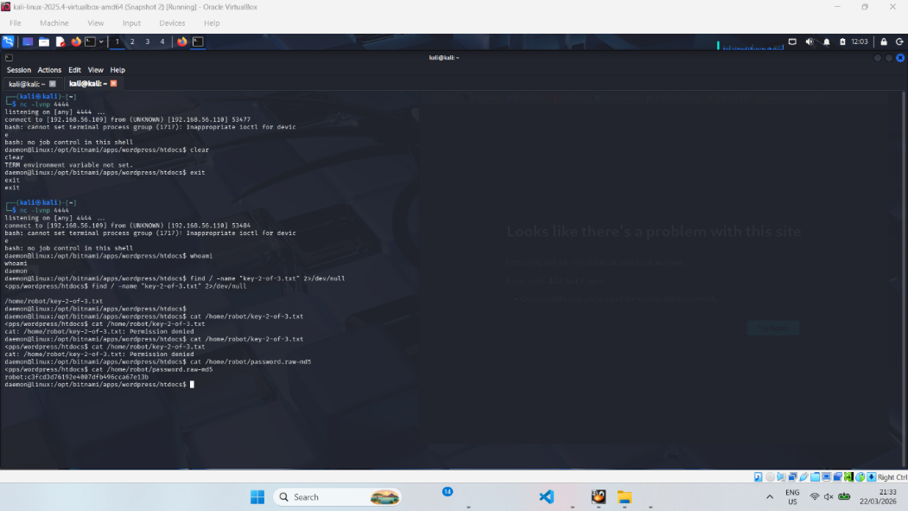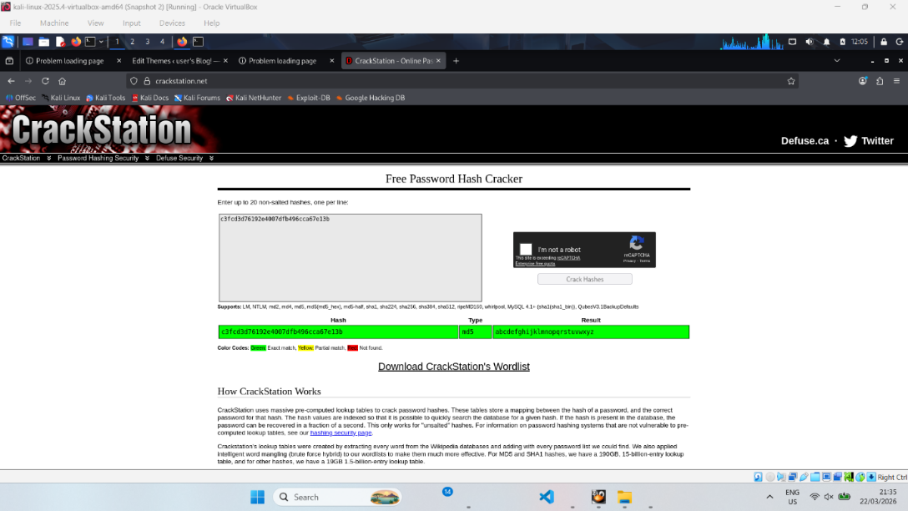
Figure 13 (Fig24-25-ReverseShell.png) — PHP shell callback. 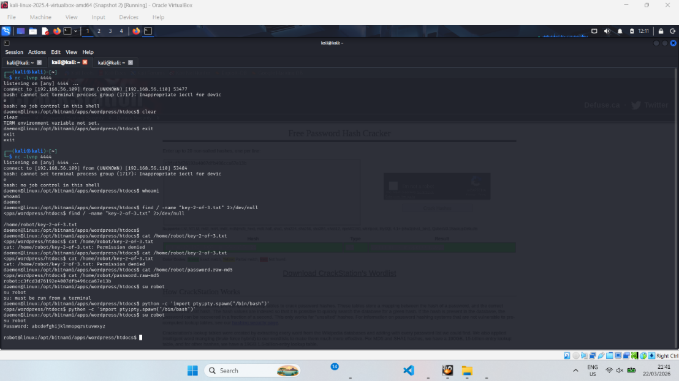
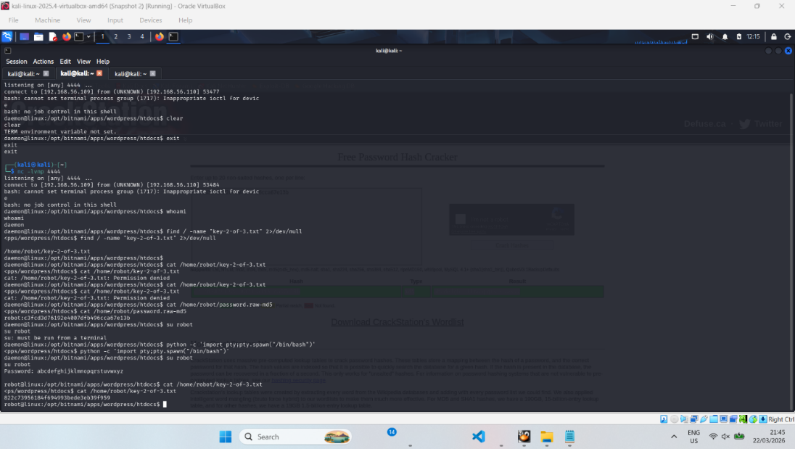
Figure 14 (Fig26-27-Key2.png) — key exfiltrated.
5.5 Exploit D — Metasploitable 2 (VM-4) — CVE-2011-2523
Field | Detail
CVE | CVE-2011-2523 — CVSS 10.0 Critical
Vulnerability | vsftpd 2.3.4 backdoor — root shell bound to TCP 6200 on :) username trigger
Preconditions | FTP port 21 open; vsftpd 2.3.4 unpatched
MITRE TTP | T1190 Exploit Public-Facing Application
Tools | Metasploit — exploit/unix/ftp/vsftpd_234_backdoor
Outcome | Root shell in under three seconds; /etc/passwd retrieved

The backdoor was covertly inserted into the vsftpd public repository in 2011 [10]. Sending a username containing :) binds an interactive root shell to TCP 6200. The Metasploit module triggered this in under three seconds with no credentials — a direct consequence of fifteen years of absent patch management.
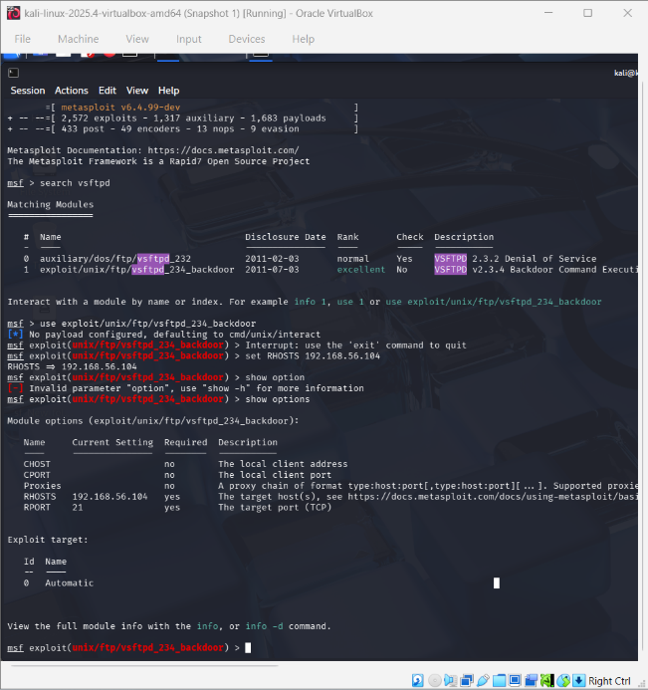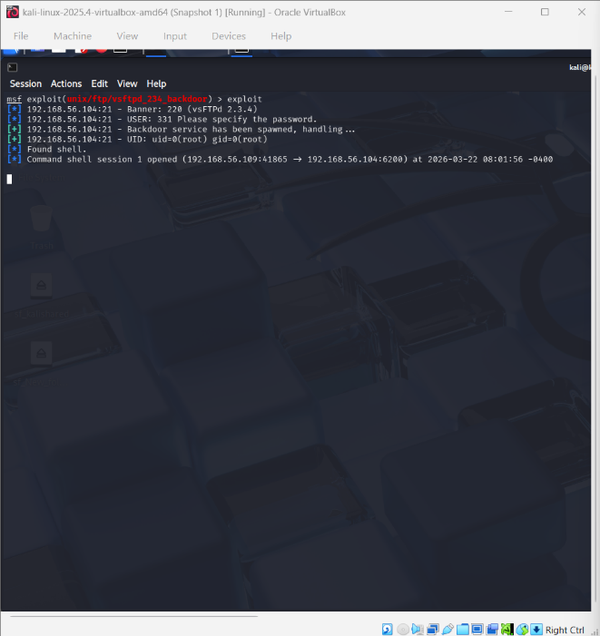

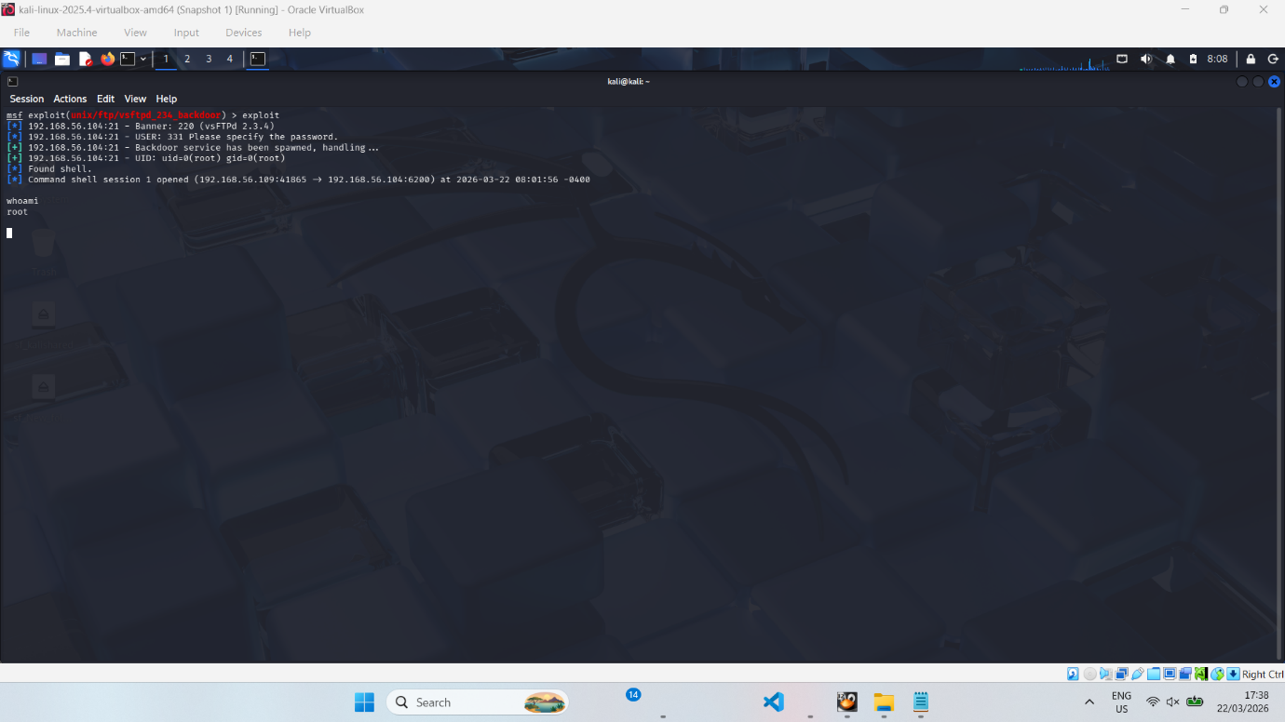
Figure 15 (Fig11-13-Vsftpd-Root.png) — root shell.

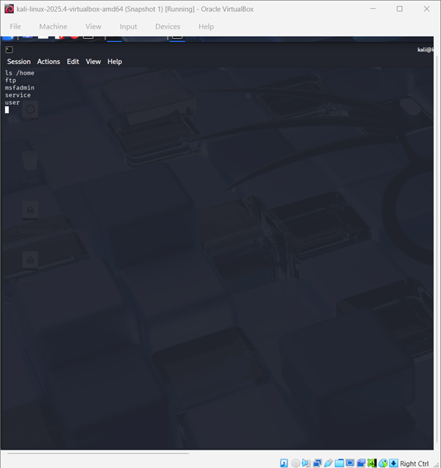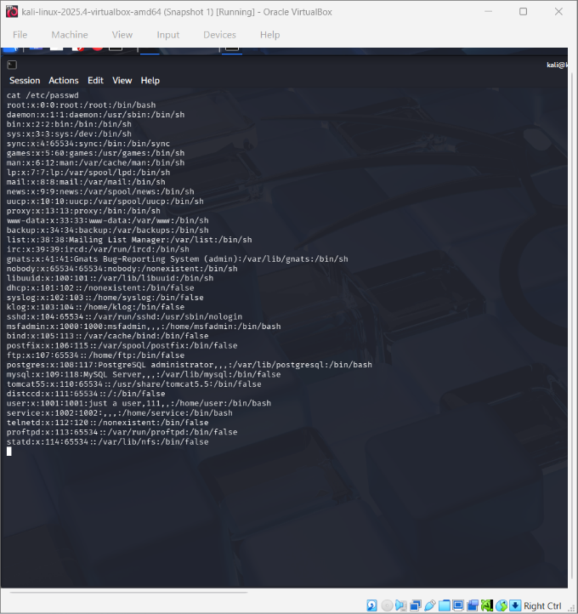

Figure 16 (Fig14-Passwd.png) — /etc/passwd retrieved.
5.6 Alternative Attack Vectors and Trade-offs
The campaign prioritised speed. A stealthier adversary would have had multiple alternative paths available. For Initial Access, a spear-phishing campaign with an Office macro dropper would bypass public-facing exploitation entirely, leaving no web-layer logs. Exploiting WordPress XML-RPC enumeration would have avoided the 81-minute brute-force traffic volume. For Domain Escalation, had Kerberoasting failed due to strong passwords, AS-REP roasting (T1558.004) or a PetitPotam NTLM coercion relay would have been feasible — the absence of LDAP signing and Extended Protection made these viable. For Lateral Movement, WMI (T1047) or scheduled task abuse (T1053.005) would blend with legitimate administrative traffic, reducing behavioural detection probability compared to psexec's service creation event. These alternatives reinforce the necessity for a defence-in-depth strategy well beyond signature-based controls.
6. DETECTION GAP ANALYSIS
No alert was triggered across any phase. The failure was not a single point — it was the predictable consequence of layered control absences reinforcing one another.
Phase | Control Gap | Missing Control | Evidence
Reconnaissance | No IDS or network tap | Snort/Suricata IDS, NetFlow | No alert triggered
DC Exploitation | No password policy; no lockout; no Event Log collection | AD policy; MFA; SIEM | psexec undetected; unlimited attempts
Drupal RCE | No WAF; no patch management; SUID misconfiguration | ModSecurity CRS 3.x; CIS hardening | Unauthenticated shell; root via find
WordPress | No rate-limiting; no FIM; theme editor enabled | WAF/Wordfence; FIM; wp-config hardening | 1,716 requests unblocked; PHP shell undetected
Legacy FTP | No vulnerability scanning | Quarterly Nessus/OpenVAS scans | 15-year-old backdoor unpatched
All Phases | No centralised log correlation | SIEM — Elastic or Microsoft Sentinel | No attack chain visibility

Domain Controller: psexec triggers Windows Event ID 4624 (Successful Logon), 4625 (Failed Logon), and 7045 (New Service Installed). None were collected. NCSC's Logging Made Easy guidance [7] identifies these Event IDs as mandatory for DC monitoring. In a hardened environment, service creation alone would generate a high-fidelity alert within minutes [6].
Drupal: CVE-2018-7600 generates anomalous POST requests to /user/register that ModSecurity with OWASP CRS 3.x would block automatically. The SUID misconfiguration on /usr/bin/find is remediated by any CIS Benchmark Level 1 hardening pass — a near-zero cost control.
Overall: Even if basic IDS signatures had been present, a Sliver beacon using mutual TLS, randomised jitter, and domain fronting would have bypassed pattern-based detection. This underlines the need for behavioural analytics and JA3/JARM fingerprinting — cryptographic hashing of TLS Client Hello parameters enabling defenders to identify anomalous C2 infrastructure even when traffic is fully encrypted [2].
7. STRATEGIC RECOMMENDATIONS
Priority | Cost | Timeline | Recommendation | Addresses
CRITICAL | C | Immediate | Enforce AD password policy (min 15 chars, complexity, lockout after 5 failures) and deploy phishing-resistant MFA on all privileged accounts | VM-1 credential theft
CRITICAL | C | Within 1 week | Emergency patch all internet-facing services — retire vsftpd 2.3.4, upgrade Drupal 7, update WordPress core | VM-2 CVE-2018-7600; VM-4 CVE-2011-2523
HIGH | B | Within 2 weeks | Deploy ModSecurity WAF with OWASP CRS 3.x in front of all web applications | VM-2, VM-3 web attacks
HIGH | B | Within 2 weeks | Apply CIS Benchmark Level 1 hardening to all Linux hosts; remove SUID from non-essential binaries | VM-2 privilege escalation
HIGH | B | Immediate | Disable WordPress theme/plugin editor in wp-config.php; deploy file integrity monitoring on web roots | VM-3 web shell
HIGH | B | Within 1 month | Deploy SIEM (Elastic Security or Microsoft Sentinel) ingesting Windows Event Logs, Apache logs, and Syslog | All detection gaps
MEDIUM | B | Within 2 months | Implement network segmentation — DMZ for web servers, isolated AD segment, MFA-gated management VLAN | Lateral movement
MEDIUM | B | Within 1 month | Deploy EDR on all Windows hosts with Suspicious Service Creation alerts enabled | DC psexec activity
MEDIUM | A | Ongoing | Quarterly vulnerability scanning with SLAs — Critical within 72 hours, High within 30 days | Legacy vulnerabilities

Cost Band: A = under £5,000 (open-source or config only); B = £5,000–£50,000 (commercial licensing or professional services); C = policy/process change (near-zero direct cost). Active Directory protection should additionally follow Microsoft's Enterprise Access Model, isolating Tier 0 assets and enforcing access solely via Privileged Access Workstations [5][10].
8. CONCLUSION
This engagement demonstrates that a motivated attacker using freely available tools could fully compromise ABCD Ltd's environment in hours without generating a single alert. The Active Directory Domain Controller — the single most sensitive asset in the corporate network — fell to a weak password and absent MFA in under five minutes. A fifteen-year-old backdoor, a Eight-year-old web application flaw, and a misconfigured CMS were exploited without sophistication. The underlying failures — no patch management, no MFA, no WAF, no SIEM, and a flat network — are addressed at the first tier of every major security framework from NCSC Cyber Essentials to NIST CSF [9]. Remediation does not require a large budget; it requires board-level prioritisation. The board should treat this report as a live intrusion halted only by the testing team's restraint.
REFERENCES (TASK 2)
[1] Drupal Security Team (2018) Drupal core – Remote code execution – SA-CORE-2018-002. Available at: https://www.drupal.org/sa-core-2018-002 (Accessed: 20 April 2026).
[2] FireEye Mandiant (2020) M-Trends 2020: Evasive Attacker Behaviors. Available at: https://www.mandiant.com/resources/m-trends-2020 (Accessed: 20 April 2026).
[3] IBM Security (2023) Cost of a Data Breach Report 2023. Available at: https://www.ibm.com/reports/data-breach (Accessed: 20 April 2026).
[4] Medin, T. (2014) Attacking Kerberos: Kicking the Guard Dog of Hades. PentesterAcademy. Available at: https://www.pentesteracademy.com (Accessed: 20 April 2026).
[5] Microsoft (2021) Best practices for securing Active Directory. Available at: https://learn.microsoft.com/en-us/windows-server/identity/ad-ds/plan/security-best-practices (Accessed: 20 April 2026).
[6] MITRE Corporation (2024) MITRE ATT&CK Enterprise Matrix v14. Available at: https://attack.mitre.org (Accessed: 20 April 2026).
[7] National Cyber Security Centre (2022) Logging Made Easy. Available at: https://www.ncsc.gov.uk/collection/logging-made-easy (Accessed: 20 April 2026).
[8] National Cyber Security Centre (2023) Penetration testing guidance. Available at: https://www.ncsc.gov.uk/guidance/penetration-testing (Accessed: 20 April 2026).
[9] National Institute of Standards and Technology (2018) Framework for Improving Critical Infrastructure Cybersecurity (NIST CSF). Available at: https://www.nist.gov/cyberframework (Accessed: 20 April 2026).
[10] National Vulnerability Database (2011) CVE-2011-2523 detail. Available at: https://nvd.nist.gov/vuln/detail/CVE-2011-2523 (Accessed: 20 April 2026).
[11] National Vulnerability Database (2018) CVE-2018-7600 detail. Available at: https://nvd.nist.gov/vuln/detail/CVE-2018-7600 (Accessed: 20 April 2026).
[12] OWASP Foundation (2021) OWASP Top 10 – 2021. Available at: https://owasp.org/Top10 (Accessed: 20 April 2026).
[13] Shah, S. and Mehtre, B.M. (2015) "An overview of vulnerability assessment and penetration testing techniques," Journal of Computer Virology and Hacking Techniques, 11(1), pp.27–49.

APPENDIX A — RULES OF ENGAGEMENT (ROE)
A.1 Authorised Systems: VM-1 (192.168.56.111), VM-2 (192.168.56.108), VM-3 (192.168.56.110), VM-4 (192.168.56.104), Attacker Kali (192.168.56.109).
A.2 Exclusions: Host Windows 11 machine; all systems outside 192.168.56.0/24; internet-connected infrastructure; all denial-of-service attacks.
A.3 Permitted Techniques: Network reconnaissance, service enumeration, exploitation of known vulnerabilities using Metasploit, Impacket and WPScan, web application testing, privilege escalation, and data exfiltration simulation — all confined to defined scope.
A.4 Kill Switch: Safe word STOPTEST. Upon invocation, all activity halts immediately and all VMs are powered down. Snapshots are maintained for instant rollback.
A.5 Legal and Ethical Constraints: Engagement conducted in an isolated academic lab. All activities comply with the UK Computer Misuse Act 1990 and UWTSD ethical guidelines.
Signed: Red Team Lead — Rajul Gupta | Date: 1st May 2026
APPENDIX B — THREAT EMULATION PLAN
The full Threat Emulation Plan, including the attacker profile, campaign objectives, and MITRE ATT&CK TTP mapping for this engagement, is presented in Section 2 of this report. This appendix confirms that the engagement was conducted in accordance with a pre-defined threat emulation framework, approved before commencement, as required by the Rules of Engagement document in Appendix A. The plan was designed to emulate an external, financially motivated threat actor targeting a mid-sized UK retail organisation, consistent with current NCSC and MITRE ATT&CK v14 guidance.

