James Turner - 2304088
Network Operating Systems and Services (ACCA5023)

Contents
RRAS and ICMP Traffic 1
Mounted Disk to E:\SwanseaFiles 1
Wireguard VPN 2
DNS/Domain Services 3
Pings So Far 4
ClientC1 4
C-server 5
S-DC 6
ClientS1 7
DHCP Windows 7

Introduction

The following screenshots show the process taken from a bare-bones connection between two different networks, into an integrated connected network, connecting together each device with each other

RRAS and ICMP Traffic
The first thing I did was install the Routing and Remote Access service, and configure my firewall to be enabled and allow ICMP traffic through. Allowing ICMP traffic allowed me to be able to “ping” devices and ensure that a connection was established. Without allowing the traffic, the requests would be blocked and would be very difficult to test the connection.

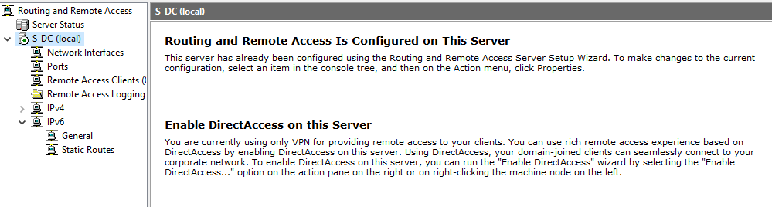
Figure 1: Routing and Remote Access configured on S-DC
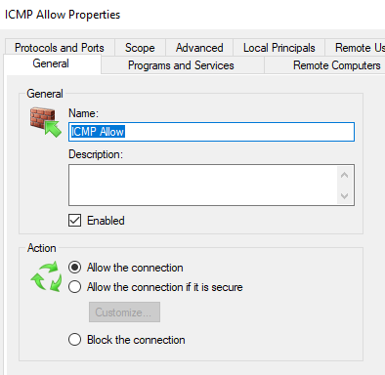
Figure 2: ICMP connection allowed, both S-DC and ClientS1
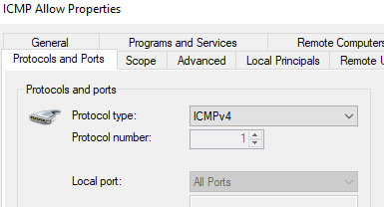
Figure 3: ICMP IPv4 Connection allowed

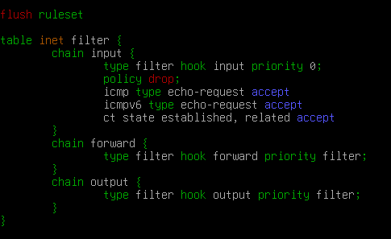
Figure 4: C-server and ClientS1 ICMPv4 allowed
Figure 5: C-server packet forwarding enabled

Mounted Disk to E:\SwanseaFiles
After configuring the firewall and RRAS, another simple task was to mount a disk to the Swansea network, and the following screenshot shows a successful mounting of the drive

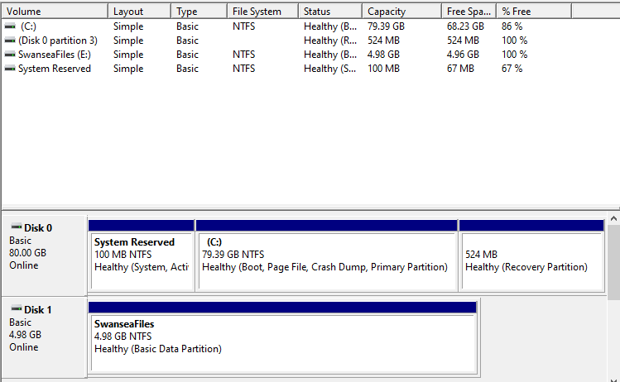
Figure 6: New disk recognised by S-DC
You may notice that the new disk has been named “E” rather than “D”. This is because the “D” drive is taken by the installation media for windows, and so if there are any problems, the installation media can be used to re-install windows if necessary. The fact it is an “E” rather than a “D” has no effect on the configuration

Wireguard VPN
For the VPN site-to-site connection, I used a common tool called Wireguard, as it was not only recommended by my lecturer but was also recommended by several other sources. This tunnel allowed me to connect the two networks via a tunnel, allowing for connections to occur between both client devices
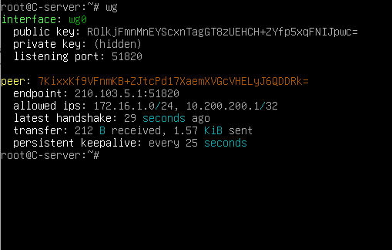
Figure 7: C-server wireguard set-up
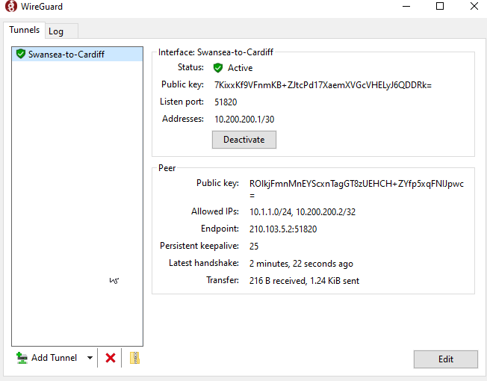
Figure 8: S-DC wireguard setup

DNS/Domain Services
After the VPN was set up, I could start to configure the DNS as well as the Domain Services for both the Windows and Linux devices. The linux devices required a tool called “realm” which allowed me to connect to the domain, whereas the windows client just required a simple change of the workgroup to domain.
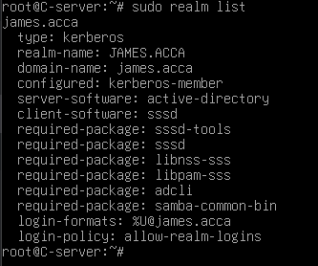
Figure 9: C-server joined james.acca domain
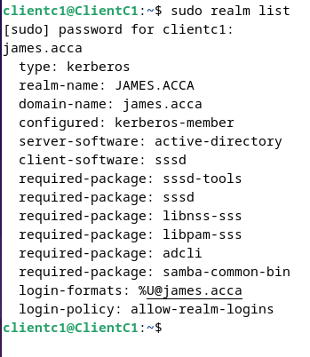
Figure 10: ClientC1 joined james.acca
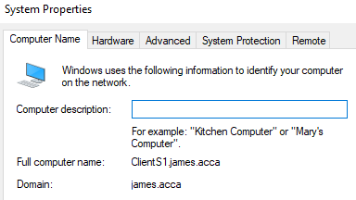
Figure 11: ClientS1 has joined james.acca domain
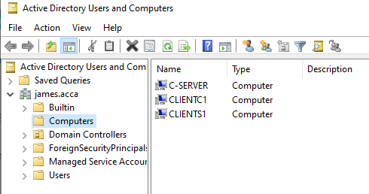
Figure 12: Confirmation from S-DC that all the computers have joined the domain

Pings So Far
After these steps had been completed, I decided to test the connections between each device. This was mostly a success, however, there were a few hurdles along the way and there are still some connections that are not fully implemented.

ClientC1
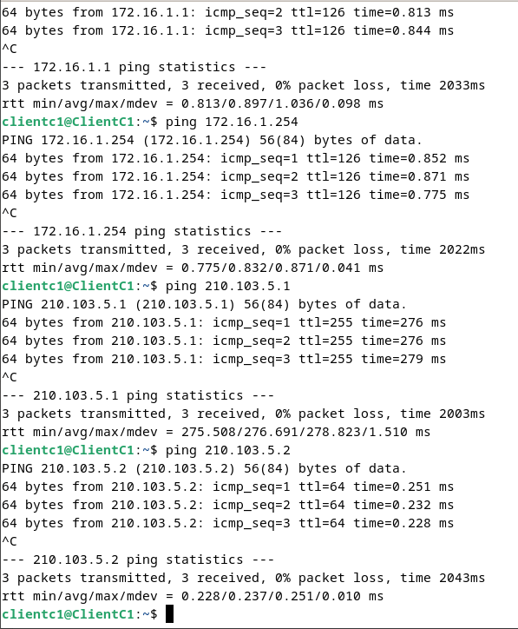
Figure 13: Current C1 pings, can ping each interface

C-server
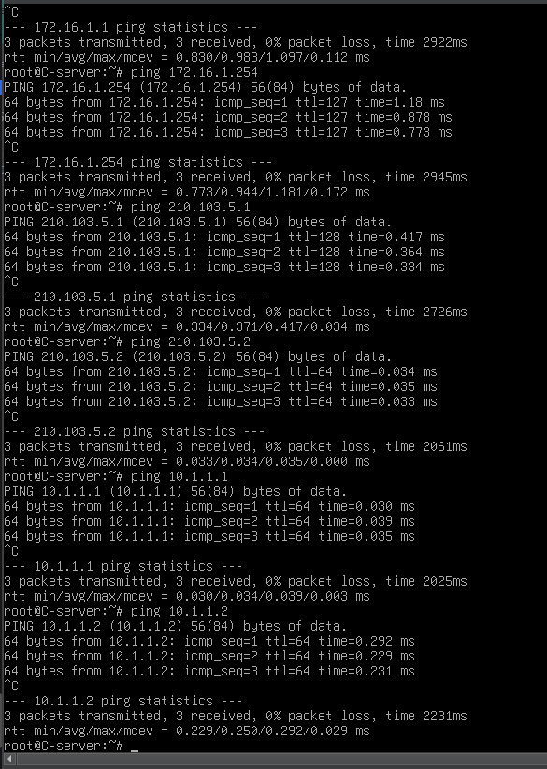
Figure 14: C-server, all pings go through

S-DC
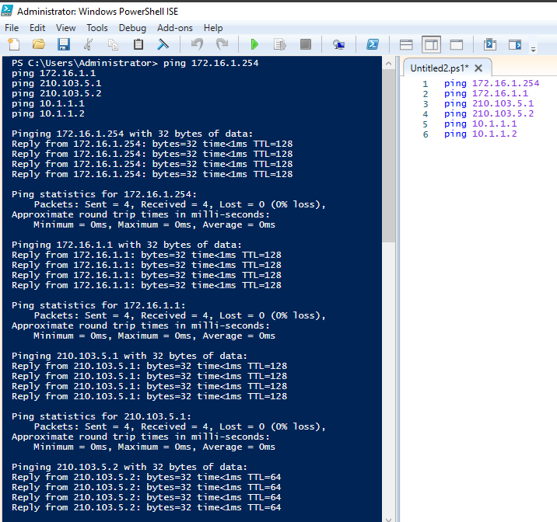
Figure 15: Ping from S-DC, all pings go through
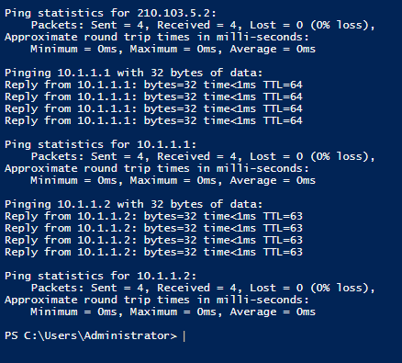
Figure 16: Continued Pings

ClientS1
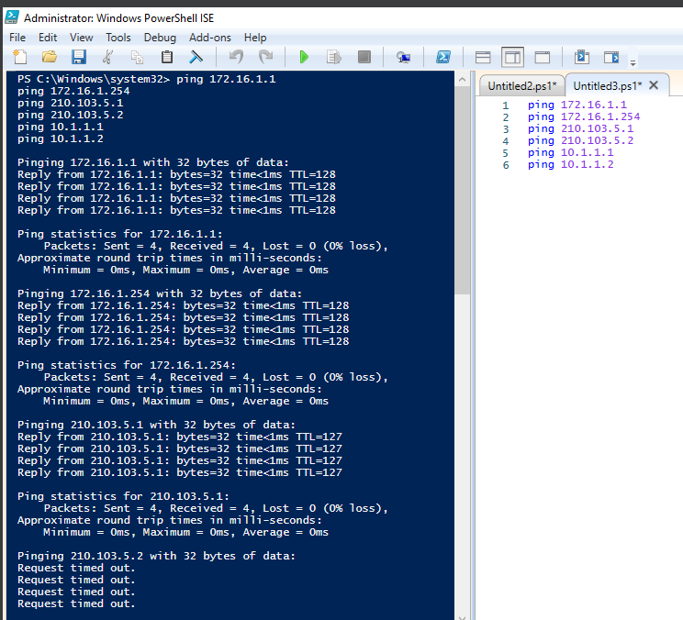
Figure 17: ClientS1 Pings except 210.103.5.2
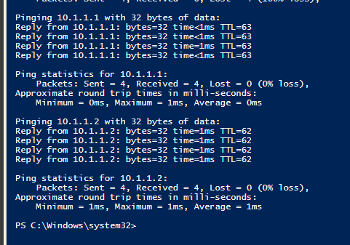
Figure 18:ClientS1 pings cont

DHCP Windows
Finally, it was time to install the DHCP service on windows, and configure to the specification. The following screenshots show that the DHCP service has been correctly configured and implemented.
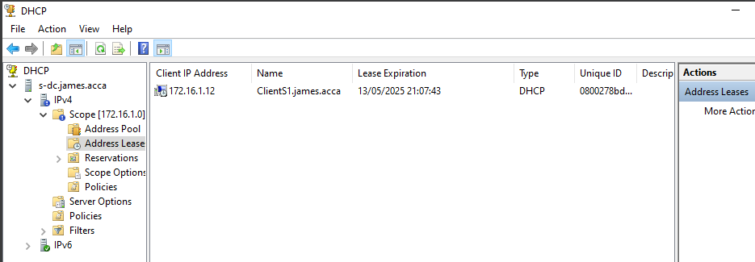
Figure 19: DHCP installed and configured on S-DC for windows devices
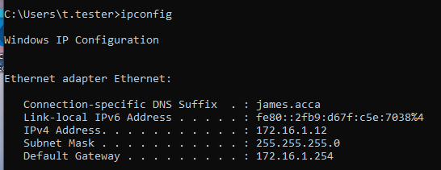
Figure 20: Example of automatic IP assignment and gateway from DHCP
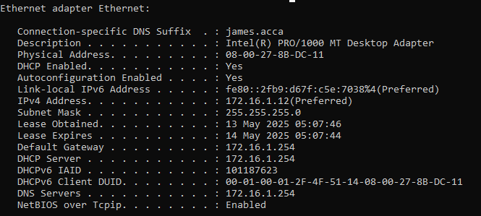
Figure 21: Extra information of DHCP in action

