
BA (Hons) Leadership and Management Skills for the Workplace
Module Name: Developing Emotional Intelligence Skills
Module Code: LCLM5006
Student ID: 2312849
Elena Buzatu
Lecturer Name: Nishi Ramsurrun

TITLE: EVALUATION OF THE APPLICATION OF EMOTIONAL INTELLIGENCE (EI) WITHIN THE WORKPLACE, FOCUSING ON VARIOUS EI MODELS AND GENERATIONAL GAP

Executive Summary
Emotional Intelligence (EI) is important for employees and in the present workplace culture as it helps in enhancing the productivity of employees and improving organisational culture. This present report focuses on ensuring EI in the workplace through employees as it helps in enhancing their performance. Later, this report also focuses on various theories and models of EI, which influence the employees of an organisation and their performance.
In addition to this, this report also focuses on the impact of the generational gap on influencing Emotional Intelligence. Further, the findings of this report stated that various components of the model explained are utilised by the employees to enhance their Emotional Intelligence. The generational gap between X, Y and Z also positively and negatively impacts an organisation.
The recommendations to the management team are to introduce emotional intelligence in employee training and development, within the company culture and promote EI-driven leadership.

Table of Contents
Introduction 4
Evaluation of employees using Emotional Intelligence (EI) and its components in the workplace through various models of Emotional Intelligence 4
Daniel Goleman’s Emotional Intelligence Model 4
Salovey and Mayer’s Ability Model of Emotional Intelligence 6
Petrides’ Trait Emotional Intelligence Theory 7
Unique characteristics of emotional intelligence that a manager needs to consider while recruiting employees from various generations (X, Y and Z) 9
Recommendations 11
Recommendation 1: Introducing Emotional Intelligence training and development 11
Recommendation 2: Focus on emotionally intelligent leadership 11
Conclusion 12
Reference List 13

Introduction
In today’s workplace, it is important for every employee to incorporate Emotional Intelligence (EI). Price (2023) stated that Emotional Intelligence is important for employees to manage their emotions effectively and understand others, which effectively helps in enhancing communication and teamwork. Various researchers explained the importance of EI in their models and theories, which are explained in this report. Overall, this present report focuses on understanding the importance of EI in employment and management of an organisation. Later, this report also explains that the generational gap influences EI, which again needs to be considered by employers while recruiting employees from various generations. Lastly, a recommendation was provided to the management team to incorporate EI in their practice and workplace.

Evaluation of employees using Emotional Intelligence (EI) and its components in the workplace through various models of Emotional Intelligence
Emotional Intelligence (EI) is an important aspect of today's work culture and business environment. Using the important and major component of emotional intelligence helps employees enhance various critical skills, which eventually contribute to their success. This has become a vital skill to attain as it helps in easily understanding the thinking patterns, behaviours, as well as their performance. For employees, this skill is crucial for developing strong relationships, managing stress and handling situations properly. Regarding EI, many researchers and theorists have provided various models and theories, which effectively explain the components and nature of EI. Among them, three models/ theories that have gained popularity are Daniel Goleman’s mixed model, Salovey and Mayer’s ability model, and Petrides’ trait emotional intelligence theory. These models elaborate on EI from unique and different perspectives, and also explain how these can be utilised within the workplace. In this section of the report, using the mentioned theories and models, it is assessed how employees use EI within their workplace.

Daniel Goleman’s Emotional Intelligence Model
In 1998, Daniel Goleman explained the idea of Emotional intelligence, where he talked about five key concepts. According to Safarli (2021), the five key components of Daniel Goleman’s theory focus on managing both own and others’ emotions, while recognising and influencing the emotions of other people. Self-awareness is the first component of the theory, which is the ability to have an understanding of own emotions, strengths and weaknesses, while self-regulation focuses on effectively managing emotions. Staying focused and ability to achieve goal is regarded to be the next component in this context. Empathy and social skills are also discussed as the last aspect in this case and they adequately deal with handling of relationships and the feelings of others. These elements of the Goleman model are also applied by the employees in the organisation. It has also been noted that the concept of self-awareness is used by personnels in their organisation as a way of improving their communication patterns and also in controlling their emotions in a way that is effective (Cole 2025). The model is making the individuals assess their strengths and weaknesses in the workplace appropriately. This is later to aid in the development of good relationships at the workplace. In addition, Goleman also elaborates that motivation is a key emotional competence among employees since it enhances performance among employees. With this in mind, a research project by Celestin et al. (2024) pointed out that when the personnels in an organisation are motivated then they are able to instil a high rate of productivity and in addition, it will result in increased retention and lastly, positive work culture. The empathetic setting is also an advantageous ability that employees should achieve, since it promotes collaboration and management. In addition to this, empathy is also important for developing trust, cooperation and morale. Lastly, social skills are important in the workplace as they help in developing strong workplace relationships with others. A manager with effective social skills can easily motivate employees and lead a project efficiently. Overall, it can be said that Goleman’s model is widely used as it helps in developing a strong bond between EI, leadership and performance.
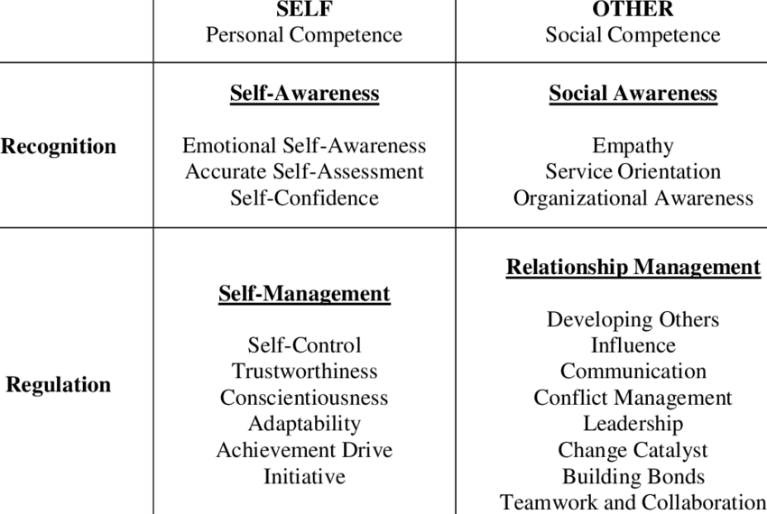
Figure 1: Daniel Goleman’s Emotional Intelligence Model
(Source: Delgoda and Weerasinghe, 2021)

Salovey and Mayer’s Ability Model of Emotional Intelligence
This model was the first that effectively explain the concept of emotional intelligence through a scientific angle. It explained emotional intelligence as a combination of different mental abilities that are connected with the process of emotional information. This theory also focuses on four major branches of emotional intelligence. The first branch is Perceiving emotions, which is recognising one’s own emotions and others as well. In this stage, employees notice facial expressions and emotional cues, tone of voice and their body language. This is effective for employees to understand the needs of others and act accordingly, while enhancing communication and reducing conflicts. The second branch is facilitating thinking using EI, which focuses on the application of emotions, which eventually helps in fostering reasoning and problem-solving. This is an advantage to the employees, because they get to know how to put their feelings into proper use to achieve not only reasoning but also creativity. Besides this, emotions also play a crucial role in assisting employees and maintaining prioritization as well as improving the effective decision-making (Coronado-Maldonado and Benítez-Márquez 2023). Understanding emotions is the next stage, as explained in Salovey and Mayer’s Model; understanding emotions also helps in identifying emotional changes. In the workplace, employees who understand emotions effectively can easily understand their own and others’ changes in emotions. This skill eventually helps in fostering various critical skills, like leadership, teamwork and conflict-resolution. Overall, it can be said that Salovey and Mayer’s model focuses on elaborating cognitive ability based on a scientific perspective. This model also explains that Emotional Intelligence is very similar to problem-solving. However, critics state that this model sheds light mostly on cognitive abilities or skills, and it does not incorporate personal factors that also has an important role in influencing emotions and behaviour.
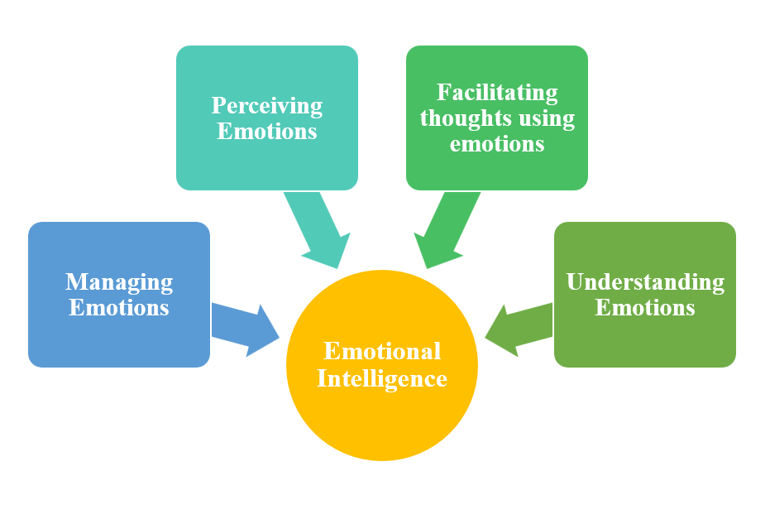
Figure 2: Salovey and Mayer’s Ability Model of Emotional Intelligence
(Source: Coronado-Maldonado and Benítez-Márquez, 2023)

Petrides’ Trait Emotional Intelligence Theory
This theory was developed by K.V. Petrides, and he explained that Emotional Intelligence is a combination of a few personality traits. These traits effectively demonstrate people's feelings, thinking and behaviour in various emotional situations. This model is not similar to others as it focuses on the personality structure of people. Further, this theory also incorporates similar components as Goleman’s theory, and these components effectively explain how people can manage their emotions and the ability to interact with others. Moreover, it has also been seen that Petrides’ theory separates EI into four factors (well-being, self-control, emotionality and sociability) (Petrides and Mavroveli, 2018). This model also suggests that people who have high EI have a few characteristics, like they are positive and being able to handle crisis situations. These people also have high adaptability skills as they can manage their emotions well enough along with others. However, people with low EI lack in managing their own emotions as well as others. Overall, it can be said that Petrides’ model states that EI is an important part of an individual and also a key aspect of their personality, which eventually fosters their emotional response to every life event.
The major factors of the trait, emotional intelligence theory, are well-being, self-control, social ability and emotion. These factors are important for employees, especially in their workplace, as these factors help employees manage their emotions effectively, develop strong relationships and enhance their overall performance. Well-being is one of the key factors that is important for employees. It helps them stay positive, motivated and confident. It has been seen that, if employees have well-maintained well-being, well-being is more satisfied with their jobs and they can handle crises better, while being productive (Sarkar et al.,2024). This eventually helps in spreading a positive behaviour across the workplace, which automatically enhances the spirit of the whole team. Next, the factor is self-control is also widely used by employees in their organisation. Self-control means managing stress, staying calm and making effective decisions instead of acting irrationally or emotionally. This factor is critical to handle any crisis situation, such as tight deadlines, criticism, or dealing with conflicts. Within a workplace, if employees can manage to self-control, they can enhance their professionalism and also contribute to the success of the company (Zhang and Ma, 2025). In addition to this, emotion is another major factor in this model. It helps employees to better understand their emotions and others. Emotion also helps in enhancing empathy, teamwork and communication. Overall, employees who are high and emotional can support other people in the workplace and also handle negative feedback effectively, which eventually reduces conflicts. The last factor is social ability, which is about developing strong and positive relationships within the workplace. Employees who are high in social ability can communicate easily, and they also have the power to resolve conflicts in a respectful way, which is important for enhancing team morale. These people also have a positive contribution to others and highly promote a healthy organisational culture. Overall, it can be said that applying these four factors, if employees are able to manage their emotions effectively, handle conflict, even better and level of stronger and more positive relationship within the workplace. Eventually, these factors will lead to better job satisfaction, good workplace relationships and it will also contribute to the success of an organisation.
For an overall summary, it can be said that emotional intelligence has an important role in bringing success to the new workplace and its rules, where employees are actively using emotional intelligence daily in their work to communicate effectively, develop strong relationships and manage their own emotional journey. Each of these models effectively contributes to an employee using important factors of emotional intelligence in the workplace. Overall, it can be said that emotional intelligence. It’s not just about understanding other people's feelings. It is about using the factors effectively and wisely to form better relationships and teamwork, which eventually leads to a successful organisation.

Unique characteristics of emotional intelligence that a manager needs to consider while recruiting employees from various generations (X, Y and Z)
In today’s workplace, it is considered that employees from various generations can provide value within an organisation. In this scenario, there is a crucial role of Emotional Intelligence (EI), as it influences the interaction between the employees, manages stress, and forms better relationships. Thus, it is important for the managers of organisations to incorporate the importance of EI and also consider the generational difference during the hiring session of employees. Although there are several positive impacts of generational differences within an organisation, it still possesses some negative impacts as well. These negative aspects need to be effectively handled by the managers of an organisation. In this section, a critical reflection is provided on the generational difference and emotional intelligence, while exploring the unique characteristics of generations X, Y and Z. These characteristics also need to be considered by the hiring managers of the organisation while recruiting employees.
Every generation has various unique characteristics and factors, including social, economic and technological factors, which also have an important impact on people’s perception regarding emotions. Emotional intelligence is a fixed character, and it is influenced by various other factors like education, life experience and workplace exposure. Concerning this, Mehler et al. (2024) explained that workplace interventions have a crucial role in training emotional competencies within employees. Thus, generational difference has an important role in providing variations within a working environment where empathy, effective communication style and adaptability are fostered. Generation X people are mainly born between 1965 and 1980. These individuals have been exposed to economic insecurity, globalisation and technological development. Dutta and Mishra (2021) also refer to Generation X as people who can effectively keep up with the changes in the globe, and the representatives of this generation also play a significant role in business today. Independent thinking, self-management, and EI is greatly appreciated by people of this generation, and is frequently manifested in their flexibility and high ability to control their emotions. The only limitation, however, is that these individuals do not openly show their feelings. When managers recruit individuals in this generation, they should know the ability of this generation, with regard to stress management, and how they can be effective in taking responsibility in making decisions. These individuals are not talkative, as it has been explained, which may affect the style of communication. Therefore, when hiring Generation X, managers should offer this kind of working environment where the cooperation with younger generations is encouraged.
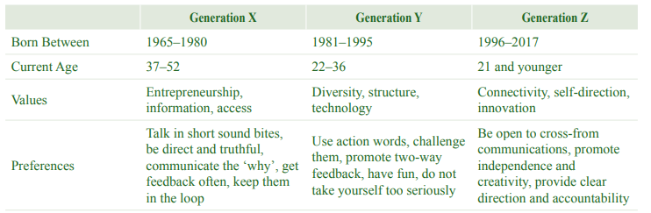
Figure 3: General overview of the characteristics of Generation X, Y and Z
(Source: Kirana and Windasari, 2019)
Generation Y or Millennials are individuals that were born between 1981 and 1996. Millennials are noteworthy due to their teamwork orientation and having an empathetic mind. These individuals tend to appreciate frankness, collaboration and feelings. With this in mind, Faber (2024) clarified that millennials are extremely concerned with the companies that give importance to the balance between work and life, and this is the primary factor that makes them successful at employment. These individuals are largely driven by positive feedback and this also shows their sense of self and social intelligence. Conversely, millennials spend much time in the digital worlds, which in some cases render them unable to manage stress appropriately. They could as well be affected negatively by negative feedback, and it could also affect them in terms of emotional stability. Therefore, in order to employ representatives of this generation, the employers must evaluate their capacity of emotional control under critical periods. The generation Z, which was born after the year 1997, has been growing up in a world with technological progress, social media and the world connectivity. This later assisted the individuals of this generation in being highly conscious of emotional and social issues. Members of this generation tend to be emotional and they are also aware of the society. Nevertheless, these individuals tend to have problems with emotional strength. Besides this, they have overdependence on technology making it difficult to develop a deeper meaning of emotions. Therefore, in order to attract members of Generation Z to work, employers should pay attention to their emotional stress management skills. Concerning this, Joshi (2025) stated that it is important for managers to provide a meaningful working environment, a flexible schedule and positive feedback to hire Gen Z employees. Overall, it can be said that managers need to adapt different strategies while hiring employees from different cultures.
Generational diversity has a vital role in the workplace; however, it still has various negative aspects as well. In the case of positive influence, generational diversity within an organisation can foster mutual learning. In an organisation, this difference can provide balance in the emotional expressiveness of people from Gen Y and Z. On the other hand, an employee from Gen X or a senior employee can learn creativity and openness. Concerning this, a study by Wang and Duan (2025) highlighted that generational differences are important for fostering creativity, problem-solving and innovation, which foster teamwork and the creation of ideas. Further, it is also important for employers to consider the generational gap, as it helps in developing an inclusive working culture and also improves empathy. On the contrary, the negative impacts include communication problems. Employees from different generations follow their own communication forms, which have the potential to lead to misunderstandings and frustration. In addition to this, people from different generations follow different coping styles. These differences can also lead to tension in the workplace. Thus, managers need to focus on their EI to understand employees from various generations and balance the differences among them. Lack of EI in leaders can change the intention of generational diversity from collaboration to conflict. Lastly, to effectively manage generational diversity, employers rely on various tools used for assessing EI. For example, it can include different psychometric assessments, behavioural interviews and others. These process helps employers effectively recognise the presence of EI in employees. Overall, to develop emotional intelligence in employees from different generations, leaders or managers need to initiate effective training, membership and feedback.

Recommendations

Recommendation 1: Introducing Emotional Intelligence training and development
This is the first recommendation for the senior management team, and this recommendation focuses on introducing training and development regarding emotional intelligence. This training needs to be mandatory for everyone in the organisation, including managers, leaders and employees. In this context, Babatunde, Sunday, and Adeshina (2023) explained that people with higher emotional intelligence have the ability to handle critical situations and develop strong relationships with others, as well as being equipped to manage conflict. This study also highlighted that leaders with high EI can handle tense situations effectively and bring effective benefits for everyone. Therefore, the management team can introduce various workshops on emotional intelligence and coaching to develop this skill.

Recommendation 2: Focus on emotionally intelligent leadership
The second recommendation that the management team can incorporate is emotional intelligence in their leadership practice. In the workplace, it is important for the leaders to act as role models for the team members and demonstrate empathy, understanding and self-awareness. The management team can incorporate a leader with high emotional intelligence to review the performance of the employees as well as their promotions. Moreover, if leaders are self-aware and showcase fairness as well as understanding can effectively encourage motivation, trust as well and teamwork among employees. Overall, it can be said that this type of leadership can foster an efficient workplace, where employees are supported, valued and respected.
Recommendation 3: Incorporating EI within the company policy and culture
The final recommendation is to incorporate EI within the organisation’s policy and culture. This will be effective for making the entire workplace supportive, fair and understanding. In addition to this, it will also help in ensuring that every aspect of an organisation’s performance management, hiring process, promotion and employee well-being program needs to be focused on EI. In this context, Neong, Isa and Manaf (2022) stated that if an organisational culture is emotionally intelligent, it helps in fostering better communication and collaboration, while helping in conflict resolutions as well. This study also explained that an EI-led organisational culture leads to higher employee engagement, productivity and motivation.

Conclusion
From the above discussion, it can be concluded that Emotional Intelligence is an important part of an organisation that helps in enhancing the performance and communication of the employees. By considering various models of EI, employees can effectively adapt EI in their working practice. In addition to this, the generational difference also has an important role in influencing EI. Thus, it is important for managers and leaders of an organisation to support the development of EI through training and development, inclusive practice and EI-led leadership.

Reference List
Babatunde, F., Sunday, H. and Adeshina, O. (2023). ‘Emotional intelligence in conflict management and leadership effectiveness in organisations.’ International Journal of Research, 10(3), pp.146-165.
Celestin, M., Vasuki, M., Sujatha, S. and Kumar, A.D. (2024). ‘Enhancing employee satisfaction and engagement to boost productivity: The role of leadership, culture, and recognition programs.’ International Journal of Computational Research and Development, 9(2), pp.67-74.
Cole, A. (2025). Emotional Intelligence Unlocked: How Anyone Can Build Self-Awareness, Empathy, and Social Skills for Success at Work, Stronger Relationships, and Emotional Wellness. Zephan Wong Kai En.
Coronado-Maldonado, I. and Benítez-Márquez, M.D. (2023). ‘Emotional intelligence, leadership, and work teams: A hybrid literature review.’ Heliyon, 9(10). Pp. 2-19.
Delgoda, L. and Weerasinghe, T.D. (2021). ‘Gender differences in emotional Intelligence: moderating role of organisational culture.’ Journal of Human Resource Management Perspectives, 6(1), pp.59-82.
Dutta, D. and Mishra, S.K. (2021). ‘Predictors of applicant attraction among Gen-X and millennials: evidence from an emerging economy.’ International Journal of Manpower, 42(8), pp.1479-1499.
Faber, E (2024). Gen Zs And Millennials Seek Purpose And Progress In A Changing World: Insights From Deloitte’s 2024 Gen Z And Millennial Survey. Available at: https://www.forbes.com/sites/deloitte/2024/05/15/gen-zs-and-millennials-seek-purpose-and-progress-in-a-changing-world-insights-from-deloittes-2024-gen-z-and-millennial-survey/ (Accessed: 19 October 2025).
Joshi, D. (2025). ‘The Role of Emotional Intelligence in Managing Gen Z Workforce.’ Journal of Marketing & Social Research, 2(7), pp. 183-189.
Mehler, M., Balint, E., Gralla, M., Pößnecker, T., Gast, M., Hölzer, M., Kösters, M. and Gündel, H. (2024). ‘Training emotional competencies at the workplace: a systematic review and meta-analysis.’ BMC psychology, 12(1), p.718.
Neong, S.C., Isa, Z.M. and Manaf, M.R.B.H.A. (2022). ‘Emotional intelligence and organisational culture: A systematic literature review.’ Journal of Pharmaceutical Negative Results, 13(5), pp.1582-1592.
Petrides, K.V. and Mavroveli, S. (2018). ‘Theory and applications of trait emotional intelligence.’ Psychology: The Journal of the Hellenic Psychological Society, 23(1), pp.24-36.
Price, A. (2023). The Importance Of Emotional Intelligence At Work. Available at: https://www.forbes.com/councils/forbeshumanresourcescouncil/2023/07/18/the-importance-of-emotional-intelligence-at-work/ (Accessed: 18 October 2025).
Safarlı, E. (2021). ‘The importance of emotional intelligence in interpersonal relationships: A study on pilots in the context of Daniel Goleman’s emotional intelligence model.’ International Journal of Business and Economic Studies, 3(Human Resources Management Special Issue), pp.76-90.
Sarkar, S., Menon, V., Padhy, S. and Kathiresan, P. (2024). ‘Mental health and well-being at the workplace.’ Indian Journal of Psychiatry, 66(Suppl 2), pp.S353-S364.
Wang, L. and Duan, X. (2025). ‘Generational diversity and team innovation: the roles of conflict and shared leadership.’ Frontiers in psychology, 15, pp. 1-16.
Zhang, X. and Ma, C. (2025). ‘Free yourself from the professionalism trap: A self-control explanation of the negative effect of involuntary professionalism.’ Journal of Business Research, 192, pp.1-15.

