

PROGRAMME: Certificate in Higher Education Business Skills for the Workplace
MODULE NAME: Managing Business Information
MODULE CODE: 5004
LECTURE NAME: AMITAVE BANIK
STUDENT NAME: Md Maynul Hasan Sumon
STUDENT ID: 2417454

Table of Contents
1. Introduction 2
1.1 Business Context 2
1.2 Problem Statement 2
2. Critical Evaluation of Existing Systems 2
2.1 Inventory Management Failures 2
2.2 CRM & Customer Data Issues 4
2.3 Reporting & Business Intelligence Gap 4
2.4 GDPR & Security Risk Exposure 4
3. Recommended Integrated System Architecture 5
3.1 Proposed Architecture Overview 5
3.2 ERP System Justification 6
3.3 Intelligent Inventory Management 7
3.4 CRM System Enhancement 8
3.5 Business Intelligence & Analytics Layer 8
3.6 Cybersecurity & Compliance Framework 9
4. Implementation Strategy 9
4.1 Implementation Phases 9
4.2 Change Management 11
4.3 Risk Assessment & Mitigation 11
4.4 Cost & ROI Considerations 12
5. Conclusion 12
References 13

1. Introduction

1.1 Business Context
Kalori Ltd is a business that uses 30-store omnichannel retailing model consisting of physical stores and an expanding e-commerce platform. This is a complex design that needs an immediate synchronisation of stock, sales and customer information both within in-store POS systems and through online channels. With volumes of transactions growing on both channels, the complexity of the system grows exponentially burdening the legacy manual processes. Under Industry 4.0 principles, the UK retail industry is progressively becoming digitised through the use of AI-based demand prediction, real-time analytics, and combined ERP solutions to boost supply chains. Competitive forces are the presence of a high price transparency on the platform of online comparisons and the customer needs of speedy fulfilment and click-and-collections. Inventory holding costs in retail usually constitute 20-30% of stock value per year, whereas a stockout will surely decrease incomes and customer loyalty. There is empirical evidence that data-driven retailers have always been more efficient and profitable in operations than less digitised competitors.

1.2 Problem Statement
The weaknesses resulting in inefficiency in business operations at Kalori lie in the disintegrated, non-integrated information systems. Lack of centralised database does not allow real-time inventory data and customer information. The use of manual spreadsheets increases the chances of human error and overselling as well as delay in reporting. The compliant and security risks presented by the weak data governance and restricted access control to the organisation in the context of the UK GDPR are revealed. Fragmentation of information systems at structural level is the root cause and not the fact of single operational errors.

2. Critical Evaluation of Existing Systems

2.1 Inventory Management Failures
The inventory system of Kalori is in spreadsheet format, which does not conform to real-time synchronisation of POS and e-commerce transactions, in that stock levels are updated after the fact rather than being updated at the time of occurrence. Inventory optimisation studies have shown that data streaming architectures are extremely effective at enhancing the visibility of stocks, the time of their replenishment, and their sensitivity to demand (Mukkath, 2025). The absence of built-in and persistent connecting data streams undermines inventory accuracy, leading to more stockouts and overstocks as well as making it impossible to compute algorithmic safety stock. Demand-driven replenishment is also hampered by the lack of predictive analytics. This organizationally conflicts with integrated models of retail operations, in which real-time visibility is the basis of mitigating volatility and enhancing the level of its service delivery (Mukkath, 2025). The architecture of Kalori thus entrenches systemic error as opposed to single operations errors.
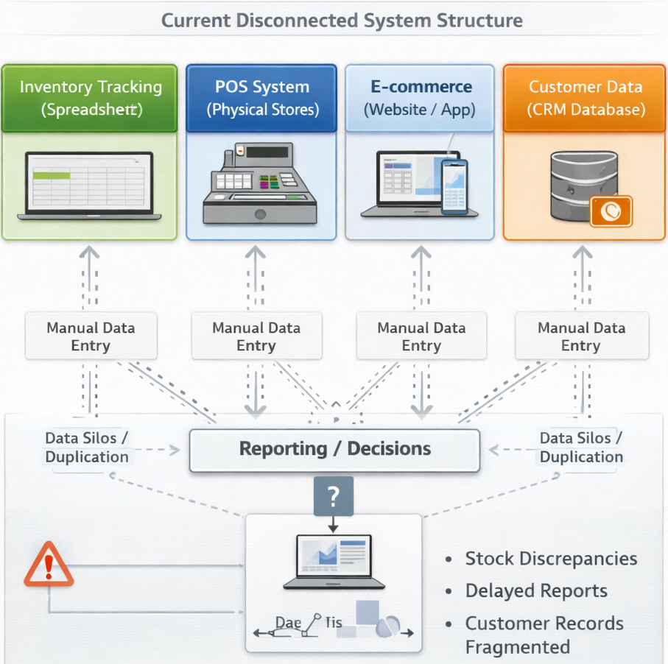
Figure 1: Current disconnected systems (POS, inventory, CRM, finance not connected).

2.2 CRM & Customer Data Issues
Kalori lacks a single customer profile in both physical and online stores, which do not allow computing Customer Lifetime Value (CLV) and churn prediction. The systematic review of AI-enabled CRM systems reveals that customer data integration makes it possible to engage the customer on a personal basis, segment their behaviour, and implement proactive retention policies, all that directly affect the long-term firm performance (Rainy & Goswami, 2025). Lack of the use of automation tools also constrains real-time decision support in marketing interventions. Kalori will not be able to operationalise the retention mechanism based on data, unless there is cohesive customer intelligence. This is a structural constraint of customer relationship management potential and not marketing implementation problem.

2.3 Reporting & Business Intelligence Gap
The use of manual spreadsheets to compile reports by Kalori generates not dynamic dashboards but static ones that are delayed. This is supported by experimental data that shows that the quality of decisions made by managers has increased when they are provided with dashboard systems of timely, full, and visually organized analytics (Hjelle et al., 2024). The paper shows that the better the information currency, the lower the complexity of tasks and the greater the satisfaction of information, which directly augments the information decision consequences in the organisation. The disjointed reporting structure at Kalori does not allow immediate monitoring of performance across stores and channels which undermines the accuracy of the forecasting and the speed of taking corrective measures. As far as the information systems point of view is concerned, the net benefits of the digital infrastructure are compromised by poor information timeliness and integration (Hjelle et al., 2024).

2.4 GDPR & Security Risk Exposure
The systems disintegrated in Kalori probably do not have fine-grained access control, immutable audit logs, and automatic compliance verification. The knowledge of GDPR-compatible system architectures contains findings that attribute-based access control and lifecycle audit logging are restrictive and crucial due to their ability to support continuous avoidance of non-compliant data processing that may go undetected (Eiza et al., 2024). The research proves that automated compliance checking contributes greatly to accountability and regulatory conformity. Weak monitoring and inconsistent permissions are more likely to breach and subject the organization to legal liability in a fragmented environment. Penalties may also be up to 4% global turnover under GDPR, and failure to govern is a material strategic risk. The present functional makeup of Kalori is therefore indicative of systemic compliance weaknesses and not procedural management.

3. Recommended Integrated System Architecture

3.1 Proposed Architecture Overview
Kalori needs to use a cloud based comprehensive ERP solution like SAP S/4HANA Retail, Oracle NetSuite, or Microsoft Dynamics 365. The suggested architecture is focused on one cloud ERP database that contains: (1) Inventory and Supply Chain Management, (2) CRM, (3) Finance and Accounting, (4) Business Intelligence, and (5) Cybersecurity and Compliance controls.
Elastic scalability is guaranteed by cloud deployment when the volume of transactions grows because of the presence of 30 stores and e-commerce channels. Cloud-native provides self-updating, automated security patches, and disaster recovery that is geographically dispersed mitigating the risk of downtime. The studies of retail cloud and secure DevOps systems emphasize that cloud integration increases agility and ensures compliance and resiliency in data-intensive retail systems (Gangula, 2025). Also, cloud architecture that is inspired by governance builds identity and alignment of compliance when planned and not retrofitted (Eltayeb, 2024).
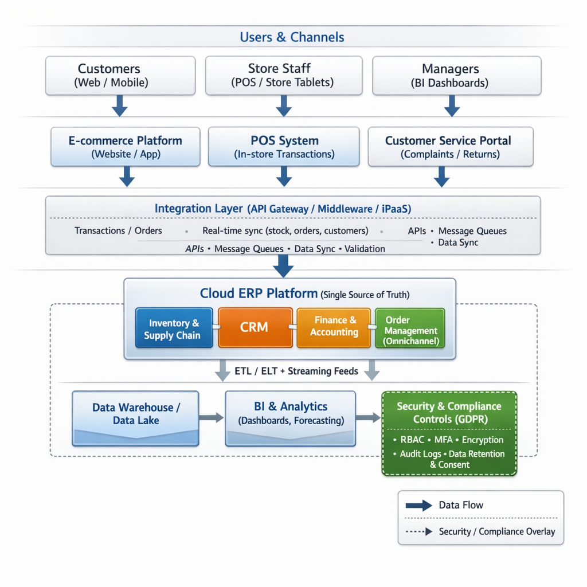
Figure 2: Proposed Architecture, Central ERP database connected to POS, e-commerce platform, CRM, BI dashboard.
A layered architecture diagram showing POS and e-commerce connected through an integration layer to a central cloud ERP platform, with BI dashboards and compliance controls wrapped around the system.

3.2 ERP System Justification
ERP system offers one source of truth by centralising in a relational database which makes real time transactions. On the point of sale, whether it is in store or online, the stock levels are instantly updated, revenue is automatically posted to the general ledger and channel synchronisation of order status occurs. This removes redundancy of data entry and delays of reconciliation.
Real-time inventory optimisation evidence has shown that event-driven and streaming architecture enhance the visibility of stocks and responsiveness to operations in the retail setting (Mukkath, 2025). ERP also raises the level of coordination through connections between procurement initiations and inventory levels and automated financial consolidation.
In terms of a Resource-Based View (RBV), integrated ERP is a valuable (operational efficiency), rare (customised data integration), and hard to imitate (embedded organisational processes) strategic capability. The operational efficiency theory also contributes to the workflow automation as a tool of minimizing the transaction and administrative overhead. In the case of Kalori, it will be automated stock updates, on-demand revenue reporting, and purchase orders generated by the system depending on the variability of demand.

3.3 Intelligent Inventory Management
The inventory module should incorporate:
- RFID or barcode integration for item-level tracking
- Automatic reorder points
- Safety stock calculation based on demand variance
- EOQ (Economic Order Quantity) optimisation
- AI-based demand forecasting models
The use of AI in forecasting helps to enhance JIT inventory accuracy by moving reorder quantities in response to current trends in sales (Ogunyankinnu et al., 2024). Retail analytics in real time also improve the replenishment time and minimize overstocks (Mukkath, 2025).
The main KPIs will be inventory turnover ratio, stockout percentage, time of order fulfilment, and the percentage of holding cost. Customers should be able to use the omnichannel to place orders and pick them up, as well as see real-time stock levels, which will enhance the reliability of the service and the rate of conversion.

3.4 CRM System Enhancement
The CRM module must establish a unified customer ID, enabling 360-degree profiles across physical and online channels. Functionality should include:
- RFM (Recency, Frequency, Monetary) segmentation
- Automated email campaigns
- Complaint and returns tracking
- CLV computation
- Churn prediction modelling
The evidence on AI-enabled CRM has been shown to be more effective in retention due to behavioural-based segmentation, proactive churn, and personalised interactions (Rainy & Goswami, 2025). Shopping experience and retention in the integrated CRM also improve in the omnichannel scenarios (Diaa & Abdel Wahab, 2023). Tactically, enhanced segmentation enhances average basket value and lifetime profitability of customers.

3.5 Business Intelligence & Analytics Layer
The BI layer should extract structured ERP data into a data warehouse, generating:
- Real-time dashboards
- KPI monitoring
- Predictive sales forecasting
- Cross-store benchmarking
Dashboard-based analytics enhanced the quality of decisions by improving the currency and completeness of the information (Hjelle et al., 2024). The KPIs to be monitored by managers include:
- Sales per square foot
- Conversion rate
- Average transaction value
- Gross margin per store
With live dashboards replacing the old-fashioned spreadsheets, the reporting latency time will be minimized, and the responsiveness of strategies across all 30 stores would be increased.

3.6 Cybersecurity & Compliance Framework
Security must be embedded architecturally through:
- Role-Based Access Control (RBAC)
- Multi-Factor Authentication (MFA)
- Encryption at rest and in transit
- Continuous vulnerability testing
- Automated audit trails
Access control and validation of compliance mechanisms have very fine grains that substantially reinforce GDPR alignment and accountability (Eiza et al., 2024). Governance-based and zero-trust IAM strategies also improve regulatory resilience in the clouds (Okunlola et al., 2025).

4. Implementation Strategy

4.1 Implementation Phases
Kalori should adopt a phased ERP implementation strategy rather than a “big bang” rollout to reduce operational disruption and risk concentration.
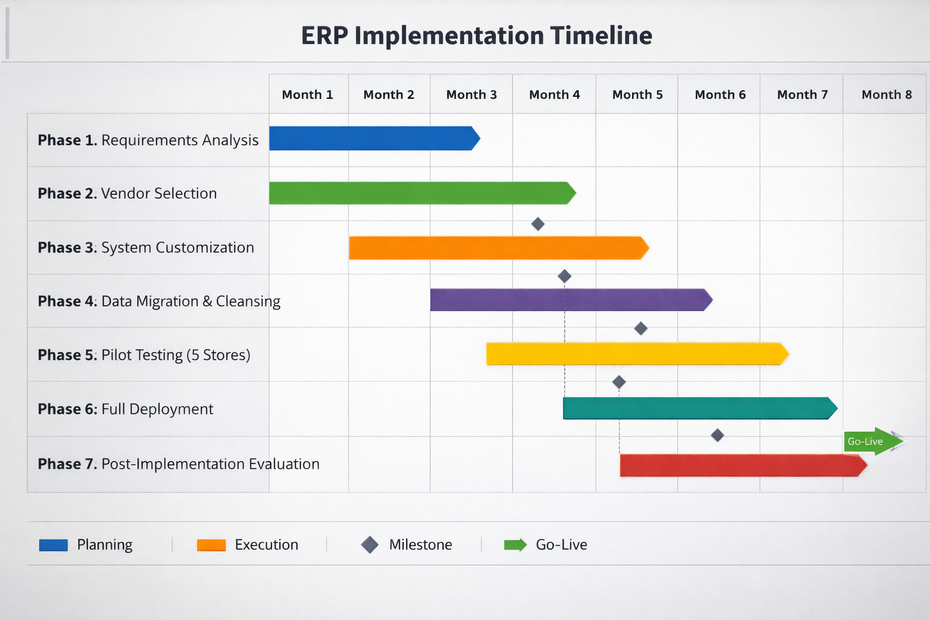
Phase 1 – Requirements Analysis: Conduct cross-departmental process mapping (inventory, CRM, finance) and define KPIs (inventory turnover, stockout rate, CLV).
Phase 2 – Vendor Selection (RFP): Issue structured RFP assessing scalability, API integration, security compliance, and total cost of ownership.
Phase 3 – System Customisation: Configure workflows, role-based permissions, and integration rules.
Phase 4 – Data Migration & Cleansing: Validate historical sales, supplier, and customer records before structured ETL transfer. Migration risk frameworks emphasise encryption, compliance checks, and structured validation protocols during system transitions (Duvvur, 2022).
Phase 5 – Pilot Testing: Deploy in 5 representative stores to test omnichannel synchronisation.
Phase 6 – Full Deployment: Gradual rollout region by region.
Phase 7 – Post-Implementation Evaluation: Measure KPI improvements and system adoption rates.
This staged approach distributes technical and operational risk across controlled phases.

4.2 Change Management
Failure of most of the information systems has been due to organisational resistance and not technology failure. To promote the change, Kotter 8-Step Change Model should be implemented in Kalori, where one should start with creating a sense of urgency (inventory losses, GDPR risk) and establish a cross-functional change coalition. Process change should be communicated to the store managers and the head-office employees in a structured communication plan.
Hands-on ERP simulations are to be taught in training workshops and the local knowledge anchors in each of the stores should be the so-called super-user champions. Adoption is supported continuously by the use of a helpdesk and performance dashboards. The research on governance-oriented IAM emphasises the fact that organisational alignment is important in the context of embedding compliance and security practices, rather than an exclusive application of technical controls (Eltayeb, 2024). The acceptance of the users should then be considered as a strategic implementation goal.

4.3 Risk Assessment & Mitigation
Primary risks include:
- Data migration errors (corrupt or incomplete records)
- Integration incompatibility between ERP and legacy POS
- Cost overruns due to scope expansion
- Operational downtime during deployment
- Cybersecurity exposure during system transition
Some of the mitigation strategies to be used are having parallel backup systems in case of migration, imposing Service Level Agreements (SLAs) with suppliers and penetration testing before go-live. Compliance checking and automatic logging systems can greatly mitigate the risk of breaches of regulations in the event of change in the system (Eiza et al., 2024). Milestones, budget variance and risk indicators must be observed by a project governance committee using well-structured reporting systems.

4.4 Cost & ROI Considerations
An ERP model based on SaaS changes the capital-intensive expenditure on hardware to operational expenditure in the form of subscriptions. This reduces the initial expense and enhances scalability. The long-term ROI is based on fewer manual labour, fewer stock losses, fewer retention due to CRM analytics, and accuracy in decision making.

5. Conclusion
Inefficiencies in the operations at Kalori begin in the structure of systems fragmentation and not just in the limited weaknesses in procedures. Lack of connections between POS, inventory and CRM and financial systems has led to inconsistency of data, slowness of reporting, exposure to compliance and lack of strategic view. The featured cloud-based integrated ERP system will solve these flaws through the creation of a single source of truth, real-time transaction processing, smart inventory optimisation, sophisticated CRM analytics, and built-in cybersecurity controls. Operational risk is reduced in a planned implementation plan and the change is adopted in the organisation through organised change management. Kalori can minimize stock turnover, boost customer retention, improve accuracy in the decision-making process, and grow the business in its 30-store omnichannel network scale through the integration of data, processes, and governance into a single architecture. This makes digital integration a long-term competitiveness and regulatory resiliency enabler.

References
Diaa, N.M. and Abdel Wahab, H.A.W., 2023. Omnichannel Retailing and Customer Retention: The Mediating Effect of Omnichannel Shopping Experience. التجارة والتمويل, 43(4), pp.40-72.
Duvvur, V., 2022. Risk Mitigation in System Migrations: A Framework for Secure Coding, Data Encryption, and Regulatory Compliance. International Journal of Artificial Intelligence, Data Science, and Machine Learning. https://doi.org/10.63282/3050-9262.ijaidsml-v3i3p107.
Eiza, M., Thong, T., Shi, Q., & Cao, Y., 2024. Secure semi‐automated GDPR compliance service with restrictive fine‐grained access control. Security and Privacy, 7. https://doi.org/10.1002/spy2.451.
Eltayeb, O., 2024. The Crucial Significance of Governance, Risk and Compliance in Identity and Access Management. Journal of Ecohumanism. https://doi.org/10.62754/joe.v3i4.3763.
Hjelle, S., Mikalef, P., Altwaijry, N., & Parida, V., 2024. Organizational decision making and analytics: An experimental study on dashboard visualizations. Inf. Manag., 61, pp. 104011. https://doi.org/10.1016/j.im.2024.104011.
Mukkath, S., 2025. Real-Time Inventory Optimization in Retail Using Streaming Data. Journal of Computer Science and Technology Studies. https://doi.org/10.32996/jcsts.2025.7.3.82.
Rainy, T., & Goswami, D., 2025. MECHANISMS BY WHICH AI-ENABLED CRM SYSTEMS INFLUENCE CUSTOMER RETENTION AND OVERALL BUSINESS PERFORMANCE: A SYSTEMATIC LITERATURE REVIEW OF EMPIRICAL FINDINGS. ASRC Procedia: Global Perspectives in Science and Scholarship. https://doi.org/10.63125/zva9wb39.
Gangula, S., 2025. Secure DevOps in Retail Cloud: Strategies for Compliance and Resilience. The American Journal of Engineering and Technology. https://doi.org/10.37547/tajet/volume07issue05-09.
Ogunyankinnu, T., Osunkanmibi, A., Onotole, E., Ukatu, C., Ajayi, O., & Adeoye, Y., 2024. AI-Powered Demand Forecasting for Enhancing JIT Inventory Models. Journal of Frontiers in Multidisciplinary Research. https://doi.org/10.54660/.ijfmr.2024.5.1.184-196.
Okunlola, O., Olaoye, J., Samuel, O., Okunlola, A., & Alao, O., 2025. Zero Trust Security Models in Cloud Environments: Compliance Implications. International Journal of Future Engineering Innovations. https://doi.org/10.54660/ijfei.2025.2.2.96-102.

