
infographic – covid 19

Analisysis and visualization of data
© 2021 University of Wales Trinity Saint David
Submitted by:
Daniela Mihalkova
Cloud Computing
Module code: ACCB4002
Student ID: 2021925

Contents
Introduction 2
What is an infographic? 2
Provided analysis and evaluation of infographics 4
Impact of Covid-19 on business 4
“Marker disruption will drive innovation. Agree or strongly agree responses.” 5
Office print volumes are in free fall. What impact are you seeing on customer print volumes? 6
“Vertical demand varies. How is demand changing by industry sector?” 7
“Collaboration, cloud and digitization opportunities Anticipated future interest” 8
“Chanel partners expects more support from their suppliers” 9
“Most are cautious about business recovery time” 10
References 12

Introduction

This report presents an evaluation and an analysis of the positive and negative aspects of visually presented data such as graphs and charts. This report will have a look at the impact of Covid-19 in all different sectors. All of the charts and graphs, as well as the presenting technique, will be reviewed throughout this report, and a conclusion will be drawn on how the given statistics and information were presented utilizing a systemic approach.

What is an infographic?

An infographic is a form of graphic that combines facts and design to assist individuals and organizations in communicating with their target audiences. An infographic is more than just a collection of images. Infographics, on the other hand, incorporate meticulously ordered typographic elements. Basic learning methods and visuals for visual presentation of data are provided by design for information. An infographic is a collection of graphs that depict a stack of data or infographic data. Rather than a straightforward writing style, the infographic standard provides a more creative language. Infographics are frequently encountered these days in the media, in printed publications, and road signs, and in manuals [1].
Infographics that are effective have a few characteristics in common. They are well-designed, convey a compelling tale, and are simple to comprehend. They provide a visual element of material in a simple and snackable format.
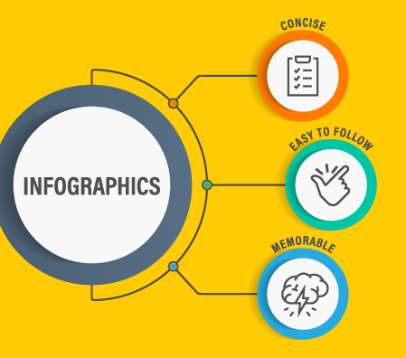
The important of infographics [2]
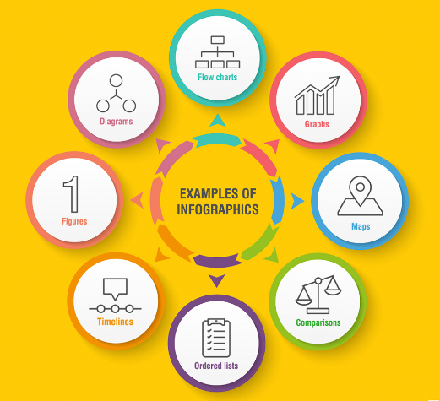
Type of infographics [2]

There are four ways that data visualization may help your company make better decisions:
- Faster Response Time – Data visualization puts information in the hands of users, allowing them to rapidly spot problems and improve response times
- Simplicity – User can see the large picture while still being able to access the specifics when needed with data visualizations. They simplify data so that consumer may cherry-pick the information they need.
- Easier Pattern Visualization - When trying to identify trends in data while analyzing hundreds of lines in spreadsheets, they are the misery of many marketing managers' life. Data visualization makes seeing new pathways and identifying new patterns and trends much easier.
- Team Involvement - Data visualizations make essential data available to all departments in real time, allowing them to work more effectively. These infographics show a variety of corporate indicators, which is useful for keeping everyone in the organization informed [3].

Provided analysis and evaluation of infographics

Impact of Covid-19 on business
This pie chart shows that the data has been divided into five quarters, each of which indicates a distinct impact on companies during Covid-19. The large impact, which increased to 66%, is an interesting discovery, but there is no thread of permanent closure for the firms included in this statistic. An analysis of the data reveals that the majority of the businesses were able to maintain their stability throughout the Covid-19. The figure shows just around 4% of firms will have to close permanently, but the vast majority will survive with positive consequences. As a result, this pie chart has been displayed in a proper manner [4].

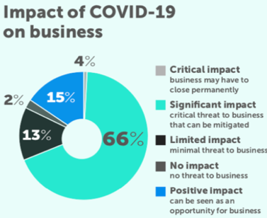

“Marker disruption will drive innovation. Agree or strongly agree responses.”

This graph demonstrates that the chart type employed is inappropriate for portraying the information that they are attempting to convey, and the message is not obvious to the audience. In this situation, a line chart may be utilized to better represent the data and make the message easier for the audience to grasp and observe how the rise progresses [4].

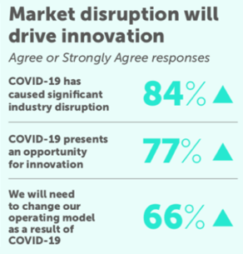

Office print volumes are in free fall. What impact are you seeing on customer print volumes?
The percentages of the various elements are shown in this stacked column chart. As can be seen, the column is divided into four pieces, each of which is colored differently. I'd like to draw attention to the section between the “3 % No change” and “2% Marginal increase” that is displayed with the same hue. It may be created in various colors so that the audience can easily notice all of the percentages for the four distinct elements. According to the analysis of this data, the substantial drop in the impact has decreased to 68% [5].

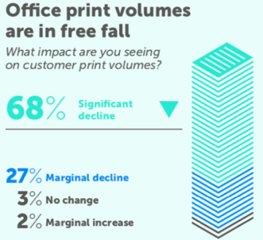

“Vertical demand varies. How is demand changing by industry sector?”

This clustered bar chart depicts how demand is increasing and declining in six distinct areas. During Covid-19, there was a significant decline in Education, Retail, Business & Professional Services, and Financial Services, with just a minor gain in Education, Retail, Business & Professional Services, and Financial Services. This is owing to the fact that all of those sections have been closed. However, there is a large increase in the government and healthcare, as well as a minor decline. As a result, they continued to function at a higher level than usual. This chart has been presented in a clear and understandable manner for the audience, and it has been utilized in an appropriate manner [6].
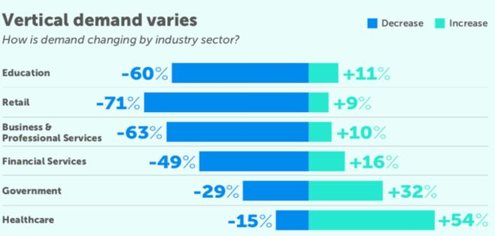

“Collaboration, cloud and digitization opportunities Anticipated future interest”
The sort of chart employed in this chart is not appropriate for portraying the information they are attempting to convey, and the message is not obvious to the viewer. In this situation, a line chart may be utilized to better represent the data and make the message easier for the audience to grasp and observe how the rise progresses [7].
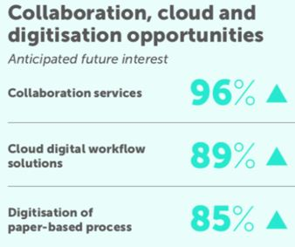

“Chanel partners expects more support from their suppliers”
These lines depict the percentage expectations in five distinct areas. It is clear from this graph that the data has been presented in an appropriate manner. Expectations based on "Longer payment terms" and "Financial help (e.g., extended credit terms)" are two of the most important areas [8].

“Most are cautious about business recovery time”

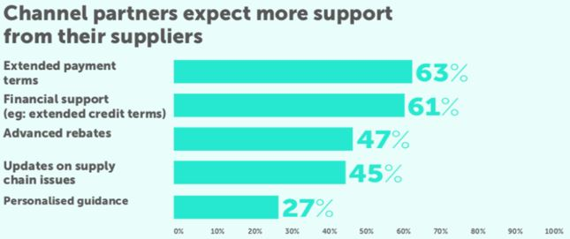
The way all firms have been split into distinct sectors may be observed in this pie chart. It also depicts the different sorts of enterprises in terms of per cent and the time required for recovery in six distinct colors. Here on the chart 15% of businesses are recovering by 1 to 3 months but 35% of the businesses they are recovering by 35% which is the biggest difference.
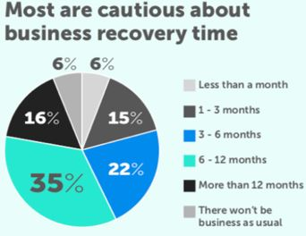

References

[1] | S. Delil, "The impact of infographic animation videos on data visualization," International Journal of Social Sciences and Education Research, 2017.
[2] | t. creative, "the importance of infographic," 05 08 2020. [Online]. Available: https://thinkcreative.uk.com/the-importance-of-infographics/. [Accessed 25 07 2021].
[3] | J. W. &. Sons, "Why infographics work," in Cool Infographics , 2016, p. 14.
[4] | J. W. &. Sons, "Static infographics," in Cool infographics, 2016, p. 31.
[5] | C. Long, "Strategic Finance," Stacked column chart , 2016.
[6] | A. Kirk, "SAGE Research Methods: Data Visualization," Clustered Bar Chart , 2021.
[7] | A. A, "Computers in Libraries," Using infographics to report research results, 2016.
[8] | B. E. Crane, "Infographics," Depic lines , 2016.
[9] | Versus, "AMD Ryzen 3 3200G vs Intel Core i3-9100F," [Online]. Available: https://versus.com/en/amd-ryzen-3-3200g-vs-intel-core-i3-9100f. [Accessed 12 03 2021].

