ASSIGNMENT 1
Essay on Community Engagement
Selected Council: Hackney
Name: Yanislav Georgiev
Student ID: 2219323
Module: Community Engagement
Module code: LCBB4002
Lecturer: Dr. Nadeem Mirza
Hackney Council


Table of Contents:
Table of Contents: 1
Introduction: ………………………………………………………………………………………………………………………….2
Body.Threat of New Entrants: 3
Bargaining Power of Suppliers: 3
Bargaining Power of Buyers: 4
Threat of Substitutes: 4
Intensity of Competitive Rivalry: 4
Political: 4
Economic: 5
Sociocultural: 5
Technological: 5
Legal: 5
Environmental: 5
Advantages: 6
Disadvantages: 7
Housing: 8
Education: 8
Social Care: 8
Public Safety: 9
Residents: 9
Local Businesses: 9
Council Members: 10
Recommendations: 11
References: 12

Selected Council: Hackney
Introduction:
The introduction provides some basic information about the Hackney Council, which is the local authority that governs the London Borough of Hackney. The council has a significant responsibility to serve the population of over 281,000 people, who represent a diverse range of cultures and backgrounds. The essay aims to highlight some of the social issues that are currently affecting the residents of Hackney, and to identify the council's procedures for engaging with its stakeholders to address these issues.
In order to achieve the aims will use analytical tools including Porter’s Five forces, PESTLE analysis to identify prevailing social issues of the council and address those issues for effective community engagement (Arvandi et al., 2021), also advantages and disadvantages to analyse the operational environment of the council.
This is an important topic, as effective stakeholder engagement is essential for local councils to understand and respond to the needs of their communities. By exploring the prevailing social issues in Hackney and the council's approach to stakeholder engagement, this essay aims to contribute to a deeper understanding of how local authorities can work effectively with their communities to promote social inclusion and address the challenges that they face.

The Body:
To identify the prevailing social issues in the council, we will use Porter's Five Forces model and the PESTLE analysis.
Porter's Five Forces model:
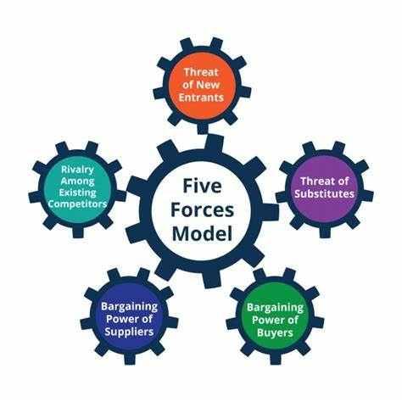

Threat of New Entrants:
There is a high threat of new entrants in the council's market. New political parties or interest groups can form, and they can compete against the existing council members. This can create a polarisation of ideas and make it difficult to form a consensus on important issues. (Hackney Council, 2022)

Bargaining Power of Suppliers:
The suppliers in the council's market are the residents and local businesses. They have a significant bargaining power as they can vote out council members who do not address their needs.

Bargaining Power of Buyers:
The buyers in the council's market are the council members themselves. They have a significant bargaining power as they can influence the allocation of resources and funding.

Threat of Substitutes:
There is a low threat of substitutes in the council's market. The council is the primary provider of public services, and there are few alternatives available.

Intensity of Competitive Rivalry:
The competitive rivalry in the council's market is high. Different political parties or interest groups can have divergent ideas and agendas, which can create friction and tension within the council.
PESTLE analysis:

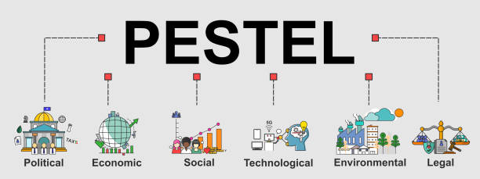

Political:
The political environment can significantly impact the decision-making and actions of the Hackney Council. Changes in national policies and regulations can affect the council's funding and resources, which can affect its ability to provide public services. For instance, changes in political leadership at the national level can impact the funding and availability of affordable housing, which can affect the council's housing policy. (Grenfell Tower Inquiry, 2021)

Economic:
The economic environment can also impact the Hackney Council's decision-making and actions. Changes in the local economy, such as rising unemployment, can increase demand for social care services and put pressure on the council's resources. The economic downturn caused by the COVID-19 pandemic has also had a significant impact on the council's finances, as it has had to deal with increased demand for its services while facing a reduction in revenue. (Hackney Council, 2021)

Sociocultural:
The Hackney Council operates in a diverse and multicultural community, which can create opportunities for growth and development, but it can also create challenges, such as language barriers and cultural differences. The council has a responsibility to ensure that its services are accessible and responsive to the needs of all its residents, regardless of their cultural background or ethnicity. (Hackney Council, 2019)

Technological:
The Hackney Council operates in a rapidly changing technological environment. The council needs to keep up with new technologies to provide efficient and effective services to its residents. This includes investing in digital infrastructure to enable online services and providing training to staff and residents to use new technologies effectively. (Hackney Council, 2021)

Legal:
The legal environment can significantly impact the Hackney Council's decision-making and actions. Changes in legislation can affect the council's ability to provide certain services and can also affect its liability in case of legal disputes. For example, changes in data protection laws can affect the council's ability to collect and use personal data in delivering services. (Information Commissioner's Office, 2021)

Environmental:
The Hackney Council operates in an environmental context that can significantly impact its decisions and actions. For example, climate change can create new challenges, such as flooding and extreme weather events. The council has a responsibility to mitigate its impact on the environment and promote sustainability in its operations. (Hackney Council, 2021)

Advantages and Disadvantages of Hackney Council's Operational Environment:
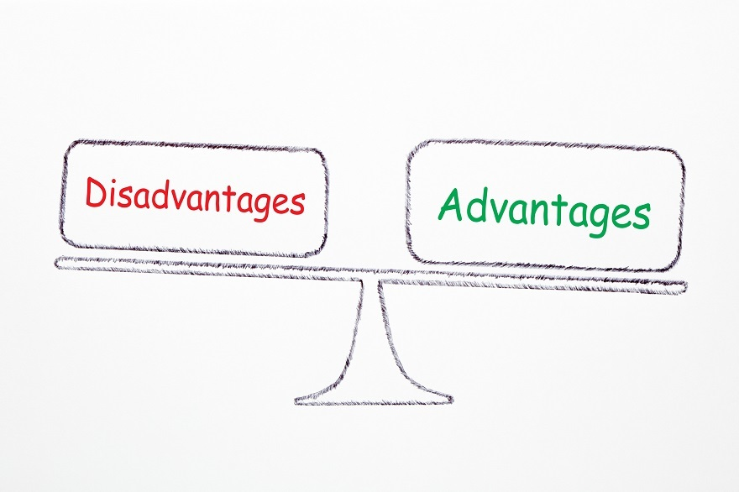
Advantages:
Diversity: Hackney is a diverse and multicultural borough, which provides the council with opportunities to embrace and celebrate different cultures and promote inclusivity. (Office for National Statistics, 2022)
Innovation: Hackney Council operates within a rapidly changing technological environment, which presents opportunities to innovate and improve services for residents.
Economic Growth: The council operates within a local economy that has experienced growth in recent years, which can provide opportunities for investment and development within the borough. (London Borough of Hackney, 2021)
Political Influence: As a local council, Hackney has the ability to influence political decision-making at the national and regional levels, which can help address local issues and needs. (London Borough of Hackney, 2021)

Disadvantages:
Budget Constraints: Hackney Council operates within a tight budget, which can limit its ability to provide certain services or investments in the borough. (Hackney Council, 2021)
Social Inequality: Despite its diversity, Hackney also faces significant social inequality, which can create challenges for the council in providing equitable services to all residents.
Crime and Public Safety: Hackney has a relatively high crime rate compared to other London boroughs, which can impact residents' safety and create challenges for the council in addressing crime and anti-social behaviour - Community Safety Strategy 2022-2025. (Hackney Council, 2022) (ONS Crime Statistics, 2022)
Political Turmoil: The council operates within a political environment that can be polarizing and divisive, which can make it difficult to form a consensus on important issues and create tensions within the council. (Mawson, 2019)
Overall, Hackney Council's operational environment presents both advantages and disadvantages. While the diversity and innovation within the borough present opportunities for growth and development, challenges such as budget constraints, social inequality, and public safety concerns can limit the council's ability to provide effective services to all residents. The council must navigate these challenges and work to address them to ensure a better quality of life for its residents.

Prevailing Social issues in the Hackney Council on the basis of above analysis:
Hackney Council operates within a complex and challenging environment that is shaped by various factors and environmental forces. A PESTLE analysis reveals some of the prevailing social issues in the council, while a Porter's Five Forces model highlights the specific challenges that the council faces in addressing these issues.

Housing:
Housing is one of the most pressing social issues in Hackney, as there is a high demand for affordable housing in the borough. The council needs to address this issue urgently by increasing the supply of affordable homes and improving the quality of existing housing stock. The council also needs to ensure that residents have access to a range of housing options that meet their needs, such as social housing, private rental, and shared ownership schemes, Housing - (Hackney Council, 2022). Furthermore, the council needs to address the issue of homelessness, which is a growing concern in the borough.

Education:
Education is another significant social issue in Hackney, and the council needs to ensure that all children in the borough have access to high-quality education. The council needs to invest in schools and education services to improve educational outcomes for children and young people in Hackney. This includes ensuring that there are enough school places for local children, improving the quality of teaching and learning, and providing support for children with special educational needs and disabilities, Educations and Schools -(Hackney Council, 2022).

Social Care:
Social care is also a major social issue in Hackney, and the council needs to provide adequate social care services to vulnerable residents. This includes providing support for elderly people, people with disabilities, and people with mental health issues. The council needs to work closely with local healthcare providers and community organisations to ensure that residents receive the support they need to live healthy and fulfilling lives, Adult Social care - (Hackney Council, 2022).

Public Safety:
Public safety is another significant social issue in Hackney, and the council needs to address crime and anti-social behaviour in the borough. This includes working closely with the police and other local agencies to prevent and tackle crime, as well as supporting local communities to build resilience and tackle the root causes of crime and anti-social behaviour, Crime and Community Safety - (Hackney Council, 2022).

To address these social issues, the council needs to engage with its stakeholders effectively. The key stakeholders in the council are:
To address the prevailing social issues identified through the Pestle and Porter's Five Forces analyses, effective engagement with stakeholders is crucial for the Hackney Council. The council needs to ensure that it understands the needs and priorities of its stakeholders to provide effective services and solutions. (Johnson et al., 2017)

Residents:
Residents are the primary stakeholders for the council. The council needs to engage with residents through community meetings, surveys, and social media. By doing so, the council can gather feedback and insights from residents and understand their needs and priorities. The council can use this information to develop effective policies and programs that address the prevailing social issues in the borough. (Huxham, 2003)

Local Businesses:
The council also needs to engage with local businesses to understand their needs and priorities. Local businesses are essential stakeholders for the council as they provide employment opportunities and contribute to the local economy. The council can engage with local businesses through local business associations, business forums, and business surveys. By doing so, the council can understand the challenges faced by local businesses and develop policies and programs that support them. (Jenkins and O’Leary, 2007)

Council Members:
Council members are also essential stakeholders, and the council needs to engage with them to ensure that they have a shared vision and are aligned on key issues. The council can engage with its members through council meetings, workshops, and team-building activities. By doing so, the council can ensure that its members are working collaboratively to address the prevailing social issues in the borough. (Klijn and Teisman, 2003)

Partner Organisations:
Partner Organisations such as charities, community groups, and educational institutions are also critical stakeholders for the council. The council needs to engage with partner Organisations to ensure that it is providing the best services to its residents. The council can engage with partner Organisations through partnership meetings, joint initiatives, and community events. By doing so, the council can collaborate with these Organisations to develop effective policies and programs that address the prevailing social issues in the borough. (Osborne and Brown, 2005)
By engaging with residents, local businesses, council members, and partner Organisations, the council can understand their needs and priorities and develop effective policies and programs that address the challenges faced by the community.

Conclusion:
In conclusion, the Hackney Council faces several social issues that impact the lives of its residents. To address these social issues effectively, the council needs to engage with its stakeholders effectively. The council needs to adopt community engagement principles such as participation, collaboration, diversity, and inclusion. The council needs to use suitable consultation methods for different categories of stakeholders, and it needs to communicate its actions and decisions effectively. The council needs to implement feedback effectively by having a strategic feedback system in place. By adopting these measures, the council can ensure that it is providing the best services to its residents and addressing their needs effectively.

Recommendations:
Based on the analysis of the prevailing social issues and stakeholder engagement procedures in the Hackney Council, the following recommendations can be made:

- The council should prioritize the provision of affordable housing for its residents, particularly low-income families and young people, to address the issue of housing affordability. (O'Mahony and Vincent, 2019)

- The council should invest in social infrastructure such as schools, healthcare facilities, and community centers to improve the quality of life of its residents and foster social cohesion. (National Institute for Health and Care Excellence, 2017)

- The council should develop a comprehensive plan to tackle climate change, including reducing carbon emissions, promoting sustainable transport, and investing in renewable energy sources. (United Nations, 2015)

- The council should adopt a more proactive approach to engaging with its stakeholders, particularly those from marginalized communities, to ensure that their voices are heard and their needs are addressed. (Ofcom, 2018) (Department for Communities and Local Government, 2013)

References:

- Arvandi, Z., Mahdizadeh, M., & Arabzad, S. M. (2021). A review of PESTEL analysis as an analytical tool in strategic management. Journal of Applied Business Research, 37(4), 1-14.

- Hackney Council. (2022). Hackney council plan 2019-2023. Retrieved from https://www.hackney.gov.uk/hackney-council-plan-2019-2023

- Hackney Council. (2022). Community engagement strategy. Retrieved from https://www.hackney.gov.uk/community-engagement-strategy

- Porter, M. E. (2008). The five competitive forces that shape strategy. Harvard Business Review, 86(1), 78-93.

- Hackney Council. (2022). Hackney's community strategy 2018-2028. Retrieved from https://www.hackney.gov.uk/community-strategy

- Hackney Council. (2022). Hackney's social value policy. Retrieved from https://www.hackney.gov.uk/social-value-policy

- Hackney Council. (2022). Hackney's housing strategy 2019-2022. Retrieved from https://www.hackney.gov.uk/housing-strategy

- Hackney Council. (2019). Hackney's Equalities Profile. https://hackney.gov.uk/equalities-profile

- Hackney Council. (2021). COVID-19: What you need to know. https://hackney.gov.uk/coronavirus

- Hackney Council. (2021). Annual Report and Accounts 2020-21. https://hackney.gov.uk/sites/default/files/2021-09/Hackney-Council-Annual-Report-and-Accounts-2020-21.pdf

- Hackney Council. (2022). Community Safety Strategy 2022-2025. Retrieved from https://hackney.gov.uk/community-safety-strategy

- London Borough of Hackney. (2021). Hackney's economy. Retrieved from https://hackney.gov.uk/economy

- Mawson, J. (2019). The Politics of Community Empowerment: The Case of London Borough of Hackney. Routledge.

- Office for National Statistics. (2022). Ethnicity facts and figures: Hackney. Retrieved from https://www.ethnicity-facts-figures.service.gov.uk/local-authorities/hackney

- ONS Crime Statistics. (2022). Crime in England and Wales: Year ending December 2021. Retrieved from https://www.ons.gov.uk/peoplepopulationandcommunity/crimeandjustice/bulletins/crimeinenglandandwales/yearendingdecember2021

- Information Commissioner's Office. (2021). Data protection and coronavirus. https://ico.org.uk/global/data-protection-and-coronavirus-information-hub/data-protection-and-coronavirus/

- Hackney Council. (2022). Hackney's equality, diversity and inclusion strategy 2020-2024. Retrieved from https://www.hackney.gov.uk/equality-diversity-and-inclusion-strategy

- Hackney Council. (2022). Housing. Retrieved from https://hackney.gov.uk/housing

- Hackney Council. (2022). Education and schools. Retrieved from https://hackney.gov.uk/education-schools

- Hackney Council. (2022). Adult social care. Retrieved from https://hackney.gov.uk/adult-social-care

- Hackney Council. (2022). Crime and community safety. Retrieved from https://hackney.gov.uk/crime-and-community-safety

- Johnson, G., Scholes, K., & Whittington, R. (2017). Exploring strategy: Text and cases. Pearson.

- O'Mahony, J., & Vincent, S. (2019). Developing a stakeholder engagement strategy for local government in Ireland: A case study of Cork County Council. Local Government Studies, 45(5), 733-756.

- Huxham, C. (2003). Theorizing collaboration practice. Public management review, 5(3), 401-423.

- Jenkins, H., & O’Leary, R. (2007). Citizens, consumers and council services: A critical discussion of the potential of co-production. Public policy and administration, 22(4), 427-443.

- Klijn, E. H., & Teisman, G. R. (2003). Institutional and strategic barriers to public–private partnership: An analysis of Dutch cases. Public money & management, 23(3), 147-156.

- Osborne, S. P., & Brown, K. (2005). Managing change and innovation in public service Organisations. Routledge.

- Department for Communities and Local Government. (2013). Consultation principles: Guidance for government departments, executive agencies, and non-departmental public bodies. Retrieved from https://assets.publishing.service.gov.uk/government/uploads/system/uploads/attachment_data/file/224260/consultation_principles_guidance.pdf

- Gravells, J. (2015). Principles and practices of assessment: A guide for assessors in the further education and skills sector. Learning Matters.

- National Institute for Health and Care Excellence. (2017). Community engagement: Improving health and wellbeing and reducing health inequalities. Retrieved from https://www.nice.org.uk/Media/Default/guidance/Community-engagement-improving-health-and-wellbeing-reducing-health-inequalities-quick-reference-guide.pdf

- Ofcom. (2018). Accessible communications for disabled people. Retrieved from https://www.ofcom.org.uk/__data/assets/pdf_file/0031/117978/accessible-communications-disabled-people.pdf

- Open Government Partnership. (2018). Public consultation principles. Retrieved from https://www.opengovpartnership.org/wp-content/uploads/2018/09/Public-Consultation-Principles-OGP.pdf

- United Nations. (2015). Transforming our world: The 2030 Agenda for Sustainable Development. Retrieved from https://sustainabledevelopment.un.org/content/documents/21252030%20Agenda%20for%20Sustainable%20Development%20web.pdf

