
APPENDIX GA36d

LEVEL 7 ASSESSMENT SPECIFICATION

Student name: |  | Student ID number:
Programme: | MSc Environmental Conservation and Management
Module: | Strategic Management for Conservation
Module code: | ACBA7007 | Contribution to Overall Module Assessment (%): | 70%
Lecturer: | Dr Alissa Flatley | Internal Verifier: | Dr Alisdair Cunningham
Assignment Title: | COP Report | Word count (or equivalent): | 4,000-word report
Submission deadline: | Report: 07/05/25 | Return date of provisional marks & written feedback: | Report: 04/06/25
Submission method: | All written assessments, where practical and possible, must be submitted via Turnitin unless otherwise instructed by the Lecturer. (Please DO NOT put this assessment specification into Turnitin or it will match many similarities with other students’ submissions.)  Alternative submission method (if applicable):  Late submission of the assessment will result in a late penalty mark:.  Work which is submitted up to 1 week late will be capped at 50% for the first attempt and will be awarded a mark of 0% for re-assessment. Late submission penalties may be lifted only if there is an approved extenuating circumstances claim.  Work submitted more than 1 week late will be considered as a non-submission and will not be marked. The work may be considered as a submission for reassessment if offered by an Examining Board or if there is an approved extenuating circumstances claim.
Academic honesty / referencing: | Academic honesty is required. In the main body of your submission, you must give credit to authors on whose research and ideas your work is based. Append to your submission a reference list that indicates the books, articles, etc. that you have used, cited or quoted in order to complete this assessment.

Module Learning Outcomes
(from module syllabus)
On successful completion of this module students will be able to: -

- Demonstrate an in depth understanding of the environmental implications of developing strategic management including that of ‘enterprise’, and application to specific case studies.
- Analyse and evaluate strategic management and environmental policies based on contextual analysis.
- To critically access management processes, utilising present business models, when applied to specific anthropogenic and natural processes.
- To consider the ramifications of climate change within the natural and business environment, and the strategies for minimising anthropogenic impacts.

TASK DESCRIPTION

“We are living through climate collapse in real time – and the impact is devastating” – UN Secretary-General António Guterres, 30 November 2023

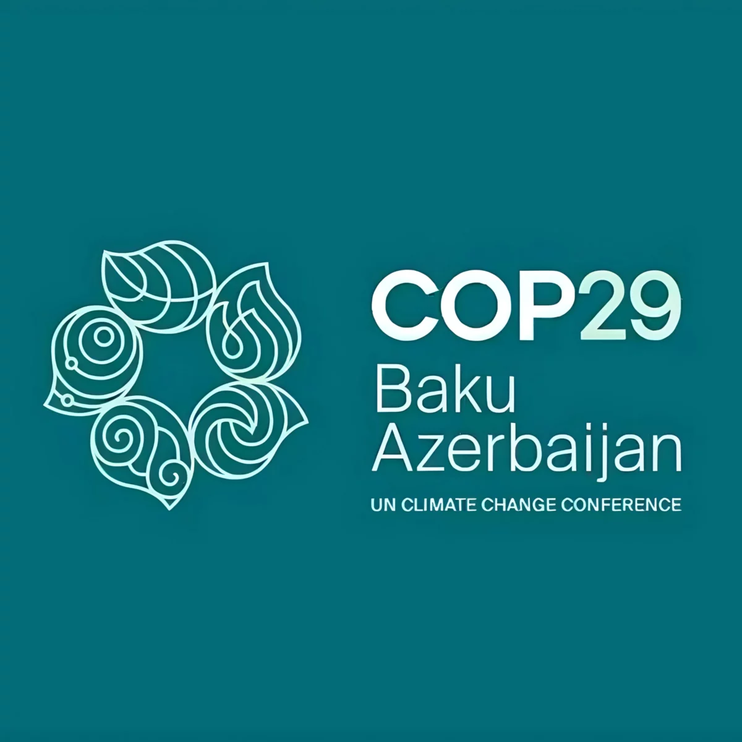

The 29th Conference of the Parties will be held from the 11–22 November, 2024, in Baku, Azerbaijan. Please select a topic from the COP 29 Conference and assess to what extent previous COP conferences addressed it. Second, you will critically discuss your topics prospects after COP 29.

Topics

- Action for climate empowerment
- Children and Youth
- Adaptation and Resilience
- Capacity-building
- Climate Finance
- Climate Technology
- Cooperative activities and SDGs
- Gender
- Global Stocktake
- Innovation
- Just Transition
- Land Use
- Local Communities and Indigenous Peoples Platform
- Market and non-market mechanisms
- Mitigation
- Pre-2020 Ambition and Implementation
- Science
- The Ocean

Your chosen Topic needs to be of particular interest or use to you. You need to engage with your chosen Topic via journal articles and the media forms promoted to facilitate discussion. Please agree on your chosen Topic with A. Flatley.

Assessment Component 2 – 70% (report)

Based on your chosen Topic.
(a) Assess to what extent previous COP meetings delivered on your Topic.
(b) Critically discuss your Topic's prospects after COP 29.

This report should include the inevitable analysis of the success and failures of the conference Topic (4,000 words plus references and appendices).

Examples provided in the SLS can be used to facilitate your report.

Use of Generative AI in Assessment

RESEARCH | For this assessment, you can use Generative AI to support you in research, including searching for bibliography, using tools to summarise, compare and interrogate materials. | Yes ☐  No ☒
STRUCTURE | For this assessment, you can use Generative AI to support you in structuring your submission, including creating a draft argument structure, identifying parts and headings, etc. | Yes ☐  No ☒
PROOFREADING | For this assessment, you can use Generative AI to check your own text/creation for grammatical and syntactical mistakes, including rephrasing of your own work within specific standards. | Yes ☐  No ☒
WRITING | For this assessment, you can use Generative AI to create text for submission. | Yes ☐  No ☒
CREATIVE | For this assessment, you can use Generative AI to create creative materials, such as images. | Yes ☒  No ☐
PROGRAMING | For this assessment, you can use Generative AI to create and check code. | Yes ☐  No ☒
NONE | For this assessment, you are not allowed to use any type of Generative AI support. This includes research support, structure support, writing/proofreading support and creative support. | Yes ☒  No ☐

GUIDANCE FOR Students IN THE COMPLETION OF TASKS

NOTE: The guidance offered below is linked to the five generic assessment criteria overleaf.

- Engagement with Literature Skills
Your work must be informed and supported by scholarly material that is relevant to and focused on the task(s) set; you should make use of scholarly reviews and primary sources, as appropriate (for example, refereed research articles and/or original materials appropriate to the discipline). You should provide evidence that you have accessed a wide range of sources, which may be academic, governmental and industrial; these sources may include academic journal articles, textbooks, current news articles, organisational documents, and websites. You should consider the credibility of your sources; academic journals are normally highly credible sources while websites require careful consideration/selection and should be used sparingly. Any sources you use should be current and up-to-date, mostly published within the last five years or so, though seminal/important works in the field may be older. You must provide evidence of your research/own reading throughout your work, using correctly a suitable referencing system, including in-text citations in the main body of your work and a reference list at the end of your work.

Guidance specific to this assessment: This report should make adequate reference to relevant legislation, policy and examples of initiatives and challenges surrounding your topic through COP. You should refer to latest research on your topic. These will be referenced appropriately using Harvard referencing system.

- Knowledge and Understanding Skills
At level 7, you should be able to demonstrate a systematic understanding of knowledge, and a critical awareness of current problems and/or new insights, much of which is at, or informed by, the forefront of your academic discipline, field of study or area of professional practice, with a comprehensive understanding of techniques applicable to your own research or advanced scholarship. Your work must demonstrate your growing mastery of these concepts, principles, current challenges, innovation and insights associated with the subject area. Knowledge relates to the facts, information and skills you have acquired through your learning. You demonstrate your understanding by interpreting the meaning of the facts and information (knowledge). This means that you need to select and include in your work the contemporary concepts, techniques, models, theories, etc. appropriate to the task(s) set. You should be able to explain the theories, concepts, etc. meaningfully to show your understanding. Your mark/grade will also depend upon the extent to which you demonstrate your knowledge and understanding; ideally each should be complete and detailed, with comprehensive coverage.

Guidance specific to this assessment: You will need to demonstrate strong understanding of key concepts of your subject, informed by relevant research and scholarship. You should aim to construct a balanced critique of the topic through your report.

- Cognitive and Intellectual Skills
You should be able to: evaluate critically current research and advanced scholarship in the discipline; evaluate methodologies and develop critiques of them and, where appropriate, to propose new hypotheses; deal with complex issues both systematically and creatively to make sound judgements in the absence of complete data. Your work must contain evidence of logical, analytical thinking, evaluation and synthesis. For example, to examine and break information down into parts, make inferences, compile, compare and contrast information. This means not just describing what! But also justifying: Why? How? When? Who? Where? At what cost? At all times, you must provide justification for your arguments and judgements. Evidence that you have reflected upon the ideas of experts within the subject area is crucial to you providing a reasoned and informed debate within your work. Your choice of methodologies to gather data and information must be rigorously defended. Furthermore, you should provide evidence that you are able to make sound judgements and convincing arguments using data and concepts. Sound, valid, persuasive conclusions are necessary and must be derived from the content of your work. Where relevant, alternative solutions and recommendations may be proposed.

Guidance specific to this assessment: It is not just enough to state outcomes of your topic. You should create a critical assessment of your topic, with consideration of the context surrounding any key decision making.

- Practical Skills
At level 7, you should be able to demonstrate originality in the application of knowledge, together with a practical understanding of how established techniques of research and enquiry are used to create and interpret knowledge in the discipline. This includes acting autonomously in planning and implementing tasks at a professional or equivalent level, originality in tackling and solving problems, and decision-making in complex and unpredictable contexts or situations.

You should be able to demonstrate mastery of the leading edge subject-related concepts and ideas as they relate to real world situations and/or particular contexts. How do they work in practice? You will deploy models, methods, techniques, and/or theories, in those contexts or circumstances, to assess current situations, perhaps to formulate plans or plausible, justifiable recommendations to solve problems, or to propose new models, or to create artefacts, which may be innovative and creative, thereby demonstrating your understanding of how the boundaries of knowledge are advanced through research and/or application. This is likely to involve, for instance, the use of real world artefacts, examples and cases, the application of a model within an organisation and/or benchmarking one theory or organisation against others.

Guidance specific to this assessment: You will demonstrate an understanding of relevant examples and cases or output for your particular topic. This report should provide a clear statement on how your research was undertaken, with reference to any relevant assessment process (such as PESTEL or SWOT analysis).

- Transferable Skills for Life and Professional Practice
Your work must provide evidence of the qualities and transferable skills necessary for postgraduate-level employment in circumstances requiring sound judgement, personal responsibility and initiative in complex and unpredictable professional environments. This includes demonstrating: the independent learning ability for continuing professional development to advance existing skills and acquire new competences of a professional nature that will enable you to assume significant responsibility within organisations; that you can initiate and complete tasks, projects and procedures, whether individually and/or collaboratively, to a professional level; that you can use appropriate media to effectively communicate information, arguments and analysis in a variety of forms for a variety of audiences; fluency of expression; clarity and effectiveness in presentation and organisation. Work should be coherent and well-structured in presentation and organisation.

Guidance specific to this assessment: Your report will be written clearly with relevant subheadings, title page, contents page, page numbers, references, appendices and other relevant headings. Where appropriate, your report will make reference to appropriate tables or figures.

Student FEEDBACK FORM

This section details the extent to which the assessment criteria are demonstrated by you, which in turn determines your mark. The marks available for each category of skill are shown. Lecturers will use the space provided to comment on the achievement of the task(s), including those areas in which you have performed well and areas that would benefit from development/improvement.

Generic Assessment Criteria | Marks available | Marks  awarded
1. Engagement with Literature Skills
.
 | 15
2. Knowledge and Understanding Skills

 | 15
3. Cognitive and Intellectual Skills

 | 30
4. Practical Application Skills

 | 30
5. Transferable Skills for Life and Professional Practice

 | 10

Assessment Mark (Assessment marks are subject to ratification at the Exam Board. These comments and marks are to give feedback on module work and are for guidance only until they are confirmed. ) | Late Submission Penalties (tick if appropriate) |  | %
 | Up to 1 week late (50% Max) |  | %
 | Over 1 week late (0%) |  | %

GENERIC ASSESSMENT CRITERIA

Level 7
In accordance with the Framework for Higher Education Qualifications, at the end of Level 7 students should be able to demonstrate: a systematic understanding of knowledge, and a critical awareness of current problems and/or new insights, much of which is at, or informed by, the forefront of their academic discipline or area of professional practice; a comprehensive understanding of techniques applicable to their own research or advanced scholarship; originality in the application of knowledge, together with a practical understanding of how established techniques of research and enquiry are used to create and interpret knowledge in the discipline; conceptual understanding that enables the student to evaluate critically current research and advanced scholarship in the discipline to evaluate methodologies and develop critiques of them and, where appropriate, to propose new hypotheses. They will be able to deal with complex issues both systematically and creatively, make sound judgements in the absence of complete data, and communicate their conclusions clearly to specialist and non-specialist audiences. They will demonstrate self-direction and originality in tackling and solving problems, and act autonomously in planning and implementing tasks at a professional or equivalent level to continue to advance their knowledge and understanding, and to develop new skills to a high level. They the qualities and transferable skills necessary for employment requiring the exercise of initiative and personal responsibility; decision-making in complex and unpredictable situations/professional environments; and the independent learning ability required for continuing professional development.

Level 7 | FAIL | FAIL | MARGINAL FAIL | SATISFACTORY  (Pass) | GOOD to VERY GOOD  (Merit) | EXCELLENT  (Distinction) | EXCEPTIONAL  (Distinction)
Category | 0-29% | 30-44% | 45-49% | 50-59% | 60-69% | 70-84% | 85-100%
Engagement with literature (including current research, referencing,  academic conventions and  academic honesty) | Little or no evidence of reading and/or reliance on inappropriate sources.  Views and findings mostly unsupported and non-authoritative.  Referencing conventions used incoherently or largely absent. | Poor engagement with essential reading. No evidence of wider reading. Reliance on inappropriate sources, and/or indiscriminate use of sources. Heavily reliant on information gained through class contact. Inconsistent and weak use of referencing. | Engagement with a very limited range of relevant and credible sources. Some omissions and minor errors.  Referencing conventions evident though not always applied accurately or consistently. | Engagement with an appropriate range of research-informed literature, including sources retrieved independently. Some over-reliance on texts. Referencing may show minor inaccuracies or inconsistencies. | Engagement with a wide range of research-informed literature, including sources retrieved independently.  Selection of relevant and credible sources. Very good use of referencing, with no/very few inaccuracies or inconsistencies. | Engagement with an extensive range of relevant and credible literature, informed by the latest research. Consistently accurate application of referencing. | Exceptional engagement with an extensive range of relevant and credible literature, informed by the latest research. High-level referencing skills consistently and professionally applied.
Knowledge and understanding (A systematic, conceptual understanding of knowledge, and a critical awareness of current problems and/or new insights, much of which is at, or informed by, the forefront of the discipline; a comprehensive understanding of techniques applicable to their own research) | Major gaps in knowledge and understanding of the subject matter is not systematic. Substantial inaccuracies. No awareness of current problems, insights or the latest research and/or advanced scholarship within the discipline. | Gaps in knowledge, with only superficial systematic understanding. Some significant inaccuracies and/or irrelevant material. No critical awareness of current problems, insights, or latest research within the discipline. | Limited knowledge and systematic understanding of the concepts and principles within the subject area, which to some marginal extent, is informed by current research and scholarship. Some critical awareness of current problems and/or new insights, but often under-developed. | Knowledge is accurate and reasonably detailed. A systematic understanding of the field of study informed by, to some extent, current research and scholarship, A critical awareness of current problems and/or new insights though this may be under-developed occasionally. | Knowledge has a well-defined focus, which is reasonably extensive, coherent and detailed, with a critical awareness of current problems and/or new insights. Exhibits good understanding of the breadth and depth of contemporary and established views, and the work is, at least in part, well-informed by current research and scholarship. | Excellent mastery of a complex and specialised area of knowledge. A systematic, excellent understanding of the concepts of the subject informed by current research and scholarship. Highly critical awareness of current problems and/or new insights. A critical, awareness of how the boundaries of knowledge are advanced through research. | Exceptional mastery of a complex and specialised area of knowledge. An exceptionally critical awareness of current problems and/or new insights. An outstanding understanding of the concepts of the subject, well-informed by current research and scholarship. A critical, sophisticated and nuanced awareness of how the boundaries of knowledge are advanced through research.
Cognitive and intellectual skills  (Critical evaluation of current research and methodologies and develop critiques of them and, where appropriate, to propose new hypotheses; make sound judgements in the absence of complete data.) | Wholly or almost wholly descriptive work. Little or no evaluation or critique or attempt at a systematic approach.  Failure to develop arguments, leading to illogical or invalid judgements. Unsubstantiated generalisations, made without use of credible evidence. | Largely descriptive work, with superficial use of critical evaluation of research and methodologies. Absent or weak development of hypotheses and judgements. Information accepted uncritically, uses generalised statements made with scant evidence and unsubstantiated opinions. Ideas sometimes illogical and contradictory. | Limited attempt at critical evaluation/ critique of current research and methodologies, tending towards description.  Limited attempt to propose new hypotheses. Can deal with complex issues but not systematically or creatively. Some evidence to support emerging judgements but these may be underdeveloped or with a little inconsistency / mis-interpretation.  May assert rather than argue a case. | Some critical evaluation/ critique of current research and methodologies, though slightly underdeveloped in places, Proposes adequate but limited new hypotheses, where relevant. Can deal with complex issues but not fully systematically or creatively. Ability to make judgements based on data (that may be incomplete) but with some tendency to assert/state opinion rather than argue on the basis of reason and evidence. | Sound critical evaluation/ critique of current research and methodologies, Proposes new hypotheses, where appropriate. Can deal with complex issues systematically and with some creativity. Ability to make sound judgements based on data (that may be incomplete) | Excellent critical evaluation/ critique of current research and methodologies, Proposes innovative hypotheses, where appropriate. Can synthesise complex issues systematically and creatively. Ability to investigate contradictory or incomplete information and make strong, persuasive, arguments and sophisticated judgements. | Exceptional critical evaluation/ critique of current research and methodologies, Proposes innovative hypotheses, where appropriate. Exemplary systematic and creative synthesis of complex issues.  Ability to investigate contradictory or incomplete information and make strong, persuasive, arguments and sophisticated, nuanced, judgements. Potential for journal publication or doctoral research.
Practical skills  (Originality / creativity in the application of knowledge, tools and techniques and in tackling and solving problems in complex and unpredictable professional situations; practical use of established techniques of research and enquiry to create and interpret knowledge in the discipline.) | Limited or no use of methods, materials, tools and/or techniques.  Little or no appreciation of the context of the application.  Limited understanding of the application of theory to practice or making appropriate links between the two.  Very weak problem-solving skills in complex and unpredictable contexts. | Rudimentary application of methods, materials, tools and/or techniques but without consideration and competence. Flawed appreciation of the context of the application.  Weak understanding of the application of theory to practice, with only occasional evidence of making appropriate links between the two. Weak problem-solving skills in complex and unpredictable contexts. | An awareness and mostly appropriate application of well-established methods, materials, tools and/or techniques, with occasional errors.  Basic appreciation of the context of the application. Theoretical knowledge and understanding applied in practice, but not always making logical links between the two.  Can identify problems and propose basic solutions without fully appreciating the complexity of unpredictable contexts. | An appropriate application of standard methods, materials, tools and/or techniques.  Clear appreciation of the context of the application. Mainly consistent, accurate and logical application of theory to practice, making appropriate links between the two.  Can identify problems and propose mostly appropriate solutions in complex and unpredictable contexts, with elements of originality. | A very good application of a range of methods, materials, tools and/or techniques.  Very good consideration of the context of the application, with perceptive insights. Can identify problems and propose appropriate solutions in complex and unpredictable contexts.  Evidence of originality and creativity. | An advanced application of knowledge, methods, materials, tools and/or techniques.  The context of the application is well considered, and insightful.  Can identify complex problems and propose excellent solutions. An excellent grasp of techniques applicable to own research or advanced scholarship.  Shows originality in application of knowledge and techniques, and of how established techniques of enquiry create and interpret knowledge in the discipline. | Exceptional application skills in complex, unpredictable, contexts, drawing skilfully on the latest research within the discipline. Can identify complex problems and propose sophisticated, original solutions.  An outstanding application of techniques applicable to own research or advanced scholarship.  Shows originality in application of knowledge and techniques, and of how established techniques of enquiry create and interpret knowledge in the discipline with assimilation and development of cutting edge processes and techniques.
Transferable skills for life and professional practice  (Exercise of self-direction, autonomy and personal responsibility; plan and implement tasks at a professional level; independent learning; use appropriate media to communicate effectively and professionally to a variety of audiences; fluency of expression; systematic approach; clarity and effectiveness in presentation and organisation.) | Communication medium is inappropriate or misapplied.  Work is poorly structured, disorganised and/or confusingly expressed. Very weak use of language and/or very inappropriate style. Little or no evidence of autonomy (or collaboration, where relevant) in the completion of tasks. Little or no evidence of the skills required in professional, postgraduate employment. | Communication medium is poorly designed and/or not suitable for the audience.  Work is poorly presented in a disjointed manner. It is loosely, and at times incoherently, structured, with information and ideas often poorly expressed. Weak use of language and/or inappropriate style. Weak independent initiative (or collaboration, if relevant). Limited evidence of the skills required in professional, postgraduate employment. | Can communicate in a suitable medium but with some room for improvement.  Mostly ordered presentation and structure in which relevant ideas / concepts are reasonably expressed. Work may lack coherence in places. Can work as part of a team, but with limited involvement in group activities.  Demonstrates some but not all of the basic skills required in professional, postgraduate employment, with some areas of minor weakness. | Can communicate effectively in a suitable format, but may have minor errors.  Mostly coherent, organised work, in a suitable structure and is for the most part clearly expressed. Can work effectively independently and/or as part of a team, with clear contribution to group activities.  Demonstrates the skills required in professional, postgraduate employment, with some areas of strength and some of minor weakness. | Can communicate well, confidently and consistently in a suitable format.  Work is coherent, fluent, well-structured and organised. Can work very well autonomously and/or as part of a team, with a good contribution to group activities.  Demonstrates comprehensive professional, postgraduate employment skills. | Can communicate professionally confidently and consistently in a suitable format.  Work is coherent, very fluent and is presented professionally. Can work autonomously with initiative. Where relevant can work professionally within a team, showing leadership skills as appropriate, managing conflict and meeting obligations. Demonstrates excellent professional, postgraduate employment skills and a strong appetite for further development. | Can communicate with an exceptionally high level of professionalism.  Work is remarkably coherent, very fluent and is presented professionally. Can work outstandingly well and professionally within a team, showing advanced leadership skills. Demonstrates exemplary professional, postgraduate employment skills and a strong appetite for further development.

THIS DOCUMENT IS ALSO AVAILABLE IN WELSH

