PROBLEM SOLVING AND DECISION MAKING REPORT
MODULE : BMSW 4004
Student ID: 1921231
Student Name: WARIS QADRI
Lecturer’s Name: JULIUS AZASOO

Student ID:
Student Name:
Lecturer’s Name:

Table of Contents
1 Introduction 3
2 Discussion 4
2.1 Nature and Impact of Complex Issue 4
2.2 PESTLE Analysis 5
2.2.1 Political 5
2.2.2 Economic 6
2.2.3 Social 6
2.2.4 Technology 6
2.2.5 Legal 6
2.2.6 Environment 7
2.3 Cause and effect analysis 7
2.4 Strategies to Provide Solution of the shortage of staffm 8
2.4.1 Proper Attendance Policy 8
2.4.2 Incorporating a Reward System 8
2.4.3 Proper Feedback Policies 8
2.5 Plan to Implement the Solution 9
2.6 Measures of the Effectiveness 9
3 Conclusion 9
4 References 10

Introduction
In an organisation, problem-solving is the main aspect in order to pursue success as well as to maintain its future goal. According to Harvey et al. (2020), problem-solving is referred to as an analytical process which is used to identify the possible solutions to the situation at hand, in order to resolve the solution, the initial step after the identification of the issue is to decide in order to act accordingly. The selection of this decision allows an organisation to ensure its future progress. In line with this, the aim of this report is to identify the solution of the NHS which is dealing with the high rate of employee turnover, and the limited staff has not only increased the workload but also influenced the nature of the provided service to the patients. At the same time, this research report has represented the research-informed discussion on the nature as well as the impact of the complex issue on the employees as well as on their organisation. In addition to this, through the PESTLE analysis, the macro-environmental factors have been identified which are leading to employee turnover at NHS. In addition to this, in order to be more effective, this report has represented the issue through the fishbone. After that, An evaluation of alternative solutions to staff shortage to choose the most appropriate solution among these alternatives has been represented.

Discussion

Nature and Impact of Complex Issue
According to Matemani, (2019), in order to maintaining management practices as well as to make sure that the employees must be comfortable with their assigned jobs. The shortage of employees in an organisation occurs when the demand for a particular employee is beyond the supply of the workers who are qualified, available as well as enriched to perform the work under the existing conditions of the market. In addition to this, as in NHS the shortage of workers has been identified which is leading because of numerous reasons, additionally, there are a few reasons of the management that have been identified which is throwing a negative impact on the productivity of the employees of the NHS. The influenced productivity is ultimately influencing the provision of care to the patients as well. Based on the explored information provided by Ndawo, (2021), it has been overlooked that for the administration of the providers it is a serious issue, and it needs to be fixed in order to continue the care service as well as to ensure that the patients are being facilitated through the provided service. However, it is leading to the infecting g the productivity of the NHS, as well as the employees of the organisation, which have been required to throw a negative impact on the productivity of the business. The health care provider at HNS has been found afraid that if this trend goes on for a long time, then the care providers might be forced to cut back on their services or extinction might be faced.
Sheketa et al. (2019), have indicated that in HNS, the unsuitable office, as well as poorly built stations of the workplace, might throw a negative influence on productivity. It usually happens, while working at the medical facility in the presence of the lack of ventilation as well as at the time of excessive noise. A negative impact on the mental health as well as the morale of the employees can be identified due to the poorly designed environment at the workplace, which leads to job dissatisfaction as well as a low level of motivation have been observed. In the same manner, it has been noted that the health of the workforce of an organisation directly influences the feelings of the employees towards their workplace.

PESTLE Analysis
PESTLE analysis is a model which is used to find out the impact of some of the external environmental factors on business productivity. In line with this, through the identification of the factor which includes political, economic, social, technological, and legal as well as the environment the reasons for the issues in the NHS have been identified.
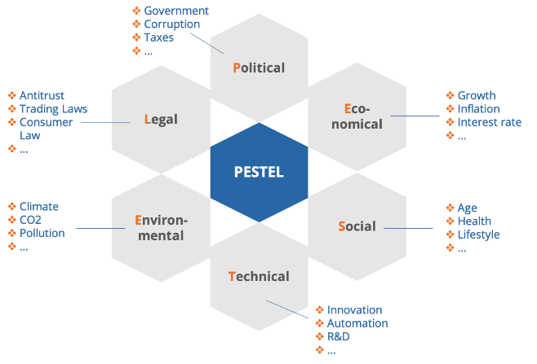
Figure 1 PESTLE analysis model
Source (Thomas et al., 2021)

Political
The political factors which have raised the issue at the NHS are based on the identification of some of the factors which have been mentioned further. According to Allsop, (2018), Brexit is the most divisive subject in British politics, still, the fact has not been discovered yet how Brexit might influence the NHS, there are numerous publications have been assumed yet but none have been planned for the future of the NHS. Considering this, NHS personnel could be adversely affected if Brexit results in more difficult or less acceptable living conditions for immigrants (Buchan et al., 2018).

Economic
The crises due to the economy in the UK in the last quarter of 2008 have a huge contribution to the current situation of the NHS. Due to the economic crises, NHS cannot provide effective therapy for patients because, due to financial imbalance, it has become hard to keep the employee for a long time. In addition to this, it has been noted that the training industry is suffering from the scarcity of qualified staff as their economic ability is not able to fulfil their demands.

Social
Social factors, factors have been identified, particularly the demands of the patients for qualified care are enlisted. According to, Kerr (2018), in order to maintain as well as to train the late-onset diseases for instant diabetes as well as the serval cancers, the costs of the service might be prohibitive. In the UK, the National Health Service (NHS) is dealing with the increased demand due to the ageing population. In addition to this, apart from the low rates of morality, the NHS has encountered new challenges in order to provide better care as compared to the previous experience (Dyrbye et al., 2019).

Technology
In the NHS, the involvement of technology is helping the organisation in order to deal with the identified issues concerning the organisational development in improving the health care facilities. In healthcare institutions, scanning technologies have become a need because of their low cost, data access process become easier along with the availability

Legal
In the management and the progress of the organisations, legal factors tend to influence, and it is dealing with the reputation of the organisation as well. In addition to this, in the case of the NHS, the legal factors are leading to influencing the internal business activity. There has been an uptick observed against the health care professional which has fallen short of the expectation of the patients. According to Christodoulou, and Cullinane, (2019), the cost of legal tends to defence as well as repeat the settlements, which will add meaningfully to the budget system of the healthcare industry.

Environment
Some reasons related to the performance of the environment have been noted that influence the performance of the employees at the NHS. In this manner, the extremes of the temperature can lead to overheating. In the end, the health care provider's overall performance is affected.

Cause and effect analysis
The help of causes and effect analysis helps the individual to find out the reasons which have led to the particular issue (Moorthi, 2018). It has been noted that in the case of the NHS and its rising issues this analysis can be proved beneficial in order to find the reasons and that reasons can be minimised for the sake of effective outcomes.
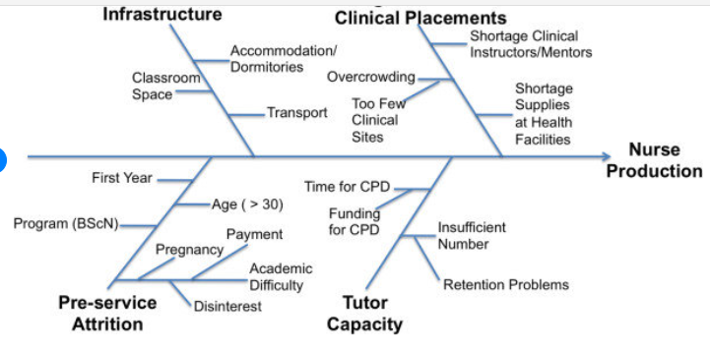
Figure 2 Fishbone
Source: self-made (2022)
According to, Henshall et al. (2022), it has been noted that a problem with the operations of the business firm, equipment, or atmosphere may be the root of long wait times. The fishbone has indicated that the shortage of staff has thrown an impact on the productivity of the nurses, the reasons which have caused the influence on performance include the infrastructure of the NHS as well as placements of the clinical. Under the placement of the clinic, the shortage of clinical instructors as well as mentors, and the shortage of supplies at the health facilities has led to the impact on the production of the nurse as well as due to the workload and the lack of training the high rate of the absenteeism has been noted among the available staff. In addition to this, it has been noted that the case of care service provided by the side of nurses might throw a negative impact on the productivity of the employees.

Strategies to Provide Solution to the shortage of staff
In business development, there is a need to focus on strategies which can reduce the rate of shortage of staff. Some of the strategies which can help to deal with absenteeism include the following strategies:

Proper Attendance Policy
In the organisation, since already the employee turnover rate is high, therefore it needs to focus on the increase the attention of the already present employees in the NHS. In addition to this, it has been noted that in the case of the provide the solution for reducing employee shortage there is a need to focus on the provision of the proper attendance policy. According to Gubbels et al. (2019), for proper care, the procedures in order to report the absences as well as to keep engaging the employees this policy needed to be established.

Incorporating a Reward System
In order to focus on the reduction of employee shortage, there is a need to focus on the innovation of the reward system. Utami et al. (2021), have demonstrated that the employees who focus on punctuality are deserved to be awarded, and the recognition of the business firm towards the punctual employee will boost the dedication of the employee.

Proper Feedback Policies
In addition to this, in order to keep engaged the employees the provision of feedback to the employee will help the management of the NHS in order to contribute to the enhancement of employee productivity. Considering this, regular, as well as actionable feedback, needs to be given to the employees, particularly after when an employee performs well, it is the responsibility of the staff to appreciate the employee.
After mentioning all the available strategies for the NHS, it has been noted that for the NHS the best strategy would be the reward policy. Since for all the employees in an organisation, the only way to keep them motivated is the provision of rewards and extra income helps them to contribute to the daily work activity.

Plan to Implement the Solution
In order to plan the solution for NHS, the selected way is to first reduce the rate of shortage of staff due to which the organisation can be able to focus on the keep of the already present employees in the organisation. In the NHS the first step is to engage the employees for a long time and there is a need to ensure that the nurses must be attentive to their job (Hassanein et al., 2020). The employees will be offered the reward system, in this step the management must be focusing on the fact that all the employees must be aware of the degree to which the provision of the policy will be applied as an imperative which has been signed off on it.

Measures of the Effectiveness
The measures of the effectiveness of the plan are based on the factors which have allowed the employees in order to determine the nature of the employee nature. Since the reward, as well as the extra income, is the best motivation for the employee it helps the management order to keep them engaged and to keep them connected with their job. In addition to this, another measurement of the plan is based on the use of technology since in the 21st century the involvement of technology empowers the staff to focus on their goal.

Conclusion
The first step after identifying the problem is to decide in order to act accordingly. Problem-solving is referred to as an analytical process that is used to find potential solutions to the situation at hand. By making this choice, an organisation can guarantee its continued growth. The NHS must have focus on the identification of strategies in order to reduce the rate of absenteeism and to keep engaging the already present employees at NHS, then the focus on employee recruitment will be effective for the employees.

References
Allsop, J., 2018. Health policy and the NHS: towards 2000. Routledge.
Christodoulou, A. and Cullinane, K., 2019. Identifying the main opportunities and challenges from the implementation of a port energy management system: A SWOT/PESTLE analysis. Sustainability, 11(21), p.6046.
Dyrbye, L.N., Shanafelt, T.D., Johnson, P.O., Johnson, L.A., Satele, D. and West, C.P., 2019. A cross-sectional study exploring the relationship between burnout, absenteeism, and job performance among American nurses. BMC nursing, 18(1), pp.1-8.
Gubbels, J., van der Put, C.E. and Assink, M., 2019. Risk factors for school absenteeism and dropout: a meta-analytic review. Journal of youth and adolescence, 48(9), pp.1637-1667.
Harvey, T.R., Corkrum, S.M., Fox, S.L., Gustafson, D.C. and Keuilian, D.K., 2022. The Practical Decision Maker: A Handbook for Decision Making and Problem Solving. Rowman & Littlefield.
Hassanein, R.A.A., Al-Qassas, S.A., Tir, F.N.A. and Abu-Naser, S.S., 2020. Artificial neural network for predicting workplace absenteeism. International Journal of Academic Engineering Research (IJAER), 4(9).
Henshall, C., Jones, H., Smith, T. and Cipriani, A., 2022. Promoting inclusivity by ensuring that all patients with mental health issues are offered research opportunities in the NHS. Evidence-Based Mental Health, 25(1), pp.e1-e1.
Kerr, R., 2018. Empowering NHS leaders to lead.
Matemani, J.K., 2019. IMPACTS OF LABOUR SHORTAGE ON ORGANIZATION PERFORMANCE: A CASE STUDY MINISTRY OF WATER AND IRRIGATION-TANZANIA. International Journal of Economics, Business and Accounting Research (IJEBAR), 3(03).
Moorthi, S., 2018. Problem solving skills among college students. International Journal of Innovative Research Explorer, 5(4), p.207.
Ndawo, G., 2021. Facilitation of emotional intelligence for the purpose of decision-making and problem-solving among nursing students in an authentic learning environment: A qualitative study. International Journal of Africa Nursing Sciences, 15, p.100375.
Sheketa, V., Romanyshyn, Y., Vovk, R., Pikh, V. and Pasyeka, M., 2019, October. Formal methods for solving technological problems in the infocommunications routines of intelligent decisions making for drilling control. In 2019 IEEE International Scientific-Practical Conference Problems of Infocommunications, Science and Technology (PIC S&T) (pp. 29-34). IEEE.
Thomas, P.J.M., Sandwell, P., Williamson, S.J. and Harper, P.W., 2021. A PESTLE analysis of solar home systems in refugee camps in Rwanda. Renewable and Sustainable Energy Reviews, 143, p.110872.
Utami, P.P., Widiatna, A.D., Karyati, F. and Nurvrita, A.S., 2021. Does Civil Servant Teachers' Job Satisfaction Influence Their Absenteeism?. International Journal of Evaluation and Research in Education, 10(3), pp.854-863.

