The journey inside
Building a Personal Development Plan

This report has been written as an assignment to Academic & Employability Skills course at T.S.D. University, London Campus

Biancamaria Di Napoli
30 December 2018

TABLE OF CONTENTS

- INTRODUCTION pg. 3

- STARTING POINT pg. 4
2.2 WHERE AM I? pg. 4 - 5

- DESTINATION POINT pg. 6

- FUELL STATION pg. 7

- BE SAFE pg.7 – 8

- CONCLUSION pg. 9

BIBLIOGRAFY pg. 10 – 11
REFERENCES pg.12
APPENDIX:
APPENDIX 1 pg. 13 – 14
APPENDIX 2 pg. 15 – 18
APPENDIX 3 pg. 19 – 24
APPENDIX 4 pg. 25 - 27

- INTRODUCTION

This report is a reflective discussion based on drafting my Personal Development Plan. This process has led me to examine my goals and desires and it has rekindled my desire to dream again. In this way, my journey starts, as a deep look inside myself trying to understand my location first and defining my destination point then. The trip planning is tricky but terribly motivating and I found interesting evaluating different pathways as a request to different situations. The material consulted helped me to calibrate my compass and to achieve the knowledge of how to plan my journey. So, let start!

- STARTING POINT

My journey starts with me. When I was introduced for first in my AES lecture to the Personal Development Plan (Appendix 1), I approached it as an academical homework, but I quickly realized it was something more than that. In the beginning, I could not even start to fill the form that our lecturer gave us. I had to fix targets to achieve and skills to improve, but first of all, I had to give an overview to Bianca. I had to critical analyse myself and comprehend what really was already inside. In this purpose, I found really useful the video of Dr. John Kenworthy (2013), who helped me to identify my starting point and to figure out all the processes as a journey in which I was involved. The most stimulating part was to analyse my strengths and I was surprised to find a determined and ambitious person, being curious and passionate to catch new knowledge, with perseverant motivation to reach new targets and looking forward new challenges. What about my weaknesses? Time management is one of those because I use to dedicate a lot of time and personal energy to my job and at the end of the day there is not that much left for my interests and myself and also when I have time off I have never planned to get maximum profit from it. These are the bases for my Personal Development Plan(PDP) to convert in a PowerPoint Presentation to briefly introduce myself to my classmates. I found this experience very powerful to improve my personal confidence and organize my communication skill. I built a very simple PowerPoint Presentation (Appendix 2), only eight slides, essential text with key points of my message and few citations who enforced what I wanted them to perceive and final space for answering questions to involve my audience.

2.1 WHERE AM I?

Building my PDP meant establish S.M.A.R.T., Specific, Measurable, Attainable, Relevant, Time based, (Toolshero,2013) and realistic goals to reach through my University path. In this picture, High Education learning, rules an important part in reaching the expected results. In which way, could I really be successful and maximise my learning? What exactly is my learning style? In this evaluation was really useful the ‘Kolb’s learning questionnaire’ (Appendix 3), which shows that my learning style is Reflector, and I really recognised myself in the profile description, because I am a kind of meditative person, before to develop my conclusion I like to listen and observe others opinions and reaching this awareness help me to elaborate next step to improve my learning. Learning anyway is a brain process and it involves specific skills and about it I found very interesting the material exposed in the University of Manchester website(2018), who spots as required skills for High Education Learning: Networking, as a way to create new connections with other students and create study groups; Time management, to organise and plan in advance the time you will need to accomplish your studies; Resilience, to accept and manage critical opinions about your ideas or your assignments; Presentation Skill, to introduce in a successful way yourself, your skills and your projects; Leadership and Management, is fundamental to organise your assignment and analyse your skills progress. So, result essential to work constantly to develop and improve these skills to optimise the learning process and it also helps to meet the need of your future employer. This kind of scenario needs to be also considered in reaching goals, in fact, I am talking about the Employability skills that need to be cultivated during the journey, that make you an attractive candidate in the job market. YouTube gave me very practical material(Career experts,2016) that identify as wanted skills: Team Work, it is very important to be open and flexible to work and cooperate with all the members of the team to accomplish a common project; Communications Skill, to express in a common language our needs or our contribution to complete a task; IT Skills, technologies are everywhere so it is important to have knowledge about how to use them in a profitable way; Problem Solving, being proactive is possible to focus on a practical solution to improve the situation and solving problem; Time Management, to implement the productivity of working hours having a plan with priorities; Customer Awareness, to prioritise customer needs and requests. To understand where exactly I was in my virtual map to achieve my goals, I also did a Self-Evaluation Test to compare the results with my awareness, to have an objective evaluation of my skills. I conducted the Mind Tools Questionnaire (Mind Tools,2016) and the results (Appendix 4) shows that I have a good Leadership and Management skills (score 11 out of 15), satisfying Communication skill (score 12 out of 15) and Personal Mastery (score 8 out of 10), as I was already conscious and on the contrary, I was disappointed with a low score in Problem Solving and Decision Making skills (score 7 out of 15) where I was thinking to be really confident, and high score in Time Management (score 18 out of 20) that I considered to be my weakness at a first observation of myself using SWOT analysis of Dr. John Kenworthy (2016). I found this kind of exercise really constructive because it gave valuable information about my personal skills and helped me to individuate an opportunity in the skills where I need to progress.

- DESTINATION POINT

When I first start to draft my PDP, I noticed it was quite hard to establish short and long-term goals, I knew that my main goal it was to became Data Analyst and for this reason I joined the Cloud Computing Courses in T.S.D. University, but I could not really understand why I had to set up something else in the middle. It was when I started to see the Data Analyst as destination point of my journey, that I realised that I needed to fix intermediate stops to define my path. In this way, I could also be aware of my exact position in my travel way and I could evaluate if the timing it was sticking to the planned one. So I identify my first step in short-term goals, that consists in being confident in small activities with computer, as for instance be confident user of Python as programming language and to be able to connect devices in a small network; the second step is identified in middle term goals in which I start to became more confident with Cloud Computing Technologies and I am able to analyse, project, plan and realise a project’s object, and as destination point there is the long-term goal where I have all the knowledge and University experience to be a Data Analyst and be able to translate data in relevant information. During this journey, the reaching of every single stage is strictly connected with skills development and in this perspective, is suitable to have an Action plan in place to attain or improve the Academic and Personal Skills. For instance, coming back to my Self-Evaluation analysis, Problem solving and Decision Making is a kind of skill that I need to improve during my journey and I can ensure to make progress elaborating an Action Plan, which in practice by definition is: “A sequence of steps that must be taken or activities that must be performed well, for a strategy to succeed.” (Business Dictionary, 2006).

ACTION PLAN
SKILLS TO IMPROVE | PROBLEM SOLVING AND DECISION MAKING
MY GOAL | To be able to solve a problem/make a decision, evaluating all the options available
PRACTICAL STEP I WILL TAKE TO ACHIEVE THE GOAL | Understand the root of the problem using 5 whys approach;pondering all the possible resolutions in term of time and effectiveness; put in place one solution and check the outcome.
RESOURSE | Lecturer,  Empirical observation

Ultimately using this action plan I can be sure to transform my weakness in strength and above all, it gives me a practical instrument to increase my performance.

- THE FUEL STATION

One of the most important aspects who contributes in reaching targets and improving skills is the way in which we manage our time. So, Time Management is not only a skill to develop but is the essential part, is the core of all the PDP. We cannot ignore that the quality of our life is strictly correlated to the way in which we spend our time and then we can easily consider it the fuel who ensures we can make our journey. For this reason, it is fundamental to Plan and to Organise our time, to be sure to reach the right balance to achieve our targets in all the different aspects of our life. I really liked Brian Tracy’s approach to time management, I founded really practical and effective. In his book ‘Eat that frog’, he suggests to “think on paper”, drawing down a list of tasks that need to be done and prioritised, then the frog that we need to eat is the most important task that needs to be done. Procrastinating is not necessary; it would only increase our frustration level.
Of course, we can use this kind of approach to improve our Time Management skills, making a list of our priority in all the parts of our life and ensuring we will stick with the list eating the frog first (2017, pg.8). By Time management depends also the travelling time between the steps of our path to our goals, so it is very important before to develop a PDP to evaluate exactly how we intend to manage our time.

- BE SAFE

In our journey, and in our lives in general, we are surrounded by technology and electronics devices, all the information and sensitive data are in a digital format and actually, this is a big advantage, because it makes the information immediately available, but it represents also a big risk for our digital material. We store our digital data in different kind of devices, like smartphone, tablet, computer and we use to share it in our daily life, sometimes, without any awareness, like for instance when we buy something online or when we share digital file with our university colleagues. Well, in the same way, our data go virtually out from our device, other kinds of data can come in putting in danger our sensitive information. About this topic I found very useful all the materials exposed during the Academic & Employability Skills lecture (Bocij et al., 2014), in fact they explain in which ways we can really compromise or lose our data: Accidents, where we can lose data because of an error of data entry or maybe for an update of a new software application and part of our data could be lost, or more easily deleting by mistake; Natural disaster, situations like an earthquake or fire events, that physically compromise our devices and as a consequence our data; Sabotage, where someone deliberately manipulate our data using logic bomb, back door, data theft; Malware, where a malicious software as a virus, a Trojan horse or spyware, comes unnoticed in our device stealing our data; Hacker and Cracker, where someone manages to circumvent the security barrier of a system having access to sensitive data. So, in which way we can really protect our data? During our University path, we need to start to be sensitive to this kind of problematic because of our assignments or projects stored as a data. Of course, we can resort to a regular backup of our data, but I found ingenious the ‘3-way backup rule’ explained in an online article by Alex Mayer (2017), following this system we should have all the times three copies of our data. The first one in our main device, we could operate a partitioning of our hard drive and store our data in one of the segments generated from the portioning process; the second copy it could be stored on an external hard drive or in another device; and the third one in an offsite storage or cloud, as One Drive, Dropbox and similar. Using this system for protecting my data I can be sure that in every situation at least I can access to a most recent copy of my backup, for instance in case of accident, or sabotage or malware on my personal device, I can still count on my copy saved in an external hard drive or in the cloud, or in case of natural disaster in which I could lose my devices and my external hard drive, I can still count on my data saved in the cloud. This is a very practical and easy way to manage our personal data and I founded really quick to put in place.

- CONCLUSION
From when I started my journey, I had to manage how to deal with my personal limits and self-awareness, and I found an unexplored world, which immediately frightened me, placing me in front of new questions and kidnapping me with its multiple choices then. I had to face my weaknesses and build my refuge on my strengths and it was only in this point that I could see my position in the map. Everything, that was previously blurred, it began to take a shape and I commenced to glimpse a destination. Through a Personal Development Plan, I could easily draft the way, evaluating the available resources and the time needed for each step, I could also build an Action Plan as a strategy to face the obstacles during my way, improving my soft skills. I also learnt how to manage the most precious thing I have: the time. There is a correspondence between time and happiness, time and satisfaction, time and personal power; the key to happiness can be identified in the way which we manage our time. Everything is related to it, above all in an academical environment we need to be able to understand our priorities in term of time making our journey smooth. Having also a clear awareness of safety, give me the chance to learn and use a new and more effective system to protect my personal data. In this module, I accepted the challenge of questioning myself as a person, and what I learned goes beyond a knowledge that will help me in my academic and work life. I realized that I control my path and that though the cognitive processes I can continuously renew myself with new skills to be acquired.

BIBLIOGRAFY

Alexander Lynch, (2012), Personal Development Plan, Available at https://www.youtube.com/watch?time_continue=5&v=qpBLrqsDMhM (Accessed: 27/12/2018)

BNETvideo, (2011), 7 Step Problem Solving, Available at https://www.youtube.com/watch?time_continue=29&v=s1lt6pwIF1o (Accessed: 27/12/2018)
Brian Tracy, 2017, Eat that frog, Ed. Yellow Kite

Bryan Tracy, (2012), Improve your problem-solving skills, Available at https://www.youtube.com/watch?time_continue=29&v=s1lt6pwIF1ohttps://www.skillsyouneed.com (Accessed: 27/12/2018)
Career Key, (2017), Identify your skills, Available at https://www.careerkey.org/identify-your-skills/ (Accessed: 27/12/2018)
Chrissy Scivicque, (2011), 10 Steps to create your personal development plan, Available at https://www.youtube.com/watch?time_continue=1&v=Dj8pG-oHQg0 (Accessed: 27/12/2018)

Elizabeth Bacchus, (2010), Changing your career: How to identify your transferable skills, Available at https://www.theguardian.com/careers/careers-blog/changing-your-career-how-to-identify-your-transferable-skills (Accessed: 27/12/2018)
Jhon Whitehead, (2016), What are soft skills?, Available at https://www.youtube.com/watch?time_continue=1&v=Tiy2LONr050 (Accessed: 27/12/2018)

LifeTurnAroundNow, (2010), Do you have a personal development plan?, Available at https://www.youtube.com/watch?time_continue=2&v=HMmnYSVOAGA (Accessed: 27/12/2018)

LoveYourPencil, (2012), Writing a reflection, Available at https://www.youtube.com/watch?v=WjLa2sJjla0 (Accessed: 27/12/2018)

Study Sidney, (2017), What can you do to make yourself more employable?, Available at https://www.youtube.com/watch?time_continue=1&v=QmCB3WekZvg (Accessed: 27/12/2018)

TED-Ed,(2013), Working backward to solve problems, Available to https://www.youtube.com/watch?time_continue=1&v=v34NqCbAA1c (Accessed: 27/12/2018)

Trevor Ragan, (2014), Leaerning – How it works & How to do it bettervft. Seth Godin, Available at https://www.youtube.com/watch?time_continue=3&v=u9WpHHJz5Dc (Accessed: 27/12/2018)

UDCVideo, (2012), Stella Cottrell – What is PDP? , Available at https://www.youtube.com/watch?time_continue=3&v=HoG0fi4S_dU (Accessed: 27/12/2018)

University of Derby, (2016), How do I develop my employability skill? – Tony Walker Deputy MD – Toyota, Available at https://www.youtube.com/watch?time_continue=1&v=0k7GcHhpLCE (Accessed: 27/12/2018)

Victoria Careers and Employement, (2016), Employability explained, Available at https://www.youtube.com/watch?time_continue=1&v=xIGEt4NKkwo (Accessed: 27/12/2018)

REFERENCES

Alex Mayer, (2017), The 3-2-1 backup rule- An efficient data protection strategy, Available at https://www.nakivo.com/blog/3-2-1-backup-rule-efficient-data-protection-strategy/, (Accessed 26/12/2018)
Brian Tracy, (2017), Eat that frog, Ed. Yellow Kite
Business Dictionary, (2006), Action plan definition, Available at http://www.businessdictionary.com/definition/action-plan.html (Accessed 26/12/2018)
Career Experts, (2016), Employability Skills: Have you got them?, Available at https://www.youtube.com/watch?time_continue=9&v=G_kzfEDOdo8 (Accessed 26/12/2018)
Dr John Kenworthy, (2013), Personal SWOT Analysis, Available at https://www.youtube.com/watch?v=M-rOQ3hJWsw, (Accessed 27/12/2018)

Jeff Hajek, Velaction videos, (2009), 5 Whys Root Cause Analysis Problem Solving Tool - Video Training, Available at https://www.youtube.com/watch?time_continue=350&v=zvkYFZUsBnw, (Accessed 27/12/2018)
Mind Tools, (2016), Get started with Mind tools – Test your skills!, Available at https://www.mindtools.com/pages/article/get-started.htm (Accessed 26/12/2018)
Paul BociJ, Andrew Greasley, Simon Hickie, (2014), Business Information Systems, 5th edn: Technology, Development and Management for the E-Business (Accessed 24/12/2018)

Toolshero, (2013), SMART goals, Available at https://www.toolshero.com/time-management/smart-goals/, (Accessed 24/12/2018)
University of Manchester web site, (2018), An academic career, Available at http://www.academiccareer.manchester.ac.uk/about/do/skills/, (Accessed 24/12/2018)

APPENDIX 1

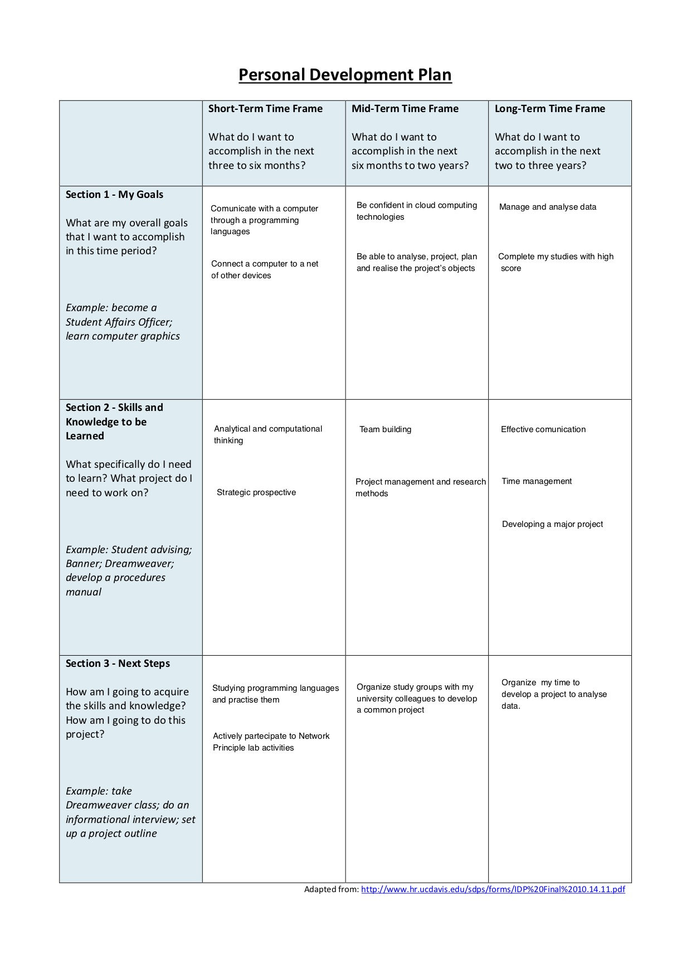

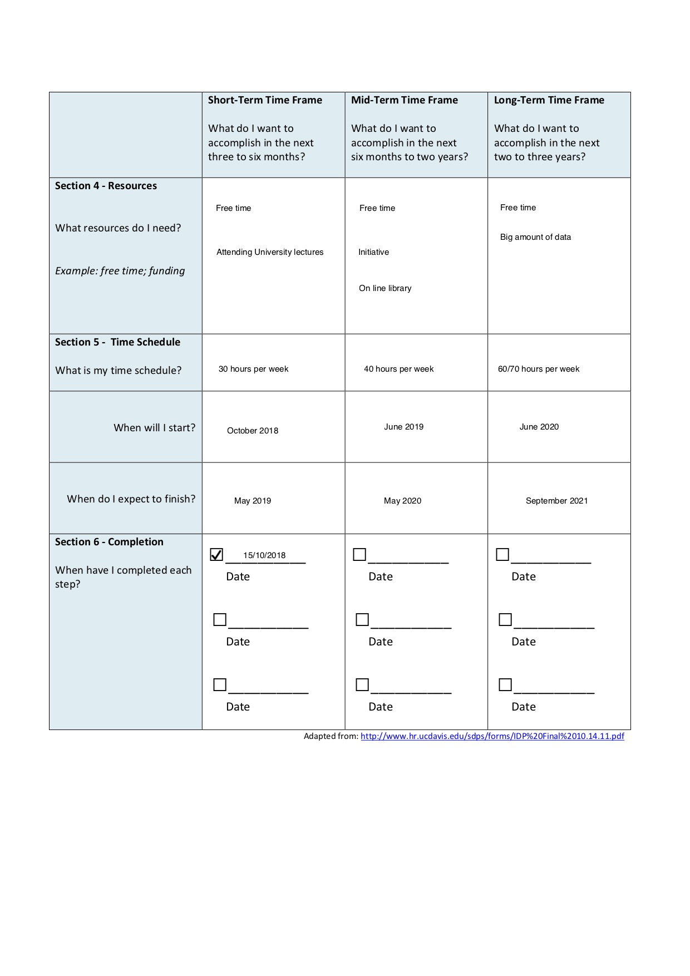

APPENDIX 2


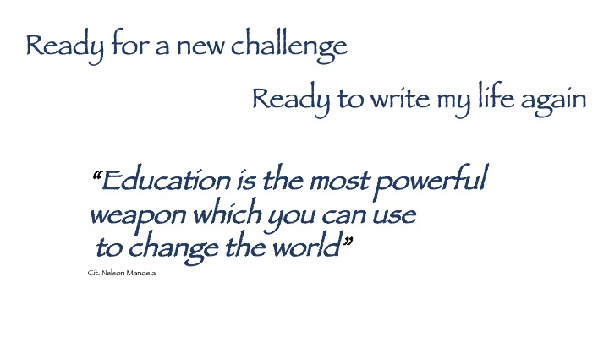

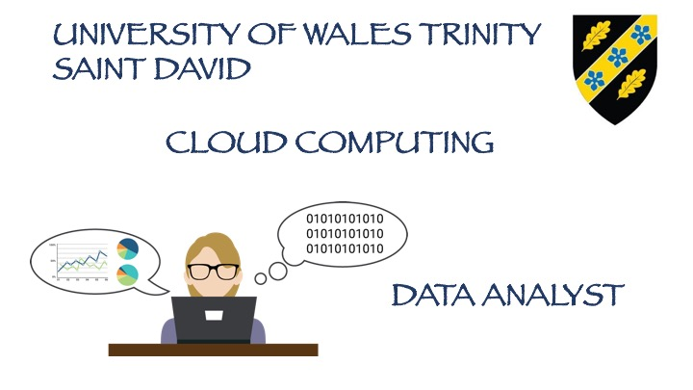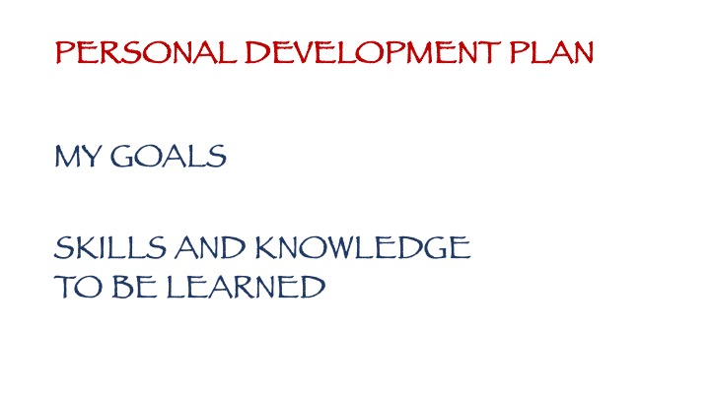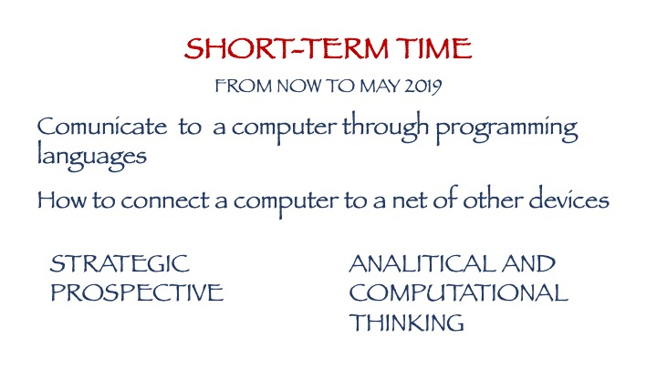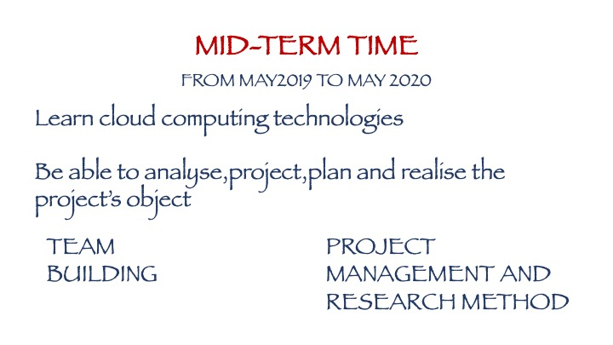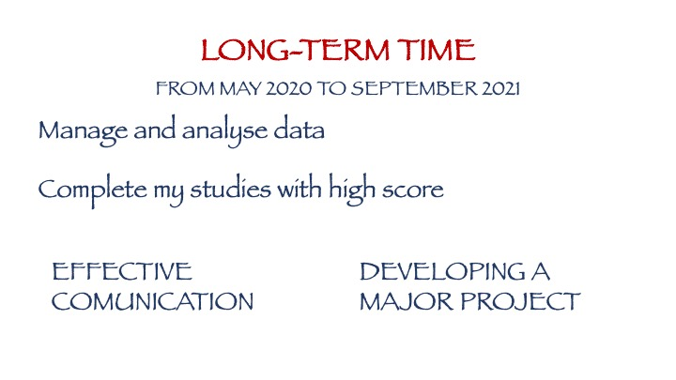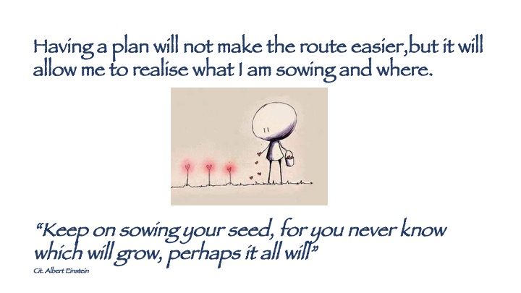

APPENDIX 3

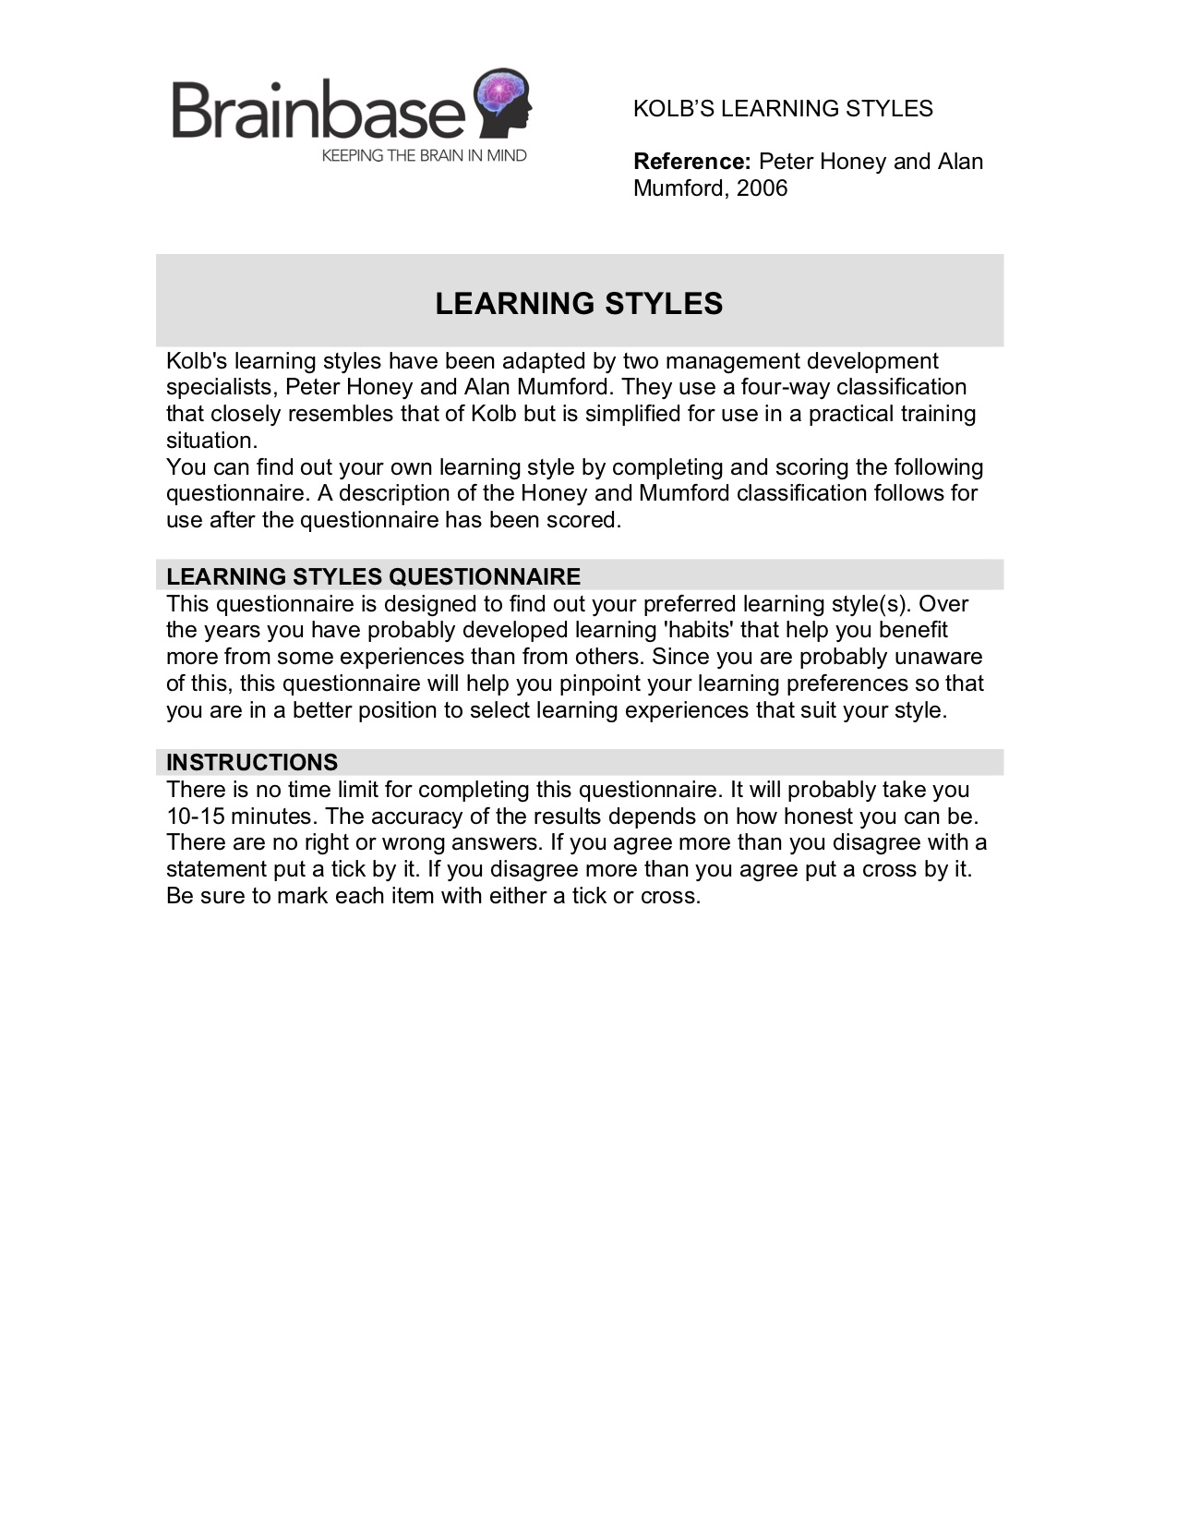
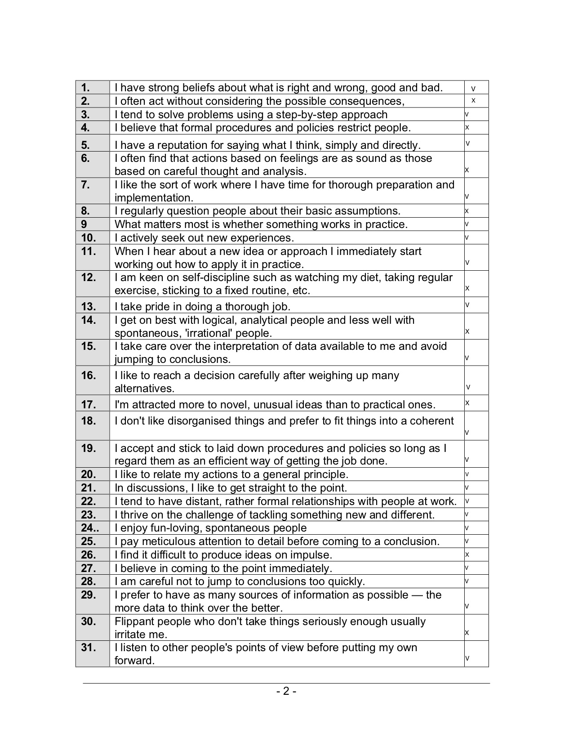

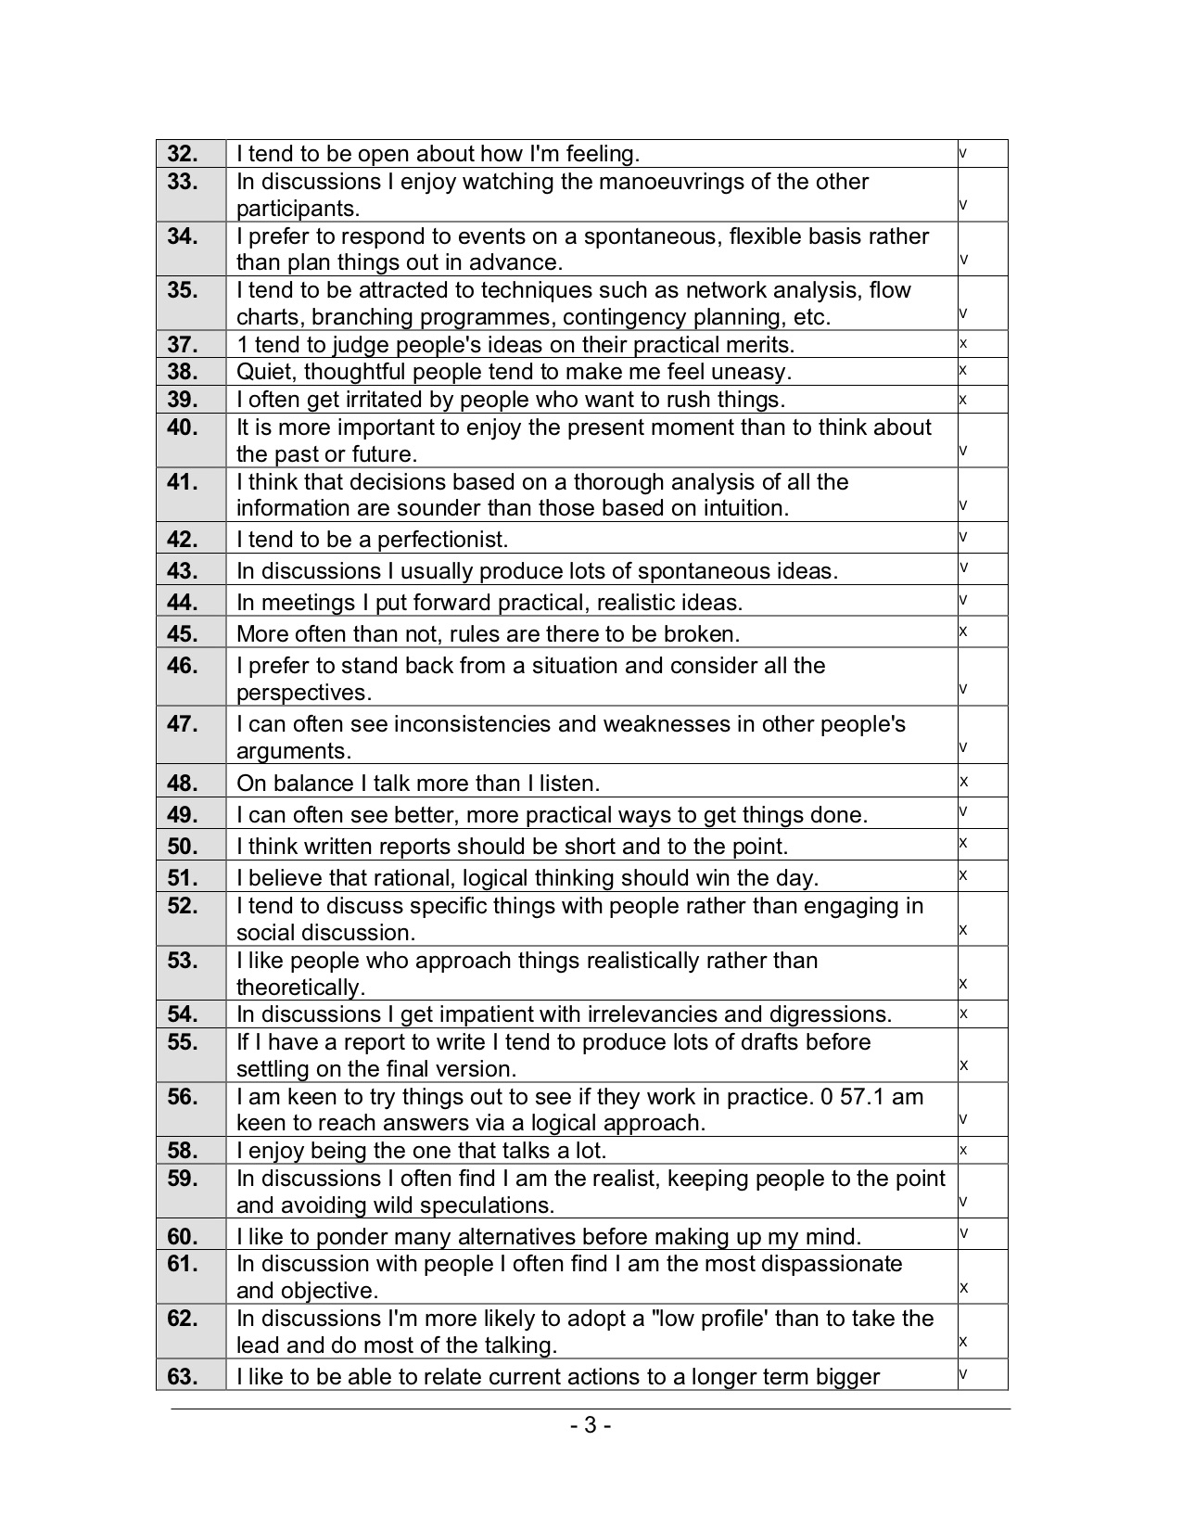

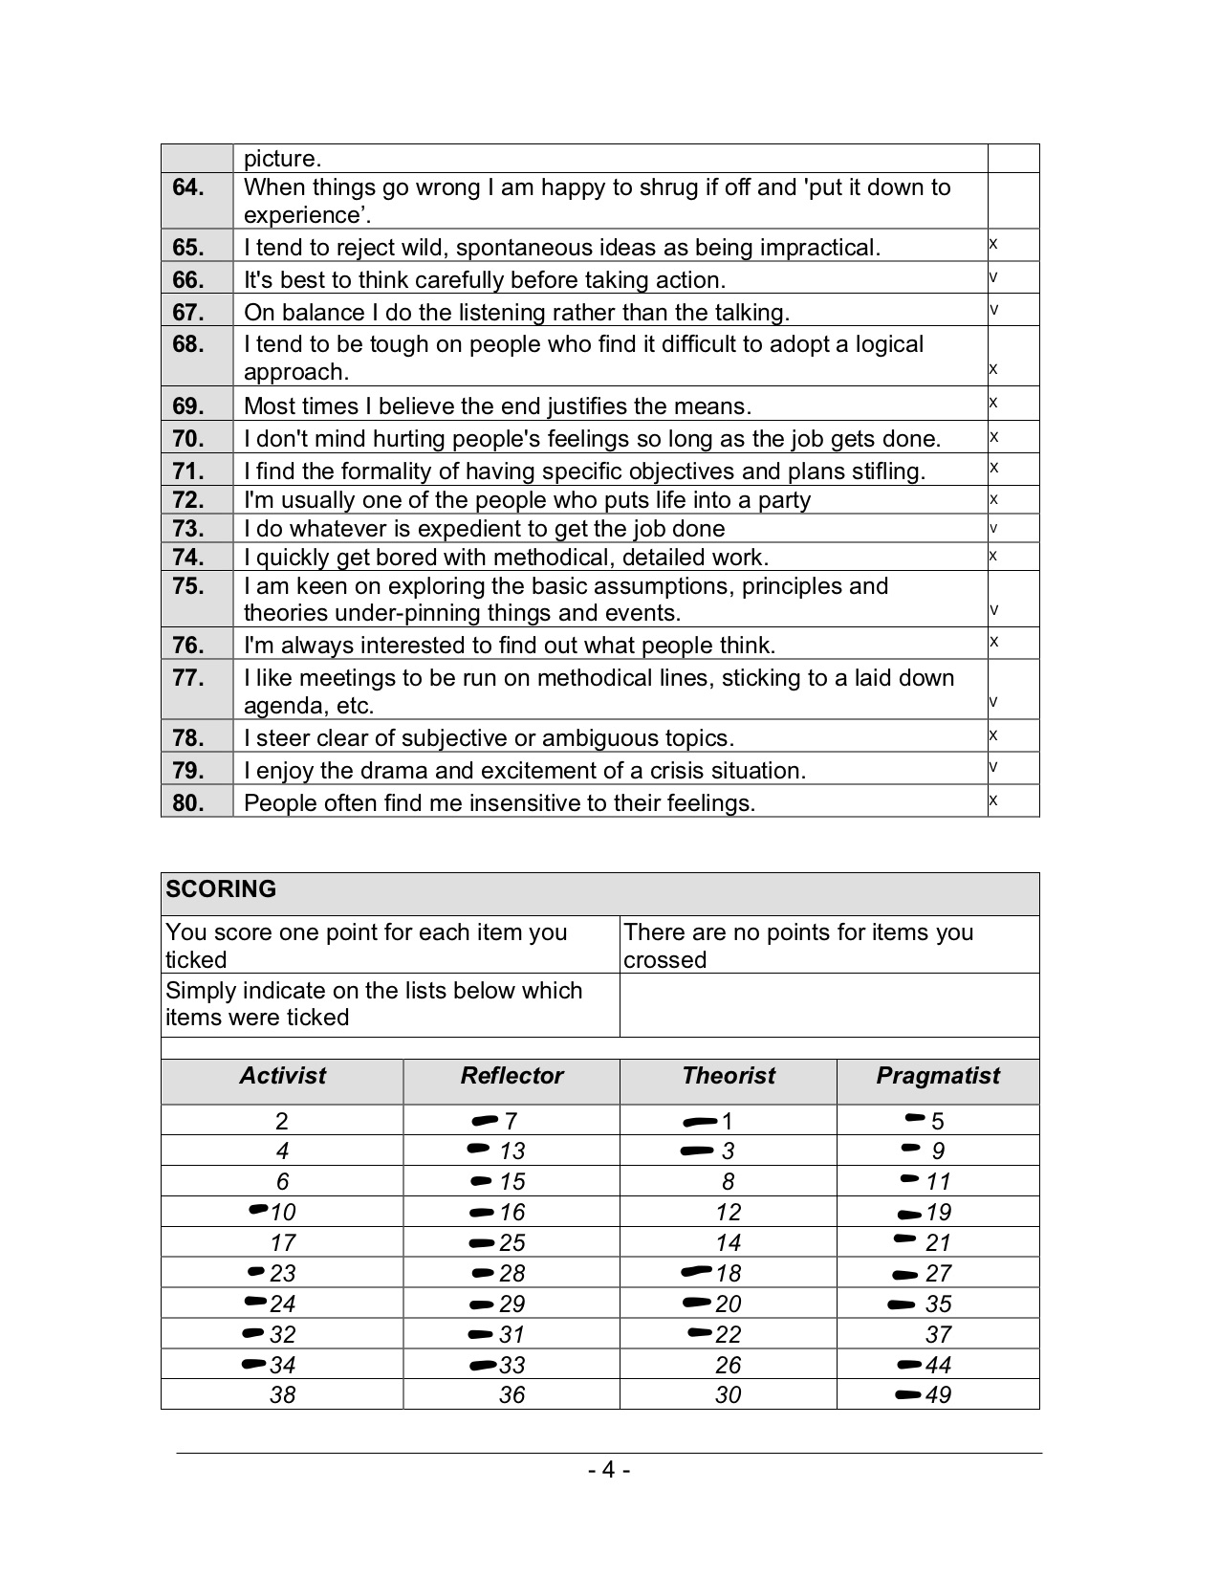

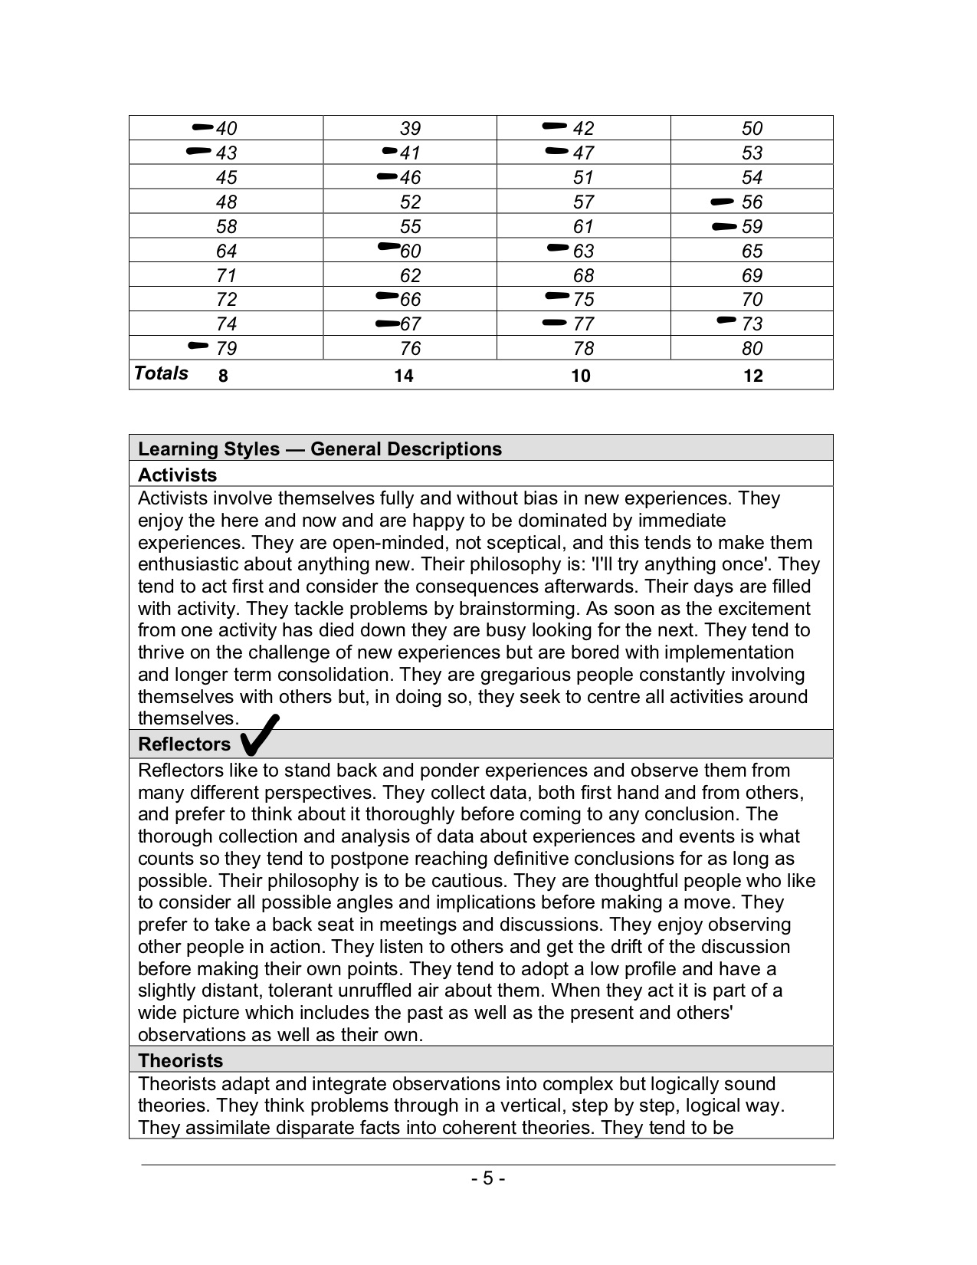

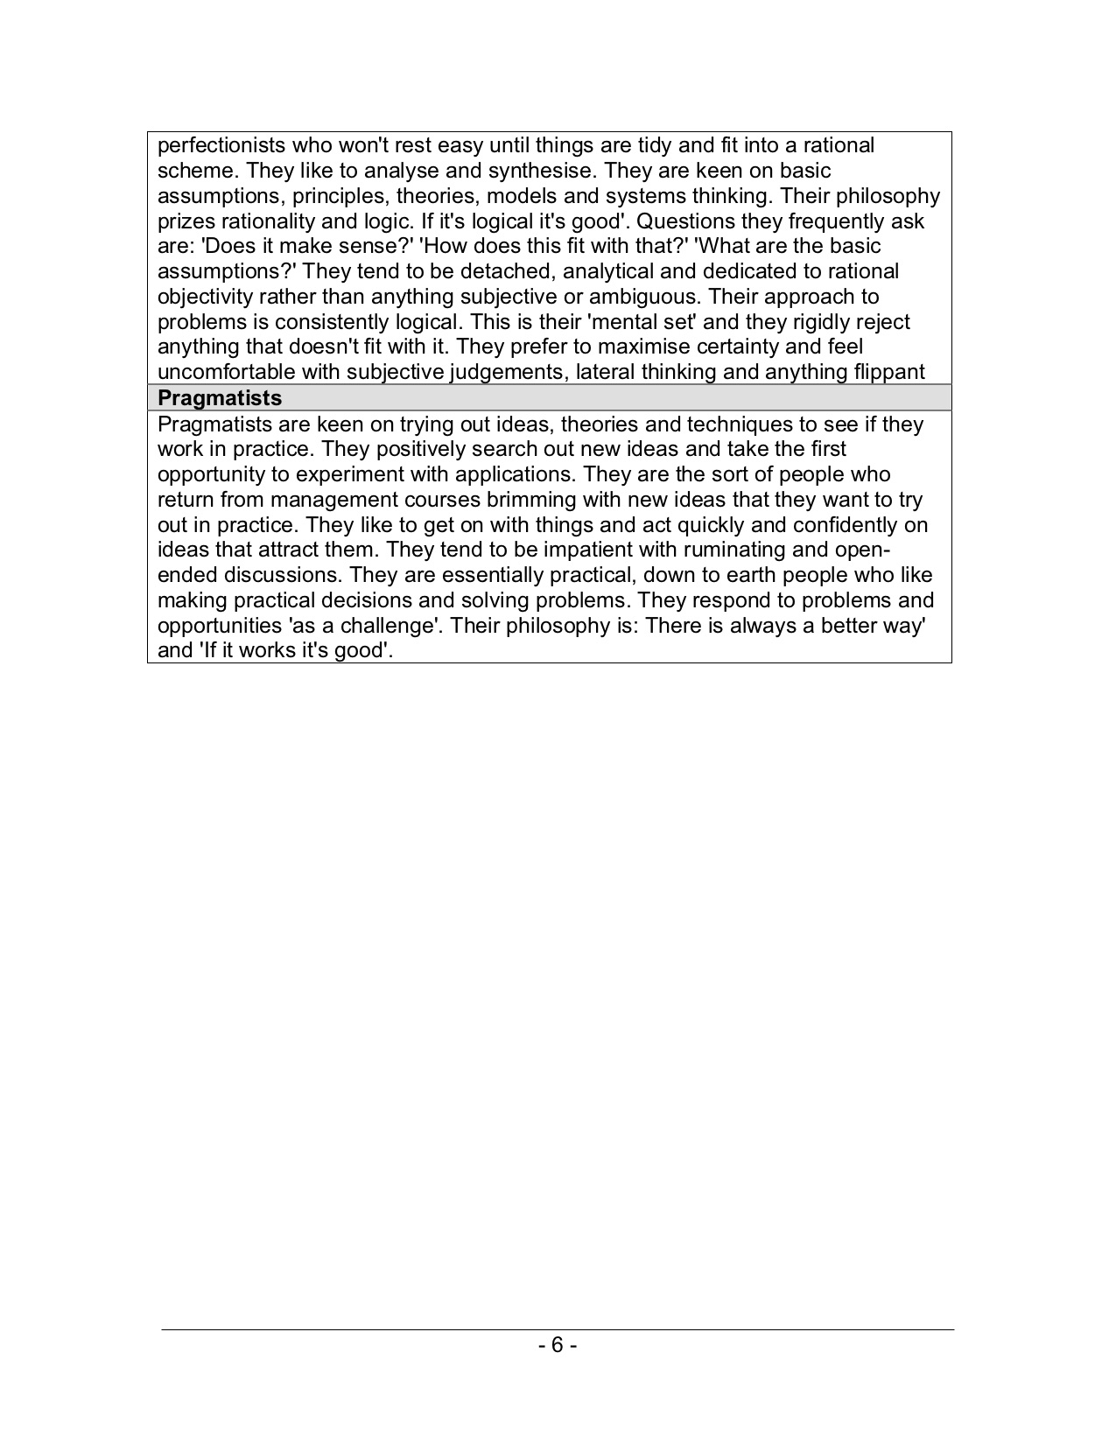

APPENDIX 4

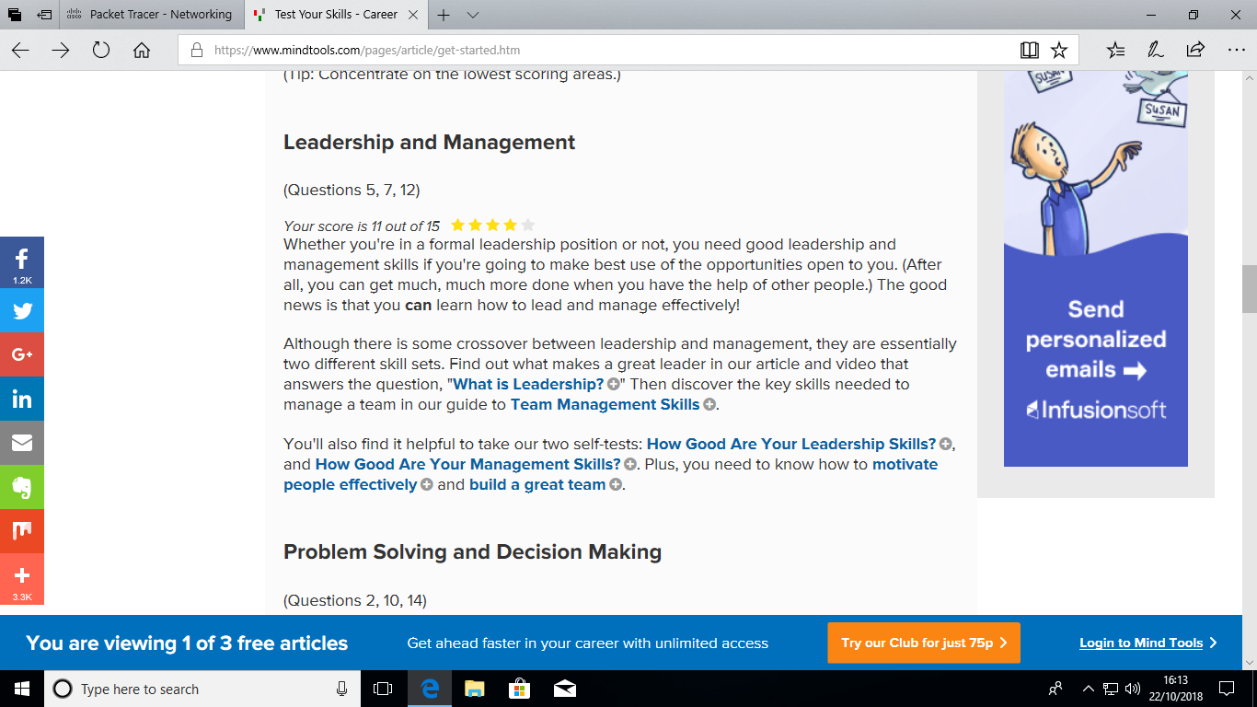

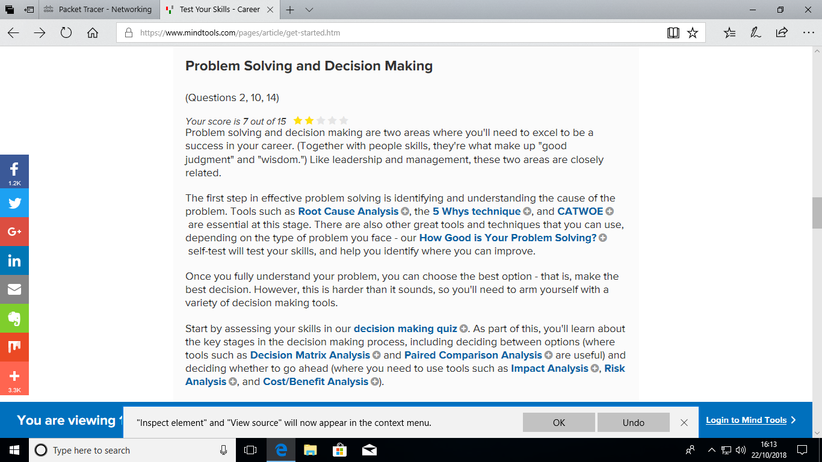

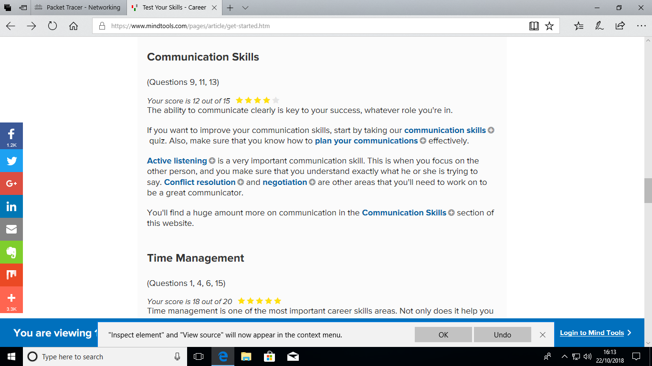

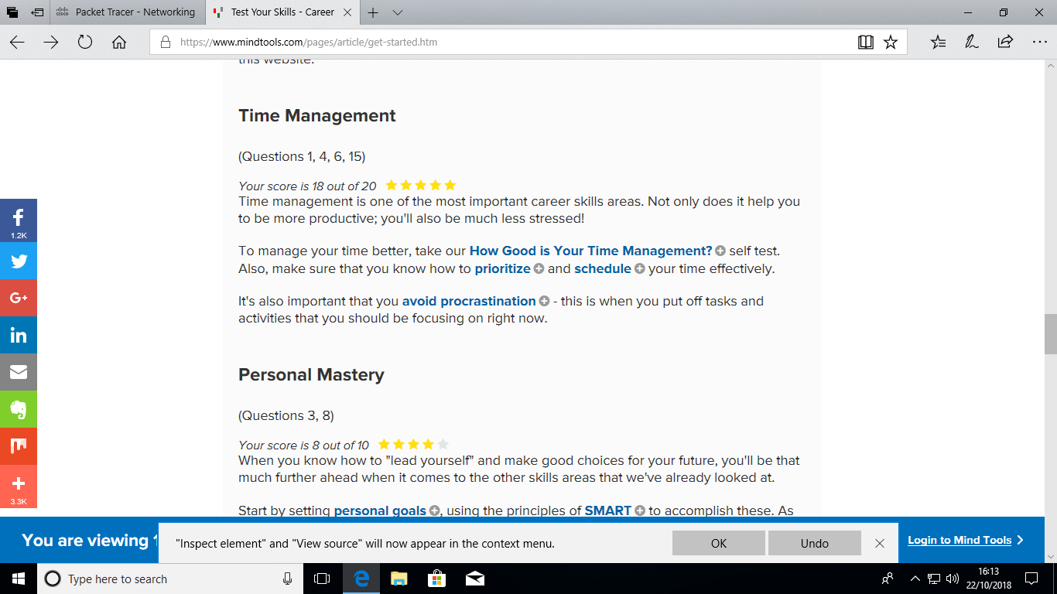

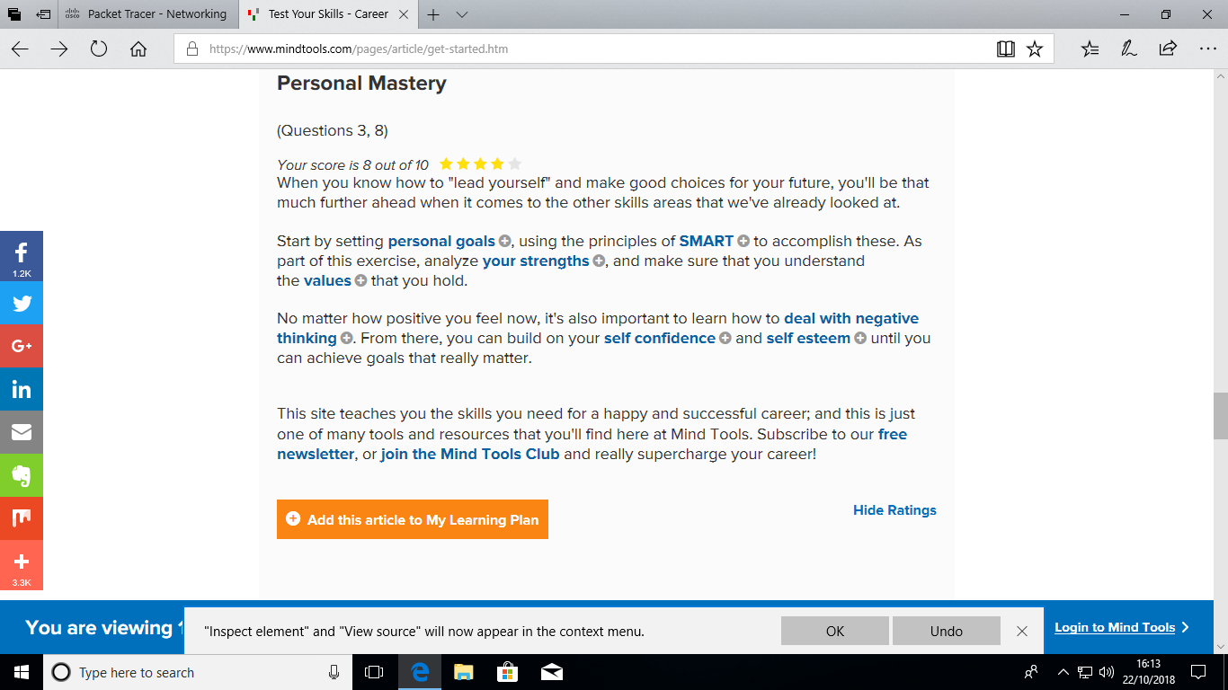

(Jeff Hajek,2009)

